|  |
| --- |
| Trackit-V3 |
| Standard Operation Procedure |
|  |
|  |
| 11/14/2023 |

Content

Prerequisite 3

How to install 3

Menu items 4

Home menu 4

Configuration 4

Show Base Configuration 5

Show Game Configuration 8

Show Serial Configuration 13

How to Run Trackit 13

Write your own sequence mode 13

Random event Generation mode 13

Configuring Trackit 13

Trackit Datafiles 13

How to Run SVIPT 13

Write your own sequence mode 13

Random event Generation mode 13

Configuring SVIPT 13

SVIPT Datafiles 13

References 13

[1] SVIPT article goes here 13

# 

# Prerequisite

Before running Trackit for the first time you need to have the following software installed on the computer:

Python version 3.11.4

With PIP install the following packages to python.

* Pygame
* Dearpygui
* pyDAQmx
* numpy
* Pillow
* Desktopmagic
* Pywin32
* Pyserial

With these software installations, you are able to run Trackit_v3

**Optional -**  if you want to connect a sensor to Trackit and control it through it connect a NiDAQ board from national instruments or a microcontroller board configured by UCPH Electronics workshop like a STM32.

**Optional –** If you want to send out triggers connect a NiDAQ board to your system it to distribute trigger signals

# How to install

When the prerequisite items has been for filled you are able to run Trackit_v3 from the very folder you have placed it.in the Trackit_v3 folder find “Trackit_v3_mainmenu.py” open it with IDLE, , visual code, or your favorite python IDE or run it through the terminal.

As a result, The following output will appear.

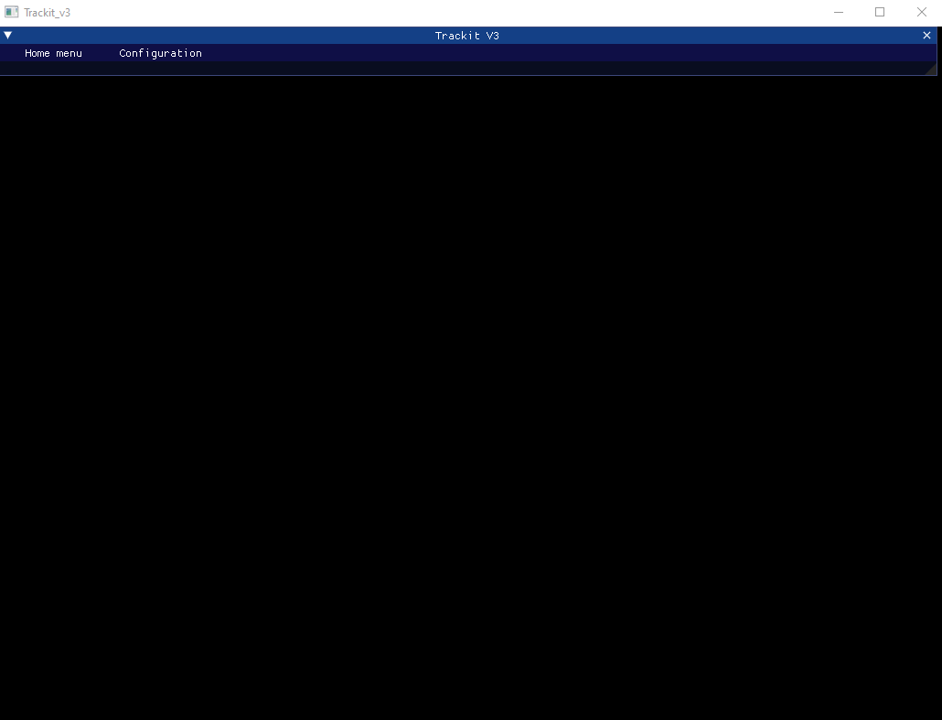

# Menu items

## Home menu

This menu item contains the main basic elements of any software. In here you will be able to start Trackit, Save your configuration, Load previous configuration, look at high scores and quit Trackit.

The most important elements in here are the save configuration and start Trackit. You will need to save your current trackit configurations before running trackit. The system will look for that configuration file after you have played and save it together with the data files created by the play through.

## Configuration

Configuring Trackit requires you to be aware of the different configuration panels. Base, Game and Serial, especially the two former are important for most of your experiments.

### Show Base Configuration

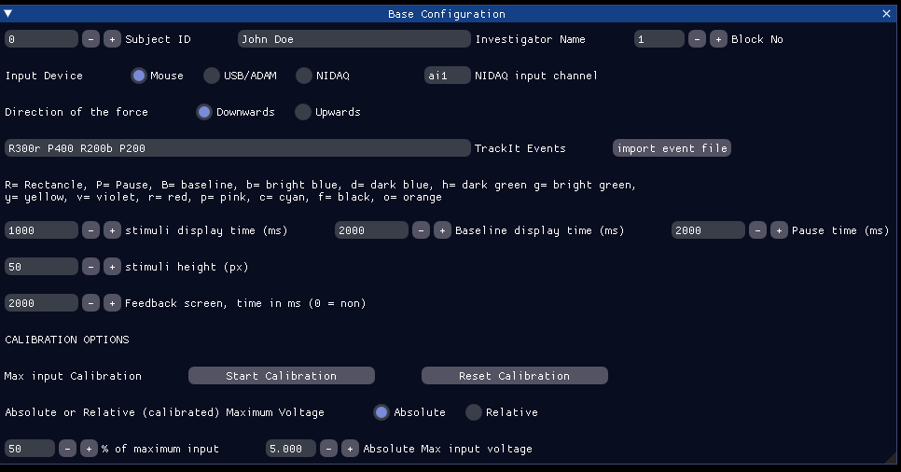

This menu will configure the core parameters of the Trackit experience. It concerns who the subject is and who the investigator is. The main input and output parameters. Lastly, the menu concerns calibration and how to use the calibration. From the top let’s look at the different elements

1. **Subject ID** – This is the identifier of the subject currently being investigated
2. **Investigator Name** – The name of the researcher conducting the experiment this can also contain project acronym for better data overview.
3. **Block No** – The number of the block currently being investigated

It is important that you keep track of the three upper item as these will be used to name the configuration and data files exported from the program after a successful Trackit run

1. **Input Device** – Here you choose whether you are working with the mouse, a sensor integrated into a microcontroller configured by UCPH Workshop (USB/ADAM) or a sensor connected to a NIDAQ national instruments board (NIDAQ). It is likely that the two latter will be for your experiment while the first option is primarily for testing and ´sitting up the experience.
2. **NIDAQ input channel** – this is the physical analog input port you have connected the sensor to the NIDAQ board, thus you are able to change sensor if there are more than one connected to the board.
3. **Direction of the force –** This item denoted the direction of the player when force is applied on the sensor, This is handy if you have an exercise where you press your foot down you will expect the cursor on the screen to move downwards. Likewise, if you raise your foot in order to adjust the angle you expect the cursor to move upwards.
4. **TrackIt Events –**  In this field you are able to write your very own Trackit sequence. There are three types of events you are able to create Baseline (B), Rectangle (R), and Pause (P). Baseline will always appear at either the bottom or the top of the screen dependent on the direction of the force **(6)**. When writing a baseline event you write e.g “B2000r”, where “B” is for baseline, “2000” is the amount of ms baseline is present on the screen, “r” is the color of the baseline. In this case, the color is red. You can see in the configuration menu a number of colors to choose from. Rectangle (R) is a bit different. It is written in the same way “R600g”, here “600” denotes the position on the screen. Pause (P) is the same syntax as a baseline. The only difference is that the color notation is irrelevant as the Pause is invisible and is a break between events. It shall be noted that all events have to be separated by space.
5. **Import Event File –** This button allows you to import Trackit events written in a Text file. Formatted in the same way as described in **(7)** e.g “B1500r P1000r R600g P1000r R400v” Note that all events are separated by spaces.
6. **Stimuli Display Time (ms) –** This information is used to tell how long time each of the Rectangle events denoted in (**8**) is shown on the screen
7. **Baseline Display Time (ms) –** This information is only used when “Return to Baseline” game mode is used, as it will create the baselines with the given time noted in this input box.
8. **Pause Time (ms) –** This time information is used when the researchers uses the game modes called “Return to baseline” and “Random Target Position”. In these games modes this variable denotes the lengths of the time the Pause is present between Rectangles and Baselines.
9. **Stimuli height (px) –** The size of the targets and the baseline, use this parameter as one way to adjust the difficulty level of your TrackIt game.
10. **Feedback screen, time in ms (0=non) –** denotes the amount of time feedback is shown to the subject after they have successfully completed a Trackit run.
11. **Start Calibration –** This button opens up a simple game where the subject has to apply the highest input into the system they are able to. The system provides direct feedback with a raw input number coming from the sensor of choice. It takes roughly 8.5 seconds to run the calibration sequence
12. **Reset Calibration –** If you are not satisfied with the calibration measure This button will reset all the recorded numbers and allow the subject to provide you with another calibration run.
13. **Absolute or Relative (calibrated) Maximum Voltage –** Here you are able to select whether the input from the subject will be compared up against the relative (calibrated) highest possible input or against an absolute input boundary, which is provided to the program.
14. **% of maximum input –** From either the calibrated maximum or the absolute value a certain % is used as the boundary used in the game, such that the maximum effort is newer used, but at max X % of the relative or absolute value.
15. **Absolute Max input voltage –** Here you denote an absolute value for the max value the subject have to perform in order to reach the toughest targets.

### Show Game Configuration

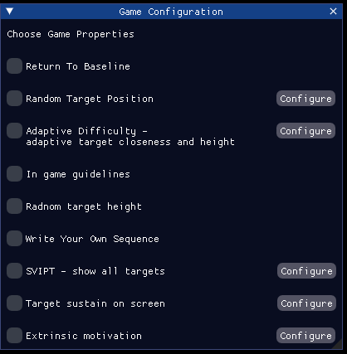

This menu adjust which kind of experience you will expose the subjects to. All of these checkmarks will have a major impact on the experience.

1. **Return To Baseline** – This option will take the sequence you have written and add a baseline and a Pause event after every second event. To use this option properly either use it together with “Random Target Position” or together with “Write Your Own Sequence”. If you write your own you have to follow this syntax R1 P1 R2 P2 R3 P3 ….. Rn Pn.
2. 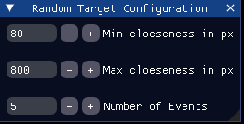**Random Target Position –** This option allows the system to create a random sequence. For it to do it properly you have to configure it. You can tell the system how far or close apart the different targets are by adjusting min and max closeness. Between each generated target the next target cannot be closer than the minimum value nor further away than the maximum from the previous generated target. Number of Events determines how many events will be generated to run this version of Trackit. This option will use **(9, 11 and 12)** from Base configuration screen.
3. 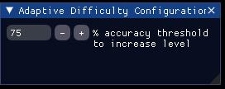**Adaptive Difficulty – adaptive target closeness and height –** Dependent on how good the subject performs the height of targets will be shallower and the targets will be further apart. As a default setting, the subject has to have an accuracy of 75% in order for the user to progress and reach a higher difficulty level. This can be adjusted to a different number if needed. Accuracy is simply the amount of time on target versus the total time the target is visible. Each subject starts at level 1. Behind the curtains the algorithm for these five adjusted parameters looks like the following

Minimum Closeness = Minimum Closeness + (level*5)*2

Maximum Closeness = Maximum Closeness + (level*5)*2

Random minimum target height = Random minimum target height - (level*5)/2

Random maximum target height = Random maximum target height - (level*5)

Target height = Target height - (level*5)

1. **In game guidelines –** This is a simple text prompt telling the subject to be as accurate and fast as possible.
2. **Random target height –** This will provide your targets with random heights between 20 and 50. You are able to adjust it by visiting your configuration file and find the variables called minRandomHeight and maxRandomHeight. They are currently hidden from the interface. We have seen previously these two variables are adjusted by the adaptive difficulty option.
3. **Write Your Own Sequence –** This option enables you to write your own sequence. It takes its input from (**7**) in base configuration. This or “Random Target Position” has to be enabled in order for TrackIt to work.
4. 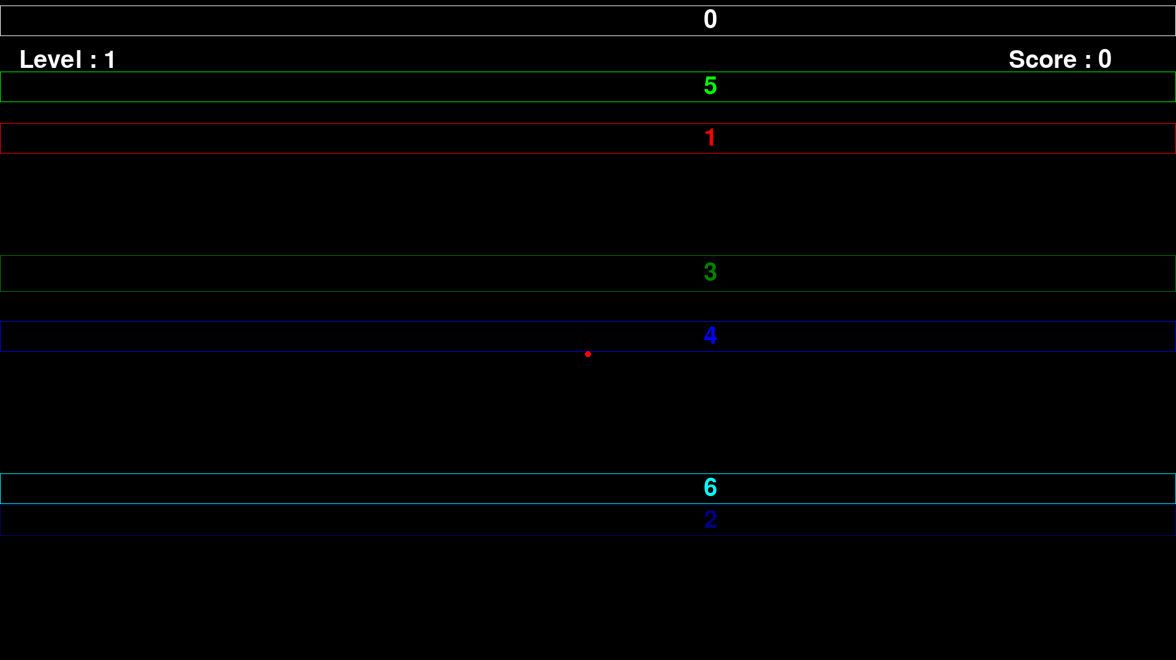**SVIPT – show all targets –** This is a completely different game mode than the usual TrackIt. While track it is all about reaching target fast and accurate as possible before they disappear SVIPT is a different beast entirely. In this game mode all targets are visible all the time, they are numbered and you have to return to baseline after each target. You have to go through the sequence as fast and accurate as possible. You only have to be within each target 150 ms before it counts as a visit. Each run through of a sequence of targets is called a Trial and targets are called gates. Two interesting parameters are given from each trial completion time and error. Completion time is the amount of time it took to go visit all the gates in the right order. Error is the amount of times the subjects misses the gate when they try to stop within the boundaries of the rectangles. Stopping before a gate also count as an error this is called an undershoot while stopping after a gate is called an overshoot.

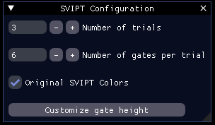You are capable of adjusting different parameters regarding the SVIPT game.Apart from the already visited options this configuration menu is unique to SVIPT.

You van adjust the number of Trials and the number of gates per trial. You can choose to work with original SVIPT colors, which are adjustable colors, which in the random target case matches those of SVIPT articles [1]. While none original colors will provide the subject with more guidance towards which gate he has to visit.

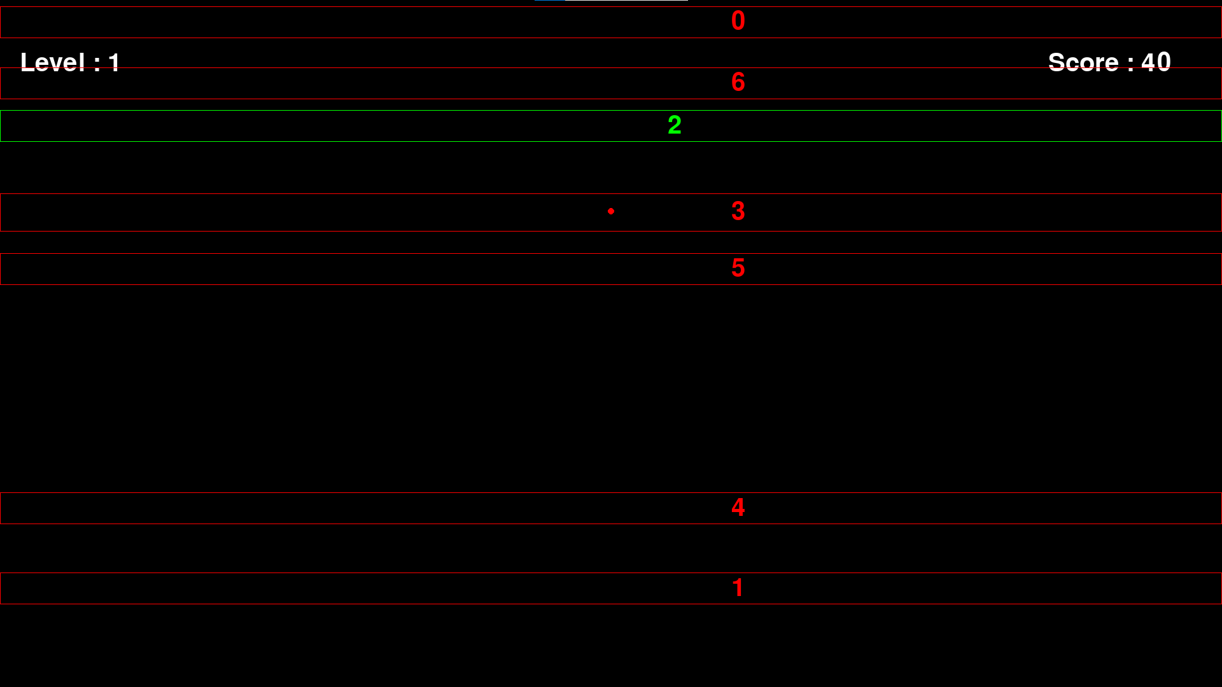

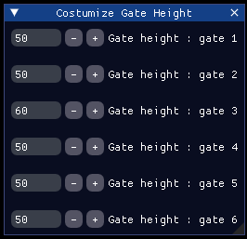The last element you are able to customize regarding the SVIPT game is the height of the gates. In case you want to have different heights and you want to have control to how different the height has to be you can adjust it in the configuration menu point.

When choosing SVIPT you have to either choose **Random Target Position** or **Write Your Own Sequence** as well. If you choose Random target position the computer will compute the position of the gates. It can fail a couple of times, but do not be discourage and try again. If you choose Write Your Own Sequence you have to use the input field found in the previous configuration menu **(7)**. The syntax however is a bit different**.** Writing a SVIPT sequence only includes gates and baseline, but only the baseline once. E.g. B1000r R300g R200b R600v …

1. 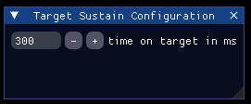**Target sustain on screen** – This item changes the TrackIt game entirely. With this option the target will remain on the screen until the subject has been within the target for a certain amount of time. Thereby changing the game to be more focused on tonic muscle control as they now have to be within the target for a certain amount of time instead of hitting it and stay within it before it disappears. The associated configuration menu can adjust the time.
2. 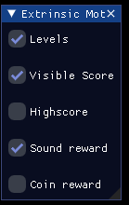 **Extrinsic motivation –** This option enables you to add game elements into the Trackit or SVIPT experience.   
   Levels

### Show Serial Configuration

# How to Run Trackit

## Write your own sequence mode

## Random event Generation mode

## Configuring Trackit

## Trackit Datafiles

# How to Run SVIPT

## Write your own sequence mode

## Random event Generation mode

## Configuring SVIPT

## SVIPT Datafiles

# References

### [1] SVIPT article goes here