AVA CONSULTANTS
Website Admin Panel
User Manual
A step-by-step guide for AVA Consultants staff. It explains how to look after job applications, blog posts, comments, testimonials, subscribers and staff accounts. You don't need any technical knowledge to use it.

Version 1.0 · October 2026
The screenshots in this manual show example data, not real applicants.
Contents
1. About the admin panel 3
2. Signing in and out 4
3. The Dashboard 6
4. Applications 7
5. Blog Posts 10
6. Comments 13
7. Testimonials 14
8. Subscribers 17
9. Staff accounts (admins only) 18
10. My account 20
11. Admin and Staff: who can do what 21
12. Problems and questions 22

1. About the admin panel
The admin panel is a private part of the AVA Consultants website. Only your staff can open it, and each person needs their own email and password.
Everything visitors send from the website arrives here: job applications, newsletter sign-ups, success stories and blog comments. You also use the admin panel to publish blog posts and decide which reviews appear on the website.

What you can do
Section | What it is for
Dashboard | A quick summary: new applications and things waiting for you.
Applications | Job applications from the website's contact form.
Blog Posts | Write, publish and edit the articles on the Blog page.
Comments | Approve or remove visitor comments on blog posts.
Testimonials | Approve success stories, or add your own client reviews.
Subscribers | People who want job updates by email.
Staff | Add or remove staff accounts. Only admins see this.
My account | Change your own password.

Two kinds of users
Every account is either Admin or Staff. Admins can do everything. Staff can do the daily work but can't delete applications or manage other accounts. See section 11 for the full list.

A good daily routine
- Sign in and look at the Dashboard.
- Open Applications and contact the new applicants. Change their status as you go.
- If the Dashboard shows testimonials or comments to review, approve or reject them.
- Sign out when you finish, especially on a shared computer.

2. Signing in and out

Open the admin panel
Type your website address followed by /admin into your web browser, for example www.avaconsultants.org/admin. It works on a computer, tablet or phone. Chrome, Edge, Safari and Firefox are all fine.
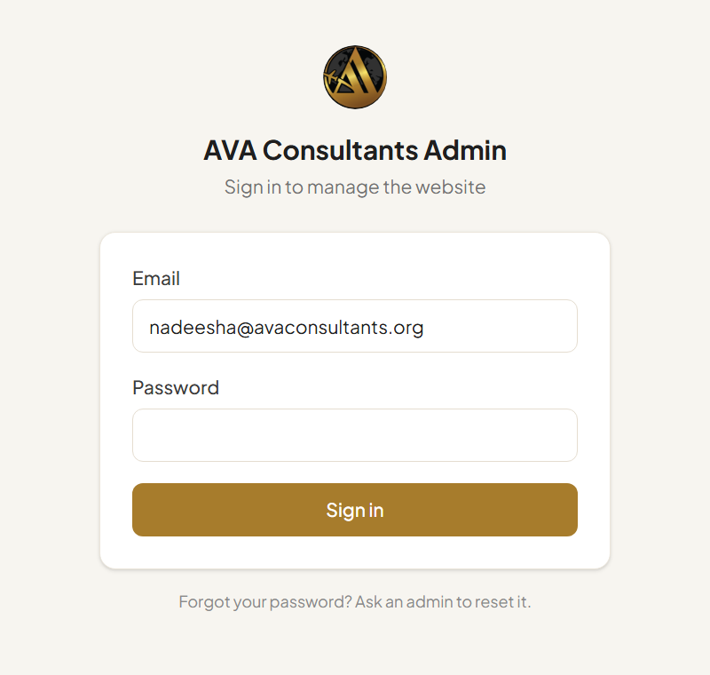
The sign-in page
- Type your Email.
- Type your Password.
- Click Sign in. The Dashboard opens.
Wrong password? You'll see “Incorrect email or password.” Check for typing mistakes and that Caps Lock is off, then try again.
Forgot your password? Ask an admin to set a new one for you from the Staff page (section 9). After you sign in, change it to your own password in My account (section 10).

Sign out
Click Sign out at the bottom of the left menu. Always sign out on a shared or public computer. Applicant details are private.

Getting around
The menu on the left takes you to each section. The section you're in is highlighted in gold. At the bottom you'll find your name, your role (Admin or Staff), My account, View website (opens the public website in a new tab) and Sign out.
On a phone, the menu is hidden to save space. Tap Menu at the top right to open it.
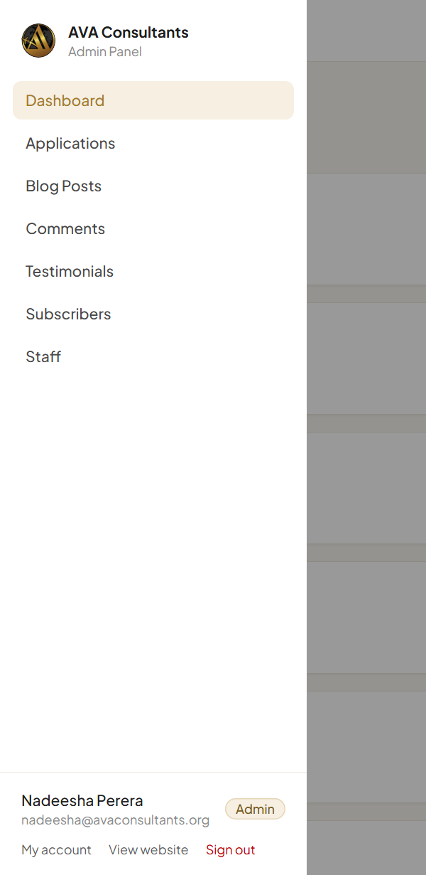
On a phone, tap Menu to open the left menu

3. The Dashboard
The Dashboard is the first page you see after signing in. It shows what needs your attention.
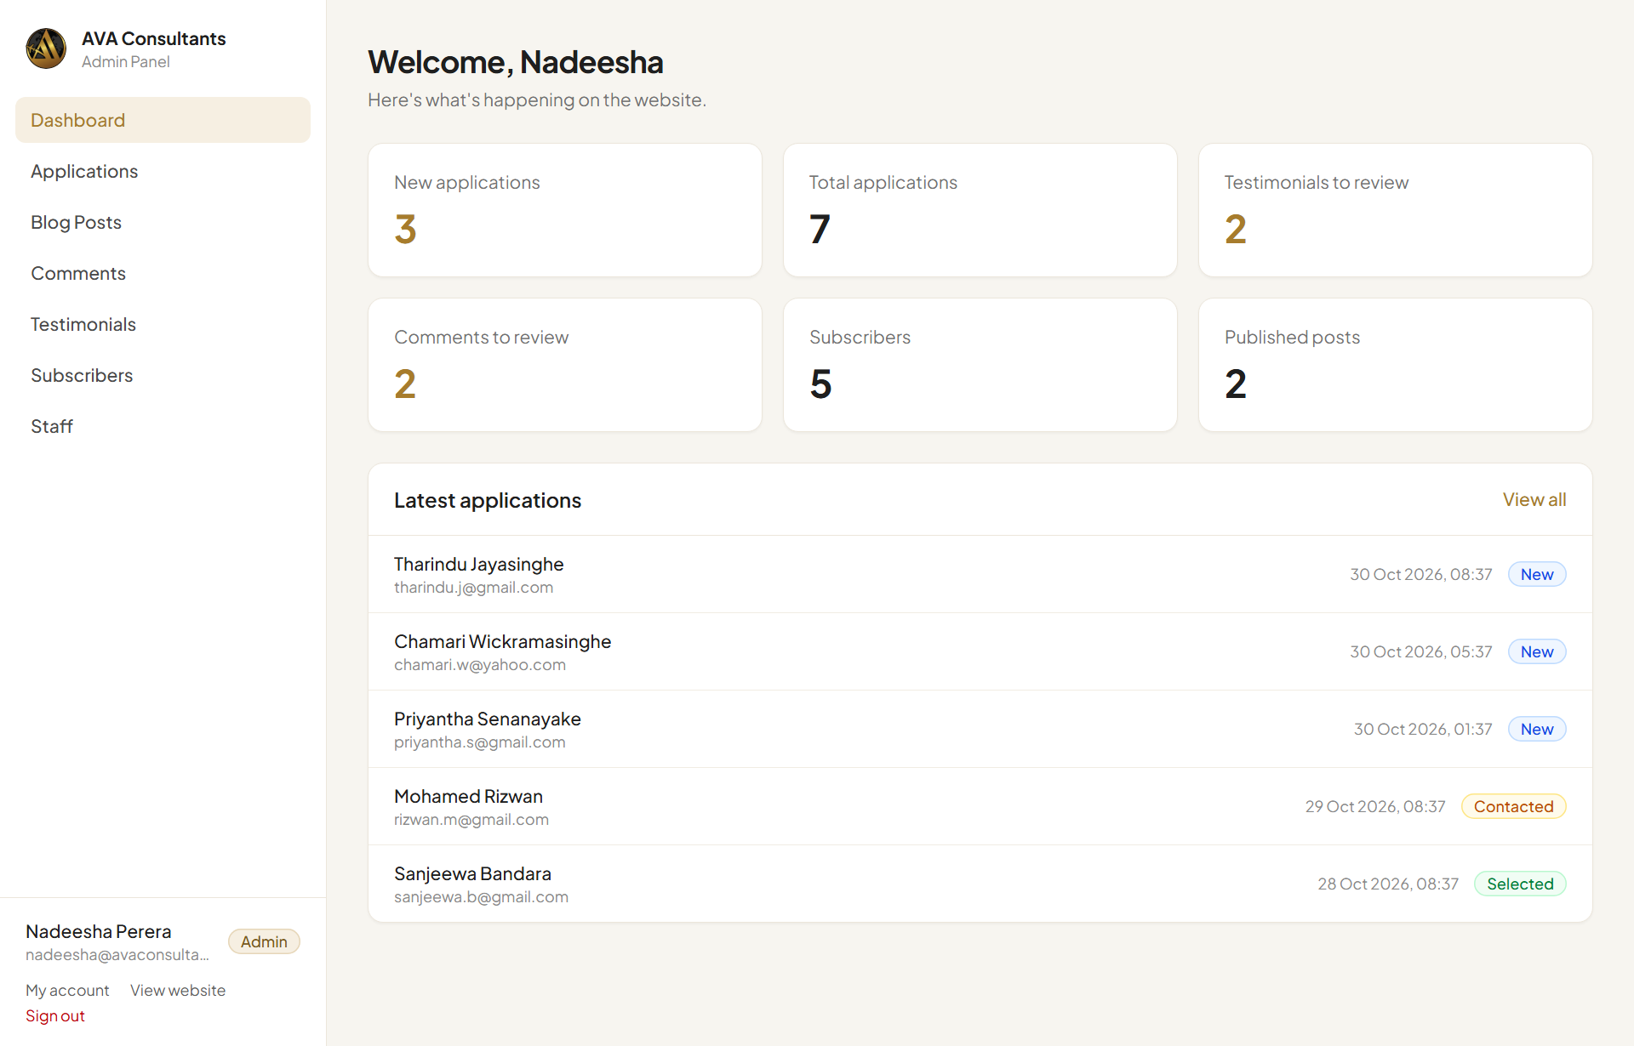
The Dashboard
Box | What the number means
New applications | Applications nobody has handled yet (status “New”).
Total applications | All applications ever received.
Testimonials to review | Success stories from the website waiting for approval.
Comments to review | Blog comments waiting for approval.
Subscribers | People on your email list.
Published posts | Blog posts visitors can see now.

Numbers that need action are shown in gold when they are above zero. Click any box to go straight to that section.
Below the boxes, Latest applications lists the five newest applications. Click View all to open the full list.

4. Applications
When someone fills in the contact form on the website, their application appears here straight away. The office Gmail also receives an email, and the applicant gets an automatic “thank you” email.
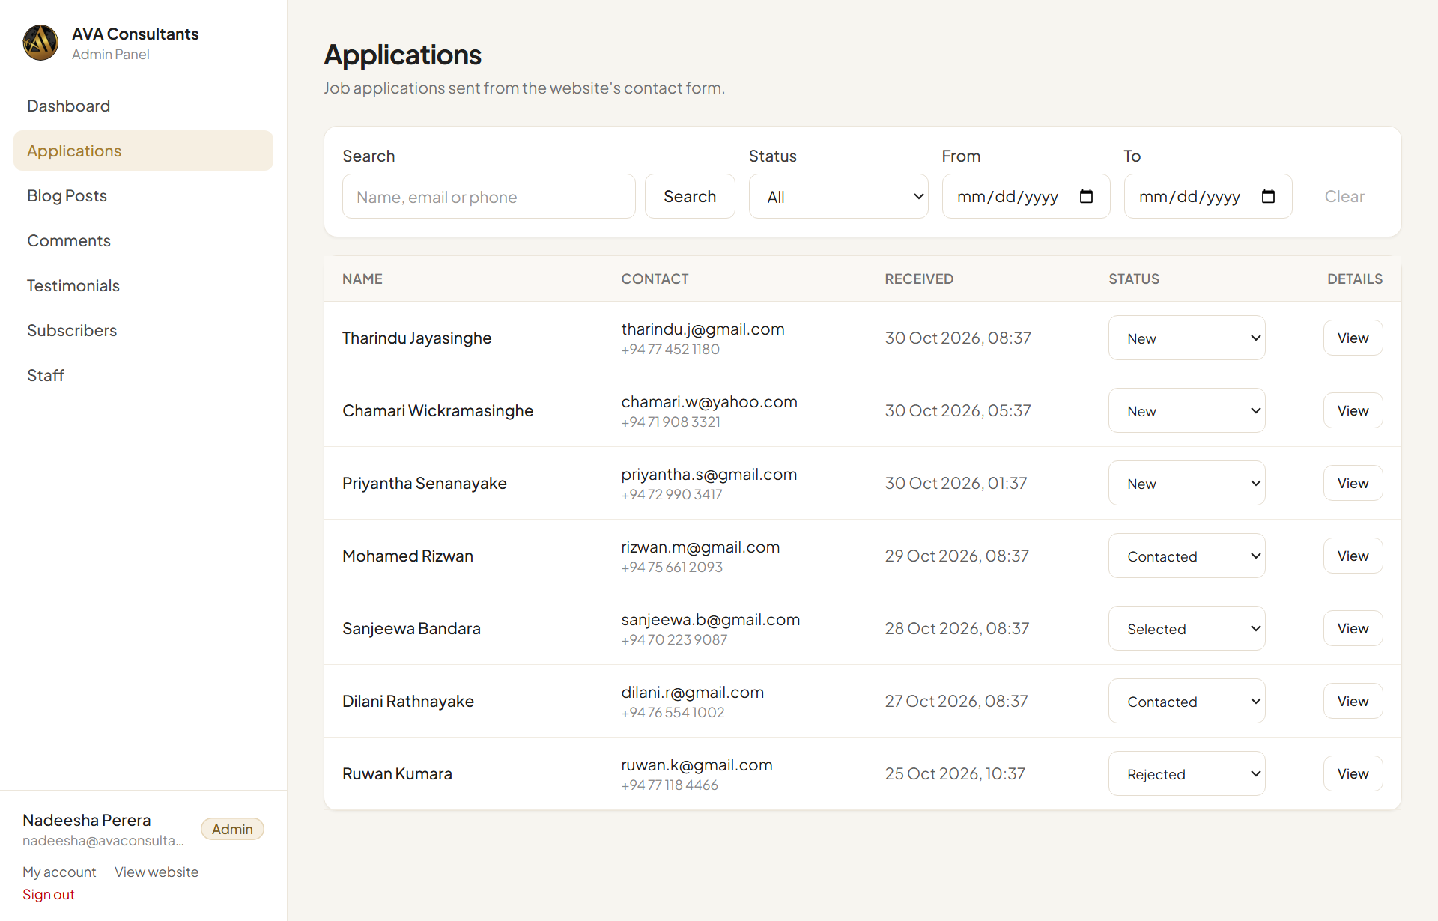
The Applications list

What the statuses mean
Every application has a status. Use it to keep track of where each person is.
Status | Use it when…
New | The application has just arrived and nobody has handled it yet.
Contacted | You have called, emailed or messaged the applicant.
Selected | The applicant is going ahead to the next stage (interview, visa, job).
Rejected | The applicant isn't suitable at the moment.

Open an application
- Click the applicant's name, or the View button on the right.
- A panel opens on the right with all their details: email, phone, address, passport number and expiry date (if they gave them), their message, and when they applied.
- Click the ✕ at the top right, or anywhere outside the panel, to close it.
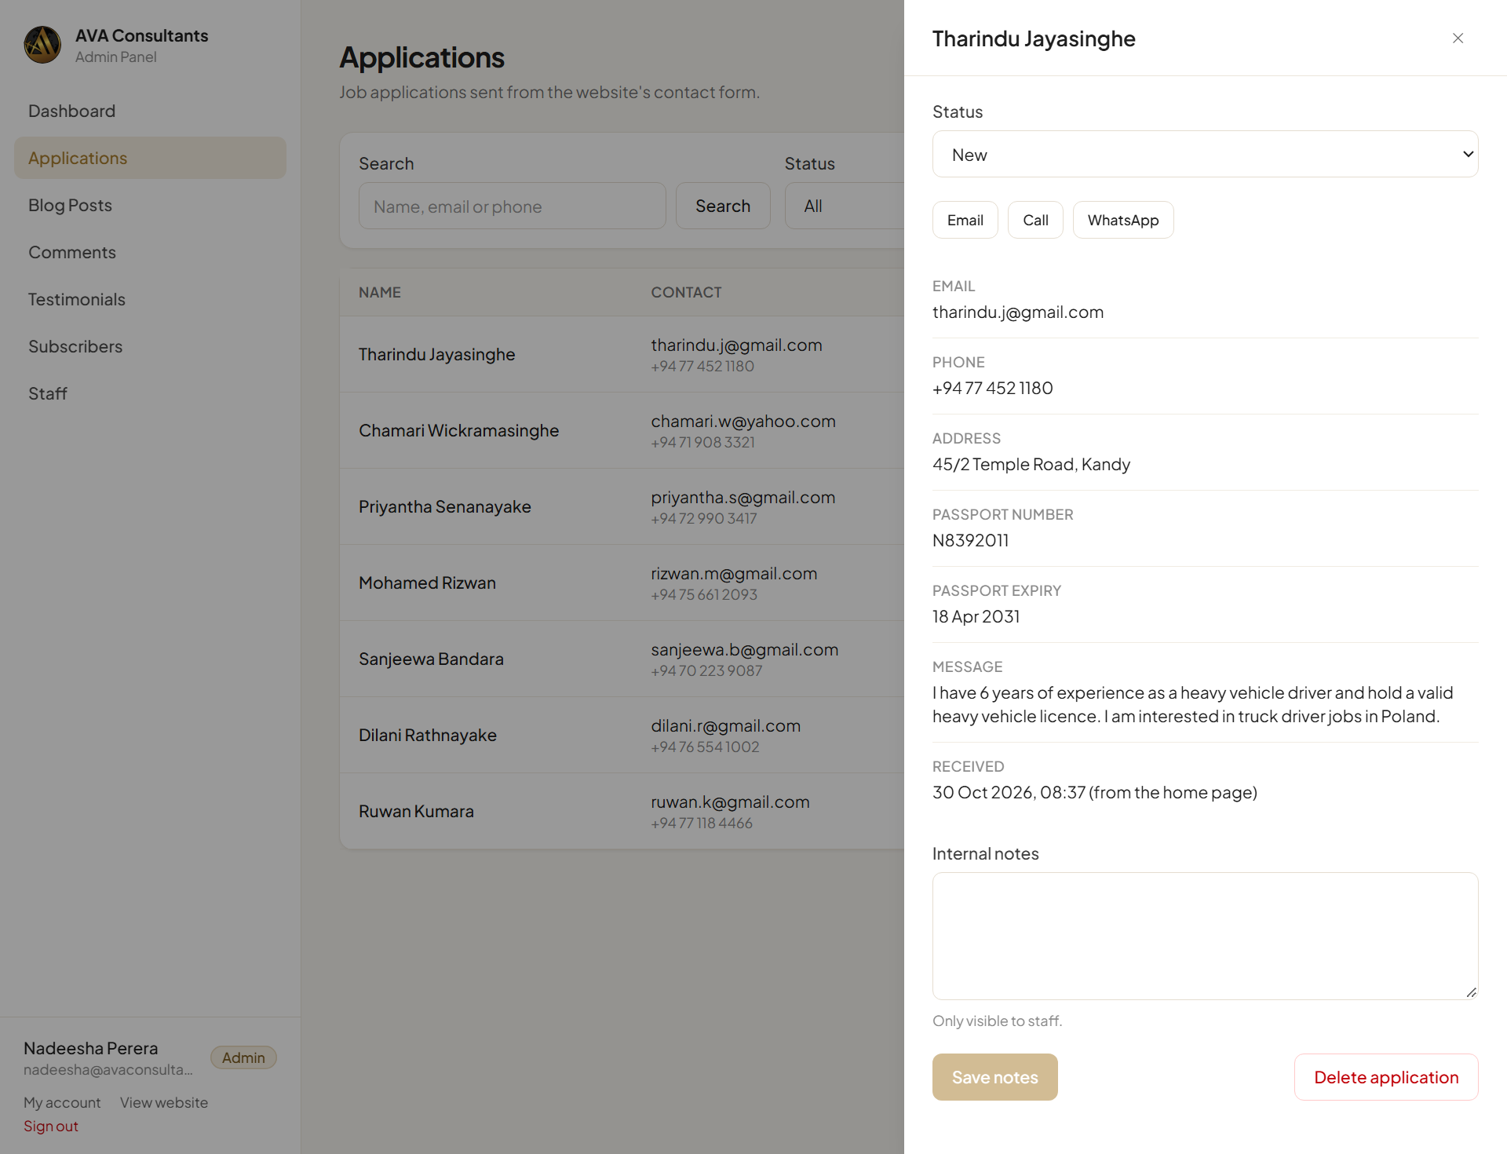
Application details

Contact the applicant
At the top of the panel there are three buttons:
- Email opens your email program with the applicant's address filled in.
- Call starts a phone call (on a phone, or a computer set up for calls).
- WhatsApp opens a WhatsApp chat with the applicant.

Change the status
You can change the status in two places:
- In the Status list at the top of the details panel. You'll see “Saved.” when it's done.
- Straight from the list, using the status drop-down on the applicant's row.

Add internal notes
Notes help your team remember what happened, for example “Called on Monday, sending CV by WhatsApp”. Applicants never see notes.
- Open the application.
- Type in the Internal notes box.
- Click Save notes. You'll see “Saved.”

Find an application
Use the boxes above the list:
- Search: type part of a name, email or phone number, then click Search.
- Status: show only New, Contacted, Selected or Rejected applications.
- From / To: show applications received between two dates.
- Clear: remove all filters and show everything again.
The list shows 20 applications at a time. Use Previous and Next at the bottom to see more.

Delete an application (admins only)
Open the application and click Delete application, then confirm. Staff members don't see this button.
Careful Deleting can't be undone. If you're not sure, set the status to Rejected instead.

5. Blog Posts
Blog posts appear on the website's Blog page. Use them for news, visa guides, job openings and tips for workers.
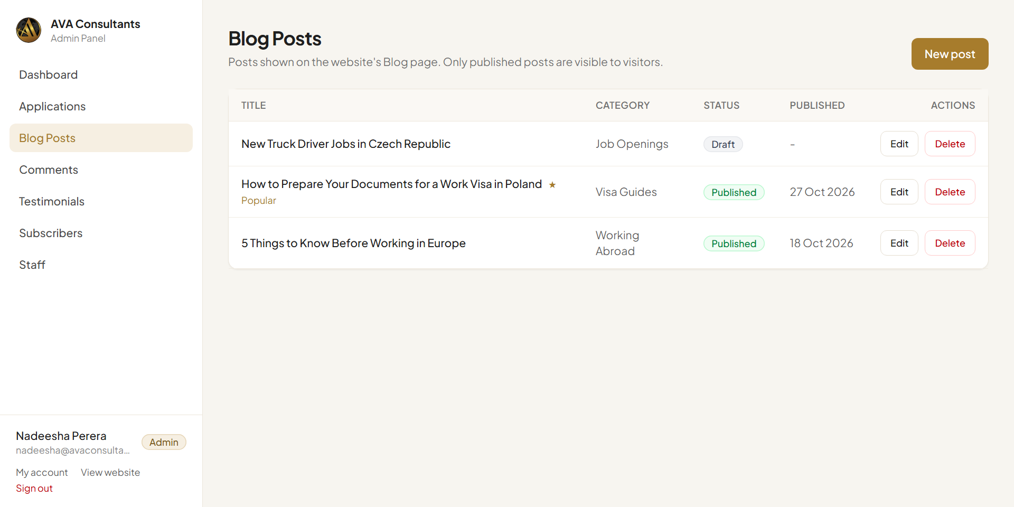
The Blog Posts list
Each post is either Draft (only staff can see it) or Published (everyone can see it on the website).

Write a new post
- Click New post (top right).
- Type a short, clear Title.
- Write the post in Content. Leave an empty line between paragraphs.
- Add a Cover image: click Upload image and choose a photo (JPG, PNG, WEBP or GIF, up to 5 MB).
- Type a Category, for example “Visa Guides”. Categories you used before appear as suggestions.
- Add Tags: a few keywords separated by commas, for example “Poland, Work Visa”.
- Author name is shown as “By …” on the post. You can leave it as “admin” or type your name.
- Tick Show in “Popular Post” if the post should appear in the Popular Post box on the Blog page.
- Choose the Status: Draft to save it for later, or Published to show it on the website now.
- Click Save.
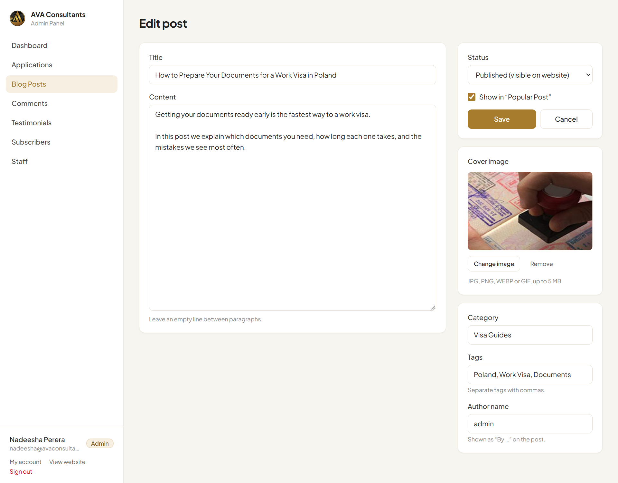
Writing or editing a post
Tip Not ready yet? Save it as Draft. You can come back, edit it and publish it later.

Edit or unpublish a post
- In the Blog Posts list, click the post's title or Edit.
- Make your changes. To take a post off the website without deleting it, set Status to Draft.
- Click Save.

Delete a post
Click Delete next to the post and confirm. This also deletes all comments on that post, and can't be undone.

How it looks on the website
On the Blog page, visitors see the cover image, the author, the date, the number of comments, the title and the first lines of the post. Learn More shows the whole post and the comments. The right side shows a search box, popular posts, categories and tags, all built from your posts.
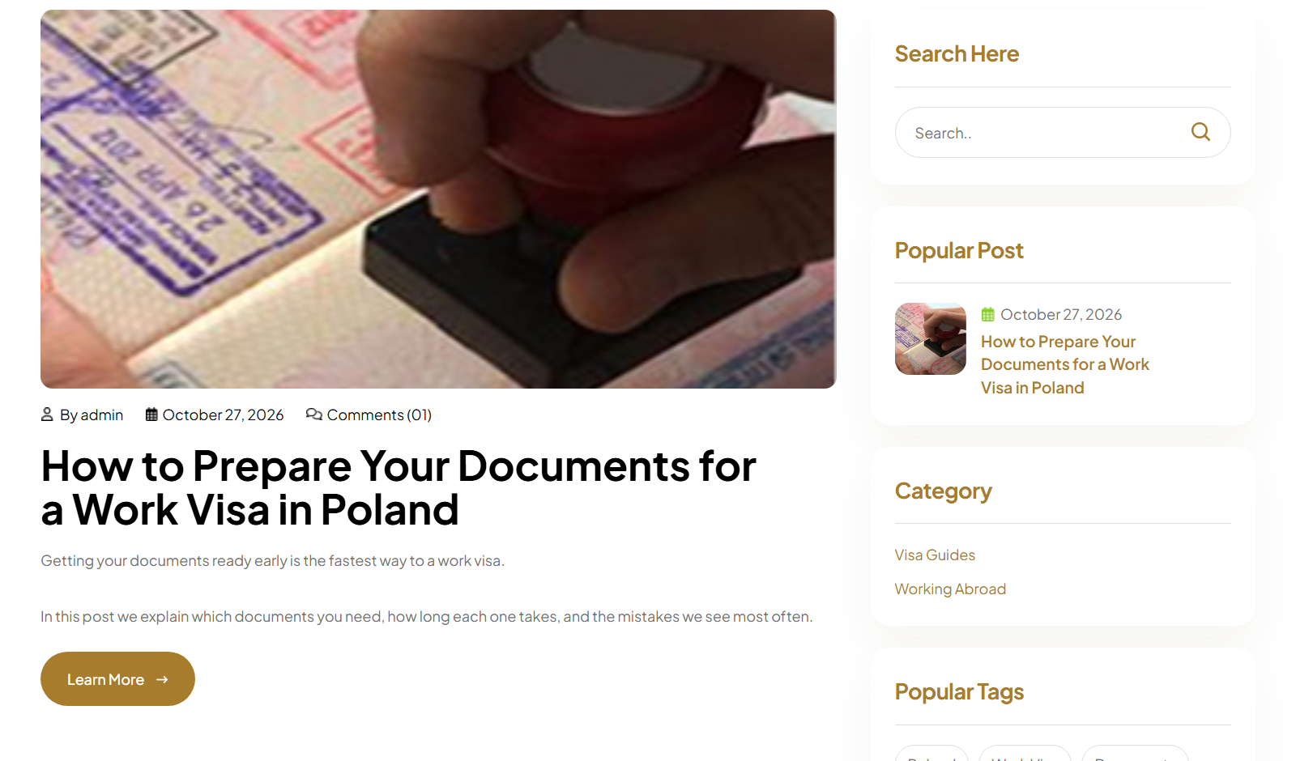
A published post on the website's Blog page
Good to know Until your first post is published, the Blog page shows the website designer's sample posts. They disappear as soon as one real post is published.
If no post is ticked as Popular, the Popular Post box shows the three newest posts.

6. Comments
Visitors can leave a comment under any published blog post. Comments are not shown on the website until someone approves them. This stops spam and rude messages.
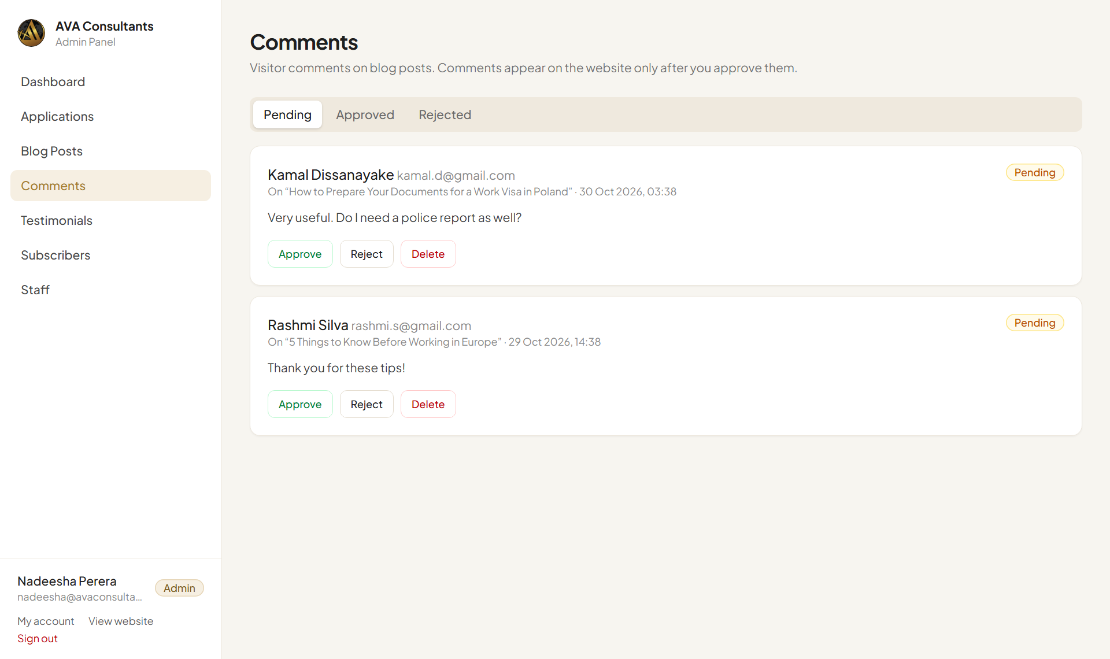
Comments waiting for review
Use the tabs at the top to switch between Pending (waiting for you), Approved and Rejected.
Each comment shows the visitor's name, email, the post they commented on, the date and the message. The visitor's email is only shown to staff, never on the website.
Button | What happens
Approve | The comment appears under the post on the website.
Reject | The comment stays hidden. You can still find it under the Rejected tab.
Hide | (On approved comments) Takes it off the website again.
Delete | Removes the comment permanently.

Tip Reply to a visitor's question by writing to the email address shown on the comment.

7. Testimonials
Testimonials are success stories from people you have helped. They appear on the Blog page and in the Client Testimonials box on the Home page.

Stories sent from the website
Visitors can share their story with the “What Is Your Success Story?” form on the Blog page. They enter their name, occupation, an optional photo and their story.
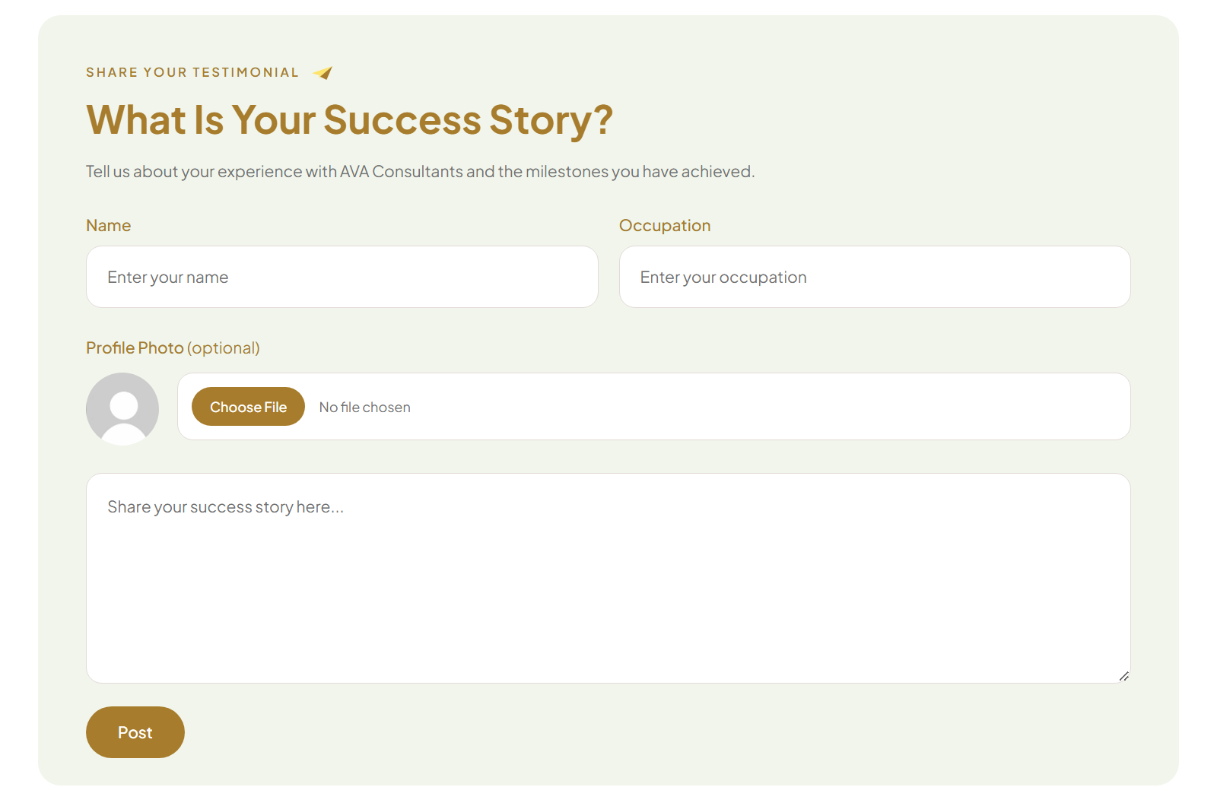
The form visitors use to share a story
New stories arrive in the Pending tab. They are not shown on the website until you approve them.
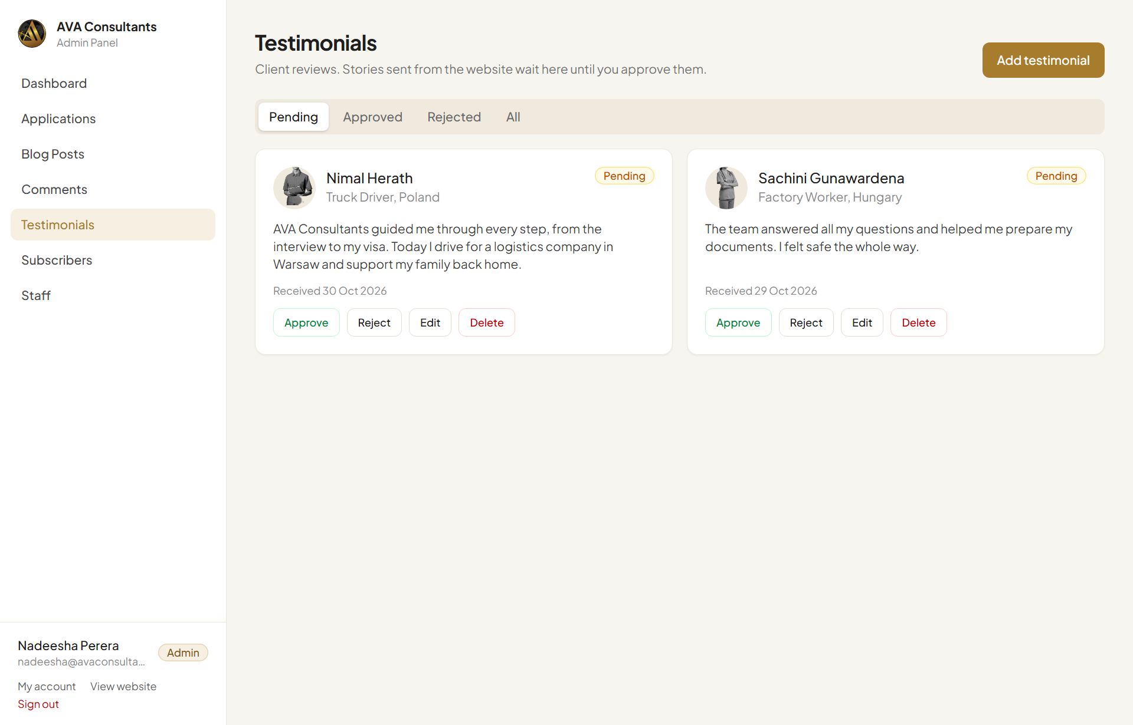
Testimonials waiting for review
Button | What happens
Approve | The story appears on the website.
Reject | The story stays hidden (find it under Rejected).
Hide | (On approved stories) Takes it off the website again.
Edit | Fix spelling, shorten the story, or change the photo.
Delete | Removes the story permanently.

Add a testimonial yourself
If a client sends you a review by WhatsApp or email, you can add it yourself.
- Click Add testimonial (top right).
- Click Upload photo and choose the person's photo (optional, up to 2 MB).
- Type their Name, Occupation (for example “Truck Driver, Poland”) and their Story.
- Leave Status as Approved to show it on the website straight away.
- Click Save.
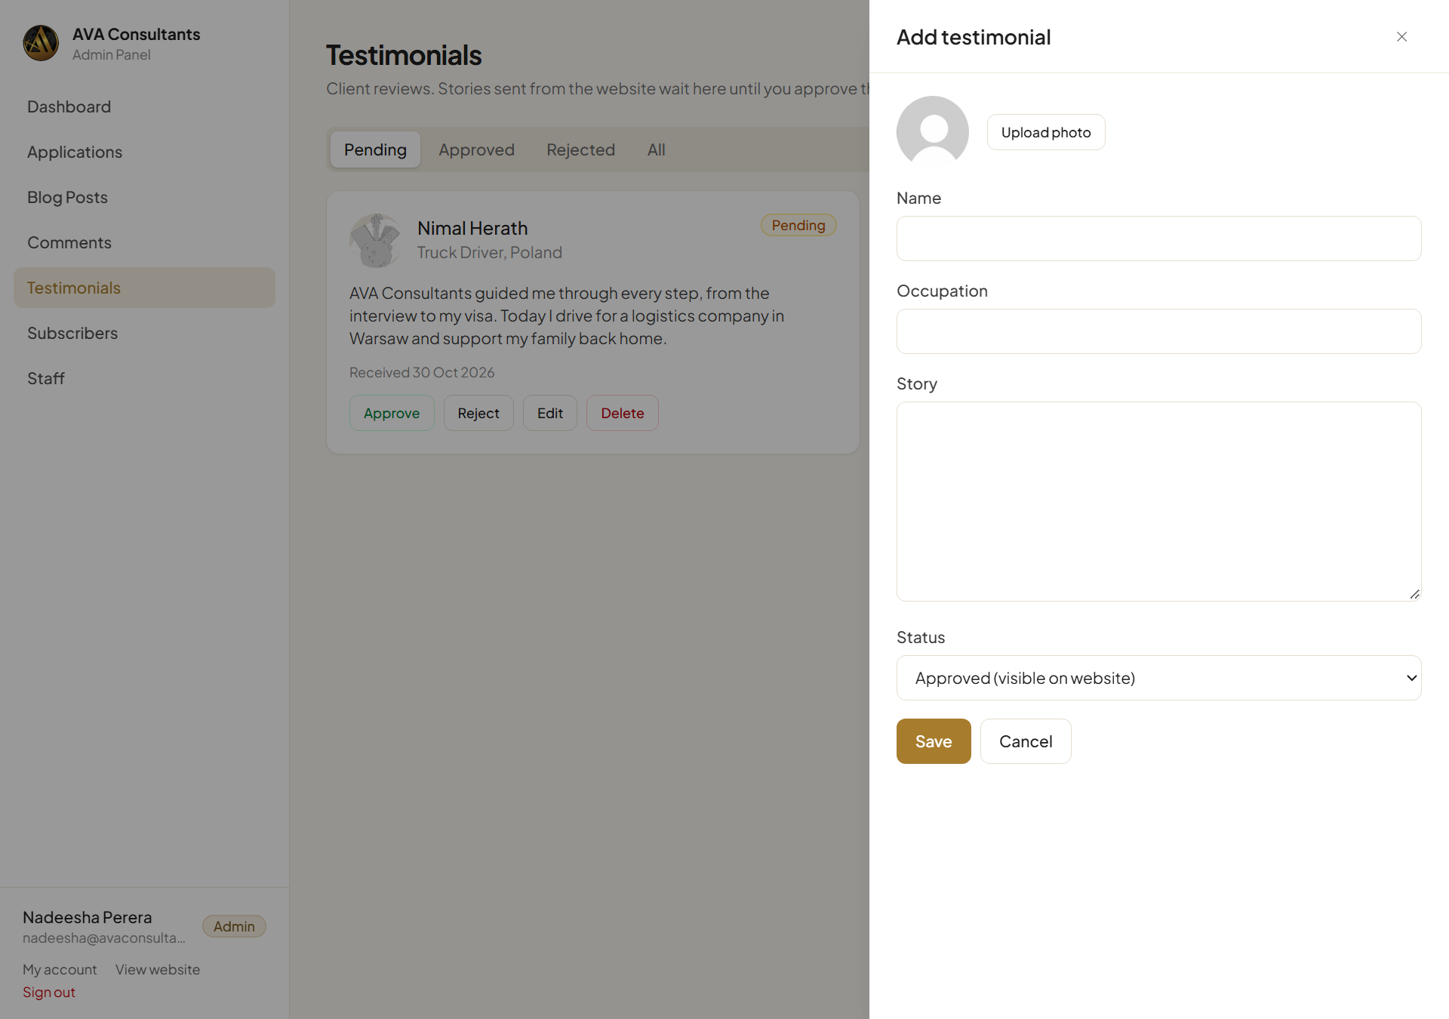
Adding a testimonial
Permission Only publish a person's name and photo if they have agreed to it.

How it looks on the website
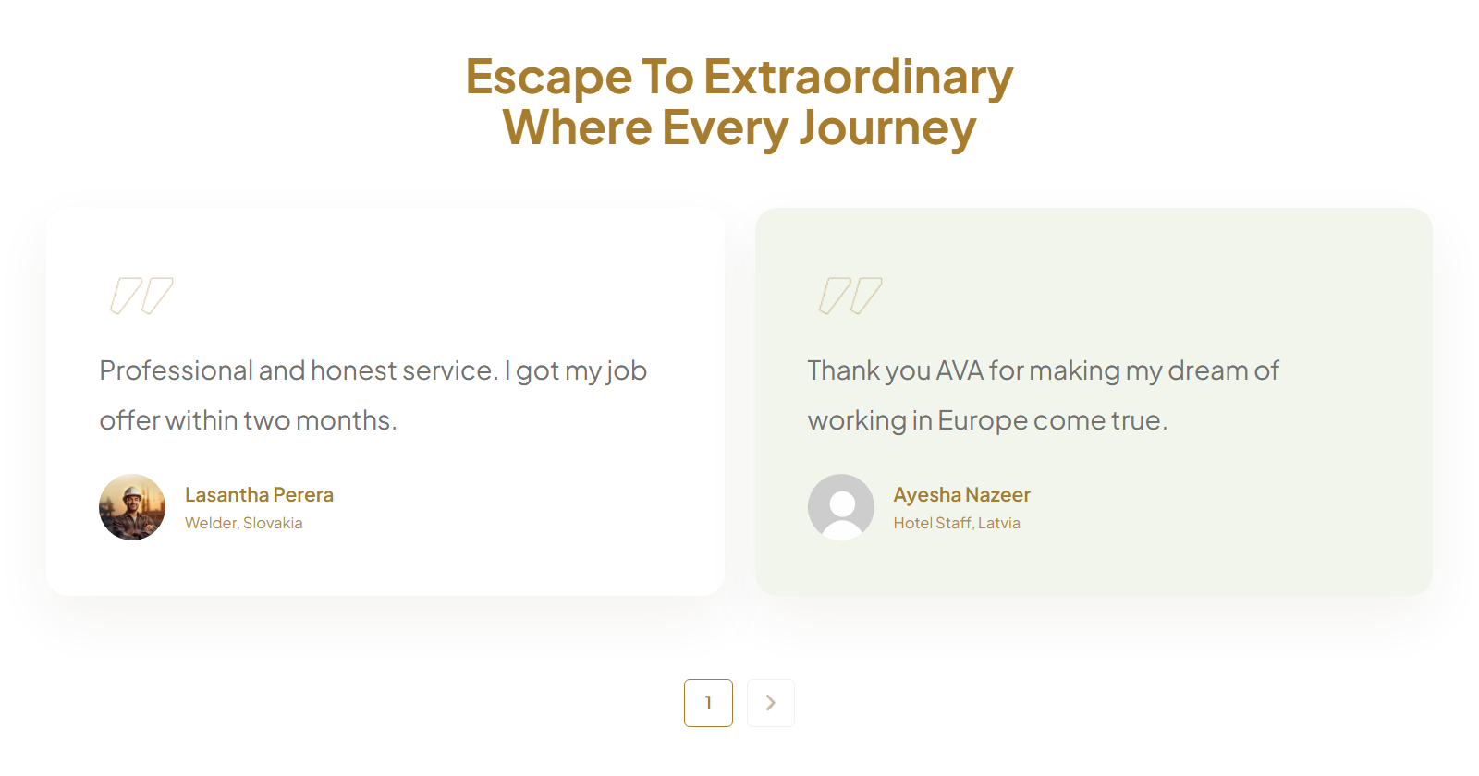
Approved testimonials on the Blog page
Good to know Until the first testimonial is approved, the website shows the designer's sample reviews. They disappear as soon as one real testimonial is approved.

8. Subscribers
Subscribers are people who want to hear about jobs from you. They join in two places on the website:
- The “Are You Ready To Fly?” box on the Home page, where they choose up to two preferred countries.
- The Subscribe Our Newsletter box at the bottom of every page.
If the same person signs up in both places, they appear only once, and both places are listed under “Signed up from”.
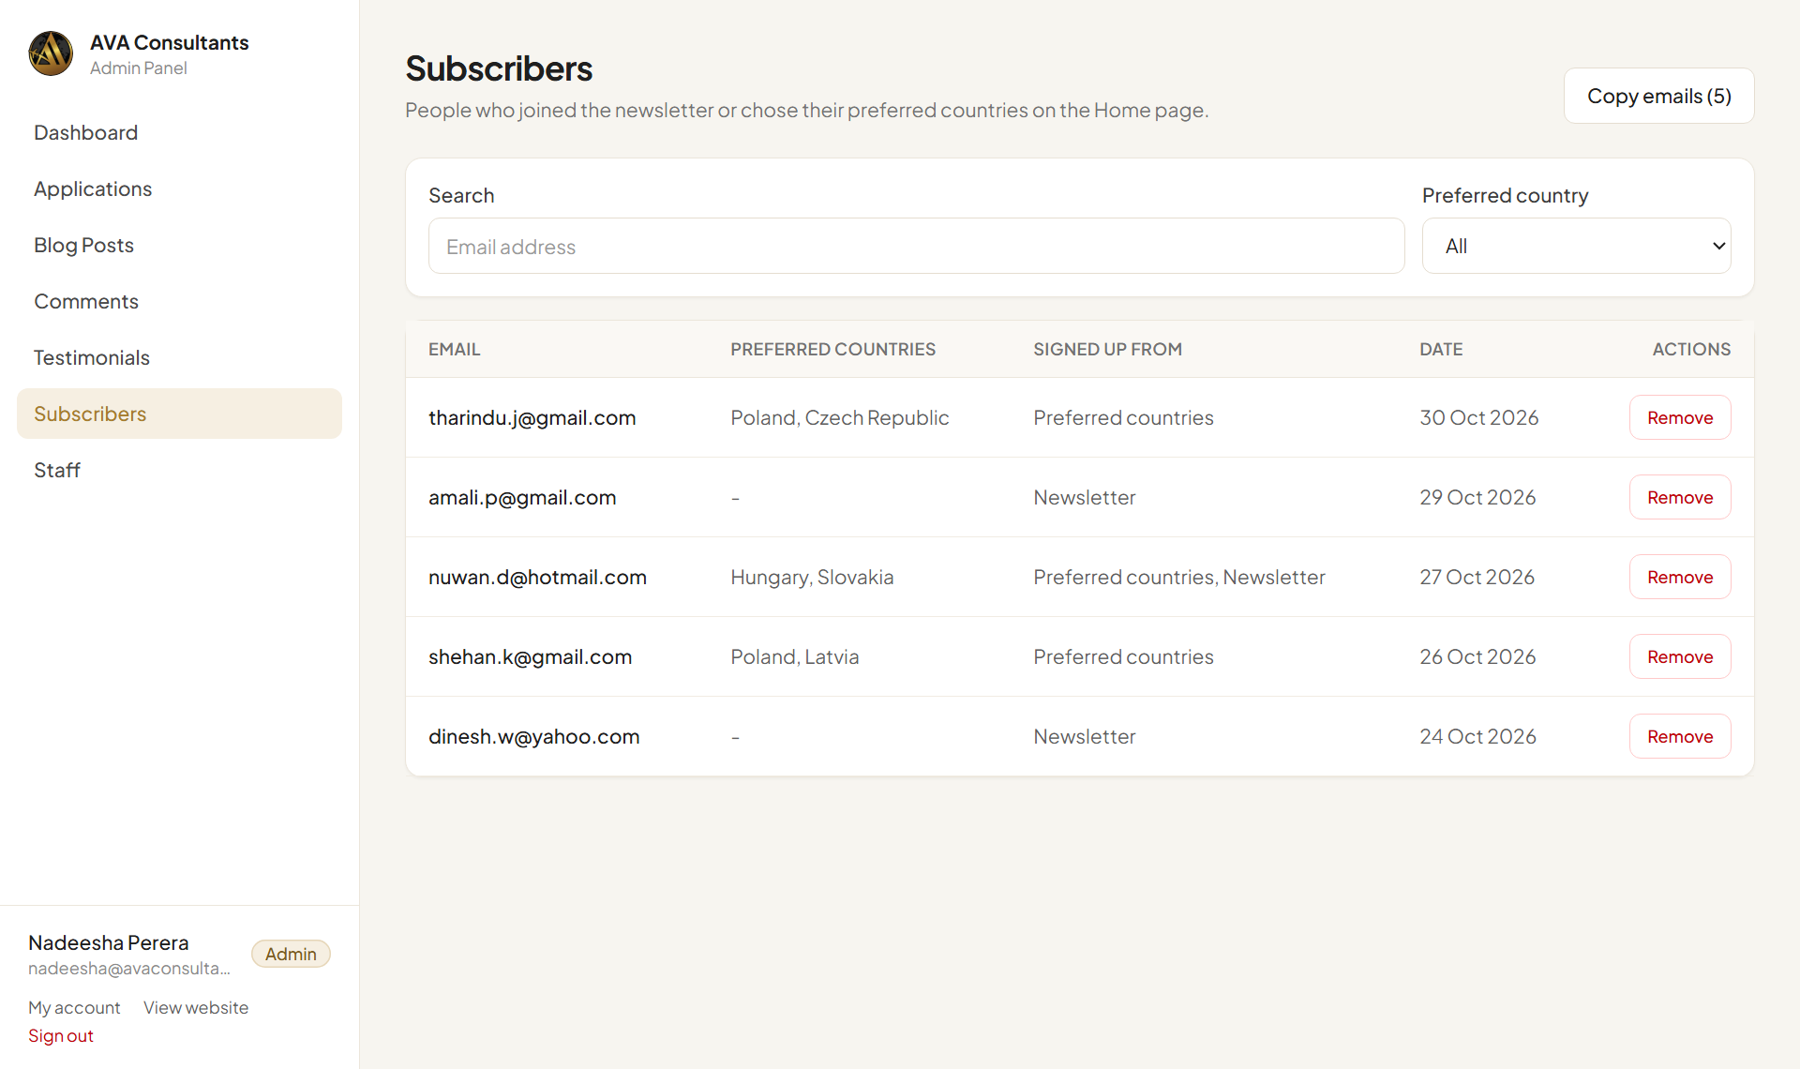
The Subscribers list

Find subscribers
- Search: type part of an email address.
- Preferred country: show only people interested in one country, for example everyone who chose Poland.

Send them an email
- Filter the list if you want, for example Preferred country = Poland.
- Click Copy emails. All email addresses in the list are copied.
- Open Gmail, start a new email, and paste the addresses into the Bcc box.
Privacy Always use Bcc, not To or Cc. Then subscribers can't see each other's email addresses.

Remove a subscriber (admins only)
If someone asks to be removed from your list, click Remove on their row and confirm.

9. Staff accounts (admins only)
The Staff page lists everyone who can sign in to the admin panel. Only admins can see this page.
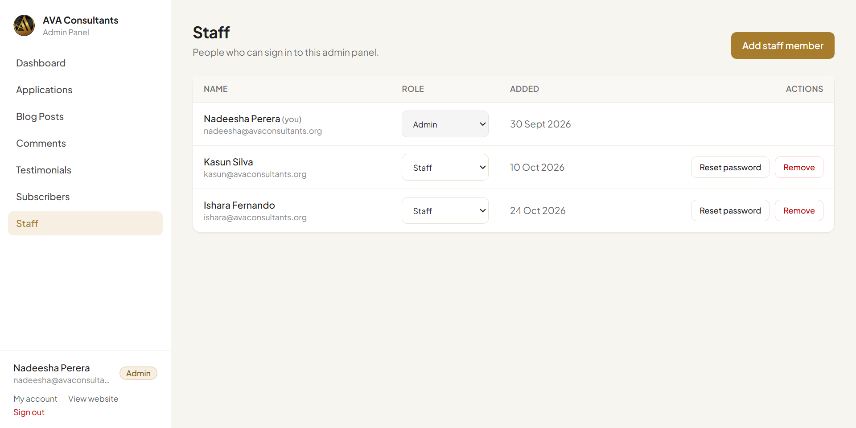
The Staff page

Add a staff member
- Click Add staff member.
- Enter their Full name and Email.
- Type a Temporary password of at least 8 characters.
- Choose the Role: Staff for most people, Admin only for managers.
- Click Add staff member.
- Give the person their email and temporary password, in person or by phone. Ask them to change it in My account after their first sign-in.
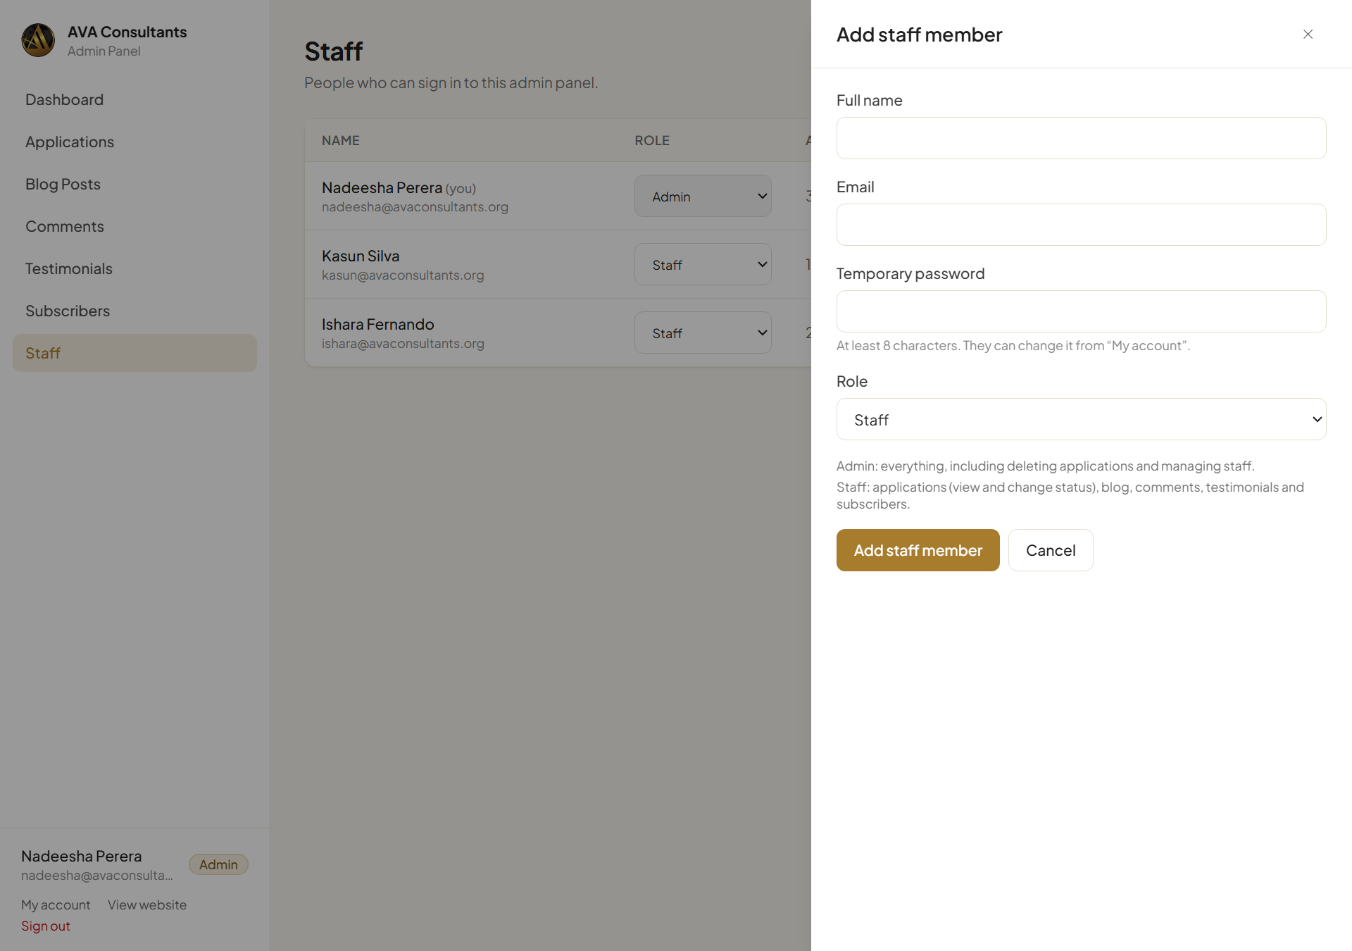
Adding a staff member

Change someone's role
Use the Role drop-down on their row. The change is saved at once. The person sees the new menu the next time they open or reload the admin panel.

Reset a forgotten password
Click Reset password on their row, type a new password (at least 8 characters), and give it to them.

Remove a staff member
When someone leaves the company, click Remove on their row and confirm. They can no longer sign in. Do this on their last working day.
Your own account You can't change your own role or remove yourself. This stops anyone locking themselves out. Ask another admin if needed.
Keep two admins Always have at least two admin accounts. Then there's someone who can reset the other's password.

10. My account
Click My account at the bottom of the left menu to see your details and change your password.
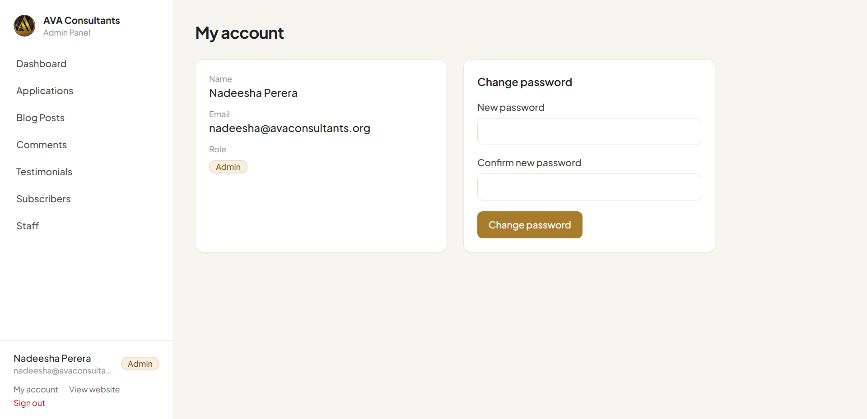
My account
- Type your new password in New password (at least 8 characters).
- Type it again in Confirm new password.
- Click Change password. You'll see “Your password has been changed.”
Tip Use a password nobody can guess. Don't share it, and don't write it on a note next to the computer.

11. Admin and Staff: who can do what
Task | Staff | Admin
See the Dashboard | Yes | Yes
View applications, change status, add notes | Yes | Yes
Delete applications | No | Yes
Write, publish, edit and delete blog posts | Yes | Yes
Approve, reject and delete comments | Yes | Yes
Approve, add, edit and delete testimonials | Yes | Yes
View subscribers and copy emails | Yes | Yes
Remove subscribers | No | Yes
Add or remove staff, change roles, reset passwords | No | Yes
Change your own password | Yes | Yes

Staff members see the same menu as admins, but without Staff, and without the delete and remove buttons above.
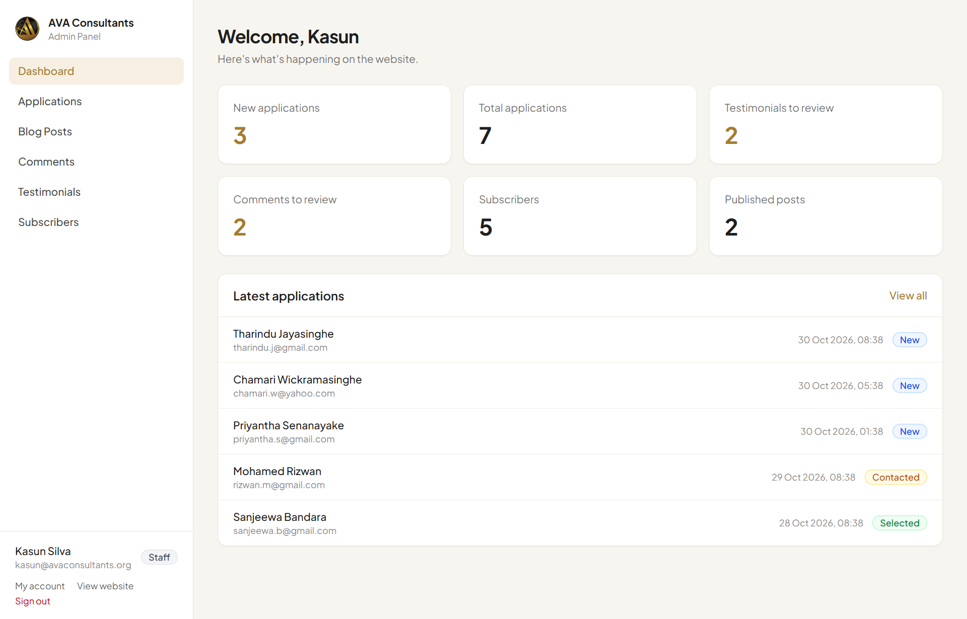
What a Staff member sees: no Staff page in the menu

12. Problems and questions
Problem | What to do
I forgot my password. | Ask an admin to reset it on the Staff page. If no admin can sign in, contact your website developer.
After signing in I see “No admin access”. | Your sign-in exists but isn't on the staff list. Ask an admin to add you.
I approved a testimonial or comment, but it isn't on the website. | Reload the website page (press F5, or pull down on a phone). Check it's in the Approved tab.
My blog post isn't on the website. | Open the post and check the Status is Published, then reload the Blog page.
The Blog page still shows sample posts or reviews. | They disappear when the first real post is published or the first testimonial is approved.
A photo won't upload. | Use a JPG or PNG photo. Blog covers must be under 5 MB and testimonial photos under 2 MB. Try a smaller photo, or a screenshot of it.
I didn't get the email for a new application. | Check the Spam folder in Gmail. Every application is always saved in the admin panel, even if an email is missed.
I deleted something by mistake. | Deleting can't be undone. Next time, use Reject or Hide when you're not sure.
A message says “Something went wrong”. | Check your internet connection and try again. If it keeps happening, take a screenshot and send it to your website developer.
Can several people use the admin panel at the same time? | Yes. Each person signs in with their own account.

Keeping applicants' information safe
- Applications contain personal details such as passport numbers. Only share them with people who need them for the job.
- Never share your password, and give every staff member their own account.
- Sign out on shared computers, and remove staff accounts when people leave.

Need more help?
Contact your website developer. Tell them what you were trying to do and what you saw, and include a screenshot if you can.

