


GRADUATION PROJECT
Emergency Medical Profile
By:
Ibrahim Yasser Abdelmoniem 23017792 NT
Abdallah Ali Abdallah 23017771 NT
Mohamed Hany Abdelrahman 23017738 CS
Omar Sameh Sabry 23017897 CS
Ahmed Adel Ahmed 202202565 CS
Ahmed Saad Soliman 202202089 AI
Abdelrahman Atia 202207021 IS

Supervisor

Dr.Reham Hussein

Co-Supervisor

Eng. Ahmed Abdelmoniem

2025 / 2026

Acknowledgment

Acknowledgment

Both scientifically and practically, we have dedicated immense effort and commitment to the success of this project. None of these achievements would have been possible without the grace of Allah, followed by the invaluable support of the doctors, assistants, and every member of our team.

We wish to express our deepest gratitude to the Dean of the College, Prof. Dr. Nabila Mohamed Hassan, for her insightful guidance, constructive feedback, unwavering support, and for providing all the essential resources that were fundamental to accomplishing this work.

Our heartfelt thanks also go to Dr. Reeham Hussein (the Supervisor) for her exceptional supervision, persistent encouragement, and for generously sharing her expertise and critical information, which were pivotal in steering the project to completion.

Furthermore, we extend our sincere appreciation to Eng. Ahmed Abdelmoniem for his continuous support, insightful suggestions, and kind cooperation, all of which significantly contributed to the successful realization of this project..

Table of Content

Table of Contents
Table of Contents
Acknowledgment 2
Table of Content 4
Abstract 8
Chapter One Introduction 14
1.1 Overview 14
1.2 Problem Statement 15
1.3 Objectives and Aims 16
1.3.1 Objectives 16
1.3.2 Aims 17
1.4 Project Scope and Limitations 18
1.4.1 Project Scope 18
1.5 Limitations 19
1.5.1 Significance of the Study 19
1.5.2 Contribution to Medical Technology 20
Chapter Two Literature Review 22
Introduction : 22
2.1 Review Tobics : 22
2.1.1 Advanced Language Models in Medical Data Summarization and Emergency Identification 22
2.1.2 Secure and Accessible Patient Health Records via QR Code Technology 23
2.1.3 Implementing Artificial Intelligence for Intelligent Health Record Systems and Emergency Triage 25
2.2 Summary of comparisons between research papers : 27
2.2.1 QR-Based Patient Health Records Table 27
2.2.2 AI and Large Language Model (LLM) Table 28
2.3 Research Gap : 28
Chapter Three 30
3.1 System Analysis 30
3.1.1 Problem Definition 30
3.1.2 Functional Requirements 30
3.1.3 Non-Functional Requirements 31
3.1.4 How the System Meets Its Goals 32
3.2 System Models 32
3.2.1 Use-Case Diagram 32
3.2.2 Class Diagram 35
3.2.3 How the System Works in Real Life 37
3.2.4 Sequence Diagram 39
3.2.5 Entity-Relationship Diagram (ERD) 42
3.3 Data Flow Diagram (DFD) 47
3.3.1 Data Flow Diagram (Level 0) 47
3.3.2 Data Flow Diagram (Level 1) 49
References : 51

Abstract

Abstract

In emergency medical situations, rapid and accurate access to a patient’s health information is often unavailable, particularly when the patient is unconscious or arrives at the hospital without accompanying relatives. The absence of critical data such as medical history, chronic diseases, ongoing medications, and drug allergies may lead to delayed diagnosis, inappropriate treatment, and an increased risk of medical errors during critical moments.

This project proposes an intelligent medical system based on artificial intelligence to create a Digital Medical Profile for each patient, enabling instant and secure access to essential medical information during emergencies. The system employs AI techniques to analyze previous medical records, diagnostic reports, laboratory results, medical imaging, and vital signs, and then automatically generates a concise and accurate medical summary that reflects the patient’s current health status.

Each patient is associated with a smart medical bracelet containing a unique QR code that provides emergency healthcare providers with read-only access to the patient’s medical profile through a secure web interface. The bracelet also includes an emergency alert button capable of sending real-time notifications and location data to predefined contacts. Additionally, the system supports routine medical follow-ups through a web and mobile platform, allowing new medical data to be uploaded and continuously analyzed to keep the medical profile up to date.

By integrating artificial intelligence, digital medical identity, QR-based access, and emergency alert mechanisms, the proposed system reduces diagnosis time, minimizes medical errors, and enhances emergency response efficiency. The solution aims to improve patient safety and support healthcare professionals in making fast, accurate, and informed decisions in critical healthcare environments.

List of Abbreviations

List of Abbreviations
- AI : Artificial Intelligence.
- LLM : Large Language Model.
- EHR : Electronic Health Record.
- QR : Quick Response Code.
- GPS : Global Positioning System.
- SMS : Short Message Service.
- NLP : Natural Language Processing.
- ViT : Vision Transformer.
- UML: Unified Modeling Language.
- DFD : Data Flow Diagram.
- ERD : Entity Relationship Diagram.
- DB : Database.
- UI : User Interface.
- UX : User Experience.
- API : Application Programming Interface.
- DMI : Digital Medical Identity.

List of Figures

List of Figures

Figure 1: Use-Case Diagram for the Digital Medical Identity System 34
Figure 2 : Class Diagram for the Digital Medical Identity System 38
Figure 3 : Sequence Diagram for the Digital Medical Identity System 41
Figure 4 : ERD Schema 45
Figure 5 : DATA BASE Digram 46
Figure 6 : Data Flow Diagram Level 0 48
Figure 7 : Data Flow Diagram Level 1 50

Chapter One ‘Introduction’

Chapter One
Introduction

Overview
The “AI-Driven Medical ID and Intelligent Emergency Support System” project aims to transform the way patients’ critical medical information is accessed, organized, and delivered especially during emergencies where every second matters. Today, healthcare environments face persistent issues related to scattered medical records, slow information retrieval, and communication gaps between patients, doctors, and emergency responders . These challenges become even more severe for individuals with chronic illnesses, allergies, or life-threatening conditions, where delayed or inaccurate information can lead to dangerous treatment decisions.

Patients often receive care from multiple hospitals and clinics, resulting in fragmented medical histories that are difficult to consolidate or interpret quickly. In high-stress emergency situations, patients may be unconscious, panicked, or unable to communicate essential details such as medications, chronic diseases, allergies, or recent lab results. This disconnect highlights the need for a system that can provide instant, reliable, and structured access to a patient’s complete medical profile without dependence on the patient’s ability to communicate.

To address these gaps, the project proposes a wearable QR-enabled wristband, serving as a secure gateway to the patient’s digitized medical identity. By scanning the wristband, emergency responders and clinicians can immediately access critical health details such as chronic conditions, ongoing medications, allergies, and recent vital readings. This approach ensures fast, informed decision-making, significantly reducing the risk of misdiagnosis or harmful interventions.

Beyond emergency access, the system integrates advanced Artificial Intelligence (AI) techniques to automatically summarize and organize medical records, including clinical visits, laboratory tests, and radiology reports . Instead of sifting through raw and complex documents, doctors receive clear, chronological summaries that highlight essential patterns and significant changes in the patient’s health. This not only improves clinical efficiency but also enhances long-term patient management.

The platform also introduces an Emergency Mode, which prioritizes life-saving information and automatically sends the patient’s live GPS location to pre-selected contacts through WhatsApp or SMS. This ensures rapid response and improved safety for vulnerable patients, especially those with chronic illnesses, elderly individuals, or people living alone.
By combining wearable technology, secure digital health management, and AI-powered summarization, the project aims to deliver a comprehensive solution that improves emergency response, reduces medical errors, and empowers patients to maintain an accurate and accessible medical identity. Ultimately, this system strives to strengthen communication among patients, doctors, and emergency teams leading to safer, faster, and more informed healthcare interactions.

Problem Statement
Patients today face major challenges when it comes to managing and communicating their medical information, especially in emergency situations where rapid access to accurate data is crucial. Many individuals receive treatment from multiple hospitals, clinics, and specialists, resulting in fragmented medical records that are difficult to consolidate or retrieve quickly. This fragmentation can delay diagnosis, contribute to treatment errors, and complicate decision-making during critical moments.

A significant problem arises when patients particularly those with chronic illnesses, allergies, or conditions requiring continuous care are unable to communicate essential details such as medications, past diagnoses, or recent test results. In emergencies, patients may be unconscious, disoriented, panicked, or physically unable to respond, leaving healthcare teams without the vital information needed for safe intervention. This lack of immediate medical insight increases the risk of incorrect treatment, drug interactions, or delayed response, all of which can be life-threatening.

Traditional solutions like physical medical ID cards or basic wristbands offer only limited static information and cannot reflect updated medical history, recent lab readings, or changes in medication. Likewise, hospital Electronic Health Record (EHR) systems are often inaccessible across institutions, making it nearly impossible for emergency responders to quickly gather the patient’s full medical background. These limitations create a significant gap between the information healthcare teams need and what is actually available during emergencies.

Furthermore, interpreting unorganized medical documents such as lab reports, radiology scans, and clinical notes requires time and expertise, which may not be available in urgent situations. Patients and families also struggle to keep track of medical details, making it challenging to provide accurate information when under stress.

This project addresses these issues by identifying the core problem: there is no unified, real-time, intelligent system that provides instant access to critical, up-to-date medical information while also simplifying the interpretation of complex health records. Without such a system, emergency responders and clinicians continue to face delays, uncertainty, and a lack of structured information ultimately compromising patient safety and the quality of care.

Objectives and Aims
This project aims to develop an intelligent medical ID system that provides instant access to essential patient information during emergencies. The system focuses on unifying medical records, simplifying health data through AI, and ensuring that responders can quickly view critical details, improving both treatment accuracy and emergency response time.

Objectives
- Intelligent Medical Identity & Instant Access
To develop a smart digital medical identity connected to an AI-powered wristband that instantly provides access to the patient’s critical health information, including chronic diseases, allergies, and current medications.
To implement a secure and scannable QR code on the wristband that enables fast and reliable retrieval of medical records during emergencies.
- AI-Powered Medical Record Analysis & Summarization
To design AI models capable of automatically analyzing medical reports, lab results, prescriptions, and clinical notes to generate concise and medically accurate summaries.
To organize patient information chronologically and contextually to support doctors in making faster and more informed clinical decisions.
- Advanced Emergency Response Support
To develop an emergency mode interface that highlights life-saving medical details such as blood type, allergies, and recent vital signs for rapid response.
To enable a smart emergency button in the wristband that automatically sends real-time alerts and location information to predefined contacts through SMS or WhatsApp.

- Secure & Unified Medical Data Management
To create a centralized medical record platform that securely stores a patient’s complete medical history and ensures consistency across different healthcare providers.
To implement advanced authentication, patient consent controls, and encrypted data access to maintain privacy and protect sensitive health information
- Enhanced Communication Between Stakeholders
To ensure that medical professionals receive accurate, updated, and AI-verified information that reduces medical errors caused by missing or outdted data.
To enhance collaboration between patients, clinicians, emergency responders, and caregivers by providing a single, trustworthy medical information source.
- User-Friendly Interface
To design an interactive, clear, and simple interface that allows both patients and healthcare providers to easily access medical data and navigate through different sections without requiring technical expertise.
To enhance the user experience by organizing information into structured sections and cards, providing quick access to vital data and AI-generated summaries in a clean and easy-to-read format.
To ensure full compatibility of the interface across multiple devices—including smartphones, tablets, and smart wristbands allowing seamless access anytime and anywhere.
To integrate supportive elements such as intuitive icons, guided notifications, and fast search tools to help users quickly locate the medical information they need with minimal effort.

Aims
- Ensure Instant Access to Critical Medical Information
To provide emergency responders with immediate access to essential patient data such as chronic diseases, medications, and allergies through a scannable smart wristband.
- Enhance Medical Decision-Making Using AI
To support doctors with accurate and concise AI-generated summaries of medical records, enabling faster and more informed clinical decisions.
- Improve Emergency Response Efficiency
To enable rapid response during critical situations through a dedicated emergency mode and automated real-time alerts sent to predefined contacts.
- Strengthen Patient Safety Through Secure Data Management
To ensure the safe storage and controlled access of medical information using encrypted systems, authentication mechanisms, and patient-centered consent controls.
- Promote Seamless Communication Between Stakeholders
To facilitate clear communication between patients, healthcare professionals, and emergency teams by offering a unified and reliable medical information platform.
- Provide a User-Friendly Interaction Experience
To deliver an intuitive interface that allows users of all technical levels to easily view, update, and understand medical data and AI-generated summaries.

Project Scope and Limitations

Project Scope
This project aims to develop an AI-driven intelligent medical identification and emergency support system designed to provide fast access to critical medical information and enhance emergency response efficiency. The system will include:
- Smart Medical Wristband:
A wristband that stores essential patient data such as chronic illnesses, medications, and vital medical information. It includes a smart emergency button that sends instant alerts during critical events.
- Digital Medical Identity:
A unified medical identity that organizes the patient’s medical history, ensuring immediate access to essential records when needed .
- QR Code System:
A unique QR code integrated into the wristband, allowing rapid access to the patient's intelligent medical summary through a clear and organized interface .
- Intelligent Medical Summary:
Use of artificial intelligence to analyze medical records and generate a structured, concise summary that supports quicker and more accurate decision-making in emergencies .
- Smart Emergency Alerts:
A quick-response mechanism triggered through the wristband’s emergency button, sending instant notifications to predefined contacts or healthcare responders.

Limitations
- Data Accuracy Constraints:
The system relies heavily on the accuracy of the medical information provided. Incomplete or outdated records may affect the reliability of the AI-generated summaries .
- Device Dependency:
The efficiency of the system depends on the availability and functionality of mobile devices used to scan the QR code or receive alerts .
- User Adoption:
Successful implementation requires users (patients and responders) to consistently use and maintain the wristband and mobile application .
- Technical Challenges:
Possible issues such as QR scanning errors, connectivity problems, battery limitations of the wristband, or software bugs could hinder system performance during emergencies .
- AI Limitations:
AI-generated summaries may occasionally overlook context or nuances in medical history, particularly if data is limited or inconsistent .

Significance of the Study
- Enhanced Emergency Response
Objective: Enable immediate access to medical information during emergencies using QR scanning and AI-generated summaries.
Impact: This reduces response time, accelerates diagnosis, and improves survival rates in critical events .
- Improved Medical Decision-Making
Objective: Provide healthcare professionals with accurate, structured medical summaries .
Impact: Enhances the precision of decisions made during emergency interventions, reducing errors and improving outcomes.
- Strengthened Patient Safety
Objective: Ensure vital medical information is always available, even when the patient is unconscious or unable to communicate .
Impact: Boosts patient safety, especially for individuals with chronic conditions or high-risk medical histories.

Contribution to Medical Technology
Objective: Integrate artificial intelligence with wearable medical devices to revolutionize emergency medical identity systems .
Impact: Supports the development of new solutions that improve digital health ecosystems and emergency responsiveness .
- Awareness and Education
Objective: Promote understanding of digital medical identity and its role in saving lives during emergencies .
Impact: Encourages adoption among patients, caregivers, and healthcare providers, contributing to better public safety .
- Potential for Broader Applications
Objective: Extend the system to support not only emergency cases but also chronic disease management and elderly care .
Impact: The system’s core principles could be adapted for broader healthcare applications, including remote monitoring and assisted living support.

Chapter Two
‘Literature Review’

Chapter Two

Introduction :
Emergency medical systems have advanced significantly, yet many studies highlight a persistent gap in providing fast and accurate access to patient information during critical moments especially when the patient is unconscious or unaccompanied. Various solutions have emerged, including electronic health records, QR-based access systems, medical ID wearables, and AI-driven tools for summarization, prediction, and triage. However, existing approaches remain fragmented and fail to offer an integrated solution that combines instant access, intelligent analysis, and strong security. This literature review examines recent research across these domains to identify current progress, highlight limitations, and define the remaining research gap that the proposed system aims to address.

Review Tobics :

Advanced Language Models in Medical Data Summarization and Emergency Identification
Ritchie Verma et al., 2025 .This paper aimed to explore the feasibility of using Large Language Models (LLMs) to generate verifiable summaries of electronic health records, highlighting the source of each summarized fact. The researchers utilized datasets of unstructured medical texts from patient records. Their methodology involved extracting key medical sentences followed by generating natural language summaries, with an added verification layer to minimize errors caused by automated generation. Experiments demonstrated significant improvements in summary quality compared to traditional methods, alongside increased clinician satisfaction during evaluation. However, limitations included reduced performance with scattered and unstructured data, the necessity for human review in critical cases, and privacy concerns. The paper recommends deploying the system in secure environments with stringent auditing mechanisms for practical use .[1]
Ferit Akaybicen et al., 2024 .This paper presents a system leveraging large language models to detect emergency cases from unstructured medical texts. The researchers used labeled textual data classified as emergency or non emergency and applied model training and fine-tuning techniques to reduce false positives and negatives. The system achieved high accuracy and recall, with response times suitable for practical deployment. Limitations include heavy dependence on data quality and labeling, challenges in generalizing across different medical institutions, and potential model biases. The authors recommend extensive field testing and incorporating human review before clinical application. [2]

Secure and Accessible Patient Health Records via QR Code Technology
Barkade et al, 2025 .This paper presents a digital patient record management system using QR codes, designed for use across healthcare settings. Patient data is securely stored in a centralized database during hospital visits to ensure real-time updates and support clinical decision-making. The system provides controlled access based on user roles (patients, doctors, lab assistants) with two-factor authentication for security. It integrates a machine learning-based disease prediction module that analyzes symptoms and medical history for early diagnosis. Additional features include appointment scheduling and direct doctor-patient communication through chat. Cloud storage ensures data security and flexible access. Results demonstrate improved information retrieval speed and diagnostic accuracy. Limitations include challenges in data updating and privacy protection, highlighting the need for continuous monitoring and secure data management. [3]
Yoshihiko Izumida et al, 2024 .This paper proposes a personalized electronic health record system based on QR codes, enabling patients to securely store and manage their medical data. Data is collected during hospital visits, including diagnoses, medications, and medical history, and encrypted in a centralized database. The QR code allows quick access to information during emergencies and routine care, with controlled access to ensure security. Results showed improved data retrieval speed, while challenges include reliance on internet connectivity, risk of outdated data, and unauthorized access. The study recommends implementing automatic updates and intelligent analysis to enhance care quality. [4]
Yutao.G et al,2024 .This paper presents a QR-based system designed to securely store and share electronic health records during medical care. Patient data including diagnoses, medications, allergies, tests, and visit history are stored on a secure centralized server and updated manually by healthcare staff while the patient is in the hospital to ensure accuracy. When the QR code is scanned, caregivers can instantly access the record to support rapid assessment, making the system suitable for clinical environments rather than patient-only use. The system uses encryption for privacy but includes no AI features. Benefits include speed and accessibility, while limitations involve internet dependency and risks of outdated data.[5]

Prerna Thonge et al,2025 .This study aims to create a patient "health locker" system based on QR codes to display medical data during emergencies. The system stores information such as diagnoses, medications, lab results, and allergies in a centrally managed database updated manually. Upon scanning, the patient’s record instantly appears on the responder’s device. The approach is straightforward, without using artificial intelligence: manual data entry, organized storage, and generating a unique QR code per patient. Experiments showed faster access to emergency data; however, the system faces challenges including dependence on internet connectivity, risks of outdated information, and potential unauthorized access. [6]
Razzak et al., .2020The paper focuses on how big data can enhance preventive medicine by leveraging the volume, velocity, and variety of health-related data. It presents examples of using machine learning algorithms to predict diseases, monitor patient patterns, and identify potential health risks. The study also discusses the ability to integrate data from monitoring devices, smartphones, and laboratory tests to provide a comprehensive view of an individual’s health. The findings indicate that these technologies have improved the detection of chronic diseases and reduced associated costs. However, the paper highlights challenges related to security, data quality, and the shortage of skilled experts. It emphasizes the need to develop stronger data infrastructures to achieve effective outcomes.[7]
MedicAlert Foundation, n.d. This paper aims to provide a practical solution for delivering emergency medical information through a QR code embedded on medical bracelets or cards. The system relies on a centralized database storing sensitive data such as chronic diseases, allergies, and medications, enabling first responders quick access by scanning the QR code. Data entry is manual, performed by users or healthcare professionals, with no use of artificial intelligence for data analysis or summarization. Practical tests demonstrated effectiveness in accelerating emergency information retrieval; however, limitations include potential outdated data, security risks like code forgery, and lack of integration with intelligent analysis systems or medical recommendation engines.[8]

Implementing Artificial Intelligence for Intelligent Health Record Systems and Emergency Triage
Alorbany et al., 2025 .This study aimed to develop an AI-driven electronic health records (EHR) system tailored for Egypt’s Universal Health Insurance program, addressing the slow adoption of EHRs only 314 hospitals had implemented such systems by October 2024. The researchers utilized structured and unstructured medical data, along with stakeholder surveys, to define requirements. The system architecture includes microservices and polyglot persistence, leveraging the Llama3-OpenBioLLM-70B model for summarizing patient histories and the Vision Transformer (ViT) model for pneumonia classification. Results showed improved data accessibility and summarization quality, though challenges remain in generating coherent narratives. The authors recommend further optimization with retrieval-augmented generation, local data fine-tuning, and standardized interoperability protocols.[9]
Harsha Kumar A. et al., 2025 .This paper aimed to design a decentralized framework for managing digital medical records using AI-driven processing. The paper did not rely on real clinical datasets; instead, it used simulated medical-record samples to test architecture behavior. Their methodology combined encrypted off-chain storage, a blockchain-based identity layer, and AI modules for medical entity extraction and automated summarization. Results demonstrated potential improvements in transparency and traceability, but the system remained conceptual without full deployment. Key limitations included the absence of real patient data, significant performance overhead, complex key management, and unresolved regulatory constraints. The authors recommend large-scale validation and practical integration with healthcare infrastructures. [10]
Annamaria Defilippo et al, 2024 .This paper explores the use of Graph Neural Networks (GNNs) to enhance automatic patient triage classification in emergency settings. The researchers utilized real electronic health record data, representing each patient as a node in a graph, with medical attributes linked as edges between nodes. They applied a GNN model to learn complex relationships between medical features and diagnoses aiming to improve the accuracy of clinical assessment compared to traditional models. Results demonstrated superior accuracy and stability of the GNN model, although it faced challenges in decision interpretability and difficulties in transferring across hospitals with different systems. The model also requires densely connected data.[11]

Nguyen et al, 2024 .This qualitative study aimed to assess AI applications in prehospital emergency care systems within low- and middle-income countries by interviewing experts and stakeholders. Using thematic analysis, the researchers identified opportunities and challenges for AI adoption. Findings suggest AI can enhance emergency response speed and accuracy while reducing human errors, but faces significant barriers including inadequate infrastructure, poor data quality, limited staff training, and ethical and legal concerns. The study recommends locally adapted AI solutions integrated with strict human oversight to ensure safety and reliability. As a descriptive study, it does not provide quantitative performance metrics.[12]
S. Steadman et al, 2024 .This paper explores how artificial intelligence is transforming emergency medicine by enhancing triage, diagnosis, and real-time clinical decision-making. The authors describe AI applications such as predictive models for identifying high-risk patients, image-based diagnostics for stroke and trauma, and NLP systems that summarize EHR data to accelerate physician understanding during critical moments. Data are collected in emergency departments and processed by machine-learning algorithms integrated into hospital systems. Benefits include reduced overcrowding, faster interventions, and improved accuracy. However, challenges remain: data bias, poor interoperability, unclear clinical accountability, and the need for stronger regulatory frameworks before full deployment in emergency care.[13]
Igor Matias et al, 2019 .The paper presents the development of a smart medical bracelet capable of monitoring vital signs such as heart rate, body temperature, and blood oxygen levels using embedded sensors. The bracelet processes the data in real time to detect any abnormal conditions and sends instant alerts via SMS or the internet to caregivers or emergency services. The system is designed to assist patients at high health risk, especially the elderly. Experimental results show that the bracelet helps reduce response time and improves early intervention. However, limitations include short battery life, sensor sensitivity issues, potential false alarms, and the lack of integration with electronic health record systems or any advanced intelligent analysis. [14]

Summary of comparisons between research papers :

QR-Based Patient Health Records Table
Paper Title | Authors & Year | QR / Emergency Tech Used | Key Outcomes & Challenges
QR Based Patient Health Record System with Disease Prediction | Barkade et al., 2025 | QR codes, centralized DB, ML prediction | Faster info access; data update & privacy challenges
Patient-Centric Personalized EHR Using QR Code | Yutao Guo et al,2024 | QR codes, encrypted DB | Quick emergency access; internet dependency
A Novel QR-Based Solution for Secure Electronic Health Records | Yoshihiko Izum et al, 2024 | QR codes, secure centralized server | Instant access; internet reliance, no AI
MediAssist QR based Patient Health Locker | Prerna Thonge et al., 2025 | QR codes, manual data entry | Faster emergency access; risks of outdated info
MedicAlert QR Code Medical IDs | MedicAlert Foundation, n.d. | QR on medical bracelets/cards, manual data input | Accelerates emergency info retrieval; risks of forgery & outdated data
Smart Medical Bracelet with Emergency Alert System | Igor Matias et al., 2019 | Wearable sensors, alert via SMS/Internet | Reduced response time; battery and sensor limitations

AI and Large Language Model (LLM) Table
Paper Title | Authors & Year | AI / ML Technology | Key Outcomes & Challenges
Verifiable Summarization of Electronic Health Records Using LLMs | Ritchie Verma et al., 2025 | Large Language Models (LLMs) | Improved summaries; issues with unstructured data & privacy
Machine Learning Approach for Emergency Detection Using LLMs | Ferit Akaybicen et al., 2024 | LLMs, supervised learning | High accuracy; challenges in data quality & model bias
AI-Driven Electronic Health Records System (Egypt) | Alorbany et al., 2025 | Llama3, Vision Transformer, microservices | Better data access & summarization; narrative coherence issues
Decentralized Digital Health Ecosystems | Harsha Kumar A. et al., 2025 | AI for entity extraction, blockchain, encryption | Transparency gains; conceptual, needs real data & performance
Leveraging Graph Neural Networks for Automatic Triage | Annamaria Defilippo et al., 2024 | Graph Neural Networks (GNNs) | Higher triage accuracy; interpretability & data transfer issues
AI in Prehospital Emergency Care in Low/Middle Income Countries | Nguyen et al., 2024 | Qualitative AI adoption analysis | Identifies barriers; no quantitative metrics
The AI Future of Emergency Medicine | S. Steadman et al., 2024 | AI predictive models, NLP, image diagnostics | Enhanced care speed & accuracy; data bias & regulation issues

Research Gap :
Most existing research in electronic health record management relies on static data and does not fully leverage artificial intelligence to achieve more accurate and dynamic data analysis. These systems lack advanced analytical tools for precise patient condition assessment and do not provide real-time alerts integrated with smart applications. Furthermore, many studies face challenges in automatic data updating and managing user access permissions at different levels.
This study focuses on developing an integrated system that uses QR codes and an alert button connected to a smart application, providing advanced analytics powered by artificial intelligence. It includes generating periodic reports for each medical visit and analyzing health data such as blood pressure and glucose levels with graphical representation. Additionally, a supportive chatbot will be integrated to facilitate interaction, alongside an intelligent triage system to classify patient conditions based on available data. The project aims to offer this system at a near-free cost to serve underprivileged populations, especially in emergency situations, with automatic data updates and access control settings to ensure security and privacy.

Chapter Three
‘System Analysis and Design’

Chapter Three

System Analysis

Problem Definition
In medical emergencies, quick access to a patient’s accurate medical history is often impossible, especially when the patient is unconscious or arrives at the hospital without family members. This creates major difficulties for doctors in knowing:
- Past medical history and chronic conditions.
- Current medications.
- Drug allergies or critical warnings (e.g., hypertension, diabetes patients).
This leads to:
- Delayed or incorrect diagnosis and treatment.
- Increased risk of medical errors.
- Loss or unavailability of important patient records.
The absence of a unified, secure, and instantly accessible medical profile in emergencies results in delayed or inaccurate decisions at critical moments.

Functional Requirements
- Create a Digital Medical Identity for Each Patient
- Assign a unique QR code to every patient.
- Scanning the QR code instantly opens a secure, read-only web page displaying the full summarized medical report.
- AI-Powered Analysis of Medical Documents
- Allow patients/doctors to upload previous reports, X-rays, lab results, diagnoses, prescriptions, and vital measurements.
- The AI automatically analyzes all uploaded files and generates a clear, concise, and accurate medical summary report.
- Smart Medical Bracelet
- Physical bracelet containing:
- Printed QR code for instant access to the medical report.
- Emergency button that sends an immediate alert + GPS location to registered contacts.
- Patient Mobile Application
- Enable patients to manage their medical profile.
- Upload new medical documents (reports, test results, prescriptions).
- View AI-generated summaries and updates.
- Emergency Access for Medical Staff
- Scanning the QR code opens a read-only web page showing the latest AI-generated medical summary (patient name, age, chronic diseases, current medications, allergies, latest vital readings, etc.).
- Automatic Report Update
- Every time new medical data is uploaded, the AI re-analyzes everything and updates the summary report automatically.
- Voice Input Support
- Allow voice entry of diagnoses or prescriptions to facilitate data input during regular visits.

Non-Functional Requirements
- Security and Privacy
- Medical reports accessed via QR are read-only.
- Access restricted to the patient’s account only.
- Full encryption of all stored medical data.
- Performance and Speed
- QR scan must open the medical report in seconds.
- AI analysis and summary generation must complete quickly after new data upload.
- Usability
- Simple, clear, and responsive interface for both web and mobile.
- Medical summary presented in an easy-to-read format for doctors and paramedics.
- Reliability
- System must ensure high availability and secure storage of medical records.
- Accuracy
- AI must extract and summarize medical information with high precision, especially critical items (allergies, chronic conditions, current drugs).

How the System Meets Its Goals
- Provides instant, accurate access to a patient’s full medical history in emergencies via a simple QR scan on a bracelet.
- Reduces diagnostic delays and medical errors caused by missing information.
- Eliminates the need to carry paper records or wait for family members to explain the patient’s condition.
- Automatically keeps the medical summary up-to-date using AI whenever new reports are added.
- Combines AI analysis, QR code access, smart bracelet, and emergency alerts into one integrated system offering a unique solution not fully covered by existing tools like Apple Health.
This directly solves the core problem stated in the project: lack of fast, reliable access to critical patient information when every second counts.

System Models

Use-Case Diagram
System Name: Digital Medical Profile System
Actors:
1. Patient
2. Doctor / Medical Staff (in regular visits)
3. Emergency Responder (Doctor, Paramedic, Nurse in ER or ambulance)

Use Cases:
1. Register and Manage Personal Medical Profile
Actor: Patient
- Create account
- Upload medical reports, X-rays, lab results, prescriptions, diagnoses
- Use voice input for new diagnoses/prescriptions
- View AI-generated medical summary
2. Generate & Update AI Medical Summary
Actor: System
- When new files are uploaded → AI analyzes all data
- Automatically creates/updates concise, accurate medical summary
3. Scan QR Code to View Medical Summary (Emergency)
Actor: Emergency Responder
- Scan QR code from bracelet
- System opens secure read-only web page
- Displays latest AI-generated medical summary instantly
4. Press Emergency Button on Bracelet
Actor: Patient
- Press physical button on bracelet
- System sends instant alert + current GPS location to registered emergency contacts
5. Upload New Medical Data during Regular Visit
Actor: Patient or Doctor
- After clinic visit, upload new reports/tests/prescriptions via mobile app
- Triggers automatic AI re-analysis and summary update

Use-Case Diagram:

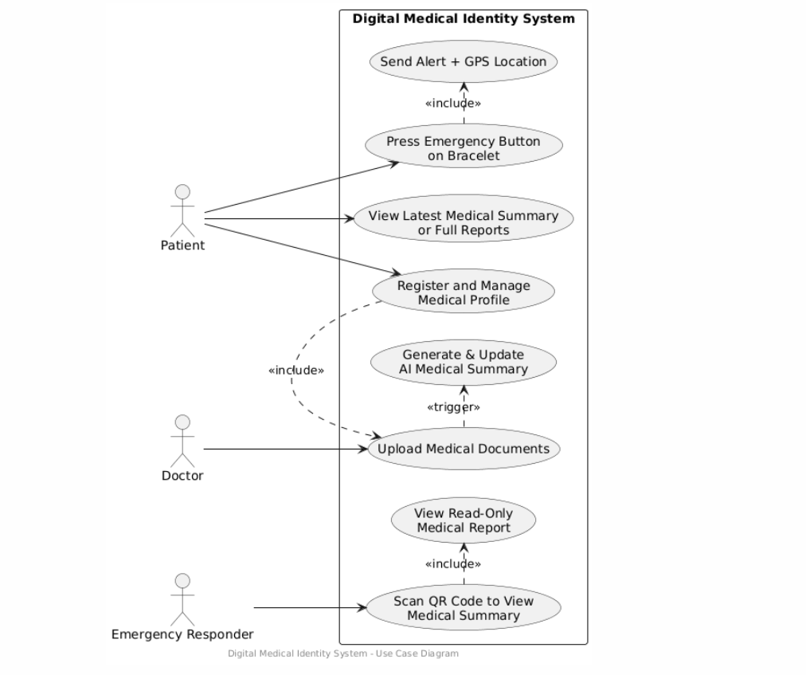
Figure 1: Use-Case Diagram for the Digital Medical Identity System

Class Diagram
This is a UML Class Diagram for a patient-centered emergency medical system that uses a QR code and a smart bracelet to give doctors and paramedics instant access to critical medical information

Classes and Their Responsibilities
- Patient
Represents the person using the system.
- Attributes: patientId, name, age, phoneNumber
- Methods:
- register()
- manageProfile()
- uploadDocuments()
- MedicalRecord
- Attributes: recordId
- documents: all uploaded files
- latestSummary → references the most recent AI-generated summary
- Methods:
- generateQRCode()
- viewReadOnlyReport() → doctors/hospitals can view (read-only)
- viewMedicalSummary()
- QRCodeSystem
Handles scanning and quick access.
- Attributes: qrCode
- Methods:
- scanQRCode()
- viewMedicalSummary() → after scanning, instantly shows the summary

- SmartBracelet
- Attributes: - braceletId - qrCode (same QR code as the patient’s MedicalRecord)
- location (real-time GPS)
- Methods:
- pressEmergencyButton()
- sendAlertWithLocation() → triggers the emergency system
- MedicalDocument
- Attributes:
- documentId, documentType (e.g., blood test, X-ray, prescription)
- uploadDate, filePath
- AI_MedicalSummary
- Attributes: - summaryId, generationDate, summaryContent (text summary)
- Methods:
- generateSummary() → AI analyzes all documents and creates a concise summary
- updateSummary() → automatically refreshes when new documents are added
Contains key info: chronic diseases, allergies, current medications, past surgeries, blood type.
- EmergencySystem
- Methods:
- sendEmergencyAlert() → receives alert from the bracelet
- shareGPSLocation() → sends patient’s exact location to ambulance/hospital

Key Relationships
- Patient 1 → 1 MedicalRecord (one patient has exactly one medical record)
- MedicalRecord 1 → * MedicalDocument (one record contains many documents)
- MedicalRecord 1 → 1 AI_MedicalSummary (one latest summary)
- Patient 1 → 1 SmartBracelet (one bracelet per patient)
- SmartBracelet contains the same QR code as the MedicalRecord
- SmartBracelet → triggers EmergencySystem when the button is pressed
- QRCodeSystem provides fast access to MedicalRecord and AI_MedicalSummary

How the System Works in Real Life
1. Patient registers and uploads all medical documents (reports, labs, scans).
2. The system automatically generates a QR code and an AI-powered medical summary.
3. The QR code is stored on a SmartBracelet that the patient wears.
4. In an emergency:
- Option A: Patient presses the emergency button on the bracelet → alert + GPS location sent immediately to EmergencySystem.
- Option B: Paramedics scan the QR code on the bracelet → instantly see the AI medical summary without logging in or searching through files.

Class Diagram

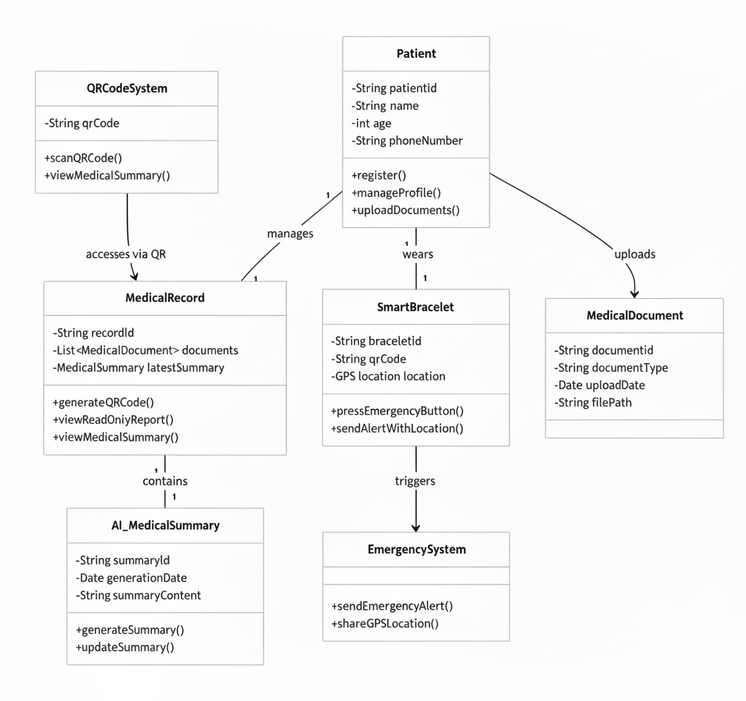
Figure 2 : Class Diagram for the Digital Medical Identity System

Sequence Diagram
This sequence diagram illustrates the core interaction flows of the Digital Medical Identity System, covering three primary use-case scenarios:
Participants
- Patient – The end-user
- Doctor – Authorized healthcare provider
- MobileApp – Patient-facing mobile application
- Bracelet – Wearable smart medical bracelet with QR code and emergency button
- MedicalRecord – Central secure repository storing all patient records and AI summaries
- AI Engine – Artificial intelligence module responsible for analyzing documents and generating/updating medical summaries

1. Patient Registration & Initial Data Upload
1. Patient → MobileApp : register()
2. Patient → MobileApp : uploadDocuments() (lab results, scans, prescriptions, etc.)
3. MobileApp → MedicalRecord : viewReport() / analyzeData() – sends uploaded documents
4. MedicalRecord → AI Engine : generateSummary()
5. AI Engine returns a concise, up-to-date medical summary (allergies, chronic conditions, current medications, blood type, surgical history, etc.)
6. MedicalRecord stores the summary as the patient’s active AI_MedicalSummary and links the generated QR code to it.

2. Emergency Scenario
1. Patient presses the emergency button on the Bracelet
2. Bracelet → MedicalRecord : pressEmergency() → trigger()
3. MedicalRecord → Emergency Response System (implicit) + Bracelet : sendNotification() with real-time GPS location
→ Nearest ambulance/hospital is alerted automatically.
4. Doctor (or paramedic) → Bracelet : scanQR()
5. Bracelet → MedicalRecord : accessReport()
6. MedicalRecord → Doctor : displayMedicalHistory()
→ The complete AI-generated medical summary is displayed immediately (read-only, no login required).
3. Regular Doctor Visit & Record Update
1. Patient visits clinic; Doctor → MobileApp : checkup()
2. Doctor → MedicalRecord : viewRecord() – retrieves full history and latest summary
3. After examination, Doctor → MobileApp : updateData()
4. MobileApp → MedicalRecord : processUpdate()
5. MedicalRecord → AI Engine : refreshSummary() – AI re-analyzes all documents including the new ones
6. AI Engine returns updated summary
7. MedicalRecord → Doctor : confirmUpdate() – update confirmation is shown.

Key Benefits Highlighted by the Diagram
- Single source of truth (MedicalRecord + AI Engine) always contains the latest summary.
- Zero-delay access in emergencies via bracelet QR or emergency button.
- Automatic summary refresh on every update – doctors and paramedics always see current information.
- Seamless integration between mobile app, wearable device, central records, and AI analysis.

Sequence diagram

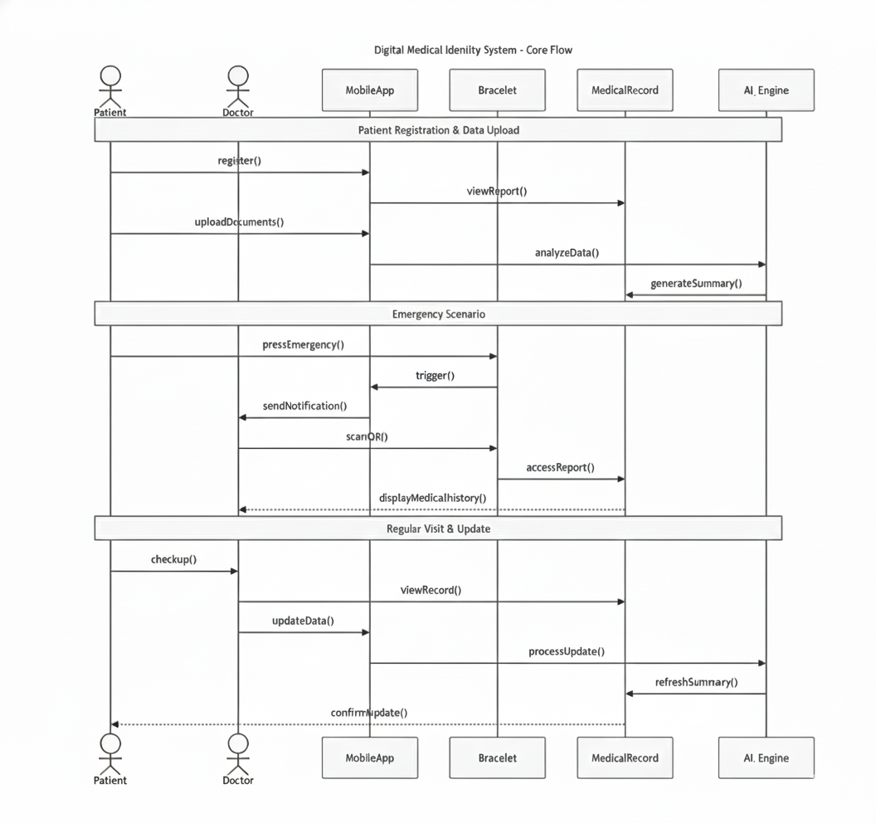
Figure 3 : Sequence Diagram for the Digital Medical Identity System

Entity-Relationship Diagram (ERD)
This ERD represents the database design for a Digital Medical Identity System. The system manages patient data, medical records, smart bracelet monitoring, emergency alerts, and alert delivery to emergency contacts.
1. Patient
The Patient entity stores core information about system users.
- Each patient has a unique PatientID.
- Stores personal and login-related data such as full name, age, phone number, and password.
- IsDeleted is used for soft deletion.
- A patient can have:
- Multiple medical documents
- One or more medical summaries over time
- Multiple voice notes
- One or more smart bracelets
- Multiple emergency contacts
- Multiple emergency alerts
2. Medical Document
The MedicalDocument entity stores uploaded medical files related to a patient.
- Each document belongs to one patient (PatientID as a foreign key).
- Stores document type, file URL, upload date, and AI processing status.
- Supports soft deletion using IsDeleted.
Relationship:
- One patient → Many medical documents

3. Medical Summary
The MedicalSummary entity represents an AI-generated medical overview of a patient.
- Linked to a patient using PatientID.
- Stores structured medical data such as:
- Chronic diseases
- Current medications
- Allergies
- Includes last known blood pressure and blood sugar values.
- Contains a textual medical summary and a QR code URL for quick access.
- IsActive indicates the current valid summary.
Relationship:
- One patient → Many medical summaries (only one can be active)
4. Voice Note
The VoiceNote entity stores audio notes recorded for a patient.
- Each voice note is linked to a patient.
- Includes the audio file URL, upload date, and transcribed text.
- ProcessedByAI indicates whether AI transcription is completed.
Relationship:
- One patient → Many voice notes
5. Smart Bracelet
The SmartBracelet entity represents wearable devices assigned to patients.
- Each bracelet belongs to one patient.
- Stores serial number, QR code URL, battery level, and activation status.
- Used to trigger emergency alerts.
Relationship:
- One patient → Many smart bracelets

6. Emergency Alert
The EmergencyAlert entity records emergency events triggered by a smart bracelet.
- Each alert is linked to:
- A specific bracelet
- A patient
- Stores trigger time, GPS location (latitude and longitude), alert type, and status.
Relationship:
- One smart bracelet → Many emergency alerts
- One patient → Many emergency alerts
7. Emergency Contact
The EmergencyContact entity stores people to be notified in case of emergencies.
- Each contact belongs to a patient.
- Stores contact name, phone number, relationship, and priority (IsPrimary).
Relationship:
- One patient → Many emergency contacts
8. Alert Delivery
The AlertDelivery entity tracks how emergency alerts are delivered to contacts.
- Each record links:
- An emergency alert
- An emergency contact
- Stores delivery method (SMS, call, etc.), status, message content, sent time, and response time.
Relationship:
- One emergency alert → Many alert deliveries
- One emergency contact → Many alert deliveries

Overall System Flow
- A patient is registered in the system.
- Medical documents and voice notes are uploaded and processed by AI.
- Medical summaries are generated and linked to patients.
- Smart bracelets monitor patient status.
- When an emergency occurs, an alert is triggered.
- Alerts are deliveed to emergency contacts and tracked through delivery records.

ERD Schema
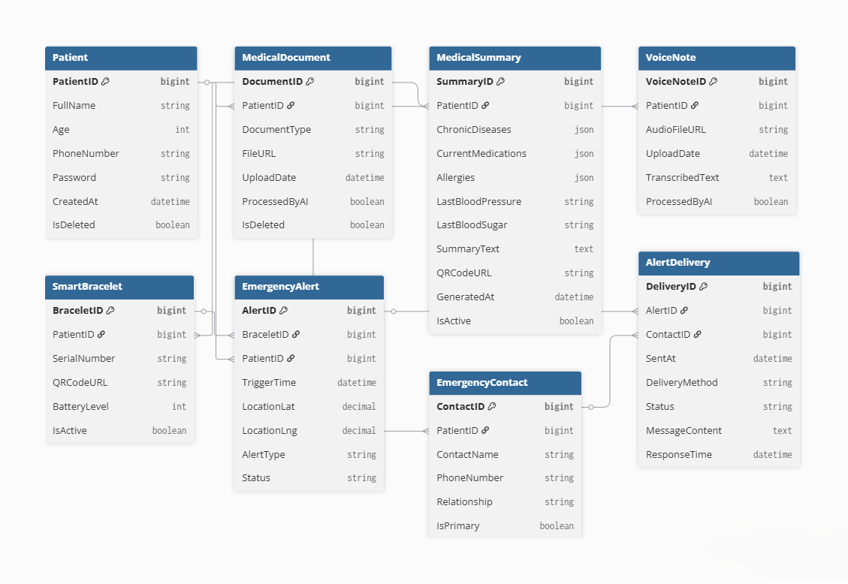
Figure 4 : ERD Schema

DATA BASE Digram
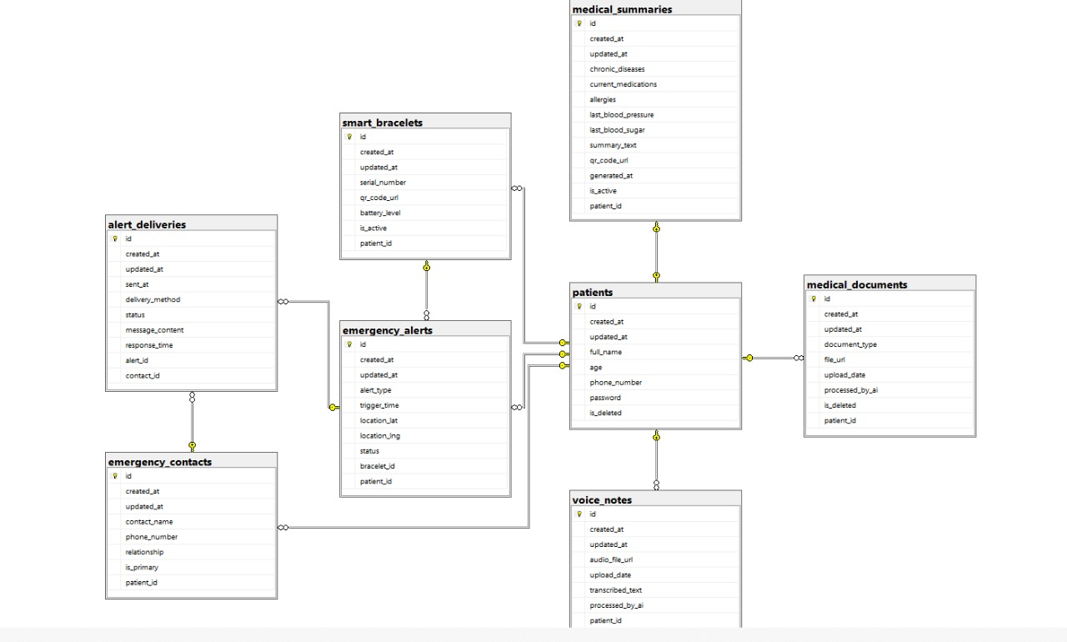
Figure 5 : DATA BASE Digram

Data Flow Diagram (DFD)
A DFD illustrates the ow of data within a system. It shows how data enters and exits a system, the paths it takes, the processes that transform it, and where it's stored. It's useful for understanding the movement of information in a system and identifying potential bottlenecks or vulnerabilities.

Data Flow Diagram (Level 0)
- Emergency Responder:
Initiates the emergency data access by scanning the QR code and relies on the system to receive the final intelligent medical summary.
- Patient / User:
Wears the Smart Wristband and initiates the emergency alert via the physical button.
- Smart Wristband:
The physical hardware component that holds the unique QR code (ID carrier) and contains the physical emergency button (alert trigger).
- Mobile Application:
Acts as the communication bridge, relays the emergency signal from the Wristband to the Backend, and renders the final intelligent summary for the Responder.
- Backend Server:
Manages data flow, performs authentication checks, coordinates data retrieval from the DB, and orchestrates the AI analysis process.
- Medical Records DB (D1):
Securely stores all static raw patient files, medical history, and prescribed medication data, accessed by the Backend.
- AI Analyzer:
Receives raw medical records from the Backend, applies algorithms to interpret critical information, and instantly generates a concise medical summary.
- Emergency Notification System:
Handles the dispatching of high-priority alerts (SMS/App/Call) to external parties (contacts and responders) immediately upon trigger.
- Emergency Contacts:
External party that receives high-priority alerts from the Notification System, confirming the patient's location

Data Flow Diagram Level 0

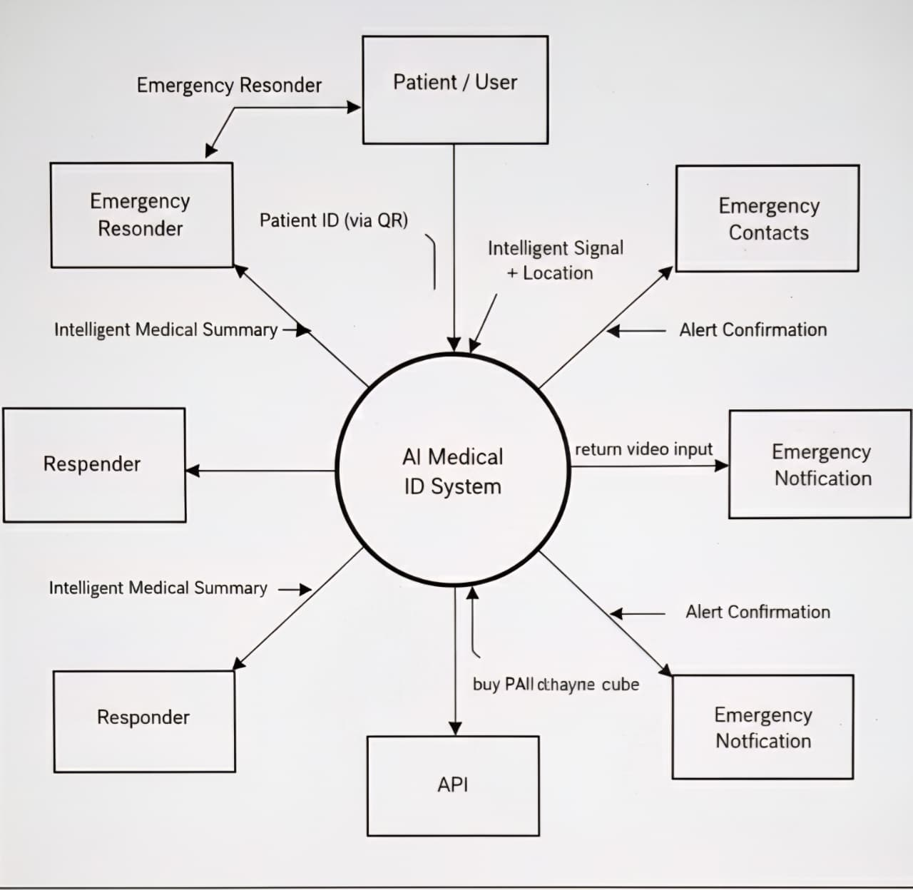
Figure 6 : Data Flow Diagram Level 0

Data Flow Diagram (Level 1)
User Actions (Input Trigger):
The system's operation is initiated by two critical external actions: The Emergency Responder triggers the data access flow by scanning the QR code, and the Patient / User triggers the alert flow by pressing the physical emergency button on the Smart Wristband.
Core System Processes:
The Level 1 DFD details three concurrent operations: Process QR Access (1.0), which handles authentication and data retrieval; AI Analysis & Summary Generation (2.0), which is responsible for transforming the data; and Activate Instant Alert (3.0), which coordinates external notifications.
Data Storage & Retrieval:
The Medical Records DB (D1) serves as the central data store. The system performs a dedicated retrieval process (initiated by Process 1.0) to fetch the full, raw historical records, ensuring data integrity before processing.
Intelligent Transformation (AI):
The AI Analyzer component executes the key transformation (Process 2.0). It receives the complex Raw Medical Records and instantly interprets critical information (e.g., chronic diseases, allergies) to generate the concise, high-value Intelligent Medical Summary.
System Output (Critical Delivery):
The system delivers two immediate, high-priority outputs: The Intelligent Medical Summary is displayed on the Responder's device interface for rapid diagnosis.

Data Flow Diagram Level 1
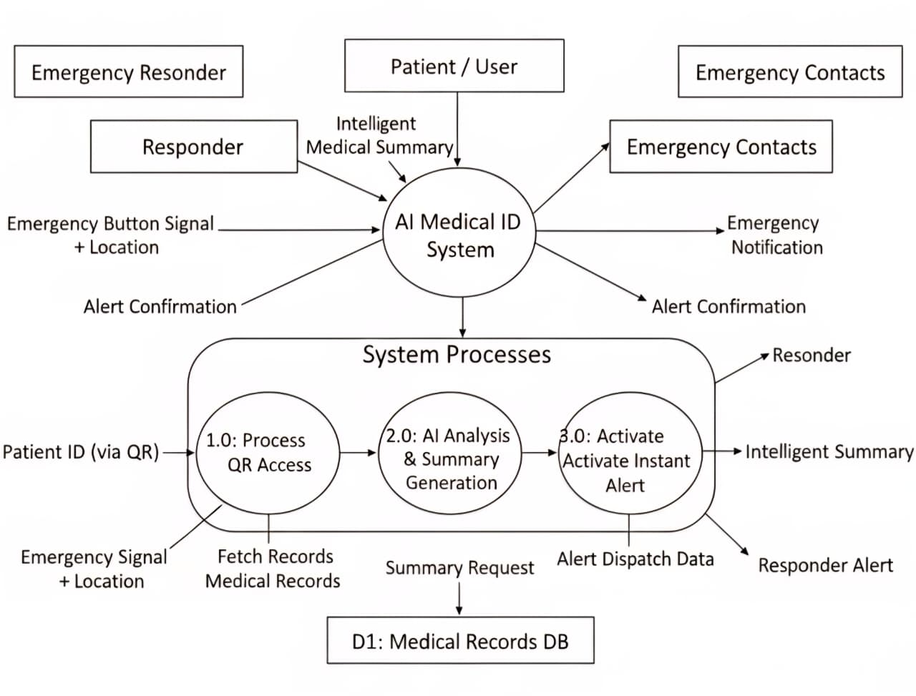
Figure 7 : Data Flow Diagram Level 1

References :
- Verma, R., Shams, S., & Hussain, S. (2025). Verifiable summarization of electronic health records using large language models. medRxiv.https://www.medrxiv.org/content/10.1101/2025.06.02.25328807v1.full.pdf
- Akaybicen, F., Akyürek, Ö., & Ertaş, F. (2024). A machine learning approach for emergency detection in medical scenarios using LLMs. arXiv. https://arxiv.org/pdf/2412.16341.pdf
- Barkade, S., Gupta, R., & Patil, S. (2025). QR based patient health record system with disease prediction. IJARSCT. https://ijarsct.co.in/A17243.pdf
- Izumida, Y., Nakamura, H., & Tanaka, K. (2024). Patient-centric personalized electronic health record using QR code. i-JMR. https://www.i-jmr.org/2024/1/e57332/pdf
- Yutao, G., Li, X., & Zhang, H. (2024). A novel QR-based solution for secure electronic health records. JMIR Rehabilitation and Assistive Technologies. https://www.ncbi.nlm.nih.gov/pmc/articles/PMC12338849/pdf/rehab-xx-xxxxx.pdf
- Thonge, P., Sharma, N., & Kumar, R. (2025). MediAssist: QR based patient health locker. International Journal of Innovative Research in Science, Engineering and Technology (IJIRSET) https://www.ijirset.com/upload/2025/may/97_MediAssist.pdf
- Razzak, M. I., Imran, M., & Xu, G. (2020). Big data analytics for preventive medicine. Neural Computing and Applications, 32(10), 5413–5430. https://link.springer.com/article/10.1007/s00521-019-04095-y
- MedicAlert Foundation. (n.d.). MedicAlert — QR code medical IDs. https://www.medicalert.org/medical-id/qr-medical-ids
- Alorbany, M., Mahmoud, A., & Soliman, H. (2025). AI driven electronic health records system for enhancing patient data management and diagnostic support in Egypt. arXiv. https://arxiv.org/pdf/2502.05603.pdf
- Kumar, H. A., Singh, R., & Patel, D. (2025). Decentralized digital health ecosystems: A unified architecture for AI-enhanced medical record management. Frontiers in Digital Health. https://www.ncbi.nlm.nih.gov/pmc/articles/PMC12598492/pdf/fdgth-07-1685628.pdf
- Defilippo, A., Romano, F., & Barone, R. (2024). Leveraging graph neural networks for supporting automatic triage of patients. PLOS ONE. https://www.ncbi.nlm.nih.gov/pmc/articles/PMC11143315/pdf/pone-018-11143315.pdf
- Nguyen, T., Pham, H., & Tran, L. (2024). Artificial intelligence in prehospital emergency care systems in low- and middle-income countries: Cure or curiosity? Insights from a qualitative study. BMC Emergency Medicine. https://www.ncbi.nlm.nih.gov/pmc/articles/PMC12521113/pdf/
- Steadman, S., Miller, J., & Thompson, A. (2024). The AI future of emergency medicine. JMIR Medical Informatics. https://medinform.jmir.org/2025/1/e70903/PDF
- Matias, I., Silva, P., & Fernandez, M. (2019). Smart medical bracelet with emergency alert system. ScitePress. https://www.scitepress.org/papers/2018/68008/68008.pdf

