MOWLI K

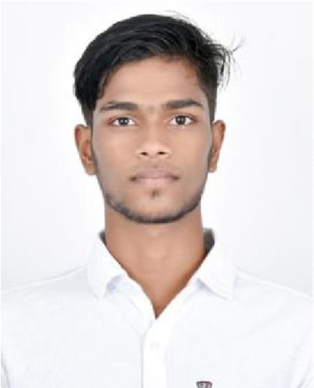

# B.SC INFORMATIONAL TECHNOLOGY

Address:70/1, Vedhamball Nagar, Near masjeed, Ganapathy, Coimbatore-641006.

Contact: +91 7010530105

Mail Id: mowli.k0101@gmail.com

LinkedIn id: Mowli Krishnamoorthy

Nationality: Indian

# Objective

Intend to build a career with leading corporate of Hi-tech environment with committed & dedicated people, which will assist me to explore the opportunities and knowledge. I’ll be able to realize my potential.

**Educational Qualification**



|  |  |  |  |
| --- | --- | --- | --- |
| Education | Institution | Year | Percentage |
| B.sc Information technology | Sri Krishna Adithya College of Arts and Science | 2024 | 77.9% (up to  IV semester) |
| HSC | The Suburban Matric Higher Secondary School | 2021 | 80% |
| S.S.L.C | Government Higher Secondary School | 2019 | 70% |

# Certificate Courses

* COURSERA- **1**. **Introduction to Artificial Intelligence**

**2.Develop a free website with WordPress**

* GREAT LEARNING**- Front end development-HTML** o NASSCOM FOUNDATION**-HTML&CSS** o LEARNMALL-**Google Ads** o CISCO NETWORKING ACADEMY**-Linux**

# Skills

C++ Windows 10 JAVA

MS Office

**Languages**

English (read, write& speak)

Tamil (read, write& speak

Malayalam(speak)

# Internships

Done my internship in **Accent soft Tech, Coimbatore** in the field of python and submitted my report in the title of **python.**

**Programming Languages**

**Operating System**

C

Ubuntu



Done an internship in **HRH NEXT, Coimbatore** in the DPO sector as a costumer intermediator for 2 weeks.

# Abilities

* Event Organiser& Event coordinator.
* Great in Time management & Communication.
* Smart worker.
* Administrative skills. o Team spirit, Adaptable, Passionate& Punctual.

**DECLARATION**

I, Mowli.K hereby declare that all the information provided in the resume is true and accurate and complete to the best of my skills and knowledge

Place: Coimbatore

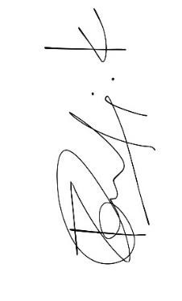

Mowli.K