* Week 4 Summary
  + Schematic:

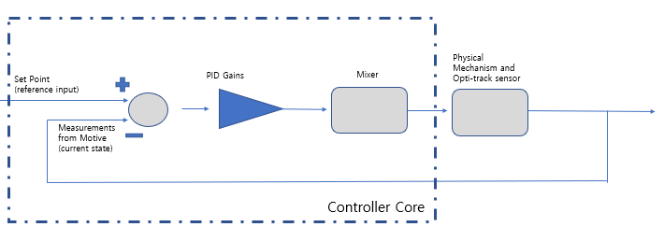

1. PID controller for multiple states in while loop is finished (Block PID Gains)

PID Block works on:

single input of reference for each state

single input of measurement for each state

Three gain values for P(proportional), I(Integral), D(Derivative).

Output control value for corresponding state

Work inside a class definition

PID Block detail (With error calculation):

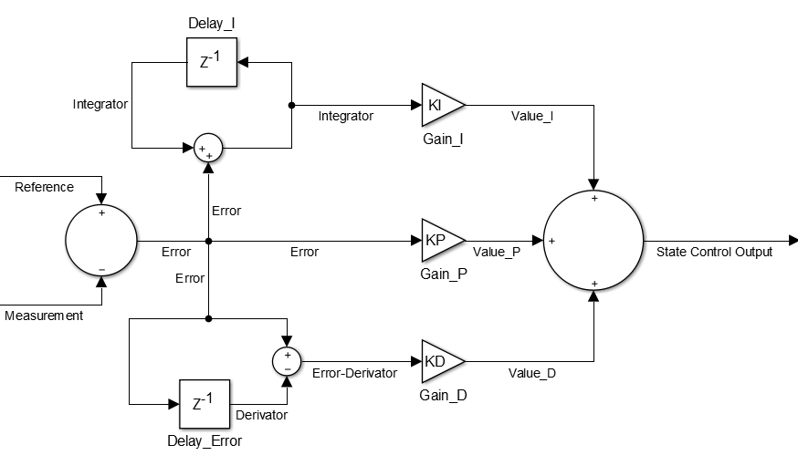

Mathematics written in coding method:

$${StateOutput}_{PID}=Value_{P}+Value_{I}+Value_{D}$$

P:

$$Value_{P}=Gain_{P}×Error$$

I:

$$Value_{I}=Gain_{I}×Integrator$$

$$Integrator=Integrator+Error$$

D:

$$Value_{D}=Gain_{D}×(Error-Derivator)$$

$$Derivator=Error$$

1. Mixer is a code directs a set of combination of state control values to get final pin output values.

Mathematics written in coding method:

$$MainThrottle=Z_{MixerMain}×Z_{PID}+ϕ_{MixerMain}×ϕ_{PID}+θ_{MixerMain}×θ_{PID}$$

$$RollServo=Y_{MixerRoll}×Y_{PID}+p_{MixerRoll}×p_{PID}+q_{MixerRoll}×q_{PID}+ϕ_{MixerRoll}×ϕ_{PID}+θ_{MixerRoll}×θ_{PID}$$

$$PitchServo=X_{MixerPitch}×X_{PID}+p_{MixerPitch}×p_{PID}+q_{MixerPitch}×q_{PID}+ϕ_{MixerPitch}×ϕ_{PID}+θ_{MixerPitch}×θ_{PID}$$

$$TailRotor=ψ_{MixerTail}×ψ_{PID}+r_{MixerTail}×r_{PID}$$

Mixer is not required after meeting done in week 6

* Week 5 Summary

(New drawing)

1. If in second form of block diagram, instead of mixing, a back calculation of thrust roll pitch yaw is implemented.

VBAR introduces a virtual precession reaction according to the IMU on board. This step act as a black box that stabilizes the aircraft. Thus the outer loop is only required for a controller. To do this, reverse-calculation is required to know measured values for 4 outputs.

Mathematics: