GlobalTech Small Business Network Project
Group 2 – Switching Team Report
VLAN creation, access-port assignment and 802.1Q trunking
Prepared by: Hamzat Habeeb Adeyemi (MoXarT), Group 2
Device: GlobalTech_Switch (Cisco Catalyst 2960 or equivalent)
Date: 29 September 2026

1. Objective and Scope
Group 2 is responsible for the Layer 2 design of the shared GlobalTech network. Our required outcome is to create VLANs 10, 20, 30, 40 and 99, assign the user-facing switch ports to the correct VLANs, configure the router-facing link as an 802.1Q trunk, verify VLAN membership and trunk operation, and document every department-to-port assignment.
This report records what was configured, the evidence captured from the switch, and the points that still need attention before handover to Group 3 (Routing Team). It is deliberately specific about what the screenshots prove and what they do not. A note on constraints: no router was supplied for this lab, so trunk operation and inter-VLAN connectivity could not be tested by our team.

2. VLAN Plan
The VLAN IDs, department names and addressing below come from the project requirements. The gateway address on each VLAN is reserved for the router subinterface configured by Group 3.
VLAN | Department | Network | Default Gateway
10 | ADMIN | 192.168.10.0/24 | 192.168.10.1
20 | STAFF | 192.168.20.0/24 | 192.168.20.1
30 | IT | 192.168.30.0/24 | 192.168.30.1
40 | GUEST | 192.168.40.0/24 | 192.168.40.1
99 | MANAGEMENT | 192.168.99.0/24 | 192.168.99.1

3. VLAN Creation and Verification
All five VLANs exist on the switch and show as active in the output below. Ports Fa0/9 to Fa0/48 and both Gigabit uplinks remain in the default VLAN 1, which is expected at this stage because they are not yet assigned to a department or to the trunk.
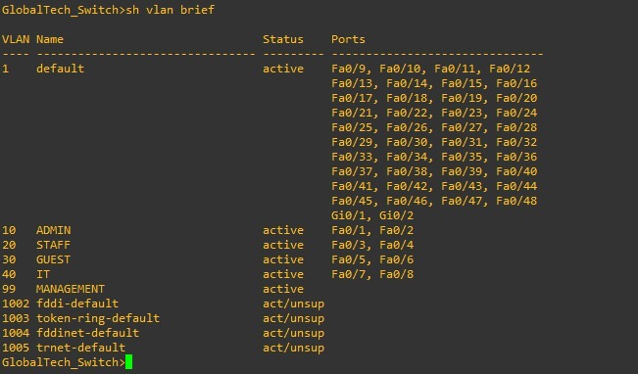
Figure 1: show vlan brief on GlobalTech_Switch
Discrepancy found: VLAN 30 and VLAN 40 names are swapped
Figure 1 shows VLAN 30 named GUEST and VLAN 40 named IT. The project requirements define VLAN 30 as IT and VLAN 40 as GUEST. The VLAN numbers and port memberships are correct; only the names are reversed. This matters because Group 4 will apply guest restrictions by VLAN, and a mislabelled VLAN invites the wrong ACL being placed on the wrong network. The correction is listed in Section 7.

4. Access-Port Assignment
Two access ports were assigned to each department using interface ranges. Each range was set to access mode before the VLAN was applied.
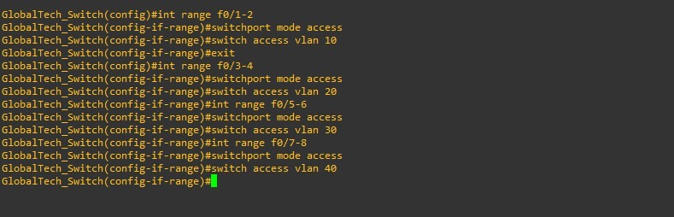
Figure 2: Access-port configuration by interface range
The resulting department-to-port assignment is documented below.
VLAN | Department | Ports | Mode
10 | ADMIN | Fa0/1 – Fa0/2 | Access
20 | STAFF | Fa0/3 – Fa0/4 | Access
30 | IT (named GUEST at time of capture) | Fa0/5 – Fa0/6 | Access
40 | GUEST (named IT at time of capture) | Fa0/7 – Fa0/8 | Access
99 | MANAGEMENT | No user ports | Switch management SVI only

The interface status output confirms that each port sits in the intended VLAN.
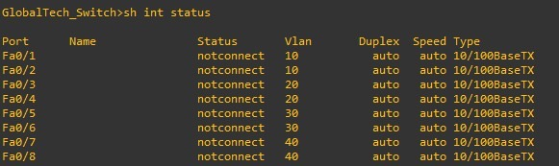
Figure 3: show interfaces status for Fa0/1 – Fa0/8
All eight ports report notconnect. That is consistent with the assignment being correct but tells us nothing yet about end-device connectivity, because no PCs were attached when these captures were taken. Live connectivity is a separate check, covered in Section 6.

5. 802.1Q Trunk to the Router
Limitation: no router was available for this lab
A router was not provided, so the trunk could not be brought up or tested end to end. The switch-side configuration can still be applied and checked, but the link will remain down and no tagged traffic can be demonstrated. Figure 1 also shows both Gigabit uplinks still in VLAN 1, so the trunk should not be treated as configured until the switch-side commands below have been applied and captured.

The intended switch-side configuration for the router-facing port is shown below. The port shown (GigabitEthernet0/1) should be replaced with whichever port would be cabled to the router.
interface GigabitEthernet0/1
switchport mode trunk
switchport trunk native vlan 99
switchport trunk allowed vlan 10,20,30,40,99

Restricting the allowed VLAN list to the five project VLANs keeps unused VLANs off the link, and moving the native VLAN away from VLAN 1 follows standard hardening practice. Group 3 must configure the matching native VLAN on the router side, otherwise untagged traffic will be mismatched between the two devices.
Without a router, the strongest evidence available is the port’s administrative state. The command below should report Administrative Mode: trunk, even though the operational mode stays down with no link. Note that show interfaces trunk may not list the port at all while it has no link.
show interfaces GigabitEthernet0/1 switchport

Verification possible without a router
VLAN membership can still be demonstrated at Layer 2. Two PCs connected to ports in the same VLAN (for example Fa0/1 and Fa0/2 in VLAN 10) and given static addresses in that subnet should be able to ping each other. A PC in one VLAN should not be able to reach a PC in another, because nothing routes between them yet. That failure is the expected result and confirms the VLANs are isolated. These tests were not performed at the time of writing; results should be added if the team runs them.
Full trunk verification (show interfaces trunk with the link up, and inter-VLAN pings) has to wait until a router is available, or until Group 3 tests the routing configuration in a simulator such as Packet Tracer.

6. Switch Virtual Interfaces and Observations
The switch also carries SVIs for the department VLANs and the management VLAN. Figures 4 and 5 show how they were entered and their resulting state.
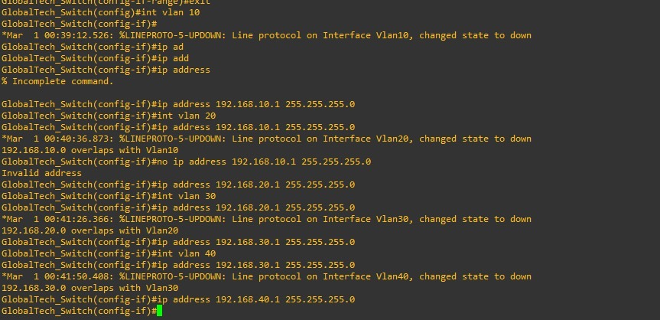
Figure 4: SVI configuration session, including overlap warnings
During entry, three overlapping-subnet warnings appeared (for VLANs 20, 30 and 40). These were caused by typing the previous VLAN’s address under the next interface before correcting it, not by a design fault. Each SVI was then re-entered with its own address, and the final state is consistent.
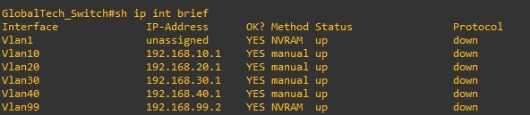
Figure 5: show ip interface brief
Two things stand out in Figure 5. First, every VLAN interface shows protocol down. That is expected here: an SVI stays down until at least one port in its VLAN is active, and all access ports are currently notconnect with no trunk up. Second, Vlan99 holds 192.168.99.2, which was set by Group 1 and is the correct management address on the 192.168.99.0/24 network, leaving .1 for the router.
Potential conflict: switch SVIs use the router gateway addresses
The SVIs for VLANs 10, 20, 30 and 40 were given the .1 addresses, which the project reserves as default gateways on the router subinterfaces. Once the trunk is live, the switch and router would hold the same IP on each network. Creating these SVIs was also outside the Group 2 scope, and the switch only needs one management address (Vlan99). Section 7 recommends removing them.

7. Issues Identified and Corrective Actions
Issue | Impact | Corrective action
VLAN 30 and 40 names swapped | Mislabelled departments; risk of misapplied ACLs by Group 4 | vlan 30 → name IT; vlan 40 → name GUEST
Department SVIs (Vlan10–40) use gateway .1 addresses | Duplicate IP with router subinterfaces once trunk is active | no interface vlan 10, 20, 30, 40; keep Vlan99 only
Trunk cannot be verified (no router provided) | Trunk operation and inter-VLAN routing cannot be demonstrated | Apply trunk config and capture show interfaces switchport; full test deferred until a router is available
No end devices tested | Port assignment proven, connectivity not | Connect PCs and run same-VLAN ping tests; confirm ports come up in the correct VLAN

vlan 30
name IT
vlan 40
name GUEST
exit
no interface vlan 10
no interface vlan 20
no interface vlan 30
no interface vlan 40

8. Handover to Group 3 (Routing Team)
- VLANs 10, 20, 30, 40 and 99 exist on the switch, with access ports Fa0/1 – Fa0/8 assigned as documented in Section 4.
- The router must provide one subinterface per VLAN with the .1 gateway address listed in Section 2, using 802.1Q encapsulation with the matching VLAN ID.
- The native VLAN on the trunk is intended to be VLAN 99; the router subinterface for VLAN 99 must be configured to match.
- The switch management address is 192.168.99.2 on VLAN 99, with 192.168.99.1 reserved for the router.
- The trunk has not been tested against a live router, since none was provided. Group 3 should treat trunk operation as unverified and confirm it when the link is first brought up.

9. Conclusion
Group 2 has completed VLAN creation and access-port assignment, and the evidence supports both. Three items remain: correcting the VLAN 30 and 40 names, removing the department SVIs that duplicate the router gateway addresses, and applying the trunk configuration. Because no router was provided, trunk operation and inter-VLAN connectivity remain unverified, and we have recorded that as a limitation of the lab rather than a completed check. Once a router is available, the switch is ready for Group 3 to begin inter-VLAN routing.

