PROJECT BLUEPRINT
Smart Student Companion — An AI-Powered Academic & Parent Management System

Project Blueprint
This document presents the project blueprint for Smart Student Companion, an enterprise-grade mobile ecosystem designed to bridge communication gaps between students, educators, parents, and campus administrators. It outlines the project's objectives, target audience, core features, application workflow, and user interface designs, prepared in accordance with university evaluation guidelines.
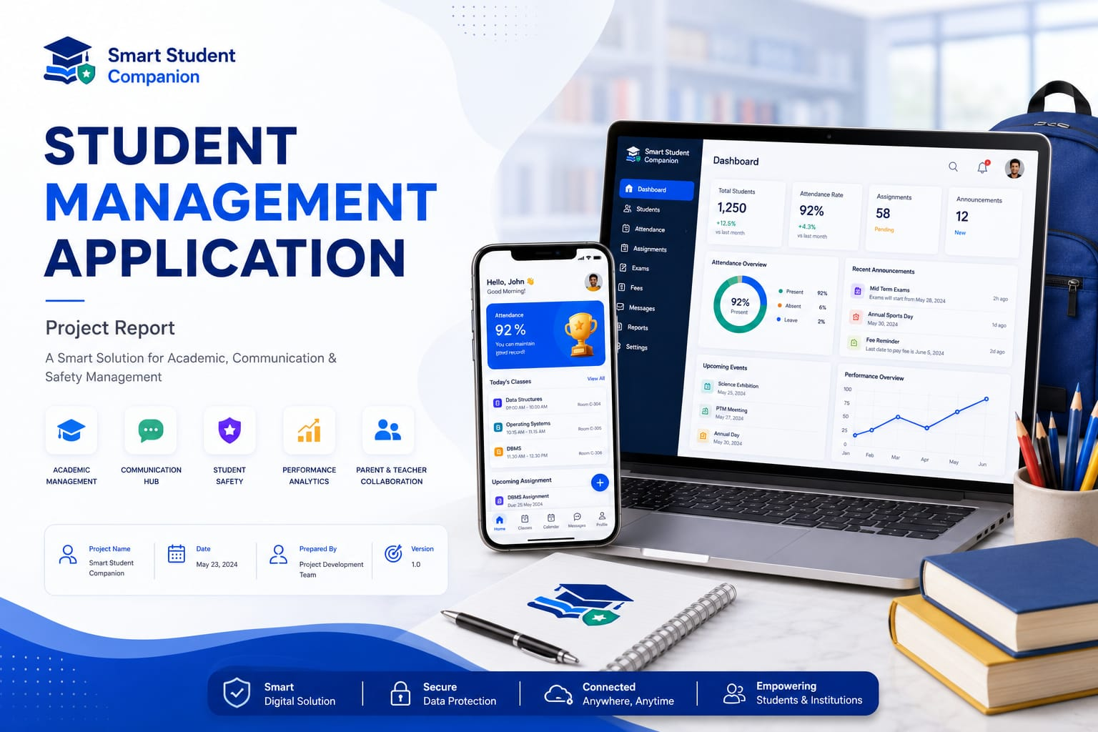

Project Title & Objective

Objective

The Smart Student Companion replaces archaic portal systems with an intuitive, unified application that streamlines core academic processes such as attendance tracking, timetable dissemination, assignment management, and institutional reporting. Equipped with an embedded AI Study Assistant and real-time parent-focused tracking tools, this platform drastically optimizes student accountability, eliminates academic friction, and modernizes campus management.

Target Audience
The application caters to four distinct ecosystem stakeholders:
- Students: Individuals balancing academic coursework, tracking their compliance, and seeking modern AI-assisted study tools.
- Teachers: Educators looking to minimize administrative overhead by taking quick digital attendance, managing assignments, and addressing leave queries easily.
- Parents: Guardians who want a direct, read-only analytical view into their child’s live academic metrics and attendance health without waiting for traditional report cards.
- Administrators: Campus authorities managing multi-department databases, master configuration timelines, and overarching institutional announcements.

Core Features
The application runs on a Role-Based Access Control (RBAC) architecture. Users authenticate through a single portal and are dynamically routed to their specific interface:
# | Feature | Description
01 | Multi-Role Unified Login | A secure interface with interactive segmentation controls allowing users to toggle between Student, Teacher, Parent, and Admin roles via dual-field institutional validation.
02 | Student Command Center | A dashboard featuring a personalized profile, digital QR ID, live academic metrics (Attendance %, CGPA), a Smart Timetable grid, and subject-wise compliance counters.
03 | AI Study Assistant | A conversational dual-chat window utilizing contextual model prompts to explain difficult topics, generate MCQs, and summarize textbook notes..
04 | Parent Observation Portal | A read-only analytical dashboard keeping track of "My Child's Progress," utilizing real-time synced charts indicating attendance stability and GPA fluctuations.
05 | Teacher Logistics Suite | A robust suite containing a Digital Attendance Roster with automated back-end sync, a curriculum manager, and a digital Leave Evaluation Queue.
06 | Campus Admin Hub | A centralized console for multi-department analytics, campus-wide circular broadcasts, and auxiliary utilities (Library, Placements, Events, Lost & Found).

Application Workflow
The diagram below illustrates the complete user navigation and architecture flow within the Smart Student Companion, mapping out user journeys across all distinct roles.

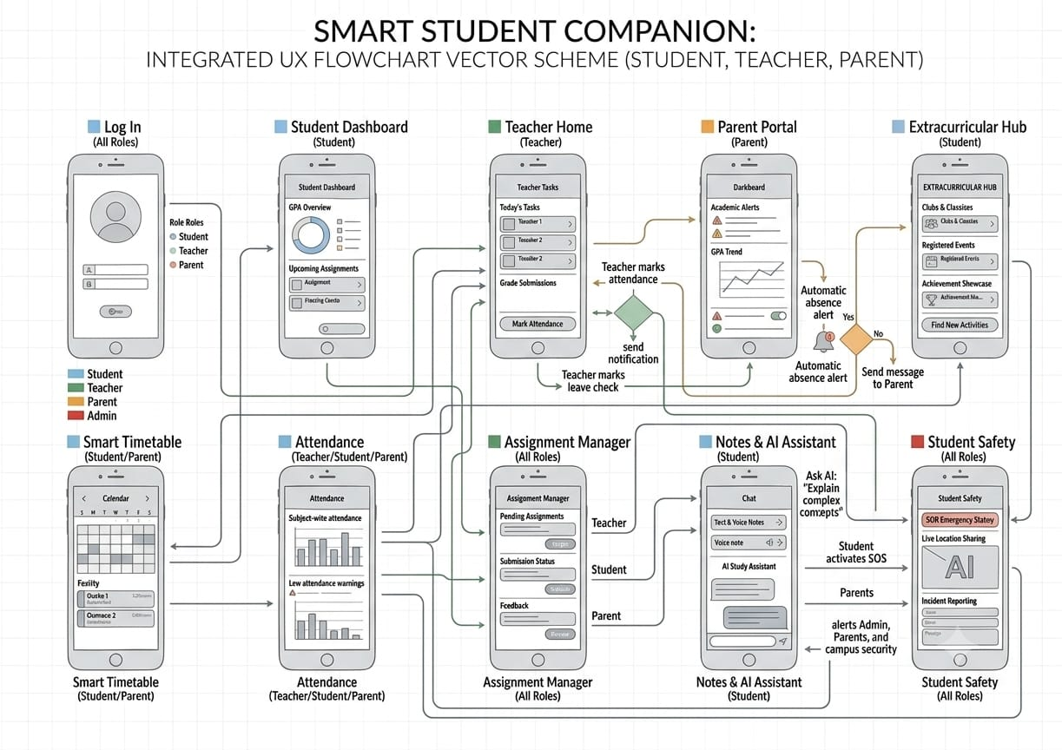
Figure 1. User Navigation Workflow

UI Wireframe Sketches

Cross-Role Dashboards Overview
The core interfaces dynamically alter metrics based on user authentication properties:

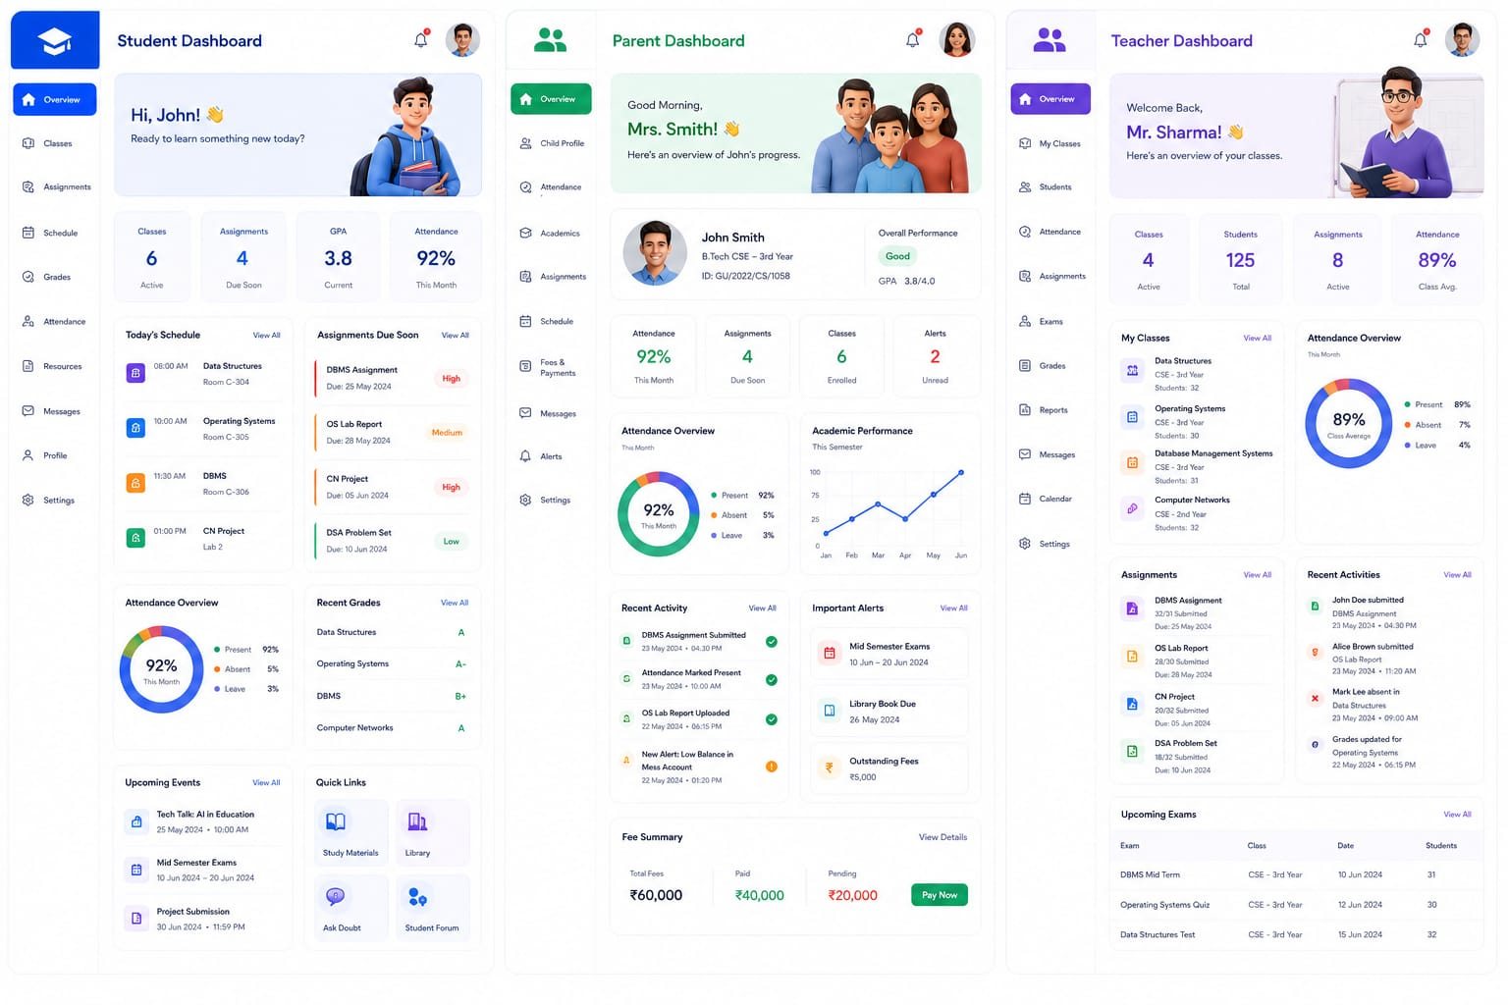

Figure 2. Dashboard

Onboarding Screen
The initial application interactions focus on clean, interactive user onboarding and zero-friction authentication screens.

Splash / Welcome Screen:
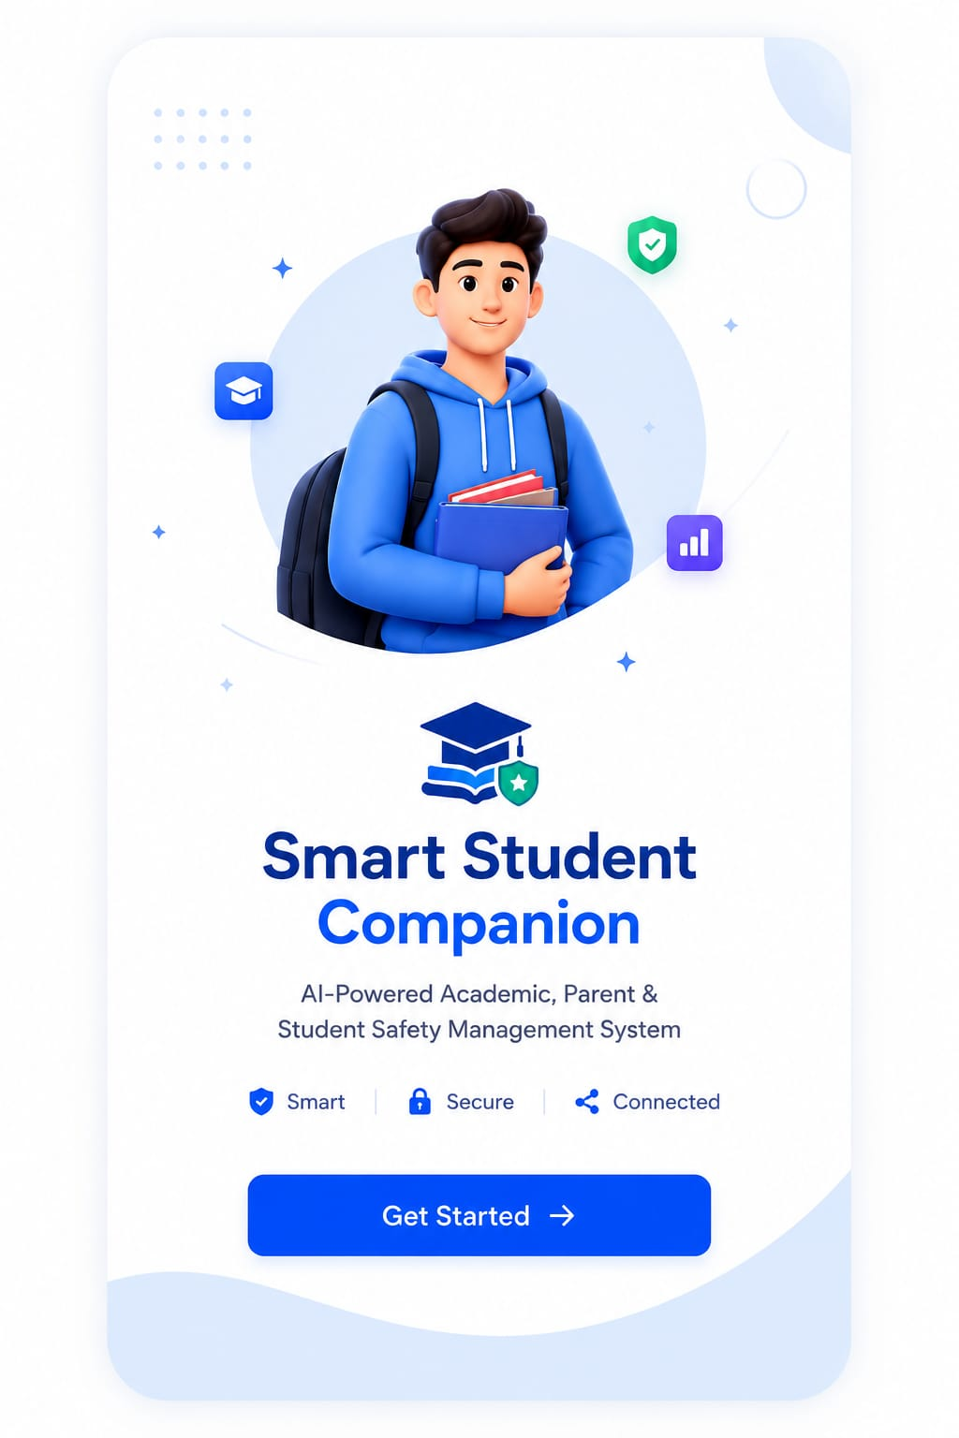
Figure 3. Onboarding Screen Sketch
Multi-Role Login Gateway:
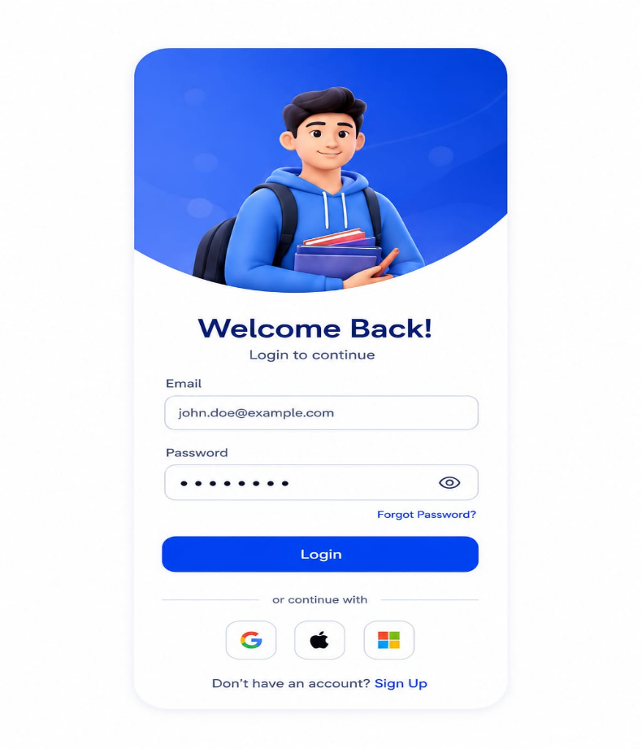
Figure 4. Login Screen Sketch
Technical Implementation Stack
To bring the exact features of this user flow to life smoothly, the following development stack is implemented:
- Frontend Framework (Mobile App)Flutter & Dart
- State Management: Riverpod or Provider
- Backend & Live Sync Database: Firebase (Cloud Firestore)
- Push Notification Service: Firebase Cloud Messaging (FCM)
- Artificial Intelligence Engine: Gemini API or OpenAI API
- Data Visualization UI Package fl_chart (Flutter package)

