Data Visualisation Assignment 2

Document Submission Cover Sheet

Please ensure that you complete all relevant sections below and that you make this the **first page** of your assignment submission.

For submission, you are required to put all aspects of the assignment into one document, including the cover sheer below and then to submit the assignment on Moodle in the relevant module location.

The assignment must be completed on or before the designated submission date and time. Students are recommended to keep a copy of the assignment, as submitted.

Please complete the following, in advance of submission.

If for some reason you cannot complete this form to attach to your assessment, please hand write the details, photograph and upload to Moodle.

|  |  |  |
| --- | --- | --- |
| **Student Number**  A00304383 | **Programme Title:**  MSc Software Des with AI PT (AL_KSAIM_9) | |
| **Programme Year:**  2022-2023 | | **Module Title:**  Data Visualisation - (AL_KSAIM_9_1) |
| **Lecturer Name:**  Mark Daly | | |
| **Visualisation Title:**  Philippines economic data dashboard | | |
| **Declaration of Authenticity: (Please Sign)**  *By uploading this document, I confirm that I have read and understood the assignment instructions and that the attached assignment is original (save for the visualisation being analysed) and represents all my own work.*  *Liam Kelly* | | |

Table of Contents

Table of Figures 3

Introduction 4

Dataset 6

Visualisations and Analysis 7

Conclusion 15

# Table of Figures

Figure 1.1: World Bank Data 5

Figure 1.2: PSA Infographic 5

Figure 3.1: Line Graph GDP$ 9

Figure 4.1 Scatterplot: Inflation%-Unemployment% 12

Figure 5.1 Sunburst: Inflation Rate% 13

Figure 6.1 Treemap: GDP Growth% 14

# Introduction

**Brief history of the Philippines economy**

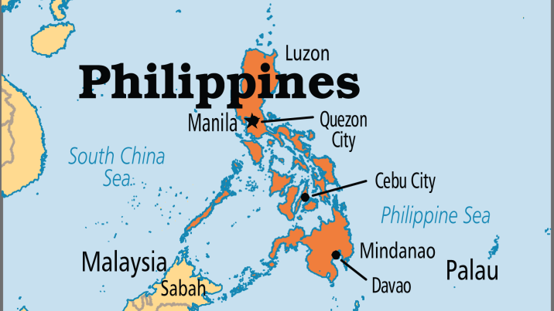

The Philippines is an archipelago in Southeast Asia composed of more than 7,000 islands. It was colonized by Spain in the 16th century, and then by the United States in the 20th century. The Philippines gained independence from the US in 1946.

The economy of the Philippines has undergone significant changes since independence. During the 1950s and 1960s, the country experienced strong economic growth, driven by agriculture, manufacturing, and exports. However, in the 1970s, economic growth slowed due to a combination of factors including political instability, natural disasters, and the oil crisis.

During the 1980s, the Philippines implemented economic reforms and shifted towards a more market-oriented economy. This led to improved economic performance and increased foreign investment. In the 1990s, the country experienced a period of sustained economic growth, driven by the service sector, particularly the business process outsourcing (BPO) industry.

However, the Philippines has also faced significant economic challenges, including high levels of poverty, income inequality, and a persistent trade deficit. The country has also been vulnerable to external shocks, such as the Asian financial crisis in the late 1990s and the global economic downturn in 2008.

In recent years, the Philippines have continued to experience strong economic growth, driven by the services sector and remittances from overseas Filipino workers. However, the country still faces challenges in addressing poverty and inequality, improving infrastructure, and attracting more foreign investment.

The Philippines has a diverse range of trading partners, with its top export destinations including Japan, the United States, China, Hong Kong, and Singapore. Its top import partners are China, Japan, South Korea, the United States, and Thailand.

The Philippines is a member of several trading blocs, including the Association of Southeast Asian Nations (ASEAN), which promotes economic cooperation and integration among its member countries. The Philippines is also a member of the Asia-Pacific Economic Cooperation (APEC) forum, which aims to promote free and open trade and investment in the Asia-Pacific region. Additionally, the country has bilateral trade agreements with several countries, including Japan, China, and South Korea.

**Economic data to be used and sources**

The data used for the dashboard was mostly collected from the World bank website (<https://data.worldbank.org/country/PH>). I was mostly looking for basic economic indicators, e.g. GNP, GNI and inflation. The site included a summary page for basic economic indicators so I made sure to collect this data specifically.

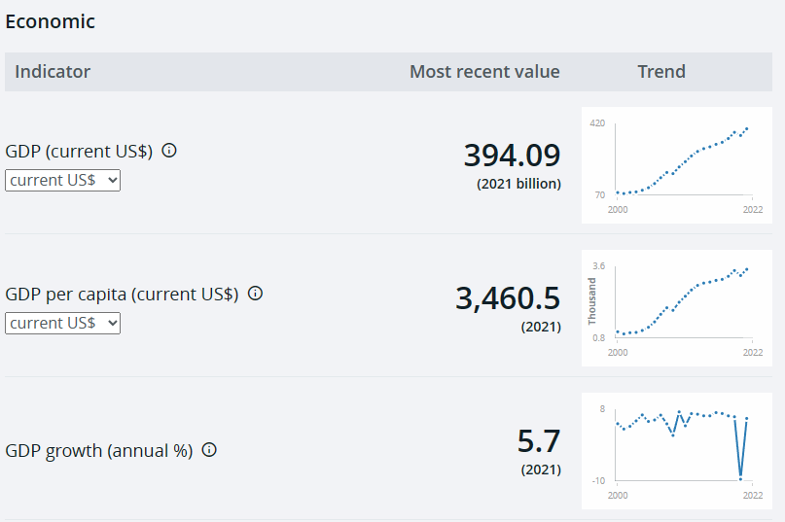

Figure 1.1: World Bank Data

I also looked at other sources of data and statistics. The PSA (Philippine Statistics Authority) proved an excellent source of economic data relating to the Philippines. However, I was unable to find simple year on year KPIs and some of the data I downloaded was formatted in ways that made it awkward to work with. It also mostly used quarterly data while I wanted to focus on yearly totals. <https://psa.gov.ph/national-accounts/base-2018/estimates>. The UN (United Nations) website also have some data related to the Philippines but it is a little too general and can only be viewed in five year increments. <https://data.un.org/en/iso/ph.html>. Finally I also looked to collect data from the trading economics website, however this data would have required me to pay a large subscription fee so I avoided it. <https://tradingeconomics.com/>.

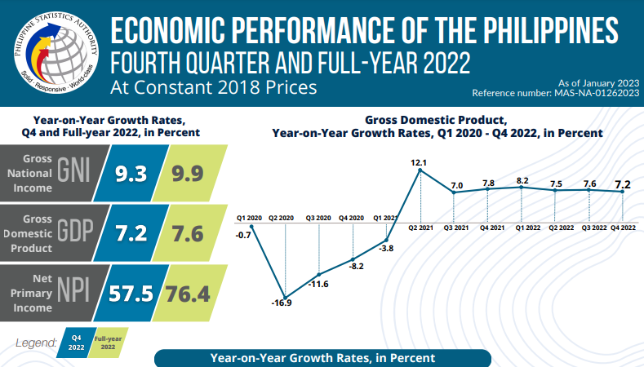

Figure 1.2: PSA Infographic

# Dataset

The World Bank website provided me with a large dataset, 1400+ rows of data related to economics, population and other statistics that they keep track of. A lot of the economic data collect proved far to niche or went into too much detail to be suitable for use in the dashboard. The dataset downloaded contained data dating from 1960 to 2021, for my dataset I started from the year 1977. From the selected rows of data I found that in some areas data was missing from the years before that and I felt it would be tidier to start collecting data from that year forward. Despite this some areas are missing data for certain years, though this has little effect on the visualisations themselves.

The column headings include:

* GDP (current US$)
* Age dependency ratio, old (% of working-age population)
* GDP growth (annual %)
* GDP per capita (current US$)
* Unemployment %
* Inflation %
* Personal remittances, received US$
* GNI (current US$)
* The last five columns cover industries related to the export of goods and the % each industry contributes to this

There is a mix of percentages and total monetary value in United States Dollars. I used USD instead of the Philippine Peso as it is often used as a standard to compare economic data this way.

The data collected was all temporal from 1977-2021. I split the data into two parts, the first would be used for line graphs/bar charts and scatterplots if applicable, the second part of the data was related to the categories of goods exported from the country and the percentage of total exports. This second part was to be used in treemaps and sunburst diagrams as I felt that the previously gathered data would not be suited to this it wasn’t suited to this type of categorisation. Ideally I would have found and used more general export and import data for use in the sunburst and treemap diagrams.

Editing the dataset to make it suitable for a data frame involved switching the columns (years) with the rows (categories). The data for the line graph/bar chart and scatterplots were spread across the first eight columns, while the rest of the export data was contained in the last five columns.

# Visualisations and Analysis

**Overview of the dashboard**

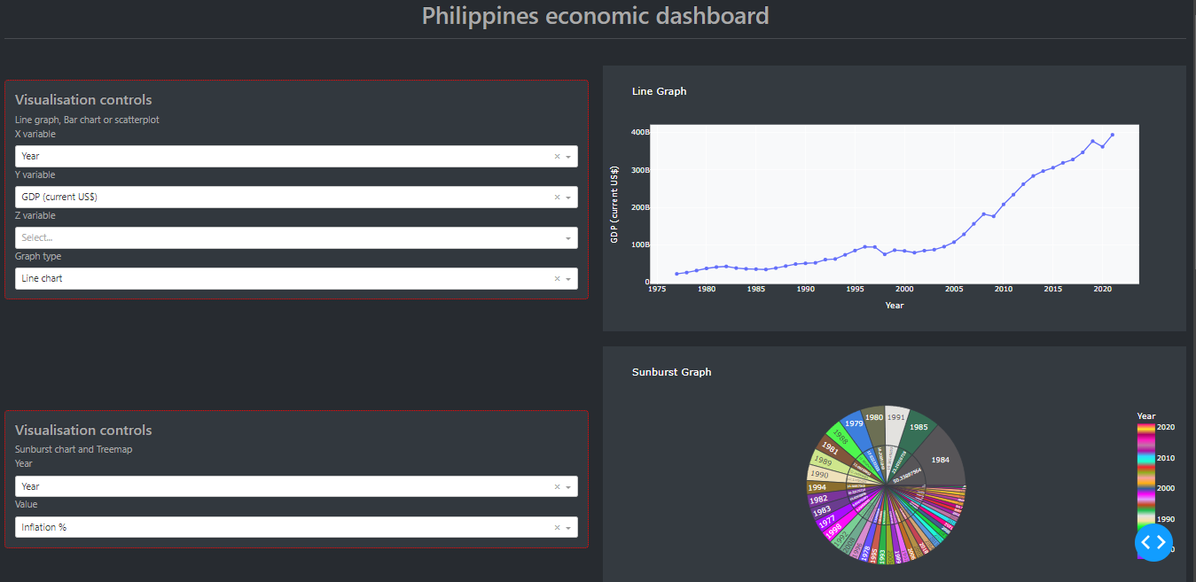

Figure 2.1: Dashboard Part 1

The dashboard itself is split into six sections. The first ‘card’ labelled ‘visualisation controls’ contains dropboxs that allow the user to select different variables to be visualised within the graph on the top right hand side. The user can also select from the dropbox the graph type, either a line graph, bar chart or scatterplot. The only x variable available is ‘year’ as these plots are used to visualise temporal data and to compare economic change over a period of time 1977-2021. The z-variable is used within the scatterplot and allows the user to visualise the co-relation between two different economic variables, for example unemployment and GDP.

A second ‘Visualisation controls’ box can be seen on the bottom left. This controls the variables used in the sunburst and treemap visualisations, the sunburst visualisation can be seen on the bottom right. From here different values can be selected either ‘inflation %’, ‘GDP growth%’ or ‘GNI’. Within the inner section of the sunburst diagram the value is marked and it’s associated year can be seen within the other section. Due to the number of years(rows) within the dataset this particular visualisation appears very busy. I had hoped to use this diagram for inport/export data whee the user could enter a specific year to view data for that year. This would have split the diagram into fewer sections, with all sections sum total being 100%. Going through the data collected from World bank split import and export data into services, manufactured goods and industries related to this which proved too time consuming to organise and prepare for this report. I also had difficulty selecting specific rows (years) to visualise.

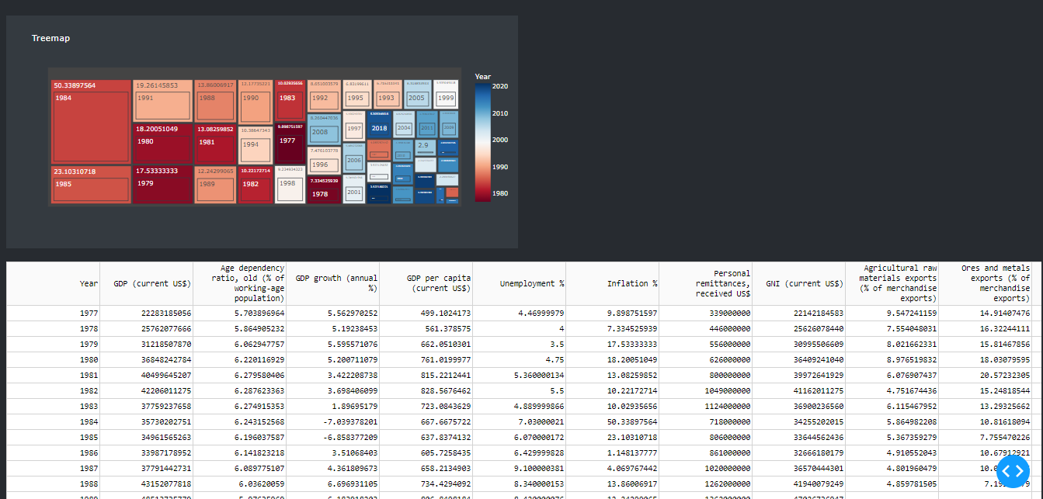

Figure 2.2: Dashboard Part 2

For the lower section of the dashboard we can see the treemap visualiation which can have it’s data inputs changed by the user from the control box mentioned earlier. Compared to the sunburst visualisation the treemap is better suited to the large number of data entries (years). The colour progression starting from early years in red to newer years in blue gives the user a clear idecation of what decades might have been more affected by high inflation, or the time periods related to high GDP growth. We can quikly spot some outliers, such as 2008 which likely had a high inflation rate due to the worldwide recession at that time.

Finally I included a view of the actual dataset used which can be viewed at the bottom of the dashboard. Overall the dashboard and each of the visualisations uses a dark theme, the linegraph looked clearer with a white background however. If I had more time to change the layout or add extra content I would like to include another box that shows simple KPIs for the year selected, automatically starting with the current year, this would be somewhat similar to the World Bank statistics page. This could include a display indicating whether the statistics are improving or declining from previous years. Also the use of pie charts and the sunburst diagram for import and export data.

**Analysis of Line graphs/Bar charts**

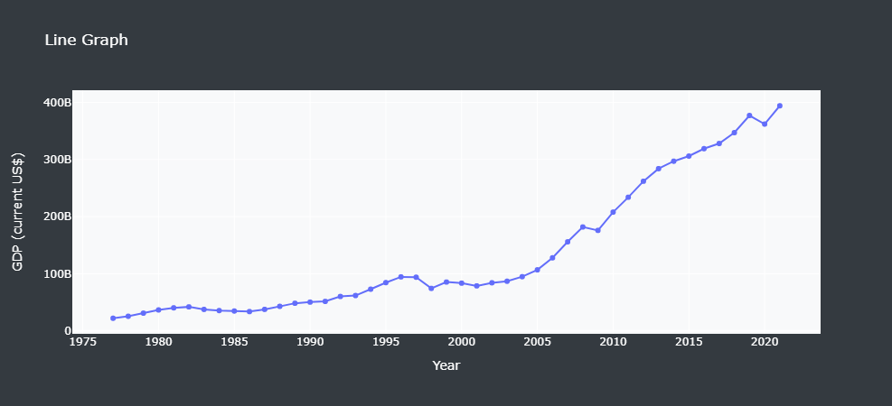

Figure 3.1: Line Graph GDP$

Gross Domestic Product (GDP) is a measure of the total value of all goods and services produced within the country over a given period. In recent years, the Philippine economy has been experiencing steady growth, with GDP increasing year after year from the 2000s onwards. The Philippines GDP reached $376.8 billion in 2019, up from $166.8 billion in 2010.

One of the factors driving the Philippines' economic growth is the country's large and growing population, which is projected to reach over 110 million by 2023. This has created a large and expanding consumer market, which has helped to boost demand for goods and services.

Another factor contributing to the country's economic growth is its strategic location and its growing connections to the global economy. The Philippines is situated at the crossroads of several important shipping routes, which has helped to make it a hub for trade and investment in the Asia-Pacific region. The Philippines has been investing in key industries such as information technology and business process outsourcing (BPO), which have helped to drive economic growth and create jobs.

Overall, the Philippines' consistent GDP growth is a testament to the country's strong economic fundamentals, its strategic location, and its growing connections to the global economy. While the COVID-19 pandemic has posed significant challenges for the Philippines and its economy, the country has shown resilience and remains well-positioned for future growth. When gathering data I came across many articles that discussed how the Philippine economy is growing from strength to strength.

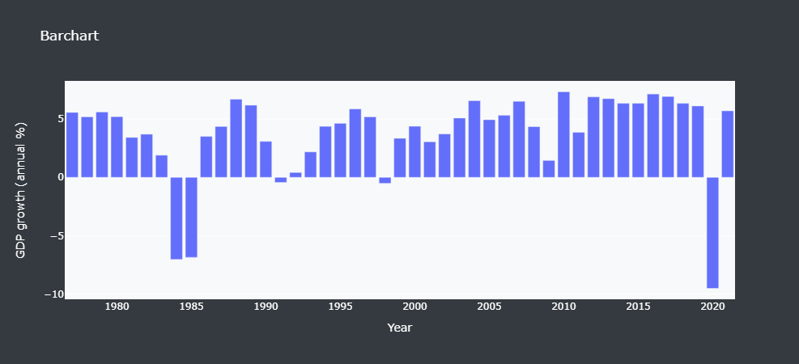

Figure 3.2 Barchart GDP%

When looking at the GDP growth% we can see two periods in which there was a strong decline in GDP. These involved a recession in the 1980s and the Covid 19 pandemic in 2019.

One of the main drivers of the recession in the Philippines was the country's large external debt, which had grown rapidly in the 1970s as the government borrowed heavily to fund ambitious infrastructure projects and other development initiatives. When global interest rates rose sharply in the early 1980s, the cost of servicing this debt became prohibitively expensive, placing a significant strain on the Philippine economy.

In the Philippines, the pandemic hit just as the economy was starting to gain momentum, following several years of strong growth. In 2020, the country's GDP contracted by 9.6%, the first annual contraction since the Asian financial crisis in 1998. The pandemic has had a particularly severe impact on key sectors of the Philippine economy, including tourism, which has been severely impacted by travel restrictions and border closures, and the services sector, which has seen significant disruptions due to lockdowns and social distancing measures.

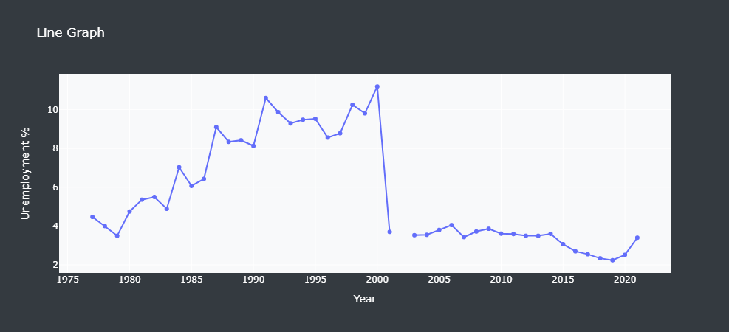

Figure 3.3 Line Graph: Unemplyment%

In the 1980s and 1990s, the Philippines experienced a period of high unemployment, which was largely driven by the economic challenges of the time, including high inflation and a large external debt. In 2000, the unemployment rate reached a peak of 11.2%. Following this the unemployment rate in the Philippines began to decline, reflecting a period of relative economic stability and growth. Some data is missing from the early 2000s, also I’m not sure how accurate the measure of unemployment is for 2020 as it seems that covid would have likely had more of an impact in this area.

**Analysis of the Scatterplot**

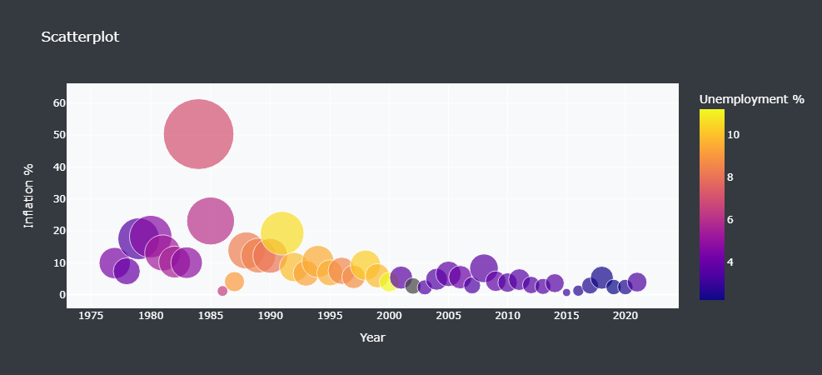

Figure 4.1 Scatterplot: Inflation%-Unemployment%

Using the scatterplot as a visualisation, we can quickly determine the correlation between two selected columns of data. In the example above I compared the rate of inflation with the unemployment rate. The size of the bubble correlates to the amount of inflation while the colour is used to represent the rate of unemployment, using a colour gradient of purple to yellow. From the graph above there seems to be some correlation though not directly, the spike of inflation indicating the recession in the 1980s seems to have sparked a period of high unemployment during the 1990s.

Inflation and unemployment are often viewed as being inversely related, meaning that as one goes up, the other tends to go down this is known as the Phillips curve. The Phillips curve suggests that when unemployment is low, workers are in high demand, and as a result, wages tend to rise, leading to higher prices and inflation. Conversely, when unemployment is high, workers are less in demand, and wages tend to stagnate or decline, leading to lower prices and inflation.

This relationship between inflation and unemployment can be seen in many countries' historical data, where periods of high inflation have tended to be accompanied by low unemployment rates, and periods of low inflation have tended to be accompanied by high unemployment rates. However, the relationship between inflation and unemployment is not always consistent and can be influenced by a range of factors, including changes in productivity, government policies, and global economic conditions.

**Analysis of the Sunburst graph**

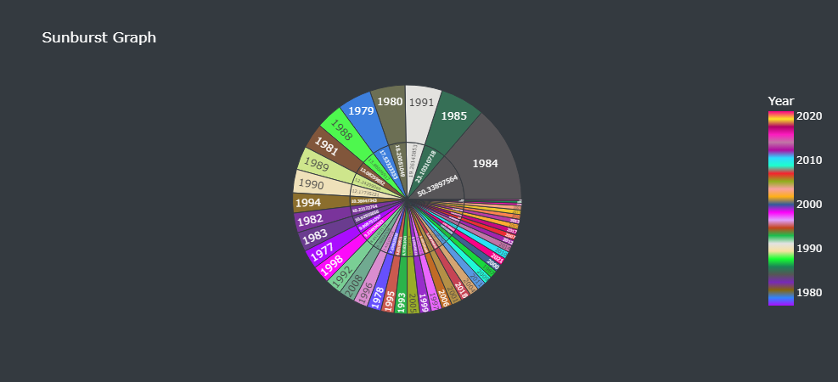

Figure 5.1 Sunburst: Inflation Rate%

Typically sunburst graphs are used to break down data based on categories/hierarchies across a series of nested arcs. For the analysis of temporal economic data a financial year could be split inot quarters and a KPI such as GDP could be displayed for each. Due to a lack of time and difficulty organising data I had to use this in a similar way to a pie chart.

In this graph we can visualise what years had the highest inflation rate for the Philippines. 1984/1985 saw a large increase in the inflation rate due to a recession. Most of the highest values, with the exception of 2008 are pre- 2000.

I had originally wanted to use this particular graph to visualise import and export data based on sector and industry as this would have been a more suitable use case for such a chart. Some of the data collected is related to this but remains unused. Another use case would be for quarterly economic data as suggested above. Due to the large number of data entries(years) the graph is somewhat difficult to read and other forms of visualisation are better suited for this, line graph or treemap.

**Analysis of the Treemap**

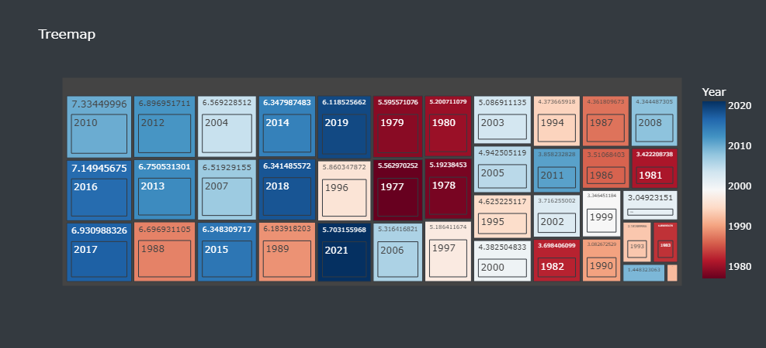

Figure 6.1 Treemap: GDP Growth%

A treemap is a type of hierarchical chart that can be used to visualize temporal economic data. The chart consists of nested rectangles or squares, with each rectangle representing a different category or subset of data. The size of each rectangle represents the relative value of that category, and the rectangles can be coloured or shaded to represent different values or categories.

Here we see a Treemap outlining GDP growth% by year. Similar to the scatterplot this type of visualisation also uses a colour gradient, in this case to measure the year range. The years that show the largest rate of growth start from left to right. GDP growth was interesting for this particular visualisation as there are a few outliers at both ends of the timeline. While most GDP growth can be seen in recent years (blue), 1988/89 shows a large growth in GDP probably due to some recovery following the earlier recession.

By using a treemap to visualize temporal economic data, it is possible to quickly identify patterns and trends over time, and to see how different economic indicators relate to one another. The hierarchical nature of the chart also allows for easy comparison between different time periods and components of the economy, making it a useful tool for visualizing complex economic data.

# Conclusion

When starting this project I decided to collect historic economic data related to the Philippines. This enables the user to examine patterns and identify trends within the historic data that would help them better understand the potential future of the economy. One of the most common visualisations used for economic data is the line graph and I wanted to make good use of that. Line graphs are particularly useful for visualizing trends in time-series data. They can be used to plot a single variable over time or to compare multiple variables over time. In economics, line graphs are commonly used to represent time-series data for macroeconomic indicators such as GDP, inflation, and unemployment.

The code I used was based on the dashboard example from the tutorials on model. I edited the code to change the data to be input, removed and moved and restricted some of the data columns to be used in the visualisations. I also edited the theme and visuals for the dashboard

The use of bar charts within the project could have been more effective if I had used it to compare data across different categories or groups of data. Even taking some economic data from neighbouring countries could have been useful to compare and contrast. I didn’t want to utilise multiple csvs however and didn’t want to mix data related to the Philippines with other nations as this project is focused on the one region. In economics, bar charts are often used to represent categorical data such as government spending on different sectors, trade balances between different countries, and breakdowns of GDP by sector.

I felt that the inclusion of scatterplots would be interesting as we could quickly compare the correlation between different economic variables and this might give us insight into any unexpected relationships between them. For example the Philips curve discussed earlier doesn’t seem quite accurate to the economic situation in the 1980s for the Philippines. Due to the temporal nature of this data it is easy and interesting to view these relationships over a period of time.

Both the sunburst and treemap visualisations are both better suited to hierarchical/categorical data rather than the temporal data used in the dataset. Despite this the sunburst graph filled the role of a pie chart and the treemap provided an interesting gradient for visualising the data, highlighting areas where the data made unusual changes. As discussed earlier the sunburst diagram would have been useful to visualise trade data by import/export followed by sector followed by industry. I wanted to include this and have the user select a particular year to be visualised but had difficulty collecting and setting up the data as well as the particular code for selecting particular years.

Many of the economic indicators for the Philippines look promising for the future. The steady increase in GDP and gradual fall of unemployment are good signs. While there are still significant challenges and uncertainties facing the Philippine economy, there are also reasons to be optimistic about its future prospects. Continued investment in infrastructure, the growing labor force, and the adoption of new digital technologies could all help to drive economic growth in the years to come.