Linear Algebra

Laboratory Activity No. 8

System of Linear Equation

|  |  |
| --- | --- |
| *Submitted by:* | *Instructor:* |
| Sustento, Myke Alvin E. | Engr. Dylan Josh D. Lopez |

December 23, 2000

# Objectives

This laboratory activity aims to implement the principles and techniques of a system of linear equations using various linear algebra techniques and python programming specifically the NumPy library.

# Methods

The deliverables of the activity are to solve a system of linear equations using various linear algebra techniques and python programming. In order to achieve the deliverables, the practices of the activity consists of using the NumPy library specifically the np.array(), np.linalg.inv(), and np.linalg.solve(). Np.array() was used to create an array [1] which would represent the equations and matrixes, np.linalg.inv() was used to compute the multiplicative inverse of a matrix [2] which would give us the identity matrix multiplied by the original matrix, and np.linalg.solve() was used to solve a system of linear matrix equation [3].

# Results

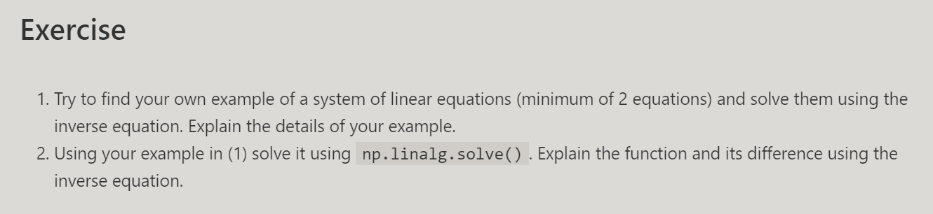

Figure Exercise Requirement

Figure 1 shows the instructions on what to do for the exercise in laboratory 8. There are 2 exercises to be done and both of them have an objective of getting the system of the linear equation but the 1st exercise uses the inverse equation while the 2nd exercise uses the np.linalg.solve() function.

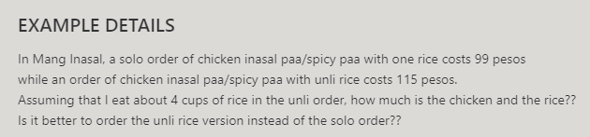

Figure 2 Real Life Example Details

Figure 2 shows an example of a system of linear equations. It is about the spicy chicken inasal in Mang Inasal. It asks what is the price of the chicken and the rice in the unli rice order and is it better to order the unli rice order instead of the solo order.

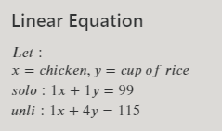

Figure 3 Linear Equation for the Exercise

Figure 3 shows the linear equation that will be used for the exercises. $x$ represents the chicken which has a quantity of one for both solo and unli order while $y$ represents the cup of rice which has a quantity of 1 for the solo order and a quantity of 4 for the solo order. The constants on the right side of the equation are the price of the orders which is 99 pesos for the solo order while 115 pesos for the unli order.

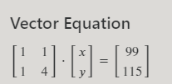

Figure 4 Vector Equation for the Exercise

Figure 4 shows the vectorized equation of the linear equation in figure 5.

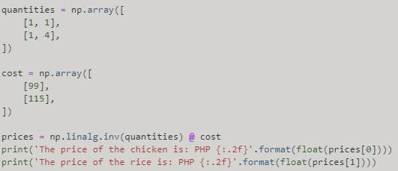

Figure 5 Code for Exercise Number 1

Figure 5 shows the code for exercise number 1. The code contains two arrays which are quantities and cost. Quantities represent the quantities of the $x$ and $y$ values while costs represent the cost of the order which is 99 pesos for the solo order while the cost is 115 pesos for the unli order.



Figure 6 Result of the Code for the Exercise Number 1

Figure 6 shows the output of the code for exercise number 1. It can be seen that the price of the chicken is 93.67 pesos while the price of the rice is 5.33 pesos. Assuming that the price for a cup of rice in restaurants is 10 pesos, it would be better to order the unli rice version if your appetite can handle at least 3 cups of rice.

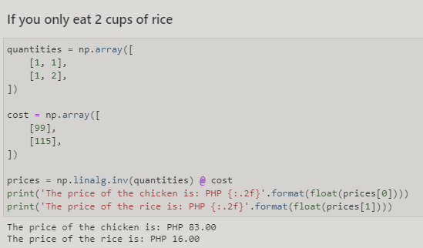

Figure 7 Only 2 Cups of Rice

Figure 7 shows the scenario where a person would only eat 2 cups of rice in the unli order. It can be seen that the price of the rice would be 16 pesos which would give the customer a deficit of 6 pesos.

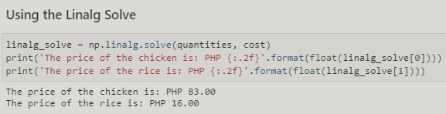

Figure 8 Using the np.linalg.solve()

Figure 8 uses the same real-life example but instead of using the np.linalg.inv() function, it would use the np.linalg.solve(). In order to get the $r$ in the equation $Xr=Y$, multiply both sides with the inverse of X and the equation would be $r=X^{-1}Y$. This would be the reason why “np.linalg.inv(quantities) @ cost” would get the same result as “np.linalgsolve(quantities, cost)” since it would both get the system of linear equation.

# Conclusion

This laboratory is about solving a system of linear equations using linear algebra techniques and python programming. A system of linear equations is a set of linear equations that looks like $ax+by+cz=K$, with $x, y, z$ as a variable and $a, b, c,$ and $K$ as constants. These sets of linear equations can be used to get the rate of change, predicting changes, graphing lines at a plane, or simply getting an unknown quantity using the variables given by the equations. This laboratory also proves that the Numpy and matplotlib library can be used to solve and graph systems of linear equations specifically using functions such as np.linalg.inv()which computes the multiplicative inverse of a matrix [2] and np.linalg.solve() which solves a linear matrix equation [3]. It is worth noting that the r in the equation $Xr=Y$, multiply both sides with the inverse of $X$ and the equation would be $r=X^{-1} Y$.

System of linear equation can be used in robotics to create a control algorithm that tracks trajectory of mobile manipulator robots [4]. The algorithm is used to control the kinematics of the robot, which is approximated using the Euler method. The control then acts as an operation of the system which is obtained by solving a system of linear equations [4].

**References**

[1]"numpy.array — NumPy v1.19 Manual", Numpy.org, 2020. [Online]. Available: https://numpy.org/doc/stable/reference/generated/numpy.array.html. [Accessed: 18- Dec- 2020].

[2]"numpy.linalg.inv — NumPy v1.19 Manual", Numpy.org, 2020. [Online]. Available: https://numpy.org/doc/stable/reference/generated/numpy.linalg.inv.html. [Accessed: 18- Dec- 2020].

[3]"numpy.linalg.solve — NumPy v1.19 Manual", Numpy.org, 2020. [Online]. Available: https://numpy.org/doc/stable/reference/generated/numpy.linalg.solve.html. [Accessed: 18- Dec- 2020].

[4] V. Andaluz, E. Sasig, W. Chicaiza, and P. Velasco, "Control Based on Linear Algebra for Mobile Manipulators", Researchgate, 2020. [Online]. Available: https://www.researchgate.net/publication/318234646_Control_Based_on_Linear_Algebra_for_Mobile_Manipulators. [Accessed: 18- Dec- 2020].

**Appendix**

Github Link - https://github.com/Sus102/LA_Lab/tree/master/LA_LAB_8