

Tribhuvan University
Faculty of Humanities and Social Sciences

A Project Report on “Newari Dress”
In partial fulfillment of the requirement for the degree of Bachelor in Computer Application
(BCA)

Submitted To:

Mr. Diwakar Upadhyaya

Department of Computer Application

Kathmandu College of Technology

Submitted by:
Alish Pawn (6-2-1105-4-2021)
July 2025



Tribhuvan University
Faculty of Humanities & Social Science
Kathmandu college of technology

Supervisor’s Recommendation
I hereby recommend that this project, prepared under my supervision by Alish Pawn, entitled “Newari Dress”, in partial fulfillment of the requirements for the degree of Bachelor of Computer Application, is recommended for final evaluation.

Signature:
Mr. Diwakar Upadhyaya



Tribhuvan University
Faculty of Humanities & Social Science
KATHMANDU COLLEGE OF TECHNOLOGY

LETTER OF APPROVAL
This is to certify that this project, prepared by Alish Pawn, entitled “Newari Shop”, in partial fulfillment of the requirements for the degree of Bachelor of Computer Application, has been evaluated. In our opinion, it is satisfactory in scope and quality as a project for the required degree.

Signature  Mr. Diwakar Upadhyaya  Supervisor  Kathmandu College of Technology  Lokanthali, Bhaktapur | Signature  Mr. Santosh Rijal  Campus Head  Kathmandu college of Technology  Lokanthali, Bhaktapur
-------------------------  Internal Examiner | --------------------------  External Examiner

ACKNOWLEDGEMENT
This project report on Newari Dress would not have been completed without the guidance and encouragement of several individuals. I would like to express my deepest gratitude to my supervisor, Mr. Diwakar Upadhya
ya, for their continuous support, expert guidance, and valuable feedback throughout the development of this project. I also extend my thanks to my college, Kathmandu College of Technology, for providing the necessary resources and fostering a supportive academic environment.
Special thanks to my friends for their constant encouragement and to my peers for their collaboration and moral support during challenging times. Finally, I am sincerely grateful to everyone who contributed, directly or indirectly, to the successful completion of this project.

Alish Pawn (6-2-1105-4-2021)

ABSTRACT
The project titled "Newari Dress" is an innovative e-commerce platform dedicated to promoting and streamlining the purchase of traditional Newari clothing, jewelry, and cultural artifacts. The primary goal of this project is to enhance the shopping experience for individuals interested in Newari heritage by offering a user-friendly interface, curated collections, and efficient functionality. This platform aims to preserve and promote Newari culture while providing a centralized, reliable, and accessible marketplace for authentic traditional products.
The website consists of two main sections: one for administrators and another for users. Administrators can manage product listings, oversee inventory, handle customer inquiries, and track sales performance. Users can register an account, browse a wide selection of traditional items, apply filters to customize their searches, add products to their cart, and choose from multiple secure payment methods, including cash on delivery.
The project includes detailed system diagrams to illustrate workflows and has undergone thorough testing to ensure smooth performance and reliability. Future recommendations and possible upgrades are also discussed to accommodate the evolving needs of users and support the ongoing promotion of Newari culture through digital commerce.
Keywords: Newari clothing marketplace, traditional wear e-commerce, user-friendly platform, inventory management, secure transactions.

TABLE OF CONTENT

ACKNOWLEDGEMENT iii
ABSTRACT iv
LIST OF FIGURES vii
LIST OF TABLES viii
LIST OF ABBREVIATIONS ix
CHAPTER 1: INTRODUCTION 1
  - Introduction to the Newari Dress 1
  - Problem Statement 2
  - Objectives 2
  - Scope and Limitation 2
    - Scope of project 2
    - Limitation of project 2
  - Development Methodology 3
  - Report Organization 3
CHAPTER 2: BACKGROUND STUDY AND LITERATURE REVIEW 5
  - Background Study 5
  - Literature Review 1
CHAPTER 3: SYSTEM ANALYSIS AND DESIGN 2
  - System Analysis 2
    - Requirement Analysis 2
    - Feasibility study 3
    - Data modelling (E-R diagram) 4
    - DFD (Dataflow Diagram) 5
  - System Design 6
    - Architectural design 6
    - Gantt Chart 7
CHAPTER 4: CONCLUSION 8
  - Lesson Outcome 8
  - Conclusion 8
CHAPTER 5: BIBLIOGRAPHY 9

LIST OF FIGURES
Figure 1. 1 Agile model 11
Figure 3. 1 Use Case Diagram of Newari Shop 15
Figure 3. 2 ER Diagram of Newari shop 17
Figure 3. 3 Level 0 DFD of Newari Shop 18
Figure 3. 4 Level 1 DFD of Newari Shop 19
Figure 3. 5 Level 2 DFD of Newari Shop 20
Figure 3. 6 Architectural design of Newari Shop 21
Figure 3. 7 Database Schema Design 22
Figure 3. 8 Login ui of Newari Shop 23
Figure 3. 9 Register ui of Newari Shop 23
Figure 3. 10 Physical DFD 24

LIST OF TABLES
Table 3. 1 Gantt Chart of Newari shop 24
Table 4. 1 User test case 30
Table 4. 2 Admin Testing 31
Table 4. 3 Product Functionality Testing 32
Table 4. 4 Cart & Order Processing 32
Table 4. 5 Payment Processing 32
Table 4. 6 Critical Failure Testing 33

LIST OF ABBREVIATIONS

API | Application Program Interface
CSS | Cascading Style Sheet
ER | Entity Relation
HTML | Hypertext Markup Language
JS | JavaScript
MERN  B2B  B2C | MongoDB, Express, React, and Node.js  Business 2 Business  Business 2 Customer

CHAPTER 1
INTRODUCTION

Introduction
Experience the fascinating world of Newari culture with Newari shop, where traditions and style combine. Enjoy exquisite collection of Newari clothing, jeweler and cultural artifacts that represents the ageless beauty and artistry of Nepal's Kathmandu Valley. Experience the appeal of carefully created ornaments, modern fusion pieces, and traditional dresses, each item presenting a tale of rich cultural heritage. We at Newari shop warmly welcome you to embrace the elegance of Newari customs and include these unique cultural artifacts into your daily wardrobe. With each purchase, discover the beauty and distinct charm of Newari craftsmanship.

Problem Statement
Imagine wanting to celebrate the vibrant Newari culture through authentic clothing, jewelry, or artifacts, but finding no dedicated space that truly honors this heritage. Many people face this struggle, unable to easily discover genuine Newari products that capture the heart of the Kathmandu Valley. On top of that, existing online platforms can feel clunky, with confusing search tools and filters that make finding the right item a chore. Worse, limited or complicated payment options often turn a joyful shopping moment into frustration. At Newari Shop, we understand these challenges and are here to create a welcoming, user-friendly platform that makes embracing Newari craftsmanship effortless and delightful.

Objectives
- To provide platform for e-commerce website using MERN Stack.
- To generate revenue by providing a platform for customers to browse, select, and purchase products or services online.
- To perform and integrate with inventory management, payment processing, and shipping systems.

Scope and Limitation

Scope of project
This system has following scope: -
      - Customers can browse and buy Newari product online through the website.
      - Its user-friendly UI helps consumers save time and effort.
      - Order and payment processing (via Stripe/Khalti)
      - Basic security and error handling

Limitation of project
      - Limited availability of authentic Newari products in bulk.
      - Payment timeout and database errors not handled properly.
      - Possible memory leaks during long usage sessions.
      - No restriction on large file uploads

Development Methodology
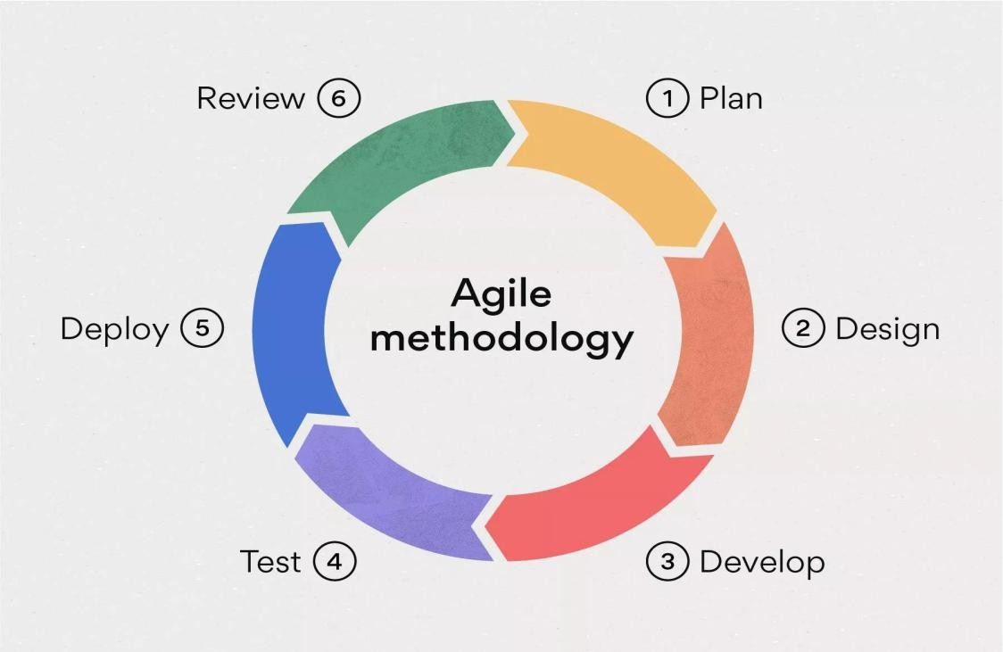
The development methodology for the Newari Dress eCommerce website follows the Agile model. This model is ideal for the Newari Dress project as it allows for flexibility, regular testing, and quicker adaptation to changing requirements. Agile ensures that the system evolves incrementally, keeping the project aligned with customer needs and ensuring a smooth and efficient development process.
Figure 1. 1 Agile model

Report Organization
The report for this project is in the following format:
Chapter 1: Introduction: In this section, the main points discussed are the overview, the background of the project, the objectives of the project, the scopes and limitations of the project, and the methodology of the project.
Chapter 2: Background study and Literature Review: This section discusses the literature review and background study to understand the existing system and their features.
Chapter 3: System Analysis and Design: This section discusses the literature review, functional and nonfunctional requirement analysis, and feasibility analysis that are used to study the system's feasibility and the requirements needed for its proper operation. The ER Diagram describes various entities and attributes used to store the records in the database. It provides the overall working mechanism of the system entities involved, along with their attributes, and generates relationships between them.
Chapter 4: Implementation and Testing: A product software implementation method is a systematically structured approach to effectively integrating a software-based service or component into the workflow of an organizational structure or an individual end-user. Here we discuss the methodology used, tools used, and algorithm implemented and various software testing methods are used to test software, like unit testing, and system testing.
Chapter 5: Conclusion: Here, the project is concluded with the results of the proposed method that has been analyzed and recommendations are made according to the results obtained from the analysis.

CHAPTER 2
BACKGROUND STUDY AND LITERATURE REVIEW

Background Study
In the last few years, e-commerce has revolutionized the fashion world globally by opening a window of opportunity for niche markets to grow. The online fashion market, as [1] shows, has substantially grown with enhanced internet access and convenience provided by it. Ethnic and cultural fashion, such as Newari traditional dressing, remains underrepresented on main online spaces.
Certain Nepalese local enterprises have attempted to market ethnic clothing online, but such sites lack dedicated functionalities for cultural heritage, history, and customization. Also, supply chain problems, low digital knowledge among the artisans, and lack of a centralized platform limit the growth of such niche products on the web.
The proposed e-commerce site aims to bridge this gap through the creation of a niche site exclusively for Newari traditional costumes and ornaments. It would serve not only as an entrepreneurial website but also an online archive with the aim of preserving and sharing Newari cultural identity. Through multimedia, information on artisans, and detailed product histories, customers can be more involved and enjoy culture as emphasized in studies on models of cultural e-commerce [2].

Literature Review
The integration of classical cultural elements within modern e-commerce websites has been increasingly popular both in academic circles and business communities. In previous research, the role of e-commerce in promoting and conserving indigenous clothes and crafts has been highlighted [1]. Empirical evidence suggests that fashion cultural markets, though niche markets, maintain powerful emotional and identity-based value among target audiences, especially diaspora populations [2].
Sharma et al. investigated in [3] the Nepali handicraft digitization, referring to the way that digital platforms help overcome the distance between local artisans and global

markets. In the meantime, they mentioned shortcomings such as poor digital infrastructure, limited marketing capabilities, and poor content localization. According to their findings, ethnic product platforms require more than the bare e-commerce capabilities they require cultural storytelling, visual sophistication, and design centered on artisans.
Another study by Thapa and Joshi [4] set out to determine the enhanced visibility of e-commerce among Nepali urban customers. Although traditional platforms like Daraz and HamroBazar provide a platform for clothing and accessories, they are not otherwise tailored for ethnic wear. The absence of filters based on cultural categories, festival wear, or traditional tailoring specifications renders low visibility to Newari products.
Globally, culturally themed e-commerce has also been studied globally. Lee and Chen [5] have studied Chinese ethnic fashion online and indicated that the integration of cultural heritage and product presentation significantly increases consumer involvement and trust. They found that websites presenting ethnic fashion are supplemented by educational information, such as the history of the designs, symbolic meanings, and cultural significance.
There evidently is a void in academic and business circles as far as specialized platforms for Newari apparel are concerned. As much as its culture is rich, no major study or system has been able to provide as yet a scalable and feasible model that serves the Newari fashion community alone. This literature review points to the necessity of a culturally specific, purpose-designed e-commerce site that empowers artisans, educates customers, and digitally archives Newari identity.

CHAPTER 3:
SYSTEM ANALYSIS AND DESIGN

System Analysis
The Newari Dress platform was developed to enhance user experience and efficiency in showcasing and selling traditional Newari products. It features user account management, order tracking, and admin tools for smooth operations. Using the Agile Development Model, the team followed an iterative process that allowed for continuous improvements based on feedback, resulting in a user-friendly and scalable e-commerce solution.

Requirement Analysis
      - Functional requirement
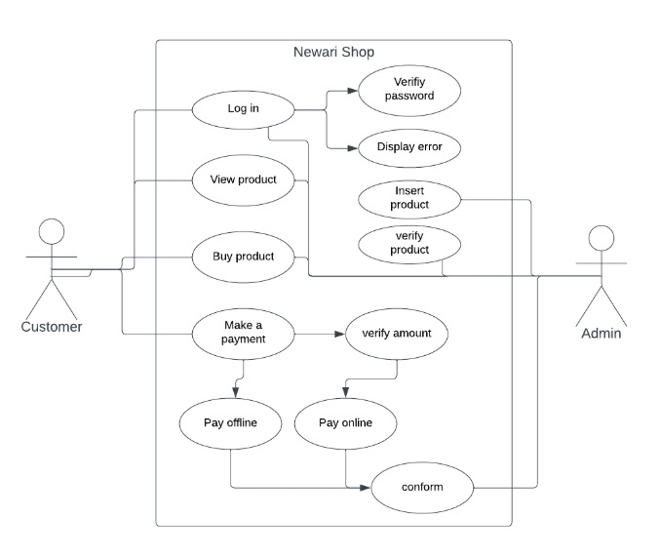
Figure 3. 1 Use Case Diagram of Newari Shop

A functional requirement (FR) is a description of the service that the software must offer. It describes a software system or its component. It is a statement of services the system should provide, how the system should react to particular inputs and how the system should behave in particular situations. It describes functionality or system services. It depends on the type of software, expected users and the type of system where the software is used.
- Non-functional Requirements
Some of the non-functional requirements of our system are summarized as following:
Availability: The system can be accessed by anyone and anywhere having internet.
Maintainability: The system can be restored to operational status after a failure occurs, so the system is highly maintainable.
Reliability: It is defined by the overall accuracy of the system and the ability of the system to predict a correct output from the given input data.
Ease of use: The system has a user-friendly interface so that any user can use the system without facing any difficulties.

Feasibility study
A feasibility study is a phase in which high management decides on the feasibility report that whether or not the proposed system is worthwhile. The objective behind the feasibility study is to create the reasons for developing the software that is acceptable to users and flexible to change.
- Technical
This project uses React for the frontend and Node.js with MongoDB for the backend, providing a modern, scalable, and efficient platform. The chosen technologies are reliable, widely supported, and suitable for building a robust e-commerce system.
- Operational
Operational feasibility evaluates the range in which the required software performs a series of levels to solve business problems and customer requirements. The main purpose of this program is to develop a web-based application which facilitates online reservation of hotel accommodation through internet.
- Economic
Economic feasibility decides whether the necessary software can generate financial profits for an organization. This can be reduced by keeping data in the digital format that is
reliable and cheaper.
- Schedule
Time Schedule according to the methodology used for development, the project was estimated to be fully developed in 4 months. The total project development task is sub- divided into various phases and allocated time schedule as per requirements.

Data modelling (E-R diagram)
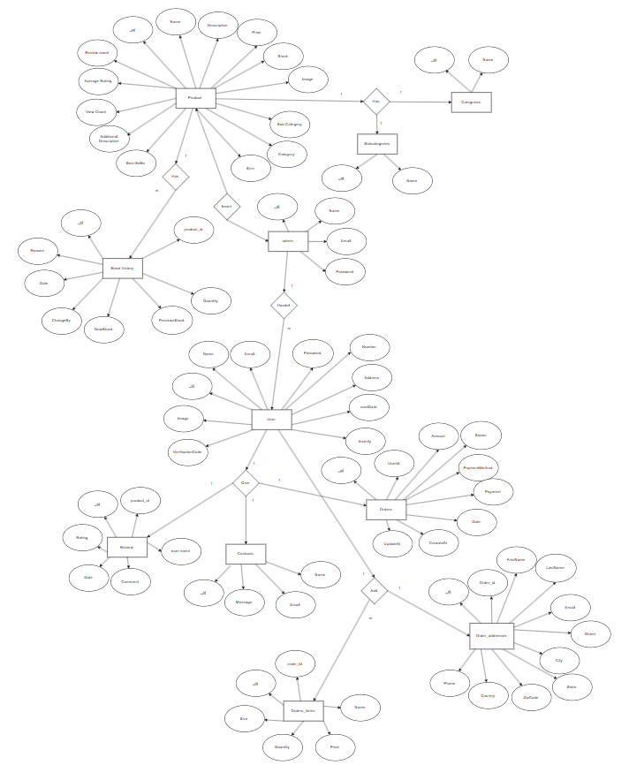
Figure 3. 2 ER Diagram of Newari shop

DFD (Dataflow Diagram)
Data flow diagram is a graphical tool. It is used to describe and analyses the movement of data through a system-manual or automated. They focus on the data following into the system, between processes and in and out of data. This is a central tool and basis from which the other components are developed. Developing a description of the system using the structured analysis follows a top-down process.
DFD Level 0
The Level 0 DFD for this e-commerce website provides a high-level overview of the system, showing basic interactions between the website, Admin, and Users. The admin sends product and price information to the website and receives purchase details, while Users submit purchase requests. It serves as a foundation for deeper system analysis and helps identify design flaws early.
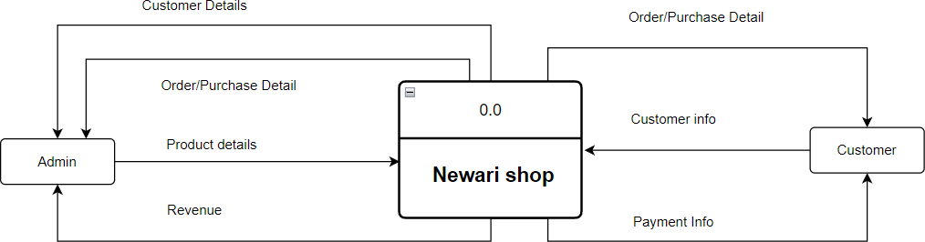
Figure 3. 3 Level 0 DFD of Newari Shop

DFD Level 1
The Level 1 DFD for the e-commerce website expands on the Level 0 diagram by breaking down the main process into detailed subprocesses. It provides a clearer view of the system’s internal data flow and interactions. Each subprocess is numbered to indicate it stems from the main process in Level 0. In the diagram, Process 1.1 manages customer information, receiving data from the User and sending it to the Admin. Another process handles product information, receiving input from both the Admin and the User.

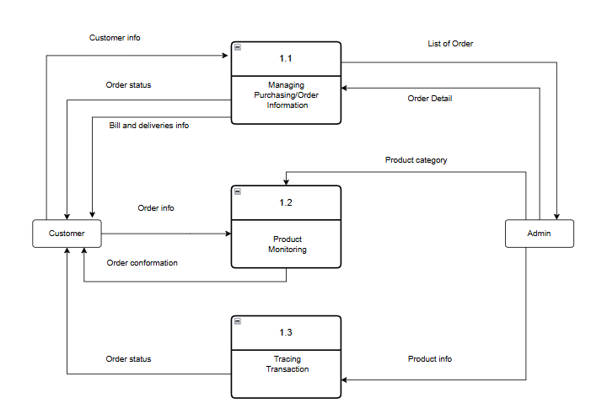
Figure 3. 4 Level 1 DFD of Newari Shop
DFD Level 2
The Level 2 DFD for the e-commerce website provides a more detailed breakdown of the processes introduced in Level 1. It offers a complete and in-depth view of how the system operates, making it useful for both planning and documentation. This level illustrates specific modules, data flows, external entities, and databases. In the diagram, the User and Product databases supply data to subprocesses 2.1 and 2.2, while the Admin and User interact with the system. The User sends order information and receives price details and purchase updates. The admin provides product and price updates and receives order information in return.

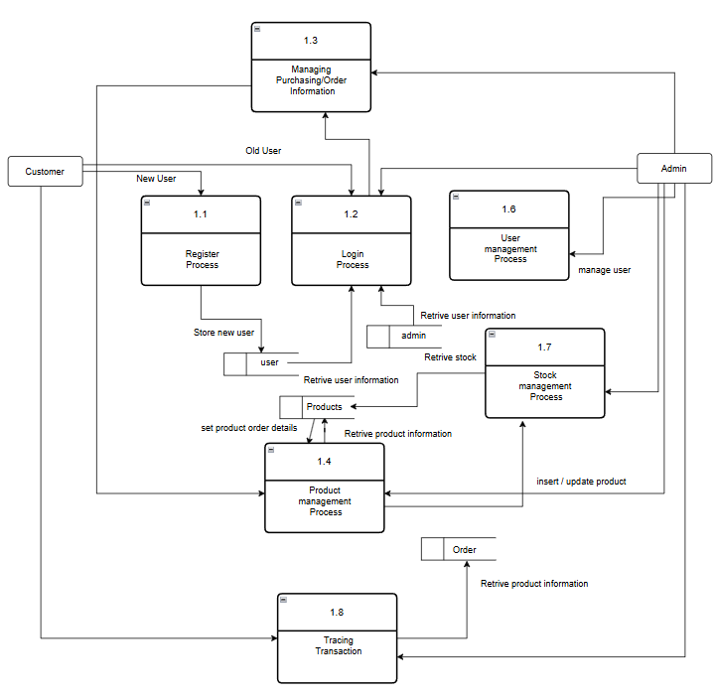
Figure 3. 5 Level 2 DFD of Newari Shop

System Design
Considering that this project involves the design and implementation of a software system, specifically a web-based one, it is important to mention and consider the models used in software development and deployment. System development refers to the process of creating or modifying systems, including the practices, methodologies, and models applied throughout the development lifecycle.

Architectural design
The shopping website uses a three-tier architecture consisting of the Presentation, Business, and Data Layers. Users interact through a simple interface, and their data is stored in a database. The system manages transactions using multiple tables, each with specific attributes, and assigns unique account numbers to users. Each layer operates independently, offering flexibility and scalability. 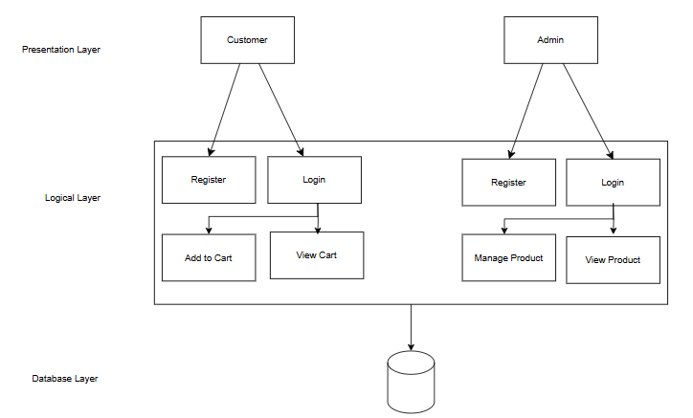
Figure 3. 6 Architectural design of Newari Shop

Database Schema Design
Database schema design structures data into distinct entities, defines the relationships between them, and applies necessary constraints to ensure data integrity. The schema provides a logical framework for users to understand how data is organized. In the given schema, entities such as Admin, Product List, Product, Order, User, and Order History are interconnected, and data is managed according to the needs of both the admin and users.
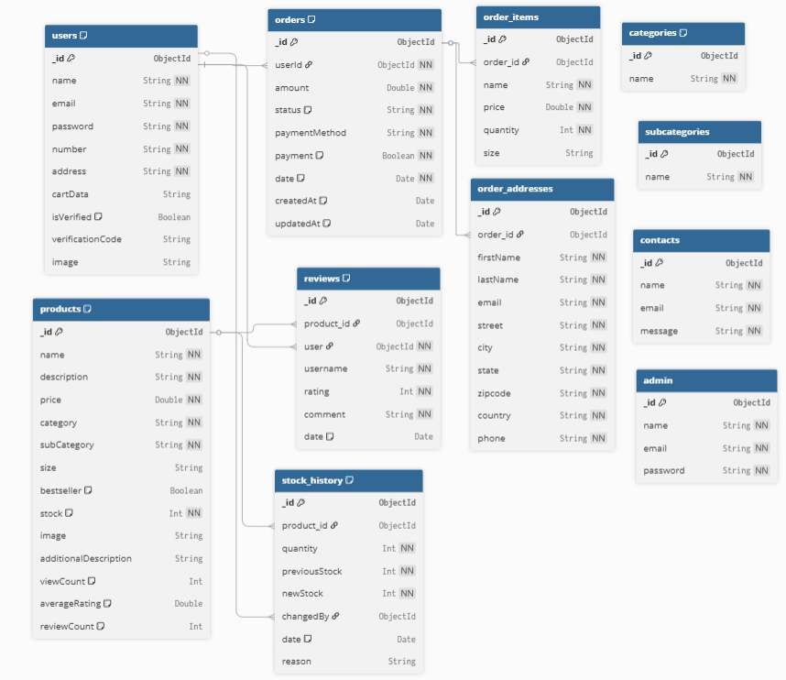
Figure 3. 7 Database Schema Design

3.2.3 Interface design (UI/UX)
Before Implementing the actual design of the few users’ interface design are constructed to visualize user interface and interaction with the system as they browse registration login and perform transaction. The user interface design will closely follow our functional decomposition diagram show the initial designs of the web pages.

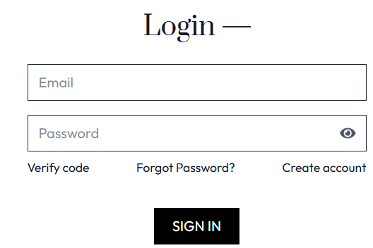
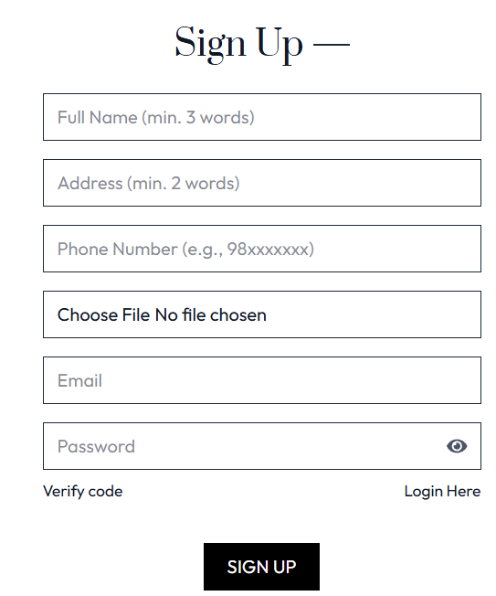
Figure 3. 8 Login ui of Newari Shop

Figure 3. 9 Register ui of Newari Shop

Physical DFD
The physical data flow diagram (DFD) illustrates how the system will be physically implemented. Compared to logical DFDs, physical DFDs are usually more detailed due to the numerous data stores involved. The acronym CRUD—Create, Read, Update, Delete—represents essential operations for managing master files in the system, and a CRUD matrix helps identify where these operations occur. Physical DFDs often include intermediate data stores such as transaction files or temporary tables, which hold data
between processes since processes accessing the same data may not run simultaneously.
In the diagram, the user selects products from the products/category database, which are then added to the cart. The cart value proceeds to the checkout page, and after the user places the final order, it is verified and approved by the Admin.

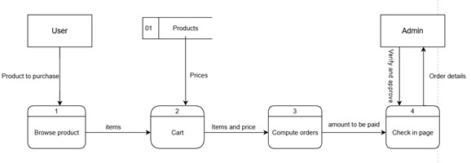
Figure 3. 10 Physical DFD

3.2.5 Gantt Chart
A Gantt chart is a bar chart that provides a visual view of tasks scheduled over time. A Gantt chart is used for planning projects of all sizes and it is a useful way of showing what word is schedule to be done on a specific day. It can also help you view the start and end dates of a project in one simple chart.
Table 3. 1 Gantt Chart of Newari shop

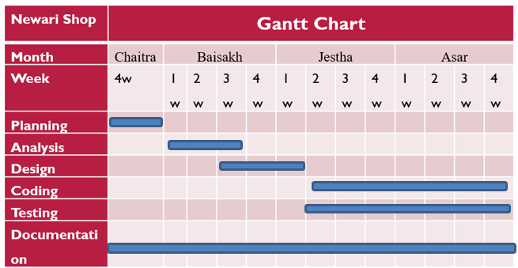
3.3 Algorithm details
- Product Recommendation Algorithm
Title: Bayesian Average Product Ranking System
Description: The product recommendation system uses a sophisticated Bayesian average algorithm:
1. Bayesian Average Algorithm:
The Bayesian Average Algorithm ensures that products with more reviews get a fair ranking while preventing products with few reviews from dominating the top spots.
```javascript
const calculateBayesianScore = (product, globalAverage, minimumReviews) => {
const score = (product.averageRating * product.reviewCount +
globalAverage * minimumReviews) /
(product.reviewCount + minimumReviews);
return score;
};
```
2. Top Products Algorithm:
- View count-based popularity ranking
- Rating-based recommendation system
- Hybrid scoring combining multiple factors

3. Review System Algorithm:
- Average rating calculation
- Review count tracking
- Spam detection and moderation

ii. Search and Filter Optimization Algorithm
Title: Real-Time Search with Debouncing and Caching
Description: The search system implements performance optimization algorithms:
1. Debouncing Algorithm:
```javascript
const debounce = (func, delay) => {
let timeoutId;
return (...args) => {
clearTimeout(timeoutId);
timeoutId = setTimeout(() => func.apply(null, args), delay);
};
};
```
2. Search Caching Algorithm:
- Memoization of search results
- Cache invalidation on data updates
- Progressive loading for large result sets

3. Filter Combination Algorithm:
- Multiple filter application
- Filter state management
- Dynamic result updates

CHAPTER 4
IMPLEMENTATION AND TESTING

4.1 Implementation
Implementation is the phase where the system is built based on the analyzed information. It involves coding, testing, installation, documentation, training, and support. This phase converts the system design into working software using the tools and technologies discussed earlier. Implementation is a critical step in any project.

4.1.1 Tools used
The various system tools that have been used in developing both the front-end and backend of the projects are being discussed in this chapter.
Front-end
React.js: React.js is a JavaScript library for building user interfaces, particularly single-page applications. It is used for creating reusable UI components and managing the application state. In this project, React.js serves as the core framework for building the front-end, including components for product listings, shopping cart, user authentication, and responsive web pages.
Vite: Vite is a modern build tool that provides a faster and leaner development experience for modern web projects. It serves as the build tool and development server for this React application, offering features like hot module replacement (HMR) and optimized builds for production deployment.
Tailwind CSS: Tailwind is a utility-first CSS framework used to create responsive and modern web designs. It offers utility classes like bg-green-500 or text-center to style elements directly in HTML. Tailwind helps build clean, user-friendly interfaces, like styling alerts such as "Added to cart successfully" or "Login successful" with ease and flexibility.

Backend
Node.js: Node.js is a JavaScript runtime environment that allows running JavaScript on the server-side. It serves as the foundation for the backend server, enabling the development of scalable and high-performance web applications.
Express.js: Express.js is a minimal and flexible Node.js web application framework that provides a robust set of features for web and mobile applications. In this project, Express.js handles routing, middleware, and API endpoints for user authentication, product management, cart operations, and order processing.
MongoDB & Mongoose: MongoDB is a NoSQL document database used for storing application data. Mongoose is an Object Data Modeling (ODM) library for MongoDB and Node.js. In this project, MongoDB stores user data, product details, orders, payments, and reviews. Mongoose provides schema-based solution for modeling application data and includes built-in type casting, validation, query building, and business logic hooks.
Database
MongoDB: MongoDB is a NoSQL document database used as the primary database for this eCommerce application. It stores user data, product information, orders, cart items, and other application data. MongoDB's flexible schema allows for easy data modeling and scalability, making it suitable for eCommerce applications with varying product attributes and user data requirements.

4.1.2 Implementation Details of modules
After the design was made and the problems arising from the design process were clarified and dealt with, it was time to start implementing the application. Implementing application of his scale requires lots of resources and explaining the whole implantation process will not be clarified in this paper. However major important aspects in the implementation will be described, some modules of the shopping websites are listed below:
Register Form: It is used in order to register the users to the website. It contains the text field like email, username and password. The information entered is further stored to be used in the login page.
Login Form: It is used in order to provide the user the gateway to the website. It uses the data like username and password from register form to authenticate the user and give further access.
Shopping Cart: It displays the quantity of products and the prices of the products which is to be bought by the user.
Product Modules: Since the shopping website offers two different Shopping categories, Product modules divides different products according to their categories. Users can select the products according io their choices.
User Module: It provides information related to the user. It Provides information like cart detail, product detail, login, register and logout.
Admin Module: Admin can manage the user, add, update, delete the product. Also admin can control the review and rating.
Payment Module: This module handles the processing of payments through multiple gateways like Khalti, Stripe, and Cash on Delivery (COD). Each payment method triggers different workflows and success pages. The system ensures that payments are securely verified and the order status is updated accordingly.
Order module: The order module manages the complete lifecycle of an order from placement to completion. It stores order details like billing information, product quantity, payment status, and delivery status. This module is directly linked with the cart and payment modules.
Review and Rating Module: This module allows authenticated users to submit a review and star rating for products they’ve purchased. Each user is allowed to give one review per product, which can be updated. Reviews help improve product visibility and trust.

4.2 Testing

4.2.1 Test Cases for Unit testing

Table 4. 1 User test case
ID | Test Case Description | Test Data | Expected Result | Actual Result | Pass/Fail
TC001 | User Registration with Valid Data | Name: "Alish Pawn", Email: "alish@gmail.com", Password: "Test123!", Phone: "9876543210" | User registered successfully, verification email sent | User registered successfully, verification email sent | Pass
TC002 | User Registration with Invalid Email | Name: "Alish Pawn", Email: "invalid-email", Password: "Test123!" | Registration failed with email validation error | Registration failed with email validation error | Pass
TC003 | User Registration with Weak Password | Name: "Alish Pawn", Email: " alish@gmail.com ", Password: "123" | Registration failed with password strength error | Registration failed with password strength error | Pass
TC004 | User Login with Valid Credentials | Email: " alish@gmail.com", Password: "Test123!" | Login successful, JWT token generated | Login successful, JWT token generated | Pass
TC005 | User Login with Invalid Credentials | Email: " alish@gmail.com ", Password: "wrongpassword" | Login failed with authentication error | Login failed with authentication error | Pass
TC006 | Email Verification Process | Enter verification code sent to email | Email verified successfully | Email verified successfully | Pass
TC007 | Email Verification with Wrong Code | Enter incorrect verification code | Verification failed with error message | Verification failed with error message | Pass
TC008 | Password Reset Request | Enter registered email address | Password reset email sent | Password reset email sent | Pass
TC009 | Password Reset with New Password | Enter new password and confirm | Password updated successfully | Password updated successfully | Pass

Table 4. 2 Admin Testing
ID | Test Case Description | Test Data | Expected Result | Actual Result | Pass/Fail
TC001 | Admin Login with Valid Credentials | Username: Admin  Email: " admin@gmail.com",  Password: "admin123" | Admin access granted | Admin access granted | Pass
TC002 | Admin Login with Invalid Credentials | Username: Admin  Email: " admin@gmail.com",  Password: "login123" | Admin access ungranted | Admin access ungranted | Pass

Table 4. 3 Product Functionality Testing
ID | Test Case Description | Test Data | Expected Result | Actual Result | Pass/Fail
TC001 | Product Filter by Category | Select "Women" category | Only women's products displayed | Only women's products displayed | Pass

Table 4. 4 Cart & Order Processing
ID | Test Case Description | Test Data | Expected Result | Actual Result | Pass/Fail
TC001 | Add Product to Cart | Click "Add to Cart" button | Product added to cart, cart count updated | Product added to cart, cart count updated | Pass
TC002 | Place Order (Cash on Delivery) | Fill order form and select COD | Order placed successfully, confirmation shown | Order placed successfully, confirmation shown | Pass

Table 4. 5 Payment Processing
ID | Test Case Description | Test Data | Expected Result | Actual Result | Pass/Fail
TC001 | Place Order (Khalti Payment) | Fill order form and select Khalti | Redirected to Khalti payment page | Redirected to Khalti payment page | Pass
Table 4. 6 Critical Failure Testing
ID | Test Case Description | Test Data | Expected Result | Actual Result | Pass/Fail
TC001 | Payment Gateway Timeout | Simulate payment gateway timeout | Timeout error handled gracefully | Timeout error not handled properly | Fail
TC002 | Database Connection Loss | Simulate database disconnection | Graceful error handling | Application crashes | Fail
TC003 | Memory Leak Test | Use application for extended period | No memory leaks detected | Memory usage increases over time | Fail

CHAPTER 5
CONCLUSION AND FUTURE RECOMMENDATIONS

5.1 Conclusion
The creation of a website dedicated to showcasing and selling Newari items, such as ornaments and traditional dresses, represents a significant role in promoting and preserving the rich cultural heritage of the Newar community. This online platform aims to bridge the gap between traditional craftsmanship and modern consumers by providing easy access to authentic Newari products.
However, the development and operation of this website come with specific limitations that must be addressed to ensure its success. The primary limitations include a limited audience reach, as the interest in Newari items may be niche; challenges in ensuring the authenticity and quality of the products; logistical constraints in sourcing and shipping items, especially notable for international orders; and competition from established platforms and local markets. Additionally, maintaining cultural sensitivity and providing an accurate representation of Newari traditions are crucial to avoid misinterpretation or misrepresentation.
Despite these challenges, the website offers significant opportunities. It can serve as a platform for cultural education, showcasing the intricate artistry of Newari craftsmanship and fostering a deeper appreciation for this cultural heritage. Furthermore, the website can support local artisans by providing them with a broader market reach, ensuring fair compensation for their work, and promoting sustainable practices. To navigate the limitations effectively, strategic planning, robust logistical partnerships, and continuous engagement with the Newar community and customers are essential.
Ultimately, the success of this Newari shop website will depend on its ability to balance cultural preservation with modern retail practices, offering a unique and enriching shopping experience that celebrates the heritage of the Newar people. By addressing the identified limitations and capitalizing on the opportunities, this platform can significantly contribute to the recognition and appreciation of Newari culture.

5.2 Lesson Outcome
Upon completing this e-commerce React project, students will understand how to develop a full-stack web application with features such as user authentication, product and cart management, and payment integration. They will gain practical experience in building both user and admin dashboards, implementing responsive design, and handling errors effectively. Through testing and debugging, students will learn to identify and address real-world limitations, while also appreciating the importance of security, performance, and accessibility in modern web development.

5.3 Future Recommendations
To further improve and expand the functionality, reach, and impact of the Newari Shop website, the following recommendations are proposed:
- Improve payment reliability and error handling
- Enhance performance and add security features like 2FA
- Verify product authenticity and quality
- Add multi-language support (Newar, Nepali, English)
- Develop a mobile app for better accessibility
- Allow local artisans to list products
- Include user reviews and ratings
- Add cultural content (blogs, videos, info)
- Use digital marketing to reach wider audiences
- Partner with couriers for better shipping

CHAPTER 6
REFERENCES

[1] | R. S. a. A. K. P. Sharma, "Digitizing Nepali Handicrafts: Challenges and Opportunities," Proceedings of the 2nd National ICT Conference, Kathmandu," 2022. [Online].
[2] | Statista, "E-commerce fashion industry worldwide - statistics & facts," Statista, 2024. [Online]. Available: https://www.statista.com/statistics/ .
[3] | J. S. a. L. Wang, "Digital Heritage: E-commerce Strategies for Ethnic Fashion, International Journal of E-Commerce Studies, vol. 9, no. 2, pp. 45–59," 2023. [Online].
[4] | A. G. a. R. Malhotra, "E-commerce and cultural preservation: Opportunities and challenges," Journal of Heritage and Digital Culture, vol. 7, no. 1, pp. 20–30," 2022. [Online].
[5] | D. M. a. S. Gurung, "Online Retailing in Nepal: An Exploratory Study of Ethnic Products," Nepal Journal of E-Commerce Research, vol. 3, no. 1, pp. 15–24," 2021. [Online].
[6] | S. T. a. B. Joshi, "Consumer Behavior in Nepali Online Marketplaces," Nepal Management Review, vol. 11, no. 2, pp. 67–75," 2023. [Online].
[7] | M. L. a. T. Chen, "Cultural Narratives in Ethnic Fashion E-commerce: A Chinese Perspective," Asian Journal of Digital Business, vol. 5, no. 3, pp. 34–49," 2022. [Online].

APPENDICES
APPENDICES A: Screen Shots
Home page
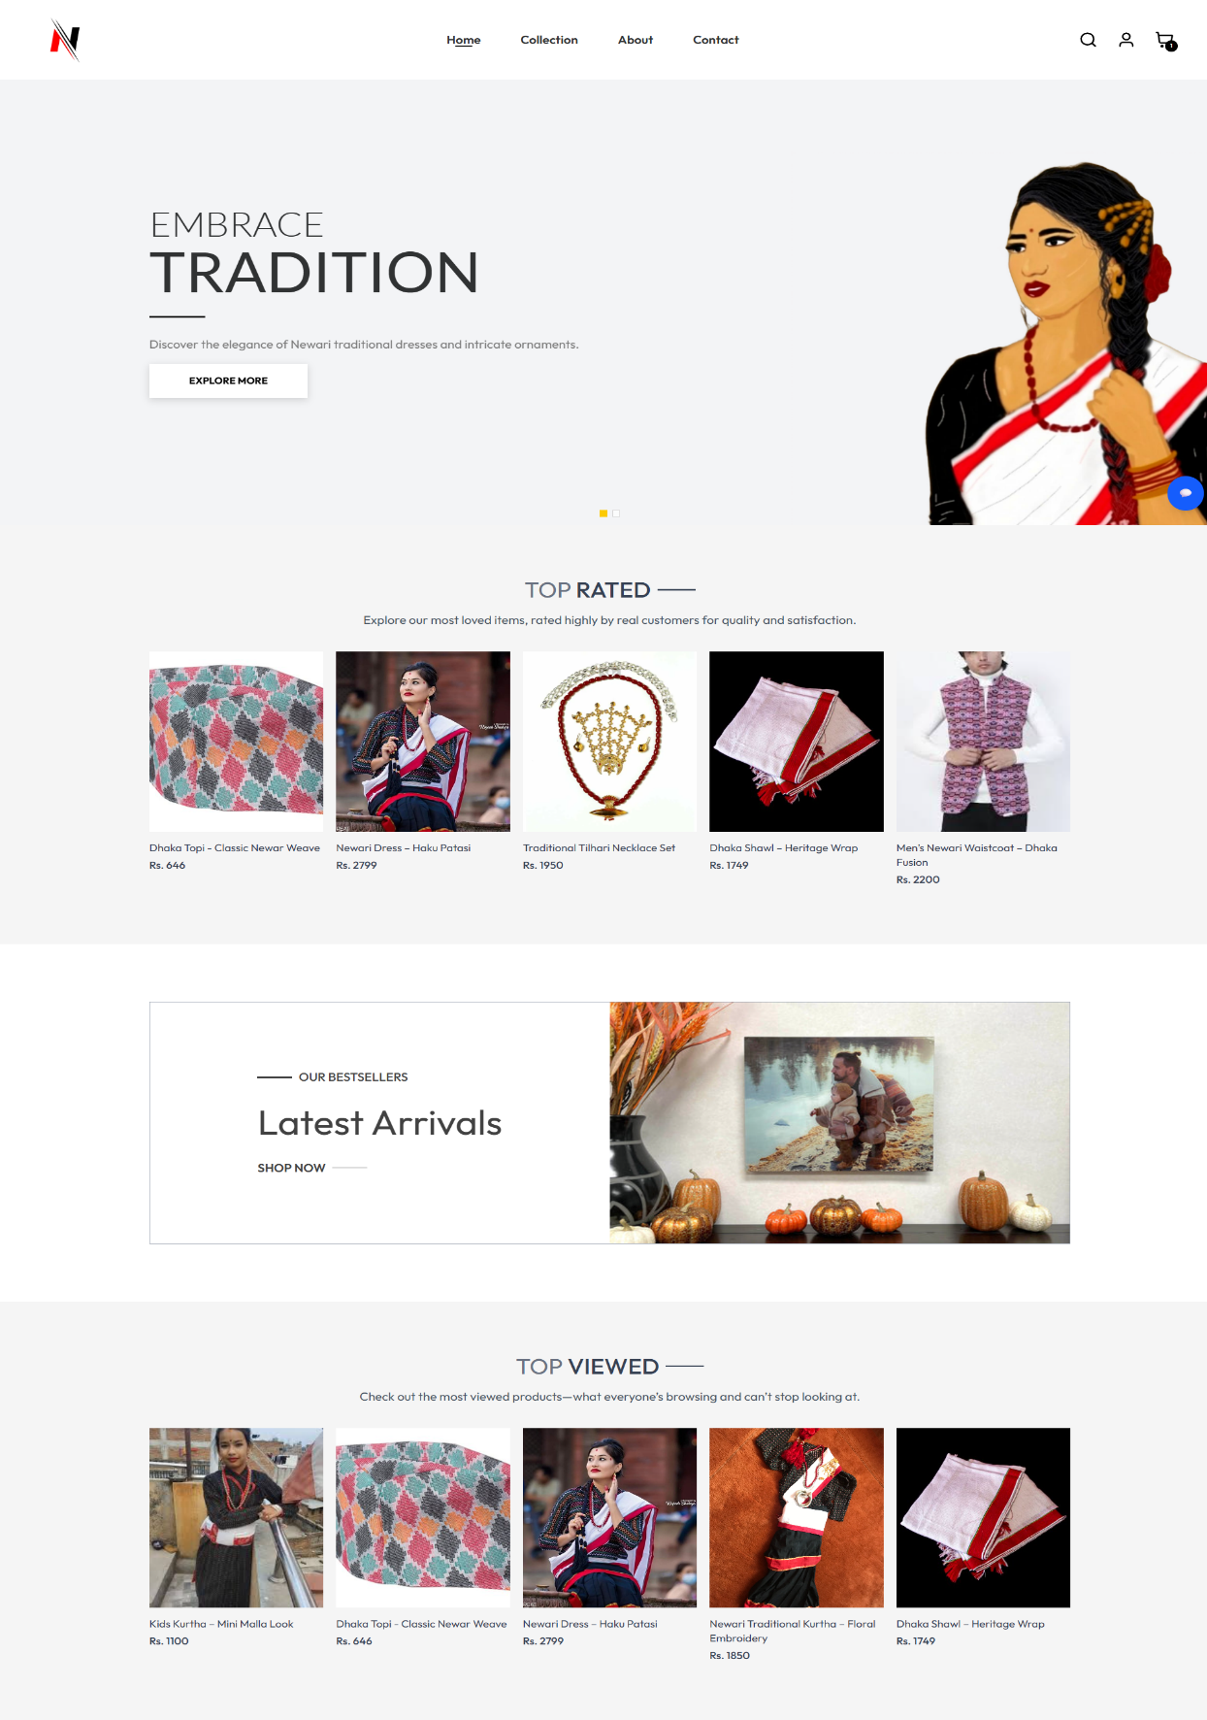

Collection
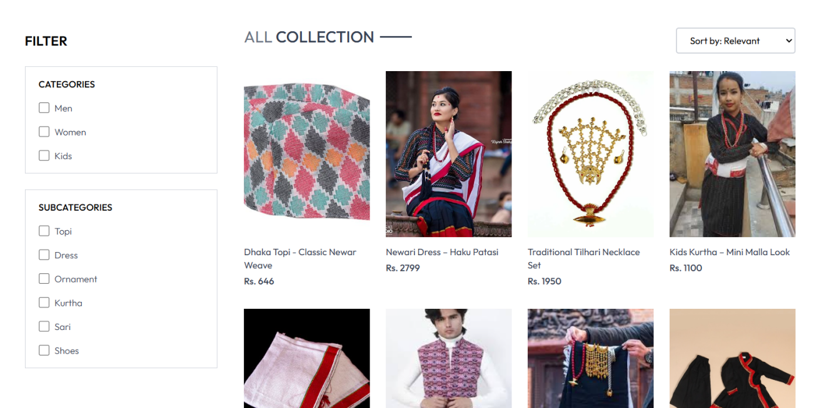
Single page
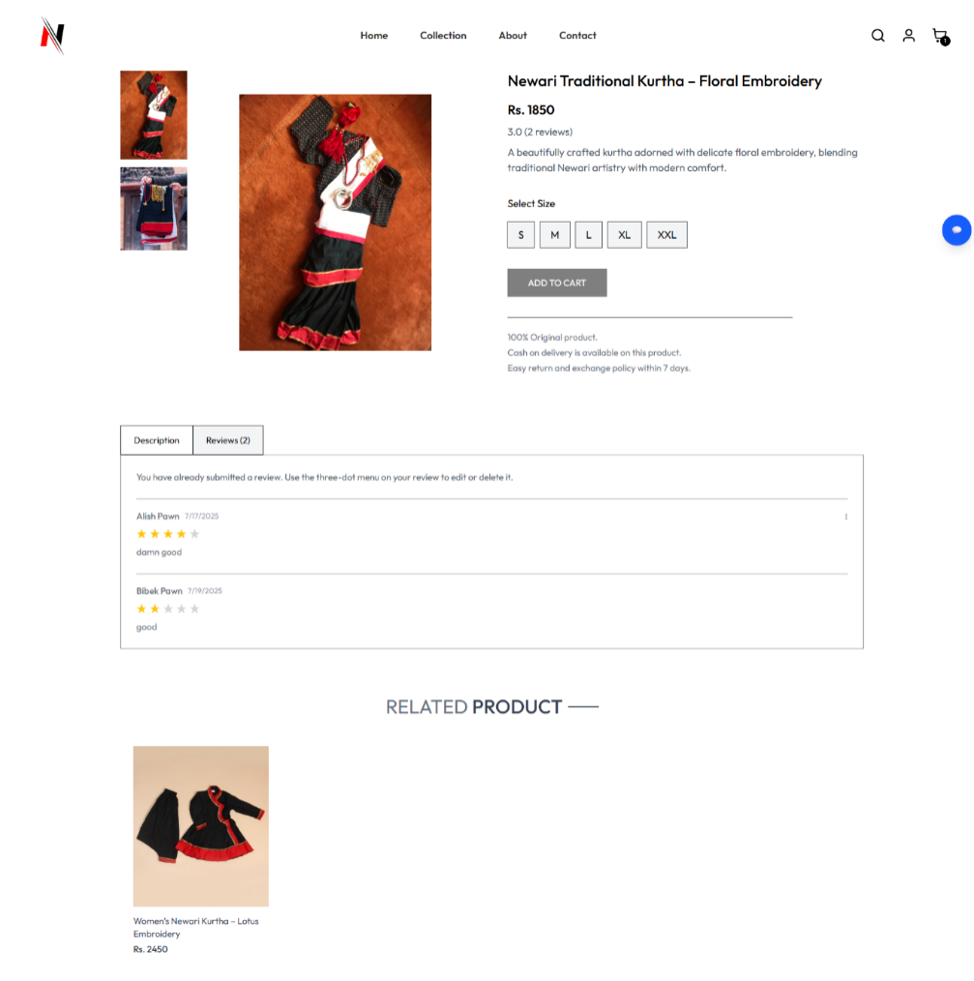

Cart Page
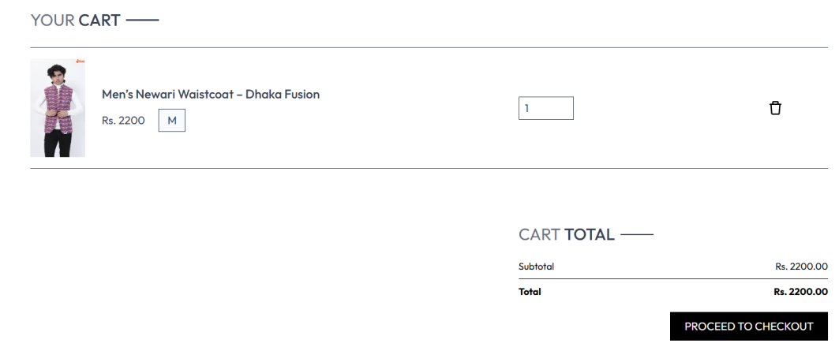
Checkout Page
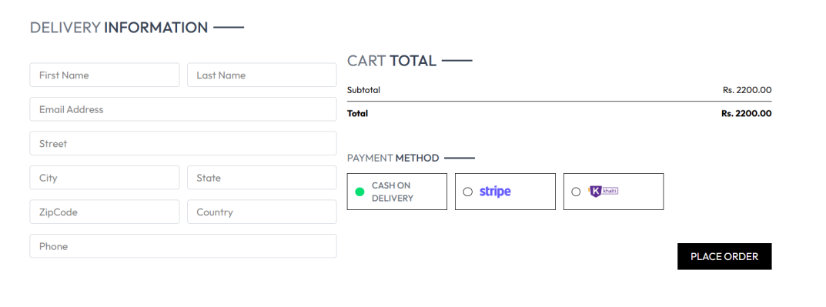
Order Page
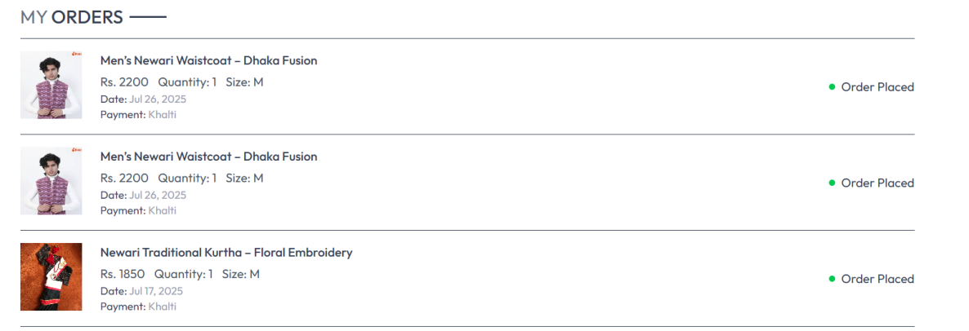
Admin Dashboard
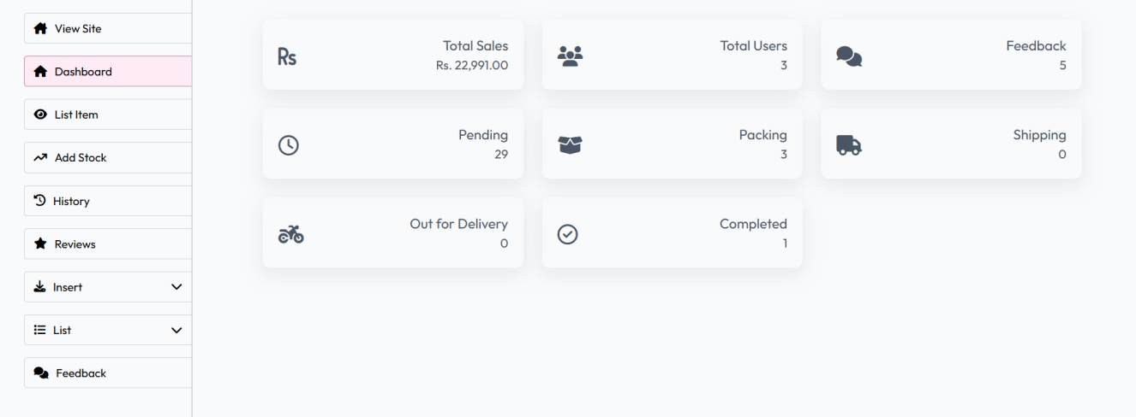

Product List
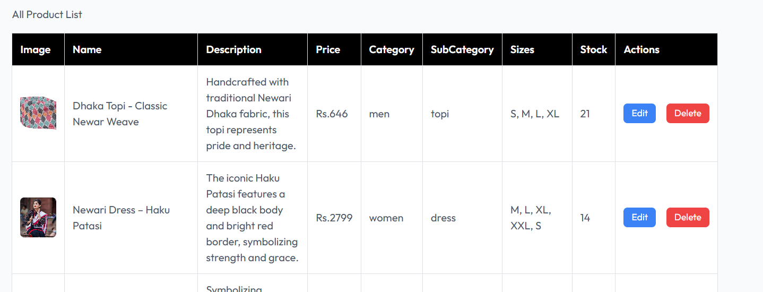
Add Product
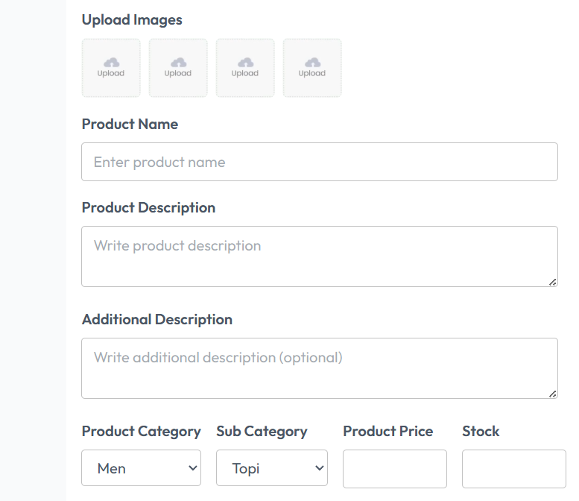
Login Page
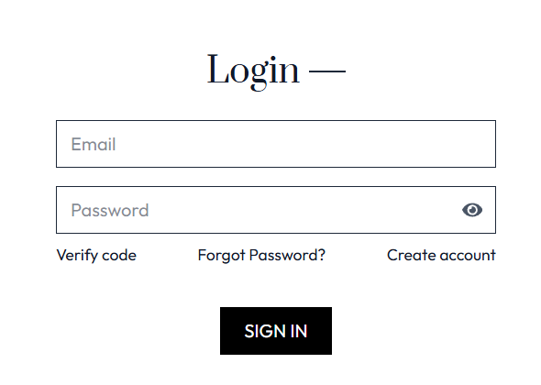
Register page
