Task 1.A

Codes:

Before sending ARP request:

After sending:

Task 1.B

1. Scenario 1

Codes:

Testing result:

1. Scenario 2

The same code would not work in this case.

Testing result:

One possible reason is that the OS would directly drop the ARP reply if target address not in ARP cache. One way to deal with is to spoof a ICMP echo to A to insert the IP address at A’s ARP cache table.

Task 1.C

1. Scenario 1:

1. Scenario 2:

Task 2:

Codes:

ARP poisoning:

Spoofing:

Running result:

Task 3

Basically, just modified the code in task 2 a little bit, then this task could be completed.

Codes:

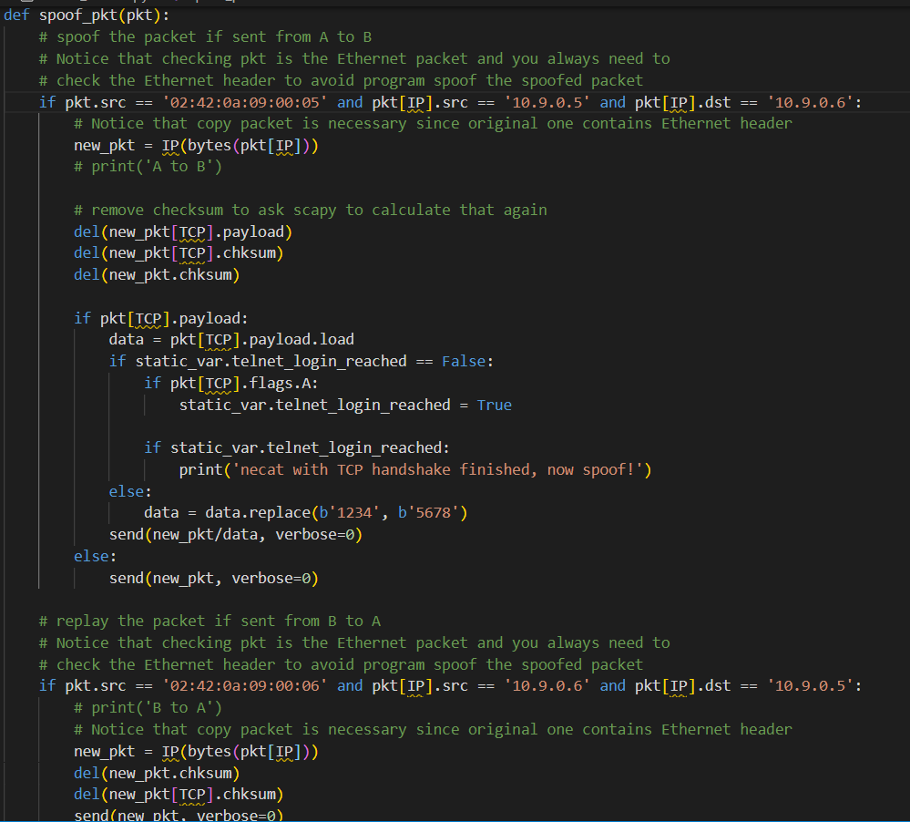

Running result:

Notice that sometimes, the packet from A is not successfully spoofed since some extra traffic may happened between A and B which may update A’s ARP cache.