MALAYSIA PRICE WATCH
Grocery Price Report
Prepared for: KPDN price monitoring, a supermarket category team and an FMCG procurement team | Data: Oct 2025 to Sep 2026 | Built with PostgreSQL, SQL, Python and Power BI | Moztoba Mutashim Billah, October 2026

Executive summary
The business problem. Malaysian households, retailers and suppliers make pricing and buying decisions with national averages, which hide where and in which kind of shop the same item costs more. This report uses 21 million government shelf-price records to set out a KPI scorecard for three stakeholders, the findings behind it and an action plan.
9.9%  more for the same basket in Kuala Lumpur than in Kedah (RM 390 on 265 items) | 12.0%  more for 8 everyday staples at wet markets than at hypermarkets | 99.95%  of shop-months had sugar and cooking oil at or below the controlled price
58%  of all price increases came from 3 fresh categories holding 17% of items | 12.1 pts  gap between the average supermarket and the cheapest chain | December  the high-risk month: 78 price-spike weeks, 74 in fresh produce
Table 1 Main findings and what they mean for the business

Finding | Business impact | Owner
Location and shop format move prices by similar amounts: 9.9% between states, 9.0% between hypermarkets and sundry shops on identical items. | Monitoring and pricing set by state average miss the shop-format effect, which is as large as the location effect. | KPDN, retailer
Sugar and cooking oil were at or below the controlled price in 99.95% of shop-months. The gaps are in uncontrolled fresh produce and dry goods. | Enforcement effort can move from controlled items to fresh produce in the dearest districts. | KPDN
Wet markets charge more than hypermarkets for fresh food (index 106.5 against 97.7); large formats win in 14 of 16 states. | Supermarkets can win on price perception with fresh produce, except in Kuala Lumpur (index 115.8). | Retailer
Cost risk is concentrated: 3 fresh categories caused 58% of increases, and fresh prices swing 8 times more than packaged goods. | Fixed contracts suit packaged goods; vegetables, onions and meat need indexed contracts and a second source. | Procurement
Festive staples fell 2.4% before Chinese New Year and 5.0% before Hari Raya Aidilfitri. December had the most spikes. | Lock fresh-staple prices before December; festive stock builds carried less price risk than December buying in 2026. | Procurement, KPDN

1 Business context and KPI framework
Each stakeholder faces a different decision, so each gets its own KPIs (Table 2). Every KPI is calculated in SQL from the same cleaned database and is refreshed by rerunning one script.
Table 2 Stakeholders and decisions
Who uses the report and for which decision; their KPIs follow in Table 3.
Stakeholder | Business problem | Decision supported
KPDN price monitoring | Limited inspectors, nationwide complaints | Where to monitor and enforce
Supermarket category manager | Shoppers compare formats and chains | Which categories to price against whom
FMCG procurement analyst | Input costs move without warning | Contract type and timing of purchases

Table 3 KPI scorecard
Values for September 2026 or the full year as stated. Alert rules are proposed thresholds for a monthly review; status follows the rule.
KPI | Definition | Value | Alert rule | Status
KPDN price monitoring
Regional basket gap | Same 265-item basket, dearest vs cheapest state | 9.9% (RM 390) | > 5% | Act
District price spread | Widest district gap inside one state, index points | 11.7 (KL) | > 8 | Act
Monitoring coverage | Districts with 4+ reporting shops | 76.4% | < 90% | Watch
Price-control adherence | Shop-months at or below the controlled price, sugar and cooking oil | 99.95% | < 99% | On track
Supermarket chain, category manager
Price position index | Average supermarket vs national median (100) | 101.4 | > 100 | Watch
Gap to price leader | Index points behind the cheapest chain (Tesco, 89.3) | 12.1 | > 5 | Act
Items priced above market | Supermarket items above the national median | 32.4% | > 25% | Watch
Fresh produce index | Supermarket fresh produce vs national median | 100.9; KL 115.8 | > 105 | Act (KL)
FMCG procurement
Annual price change | Median item, same shops, Oct 2025 to Sep 2026 | 0.0% | > 3% | On track
Increase concentration | Share of all increases from the top 3 categories | 58% | > 50% | Act
Fresh price volatility | Coefficient of variation of monthly prices (packaged: 0.87%) | 6.92% | > 5% | Act
Spike frequency | Item-weeks more than 2 standard deviations and 2% above the prior 8 weeks | 4.2%; Dec 78 weeks | Dec peak | Watch
Sources: queries q07, q09, q10, q11, q12, q13, q14, q23, q29 and q31 (Appendix A).

2 KPDN: affordability and monitoring
Where households pay more. The same 265-item basket cost RM 4,349.65 in Kuala Lumpur and RM 3,959.53 in Kedah, RM 390.12 or 9.9% more (Figure 1). The five dearest are the three federal territories, Sabah and Sarawak.
Figure 1 The same basket cost up to 9.9% more depending on the state
265-item basket at each state's median prices, September 2026. * Ten or more items not priced in the state, filled with the national median.
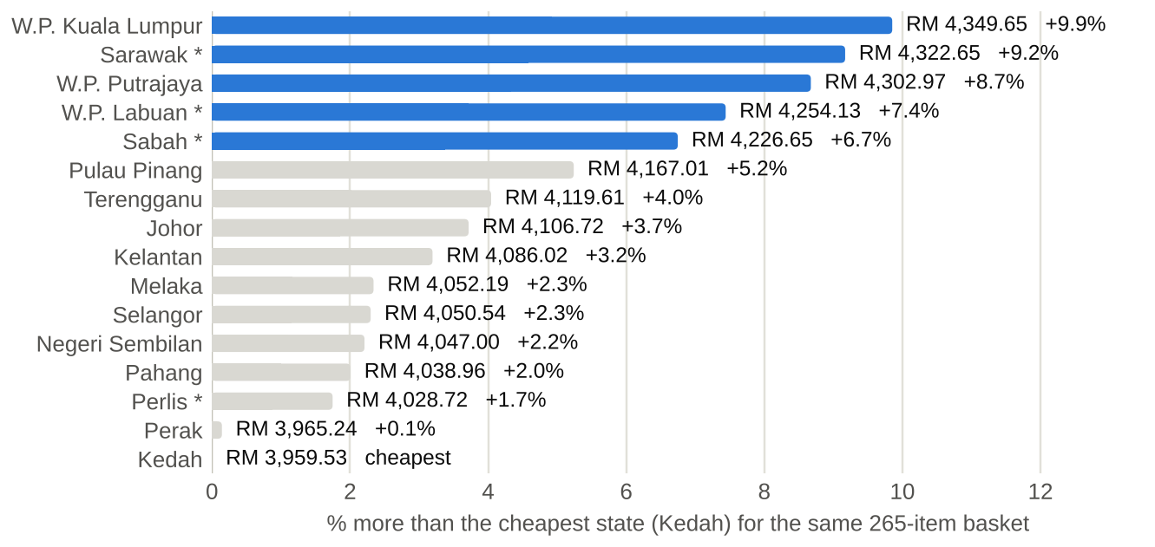
Source: query q09.
Prices also vary between districts in the same state. Inside Kuala Lumpur, district basket indexes run from 100.4 (Bandar Tun Razak) to 112.0 (Segambut); five states have a district spread above 8 points (Figure 2). The dearest districts nationally are Limbang (113.9), Segambut (112.0) and Lawas (111.4).
Figure 2 Districts in the same state differ by up to 11.7 index points
Cheapest and dearest district basket index in each state, September 2026 (100 = national median basket).
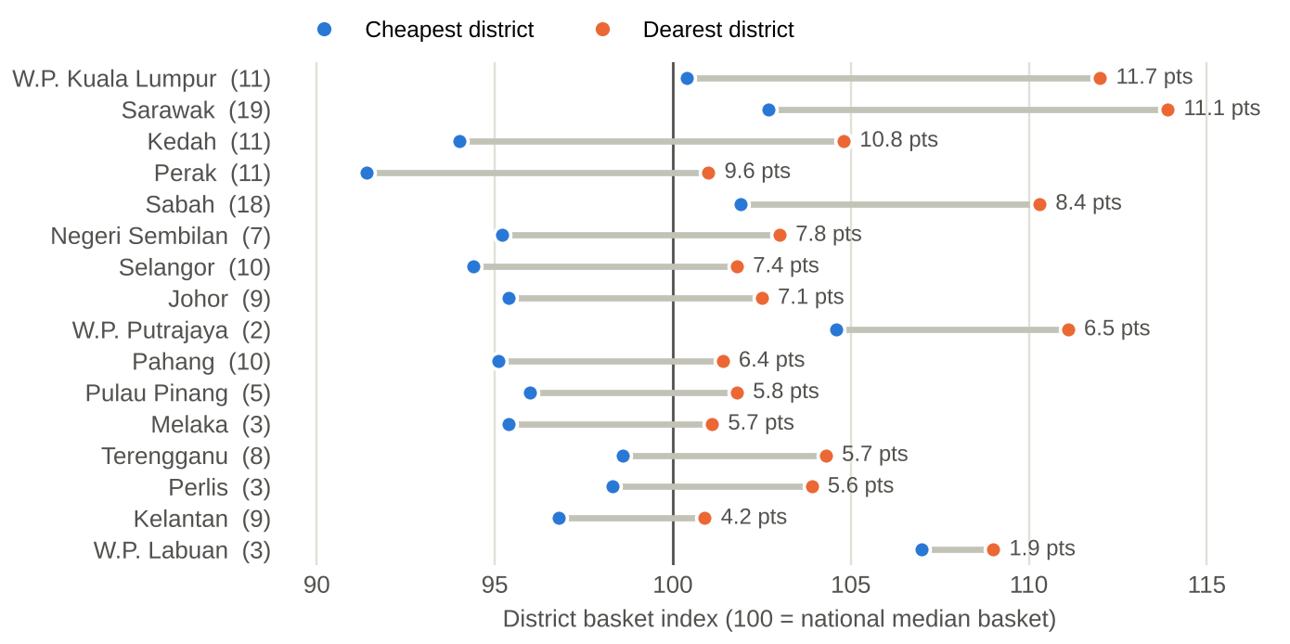
Source: query q10. Gaps are calculated before rounding.
Sugar and cooking oil stayed within the controlled price. Coarse sugar (ceiling RM 2.85) and packet cooking oil (RM 2.50) were at or below the controlled price in 99.95% of 34,609 shop-months (Bernama, 2024; Malay Mail, 2026). The price gaps in this report come from uncontrolled fresh produce and dry goods, so inspection time is better spent there.
Coverage is thinnest in Sabah and Sarawak, two of the dearest states. Only 76.4% of listed districts had four or more reporting shops in September 2026; 22 of the 30 districts with only one to three are in Sabah or Sarawak.
What KPDN should do. Shift inspections from controlled items to fresh produce and dry goods in the dearest districts; add reporting shops in the Sabah and Sarawak districts with three or fewer; run a weekly vegetable price watch from November to January.

3 Supermarket chain: price positioning
Shoppers pay most at small formats. On 181 items sold by all five formats, hypermarkets priced 5.0% below the national median and sundry shops 4.3% above it (Figure 3). For eight everyday staples, one unit of each cost RM 88.76 at hypermarkets and RM 99.45 at wet markets (Figure 4).
Figure 3 Hypermarkets were the cheapest format on identical items
Price index by shop type, 181 items sold in all five formats, September 2026 (100 = national median).
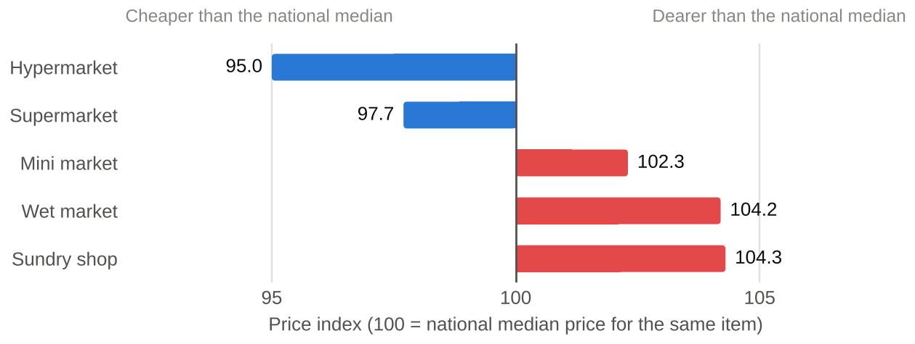
Source: query q03.
Figure 4 Eight staples cost 12.0% more at wet markets than at hypermarkets
Chicken, eggs, onions, garlic, red chilli, rice, sugar and cooking oil; median prices, September 2026.
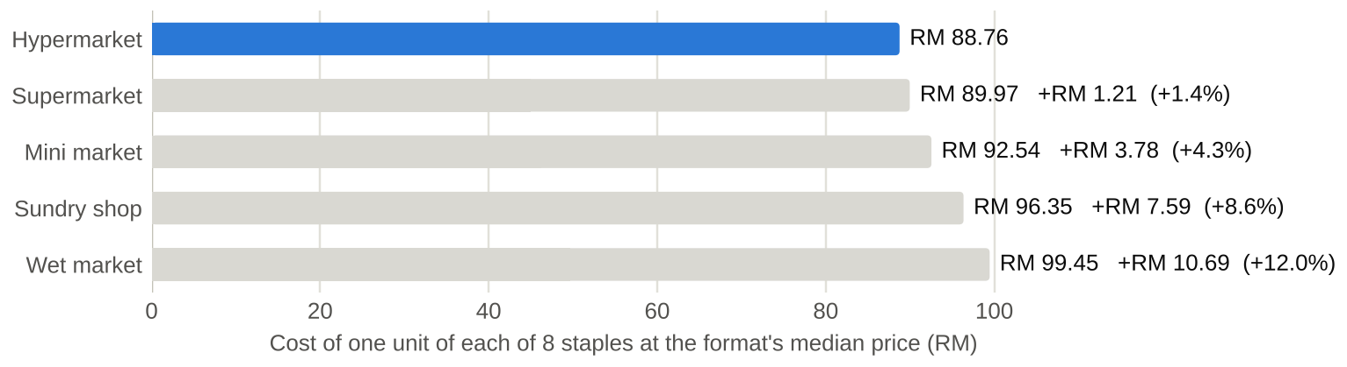
Source: query q03.
Supermarkets sit in the middle, 12.1 points behind the price leaders. The average supermarket scored 101.4, against 89.3 for Tesco, 89.4 for Lotus's and 90.2 for Econsave's 58 branches. Hypermarkets cluster at the cheap end of their state, with 54.7% in the cheapest quarter of shops; half of wet markets (49.5%) sit in the dearest quarter (Figure 5).
Figure 5 Hypermarkets cluster at the cheap end of their state, wet markets at the dear end
Share of each format's shops in the cheapest and dearest quarter of shops in their state, September 2026.
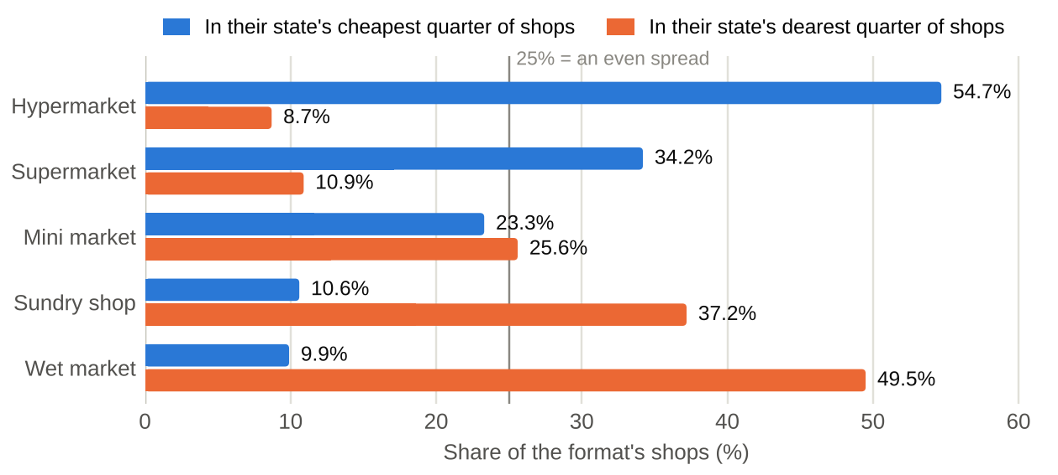
Source: queries q11 and q19.
Where to compete. Branded packaged goods sit within a few points of 100 in every format, so there is little to win there. The gaps are in fresh produce and dry goods (Table 4). Wet markets, assumed to be the cheap option for fresh food, averaged 106.5 against 97.7 at hypermarkets and lost to a large format in 14 of 16 states. In Kuala Lumpur, though, supermarket fresh produce scored 115.8 against 100.8 at hypermarkets.
Table 4 Price index by product group and format, September 2026
Shops pricing 30 or more items. Cell colour: blue below the national median (100), red above it; lighter to darker at 1, 5 and 10 points from 100.
Product group | Items | Hyper-  market | Super-  market | Mini  market | Wet  market | Sundry  shop
Fresh produce | 115 | 97.7 | 100.9 | 109.4 | 106.5 | 113.0
Dry goods | 22 | 94.4 | 99.6 | 107.1 | 119.4 | 112.8
Packaged goods | 109 | 98.2 | 100.6 | 100.2 | 104.0 | 102.7
Milk and baby products | 25 | 99.2 | 101.8 | 100.7 | 104.3 | 105.3
Household and hygiene | 27 | 97.5 | 100.0 | 100.3 | 102.9 | 106.1
Beverages | 31 | 98.6 | 101.3 | 99.9 | 101.1 | 103.1
Source: query q12.
What the category manager should do. Benchmark fresh produce and dry goods against Tesco, Lotus's and Econsave rather than independent shops; review Kuala Lumpur fresh produce pricing first; track the gap to the price leader monthly.

4 FMCG procurement: cost risk
Most prices were flat, and three fresh categories drove the increases. In the same shops, 84% of 288 items moved less than 5% over the year and the median item did not change. Vegetables, onions and garlic, and meat produced 58% of all increases with 17% of the items (Figure 6). Tomatoes rose 69.4%.
Figure 6 Three fresh categories produced most of the year's increases
Share of all price increases and share of the 288 items, by category, same shops, October 2025 to September 2026.
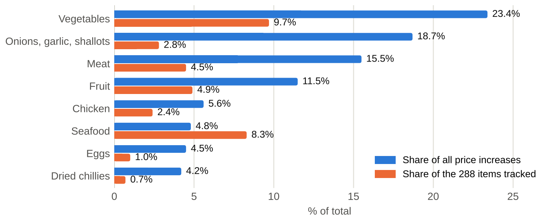
Source: query q14.
The budget risk is month-to-month volatility. Fresh produce prices varied 6.92% month to month on average against 0.87% for packaged goods. Red chilli (cili akar) ranged from RM 13.99 to RM 32.00 a kilogram across the year's monthly medians, 2.3 times from low to high (Table 5). Price-controlled sugar and cooking oil never moved (Figure 7).
Figure 7 Sugar and cooking oil stayed flat; chicken, eggs and chilli moved
National median price by month, October 2025 to September 2026.
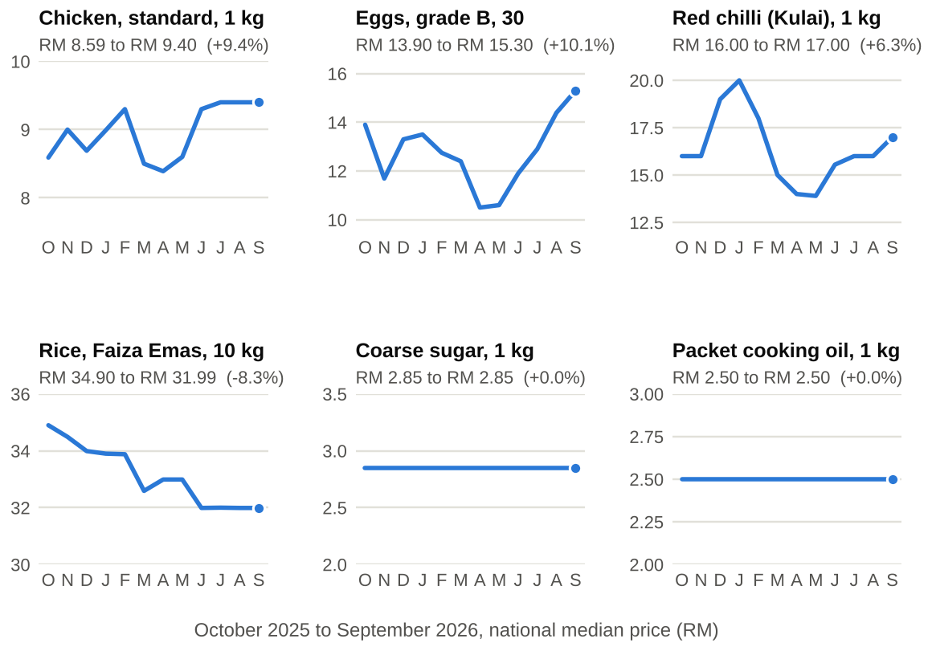
Source: queries q17 and q20.
Table 5 The most volatile items
Lowest and highest monthly national median and the coefficient of variation, October 2025 to September 2026.
Item (1 kg) | Lowest (RM) | Highest (RM) | Variation
Red chilli (cili akar) | 13.99 | 32.00 | 33.4%
Shallots, rose variety, imported (India) | 5.70 | 12.99 | 32.3%
Red grapes, seeded | 10.50 | 22.90 | 28.3%
Tomato | 4.00 | 9.49 | 26.8%
Seedless red watermelon | 1.99 | 4.49 | 22.1%
Source: query q29.
Prices fell before festivals and spiked in December. Festive staples fell before Chinese New Year (−2.4%) and Hari Raya Aidilfitri (−5.0%) in the same shops (Figure 8). Price spikes were less frequent before festivals (2.83% of item-weeks) than in other weeks (4.52%), and December 2025 had 78 spike weeks, 74 of them fresh produce (Figure 9).
Figure 8 Festive staples got cheaper before Chinese New Year and Hari Raya Aidilfitri
Average change in the same shops: 14 days before each festival against days 42 to 15 before it. * Deepavali baseline covers only 1 to 5 October.
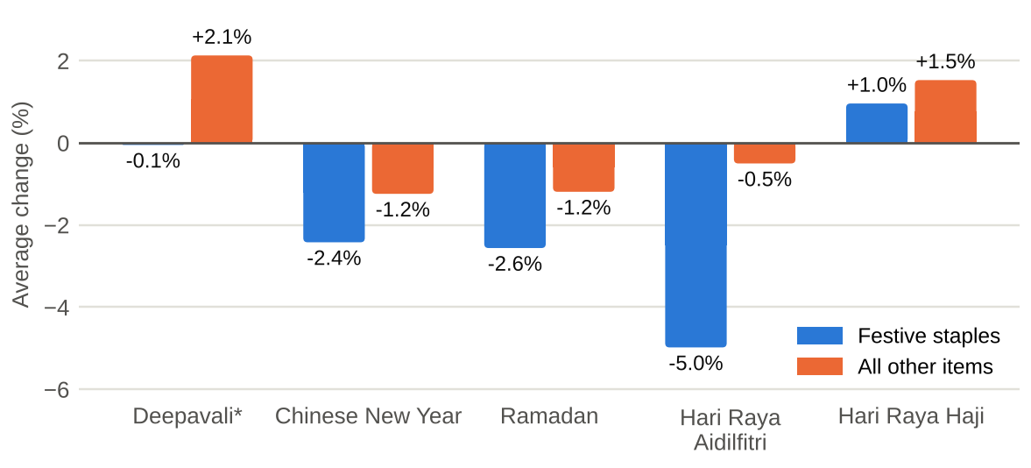
Source: query q21.
Figure 9 December had the most price spikes
Item-weeks flagged as price spikes, by month. * November 2025 is partial.
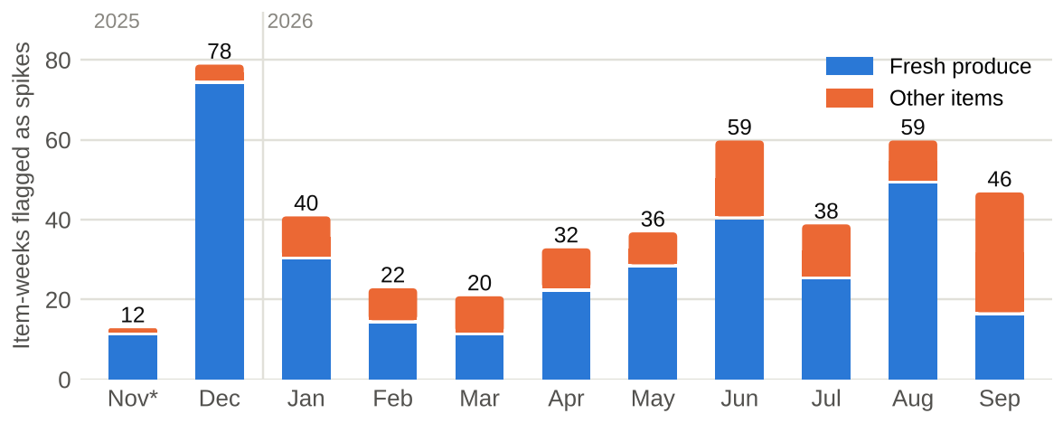
Source: query q23.
What procurement should do. Lock fixed-price contracts for packaged goods; use indexed contracts and a second source for vegetables, onions and meat; lock fresh-staple prices in October and November, ahead of the December spike window.

5 Action plan
Table 6 Recommended actions
Each action, its owner, the KPI that tracks it and a proposed target.
# | Action | Owner | KPI tracked | Proposed target | When
1 | Move inspections from controlled items to fresh produce and dry goods in the ten dearest districts | KPDN enforcement | District price spread | Below 8 points | Next quarter
2 | Add reporting shops in the 22 Sabah and Sarawak districts with one to three | KPDN PriceCatcher team | Monitoring coverage | 90% of districts | Within 6 months
3 | Run a weekly vegetable price watch from November to January | KPDN, procurement | Spike frequency | Alerts within one week | Every November
4 | Benchmark fresh produce and dry goods against Tesco, Lotus's and Econsave | Category manager | Gap to price leader | Below 5 points | Monthly
5 | Review Kuala Lumpur supermarket fresh produce pricing | Category manager, KL | Fresh produce index (KL) | Below 105 | Within 3 months
6 | Fixed contracts for packaged goods; indexed contracts and a second source for vegetables, onions and meat | Procurement | Fresh price volatility | Budget variance within 5% | Next contract cycle
7 | Lock fresh-staple prices with suppliers in October and November | Procurement | Spike frequency | No December buying at spike prices | Yearly

The KPIs are built to refresh monthly. Loading the new PriceCatcher files and rerunning the build script updates the reporting views, which feed a four-page Power BI report: an overview and one page per stakeholder.

6 How the analysis was built
Figure 10 The build pipeline
Row counts at each stage of the build.
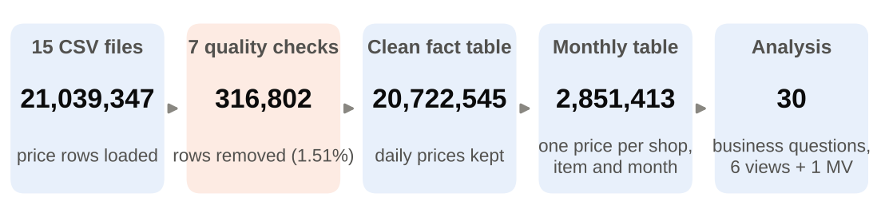
Source: build run log.
Table 7 Solution summary
What was done at each stage and the evidence of quality.
Stage | What was done | Result
Data | 12 monthly PriceCatcher files, item and shop lookups, DOSM CPI by state | 21,039,347 price records, 2,262 shops, 338 items, 16 states
Data quality | 7 documented checks: impossible prices, duplicates, unknown items and shops, outliers, shop churn | 1.51% removed; 99% of that from 17 item codes missing in the published list
Data model | PostgreSQL star schema with a daily fact table and a monthly one-price-per-shop table | Each shop counts once in every comparison
Analysis | 30 stakeholder questions and a KPI query (q31) in SQL: CTEs, window functions, GROUPING SETS, matched-shop comparisons | The KPIs and findings in this report
Validation | PriceCatcher food prices compared with DOSM's food CPI by state | Correlation 0.60 over 160 state-months
Performance | Composite index; materialized view for the weekly spike table | 2.97 s to 0.09 s; 52.5 s to 0.05 s
Delivery | 6 reporting views plus 1 materialized view for Power BI; full rebuild script | Refreshable monthly in about 13 minutes

Three method choices behind the numbers. Wet markets report each item about 15 times a month and sundry shops about 3, so every comparison uses one price per shop. Shops join and leave during the year, so changes over time compare the same shops: on a naive comparison, imported Pakistani onions rose 3.7% instead of 35.2%. Most small shops are surveyed on Mondays, so spikes are measured weekly, not daily.

7 Limitations
- PriceCatcher is collected for price surveillance; inflation is measured by DOSM's CPI (Ministry of Domestic Trade and Cost of Living & Department of Statistics Malaysia, 2026), used here only as a cross-check.
- Every item has equal weight, so baskets compare like-for-like prices rather than household spending.
- Format and location comparisons use September 2026 (the queries run for any month); freshness and bargaining are not recorded.

References
Bernama. (2024, August 14). KPDN seizes 213kg of overpriced sugar in Perak supermarket. https://www.bernama.com/en/news.php?id=2328972
Department of Statistics Malaysia. (2026). Monthly CPI by state & division (2-digit) [Data set]. OpenDOSM. https://open.dosm.gov.my/data-catalogue/cpi_state
Malay Mail. (2026, July 16). PAC: RM10.879b cooking oil subsidy failed to fully reach intended recipients. https://www.malaymail.com/amp/news/malaysia/2026/07/16/pac-rm10879b-cooking-oil-subsidy-failed-to-fully-reach-intended-recipients/227800
Ministry of Domestic Trade and Cost of Living, & Department of Statistics Malaysia. (2026). PriceCatcher: Transactional records [Data set]. data.gov.my. https://data.gov.my/data-catalogue/pricecatcher

Appendix A The SQL analyses behind the KPIs
Each analysis is one SQL file in the project repository, written for one stakeholder: A KPDN, B category manager, C procurement. q31 adds the price-control adherence and monitoring coverage KPIs.
Table 8 Analysis index
What each query answers and the SQL techniques it uses.
# | For | Business question | SQL techniques
q01 | A | National median price of each item, September 2026 | JOIN, WHERE, GROUP BY, PERCENTILE_CONT ... WITHIN GROUP
q02 | A | Most and least expensive state for the 10 most common items | CTEs, JOIN, AVG, ORDER BY, LIMIT, RANK()
q03 | B | How prices differ by premise type for the same item | GROUP BY two columns, HAVING, FILTER inside an aggregate
q04 | B | Items with the biggest gap between the cheapest and dearest shop type | CTE, MAX − MIN, ARRAY_AGG
q05 | C | How many items and premises does each state have? Is coverage balanced? | COUNT(DISTINCT), share of total with SUM() OVER ()
q06 | A | Districts with the fewest reporting premises | GROUP BY, HAVING (filters groups, after counting)
q07 | B | How many items does each shop type price above the national median? | CASE inside SUM, the FILTER clause
q08 | C | Which item categories have the widest price range across Malaysia? | STDDEV, AVG, PERCENTILE_CONT at 0.1 and 0.9
q09 | A | What does an "essentials basket" cost in each state? | multi-step CTE, CROSS JOIN, LEFT JOIN, COALESCE
q10 | A | Which district has the cheapest basket within each state? | CTE + correlated subquery in WHERE, TEMP TABLE
q11 | B | Premise price index: which shops are cheapest overall? | CTE, ratio metric, HAVING
q12 | B | Premise price index by premise type and state | CTE + GROUP BY, FILTER to pivot types into columns
q13 | C | Which items changed price most between October 2025 and September 2026? | CTE with two periods, JOIN on two keys, % change
q14 | C | Are price increases concentrated in a few categories? | CTE, share of total with SUM() OVER (), running share
q15 | B | Rank premises by price for each item within each district | RANK() OVER (PARTITION BY ...)
q16 | B | For each item and district, which premise is cheapest most often? | DENSE_RANK + COUNT, ROW_NUMBER to keep the top row per group
q17 | C | Month-on-month median price change for each item | LAG() OVER (PARTITION BY ... ORDER BY ...)
q18 | C | Rolling 4-week average price for five key staples | AVG() OVER (ROWS BETWEEN 3 PRECEDING AND CURRENT ROW)
q19 | A | Split premises into price quartiles within each state | NTILE(4)
q20 | C | Running cumulative price change since October 2025, per item | SUM() OVER (PARTITION BY ... ORDER BY ...) = running total
q21 | C | Do festive staples get dearer in the 2 weeks before each festival? | CTE + date windows built from a festival table, CROSS JOIN
q22 | A | Which states see the biggest festive price spikes? | window function (RANK) over a GROUP BY result
q23 | C | Detect price spikes: weeks far above an item's recent normal | AVG() and STDDEV() OVER (ROWS BETWEEN 8 PRECEDING AND 1 PRECEDING)
q24 | B | How often does each premise change its price on the same item? | LAG + COUNT of changes, then averages by group
q25 | B | First and latest price per premise and item over the year | FIRST_VALUE / LAST_VALUE, window frames, ROW_NUMBER to keep one row per group
q26 | A | One summary table: by state, by premise type, and grand total | GROUPING SETS, GROUPING()
q27 | All | Sense check: do PriceCatcher food prices move with CPI food (division 01)? | JOIN to a reference table, LN/EXP, CORR()
q28 | B | Premises that stopped reporting for a month or more | generate_series + anti-join, LATERAL
q29 | C | Which items have the most stable prices? | STDDEV ÷ AVG, HAVING on a count of months
q30 | All | The three most important findings, as one small report table | chained CTEs, UNION ALL, string building with || and TO_CHAR
q31 | A | KPI checks: price-control adherence and monitoring coverage | CASE inside AVG, UNION ALL, CTEs, COUNT(DISTINCT)

