MERIDIAN LOGISTICS CO.
Security Operations Center — Simulated Enterprise Deployment
Enterprise Wazuh SOC Deployment
Complete Project Documentation
Architecture & Build Guide, Five-Scenario Investigation Record, Consolidated Findings, and Recommendations
Prepared by: Moses Isemin
Cybersecurity Professional — SOC Analyst / Detection Engineering Portfolio Project
GitHub: MozB-lab
Document Version 2.0 (Unified) — September 2026

Table of Contents
Table of Contents 1
1. Executive Summary 1
2. Objectives 1
3. Rationale 1
4. Problem Statement 1
5. Scope 1
5.1 In Scope 1
5.2 Out of Scope 1
6. Architecture Overview 1
6.1 Virtual Machine Inventory 1
6.2 Firewall Policy 1
6.3 Detection and Monitoring Architecture 1
6.4 Technology Stack 1
7. Build Summary 1
7.1 pfSense-FW 1
7.2 Wazuh-SOC (Manager + Indexer + Dashboard) 1
7.3 DMZ-Web01 1
7.4 INT-FileSrv 1
7.5 INT-Win10 1
7.6 Kali-Attacker 1
7.7 pfSense to Wazuh Syslog Forwarding 1
7.8 Vulnerability Detection Module 1
8. Scenario Investigations 1
8.1 Scenario 1 — Brute-Force Attack (Internal, RDP) 1
Attack / Activity Narrative 1
Investigation 1
Supporting Evidence 1
8.2 Scenario 2 — File Tampering (FIM) and Incident Response Exercise 1
Attack / Activity Narrative 1
Investigation 1
Key Finding 1
Supporting Evidence 1
8.3 Scenario 3 — File Exfiltration (FTP) 1
Attack / Activity Narrative 1
Investigation 1
Key Finding 1
Supporting Evidence 1
8.4 Scenario 4 — Vulnerable Server Detection 1
Attack / Activity Narrative 1
Investigation 1
Key Finding 1
Supporting Evidence 1
8.5 Scenario 5 — Internal-to-DMZ Reconnaissance Scan via pfSense Syslog Integration 1
Attack / Activity Narrative 1
Investigation 1
Key Finding 1
Supporting Evidence 1
9. Consolidated Findings 1
9.1 Detection Coverage Gaps Identified 1
9.2 Custom Detection Rules Authored 1
9.3 Configuration and Operational Issues Identified 1
9.4 Open / Unresolved Item 1
10. Cross-Cutting Lessons and Troubleshooting 1
10.1 Host Resource Constraints 1
10.2 systemd Override Case-Sensitivity 1
10.3 Configuration File Editing on Wazuh-SOC's Console 1
10.4 Networking 1
10.5 Package Installation 1
11. Recommendations 1
11.1 For This Environment 1
11.2 For Future Iterations of This Project 1
12. Conclusion 1
13. Appendix 1
13.1 Skills Demonstrated 1
13.2 Supporting Documents 1
13.3 Screenshot Index 1

(Right-click and select "Update Field" in Microsoft Word to populate page numbers.)

1. Executive Summary
This document describes the design, build, and validation of a segmented enterprise network security monitoring environment, built end-to-end as a hands-on SOC analyst and detection-engineering portfolio project. The environment simulates a fictional logistics company, Meridian Logistics Co., and integrates a self-hosted Wazuh SIEM/XDR deployment across a segmented network of firewall, DMZ, internal, and management zones.
Beyond standing up infrastructure, the project's core objective was to validate detection coverage against five realistic attack and operational scenarios, executed and investigated using a consistent WHO/WHAT/WHEN/WHERE format, and — critically — to treat gaps found along the way as genuine findings rather than obstacles to work around. Several of the project's most valuable outcomes were not part of the original plan: a vendor ruleset coverage gap for allowed firewall traffic, a silent FIM alerting gap on file restoration, a log-format incompatibility suppressing FTP session alerts, a misconfigured firewall rule silently absorbing traffic ahead of its intended logging rule, and a doubled vulnerability surface caused by an unpurged legacy kernel package. Each was diagnosed and, where in scope, remediated with custom detection logic.
This document consolidates the project's objectives, rationale, problem statement, scope, architecture, build process, per-scenario investigations, consolidated findings, operational lessons learned, and forward-looking recommendations, in a single reference suitable for public portfolio presentation (e.g. GitHub).

2. Objectives
- Build a realistic, segmented enterprise network topology (firewall, DMZ, internal, and management zones) using virtualization, mirroring common small-to-mid-size enterprise network design.
- Deploy and configure Wazuh as a centralized SIEM/XDR platform, including manager, indexer, dashboard, endpoint agents, and third-party log source integration (firewall syslog).
- Simulate a representative range of real-world attack and operational scenarios — brute-force authentication attacks, file tampering, data exfiltration, vulnerability exposure, and network reconnaissance — to exercise detection coverage across different techniques and log sources.
- Practice a complete incident-response workflow where appropriate, not just detection: triage, containment, evidence preservation, and recovery.
- Identify, diagnose, and remediate real gaps in default/vendor-provided detection logic, rather than assuming out-of-the-box coverage is complete — including authoring custom decoders and correlation rules where warranted.
- Produce a professionally documented, reproducible body of work suitable for demonstrating applied SOC analyst and detection engineering skill to employers.

3. Rationale
This project was undertaken as part of a deliberate transition into cybersecurity, specifically toward SOC Analyst, Security Operations Analyst, and Threat Intelligence Analyst roles, building on an existing foundation of IT support and cross-industry operations experience alongside cybersecurity certification study (ISC2 CC, Google Cybersecurity Professional Certificate, IBM cybersecurity coursework, and CompTIA Security+ preparation).
Certifications and coursework establish theoretical grounding, but they do not, on their own, demonstrate the ability to build, break, diagnose, and fix a real monitored environment. This project was designed specifically to close that gap: to produce hands-on, verifiable evidence of practical SOC-relevant skill — SIEM deployment and tuning, log source integration, detection rule authoring, network segmentation and firewall administration, and incident response — by deliberately treating every unexpected failure encountered along the way as material worth investigating and documenting rather than a problem to route around silently.

4. Problem Statement
Organizations frequently deploy SIEM and detection tooling with an assumption that default, vendor-shipped rulesets provide comprehensive coverage out of the box. This project set out to test that assumption directly within a controlled lab environment, and found it to be false in multiple, independent instances:
- A default firewall-log ruleset that only accounted for blocked traffic, leaving allowed traffic — including an active reconnaissance scan — completely invisible to correlation logic.
- A default file-integrity-monitoring configuration that updated its internal inventory state on a file restoration without generating any corresponding alert, creating a silent blind spot between state tracking and alerting.
- A default decoder that could not parse a valid, differently-formatted log output from a common service (vsftpd), silently suppressing session-level alerts until the format mismatch was identified and corrected.
- A firewall rule base where a single broad, undocumented, unlogged rule silently absorbed traffic ahead of the intended, properly configured rule.
The problem this project set out to address, then, is broader than “can a SIEM detect an attack”: it is “how much of an organization's real detection posture depends on assumptions that were never actually verified” — and to build the habit and workflow of verifying rather than assuming.

5. Scope

5.1 In Scope
- Design and build of a 4-segment virtualized network (WAN, DMZ, Internal/LAN, Management) behind a pfSense firewall.
- Deployment of a self-hosted Wazuh Manager, Indexer, and Dashboard stack, with agent-based endpoint monitoring and syslog-based firewall log integration.
- Five scoped business/attack scenarios, each investigated using a WHO/WHAT/WHEN/WHERE format with verdict, business impact, and response action.
- Custom decoder/rule authoring in Wazuh where default coverage was found to be insufficient.
- Incident-response practices (triage, isolation, evidence handling, recovery) where a scenario's scope warranted it.
- Individual investigation reports and this consolidated project-level document.

5.2 Out of Scope
- Production-grade high-availability or clustered Wazuh deployment.
- Automated SOAR (Security Orchestration, Automation and Response) integration.
- Red-team-style advanced evasion techniques — scenarios used direct, representative techniques rather than obfuscated tradecraft, since the objective was detection validation, not adversary emulation fidelity.
- External/internet-facing exposure — the entire environment is host-isolated.

6. Architecture Overview
Four network segments behind a pfSense firewall:
Segment | CIDR | Purpose
WAN | NAT (host-provided) | Internet-facing uplink through pfSense
DMZ (dmznet) | 10.20.0.0/24 | Internet-facing/vulnerable systems, isolated from Internal
Internal (intnet) | 10.10.0.0/24 | Employee workstations and file services
Management (mgmtnet) | 10.30.0.0/24 | The SOC itself; reachable only from Internal, on specific ports

6.1 Virtual Machine Inventory
VM | Role | Static IP | Status
pfSense-FW | Firewall / router — WAN, DMZ, Internal, Mgmt segmentation | Multi-homed | Complete
Wazuh-SOC | SIEM: Manager + Indexer + Dashboard | 10.30.0.10 (mgmtnet) | Complete
DMZ-Web01 | Vulnerable web/FTP server (Apache, DVWA, vsftpd) | 10.20.0.10 (dmznet) | Complete
INT-FileSrv | Internal file server (Samba + FIM) | 10.10.0.40 (intnet) | Complete
INT-Win10 | Employee workstation / brute-force target (Windows 11, VM named per project convention) | 10.10.0.20 (intnet) | Complete
Kali-Attacker | Attacker platform, dual-homed | 10.20.0.50 / 10.10.0.50 | Complete

6.2 Firewall Policy
Default-deny enforced throughout: DMZ can reach WAN (for updates) but not Internal; Internal can reach Mgmt only on TCP 1514/1515 (Wazuh agent enrollment) and TCP 443 (dashboard access); Mgmt has zero inbound-allow rules from any other zone, with a separate outbound-only rule permitting the SOC itself to reach the internet for installation and updates.

6.3 Detection and Monitoring Architecture
All endpoint VMs run a Wazuh agent reporting to the central manager on the management segment. pfSense additionally forwards firewall event logs via syslog (UDP/514) directly to the Wazuh manager, providing network-perimeter visibility independent of host-based agents. Wazuh's built-in File Integrity Monitoring and Vulnerability Detection modules were enabled and used as primary detection sources for the relevant scenarios.
[ SCREENSHOT PLACEHOLDER — Network topology diagram ]

6.4 Technology Stack
- Virtualization: Oracle VirtualBox
- Firewall / Routing: pfSense Community Edition 2.7.2
- SIEM / XDR: Wazuh 4.14 (Manager, Indexer, Dashboard, Agent)
- Endpoint operating systems: Ubuntu Server, Windows 11, Kali Linux
- Web application stack: Apache2, MariaDB, DVWA (Damn Vulnerable Web Application)
- File services: Samba (internal), vsftpd (DMZ)
- Offensive tooling (controlled scenario simulation only): nmap, xfreerdp, wget, tcpdump

7. Build Summary
The environment was built component by component, with several real obstacles encountered and resolved along the way — documented here as they reflect genuine troubleshooting rather than a clean, linear install.

7.1 pfSense-FW
Installed pfSense CE 2.7.2. A significant early obstacle was a repeating FreeBSD boot crash (“vm_fault: pager read error, pid 1 (init)”) that persisted across multiple reinstalls, RAM/CPU acceleration settings, and ISO re-downloads. Root cause was isolated to the VM's storage controller: switching from the default IDE controller to AHCI/SATA resolved it completely. Four network adapters were configured (WAN/NAT, DMZ, Internal, Mgmt) and interfaces assigned and statically addressed, followed by per-zone firewall rules and remote syslog forwarding to the SOC. The GUI is only reachable from inside the segmented network (no native console browser) — accessed via INT-Win10's browser at https://10.10.0.1.

7.2 Wazuh-SOC (Manager + Indexer + Dashboard)
Deployed as an all-in-one install on a dedicated Ubuntu Server VM on the management segment (static 10.30.0.10/24, 4GB RAM / 38GB disk — raised from the guide's 2GB/20GB minimum). Installation failed repeatedly at first for two independent reasons, both resolved: (1) the officially documented generic download alias (packages.wazuh.com/4.x/...) intermittently returned HTTP 403 from the CDN — switching to the explicit versioned path (4.14) resolved this; (2) the Manager and Dashboard services individually exceeded systemd's default ~90-second startup timeout during first-run initialization and were killed mid-start — resolved with a systemd override extending TimeoutStartSec to 300 seconds for each service (this directive is case-sensitive; a lowercase typo caused a full-day outage before being traced, and recurred a second time during Scenario 5 rule development before the pattern was fully internalized).

7.3 DMZ-Web01
Static 10.20.0.10/24 on dmznet. Apache2 + MariaDB + DVWA (Security Level: Low) + vsftpd. A Wazuh agent (001) was installed and enrolled. Installation required working around the same 4.x download-alias issue seen on the Manager, plus a GPG keyring import failure specific to this Ubuntu build (resolved using the gpg --dearmor method rather than the documented piped keyring syntax) and a clock-drift issue common to freshly cloned VMs that caused APT repository validation failures (resolved via a manual NTP resync).

7.4 INT-FileSrv
Static 10.10.0.40/24 on intnet (a deliberate deviation from the guide's suggested .21 — functionally equivalent, documented here). A Samba share was configured at /srv/samba/shared (0777) hosting confidential.txt as the FIM test target. Real-time File Integrity Monitoring was enabled on that path inside the Wazuh agent's <syscheck> configuration block. Agent 002 confirmed active.

7.5 INT-Win10
A Windows 11 VM (retaining the “INT-Win10” name per project convention), built as a Linked Clone of an existing base image (a full clone was not possible due to host disk space constraints at build time). Static 10.10.0.20/24 on intnet, with RDP enabled as the brute-force target (OpenSSH Server could not be installed — intnet has no internet access to fetch the optional Windows feature) and failed-logon auditing enabled via auditpol. Agent 003 confirmed active. This VM also served as the primary browser access point for both the Wazuh Dashboard and the pfSense GUI throughout the build, since neither is reachable directly from the console of the systems that host them.

7.6 Kali-Attacker
Dual-homed: one interface on dmznet (10.20.0.50), one on intnet (10.10.0.50), plus host-only and NAT interfaces for management/internet access. This introduced a recurring operational lesson: adding or removing a network interface on this VM re-enumerates all of its interface names, silently breaking previously working IP-to-interface bindings. The permanent fix was pinning each connection profile to a specific physical interface name via nmcli and cross-verifying interface identity against the hypervisor's own MAC address listing before trusting any assumption about which interface was which.

7.7 pfSense to Wazuh Syslog Forwarding
pfSense was configured (Status > System Logs > Settings > Remote Logging) to forward firewall and DHCP events to 10.30.0.10:514. A matching <remote> syslog/udp/514 listener, restricted to pfSense's IP, was added to Wazuh-SOC's ossec.conf. <logall>/<logall_json> were enabled to retain raw syslog for Scenario 5 analysis. Confirmed via netstat (listener bound) and live entries appearing in archives.log.

7.8 Vulnerability Detection Module
Enabled by default in Wazuh 4.x, requiring no additional configuration. Dashboard path: Endpoint security > Vulnerability Detection (not under Server management, as the original guide implies). The DMZ-Web01 scan returned 3,680 total findings, used as the basis for Scenario 4.

8. Scenario Investigations
Each scenario follows the WHO/WHAT/WHEN/WHERE investigation format specified in the original Project Guide: business problem represented, Wazuh capability demonstrated, attack narrative, structured investigation fields, verdict, and — where applicable — the detection-engineering finding that resulted.

8.1 Scenario 1 — Brute-Force Attack (Internal, RDP)
Case ID | SCN-01-BRUTEFORCE
Business Problem | Employee accounts under password-guessing attack.
Wazuh Capability Demonstrated | Authentication monitoring and multi-failure correlation.

Attack / Activity Narrative
The target, INT-Win10, only exposed RDP (SSH was unavailable on this build). Hydra's RDP module proved unreliable in this environment, so the attack was executed instead via a custom loop calling xfreerdp in authentication-only mode against an 11-entry password list, with the real account password seeded as the final entry to guarantee a successful compromise after the failures. The attack also triggered a Windows account lockout as an incidental secondary finding.

Investigation
WHO | Local INT-Win10 account targeted by credential guessing
WHAT | Repeated RDP authentication attempts culminating in one successful login
WHEN | Captured via Wazuh alert timestamps across the attack window
WHERE | INT-Win10 (10.10.0.20)
SOURCE | Kali-Attacker, internal segment (10.10.0.50)
DESTINATION | INT-Win10 RDP service
VERDICT | True positive — confirmed brute-force with eventual successful authentication
DETECTION | Individual rule 60122 (22 alerts) plus correlation rule 60204 (“Multiple failed logins,” MITRE T1110 Brute Force)
BUSINESS IMPACT | A compromised workstation account is a foothold for lateral movement into the internal network
RESPONSE ACTION | Account lockout policy already triggered automatically; recommend RDP restricted to VPN/jump-host access only and MFA enforced

Supporting Evidence
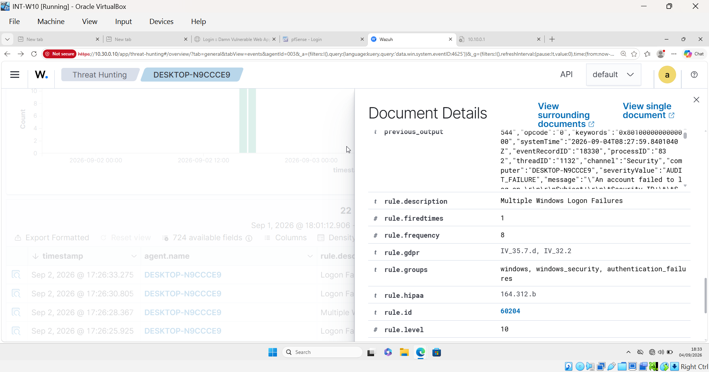
Wazuh rule metadata: rule 60204, level 10, frequency threshold 8, “Multiple Windows Logon Failures”
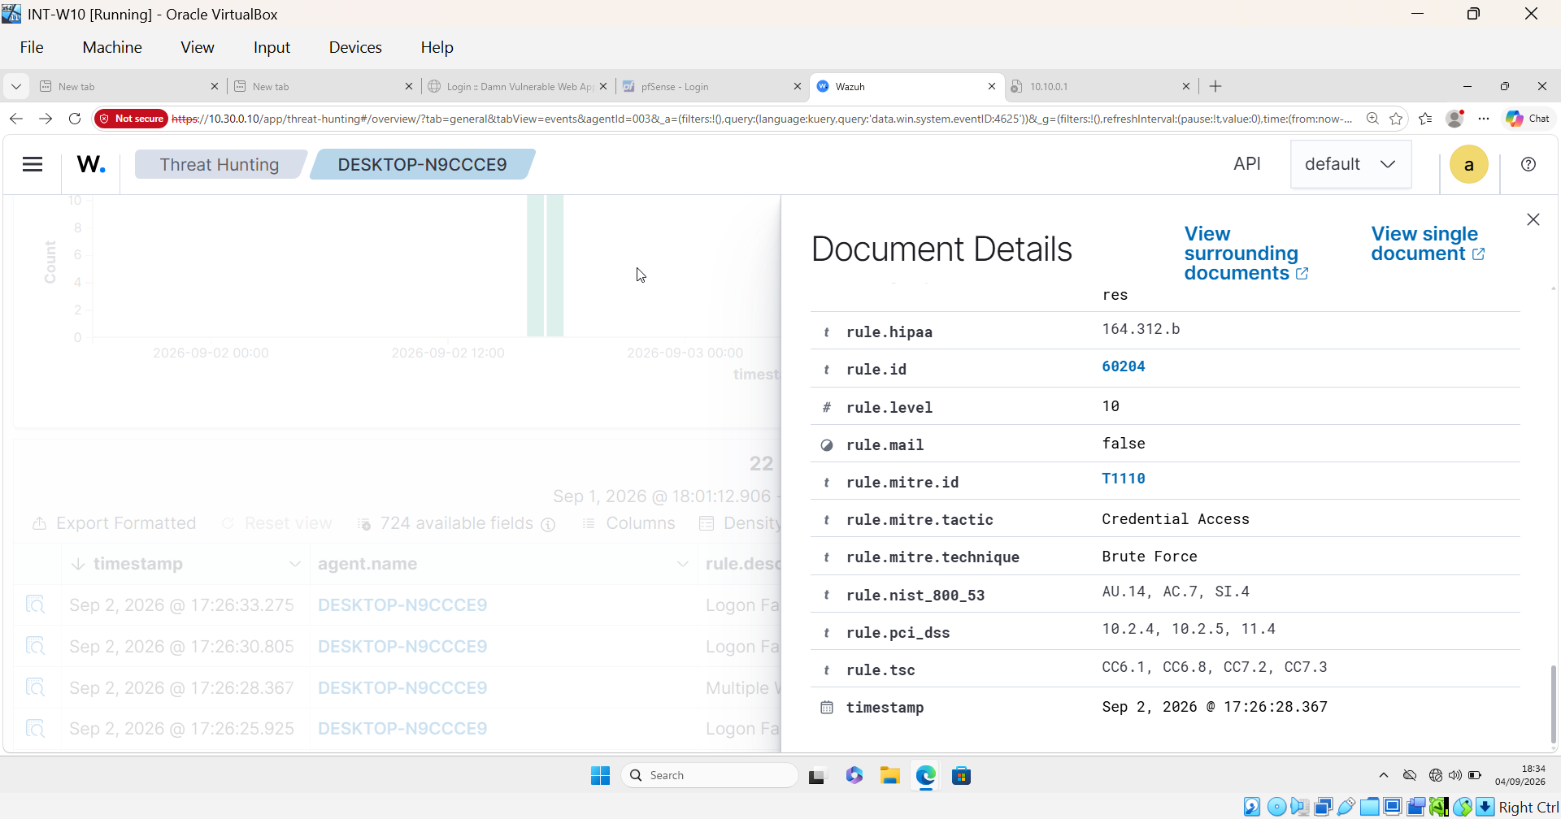
Final MITRE ATT&CK classification: T1110, tactic Credential Access, technique Brute Force

8.2 Scenario 2 — File Tampering (FIM) and Incident Response Exercise
Case ID | SCN-02-FILETAMPER
Business Problem | Unauthorized modification of business-critical files.
Wazuh Capability Demonstrated | Real-time File Integrity Monitoring.

Attack / Activity Narrative
A confidential file on the INT-FileSrv Samba share (originally 37 bytes) was tampered with directly on the host, outside business hours, via a shell command appending an unauthorized line, growing it to 114 bytes. Beyond the guide's baseline scenario, a full incident-response exercise was layered on top: an active-session check via smbstatus, account isolation, hash-based evidence preservation matching Wazuh's own recorded checksum, and finally restoration of the file with independent hash verification. The account-isolation step did not go as intended: the real analyst account was mistakenly locked instead of a disposable test account, then unlocked once the error was noticed — reported here as it happened rather than downplayed.

Investigation
WHO | Local/insider access to the file server host
WHAT | An unauthorized line appended to confidential.txt on the Samba share
WHEN | After hours — Sep 4, 2026, 21:34 UTC
WHERE | INT-FileSrv (10.10.0.40), /srv/samba/shared/confidential.txt
VERDICT | True positive — precise match to MITRE T1565.001 (Stored Data Manipulation)
DETECTION | Wazuh rule 550, Level 7, tactic Impact (FIM modification alert)
BUSINESS IMPACT | Undetected tampering with confidential records undermines data integrity and could mask fraud or sabotage
RESPONSE ACTION | File restored and independently hash-verified; recommend tightening share permissions (currently world-writable) and enabling access auditing in addition to FIM

Key Finding
The centerpiece finding of this scenario: when the tampered file was restored to its original state, Wazuh's FIM Inventory (the current-state database) updated silently in the background — correctly reflecting the restored SHA-256 checksum — but with no corresponding alert or event generated. This is a genuine gap between the Inventory sync mechanism and the alerting pipeline — a file being “quietly fixed” is exactly the kind of change a SOC would also want visibility into, and currently isn't getting it by default.

Supporting Evidence
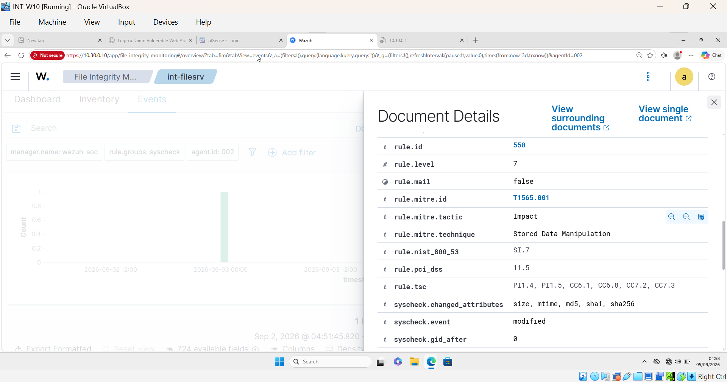
Wazuh rule metadata: rule 550, Level 7, MITRE T1565.001, tactic Impact, technique Stored Data Manipulation
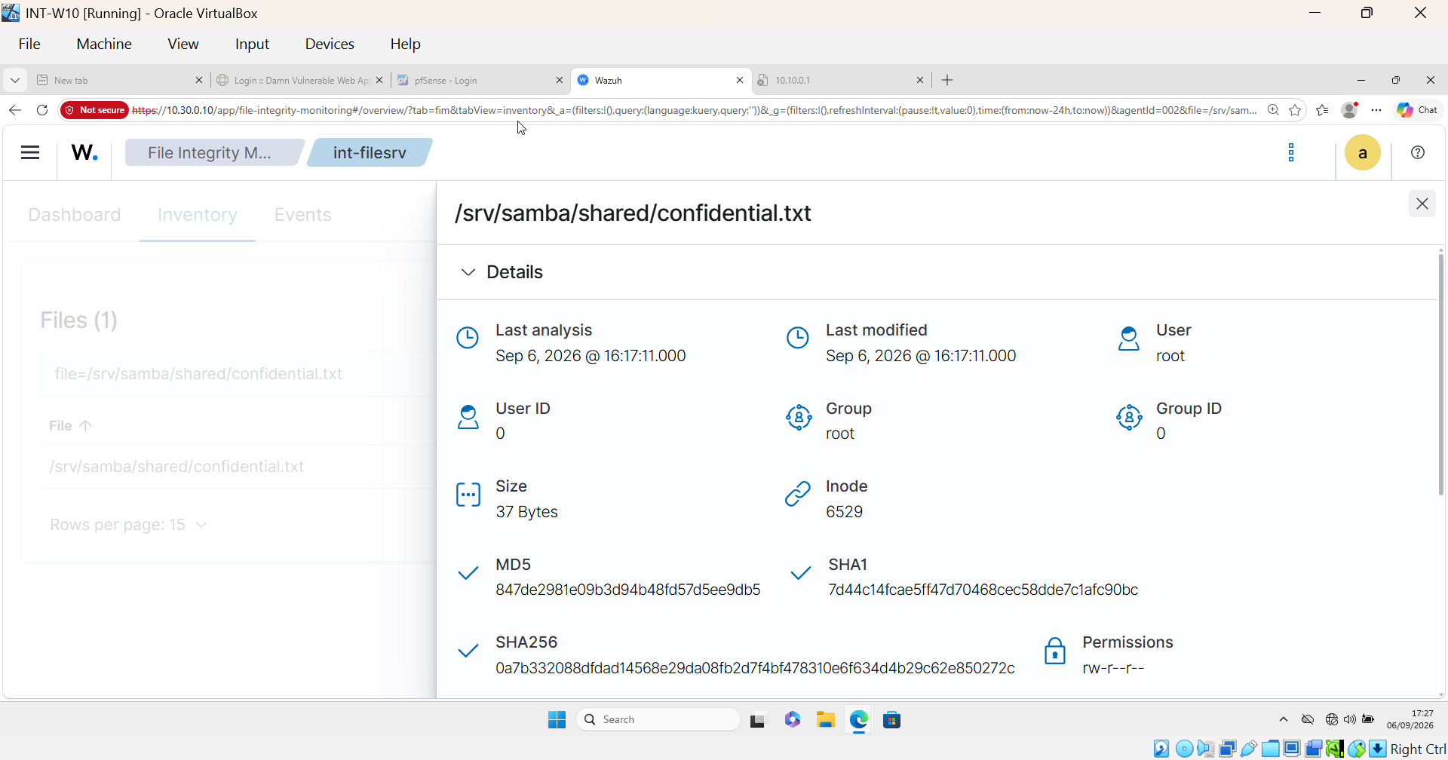
FIM Inventory after restoration: SHA-256 correctly matches the original, with no alert generated for the change

8.3 Scenario 3 — File Exfiltration (FTP)
Case ID | SCN-03-FTPEXFIL
Business Problem | Potential data exfiltration to an external or semi-trusted location.
Wazuh Capability Demonstrated | File-transfer log monitoring and correlation.

Attack / Activity Narrative
vsftpd on DMZ-Web01 was configured for anonymous, read-only access — in the process of setup, anonymous upload/mkdir were found already misconfigured to be permitted and were explicitly disabled, a real hardening finding independent of the simulated attack itself. A representative business file (customer_data_export.csv) was then exfiltrated from Kali via anonymous FTP download.

Investigation
WHO | Anonymous/unauthenticated FTP session
WHAT | Download of a file from the DMZ FTP server
WHERE | DMZ-Web01 (10.20.0.10)
SOURCE | Kali-Attacker
VERDICT | True positive, once the underlying log-parsing gap was fixed
DETECTION | Custom rule 100210 (Level 7, MITRE T1048); session/login rules 11401/11402 (MITRE T1078) after a decoder fix
BUSINESS IMPACT | Anonymous FTP with any write capability is itself a serious pre-existing exposure independent of this scenario
RESPONSE ACTION | Anonymous upload/mkdir disabled; recommend anonymous FTP be removed entirely in a production environment in favor of authenticated, encrypted transfer

Key Finding
Two layered detection gaps: (1) vsftpd's default xferlog_std_format setting produced a log format Wazuh's built-in decoder could not parse at all, silently suppressing login/session alerts. Fixed by switching the log format, which immediately restored rule 11401/11402 alerts. (2) Even after that fix, Wazuh's default ruleset had no rule at all for a successful “OK DOWNLOAD” event — only login and upload events were covered, a genuine vendor ruleset gap. Remediated by writing custom rule 100210 in local_rules.xml, confirmed firing correctly on retest.

Supporting Evidence
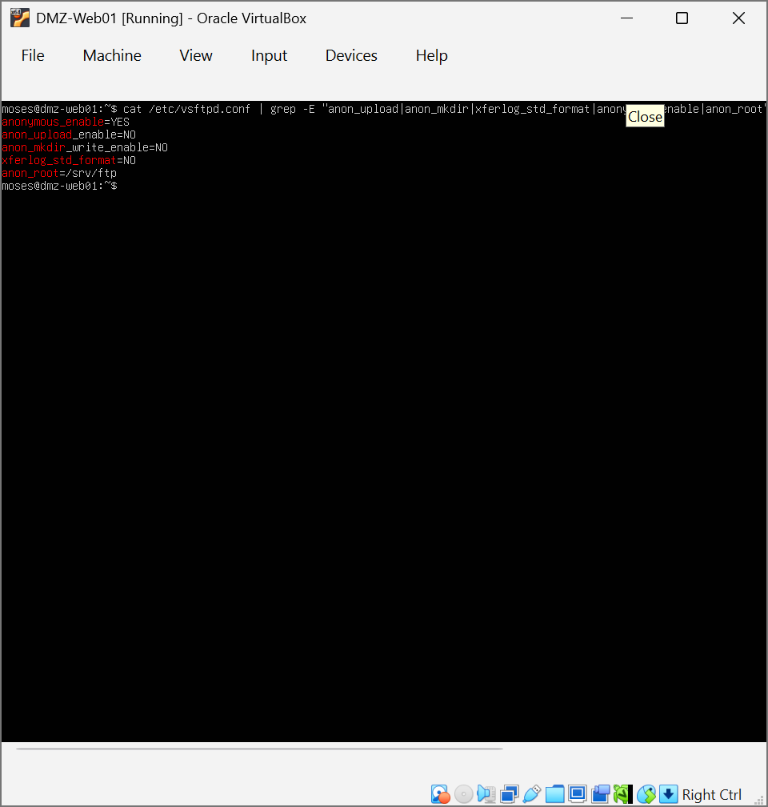
vsftpd configuration confirmed corrected: anon_upload_enable=NO, anon_mkdir_write_enable=NO, xferlog_std_format=NO
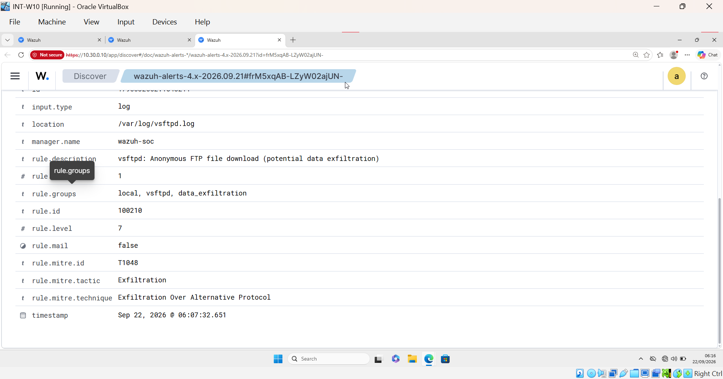
Custom rule 100210 firing on a successful FTP download: rule.level 7, rule.mitre.id T1048, decoder.name vsftpd, data.status OK DOWNLOAD

8.4 Scenario 4 — Vulnerable Server Detection
Case ID | SCN-04-VULNSERVER
Business Problem | Unpatched, internet-facing infrastructure.
Wazuh Capability Demonstrated | Automated vulnerability detection and CVE identification.

Attack / Activity Narrative
This scenario required no active attack — it reviewed Wazuh's existing vulnerability scan data for DMZ-Web01. The scan returned 3,680 total findings (352 Critical, 1,666 High, 328 Medium, 6 Low, 1,328 Pending), heavily concentrated across two coexisting kernel package versions still present on the host — itself a finding, since the older kernel package was never purged after an upgrade, effectively doubling the exposed vulnerability surface for no operational benefit.

Investigation
WHERE | DMZ-Web01 (10.20.0.10)
VERDICT | True positive — confirmed via independent vendor advisory lookup
DETECTION | Wazuh Vulnerability Detection module (version-comparison based; no active exploitation observed or claimed)
BUSINESS IMPACT | An internet-facing host running kernel-level Critical vulnerabilities is a direct path to full host compromise
RESPONSE ACTION | Patch to current kernel package and remove the superseded package version; establish a defined patch-lag SLA for Critical findings on internet-facing systems

Key Finding
Four confirmed CVSS v3.1, base score 10.0 (Critical) CVEs were isolated for the report, all published in mid-August 2026 and detected roughly three weeks later, reflecting a real-world patch lag: CVE-2026-74475, CVE-2026-72421, CVE-2026-74279, and CVE-2026-72408, each verified independently against the Canonical Security Tracker.

Supporting Evidence
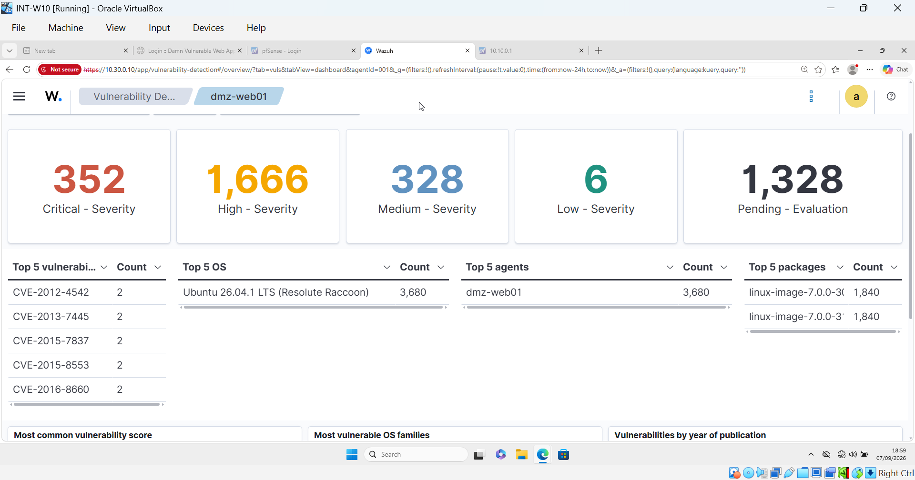
Vulnerability Detection dashboard: severity breakdown (352/1,666/328/6/1,328) and top-5 packages confirming the 1,840/1,840 doubled-kernel finding
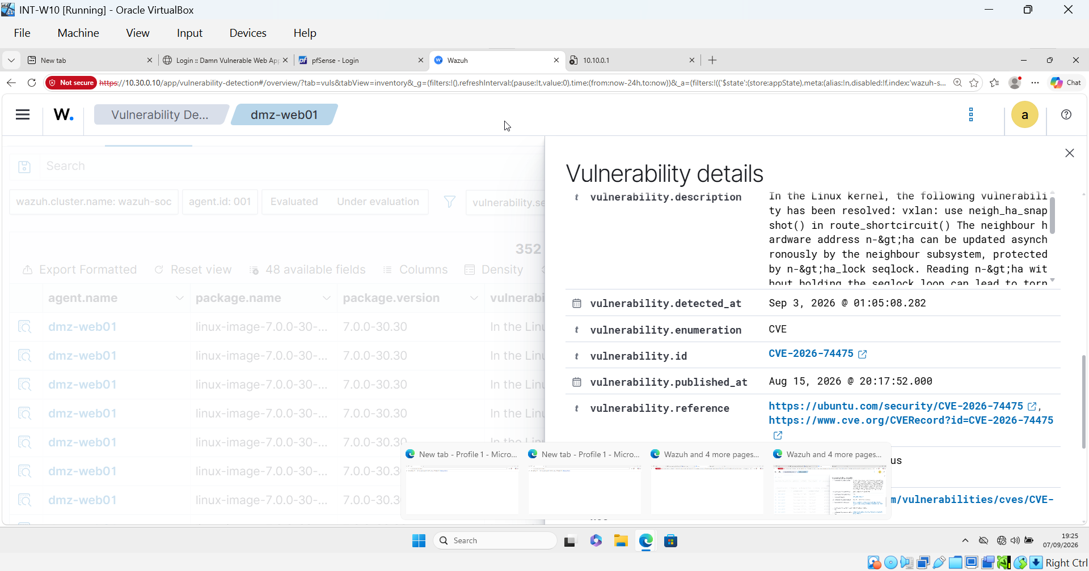
CVE-2026-74475: published Aug 15, 2026, with Ubuntu security and CVE.org references

8.5 Scenario 5 — Internal-to-DMZ Reconnaissance Scan via pfSense Syslog Integration
Case ID | SCN-05-PORTSCAN
Business Problem | External/internal actor probing internet-facing or DMZ services.
Wazuh Capability Demonstrated | Syslog ingestion from a network device (pfSense) correlated with firewall rule evaluation.

Attack / Activity Narrative
This scenario was reframed from the guide's original “external web attack” framing to an internal-to-DMZ port scan crossing pfSense, since the DMZ and Internal segments sit on separate Layer 2 networks — any traffic between them must physically cross the firewall, which is what makes it observable via pfSense syslog in the first place. An initial scan attempt run from Kali's DMZ-side interface stayed on the same L2 segment as the target and never touched pfSense at all; the scan was re-run from Kali's Internal-side interface instead (nmap -Pn -e eth2 -S 10.10.0.50 -p 1-1000 10.20.0.10), forcing the traffic through the firewall as intended. The scan confirmed 3 open ports on DMZ-Web01: 21/tcp (ftp), 22/tcp (ssh), 80/tcp (http).

Investigation
WHAT | TCP port scan, ports 1–1000
WHERE | DMZ-Web01 (10.20.0.10)
SOURCE | Kali-Attacker, routed via Internal interface (10.10.0.50) through pfSense
VERDICT | True positive, once the firewall logging gap was corrected; custom-rule alert firing not yet confirmed (see Known Limitation below)
DETECTION | Custom rules 100211 (individual) / 100212 (correlation, MITRE T1046) — designed and deployed, live firing verification pending
BUSINESS IMPACT | A misconfigured allow-rule doesn't just let traffic through unchecked — it also renders that traffic invisible to log-based detection entirely
RESPONSE ACTION | Logging enabled on the previously-silent rule; broad unlabeled allow rules flagged for firewall rule-base cleanup

Key Finding
Two independent findings, plus one open item. (1) A broad, undocumented, logging-disabled pfSense rule (blank-description “USER_RULE,” ruleid 1787874473, pass in quick on le2 inet proto tcp all) sat above the intended logged LAN rule and silently absorbed all traffic, making the scan invisible in both the GUI log and raw filter.log despite confirmed live traffic (verified via tcpdump). Diagnosed using pfctl -vvsr's per-rule packet counters, then fixed by enabling logging on the correct rule. (2) Wazuh's built-in pfSense ruleset only correlates block events (rule 87701 is deliberately excluded from logging; correlation rule 87702 only watches blocks) — there is no equivalent rule for pass events, so this scan was invisible to Wazuh's existing detection logic even after the pfSense-side fix. Remediated with custom rules 100211/100212 in local_rules.xml, mirroring the existing block-event pair. (3) OPEN ITEM: during verification testing, pfSense/filterlog events captured in Wazuh's archives were found to be undecoded entirely (empty decoder field, malformed hostname parsing) — a deeper issue, independent of the pass/block gap, that would prevent any pfSense-sourced rule from firing. This was verified under stable host-load conditions and is carried forward as a documented follow-up rather than presented as resolved.

Supporting Evidence
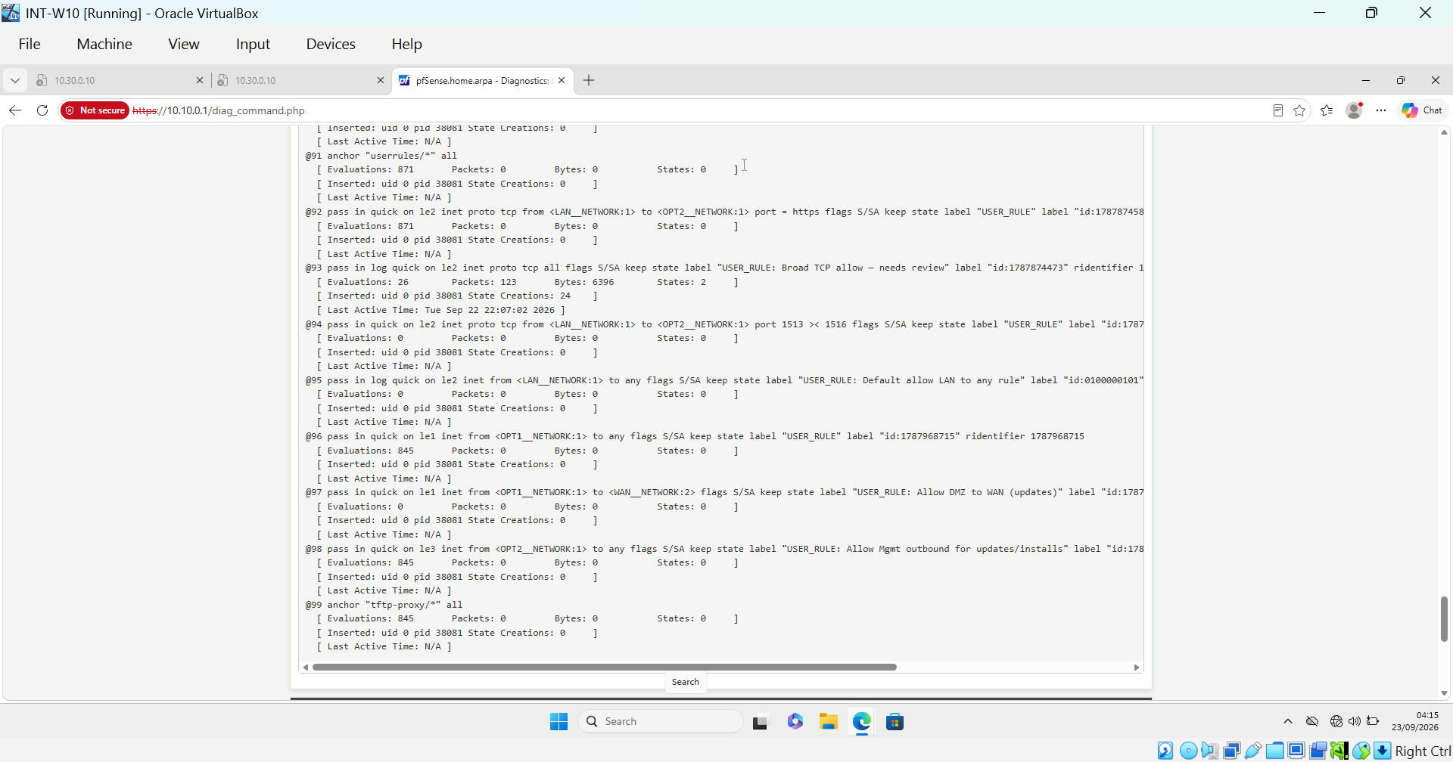
pfctl -vvsr diagnosis: the broad unlabeled rule (ridentifier 1787874473) shows nonzero Packets/Bytes/States and a recent Last Active Time, confirming it was silently absorbing the scan traffic
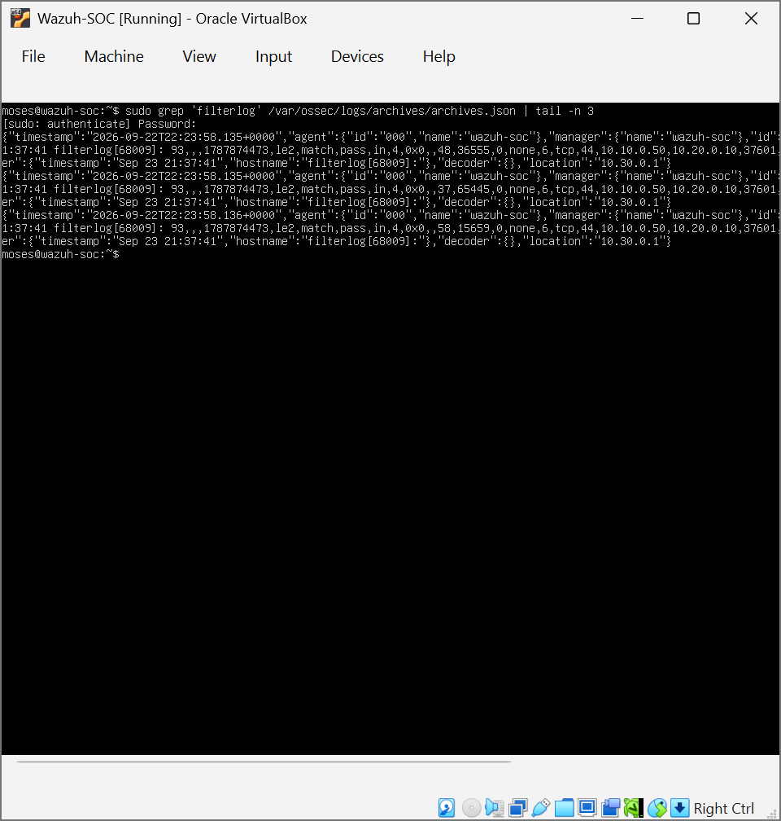
archives.json for the re-run scan’s filterlog traffic: empty "decoder":{} field and malformed hostname — the open decoder-parsing gap documented in Section 7

9. Consolidated Findings
Across all five scenarios, the following findings represent the project's core detection-engineering contributions.

9.1 Detection Coverage Gaps Identified
- No default rule for successful FTP download events on DMZ-Web01 (Scenario 3).
- No default rule for allowed ("pass") firewall traffic in Wazuh's pfSense ruleset — only blocked traffic is covered (Scenario 5).
- Silent FIM inventory/alerting desynchronization on file restoration — inventory state updated with no corresponding alert (Scenario 2).

9.2 Custom Detection Rules Authored
Rule ID | Purpose | MITRE Mapping
100210 | Detects successful FTP download events (vendor gap) | T1048
100211 | Detects individual allowed ("pass") pfSense firewall events (vendor gap) | —
100212 | Correlation rule: multiple allowed events from one source in a short window | T1046

9.3 Configuration and Operational Issues Identified
- vsftpd's extended transfer-log format (xferlog_std_format) was incompatible with Wazuh's default decoder, silently suppressing session-level alerts until corrected (Scenario 3).
- Anonymous FTP write access (upload/mkdir) was found enabled by default on the DMZ FTP service — a real access-control risk caught during scenario setup (Scenario 3).
- A broad, unlogged, blank-description pfSense firewall rule was found silently matching all internal-to-DMZ TCP traffic ahead of the intended, properly logged rule, due to top-down "quick" rule evaluation order (Scenario 5).
- An old, unpurged kernel package left installed after a prior system upgrade effectively doubled the vulnerability count reported for the DMZ web server (Scenario 4).

9.4 Open / Unresolved Item
During verification testing in Scenario 5, pfSense-sourced firewall events were found to be arriving at the Wazuh manager without being decoded at all (empty decoder assignment, malformed hostname field), independent of the pass/block coverage gap otherwise addressed. This affects both the newly authored custom rules and the vendor's own default pfSense rules, and was not fully root-caused within this project's timeline. It is documented in Section 11 as a recommended follow-up rather than presented as resolved.

10. Cross-Cutting Lessons and Troubleshooting
A pattern worth calling out across multiple scenarios: several of the most valuable findings in this project were not the simulated attacks themselves, but pre-existing misconfigurations discovered while building the environment to host them — the permissive FTP write settings, the doubled kernel package footprint, and the silently-passing firewall rule all surfaced only because building a realistic environment forced close inspection of default settings that a checklist-only assessment would likely have missed.
A second pattern: Wazuh's default ruleset, like most SIEM out-of-the-box rulesets, is tuned around the traffic patterns vendors expect to see (failed logins, blocked connections) and has real gaps around the inverse cases (successful-but-suspicious actions, passed-but-unintended traffic). Two of the five scenarios required writing custom detection rules to close exactly this kind of gap — a demonstrable detection-engineering skill beyond simply operating a pre-built tool.

10.1 Host Resource Constraints
The host has 4 physical cores / 8 logical threads. Running more than approximately 3–4 VMs simultaneously reliably produced kernel-level CPU starvation on Wazuh-SOC (soft lockups, RCU stalls, NIC watchdog resets), which in turn caused transient agent disconnects and, on at least one occasion, a stuck systemd unit. Standing practice adopted: only run the VMs actively needed for the current build or test step; shut down completed/idle VMs before starting network-sensitive work. Host disk space also became a hard blocker mid-project (15.5GB free of 475GB) when attempting a full VM clone — resolved by removing a redundant VM and a leftover installer ISO; a linked clone was used going forward for INT-Win10 to avoid repeating the issue.

10.2 systemd Override Case-Sensitivity
systemd unit-override directives are case-sensitive. “TimeoutStartSec” written as “timeoutStartSec” is silently ignored rather than erroring — this caused two separate outages on Wazuh-SOC (once during initial build, once again during Scenario 5 rule development) before the pattern was fully internalized. Diagnosed both times via systemctl cat, which shows the merged effective unit.

10.3 Configuration File Editing on Wazuh-SOC's Console
This VM's console has a terminal quirk that duplicates lines during multi-line paste or heredoc input, silently corrupting XML edits. Two different symptoms were traced back to this: a duplicated <localfile> block early in the build, and a dropped closing tag inside a MITRE ATT&CK block during Scenario 5's rule authoring. Reliable workaround adopted: build or edit XML in small batches (3–4 lines) via single-shot sed/tee commands, verifying with cat -n after every batch rather than pasting large blocks at once.

10.4 Networking
- netplan-configured static IPs can be silently overridden by a leftover systemd-networkd .network file from the base image if that file's name sorts after netplan's own generated file — fixed by restarting systemd-networkd or removing the stray file.
- On dual-NIC or cloned Windows VMs, a leftover second network adapter can “win” as the active connection even when the intended adapter is correctly configured — resolved on INT-Win10 by disabling the unused NIC.
- On Kali, NetworkManager re-enumerates ethX interface names whenever a NIC is added or removed, silently rebinding existing connection profiles to the wrong physical adapter — interface identity should always be re-verified against VBoxManage's NIC list and the guest's own MAC addresses.
- Same-Layer-2-segment traffic never crosses a firewall — a scan or transfer between two hosts on the same VirtualBox internal network will not appear in pfSense's logs at all, regardless of firewall configuration, because it never reaches pfSense.

10.5 Package Installation
- Wazuh's generic “4.x” package alias returned HTTP 403 consistently throughout the project on every VM; the versioned path (packages.wazuh.com/4.14/...) worked reliably and was used everywhere instead.
- Clock drift on freshly cloned VMs is a recurring cause of “Release file not valid yet” apt failures — resolved each time by toggling systemd-timesyncd off and back on.

11. Recommendations

11.1 For This Environment
- Investigate and resolve the pfSense syslog decoding issue identified in Scenario 5 (Section 9.4) by comparing pfSense's raw outbound syslog header format against Wazuh's base syslog decoder expectations, and adjusting pfSense's Remote Logging Options or the decoder configuration as needed.
- Conduct a full pfSense rule-base audit to identify and document (or remove) any remaining broad, undocumented rules similar to the one found in Scenario 5, using per-rule hit counters rather than visual inspection alone.
- Establish a periodic patch-management cadence for the DMZ web server informed by the Scenario 4 findings, including removal of superseded kernel packages after each upgrade.
- Tighten INT-FileSrv share permissions (currently world-writable) and enable access auditing in addition to FIM, per the Scenario 2 response action.
- Remove anonymous FTP entirely from DMZ-Web01 in favor of authenticated, encrypted transfer, per the Scenario 3 response action.
- Restrict RDP access on INT-Win10 to VPN/jump-host only and enforce MFA, per the Scenario 1 response action.
- Revert the temporary verbose-logging configuration (logall / logall_json) enabled for Scenario 5's raw-traffic visibility back to its default, disk-conserving setting.

11.2 For Future Iterations of This Project
- Introduce a SOAR-style automated response layer (e.g. active-response scripts) for at least one scenario, to demonstrate detection-to-response automation in addition to manual investigation.
- Add a sixth scenario focused on lateral movement detection across the internal segment, building on the network-segmentation groundwork already established.
- Formalize the custom decoder/rule authoring workflow into a version-controlled ruleset repository with change history, suitable for demonstrating detection-engineering-as-code practices.
- Periodically re-run all five scenarios after any Wazuh version upgrade to confirm custom rules and vendor rulesets remain compatible and correctly firing.

12. Conclusion
This project delivered a fully segmented, monitored enterprise network lab and validated its detection posture against five realistic scenarios spanning authentication attacks, file integrity, data exfiltration, vulnerability management, and network reconnaissance. Its central value is not the infrastructure build itself, but the discipline of treating every unexpected result — a missing alert, a silent log-format mismatch, an unexplained firewall rule, a service that wouldn't restart — as a finding worth root-causing and documenting rather than working around. That approach surfaced multiple genuine gaps in default vendor detection coverage, each remediated with purpose-built custom detection logic and carried through to verification wherever possible, with one item transparently carried forward as an open follow-up rather than glossed over. Taken together, the project is intended to demonstrate the applied, end-to-end workflow of a SOC analyst and detection engineer: building, breaking, diagnosing, fixing, and documenting a real monitored environment.

13. Appendix

13.1 Skills Demonstrated
- Network segmentation design and firewall administration (pfSense)
- SIEM/XDR deployment, configuration, and tuning (Wazuh Manager, Indexer, Dashboard, Agents)
- Custom decoder and correlation rule authoring (Wazuh ruleset XML)
- Log source integration (syslog forwarding, agent-based endpoint monitoring)
- File Integrity Monitoring configuration and gap analysis
- Vulnerability management and CVE triage/verification
- Incident response: triage, containment, evidence preservation, and recovery
- Linux system administration (systemd service management, permissions, troubleshooting)
- Network traffic analysis (tcpdump, nmap) and root-cause diagnosis across multiple infrastructure layers

13.2 Supporting Documents
- Scenario 1 Investigation Report — SCN-01-BRUTEFORCE
- Scenario 2 Investigation Report — SCN-02-FILETAMPER
- Scenario 3 Investigation Report — SCN-03-FTPEXFIL
- Scenario 4 Investigation Report — SCN-04-VULNSERVER
- Scenario 5 Investigation Report — SCN-05-PORTSCAN

13.3 Screenshot Index
The following supporting evidence is referenced throughout this document as placeholders and should be inserted from the project's screenshot archive prior to publication:
- Network topology diagram
- Scenario 1 — brute-force attempt and resulting Wazuh alerts
- Scenario 2 — FIM alert and incident response actions taken
- Scenario 3 — FTP exfiltration and custom rule 100210 firing
- Scenario 4 — Vulnerability Detection dashboard and CVE detail views
- Scenario 5 — port scan execution, pfSense rule diagnosis, and custom rule deployment

