MERIDIAN LOGISTICS CO.
Security Operations Center — Investigation Report
Scenario 5: Internal-to-DMZ Reconnaissance Scan via pfSense Syslog Integration
Case ID | SCN-05-PORTSCAN
Classification | Internal Exercise — Detection Engineering & Incident Investigation
Analyst | Moses (SOC Analyst, Meridian Logistics Co.)
Date of Exercise | September 2026
Target Asset | DMZ-Web01 (10.20.0.10) — Apache/DVWA/vsftpd, DMZ segment
Source Host | Kali-Attacker (10.10.0.50, intnet interface)
Detection Source | pfSense firewall syslog, forwarded to Wazuh-SOC (10.30.0.10:514/UDP)
MITRE ATT&CK | T1046 — Network Service Discovery
Status | Remediation designed and deployed; live alert-firing verification pending (see Section 7)

1. Executive Summary
This exercise originated from the Meridian Logistics Co. SOC deployment project's fifth and final scenario, specified as an “external web attack detected via pfSense syslog.” During scoping, the network's actual segmentation made a literal external-to-DMZ attack impossible to demonstrate within the lab topology (see Section 2). The scenario was accordingly reframed as an internal-to-DMZ reconnaissance scan — a port scan launched from the internal network segment against the DMZ web server, deliberately routed through pfSense so that the traffic would be visible to the firewall's syslog stream and, by extension, to Wazuh.
The exercise surfaced two independent, real detection-engineering findings, not staged for the scenario: (1) a broad, undocumented pfSense firewall rule was silently absorbing all LAN-to-DMZ TCP traffic ahead of the intended logged rule, making the firewall appear to log nothing despite confirmed live traffic; and (2) once that was corrected, Wazuh's shipped pfSense ruleset proved to have no detection logic at all for “pass” (allowed) traffic — only for “block” events — meaning a misconfigured allow rule doesn't just let traffic through, it also blinds the SIEM's existing correlation logic to it. Custom detection rules (100211/100212) were authored to close that gap, mirroring the structure of Wazuh's existing block-event rules.
A third, unresolved issue was identified late in verification testing: pfSense/filterlog events captured in Wazuh's archives are not being decoded at all (empty decoder field, malformed hostname parsing), which would prevent any pfSense-sourced rule — vendor or custom — from firing, independent of action type. This is documented as a known limitation and follow-up item in Section 7, rather than a solved problem.

2. Scope, Segmentation, and Methodology
The lab topology places DMZ-Web01 on the dmznet segment (10.20.0.0/24) and Kali-Attacker as a dual-homed host with interfaces on both dmznet (10.20.0.50) and intnet (10.10.0.50). The two interfaces sit on separate L2 segments joined only through pfSense (LAN/intnet ↔ OPT1/DMZ).
The first scan attempt used Kali's dmznet interface — the same segment as the target — and produced no pfSense log activity at all: the traffic never left the local segment, so it never reached the firewall to be logged or evaluated. This confirmed that a same-segment scan cannot exercise pfSense-based detection and is not a valid test of the syslog integration, regardless of scenario framing.
The scan was re-run from Kali's intnet interface instead, deliberately forcing the traffic through pfSense's LAN → OPT1 (DMZ) path:
nmap -Pn -e eth2 -S 10.10.0.50 -p 1-1000 10.20.0.10
This reframes the scenario as internal reconnaissance rather than an external attack, which is a more accurate description of what the syslog pipeline can actually demonstrate in this topology — and is arguably a more realistic threat model besides, since insider reconnaissance and lateral movement toward a DMZ asset are common real-world precursors to a web-application attack.
Scan result:
- Host up (0.031–0.075s latency observed across repeated runs)
- 997 of 1000 scanned ports closed (TCP reset)
- 3 open ports: 21/tcp (ftp), 22/tcp (ssh), 80/tcp (http)

Supporting Evidence — Confirmed Scan Results
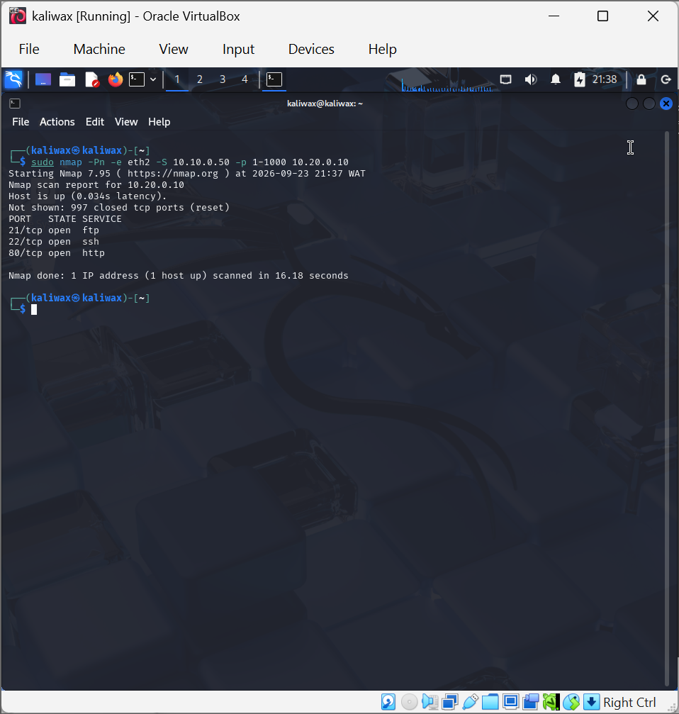
nmap scan from Kali’s intnet interface (eth2, 10.10.0.50) against DMZ-Web01: host up, 3 open ports (21/ftp, 22/ssh, 80/http)

3. Finding 1 — Broad Pre-Existing pfSense Rule Masking Traffic
Even after correctly routing the scan through pfSense, no new entries appeared in either the pfSense GUI firewall log or the raw /var/log/filter.log for an extended period — despite tcpdump on Kali independently confirming real SYN/RST packets crossing to and from 10.20.0.10.
Root cause: pfSense evaluates rules top-to-bottom with “quick” semantics, and a pre-existing, blank-description rule (“pass in quick on le2 inet proto tcp all”, ruleid 1787874473, displaying as an unlabeled “USER_RULE” in the GUI) sat above the intended, properly logged default LAN rule. This broad rule matched all LAN-to-any TCP traffic — including the scan — before evaluation ever reached the intended rule, and it had logging disabled.
Diagnosis method: rather than continuing to inspect the GUI rule list, per-rule packet/evaluation counters were pulled directly via pfctl -vvsr, which immediately showed which rule was actually being matched (nonzero packet count and recent “Last Active Time”) — a far faster and more reliable diagnostic than re-checking logging checkboxes rule-by-rule.
Remediation: enabled “Log packets that are handled by this rule” on the broad rule via Firewall › Rules › LAN. Firewall logging began populating immediately on the next test traffic.

Supporting Evidence — Diagnosis via pfctl Counters
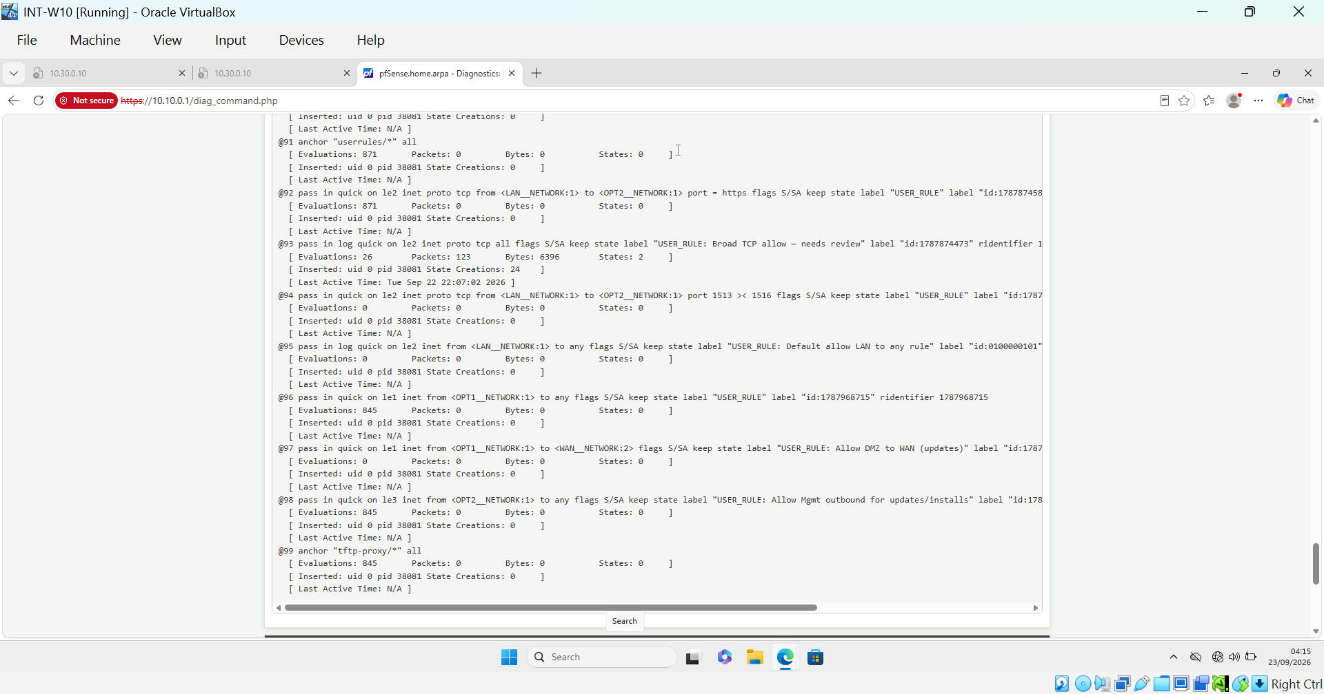
pfctl -vvsr output: rule 93 (ridentifier 1787874473, the broad unlabeled rule) shows Packets: 123, Bytes: 6396, a recent Last Active Time — confirming it, not the intended logged rule, was matching the traffic

Supporting Evidence — Remediation Applied
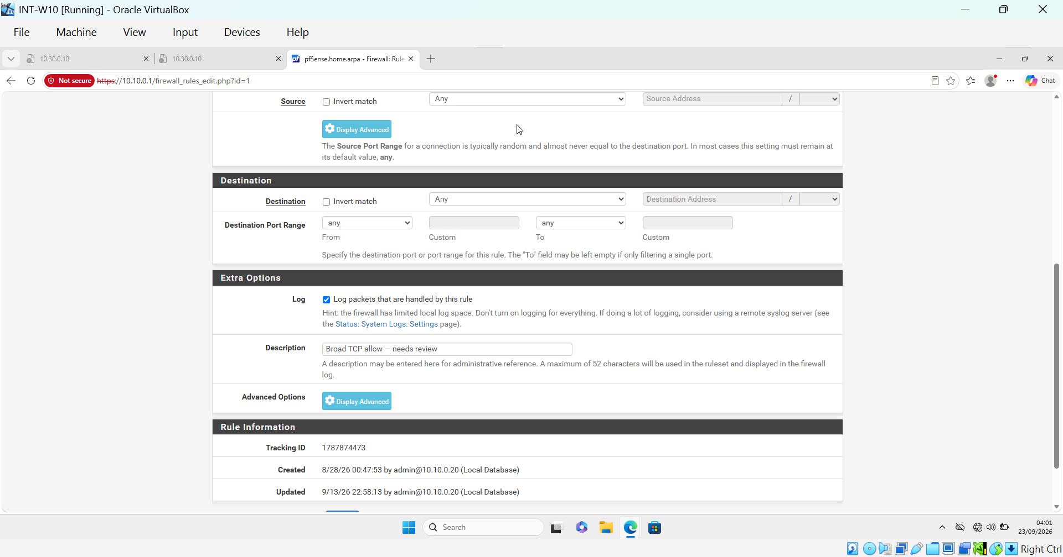
The rule (Tracking ID 1787874473, renamed “Broad TCP allow — needs review”) with “Log packets that are handled by this rule” enabled

Supporting Evidence — Logging Confirmed Live
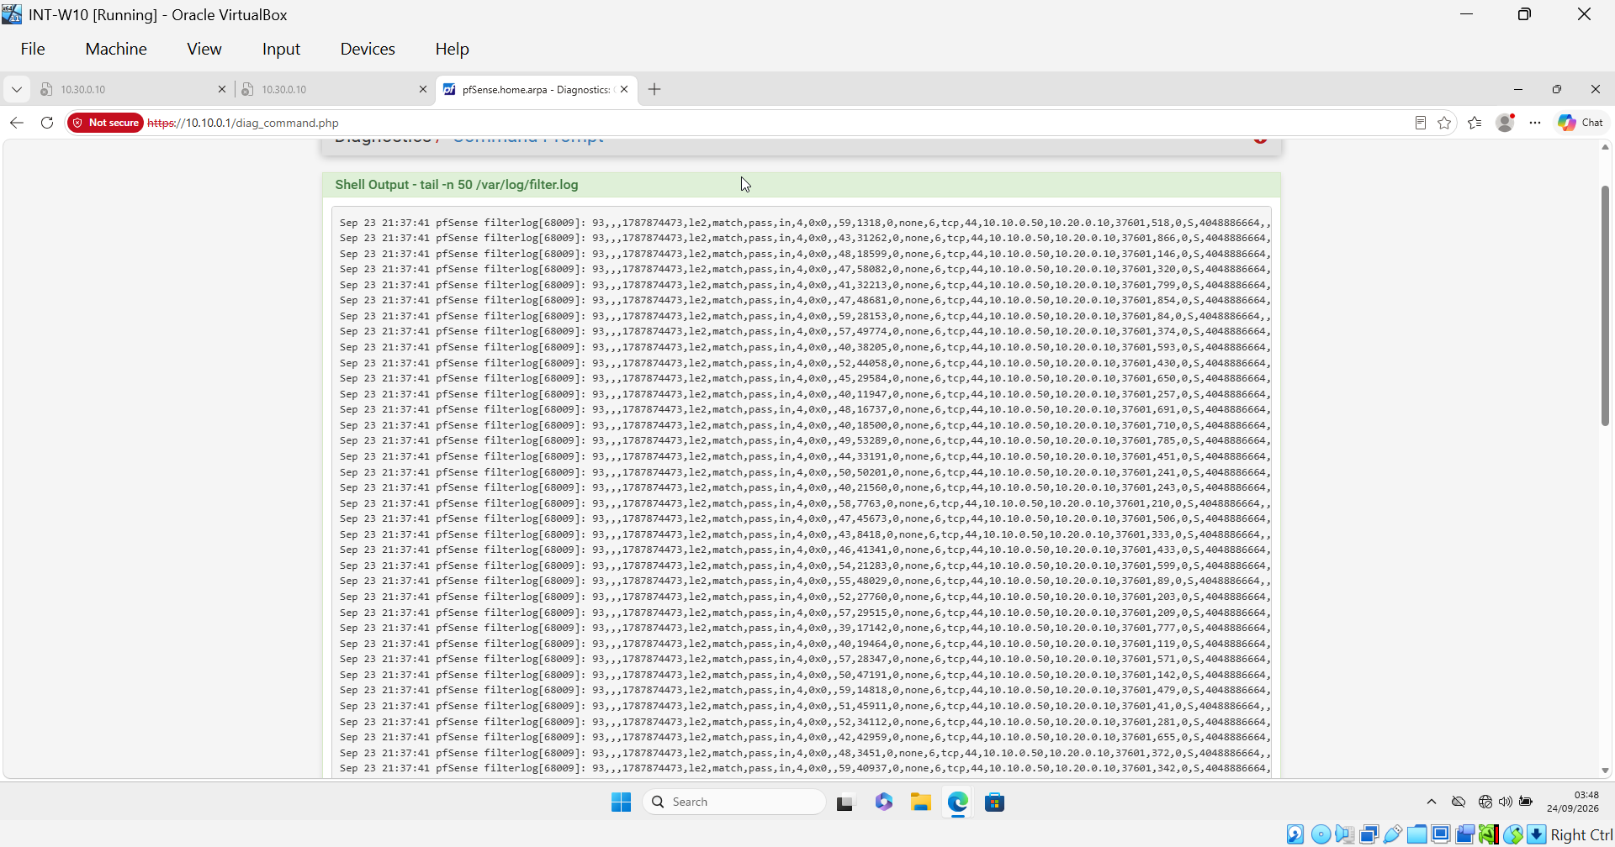
/var/log/filter.log immediately after the fix: live match,pass entries under ridentifier 1787874473, correlating with the re-run scan

4. Finding 2 — Wazuh's Default pfSense Ruleset Has No Coverage for Allowed Traffic
Wazuh ships a pfSense decoder and rule set (0455-pfsense_decoders.xml, 0540-pfsense_rules.xml) built around a parent rule (87700, matches any filterlog event) and a child rule for blocked traffic (87701), which itself feeds a frequency-based correlation rule for repeated blocks from the same source (87702, an existing multiple-block detection). Critically, rule 87701 is written with logging intentionally suppressed (<options>no_log</options>, with an in-code comment noting block events already have their own dedicated log), and there is no equivalent rule structure anywhere in the shipped ruleset for “pass” (allowed) events.
Because the scan traffic in this exercise was logged as pass (a direct consequence of the Finding 1 rule ordering issue), it fell outside Wazuh's existing detection logic entirely, even once the pfSense-side logging gap was fixed. This is a sharper version of a pattern also seen in Scenario 3 of this project: a misconfigured or overly permissive allow rule does not just grant unintended access — it can simultaneously blind the SIEM's built-in correlation logic to any resulting activity, since most vendor-shipped rulesets are naturally written to prioritize deny/block events.

5. Remediation — Custom Detection Rules 100211 / 100212
Following the same remediation pattern established in Scenario 3 (custom rule 100210 for an FTP download-logging gap), two custom rules were authored in local_rules.xml on Wazuh-SOC, mirroring the structure of the existing block-event pair (87701/87702) but scoped to pass events:
Rule ID | Purpose
100211 | Child of parent rule 87700; matches <action>pass</action> events. Level 3 — individual-event visibility, establishing the base signal that was previously entirely absent for allowed traffic.
100212 | Frequency/correlation rule built on 100211. frequency=15, timeframe=20s, same_source_ip. Level 10. Tagged MITRE T1046 (Network Service Discovery) — the pattern of many distinct pass events from one source in a short window is a canonical port-scan signature.

Deployment of this change also surfaced an unrelated operational issue worth noting for completeness: after editing local_rules.xml, wazuh-manager repeatedly failed to restart with a start-timeout error. Root cause was a case-sensitivity typo in a systemd override file (timeoutStartSec instead of TimeoutStartSec), compounded by processes left over from earlier failed restart attempts. Both were corrected (override rebuilt with correct casing; stale processes force-cleared) and the manager returned to a healthy running state. This is documented in the project's build-status notes as it fits the same class of case-sensitive systemd gotcha already known for this environment.

Supporting Evidence — Custom Rules 100211/100212 Configured
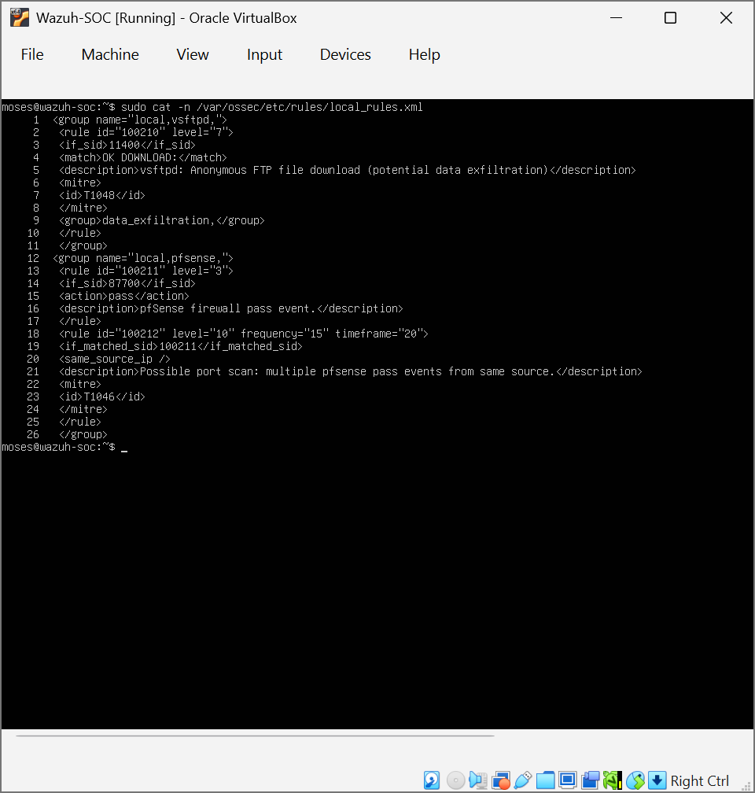
local_rules.xml on Wazuh-SOC: rule 100211 (if_sid 87700, action=pass, Level 3) and rule 100212 (frequency=15, timeframe=20, same_source_ip, Level 10, MITRE T1046)

6. MITRE ATT&CK Mapping
Technique | Description
T1046 — Network Service Discovery | Adversaries scan a target to identify running services and open ports as a precursor to further exploitation. The frequency-based signature (many distinct connection attempts from one source in a short window) is the basis for correlation rule 100212.

7. Known Limitation and Recommended Follow-Up
During verification testing (re-running the scan to confirm 100211/100212 firing), a deeper, previously unknown issue was identified: captured pfSense/filterlog events in Wazuh's archives.json show an empty decoder object for every entry — including historical block events, not just pass events — and the parsed hostname field contains “filterlog[PID]:” rather than pfSense's actual hostname. This pattern is consistent with Wazuh's base syslog header parser not matching the header format pfSense actually sends, which would prevent the pfSense-specific decoder (and therefore every rule dependent on it, both vendor rules 87700/87701/87702 and the new custom rules) from ever engaging — independent of the pass/block gap addressed in this report.
This was verified under stable host conditions (load average confirmed low immediately beforehand), ruling out the earlier CPU-starvation events observed on Wazuh-SOC during this project as the explanation. As a result, live end-to-end alert firing for rules 100211/100212 was not confirmed as of this report.
Recommended follow-up, out of scope for this scenario's remediation but noted for the project record:
- Capture the raw syslog wire format from pfSense directly (e.g. tcpdump on UDP/514 during a live event) and compare it against the header format Wazuh's base syslog decoder expects.
- Review pfSense's Remote Logging Options for any format setting (e.g. RFC 5424 vs. BSD-style headers) that may need to align with Wazuh's parser.
- Once corrected, re-run this scenario's scan to confirm 100211 (individual) and 100212 (correlation) both fire as designed.

Supporting Evidence — Decoder Gap
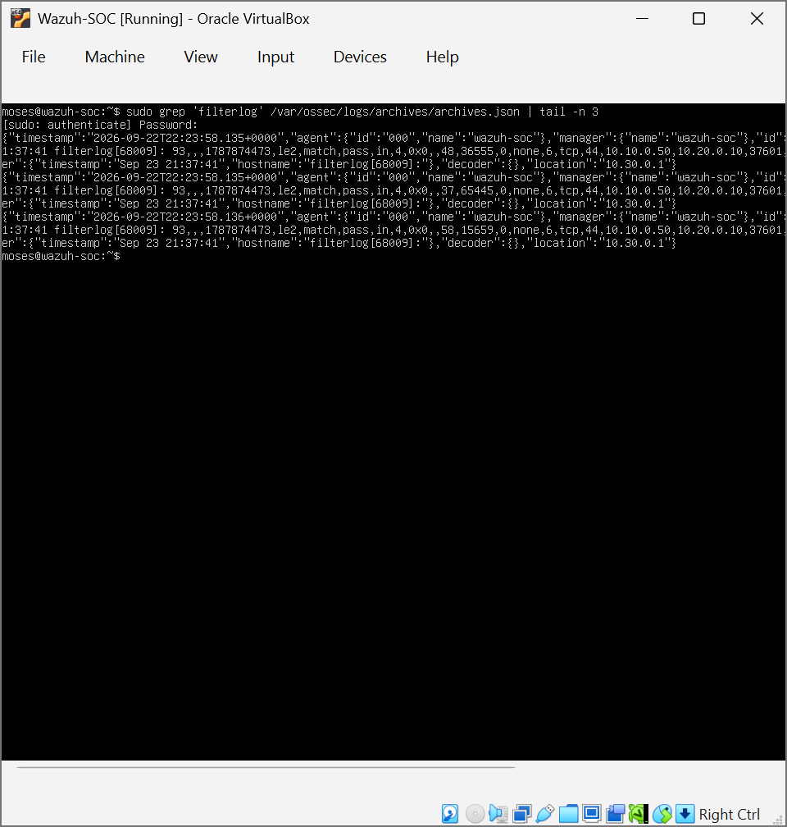
archives.json entries for the re-run scan’s filterlog traffic (ridentifier 1787874473): empty "decoder":{} field and malformed hostname "filterlog[68009]:" instead of pfSense’s real hostname

8. Conclusion
This scenario, though ultimately blocked from full end-to-end verification by a newly discovered syslog-parsing issue, still delivered its core objective: identifying a genuine, unaddressed gap in Wazuh's default pfSense detection coverage and engineering a correctly structured remediation for it. Combined with the independent pfSense rule-ordering finding and the operational troubleshooting encountered along the way, this exercise reflects a realistic SOC analyst workflow — diagnosing across multiple layers (firewall rule evaluation order, SIEM ruleset coverage, and host/service configuration) rather than a single clean-path detection test. This closes the fifth and final scenario of the Meridian Logistics Co. SOC deployment project, with the Section 7 follow-up carried forward as a documented open item rather than left unaddressed.

Screenshots: docs/screenshots/scenario5/ in the project repository.

