MERIDIAN LOGISTICS CO.
Security Operations Center — Investigation Report
Scenario 1: Brute-Force Attack (Internal, RDP)

Case ID | SCN-01-BRUTEFORCE
Classification | Internal Exercise — Detection Validation & Incident Investigation
Analyst | Moses (SOC Analyst, Meridian Logistics Co.)
Date of Exercise | September 2026
Target Asset | INT-Win10 (10.10.0.20) — Windows 11 employee workstation, Internal segment
Source Host | Kali-Attacker (10.10.0.50, internal segment)
Detection Source | Wazuh agent 003 (INT-Win10) — Windows Security Event Log
MITRE ATT&CK | T1110 — Brute Force
Status | Complete — detection confirmed at both individual and correlation level

1. Executive Summary
This exercise simulated a credential brute-force attack against an internal Windows workstation, representing the common business scenario of employee accounts under active password-guessing attack. The objective was to validate Wazuh's authentication-monitoring and multi-failure correlation capability on a Windows endpoint.
The attack was executed via repeated RDP authentication attempts from Kali-Attacker against INT-Win10, culminating in one successful login using a seeded correct password. Wazuh detected the activity cleanly at both the individual failed-logon level and the correlation level, with an accurate MITRE technique mapping. A Windows account lockout also triggered as an incidental secondary finding, adding a small amount of unplanned realism to the exercise.

2. Scope and Methodology
INT-Win10 was selected as the target because it represents a typical employee workstation on the internal segment. RDP was the only viable remote-authentication surface on this build, since OpenSSH Server could not be installed on this VM (the internal segment has no internet access to fetch the optional Windows feature).
Hydra's RDP module was attempted first but proved unreliable in this environment (inconsistent connection handling against this specific RDP configuration). The attack was executed instead via a custom bash loop calling xfreerdp in authentication-only mode against an 11-entry password wordlist, with the real account password seeded as the final entry — guaranteeing a successful compromise after ten deliberate failures, to produce both a clear failure pattern and a genuine successful-login event for Wazuh to differentiate between.
for pw in $(cat wordlist.txt); do xfreerdp /v:10.10.0.20 /u:<user> /p:"$pw" +auth-only; done

3. Investigation
WHO | Local INT-Win10 account “moz” targeted by credential guessing
WHAT | Repeated RDP authentication attempts (Windows Event ID 4625) culminating in one successful login
WHEN | Captured via Wazuh alert timestamps across the attack window (Sep 2, 2026)
WHERE | INT-Win10 / DESKTOP-N9CCCE9 (10.10.0.20)
SOURCE | Kali-Attacker, workstation “kaliwax”, internal segment (10.10.0.50)
DESTINATION | INT-Win10 RDP service
VERDICT | True positive — confirmed brute-force with eventual successful authentication
BUSINESS IMPACT | A compromised workstation account is a foothold for lateral movement into the internal network

4. Detection Analysis
Wazuh detected the activity at two levels:
- Individual event level — rule 60122 fired 22 times across the attack window, one per failed RDP authentication attempt captured from the Windows Security Event Log.
- Correlation level — rule 60204 (“Multiple Windows Logon Failures”) fired once the failure frequency threshold was met, correctly mapped to MITRE T1110 (Brute Force).
A Windows account-lockout event also fired independently as a secondary, unplanned finding — Windows' own lockout policy engaged partway through the wordlist, meaning the environment's native account-lockout control and Wazuh's detection layer both responded to the same activity, which is a reasonable outcome to highlight: detection and a native preventive control operating together rather than detection being the only line of defense.
The correlation alert (rule 60204) was traced end-to-end in the Wazuh Dashboard's Threat Hunting document view, from the source IP through to its final MITRE classification:
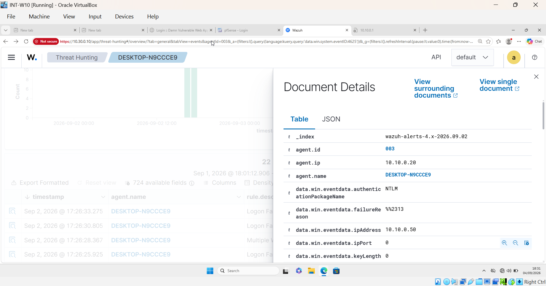
Figure 1a — Source IP (10.10.0.50, Kali-Attacker) recorded in the alert document
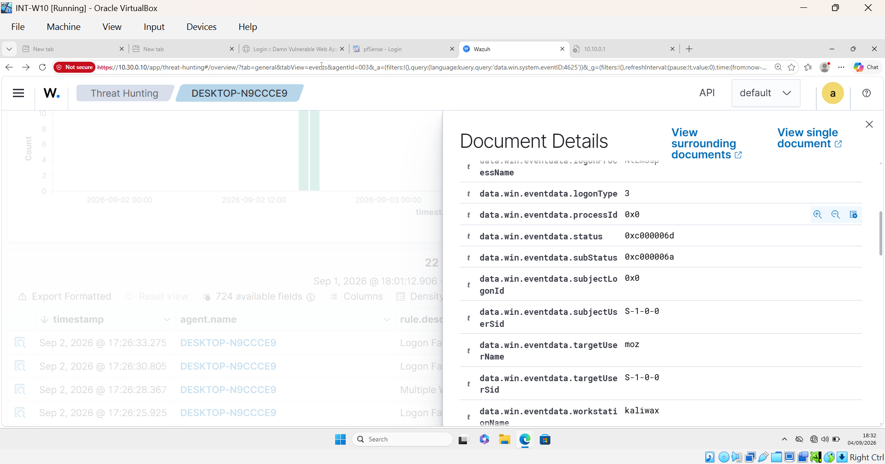
Figure 1b — Target account (moz) and source workstation (kaliwax) captured in event data
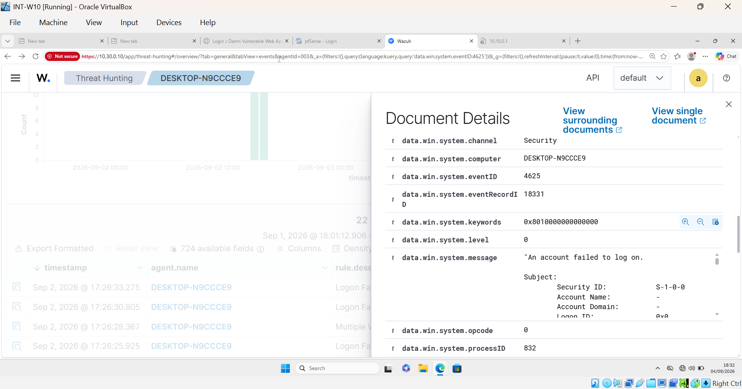
Figure 1c — Raw Windows Security Event (ID 4625, “An account failed to log on”)
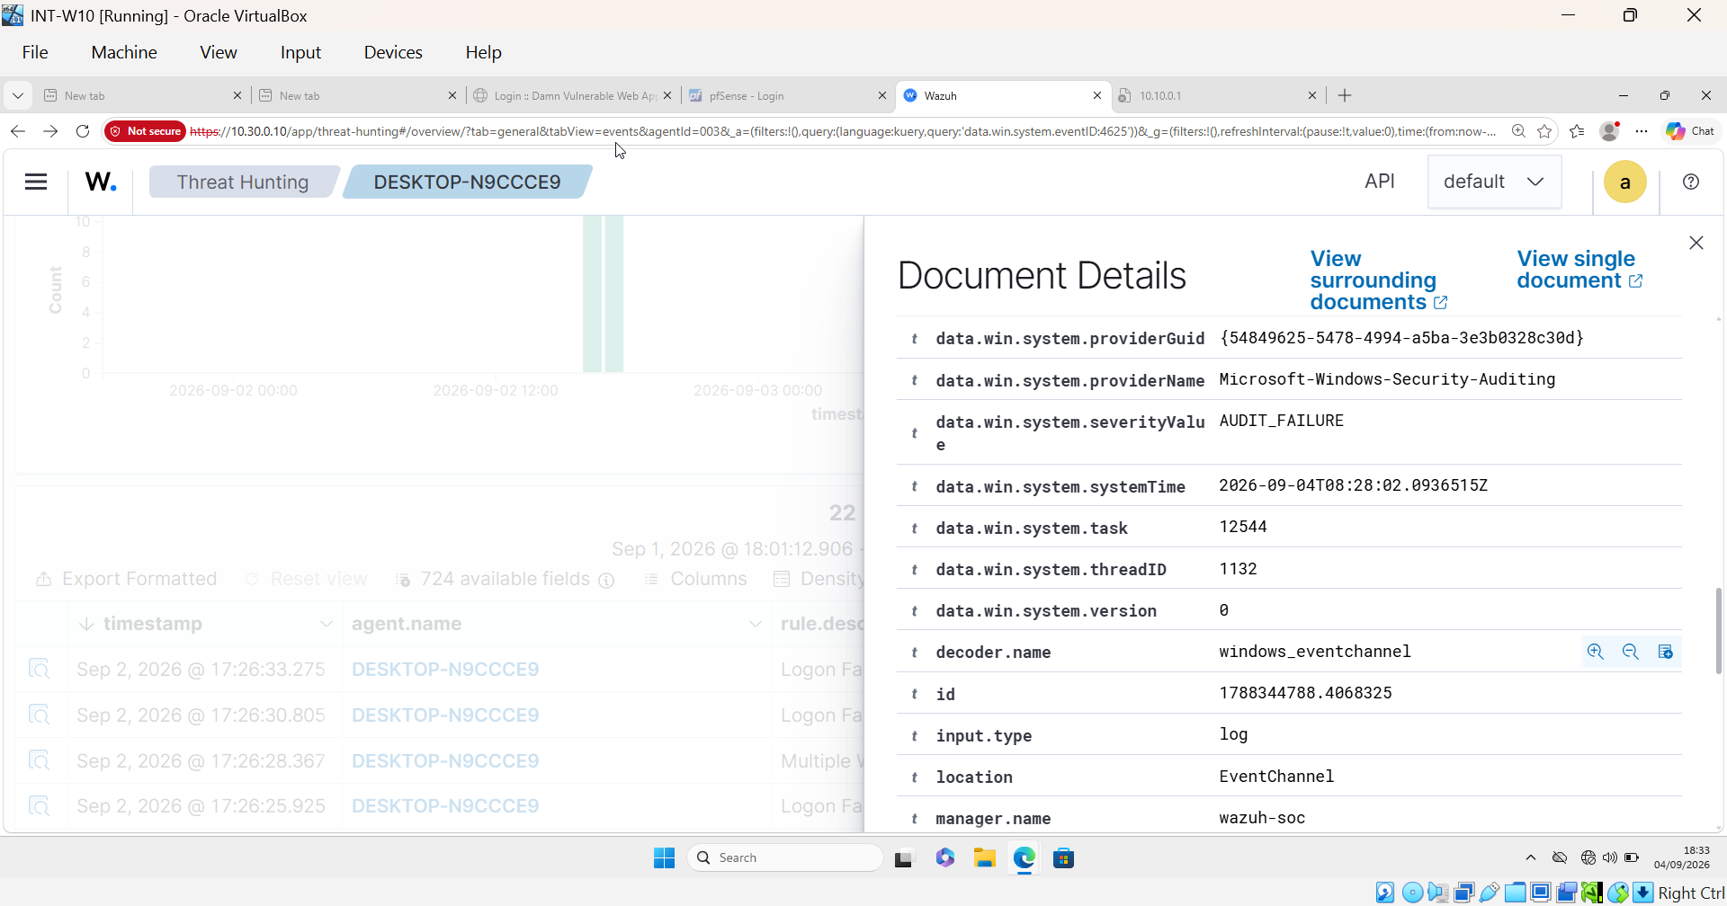
Figure 1d — Event provider metadata (Microsoft-Windows-Security-Auditing, severity AUDIT_FAILURE)
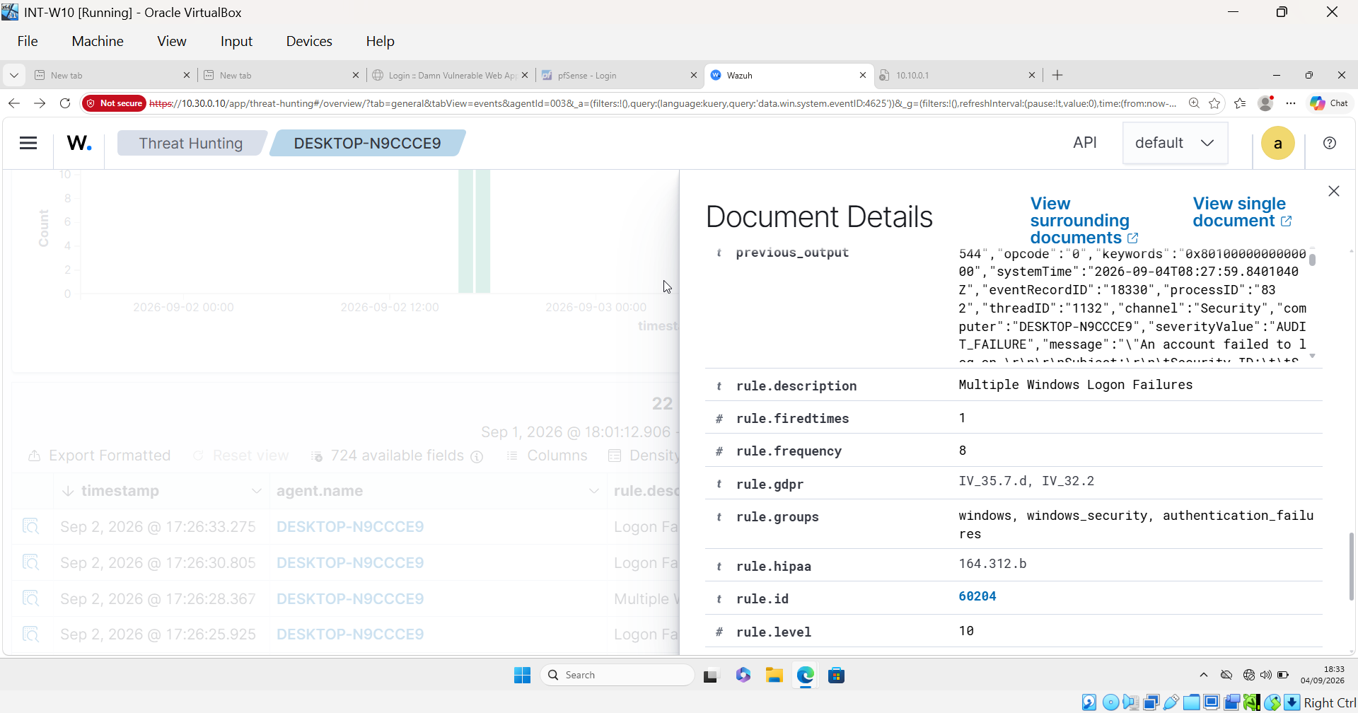
Figure 1e — Wazuh rule metadata: rule 60204, level 10, frequency threshold 8, “Multiple Windows Logon Failures”
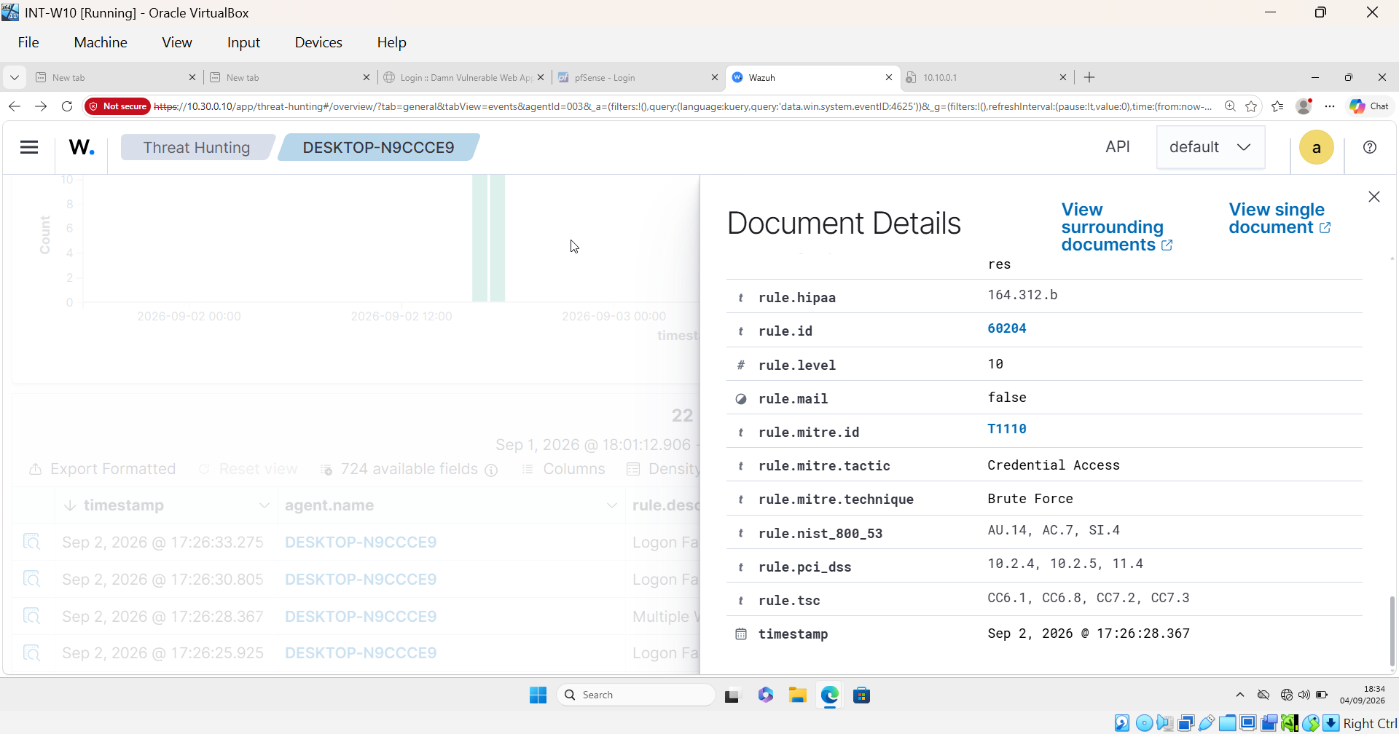
Figure 1f — Final MITRE ATT&CK classification: T1110, tactic Credential Access, technique Brute Force

5. MITRE ATT&CK Mapping
Technique | Description
T1110 — Brute Force | Adversaries attempt to gain access to accounts by systematically guessing credentials. The correlation rule's frequency-based trigger on repeated failed logons is the direct detection mechanism for this technique.

6. Business Impact and Response Action
A compromised workstation account represents a foothold for lateral movement into the internal network, and RDP exposed without additional controls is a common real-world initial-access vector.
Response actions taken and recommended:
- Windows' native account-lockout policy already engaged automatically during the exercise, limiting further guessing attempts.
- Recommend restricting RDP access to VPN or jump-host connections only, removing direct RDP exposure on the internal segment.
- Recommend enforcing multi-factor authentication on any account with RDP access, so a guessed password alone is insufficient for compromise.

7. Conclusion
This scenario validated that Wazuh's Windows authentication monitoring functions correctly out of the box, requiring no custom detection engineering — a useful contrast to later scenarios in this project where default coverage proved insufficient. The exercise closes with both a confirmed true-positive detection and a concrete, actionable recommendation for reducing RDP exposure going forward.
Screenshots: see project screenshot directory screenshots/scenario-01-bruteforce/.

