Point of Sales Management System (POS)
Business Requirements Document (BRD)
(Version 1.0)

Table of Contents
1 Introduction 3
1.1 Purpose 3
1.2 Scope 3
1.3 References 3
2 Current System 4
3 Proposed System 4
4 List of Stakeholders 5
5 Functional Business Requirements 6

<REQID>: <BR-001>: <Login>………………………….………………………………………………...………6

<REQID>: <BR-002>: <Sales Management>……………………………………………………………...……7

<BR-003>: <Product Management>……………………………………………………………………………..8

<Report>:<REQID>: <BR-004>: ................................................................................................................9

<REQID>:<BR-005>:<UserManagement>………..……………………………………………………………10
6 Requirements Priority & Status………………………………………………………11
7 Acceptance/ Fit Criteria………………………………………………………………….11
8 Assumptions, Dependencies and Constraints…………………………………….12
8.1 Requirement Assumptions……………………………………………………………………..12
8.2 Requirements Dependencies…………………………………………………………………..12
8.3 Requirements Constraints….....................................................................................................12
9 Quality Attributes (Non Functional Requirements)…………………………13

Introduction

Purpose
The purpose of this document is to collect, analyze, and define high-level user needs and product features. Focus on capabilities needed by the target users and why these needs exist. The specific requirements of how the application fulfills these needs should be provided elsewhere in the software requirements specifications and the use case specification.

Scope of the project
This system will cover the automation of the following facilities:
- Login
- Sales Management.
- Product Management
- Generate Report
- User Management

References

SL No. | Document Name / Description | File Name/ Ref. No | Document Source | Publishing Organization | Date of Accept
1 | projectProposal.doc |  | \\projects\ POS1.0\ \Static Library\ documents\ | UIU | 01-10-2013
2 | requrementSpecification.doc |  | \\projects\ POS1.0\ \Static Library\ documents\ | UIU | 07-10-2013
3 | Project Potpie : posDemo.exe |  | \\projects\ POS1.0\ \Static Library\ application\ | UIU | 06-11-2013

Current System

Benefits
- Automates the management of Inventory.
- Automates the management of Accounts.
- Multi user and location facility.
- High end security.

Features:
- Inventory management facilitation.
- User management facilitation.
- Account management facilitation.
- Employee information.
- Loan management facilitation.
- Payment using card, bKash etc.

Proposed System

Previously developed POS Software was technology outdated and was some feature problem. Previously POS developed on PHP, which has a security issues and not structured. Now currently proposed system will be developed in ASP.net with MVC4 technology and overcome feature problems. Server will support both SQL and MYSQL.

List of Stakeholders

Category | Name | Designation and  (Office Address, Email, Mobile)
Vendor | Mozaffar Hossain  (011093005) | Developer  (UIU, uiu.shahin@yahoo.com, 01719205967)

Functional Business Requirements

<BR-001>: <Login>

Requirement ID | BR-001
Requirement Type | Input
Description/Business Logic
# Access for Sales persons
# Access for Admins
Justification | - Sales persons can access only POS screen  - Admins can access all
Prototype/Mock Screen
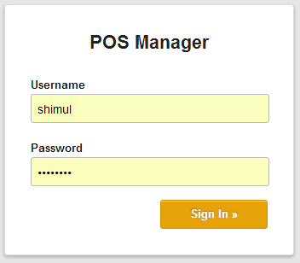

<BR-002>: <Sales Management>

Requirement ID | BR-002
Requirement Type | Input and Output
Description/Business Logic
# Sales person can add product using BARCODE Reader Or manually for Sales.
# System can automatically show the product stock.
# Sales person can add, edit, delete product quantity or remove product.
# Sales person can select payment method (Card/Cash).
# System automatically generate Date, Invoice No and Calculate Total amount.
# When Sales person complete the transaction and confirm to the system, then receipt will be generated by the system and print the receipt.
Justification | - Sales person can cancel the process.  - System can be failed at any time.
Prototype/Mock Screen
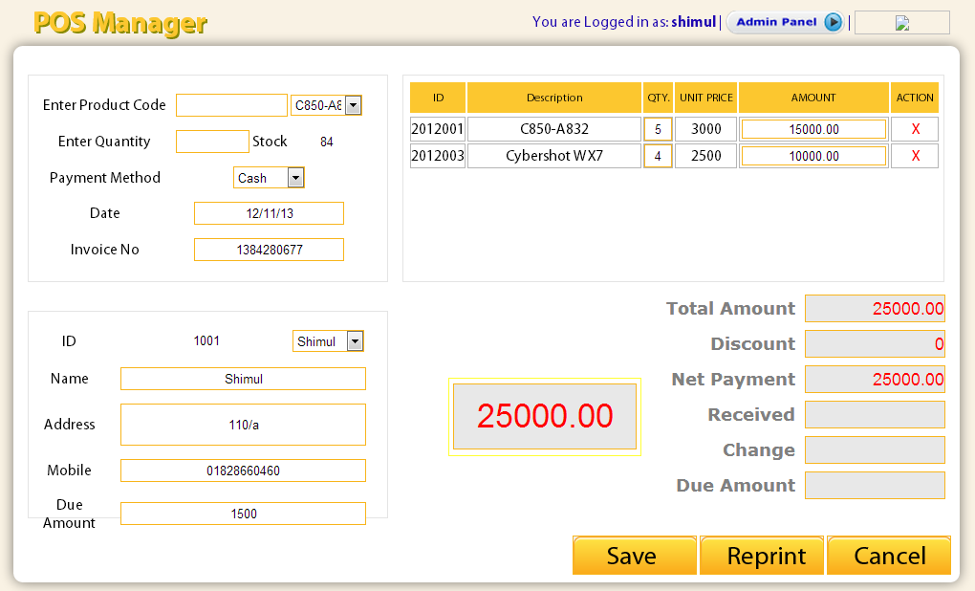

<BR-003>: <Product Management>

Requirement ID | BR-003
Requirement Type | Input
Description/Business Logic
# Add/Update/Delete Product Category
# Add/Update/Delete Product Brand
# Add/Update/Delete Product
Justification | Admins can Manage(add/edit/delete) Products/Category/Brand
Prototype/Mock Screen
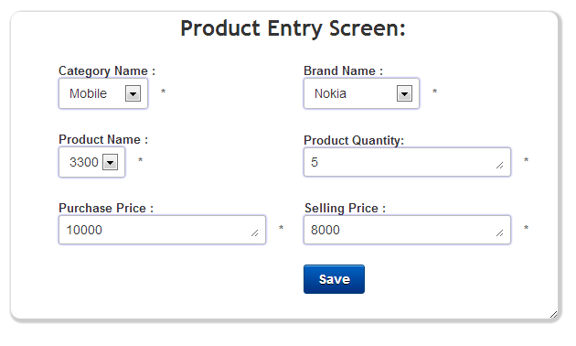

<BR-004>: < Report >

Requirement ID | BR-004
Requirement Type | Output
Description/Business Logic
# Sales Report
# Purchase Report
# Total Product Report
Justification | Admin can generate all types of report.
Prototype/Mock Screen
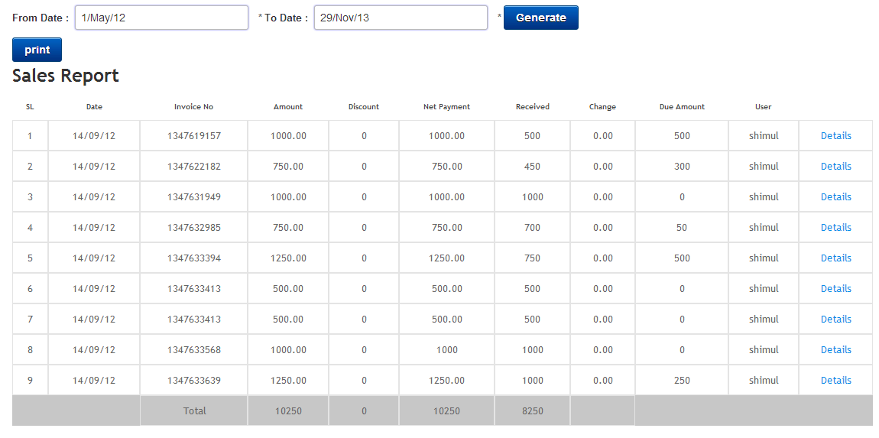

<BR-005>: <User Management>

Requirement ID | BR-005
Requirement Type | Input
Description/Business Logic
# Add User
# Update User
# Delete User
Justification | Admin can manage all types of users
Prototype/Mock Screen
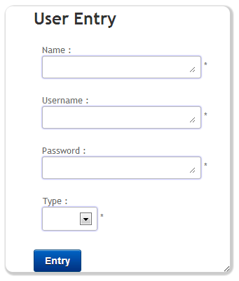

Requirements Priority & Status

Req. ID | Priority  (Essential (E), Conditional (C),  Optional (O)) | Status  (In-Process (I), Agreed To (A), Rejected (R)) | Reason of Priority & Status
[BR-001] | [E] | [A] | For Security
[BR-002] | [E] | [A] | ---
[BR-003] | [E] | [A]
[BR-004] | [E] | [A]
[BR-005] | [E] | [A]

Acceptance/ Fit Criteria

Req. ID | Criteria for Fit/ Accept Requirements
[BR-001] | User should login to access the system.
[BR-002] | Sales person can add product using BARCODE Reader Or manually for Sales.
[BR-003] | Admin can Add/Update/Delete Product.
[BR-004] | System can generate all kind of report automatically.
[BR-005] | Admin can Add/Delete/Update sales person.

Assumptions, Dependencies and Constraints

Requirement Assumptions
There is no assumption in requirement in this module.

Requirements Dependencies
Req. Id | Related Req. Id | Description
[BR-002] | [BR-001] | For Sales Management sales person should login first.
[BR-003] | [BR-001] | For Product Management Admin should login first.
[BR-004] | [BR-001] | For Report Admin should login first.
[BR-005] | [BR-001] | For User Management Admin should login first.

Requirements Constraints
There are no constraints on requirements.

Non Functional Requirements

SL No. | Requirements Description
[NBR-001] | Security:  Security requirement will have the following features:  - Role  - Privilege  - User  - User Log In  - User Log Out  Role base privilege(User will assign privilege)
[NBR-002] | Reliability & Availability:  The system needs to be available during the office time – at least whenever the database server is not kept shut-down.
[NBR-003] | Usability:  The system should be easily navigated. Dropdown menu needs to be used to ease the navigation. The following will meet the usability requirement:  - Screen resolution should be change in dynamically for any resolution PC also mobile. (Responsive)  - Date time should pick up from server and Date Time should be Auto adjust with The PC however PC Date time format is any Format is (dd/mm/yyyy)Font of the software should be large enough so that user can read easily  - The operator should be able to navigate through the fields with ease using Tab or Enter key  All drops down list should have auto fill feature.
[NBR-004] | Supportability:  - Coding will have in line documentation and proper indenting between functions, variables, etc.  - There will be naming convention for coding.

