Whenever you're ready, this is our top 1% advice:

We give away 99% of our content for free. The 1% below is our best stuff, broken down step-by-step so we spoon feed you the tactics that get you to President's Club.

The 30MPC Cold Call Course shows you exactly how Top Reps handle every moment of the call – from opener to objection to close – with the words, tone, pacing, & confidence that actually book meetings & win bigger deals.
Backed by Gong Data from 300 Million Cold Calls.

Cold Calling Course: Cold Calls to President's Club
—-
Most cold calls are won or lost within the first 60 seconds. Most end in brush hang-ups and dismissals because every seller is using the same openers, making the same tone mistakes, and using the same buzzword-filled pitches that immediately categorize you as a telemarketer.
The goal of the first 60 seconds is to get the next 60 seconds. If you can get past the first 60 seconds, that’s when you’re actually having a conversation instead of being brushed off.
And the way you do that is by mastering the two components that comprise the first minute of a cold call. Here’s what’s inside:
Openers: How do you get a complete stranger to hear you out when you called them out of the blue?
- Why most cold calls are lost in the first 30 seconds
- How should you open a cold call instead?
- The Heard The Name Tossed Around Opener
- The Tailored Permission Based Opener
Problem Propositions: How do you talk about your product in a way that doesn’t make you sound like a Billy Mays commercial?
- Why traditional value propositions and pitches suck
- The Problem Proposition
Full Examples: Four examples of the entire first 60 seconds together with your opener and a problem proposition. Listen very closely to the tone.
- Example 1: The Tailored Permission Based Opener
- Example 2: The Heard The Name Tossed Around Opener
- Example 3: Selling 30MPC Sponsorships to Sales Tech Companies
- Example 4: Selling Compensation Software to HR Leaders

Let’s dive in.

The 2 Worst Ways To Open A Cold Call
When your prospect answers your cold call, their radar is on high alert for any cues that tell them you’re another worthless telemarketer that they should hang up on:
- The overly chipper tone of voice
- The robotic sales script
- The fact that you obviously didn’t research them
- The canned openers that everyone else uses
Everything you do and say on a cold call must sound and feel different than the typical cold calls your prospect usually receives.
That’s why the following two cold call openers are banned from your cold calling dictionary because they immediately categorize you as a telemarketer.
Banned Opener #1: How’s your day going?

You and I both know you don’t really care about the day of the person on the other end of the line. You’re not calling random CFOs to inquire about the status of their days…you’re trying to sell them something.
You know it, I know it and they know it. Inevitably what you’ll hear in return is a deep sigh, followed by “I’m fine, what’s this regarding?” which is codeword for “what are you trying to sell me, telemarketer?”
Banned Opener #2: Did I catch you at a bad time?
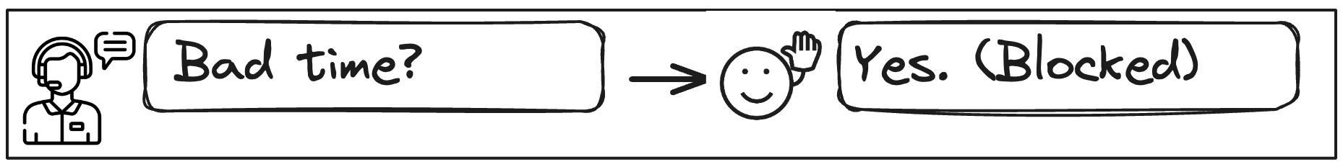
You’re making a cold call. Of course it’s a bad time. I can’t count the number of times I’ve seen a prospect say “yes, it’s a bad time,” then never answer your call ever again as if they were part of the witness protection program.
And just like the last one, this is a dead giveaway that you’re a telemarketer. You’ll hear the exact same sigh because you’ve categorized yourself with the rest.

How Should You Open A Cold Call Instead?
So, how do you avoid coming off like a telemarketer?
You open the cold call with context about them – a mutual investor, another partner that you work with in the same office, a customer in the same industry, or anything that demonstrates that you’re not a complete stranger.
Leading with context completely changes the demeanor of the call for 3 reasons:
- The Sit-Up Moment: They sit up and realize you might actually work with their peers, so you’re not a complete rando that they can treat like trash without it coming back to them.
- Can’t Be Canned: Context-first openers can’t be canned even if everyone in the world adopted them, because the context is unique to the prospect.
- Telemarketer Perception Snapped: You demonstrate that you took the time to research them in the first 5 seconds of a cold call, which sets you apart from the spam callers.
There are two context-first openers we’ll provide to do this in practice: The Heard The Name Tossed Around Opener and The Tailored Permission Opener.

The Heard The Name Tossed Around Opener
There are three main pieces to the The Heard The Name Tossed Around Opener as broken down below:
Talk Track: The Heard The Name Tossed Around Opener | Steps
Hey Bill, we work with a few other partners in the Skadden LA office.  It’s Armand from Northwestern…  Heard the name tossed around? | Lead with context  THEN intro yourself  Heard the name?
Lead with context before you say anything else, even your name. The first words that come out of your mouth determine whether or not the prospect listens to anything else you say.
- Same Investor: We work with a few other Sequoia portfolio companies.
- Same Coworkers: We work with a few other Partners in the Downtown LA office.
- Same Situation: We work with a few other multifamily homeowners down the block.
- Same Industry Peers: We work with a few folks like Gong and Salesforce.
- Same Geo + Persona: We work with other compensation leaders in Salt Lake City.
Now, you’re ready to introduce yourself and ask the question. “It’s Armand from Northwestern, heard the name tossed around?”
The final question is the twist at the end of the punch. You already got Bill to sit up by telling him that you work with his peers, and now we’re going to lean into it even more. We want him thinking: I haven’t heard of them… but should I have?
***
After you ask the question, the vast majority of people will say “no” so let’s start there.
I’ll say something like “Ha! Guess I’m not as popular as I thought. Well, the reason for my call is…” and from there I go into a very short pitch (to be covered in the next section).
But if someone says they have heard your name tossed around, you don’t need to pitch. Instead, jump in with the following line:
“Oh good, we’d normally be working with someone like you by now. What’d you hear?”
From there, they usually still have no clue what you do. So you end up giving the same pitch that you’d give if they said no anyway.

The Tailored Permission Opener
The Tailored Permission Opener works because it owns that you’re making a cold call and disarms the prospect with brutal honesty.
Talk Track: The Tailored Permission Opener | Steps
Emma, I just finished reading your press release about your new office opening.  I’m gonna be honest, this is a cold call, but it is a well-researched one.  Can I get 30 seconds to tell you why that press release prompted me to call you specifically, then you can tell me whether or not it makes sense for us to speak? | Lead with context  Own the cold call  Get permission to pitch
The key here is to lead with context related to a problem you solve instead of a random piece of information (like their alma mater).
For example, when I sold accounting software to law firms, I would lead with things like:
- “I just read about the big case win” (which means they’d be collecting money)
- “I just saw you opened a new office” (which has tax implications)
- “I was reading up on the new litigation practice” (which adds billing complexity)
After leading with context, we’ll come clean that this is indeed, a good ‘ol cold call.
“I’m gonna be honest, this is a cold call, but it is a well-researched cold call.”
It’s really hard to get mad when you acknowledge that you’re interrupting their day. Lean into humor and you’ll dispel the tension even more. Try phrases like like:
- “I know I’m an interruption.”
- “I hate to break it you, but this is a cold call”
- “You’re probably gonna hate me for this, but this is a cold call”
From here, ask for permission to pitch and give them perceived control.
Can I get 30 seconds to tell you why I called, then you can totally hang up on me if it doesn’t make sense to speak from there?
Make it clear exactly how long you need (30 seconds) and then let them decide what happens after that 30 second window. I know it feels counterintuitive, but when your prospect has complete control over the outcome of the call, they feel safe and they’ll actually listen to you.
What do I do if they say “no”?
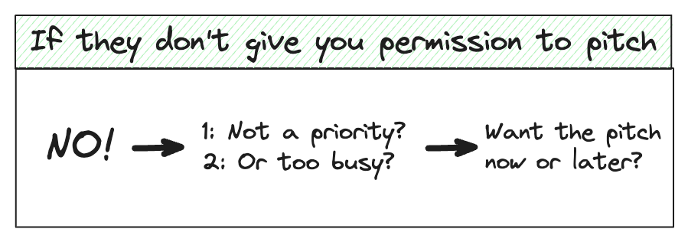
When a prospect denies you permission to pitch, they’re not objecting to your product. They’re objecting to your interruption and swatting you away as a telemarketer.
You need to get a conversation going to break the telemarketer perception, so incentivize them to share more about why they wouldn’t let you proceed by saying:
Shoot, my bad. Just so nobody from my team bugs you again…  Is it just that I caught you at a horrible time, or is it you already know what we do and this just isn’t a priority at all? | Provide an incentive  Give them 2 potential reasons
It’s critical you provide the incentive (no more cold calls!) for them to share more, otherwise they have no reason to stay on the line.
Almost no prospect will really know what you do, so from there it almost doesn’t matter what they say. You’ll respond with something like:
I appreciate you being upfront. To be honest, I don’t really love having to interrupt people like this and I’m sure you’re not a fan either.  I do promise that I did some prep for this call. Could I take 30 seconds to share what I found so I don’t interrupt you again, or would you rather have me send a calendar invite for the top of the hour to call back? | Reveal the human behind the phone  Give them options: now or later
Give them the option to take the pitch now or send them a calendar invite to call when they’re a bit more free.
Buying yourself some talk time and using humanizing language gives them an extra 60 seconds or so to realize you're an actual human being capable of having a conversation – which gives you a far better chance of earning their permission to share your pitch now (or having them actually pick up at the agreed upon callback time).

Why “Value Propositions” And “Pitches” Suck
There are three reasons why the traditional value proposition sucks:
- They often include vague telemarketer buzzwords: Phrases like single source of truth, all-in-one platform, and leading provider of X trigger every telemarketer alarm because they're the same generic value phrases that reps use at every company.
- People act on problems more than benefits: Human beings are more motivated to take action to get rid of pain than they are to achieve benefits. If someone has a headache, they’re gonna take the Advil. But even if people know that there are health benefits to taking a multivitamin, people are far less likely to jump out of their seat to take one.
- Value has no context without a problem: Unlike headaches, many outbound prospects need to be reminded of their problems before they can see the value of your solution. They won’t care about your titanium-plated non-stick pan if they like their cookware. They will if you remind them that the egg stuck to their pan last week.
It’s on you to connect the dots for them by explaining a problem in such triggering detail that it becomes impossible to ignore your solution.
A triggering problem should transport them back to the crappiest part of their day when they thought damn… I really wish there was a way for me to not do this anymore.
When you demonstrate that you understand the exact problem they’re facing, you establish yourself as an industry insider who “gets” their business… not a telemarketer.
If you nail the problem, you only need one sentence to describe your solution because all you need to say is that you can make the problem go away.

The Problem Proposition
A Problem Proposition is a problem described in such triggering detail that you only need one sentence to describe your solution because all you need to say is that you can make the problem go away.
Step 1: Triggering Problem
For a problem to trigger a painful memory, you need to repaint the story as if you were describing a movie scene. That may include many of the following descriptors:
- Persona: Who felt the problem? (CFOs of NYC Law Firms, compensation leaders of Sequoia portfolio companies)
- Annoyances: What were they annoyed about? (bill rejections, support tickets)
- Scenery: What was the setting when it happened? (after a case win, Tax Day)
- Emotion: How would they describe the feeling? (frustrated, mind numbing)
Step 2: One-Sentence Solution
The magic formula is “we do X so that the problem goes away” where X is your single biggest differentiator that allows you to solve the problem.
You’ll be tempted to include every way that you solve the problem. Don’t. Less is more. Instead, rely on the problem description and the way you’ve helped other people solve that problem (aka social proof) to fill in the gaps.
Step 3: Interest-Based Call-to-Action
The single most important thing is to validate their interest before anything else. Starting with a small ask (are you open to learning more?) increases your chances of an initial yes, at which point you can inch forward and go for the meeting.
Here are a few ways you can phrase the interest-based CTA:
- My guess is this came out of left field for you, but open to learning more when I’m not calling you totally outta the blue?
- I’m sure you have something in place, but does any of that sound even moderately interesting to you?
- My guess is you’re all set, but would you be opposed to taking a peek at what that looks like?

Full Example 1: Selling Billing Software To Law Firms
Insurance companies require law firms to follow very strict rules when sending their bills. If an attorney sends a bill that uses even a single word that the insurance carrier doesn’t pre-approve, the carrier can refuse to pay the bill!
Thus, CFOs of big law firms spend an inordinate amount of time reviewing and revising bills so that they don’t get their bill rejected.
The Tailored Permission Opener here references a case win from their website, which usually means the firm gets to send their client a bill. From there, I highlight the most frustrating part of the billing process and include some brief social proof in my description of the solution.
You (Tailored Permission Opener): Armand, I just finished reading your press release about your new office opening.  I’m gonna be honest, this is a cold call, but it is a well-researched one.  Can I get 30 seconds to tell you why that press release prompted me to call you specifically, then you can tell me whether or not it makes sense for us to speak?  Prospect: Sure.  You (Problem Proposition): The reason I’m calling you is, most of the CFOs of insurance defense law firms think it’s ridiculous that they have to deal with so many deductions, rejections, and appeals they get from insurance carriers after winning a big case.  We help other insurance defense law firms cut down on bill appeals by alerting attorneys to billing guideline violations right when they’re doing their time entries…  And I’m wondering if you might be open to learning more when I’m not completely calling you out of the blue? | 1: Lead with context  2: Own the cold call  3: Ask for permission  1: Triggering problem  2: 1-sentence solution  3: Interest-based CTA
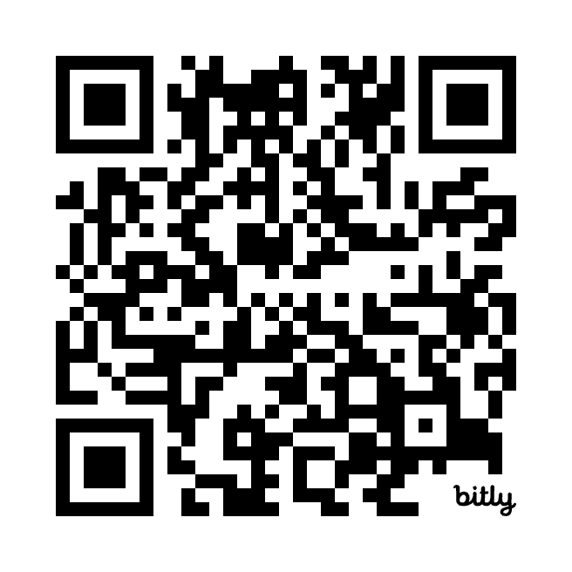

Full Example 2: Selling Insurance To Law Firm Partners
Going back to the insurance example, we’ll lead with the Heard The Name Tossed Around Opener and include the fact that we work with other partners in their office, which creates a sit-up moment.
From there, we’ll explain the triggering problem that other partners have: making way too much freaking money and giving half of it away every year:
You (Heard The Name Tossed Around Opener): Hey Nick, we work with a few other partners in the DLA Piper office.  It’s Armand Farrokh, from Northwestern.  Heard the name tossed around?  Prospect: I don’t think I have. But how can I help you?  You (Problem Prop): Well shoot, guess that makes this a good old cold call!  Typically when I’ve talked to other partners at DLA Piper, you all have the wonderful problem of making so much money that you have to give 45% of it back in taxes every April.  So we've helped them with a lot of things: investing, tax planning, etc. – so you don’t have to give up half your paycheck anymore.  My guess is you’ve got this handled. But open to hearing more, if nothing else so you know what’s out there? | 1: Lead with context  2: THEN intro yourself  3: Heard the name?  1: Triggering problem  2: 1-sentence solution  3: Interest-based CTA
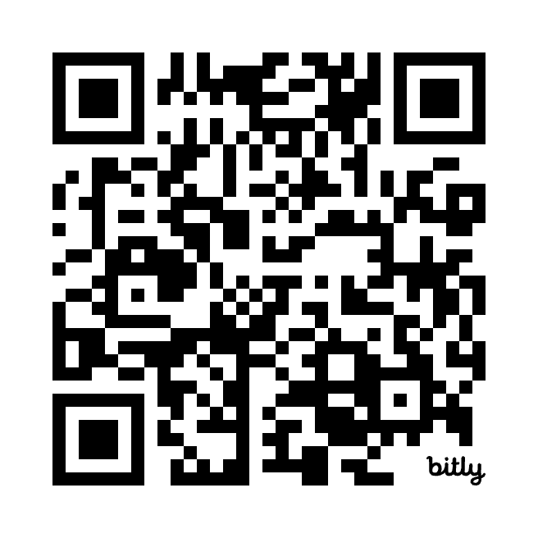

Full Example 3: Selling 30MPC Sponsorships to Sales Tech Companies
When I’m not writing, I sell our sponsorships for 30 Minutes to President's Club. Most of our customers are Sales Tech companies that want to advertise on our podcast and newsletter.
This Tailored Permission Opener leads with a product release on their website, then transitions to the problem that we solve: making sure their product launch isn’t a dud because they couldn’t break through the noise. The one sentence solution? A big announcement to over 2 million salespeople.
Nick (Tailored Permission Opener): Armand, I just finished reading about the launch of your new power dialing tool.  I’m gonna be honest, this is a cold call, but it is a well-researched cold call.  Can I get 30 seconds to tell you why I called, then you can totally hang up on me if it doesn’t make sense to speak from there?  Armand (Prospect): Hah, fine. Go for it.  Nick (Problem Prop): Usually when I talk with CMOs of Sales Tech companies, they tell me it can be really frustrating to put a ton of work into a new product launch only to have it fall on deaf ears, since the sales tech space can get really noisy.  About 2 million salespeople follow our podcast and newsletter series, and folks like Gong and Acme advertise with us to make sure their launches never fall flat.  I think our audience would be interested in your power dialer, and I’m wondering if you’d be against learning more sometime? | 1: Lead with context  2: Own the cold call  3: Ask for permission  1: Triggering problem  2: 1-sentence solution  3: Interest-based CTA
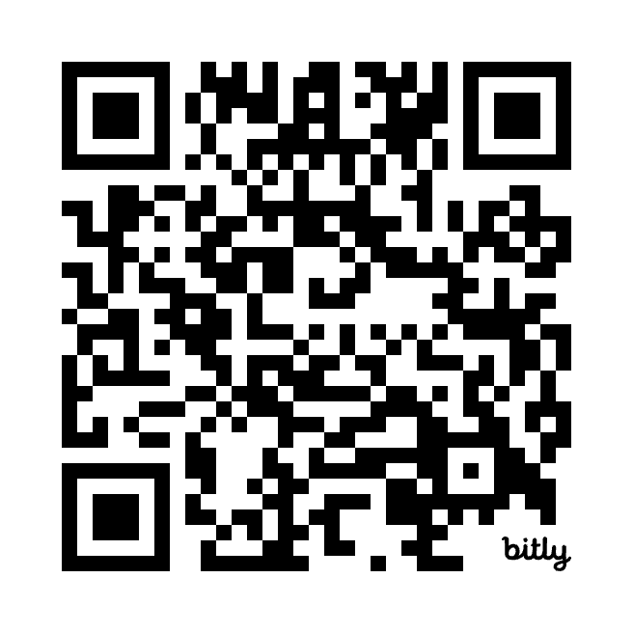

Full Example 4: Selling Compensation Software to HR Leaders
When I sold compensation software at Pave, we primarily targeted HR leaders at tech companies. Even if they weren’t interested, they’d hear you out if worked with a company that shared the same investors: that’s what we’ll reference in the Heard The Name Tossed Around Opener..
From there, the triggering problem is that HR leaders piece together separate confidential spreadsheets for every manager in the company to ensure compensation details don’t get leaked. That means hundreds of spreadsheets for a 1000 person company, which leads to serious compensation mistakes (and ulcers):
Armand (Heard The Name Tossed Around Opener): Hey Nick, we work with a few Sequoia portfolio companies.  It’s Armand, from Pave.  Heard our name tossed around?  Nick (Prospect): No, I haven’t.  Armand (Problem Prop): Well shoot, I guess that makes this one a good old cold call.  Usually when I talk to a Head of People Ops in Q1, you cannot be found because you’re buried underneath 17,000 spreadsheets trying to run a merit cycle without making a compensation mistake.  So Pave pulls together your payroll, equity, and comp data into one place so you never have to run merit cycles in spreadsheets again.  I know you’re probably a spreadsheet wizard. But open to taking a look so you know what’s out there? | 1: Lead with context  2: THEN intro yourself  3: Heard the name?  1: Triggering problem  2: 1-sentence solution  3: Interest-based CTA
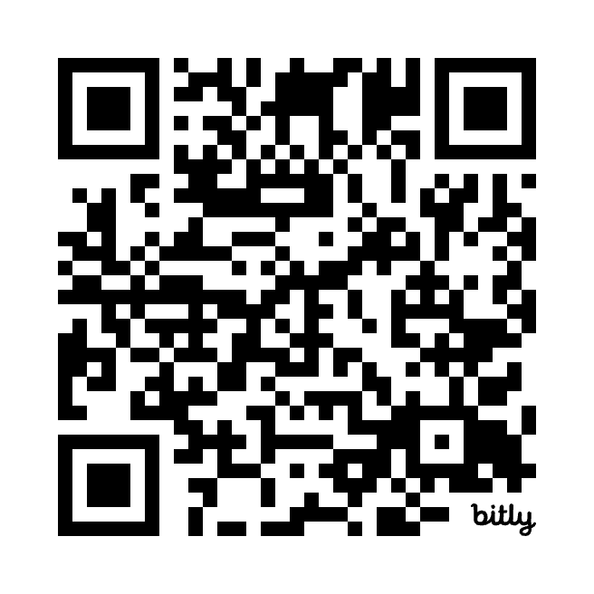

Whenever you're ready, this is our top 1% advice:

We give away 99% of our content for free. The 1% below is our best stuff, broken down step-by-step so we spoon feed you the tactics that get you to President's Club.

The 30MPC Cold Call Course shows you exactly how Top Reps handle every moment of the call – from opener to objection to close – with the words, tone, pacing, & confidence that actually book meetings & win bigger deals.
Backed by Gong Data from 300 Million Cold Calls.

Cold Calling Course: Cold Calls to President's Club

