Software Requirements Specification
Nagorik Sheba
An Agentic Web and Mobile Platform for Transparent Municipal Complaint Management with Citizen Participation
Version 0.1 - Week 1 Draft
Prepared for: Web Programming and Mobile Application Development
Department of CSE, Khulna University, Khulna
Document drafted with AI-assisted requirement writing; reviewed and edited by the project team.
Prepared by
Team members:
Mozaza-Al-Zaman
Student ID: 220210
Md. Tawfiqul Islam
Student ID: 220214

Prepared for
Dr. Kazi Masudul Alam
Professor
Computer Science and Engineering Discipline
Khulna University, Khulna

Table of Contents
Table of Contents 2
1. Introduction 3
1.1 Purpose 3
1.2 Scope 3
1.3 Objectives 4
1.4 References 4
2. Overall Description 4
2.1 Product Perspective 4
2.2 Product Functions (Summary) 4
2.3 User Classes and Characteristics 4
2.4 Operating Environment 4
2.5 Design and Implementation Constraints 5
2.6 Assumptions and Dependencies 5
3. System Features (Functional Requirements) 5
3.1 User Registration & Authentication 5
3.2 Complaint Submission, Search & Endorsement 6
3.3 AI Agent Pipeline 6
3.4 Department Staff Dashboard 6
3.5 Public Toilet Locator & Rating 7
3.6 Emergency (Fire Service) Directory 7
3.7 SMS Channel 7
3.8 Public Transparency & Participation 7
4. External Interface Requirements 8
4.1 User Interfaces 8
4.2 Hardware Interfaces 8
4.3 Software Interfaces 8
4.4 Communication Interfaces 8
5. Non-Functional Requirements 8
6. System Architecture Overview 9
6.1 Client Layer 10
6.2 Application / Agent Layer 10
6.3 Data Layer 10
6.4 Jurisdiction Layer 11
8. Appendix-------------------------------------------------------------------------------------------------------------------------------11
8.1 Appendix A: Glossary-----------------------------------------------------------------------------------------------------------11
8.2 Appendix B: Analysis Model---------------------------------------------------------------------------------------------------12
8.3 Appendix C: Issues List---------------------------------------------------------------------------------------------------------12

1. Introduction

1.1 Purpose
This Software Requirements Specification (SRS) defines the functional and non-functional requirements for Nagorik Sheba, a multi-agent AI civic complaint management platform for Bangladesh. It is intended to guide design, implementation, and evaluation of the system across the course project

1.2 Objectives
- Reduce the gap between citizens reporting civic problems and the correct department acting on them, by routing each complaint automatically and directly to the single responsible department, eliminating manual triage delay.
- Increase trust in the reporting process by verifying complaint authenticity (photo consistency, duplicate detection) before it reaches staff, reducing the ability to game or spam the system.
- Prioritize the most urgent and most-affecting issues first, using a frequency- and endorsement-weighted scoring model so widely-reported problems surface above isolated ones.
- Make the system usable regardless of smartphone access or connectivity, by supporting web, mobile, and SMS as equally valid ways to report a complaint.
- Increase government transparency and public accountability, through a public complaint feed, department-level resolution scorecards, and citizen ability to reopen unresolved complaints.
- Demonstrate a resilient AI agent architecture, where every LLM-backed agent has a rule-based fallback, so the system remains functional even without continuous external API access — an important constraint for a public-service system in Bangladesh.
- Extend civic value beyond complaint handling, by including public toilet location/cleanliness data and an emergency (fire service) contact directory, addressing everyday citizen needs alongside formal grievance reporting.
- Design with Bangladesh's actual local government structure in mind (City Corporation / Pourashava / Union Parishad, ward-level jurisdiction), rather than assuming a single-city, single-tier government model.

1.3 Scope
Nagorik Sheba allows citizens to report local civic problems (road, water, electricity, gas, sanitation, streetlight, drainage) via a website, mobile app, or SMS. The platform additionally provides a public toilet locator with cleanliness ratings, an emergency (fire service) contact directory, complaint search and community endorsement, and public transparency features including a department performance scorecard.
Submitted complaints are verified, classified, and prioritized by a pipeline of AI agents before being routed to the single correct government department's dashboard.

Real-time integration with the Bangladesh Election Commission's NID database remains out of scope for this academic project, as such access requires formal EC licensing (ToS approval and ICT infrastructure review) currently limited to institutions such as banks and Mobile Financial Service providers (e.g., bKash, Nagad). For development and demonstration purposes, the project uses a sandbox testing approach: a programmatically generated dataset of synthetic, clearly-watermarked "SPECIMEN" NID cards — populated with randomized names, addresses, and non-sequential test ID numbers — is paired with project team members' own consenting selfies to validate the perceptual-hash self-consistency check locally. No real third-party identity documents or government-issued records are collected, stored, or used at any stage. This sandbox dataset is not committed to the project repository and is not used for any production or public-facing deployment. A licensed telecom SMS short code and production-grade PostGIS deployment also remain out of scope, and are documented as future work with a stated upgrade path.

1.4 References
- mySociety FixMyStreet Platform (open-source civic reporting reference)
- Indonesia LAPOR! national multi-channel grievance platform
- India Swachhata / Swachhata-MoHUA civic complaint app
- Pakistan Citizen's Portal (PMDU)

2. Overall Description

2.1 Product Perspective
Nagorik Sheba is a new, standalone system with a client-server architecture: a responsive website and mobile app as clients, a Node.js/Express backend, and a relational database. It is scoped to Bangladesh's specific three-tier local government structure (City Corporation / Pourashava / Union Parishad) and adds an AI agent pipeline for automated verification, classification, and prioritization rather than relying solely on manual staff triage.

2.2 Product Functions (Summary)
- Citizen account creation with identity self-consistency check
- Complaint submission via web, mobile, or SMS with photo, text/voice, and GPS location
- Automated AI agent pipeline: moderation, classification, verification, prioritization, routing
- Department-specific staff dashboards with status management
- Duplicate detection, resubmission locking, and community endorsement (vote for similar complaints) of similar complaints
- Complaint search
- Public toilet locator with cleanliness ratings
- Nearby emergency (fire service) contact directory with click-to-call
- Public transparency feed and department scorecards

2.3 User Classes and Characteristics (User roles)
- Citizen (normal user) — submits and tracks complaints, rates toilets, endorses complaints; assumed to have basic smartphone literacy or, for the SMS channel, only basic phone literacy.
- Department Staff — views and manages complaints routed to their department only; assumed to have basic computer literacy and a desktop/laptop for the multi-panel dashboard view.
- Administrator — seeds departments, creates staff accounts, approves citizen-submitted complaint locations (implicit role, minimal UI in current scope). Administrator actions are performed via setup scripts rather than a UI.
- Public visitor (unauthenticated) — can browse the public complaint feed, toilet map, and department scorecards without an account.

2.4 Operating Environment
- Server: Node.js + Express, deployable on standard Linux hosting
- Database: SQLite (prototype) with a documented PostgreSQL + PostGIS upgrade path
- Client: any modern mobile or desktop browser (web, mobile-first responsive); Android/iOS via a future Expo/React Native app
- SMS: telecom SMS aggregator webhook (Twilio for prototype/demo; BD-licensed aggregator such as SSL Wireless for production)

2.5 Design and Implementation Constraints
- Real-time integration with the Bangladesh Election Commission's NID database is out of scope — such access requires formal EC licensing (ToS approval and ICT infrastructure review). The project instead uses a sandbox testing approach: a perceptual-hash self-consistency check validated against a programmatically generated dataset of synthetic, watermarked "SPECIMEN" NID cards paired with team members' own consenting selfies. No real third-party identity documents are collected or stored. Real EC database integration is documented as future work.
- Every AI agent must have a rule-based fallback so the pipeline works without a live LLM API key.
- Voice-to-text input depends on the browser's Web Speech API.
- Map: OpenStreetMap tiles for the visual map display (free, no key required), combined with Barikoi's reverse-geocoding API (free tier, 30,000 requests/month) for resolving a GPS point to district/upazila/union .

2.6 Assumptions and Dependencies
- Citizens submitting via SMS do not require a pre-existing account; identity is the phone number. This is a deliberate design trade-off — SMS complaints carry weaker identity verification than app/web submissions (no NID check), which is why the Verification Agent flags SMS-only complaints as a lower verification tier (REQ-AI-07).
- Ward-boundary resolution relies on Barikoi's City Corporation API (Ward by Geolocation, Zone by Geolocation) for jurisdiction routing, with free-tier access (30,000 requests/month) assumed sufficient for development and demo use. Barikoi's ward-level coverage is confirmed for Dhaka's city corporations; coverage for the project's demo city (Khulna) will be verified during implementation. If ward-level granularity is unavailable outside Dhaka, a manually approximated polygon boundary for Khulna City Corporation (and one Union Parishad) serves as the fallback.
- An external LLM API (e.g., Claude API) is available for the moderation, classification, priority, and content-consistency checks, with local rule-based fallback logic (REQ-AI-06) ensuring the pipeline still completes end-to-end if the API is unreachable or unavailable during development or demonstration.

3. System Features (Functional Requirements)

3.1 User Registration & Authentication
ID | Requirement | Priority
REQ-UM-01 | System shall allow a citizen to create an account using a selfie photo, NID card photo, mobile number, and email. | High
REQ-UM-02 | System shall run a perceptual-hash self-consistency check between the selfie and NID photo as a placeholder for full eKYC verification. | High
REQ-UM-03 | System shall allow department staff to log in with credentials issued by an administrator; staff accounts are not self-registered. | High
REQ-UM-04 | System shall route a logged-in user automatically to the citizen dashboard or staff dashboard based on account role, with no manual toggle. | High
REQ-UM-05 | System shall authenticate all sessions using JWT tokens and store passwords using bcrypt hashing. | High

3.2 Complaint Submission, Search & Endorsement
ID | Requirement | Priority
REQ-CS-01 | System shall allow a citizen to select a complaint category from a fixed list (road, water, electricity, gas, sanitation, streetlight, drainage). | High
REQ-CS-02 | System shall allow complaint details to be entered via text or voice (Web Speech API, Chrome-only in current scope). | Medium
REQ-CS-03 | System shall allow attachment of one or more photos as evidence of the complaint. | Optional
REQ-CS-04 | System shall capture the exact location of a complaint via the device's Geolocation API and a map preview. | High
REQ-CS-05 | System shall resolve the submitted GPS coordinate to the correct jurisdiction (ward / city corporation / union parishad) before routing. | High
REQ-CS-06 | System shall lock a given location + category combination from any new submissions once a department marks it “in progress,” releasing the lock only when marked “done.” | High
REQ-CS-07 | System shall let a citizen search existing complaints by keyword, category, and ward before submitting a new one. | Medium
REQ-CS-08 | System shall let a citizen endorse (“vote up”) an existing complaint instead of filing a near-duplicate, feeding the same priority score as location-based duplicates. | Medium
REQ-CS-09 | System shall let the original reporter reopen a complaint if unsatisfied with its resolution, and require a resolution photo from staff before a complaint can be marked done. | Medium

3.3 AI Agent Pipeline
ID | Requirement | Priority
REQ-AI-01 | System shall run every complaint through a Moderation Agent that screens text for abuse/arrogance before acceptance. | High
REQ-AI-02 | System shall run a Classification Agent that determines complaint category and target department. | High
REQ-AI-03 | System shall run a Verification Agent performing EXIF metadata checks, perceptual-hash duplicate/reused-image detection, and an AI content-consistency check between photo and description. | High
REQ-AI-04 | System shall run a Priority Agent that scores urgency 1–100, weighted by frequency count (duplicate submissions plus endorsements). | High
REQ-AI-05 | System shall run a deterministic Routing Agent that assigns the correct single department queue and an SLA deadline based on the priority score. | High
REQ-AI-06 | Every agent shall have a rule-based fallback so the full pipeline completes end-to-end even without a reachable LLM API. | High
REQ-AI-07 | System shall flag SMS-submitted complaints (no photo evidence) as a lower verification tier distinct from app/web submissions. | Medium

3.4 Department Staff Dashboard
ID | Requirement | Priority
REQ-DD-01 | System shall show each department only the complaints routed to it, never complaints from other departments. | High
REQ-DD-02 | System shall present the department's queue sorted by priority score. | High
REQ-DD-03 | System shall show staff the submitter's identity and the full agent decision trail for each complaint. | High
REQ-DD-04 | System shall let staff update a complaint's status through open → in_progress → done. | High
REQ-DD-05 | System shall automatically escalate a complaint's visibility to a higher administrative tier if it remains unresolved past its SLA deadline. | Medium

3.5 Public Toilet Locator & Rating
ID | Requirement | Priority
REQ-PT-01 | System shall display public toilet locations on the map with name, type (free/paid), and accessibility information. | Medium
REQ-PT-02 | System shall let a logged-in citizen submit a 1–5 cleanliness rating for a toilet, with one updatable rating per user per toilet. | Medium
REQ-PT-03 | System shall display each toilet's average cleanliness rating and color-code its map marker accordingly. | Low
REQ-PT-04 | System shall let a citizen propose a new toilet location for staff approval. | Low

3.6 Emergency (Fire Service) Directory
ID | Requirement | Priority
REQ-ES-01 | System shall display the nearest fire service stations to the citizen's current or selected location, sorted by distance. | Medium
REQ-ES-02 | System shall show each station's phone number with a one-tap call action on web and mobile. | Medium
REQ-ES-03 | System shall always display the national emergency numbers (999, fire service 199) regardless of location resolution success. | Medium

3.7 SMS Channel
ID | Requirement | Priority
REQ-SMS-01 | System shall accept complaint submissions via inbound SMS to a configured number, using a structured message format. | Medium
REQ-SMS-02 | System shall parse category and location text from the SMS body and pass it through the same agent pipeline as web/app submissions. | Medium
REQ-SMS-03 | System shall reply to the sender via SMS with a complaint ID and a tracking link. | Medium
REQ-SMS-04 | System shall not require an app account for SMS submission; the phone number serves as the citizen's identity for that channel. | Medium

3.8 Public Transparency & Participation
ID | Requirement | Priority
REQ-TP-01 | System shall provide a public, anonymized map/feed of complaints browsable without login. | Medium
REQ-TP-02 | System shall publish a ward-level department scorecard showing average resolution time and open-vs-closed ratio. | High
REQ-TP-03 | System shall publish a short public closure note for each resolved complaint describing the action taken. | Low

4. External Interface Requirements

4.1 User Interfaces
- Citizen web app: category picker, complaint form (text/voice/photo/GPS), track tab, public feed, toilet map, emergency directory
- Staff web dashboard: priority-sorted queue, complaint detail with agent trail, status controls, multi-panel layout above 900px width
- Public (unauthenticated) view: complaint feed, department scorecards, toilet map, emergency numbers

4.2 Hardware Interfaces
- Device camera (photo capture for complaints, toilet ratings, selfie/NID)
- Device GPS / Geolocation API
- Device dialer (click-to-call for emergency numbers)

4.3 Software Interfaces
- LLM API (Claude API) for Moderation, Classification, Priority, and content-consistency checks
- OpenStreetMap for map tile display; Barikoi API (reverse geocoding, Ward/Zone by Geolocation) for jurisdiction and address resolution in the Bangladesh administrative context
- SMS aggregator webhook (Twilio for prototype; BD-licensed aggregator for production)
- Firebase Cloud Messaging (planned) for push status notifications

4.4 Communication Interfaces
- HTTPS/REST between client and backend
- HTTPS/REST from backend to third-party APIs (Claude API, Barikoi API)
- Webhook (HTTPS POST) from SMS aggregator to backend for inbound SMS

5. Non-Functional Requirements
Category | Requirement
Performance | Complaint submission (excluding AI agent latency) shall complete in under 3 seconds on a typical 3G/4G Bangladesh mobile connection.
Security | All API traffic shall use HTTPS/TLS; passwords hashed with bcrypt; JWT tokens shall expire and require refresh.
Data Privacy | For production deployment, selfie and NID images shall be stored on infrastructure located in Bangladesh, in line with data-residency expectations under the Digital Security Act, with access restricted to the verification pipeline and authorized staff. For development and demonstration, only synthetic/mock test data is used, so this constraint does not yet apply to the project's current build.
Usability | The web interface shall be mobile-first and usable on low-end Android devices; UI text shall be available in Bangla (Hind Siliguri) and English.
Reliability | The system shall remain operational for complaint intake even if the external LLM API or the Barikoi jurisdiction-resolution API is unreachable, via rule-based agent fallbacks and manual ward-polygon approximation respectively.
Scalability | The database layer shall be designed with a documented upgrade path from SQLite + haversine (prototype) to PostgreSQL + PostGIS (production) without changing the application-layer geo interface. Without changing the application-layer geo interface; jurisdiction resolution via the Barikoi API is designed to remain unaffected by this database migration, since it is an external service call independent of the local geo storage layer.
Availability | Core citizen-facing submission flow (web) shall target 99% uptime during the project demonstration period.
Accessibility | Public toilet and emergency-service data shall remain viewable without requiring an account.

6. System Architecture Overview

overall system layout first, then the complaint's step-by-step journey through your agent pipeline.

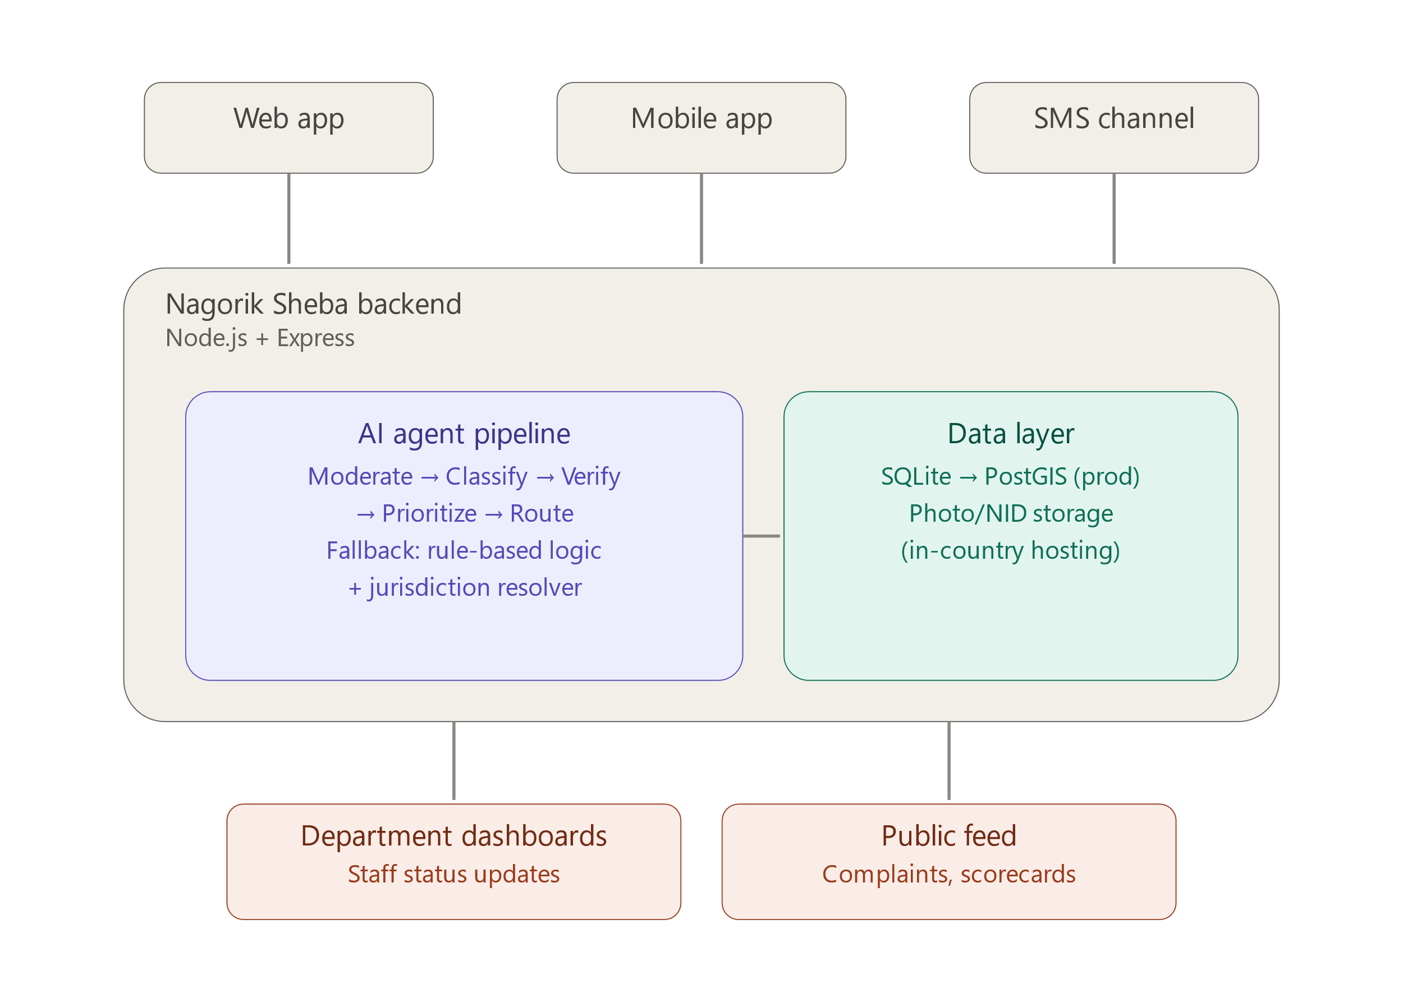

That's the layer view — citizens reach the system through three channels, the backend runs everything through the agent pipeline plus a data layer, and results surface either to staff dashboards or the public feed. Now here's what happens to a single complaint as it moves through that pipeline:

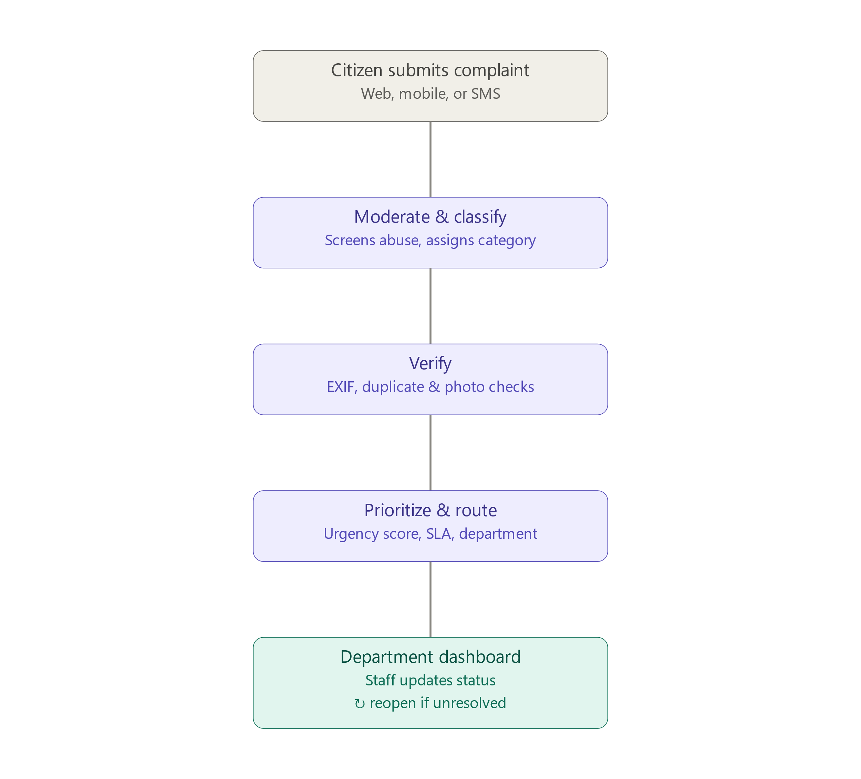
The system follows a hybrid multi-agent architecture layered over a conventional client-server web application:

6.1 Client Layer
- Responsive PWA website (primary, current build)
- Mobile app (Expo/React Native — to be rebuilt as needed)
- SMS channel (text-based, no app required)

6.2 Application / Agent Layer
- Moderation Agent → Classification Agent → Verification Agent → Priority Agent → Routing Agent (deterministic)
- Each LLM-backed agent has a rule-based fallback for availability without an external API key
- The system depends on two external APIs — the LLM API and the Barikoi jurisdiction API both with documented fallback behavior if unreachable.

6.3 Data Layer
- Relational database: SQLite (prototype) → PostgreSQL + PostGIS (production upgrade path)
- Object storage for photos, selfies, and NID images, kept on in-country infrastructure (production); development/demo uses only synthetic mock NID data, not stored under this constraint

6.4 Jurisdiction Layer
- Resolves a submitted GPS point to the correct City Corporation / Pourashava / Union Parishad and ward before department routing
- Implemented via the Barikoi API (Ward by Geolocation, Zone by Geolocation) for jurisdiction resolution in the Bangladesh administrative context; free-tier access (30,000 requests/month) covers development and demo needs
- Coverage will be verified for the demo city (Khulna) during implementation; a manually approximated ward polygon serves as fallback if Barikoi's ward-level granularity proves Dhaka-specific

8. Appendix

8.1 Appendix A: Glossary
Term | Definition
SRS | Software Requirements Specification
NID | National Identity Card (Bangladesh)
EC | Bangladesh Election Commission
eKYC | Electronic Know Your Customer — digital identity verification process
MFS | Mobile Financial Service (e.g., bKash, Nagad, Rocket)
EXIF | Exchangeable Image File Format — metadata embedded in photo files (timestamp, GPS, etc.)
SLA | Service Level Agreement — here, the resolution deadline assigned to a complaint by the Routing Agent
Ward | Smallest administrative sub-unit of a City Corporation or Pourashava
City Corporation | Local government body administering a major urban area in Bangladesh (e.g., Khulna City Corporation)
Pourashava | Municipality — local government body for smaller urban areas
Union Parishad | Lowest-tier rural local government unit in Bangladesh
Jurisdiction Layer | The system component that resolves a GPS coordinate to its governing administrative unit (City Corporation / Pourashava / Union Parishad) and ward
PWA | Progressive Web App
JWT | JSON Web Token — used for session authentication
LLM | Large Language Model (e.g., Claude API), used by the AI agent pipeline for reasoning tasks
Rule-based fallback | Non-LLM, deterministic logic that allows an agent to complete its task without a reachable external API
Perceptual hash | An image-fingerprinting technique used to detect duplicate/reused photos and to perform the selfie–NID self-consistency check
Barikoi | A Bangladesh-based location data provider used for reverse geocoding and ward/zone jurisdiction resolution
DSA | Digital Security Act (Bangladesh) — referenced for data-residency expectations around sensitive personal data
SPECIMEN dataset | The project's synthetic, watermarked mock NID card dataset used for development/testing, containing no real third-party personal data
Agent trail | The recorded sequence of decisions made by each AI agent for a given complaint, shown to staff on the dashboard
Frequency count | The number of citizens who have reported the same location + category issue, used as an input to the Priority Agent
Endorsement | A citizen's "vote" on an existing complaint instead of filing a near-duplicate, also feeding the Priority Agent
REQ-XX-## | Requirement identifier format used throughout this SRS (module prefix + sequence number), e.g. REQ-CS-01

8.2 Appendix B: Analysis Models
At the time of this document's current version, the following analysis models are planned but not yet finalized:
- Entity-Relationship Diagram (ERD) — covering users, complaints, departments, wards, toilets, toilet ratings, emergency services, and complaint endorsements. Scheduled for Week 2 alongside the API contract.
- System architecture diagram — visual representation of the client, agent, data, and jurisdiction layers described in Section 6. A layered structural diagram and a complaint-processing flow diagram have been produced as working references and will be finalized and embedded in this section in the next SRS revision.
- Data flow diagram (DFD) — tracing a complaint's path from submission through the agent pipeline to department routing and resolution; planned for Week 2.
These will be added to this appendix as they are completed; this SRS version documents their absence as a known gap rather than omitting mention of them.

8.3 Appendix C: Issues List

 | Issue | Status
2 | Ward-level coverage of Barikoi's City Corporation API is confirmed for Dhaka but not yet verified for Khulna; manual polygon approximation is the documented fallback if unavailable | Open — pending verification
3 | Whether the mobile app (Expo/React Native) is a hard course requirement, or whether the responsive PWA satisfies the "mobile application development" component, is unconfirmed | Open — pending supervisor clarification
4 | SMS aggregator for production (e.g., SSL Wireless or equivalent BD-licensed provider) has not been selected or contacted; Twilio is confirmed only as the prototype/demo stand-in | Open
5 | No public dataset exists for ward/union boundary shapefiles at the granularity needed for jurisdiction routing outside of what Barikoi's API provides; full reliance on a third-party API for this function is a design risk if the API's terms or availability change | Open — monitored
6 | Public toilet location seed data has not yet been collected | Open
7 | Emergency services directory seed data (real Khulna Fire Service & Civil Defence station numbers) has not yet been collected | Open
8 | License for the project (open-source vs. restricted) has not been decided | Open
9 | Whether SMS-submitted complaints (lower verification tier, REQ-AI-07) require mandatory staff physical confirmation before moving to "in progress" has not been finalized | Open — design decision pending
10 | Data flow diagram and finalized architecture diagram (Appendix B) not yet embedded in this document | Open — scheduled Week 2

