***Final project***

* ***Vision document:***

**Introduction**

* **Purpose:**

The purpose of this system is to introduce an online system of food ordering for our customers. The customers can get their order delivered, they can pick it up themselves or they can dine in. The restaurants receive the order on the restaurant app and prepare the meal. This is not a cliché food order service but a system where you can eat the food that is only suitable for you. Our purpose is to introduce a new service to customer where they can have trust in us and ease in eating what they want to eat through websites and mobile applications. You don’t have to go to restaurants as you can order meals from any restaurant easily from this application without any hassle. You can order meals by browsing through the lists of restaurants available in the application. The customer can check on the process from ordering till receiving the meal and doing payment. Once you order something from here, there are 90% chances of you, liking the food.

**Scope:**

This is a user-friendly application which provides you robust food items. The orders of the customers are placed online in this system, which is still new to the business of food companies. In the United States, the food delivery industry reached 18.5 billion USD in 2020. By the year 2026, this figure is expected to hit 33.7 billion USD, at a continued annual growth rate (CAGR) of 10.5%. As only international brands are providing this capability to place online orders, so this system will be attracted to the customers. The system will be having a great scope in future as the food prices are also very flexible unlike other international brand apps like McDonalds or KFC etc. The system has many advance features such as online payment method through credit card but there is still cash payment method. As the food delivery service is also a requirement of the people nowadays, thus, the system is recently working on this service which will be introduced in the future.

Moreover, there are only benefits in this app:

* Its ordering method is easy and reliable.
* It gives exposure to new customers resulting in marketing benefits.
* The online ordering is user-friendly and convenient.
* There are more business opportunities.
* It has greater reach in terms of national level.
* It offers discounts and memberships to the regular customers.
* **Definitions, Abbreviations and Acronyms:**

# OFDO-Online Consumer Adoption of Online Food Delivery Ordering

# CAGR-Continued Annual Growth Rate

* **References:**

Ali, S., Khalid, N., Jawed, H. M. U., & Islam, D. M. Z. (2020). Consumer adoption of online food delivery ordering (OFDO) services in Pakistan: The impact of the COVID-19 pandemic situation.

Journal of Open Innovation: Technology, Market, and Complexity, 7(1), 10.

**Positioning**

* **Business Opportunity:**

After the covid-19, the health of the people is affected badly, so is the food taste. This system has its own unique features that can be useful to compete with any other brands. We have introduced the order records service for our regular customers where each customers complete week orders will be observed. According to the observation of what the customer usually orders, the system will suggest the better options to him/her which will be suitable to his/her health. This recordkeeping of orders can enable us to satisfy our customers’ taste buds and maintain their health too. Moreover, the students who live in hostels and staff who works at the institute can have the benefit of having their desired food with this system. This system can be a good competitor to the great successful food delivery systems such as food panda, G Food Pakistan, OD Pakistan etc. This app can be promoted through social media posts where the customers provide their valuable feedback about the service, quality, environment and taste. The program promotes the food online system through emails by offering deals and memberships to the subscribers.

* **Problem Statement:**

|  |  |
| --- | --- |
| The problem of | * Poor quality of food * Unattractive or unfancied taste of food * Poor hygiene while cooking * Preparing food carelessly * Lacking of nutrition in food |
| Affects | The health of customers including:   * Students * Teachers * Admin * Staff * Visitors * Managers |
| The impact of which is | Making them suffer from various diseases and health issues like:   * Malnutrition * Food poisoning * Mild Heart problems * High BP * Acidity * Depression * Over-weight and obesity   These diseases are the cause of an increase in the rates of medical appointments. |
| A successful solution would be | A flexible, reliable and cost-effective food service system where:   * The customers can be nurtured for what they are looking. * The customers are provided with a premium quality of food that cannot affect their health. * They take care of the choices of the customers (that they are regularly ordering) by keeping their order records. * They also suggest the type of food that they mostly eat and is suitable for their taste buds. |

* **Product Position Statement:**

|  |  |
| --- | --- |
| For | Common working person like:   * Students * Teachers * Admin * Staff * Visitors * Managers |
| Who | * Are bored from eating tasteless food * Are suffering from depression * Are having a loss of appetite * Are suffering from illness such as cold or flu * Need healthy diet * Need better nutrition in diet |
| Online Food Delivery Ordering (OFDO) | Is a software and hardware product |
| That | * Provides the food of the greatest quality with the approval of doctors and nutritionists * Provides the customers a choice to choose among foods suitable for their health * Suggests the items that customer orders usually * Respects the feedback provided by the customer. |
| Unlike | Other ordering systems where:   * You cannot have a surety if the food is suitable for your health or not * You aren’t sure of its quality and taste. * Even the customers’ feedback isn’t acknowledged. |
| Our product | * Keeps records of regular visitors * Provides them the food suitable for their taste and health * Allow the feature that the food can be delivered online through cash or through online payment too. |

**Stakeholder and user description**

* **Market demographics (OFD):**

Demographic information of respondents. After analyzing the data, we found that, out of the 439 useable responses, 61.3% of them were males and the remaining were females. The age of most of the respondents (i.e., 58.3%) ranged between 18 to 24 years. The majority of respondents (72.4%) were single. By an educational point of view, 36.4% of respondents were qualified up to the master’s level while 46.2% of respondents were students. Moreover, 40.1% of respondents belonged to the lower middle class, and 34.4% of respondents used OFDO services once a week, with respondents who have experienced using OFDO services for 1 to 6 months comprising 57.6% of the sample.

Ali *et al 2020()*

* **Stakeholder summary:**

|  |  |  |
| --- | --- | --- |
| **Name** | **Description** | **Responsibilities** |
| System Analyst | System Analysts are responsible for maintaining and improving computer systems for an organization and its clients. | Gather requirement  Examine current system  Producing specifications  Contact with IT specialist  Implement system |
| Requirement specifier | Stakeholder works with system analyst to ensure that all needs/request convert into requirements. | Stakeholder completely analyze  The requirement that it is functional or non-functional. |
| Technical reviewer | Stakeholder maintain the developmental cycle of the project. | The Technical Reviewer role is responsible for providing timely, appropriate feedback on the project artifacts being reviewed. |
| Software Architect | Stakeholder communicate clients or technical reviewer to convert requirements into plane a solution in form of architecture. | Software architecture is responsible for making high-level design choices and decisions for software projects. Stakeholder is responsible for technical infrastructure of software applications that it is functional or non-functional requirement. |
| Project Manager | Stakeholder is primary for leading the system development. | A project manager is accountable for planning and allocating resources, preparing budgets, monitoring progress, and keeping stakeholders informed throughout the project lifecycle. |
| Market Analyst | A market analyst is responsible for studying market conditions to assess the potential sales of products and services | Market Analyst is responsible for interpreting research about the company's consumers and their buying habits. They identify target audiences and gather web analytics to prepare strategies for success in marketing campaigns with an impact on sales outcomes. |

* **User summary:**

|  |  |  |
| --- | --- | --- |
| **Name** | **Description** | **Responsibilities** |
| Faculty | Primary end user of system | Faculty is responsible for giving their feedback about the food and environment. |
| Student | Primary end user of system | Student is responsible for giving their feedback about the food and environment. |
| Guest | Primary end user of system | Guest is responsible for giving their feedback about the food and environment. |
| Chef | End user of system | chef is responsible for preparing food at work place. |
| Admin | End user of system | Admin is responsible for updating menu and ensure the quality of food. stakeholder invests on the business. |
| Worker | End user of system | Worker is responsible for cleaning of cafeteria. |
| Delivery boy | End user of system | Delivery boy is responsible for delivering the food package on time within the giving time otherwise he/she should have to delver free. |

* **Stakeholder profiles/User profiles:**
* **Admin:**

|  |  |
| --- | --- |
| **Representative** |  |
| **Descriptive** | An individual who is investing on business. |
| **Type** | This is advance user who is responsible for updating menu. |
| **Responsibilities** | Approved the items of the day. |
| **Success Criteria** | Success is defined by investing a huge amount of budget. |
| **Involvement** | Complete record of delivered, purchased and extra food on his/her profile. Profit and loss of day is also mentioned. |
| **Deliverables** |  |
| **Feedback/issues** |  |

* **Delivery boy:**

|  |  |
| --- | --- |
| **Representative** |  |
| **Descriptive** | A person who delivered food to the client. |
| **Type** | This is a Regular user. |
| **Responsibilities** | Responsible for pick the order from client. |
| **Success Criteria** | Success is defined by the delivery on time. |
| **Involvement** | Internal member of CMS. |
| **Deliverables** |  |
| **Feedback/issues** |  |

* **Faculty:**

|  |  |
| --- | --- |
| **Representative** |  |
| **Descriptive** | An individual use this system for healthy food. |
| **Type** | This is a Casual user, |
| **Responsibilities** | User is responsible for giving regular feedback of quality of food, delivery time and environment of place. |
| **Success Criteria** | The success is defined by regular intake of food or regular customer. |
| **Involvement** | This user can suggest food menu |
| **Deliverables** |  |
| **Feedback/issues** | * Good * Above average * Average * Bad |

* **Students:**

|  |  |
| --- | --- |
| **Representative** |  |
| **Descriptive** | An individual use this system for healthy food. |
| **Type** | This is a Casual user, |
| **Responsibilities** | User is responsible for giving regular feedback of quality of food, delivery time and environment of place. |
| **Success Criteria** | The success is defined by regular intake of food or regular customer. |
| **Involvement** | This user can suggest food menu |
| **Deliverables** |  |
| **Feedback/issues** | * Good * Above average * Average * Bad |

* **Chef:**

|  |  |
| --- | --- |
| **Representative** |  |
| **Descriptive** | A person who prepares food for CMS. |
| **Type** | This is a regular user. |
| **Responsibilities** | Responsible for prepare food on time. |
| **Success Criteria** | Success is defined by preparing high quality food with complete hygiene. |
| **Involvement** | Internal member of CMS. |
| **Deliverables** |  |
| **Feedback/issues** | This user can give feedback of salary. |

* **worker:**

|  |  |
| --- | --- |
| **Representative** |  |
| **Descriptive** | A person who cleans at CMS. |
| **Type** | This is a regular user. |
| **Responsibilities** | Responsible for cleaning at cafeteria. |
| **Success Criteria** | Success is defined by complete hygiene. |
| **Involvement** | Internal member of CMS. |
| **Deliverables** |  |
| **Feedback/issues** | This user can give feedback of salary. |

* **Guest:**

|  |  |
| --- | --- |
| **Representative** |  |
| **Descriptive** | An individual use this system for healthy food. |
| **Type** | This is a Casual user, |
| **Responsibilities** | User is responsible for giving regular feedback of quality of food, delivery time and environment of place. |
| **Success Criteria** | The success is defined by regular intake of food or regular customer. |
| **Involvement** | This user can suggest food menu |
| **Deliverables** |  |
| **Feedback/issues** | * Good * Above average * Average * Bad |

* **Key stakeholder or user needs:**

|  |  |  |  |  |
| --- | --- | --- | --- | --- |
| **Need** | **Priority** | **concerns** | **Current solution** | **Proposed solution** |
| Variety of cuisines | High | Large variety of item.  Menu will have | Yes | * Drinks * Fast foods * Desi food * Sweet * Ice creams |
| Delivery on time | High | Delivery will within 15 minutes. | None | Deliver food with in university boundaries. |
| Suggestion of healthy food | Moderate | Suggest us food which is suitable for our health on basis our previous intake/delivered record of food. | None | Use Artificial intelligence, which will  suggest us food which is suitable for our health on basis our previous intake/delivered record of food. |
| Security of data | Moderate | Keep Private information secure. | None | Manager user Identity with encryption and PIN number. |
| Safe and easy payment option | High | A lot of payment methods. | None | Payment can be done through   * Jazz cash * Cash on delivery * Easy paisa * On bank account number |
| Hygienic food | High | Food will be prepared at clean environment. | None | Kitchen will be open customer can see chiefs through transparent glasses. |

* **Alternatives and competitions:**
* Food panda
* Super meal
* Careem now
* Cheetay
* Eat Mubarak
* **Reference**

Ali, S., Khalid, N., Javed, H. M. U., & Islam, D. M. Z. (2020). Consumer adoption of online food delivery ordering (OFDO) services in Pakistan: The impact of the COVID-19 pandemic situation. Journal of Open Innovation: Technology, Market, and Complexity, 7(1), 10.

**Product Overview**

* **Product Perspective:**

* **Summary of capabilities:**

|  |  |
| --- | --- |
| **General Capability** | **Description** |
| Convenient access to the system | Easy to use GUI. |
| System responds quickly | Quick response at user and admin ends. |
| Suggestions based on previous orders and reviews | Yor get more suggestions based on what you ordered, reviewed, and searched most often for. |
| Online and cash-on-delivery payments | Different payment methods. Online payments range from naya pay to master and visa card payments. |
| Enhanced Searches | Speech-to-text and text-to-speech, sentence making. |

* **Assumptions and Dependencies:**

1. In using the onscreen keyboard, it is assumed that the user is literate and can type.

2. It is assumed that speech impaired users will not be using the speech to text feature

3. The default language for the cafeteria system shall be US English. It is assumed that users who cannot speak and write in English will not be using the text to speech features in the system, at least initially.

4. It is assumed that the devices used to use this application are either android 5.0 + and iOS above 12.

5. It is also assumed that the network on the user’s phone will be available in everywhere a user may go inside the university, or at least GPS connectivity is important till order is delivered.

**Software Dependencies:**

It is majorly dependent on AI system that makes decision about what food should be suggested to a user based on his/her older orders, reviews, and searches. This artificial system The AI system is based on Pyhton AI. To be more specific, packages like General AI, Machine learning, Natural language processing, and Neural networks are used.

GUI is based on adobe XD, made simple enough with the assumptions that it will be used by univesity students. Application development is using Java and C# for android and swift for iOS.

* **Cost and Pricing:**

Cost of building this system is to be determined yet. Cost determined cannot be 100% accurate since contract values with food partners change from time-to-time. The application is itself free to use. Pricing of different items will cost different.

* **Licensing and Installation:**

There is no need for a professional to install this application. It will be free available on the google playstore and Apple app store. There are no further charges in application usage as well.

**Product Features:**

* **System Features:**
* 1 Start application
* 2 Exit Application
* 3 Accept Touchscreen input
* 4 Accept Keyboard input
* 5 Change language shown
* **Users Functionalities:**

Swipe through different food categories

Favorite and friend section

Show food related to user’s

* Orders
* Reviews
* Searches

Allow friends to share their experiences

Different payment methods

* Online payments
* Cash-on-delivery
* Map marking delivery locations
* Contactless orders
* Track of order
* Contact your rider
* Push notifications
* **Admin Functionalities:**
* Reward generation for loyal customers
* Kick abusers
* Keep track of riders
* Inventory managements
* Expenses dispersant
* Salary dispersant
* Chat assistance

**Constraints:**

* Accessibility in smaller cities
* Radius in larger cities
* Total dependency on internet and food partners
* Targets specific group
* Class
* Age group
* Working hours constraints
* Cannot edit orders
* Customizable user icons
* Clear and intuitive vocabulary organization

**Documentation Requirements:**

* **User Manual:**

A short user manual will be provided under the application on play store and app store for android and iOS respectively.

* ***Architectural Diagram:***

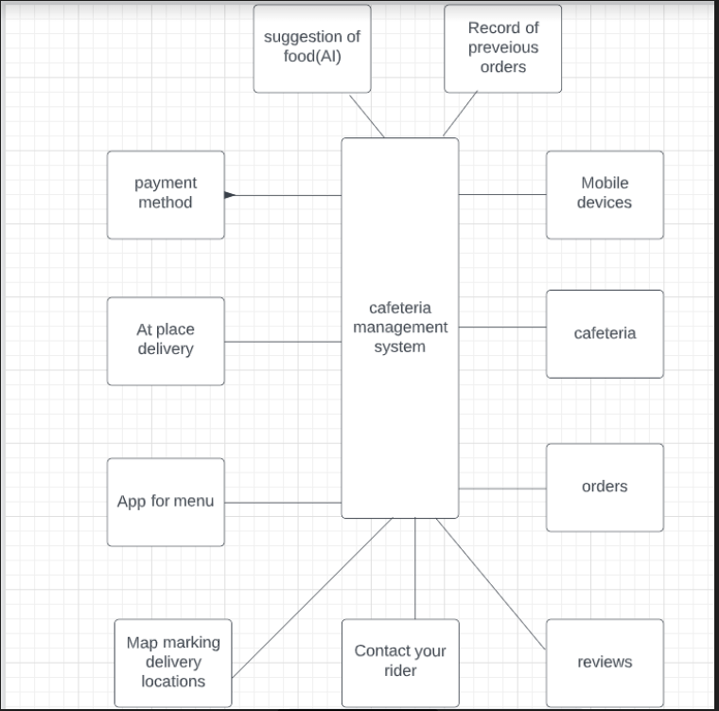

* ***Use case Diagram:***

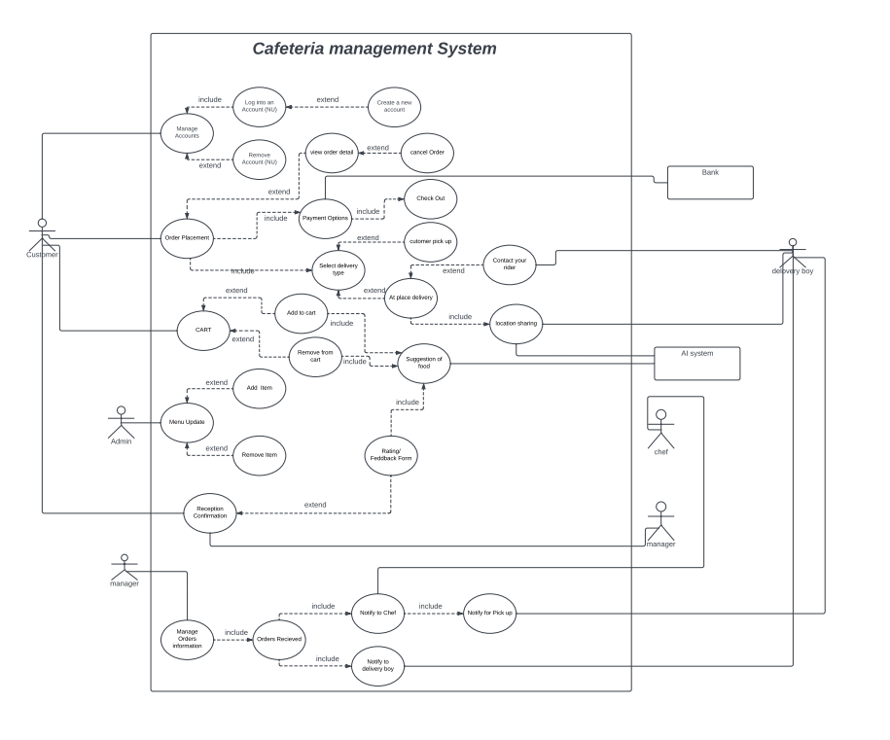

* ***Use Case Specifications:***
* ***Ayesha saqib(20f-0360)***

***Fully dressed:***

|  |  |
| --- | --- |
| Use case | Place order |
| Primary actor | Customer |
| Stakeholder | Manager, Admin |
| Pre-condition | Customer must have a NU email account (Registered) to login into the app. |
| Post-condition | He/she will be able to enjoy online facility of food delivery. |
| Main Success scenario | Firstly, He/she have to login with nu email. Then you can select order or system will suggest you according to your taste. After confirming it you can enjoy it at place or deliver it where you are. |
| Alternative flow | If you don’t have NU email account, then cannot login into it.  In this case you must create new account if that is registered then you are able to enjoy the food. Secondly you can manually order. |
| Special requirement | * Availability of all food on whole university timing * Free delivery of food. * Delivery will be within 15 to 20 minutes. * Food should be freshly cooked. * Reliability customer should be able to change the food if it not full filling his/her requirement. |
| Data variation list | App will get input from   * Touch screen * Keyboard keys |
| Open issues | You are not able to use food app without internet  Your order can take time if there is a lot traffic on the app (server down).  You are not able to place order online if your mobile cannot support the app. |

***Fully dressed:***

|  |  |
| --- | --- |
| Use case | Order payment |
| Primary actor | Customer |
| Stakeholder | Bank |
| Pre-condition | You must have selected your order (Add to cart). |
| Post-condition | You must have account from any one of them   * Easy paisa * Jazz cash * Bank account |
| Main Success scenario | Firstly, you must select item then confirm your order. Then you have a choice to pay online and cash on delivery. |
| Alternative flow | If you don’t have any selected item, then you are not able to pay.  If you have online account from mentioned above, then you can choose cash on delivery.  If on cash on delivery you are not able to pay, then your order will be back and next time you have to pay online for order conformation. |
| Special requirement | * Recipient account must exist (Availability) * Your account number must be secure |
| Data variation list | App will get input from   * Touch screen * Keyboard keys |
| Open issues | You must have online bank account. |

***Brief:***

|  |  |
| --- | --- |
| Use case | Account login |
| Actor | Customer |
| Type | Primary |
| Description | You can login to the login by using your registered NU email account.  If you first tome login then you have to create new account. |

***Brief:***

|  |  |
| --- | --- |
| Use case | Feedback form/rating |
| Actor | Customer |
| Type | Primary |
| Description | You can share your experience of online food delivery. It is optional. |

***Brief:***

|  |  |
| --- | --- |
| Use case | Suggestion of food |
| Actor | Artificial intelligence |
| Type | Secondary |
| Description | Based on reviews from user and the status of their cart, AI will decide what should be suggested to the user for future app usage. |

* ***Moaz haroon(20f-0215)***

***Fully dressed:***

|  |  |
| --- | --- |
| Use case | Manage Order Information |
| Primary actor | Manager |
| Stakeholder | Chef, Rider |
| Pre-condition | Manager must be logged into his system using his admin credentials. |
| Post-condition | Order will be delivered to the customer. |
| Main Success scenario | Manager will have to log into the system to look at all the orders placed by customers. Then from the received orders, manager will inform chef to prepare food and will inform the rider/waiter to take food to destination (either customer’s location or common customer counter). |
| Alternative flow | If no manager can log into their accounts. So, customers will be informed about the delay. Customers can either order manually and online payers can show their receipt to get their money back or they will have to wait till the system comes online again from the manager’s end. |
| Special requirement | * Riders/waiters must be available. * Chef must be available. * User must have paid their bill or mentioned “payment on delivery” otherwise. * Delivery within the mentioned time. |
| Data variation list | App will get input from   * Touch screen * Keyboard keys |
| Open issues | Manager cannot use application without an internet connection.  Order can be late depending upon order traffic and other human errors in management, cooking, and delivery. |

***Fully dressed:***

|  |  |
| --- | --- |
| Use case | Location Sharing |
| Primary actor | Customer |
| Stakeholder | AI System, Delivery boy/waiter |
| Pre-condition | Customer must have picked something to order before sharing location for delivery. (Can be user’s location or common customer counter). |
| Post-condition | Food will be delivered to user at mentioned location. |
| Main Success scenario | User picks somethings to buy, then pays bill and shares location accordingly. Food will be delivered in time if the user stays in the university premises from order placement to order delivery. User can contact rider/waiter to inform about holding his/her order. |
| Alternative flow | Location sharing is mandatory for at place delivery. Otherwise the user can pick delivery at common counter. Where the order can be set for hold for longer. |
| Special requirement | * User must have either a reliable internet or GPS connection connected to device used for order. * In case of order hold, user must inform either manager or waiter/delivery boy. * User cannot leave university for more than 10 minutes without order hold. (Maximum order hold can be 30 minutes). |
| Data variation list | App will get input from   * Touch screen * Google map marking |
| Open issues | If both of the GPS and internet connections are lost, user’s order will be cancelled after 10 minutes, without hold and maximum 30 minutes with order hold. |

***Brief:***

|  |  |
| --- | --- |
| Use case | Notify to chef |
| Actor | Manager |
| Type | Primary |
| Description | After an order is received and manager is logged into his admin module. Manager will inform the chef about pending order, so the chef can prepare those orders. |

***Brief:***

|  |  |
| --- | --- |
| Use case | View Order Details |
| Actor | Customer |
| Type | Primary |
| Description | In the “Order placement” option if the user wishes to check the status of his already ordered food, user can do by clicking “View order details”. User is also allowed to cancel the order if user wishes to, using the “Cancel order” option. |

***Brief:***

|  |  |
| --- | --- |
| Use case | Cart |
| Actor | Customer |
| Type | Primary |
| Description | Customer must have a link to add to the cart or there must be something already in the cart to remove it. If anything is added to the cart or removed from it, AI system will take note of it and will suggest food like what is already present in the cart. |

* ***Mozaib Khan(20f-0161)***

***Fully dressed:***

|  |  |
| --- | --- |
| Use case | Select Delivery Type |
| Primary actor | Customer |
| Stakeholder | Manager, Rider |
| Pre-condition | Customer must order a list of items that can be delivered to his/her location. For this purpose, the customer should use his/her account to order. |
| Post-condition | After the selection of delivery type, the manager will assign the order to workers. The food service will be either through takeaway or delivery depending on the customer’s choice. Delivery payment can be either cash or credit. |
| Main Success scenario | The customer firstly orders meal through online account and select the type of delivery. If he/she wants takeaway, then, the customer simply picks up their ordered food within short time nearly half an hour. However, when the customer wants home delivery, the delivery boy delivers the order with details to the given address through manager co-operation. |
| Alternative flow | Sometimes, there are mishaps in online ordering such as the manager forgets to inform workers about order which wastes a lot of time. Then, the customer who is having takeaway order will be provided some offers to compensate their time wastage. Sometimes, the orders are mixed up and thus wrong food service costs no money to the customers and their complaint is acknowledged. |
| Special requirement | * The location is tracked through online navigation system causing accuracy and time saving. * Online delivery services has a lot of different deals for times such as midnight, evening, and morning. * The takeaway food is prepared on given time so that customer gets fresh and warm meals. * The regular customers can efficiently order as their details are already recorded in the system. * You can get home delivery at any far place for free. |
| Data variation list | App will get input from   * Touch screen * Keyboard keys |
| Open issues | Without providing address, contact number, the order cannot be delivered.  The food delivery doesn’t deliver after 12 am and before 6 am.  If there are a lot of customers in takeaway, your turn will be very late. |

***Fully dressed:***

|  |  |
| --- | --- |
| Use case | At Place Delivery |
| Primary actor | Customer |
| Stakeholder | GPS Navigation System, Rider |
| Pre-condition | Customer must tell his/her details either his/her address through GPS location sharing method or provide contact number to the rider. |
| Post-condition | After the delivery location is provided as well as contact number, the rider delivers food to the given place within given time slot. |
| Main Success scenario | When the customer wants home delivery, he/she orders and tell the place address and for regular customer, it is more convenient for riders to find location. The delivery boy delivers the order to the customer and provides him/her the service. The payment is done either through cash on delivery or through credit card. |
| Alternative flow | When the rider is novice, there are more chances of inefficient delivery services. This causes trouble for both rider and customer. Under these circumstances, the rider should contact manager and ask the customer’s details. If food gets cold during ride, the complaint call to the manager compensates customer’s loss. Submitting feedback is also a great way to overcome future inconvenience regarding delivery services. |
| Special requirement | * The rider is sent with the order’s pre-calculated change for the customer’s convenience. * There are multiple ranges of deals of home delivery for different customers. * The riders too get tips from the tax paid in the customers’ bill. * Students get deduced tax on their online delivery meals. * There are no delivery charges for regular customers. |
| Data variation list | App will get input from   * Touch screen * GPS navigation system |
| Open issues | There are some options of order cancelling but only when your order has been placed for five minutes. Anyone who cancels the order after the order placed for more than five minutes will be deducted for the order as this causes wastage of time and effort as well as money. |

***Brief:***

|  |  |
| --- | --- |
| Use case | Menu Update |
| Actor | Admin |
| Type | Primary |
| Description | If the customers start liking a certain dish, then the similar types or flavors of that certain dish are introduced in the menu by the admin. Similarly, sometimes, there are some dishes which are least ordered and fancied and gets poor feedback. The admin removes those dishes from the menu. |

***Brief:***

|  |  |
| --- | --- |
| Use case | Customer Pick Up |
| Actor | Customer |
| Type | Primary |
| Description | After an order is placed and the workers start preparing it, the customer decides whether the order is a takeaway or a home delivery. Admin will inform the manager about takeaway order, so that the customer can pick up that order. |

***Brief:***

|  |  |
| --- | --- |
| Use case | Cash Payment Delivery |
| Actor | Rider |
| Type | Primary |
| Description | After a delivery order is received for cash payment and admin informs manager about it, the manager manages the customer’s order, calculate billing requirements, and sends the rider with the pre-calculated change to the customer’s location. The rider provides food as well as change facilities during the cash payment while delivery to the customer. |

* ***Domain Model:***

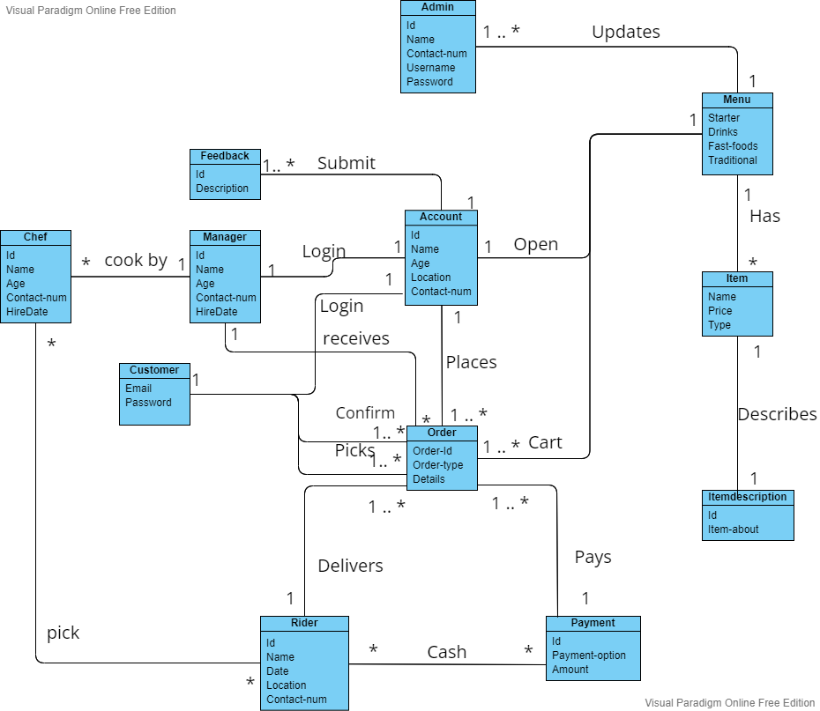

* ***System Sequence Diagram:***
* ***Ayesha saqib(20f-0360)***
* ***Use case=> Manage Account***

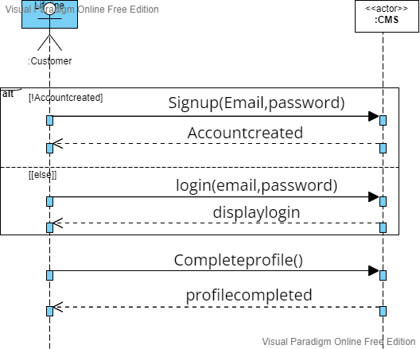

* ***Use case=>order placement***

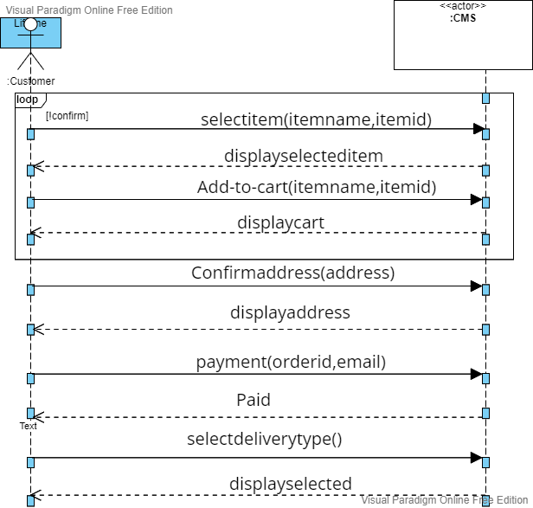

* ***Mozaib Khan(20f-0161)***
* ***Use case=> Menu Update***

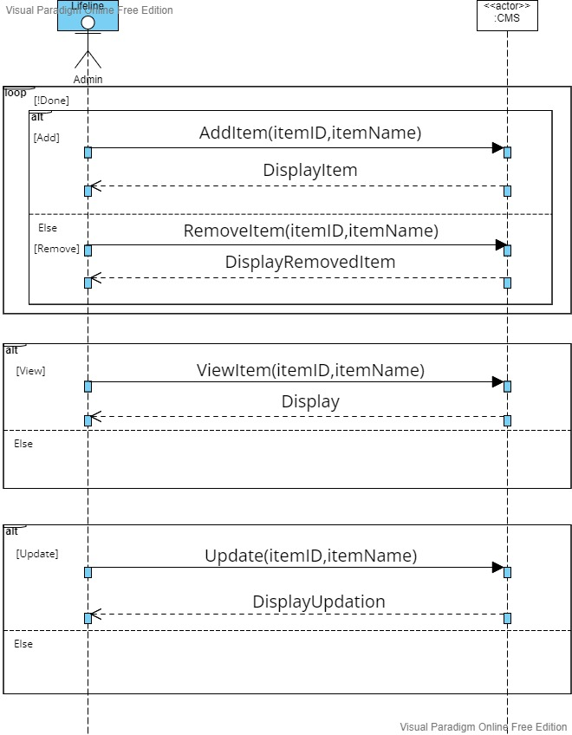

* ***Use case=> Feedback***

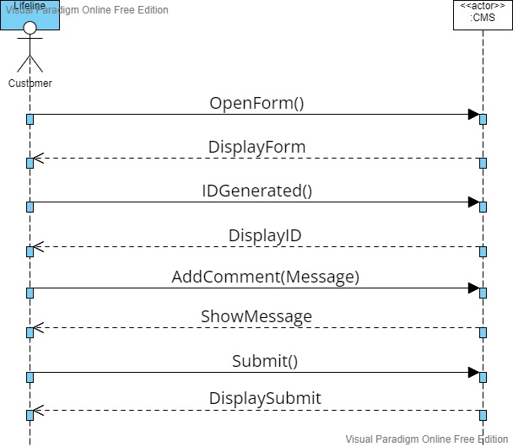

* ***Moaz haroon(20f-0215)***
* ***Use Case: Add or remove from cart***

* ***Use Case: Delivery Type***

* ***Operational Contracts:***
* ***Ayesha saqib(20f-0360)***

|  |  |
| --- | --- |
| Operations | Selectitem(itemname,itemid) |
| **Cross reference** | USE CASE: Order-Placement |
| **Pre-condition** | There is order underway. |
| **Post-condition** | * Instances of items I were created. (Instance creation) * Item is associated with item description. (Association formed) |

|  |  |
| --- | --- |
| Operations | Login(email,password) |
| **Cross reference** | USE CASE: Manage Account |
| **Pre-condition** | Your account must be registered. |
| **Post-condition** | * A Customer instance c was created. (Instance creation) * c.email is assigned by entered email.(Attribute formation) * c.password is assigned by entered password.(Attribute formation) * Customer is associated with account.(Association formed) |

* ***Mozaib Khan(20f-0161)***

|  |  |
| --- | --- |
| Operations | AddItem(itemID,itemName) |
| **Cross reference** | USE CASE: Menu Update |
| **Pre-condition** | The item must not already exist in the menu. |
| **Post-condition** | * Instances of items I were created. (Instance creation) * I.itemID is an assigned ID number of a newly added item. (Attribute formation) * I.itemName is an assigned name of a newly added item. (Attribute formation) * Item is associated with the menu. (Association formed) |

|  |  |
| --- | --- |
| Operations | RemoveItem(itemID,itemName) |
| **Cross reference** | USE CASE: Menu Update |
| **Pre-condition** | The item must exist in the menu. |
| **Post-condition** | * Instances of items I were deleted. (Instance deletion) * An item ID of I.itemID is removed from the menu list. (Attribute deletion) * An item name of I.itemName is removed from the menu list. (Attribute deletion) * Item is not associated with the menu. (Association broken) |

* ***Moaz haroon(20f-0215)***

|  |  |
| --- | --- |
| Operations | : Add to Cart |
| **Cross reference** | **Use Case: Add or remove from cart** |
| **Pre-condition** | **You must be logged in to your account.** |
| **Post-condition** | * Instances of items ‘I’ were created. (Instance creation) * Items are associated with suggestion list. (Association formed) |

|  |  |
| --- | --- |
| Operations | : Delivery Type |
| **Cross reference** | **Use Case: Select delivery type** |
| **Pre-condition** | **You must have selected products to order.** |
| **Post-condition** | * Instance of rider r was created (instance created ) * Customer account a shared with rider r.(Association formed) * Rider r delivered the order(Association formed) |

* ***Class Diagram:***

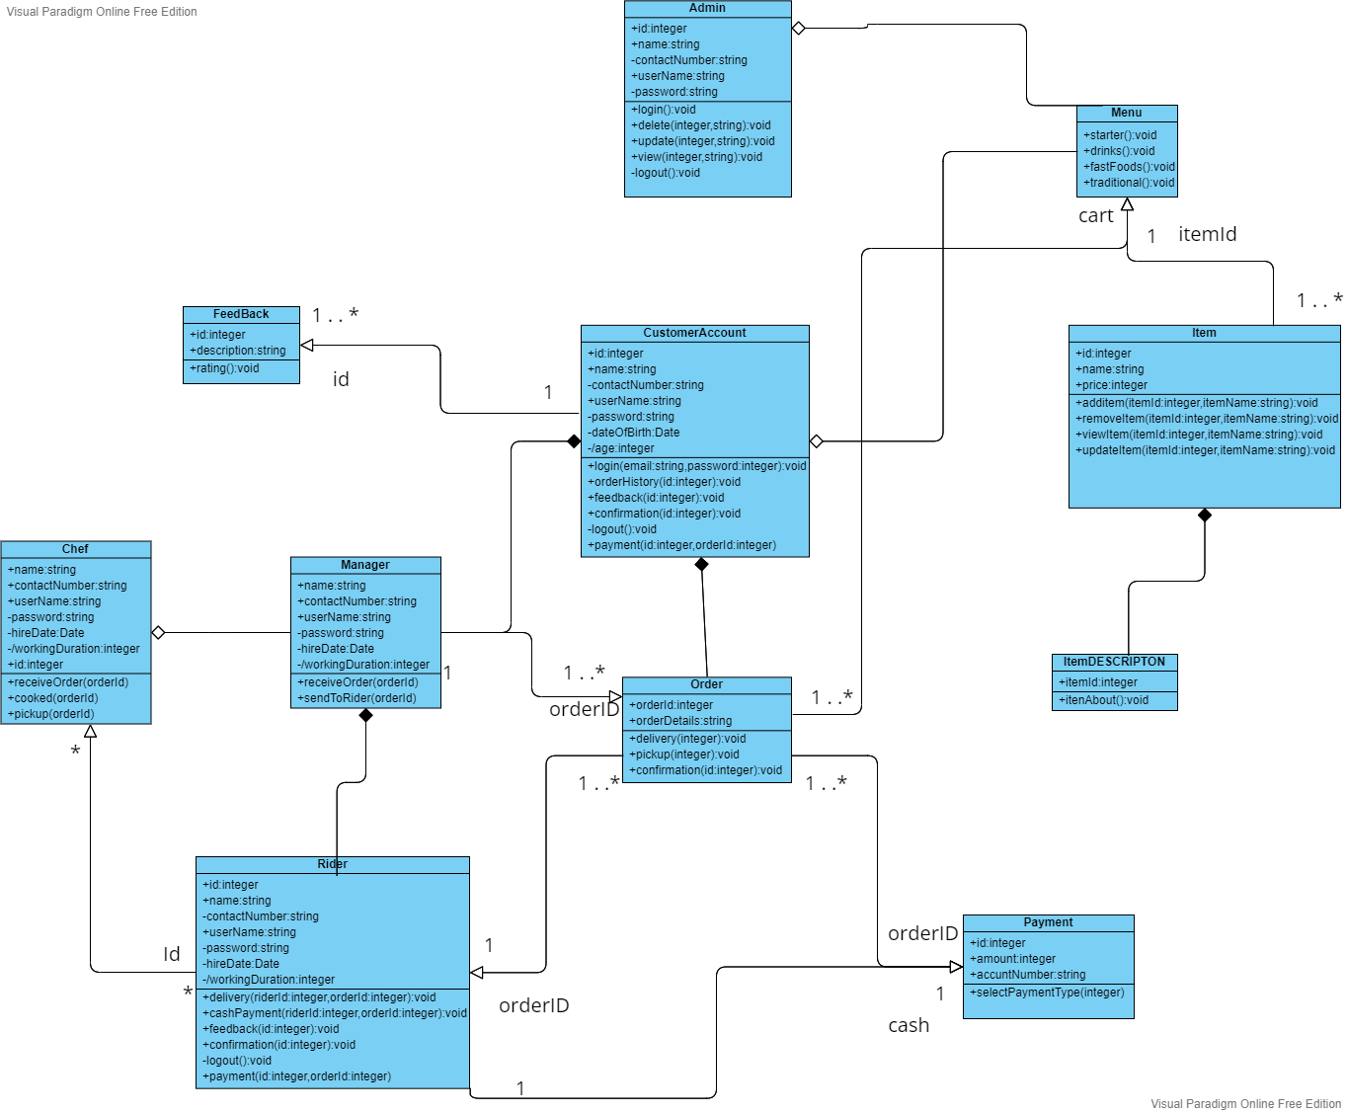

* ***Sequence diagram:***
* ***Ayesha saqib(20f-0360)***
* **Manage Account:**

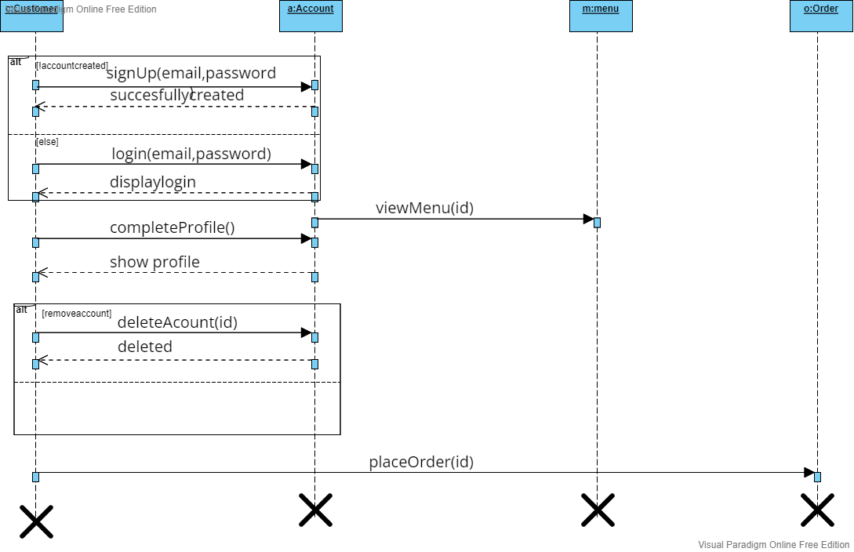

* **Order placement:**

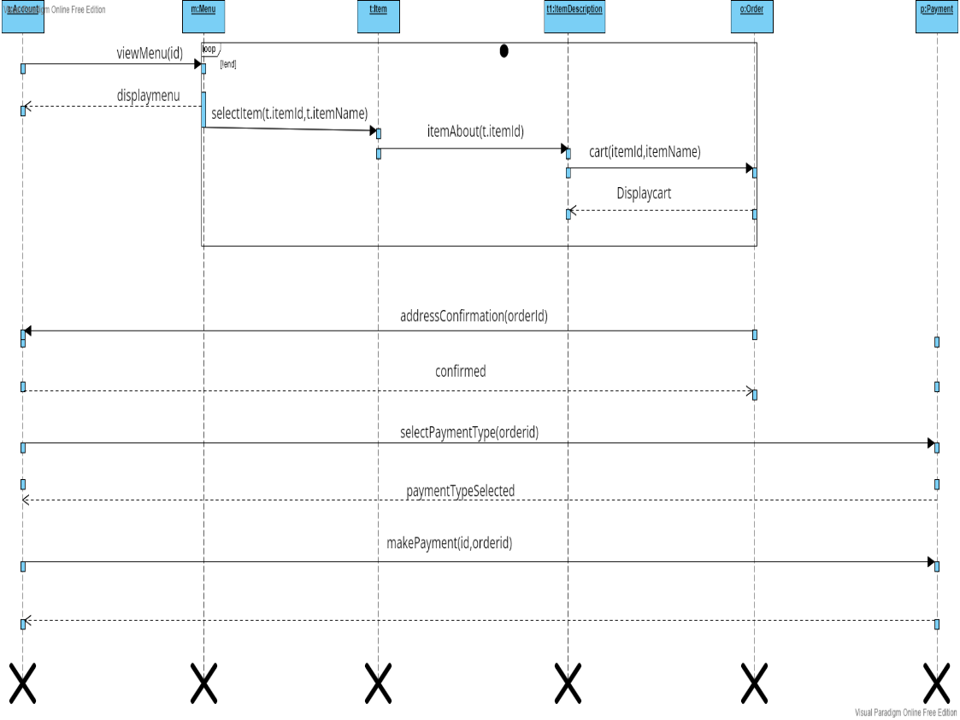

* ***Mozaib Khan(20f-0161)***

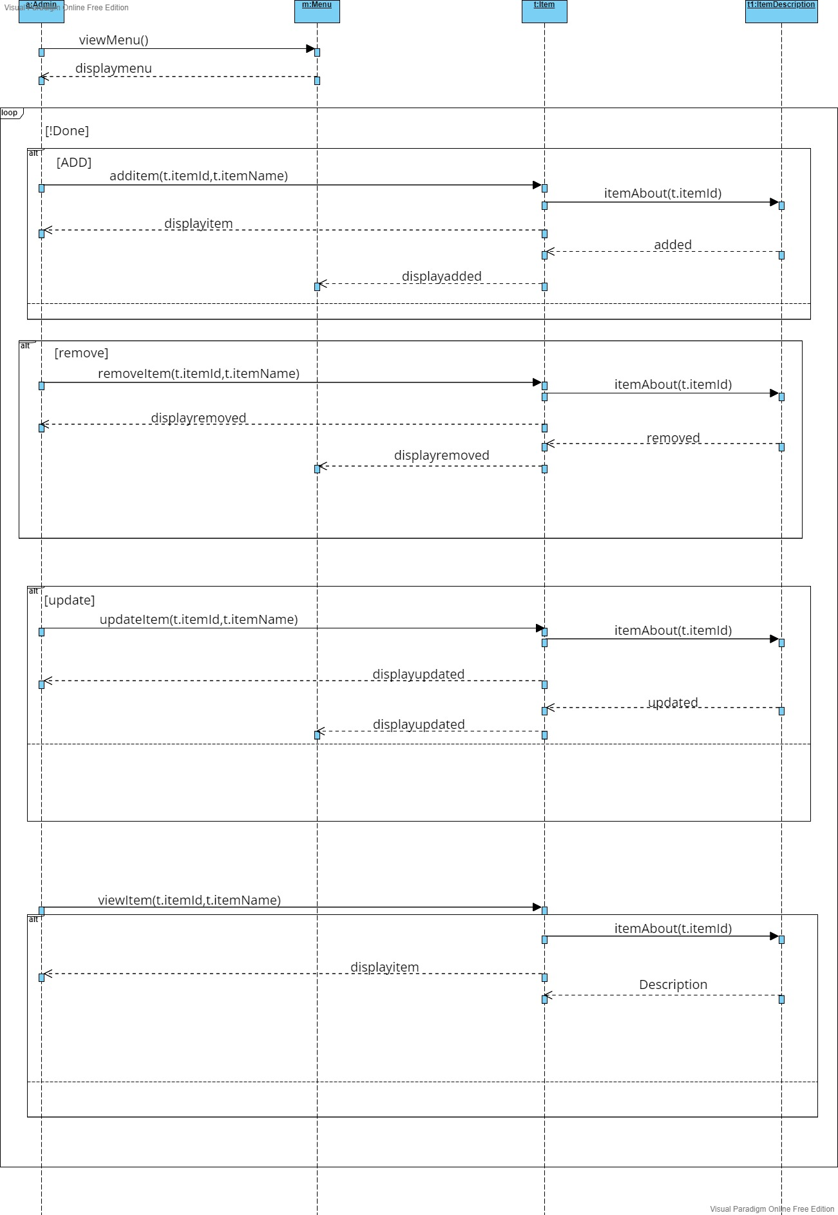

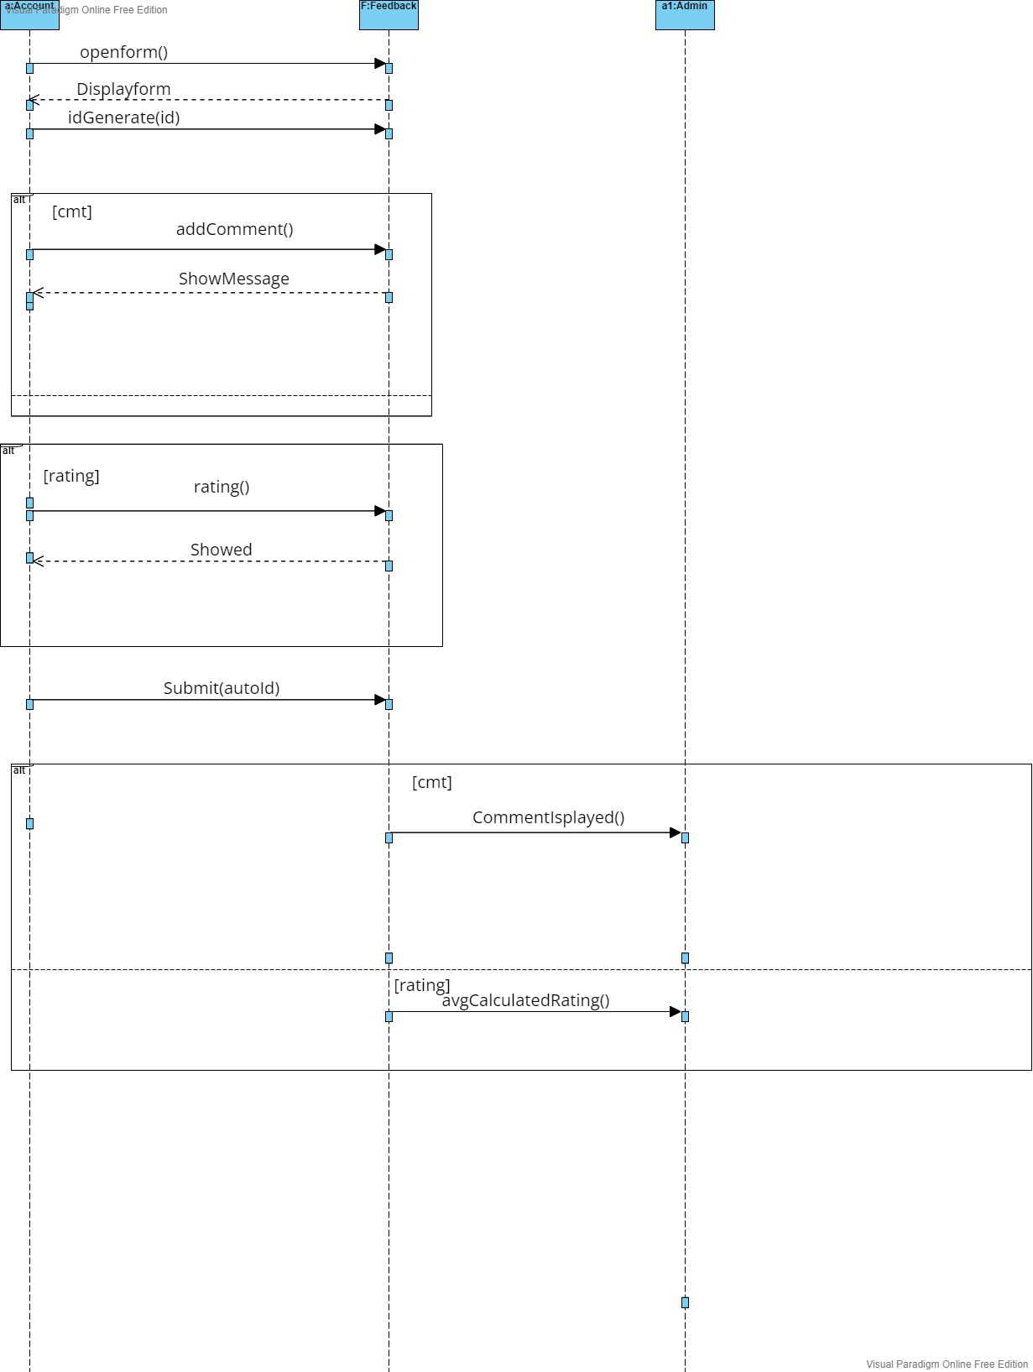

* ***Moaz haroon(20f-0215)***

* ***Activity Diagram:***
* ***Ayesha saqib(20f-0360)***

1. 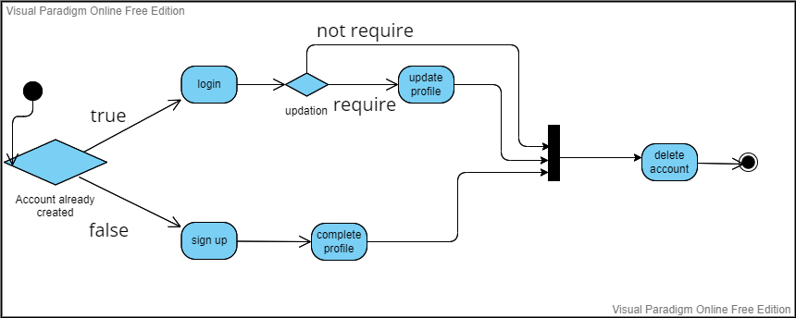
2. 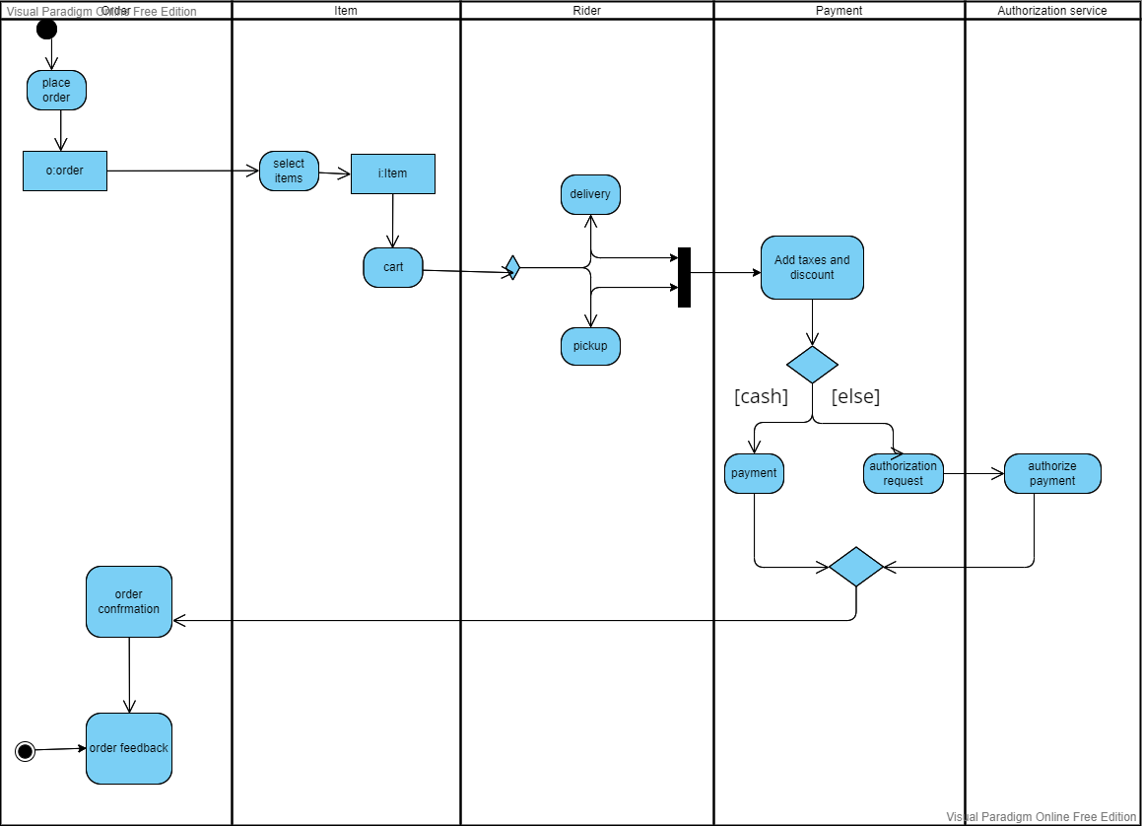

* ***Mozaib Khan(20f-0161)***

1. Diagram

   Description automatically generated
2. 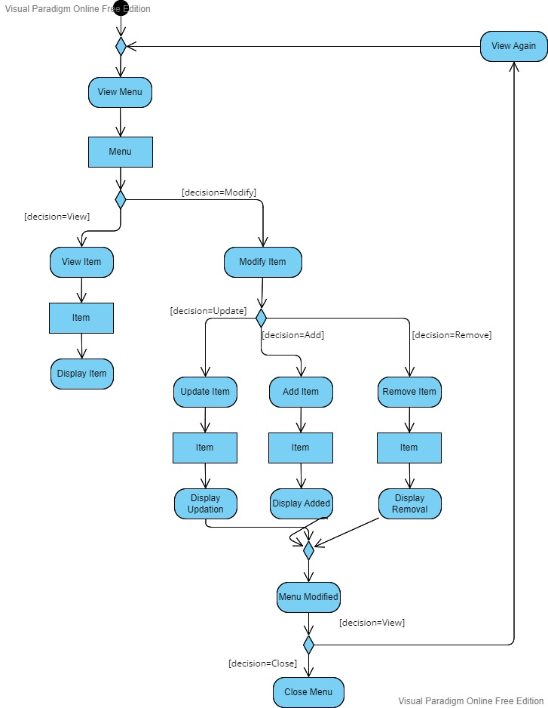

* ***Moaz haroon(20f-0215)***

1. **Diagram, schematic

   Description automatically generated**

* ***State Machine Diagram:***
* ***Ayesha saqib(20f-0360)***

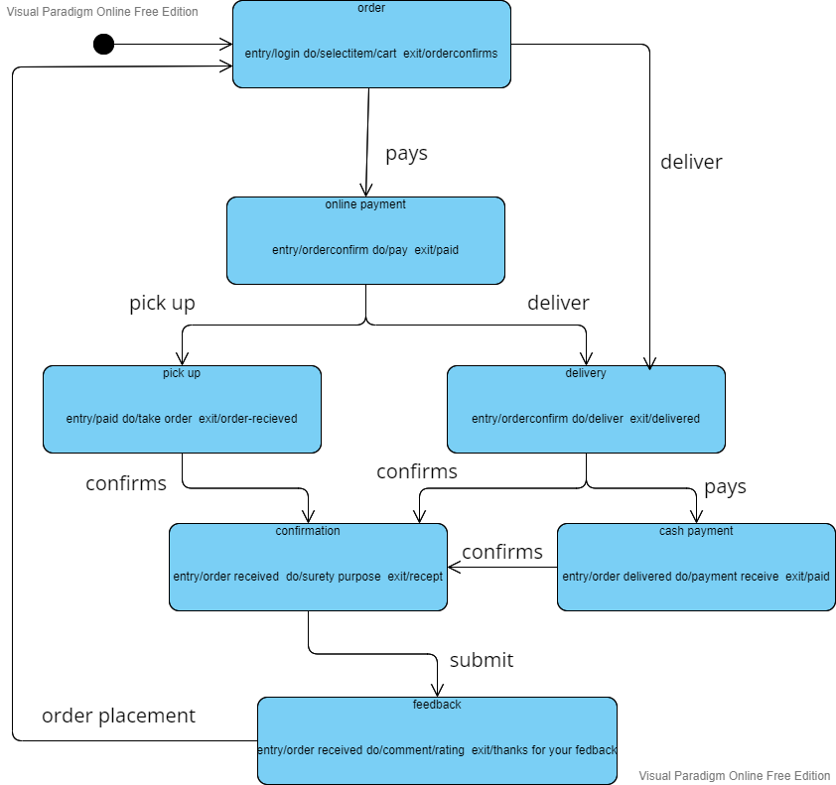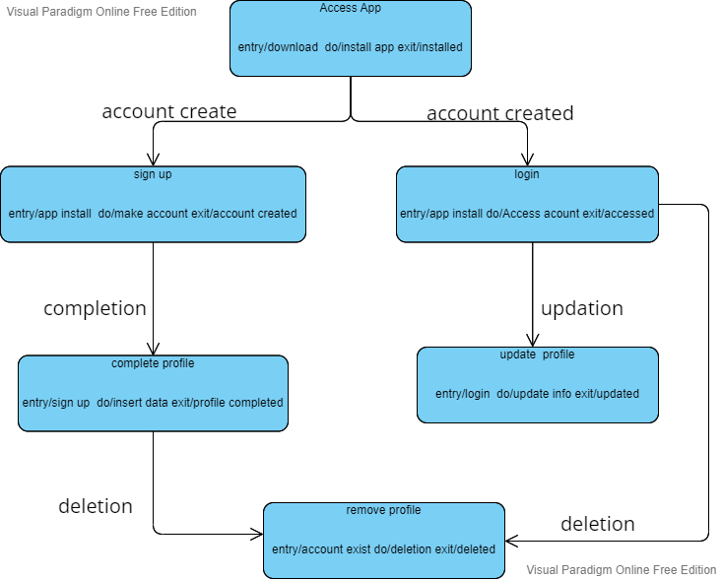

* ***Mozaib Khan(20f-0161)***

1. Diagram

   Description automatically generated
2. 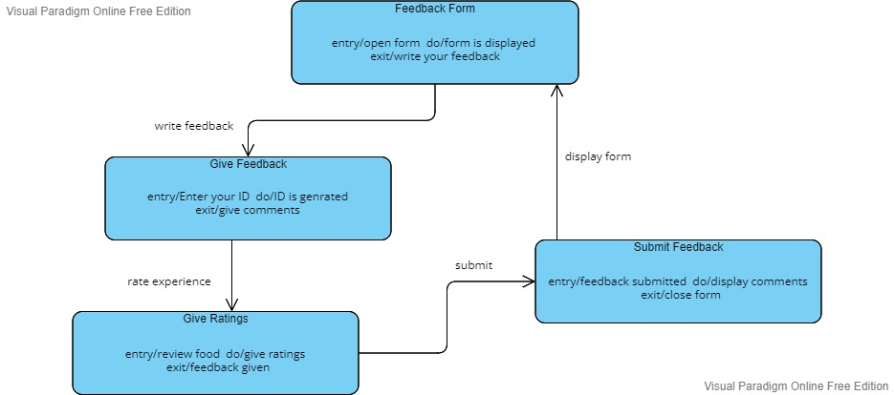

* ***Moaz haroon(20f-0215)***

1. **Diagram, schematic

   Description automatically generated**
2. **Diagram, schematic

   Description automatically generated**

***Component Diagram:***

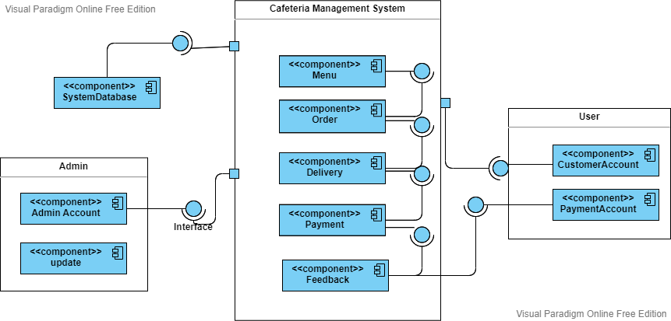

* ***Package Diagram:***

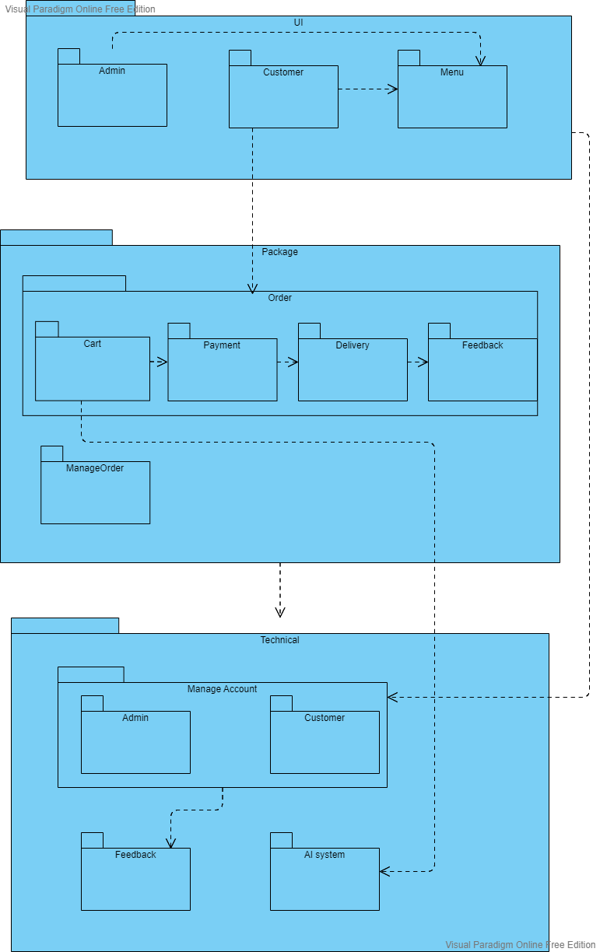

* **Sub packages:**

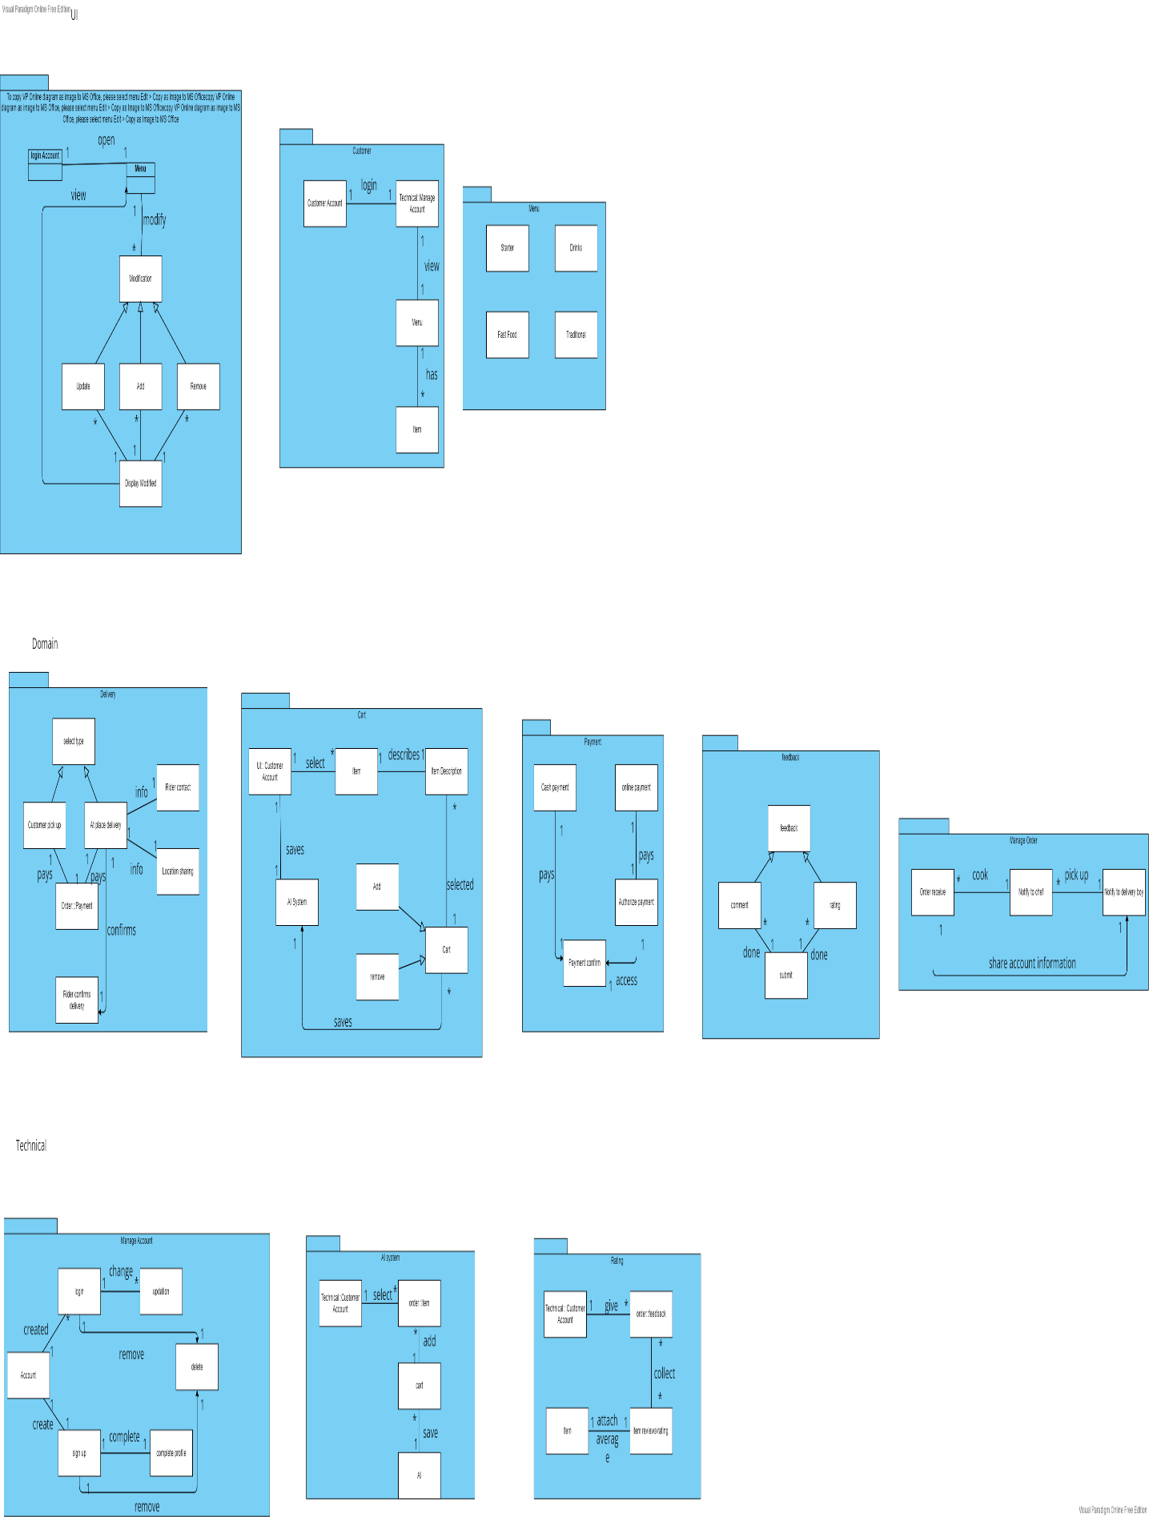

* **User interface:**

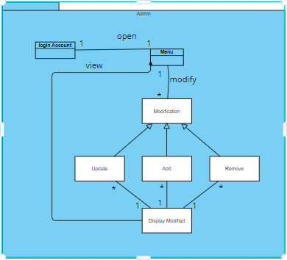

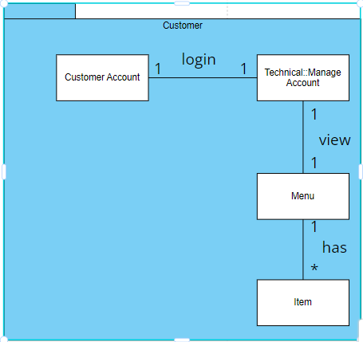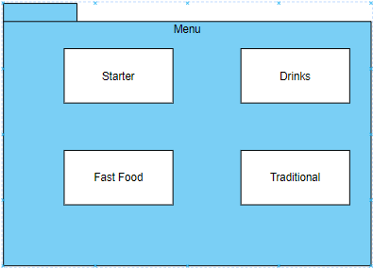

* **Domain:**

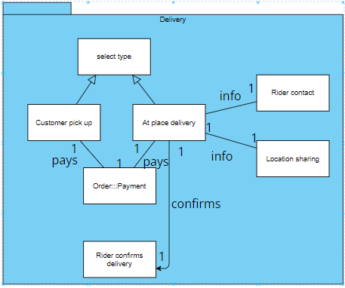

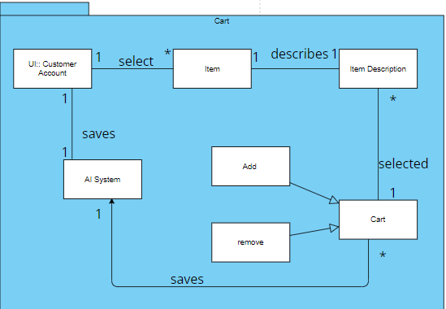

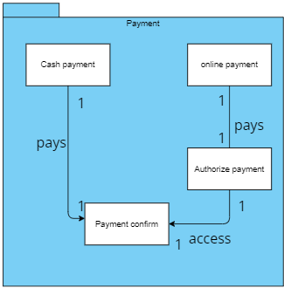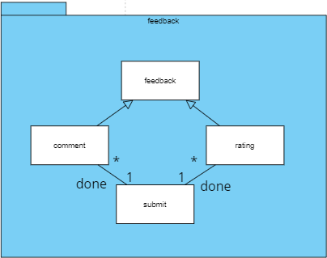

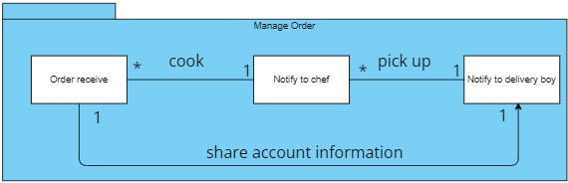

* **Technical:**

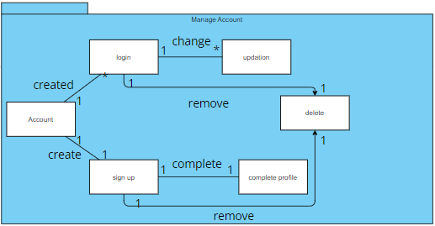

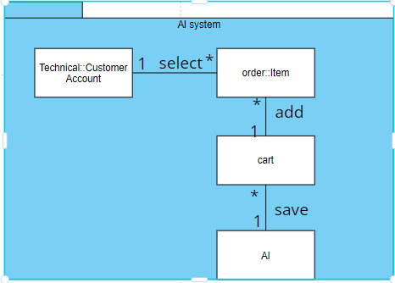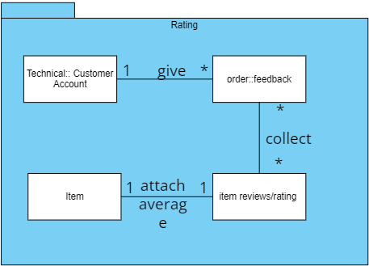

* ***Deployment Diagram:***

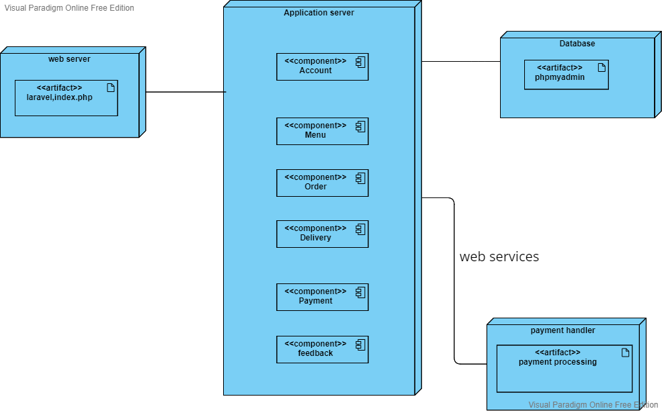

***The End***