

**CS4032 – Web Programming**

**Assignment No 1**

|  |  |
| --- | --- |
| **Instructor:** | Sumaira Mustafa |
| **Email:** | [sumaira.mustafa@nu.edu.pk](mailto:sumaira.mustafa@nu.edu.pk) |
| **Semester:** | Spring 2024 |
| **Section:** | BSCS-6C |

**Question 1: Landing Page**

**Code:**

**HTML File:**

<html lang="en">

<head>

    <meta charset="UTF-8">

    <meta name="viewport" content="width=device-width, initial-scale=1.0">

    <title>Task 1: Landing Page</title>

    <link rel="stylesheet" href="styles.css">

</head>

<body style="background-color: black;">

    <header>

        <div class="navbar">

            <img src="C:\Users\Aisha\Desktop\Semester 8\CS-4032 Web Programming\Assignments\Assignment 1\Images\logo.jpg" alt="Logo">

            <h1>EnterprenuerHub</h1>

                <a href="#home">Home</a>

                <a href="#about">About</a>

                <a href="#services">Services</a>

                <a href="#portfolio">Portfolio</a>

                <a href="#contact">Contact</a>

                <a href="#blog">Blog</a>

           </div>

    </header>

   <div class="hero"></div>

   <section class="features">

    <h1 style="font-size:40px;color: white;text-align: center;">Welcome to EntrepreneurHub</h1>

    <p style="color: gray;text-align: center;">Empowering Entrepreneurs to Succeed</p>

    <div class="features-items">

        <div style="max-width: 70%;">

            <ul>

                <h3 style="font-size: x-large;margin-bottom: 20px;padding-right: 20px;color: white;">Business Planning Tools:</h3>

                <li>

                    <p style="margin-bottom: 20px;padding-right: 20px;">Offer a variety of business plan templates tailored to different industries and business models.</p>

                </li>

                <li>

                    <p style="margin-bottom: 20px;padding-right: 20px;">Provide step-by-step guides on how to create a comprehensive business plan,

                         including sections on market analysis, financial projections, and marketing strategies.</p>

                </li>

                <li>

                    <p style="margin-bottom: 20px;padding-right: 20px;">Integrate interactive planning software that allows entrepreneurs

                         to input their business data and generates a customized business plan.</p>

                </li>

                <li>

                    <p style="margin-bottom: 20px;padding-right: 20px;">Offer access to a library of resources,

                         including articles, videos, and case studies, to help entrepreneurs refine their business strategies.</p>

                </li>

            </ul>

        </div>

        <img src="C:/Users/Aisha/Desktop/Semester 8/CS-4032 Web Programming/Assignments/Assignment 1/Images/f1.jpg" alt="Feature 1">

    </div>

    <div class="features-items">

        <div style="max-width: 70%;">

            <ul>

                <h3 style="font-size: x-large;margin-bottom: 20px;padding-right: 20px;color: white;">Networking Opportunities:</h3>

                <li>

                    <p style="margin-bottom: 20px;padding-right: 20px;">Host virtual networking events where entrepreneurs

                         can connect with industry experts, potential investors, and other like-minded individuals.</p>

                </li>

                <li>

                    <p style="margin-bottom: 20px;padding-right: 20px;">Facilitate mentorship programs matching experienced entrepreneurs

                         with newcomers seeking guidance and advice.

                </li>

                <li>

                    <p style="margin-bottom: 20px;padding-right: 20px;">Create online forums or discussion boards where entrepreneurs can ask questions,

                         share experiences, and seek recommendations from the community.

                    </p>

                </li>

                <li>

                    <p style="margin-bottom: 20px;padding-right: 20px;">Organize workshops and seminars covering topics

                         such as leadership, marketing, and fundraising, providing opportunities for entrepreneurs to learn from experts and peers.</p>

                </p>

                </li>

            </ul>

        </div>

        <img src="C:/Users/Aisha/Desktop/Semester 8/CS-4032 Web Programming/Assignments/Assignment 1/Images/f2.jpg" alt="Feature 2">

    </div>

    <div class="features-items">

        <div style="max-width: 70%;">

            <ul>

                <h3 style="font-size: x-large;margin-bottom: 20px;padding-right: 20px;color: white;">Community Support:</h3>

                <li>

                    <p style="margin-bottom: 20px;padding-right: 20px;">Establish a dedicated online community platform where entrepreneurs can engage in discussions, share resources, and collaborate on projects.

                </li>

                <li>

                    <p style="margin-bottom: 20px;padding-right: 20px;">Offer access to expert-led Q&A sessions where

                         entrepreneurs can get personalized advice and feedback on their business ideas and challenges.

                    </p>

                </li>

                <li>

                    <p style="margin-bottom: 20px;padding-right: 20px;">Provide access to exclusive member benefits,

                         such as discounts on business services, invitations to exclusive events,

                          and early access to new features and resources.

                    </p>

                </li>

                <li>

                    <p style="margin-bottom: 20px;padding-right: 20px;">Foster a culture of inclusivity

                         and support by highlighting success stories from within the community and celebrating members' achievements.</p>

                </p>

                </li>

            </ul>

        </div>

        <img src="C:/Users/Aisha/Desktop/Semester 8/CS-4032 Web Programming/Assignments/Assignment 1/Images/f3.jpg" alt="Feature 3">

    </div>

</section>

<footer>

    <div class="footer">

            <h2>AROUND THE WEB</h2>

            <a href="https://www.facebook.com"><img src="C:/Users/Aisha/Desktop/Semester 8/CS-4032 Web Programming/Assignments/Assignment 1/Images/facebook_logo.JPG" alt="Facebook"></a>

            <a href="https://www.instagram.com"><img src="C:/Users/Aisha/Desktop/Semester 8/CS-4032 Web Programming/Assignments/Assignment 1/Images/instagram_logo.JPG" alt="Instagram"></a>

            <a href="https://www.youtube.com"><img src="C:/Users/Aisha/Desktop/Semester 8/CS-4032 Web Programming/Assignments/Assignment 1/Images/youtube_logo.JPG" alt="YouTube"></a>

            <a href="https://www.linkedin.com"><img src="C:/Users/Aisha/Desktop/Semester 8/CS-4032 Web Programming/Assignments/Assignment 1/Images/linkedin_logo.JPG" alt="LinkedIn"></a>

            <a href="https://www.twitter.com"><img src="C:/Users/Aisha/Desktop/Semester 8/CS-4032 Web Programming/Assignments/Assignment 1/Images/twitter_logo.JPG" alt="Twitter"></a>

            <br><br><br>

            <a href="#">ABOUT US</a>

            <a href="#">LOCATION</a>

            <a href="#">OUR FIRM</a>

            <a href="#">OUR RESULTS</a>

            <a href="#">RESOURCES</a>

            <br><br><br>

            <p>© 2024 EntrepreneurHub</p>

    </div>

</footer>

</body>

</html>

**CSS Style File:**

body {

    background-color: black;

    color: white;

    margin: 0;

    font-family: Arial, Helvetica, sans-serif;

}

.navbar {

    display: flex;

    align-items: center;

    height: 50px;

    width: 100%;

    color: seagreen;

    margin-bottom: 10px;

    background-color: black;

    overflow: hidden;

}

.navbar img {

    height: 45px;

    width: 45px;

    margin-left: 12px;

    margin-top: 5px;

    margin-bottom: 5px;

}

.navbar a:link {

    font-size: larger;

    display: block;

    font-family: Arial, Helvetica, sans-serif;

    text-align: center;

    padding: 14px 16px 14px;

    color: white;

    text-decoration: none;

}

.navbar a:visited {

    color: gray;

}

.navbar a:hover {

    background-color: #111;

    text-decoration: underline;

    color: seagreen;

}

.navbar a:active {

    color: seagreen;

    text-decoration: underline;

    font-weight: bolder;

}

.navbar a {

    margin-left: auto;

}

.hero {

    background-image: url('C:/Users/Aisha/Desktop/Semester 8/CS-4032 Web Programming/Assignments/Assignment 1/Images/background.jpg');

    background-size: cover;

    background-position: center;

    background-repeat: repeat-x;

    color: white;

    text-align: center;

    padding: 100px 20px;

}

.features {

    padding: 10px 0;

    background-color: black;

    text-align: left;

    color: white;

}

.features-items {

    display: flex;

    flex-direction: row;

    align-items: center;

    justify-content: space-between;

    margin-left: 50px;

    margin-right: 50px;

    margin-bottom: 20px;

    color: gray;

}

.features-items img {

    max-width: 30%;

    height: 130px;

    margin-right: 30px;

}

.footer {

    background-color: black;

    color: white;

    text-align: center;

    padding: 50px 20px;

}

.footer a {

    color: seagreen;

    text-decoration: none;

    margin: 0 10px;

}

.footer a:hover {

    text-decoration: underline;

}

.footer a img {

    height: 30px;

    width: auto;

    margin: 0 5px;

}

@media only screen and (max-width: 600px) {

    .navbar {

        flex-direction: column;

        align-items: center;

    }

    .navbar img {

        margin-bottom: 10px;

    }

    .navbar h1 {

        margin: 0;

        font-size: 20px;

    }

    .navbar a {

        margin: 5px 0;

        padding: 10px;

        font-size: smaller;

    }

    .hero {

        padding: 50px 10px;

    }

    .features-items {

        flex-direction: column;

        align-items: center;

        margin-left: 10px;

        margin-right: 10px;

    }

    .features-items img {

        max-width: 80%;

        margin-bottom: 20px;

    }

}

@media only screen and (min-width: 601px) and (max-width: 1024px) {

    .navbar a {

        font-size: smaller;

    }

    .hero {

        padding: 80px 20px;

    }

    .features-items img {

        max-width: 50%;

    }

}

@media only screen and (min-width: 1025px) {

    .navbar a {

        font-size: larger;

    }

    .hero {

        padding: 100px 30px;

    }

}

**Output:**

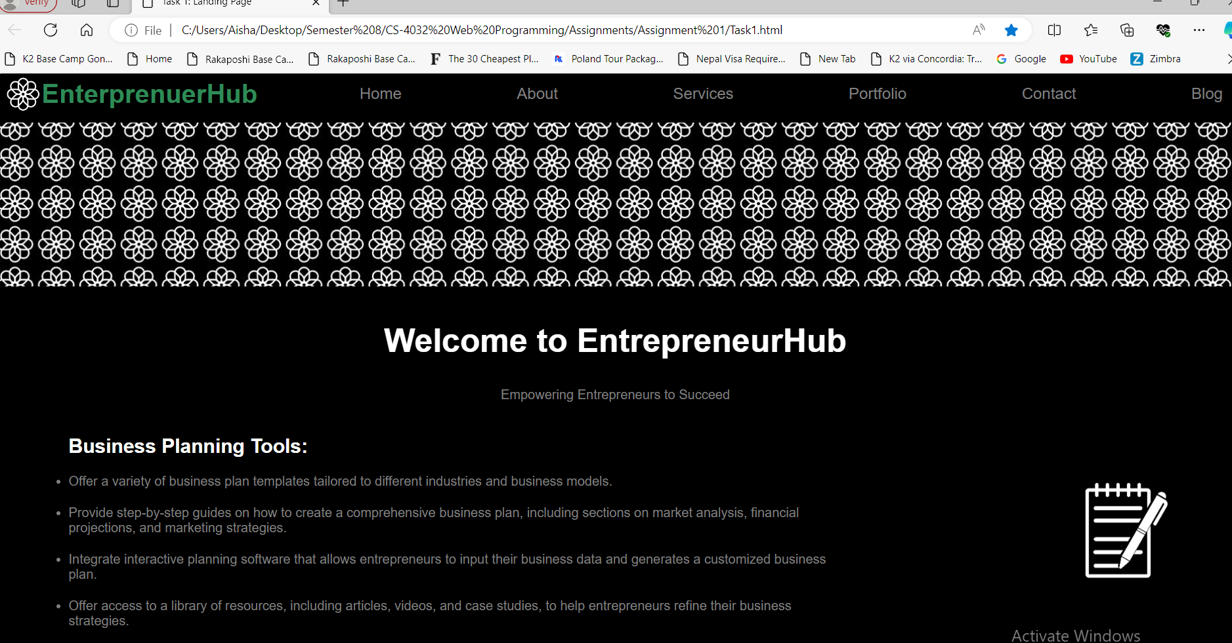

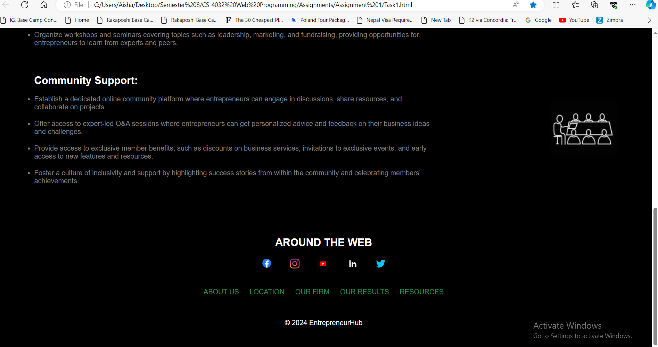

**Question 2: Signin and Signup Pages (Animation)**

**Landing Page:**

**Code:**

<!DOCTYPE html>

<html lang="en">

<head>

    <meta charset="UTF-8">

    <meta name="viewport" content="width=device-width, initial-scale=1.0">

    <title>Task 2: Sign Up</title>

    <style>

        body {

            margin: 0;

            padding: 0;

            font-family: Arial, sans-serif;

        }

        .container-navbar {

            display: flex;

            align-items: center;

            justify-content: space-between;

            height: 75px;

            padding: 0 20px;

            background-color: white;

            border-bottom: 1px solid burlywood;

        }

        .container-navbar img {

            height: 50px;

            width: auto;

            margin: 0 10px;

        }

        .container-login {

            text-align: center;

            background-color: white;

            border-bottom: 1px solid burlywood;

            padding: 20px;

        }

        .button-home,

        .button-login {

            padding: 10px 20px;

            background-color: rgb(145, 114, 36);

            color: white;

            border: none;

            cursor: pointer;

            margin: 0 10px;

        }

        .button-login {

            background-color: white;

            color: rgb(145, 114, 36);

            transition: background-color 0.3s, color 0.3s;

        }

        .button-login:hover {

            background-color: rgb(145, 114, 36);

            color: white;

        }

        .container-image {

            background-color: white;

            border-bottom: 1px solid burlywood;

        }

        .container-image img {

            width: 100%;

            height: auto;

        }

        .container-gallery {

            background-color: lavender;

            padding: 20px;

        }

        .container-gallery img {

            width: 30%;

            height: auto;

            margin: 10px;

        }

        .footer {

            background-color: white;

            text-align: center;

            padding: 20px;

        }

        .footer img {

            height: 30px;

            width: auto;

            margin-right: 10px;

        }

        .footer a {

            color: seagreen;

            text-decoration: none;

            margin: 0 10px;

        }

        .footer a:hover {

            text-decoration: underline;

        }

        @media only screen and (max-width: 768px) {

            .container-navbar {

                height: auto;

                flex-direction: column;

                align-items: flex-start;

                padding: 20px;

            }

            .container-navbar img {

                margin: 10px 0;

            }

            .container-login {

                padding: 10px;

            }

            .button-home,

            .button-login {

                margin: 10px;

            }

            .container-login1 {

                padding: 10px;

            }

            .login-form {

                max-width: 100%;

            }

        }

    </style>

</head>

<body style="background-color: lavender;">

    <header>

        <div class="container-navbar">

            <a href="https://www.facebook.com/LuxPakistan/" target="_blank"><img src="C:/Users/Aisha/Desktop/Semester 8/CS-4032 Web Programming/Assignments/Assignment 1/Images/facebook_logo1.jpg" alt="Facebook"></a>

            <a href="https://twitter.com/i/flow/login?redirect_after_login=%2FLuxStylePk" target="_blank"><img src="C:/Users/Aisha/Desktop/Semester 8/CS-4032 Web Programming/Assignments/Assignment 1/Images/twitter_logo1.jpg" alt="Twitter"></a>

            <a href="https://www.instagram.com/luxstylepk/" target="_blank"><img src="C:/Users/Aisha/Desktop/Semester 8/CS-4032 Web Programming/Assignments/Assignment 1/Images/instagram_logo1.jpg" alt="Instagram"></a>

            <a href="https://www.youtube.com/channel/UCUjdhbKM8OuXNwbtpnLkt0A" target="_blank"><img src="C:/Users/Aisha/Desktop/Semester 8/CS-4032 Web Programming/Assignments/Assignment 1/Images/youtube_logo1.jpg" alt="Youtube"></a>

            <a href="Task2-landing.html"><img src="C:\Users\Aisha\Desktop\Semester 8\CS-4032 Web Programming\Assignments\Assignment 1\Images\logo1.png" alt="Logo"></a>

        </div>

    </header>

    <div class="container-login">

        <button class="button-home" onclick="location.href='Task2-landing.html'">Home</button>

        <button class="button-login" onclick="location.href='Task2-login.html'">Login For Voting</button>

    </div>

    <div class="container-image">

        <img src="C:\Users\Aisha\Desktop\Semester 8\CS-4032 Web Programming\Assignments\Assignment 1\Images\lux.jpg" alt="Lux">

    </div>

    <div class="container-gallery">

        <h1 style="font-size:40px;color: rgb(145, 114, 36);text-align: center;">Lux Style Awards</h1>

        <p style="color: rgb(106, 93, 77);text-align: center;">Catch all the stills from the star-studded events!</p>

        <img src="C:\Users\Aisha\Desktop\Semester 8\CS-4032 Web Programming\Assignments\Assignment 1\Images\movie.jpg" alt="Movie1">

        <img src="C:\Users\Aisha\Desktop\Semester 8\CS-4032 Web Programming\Assignments\Assignment 1\Images\movie2.jpg" alt="Movie2">

        <img src="C:\Users\Aisha\Desktop\Semester 8\CS-4032 Web Programming\Assignments\Assignment 1\Images\movie3.jpg" alt="Movie3">

    </div>

    <footer>

        <div class="footer">

            <img src="C:\Users\Aisha\Desktop\Semester 8\CS-4032 Web Programming\Assignments\Assignment 1\Images\logo1.png" alt="Logo">

            <p>© 2024 LUX, UNILEVER PAKISTAN LIMITED. ALL RIGHTS RESERVED</p>

            <a href="#privacy-policy">Privacy Policy</a>

            <a href="#cookie-policy">Cookie Policy</a>

            <a href="#contact">Contact</a>

        </div>

    </footer>

</body>

</html>

**Output:**

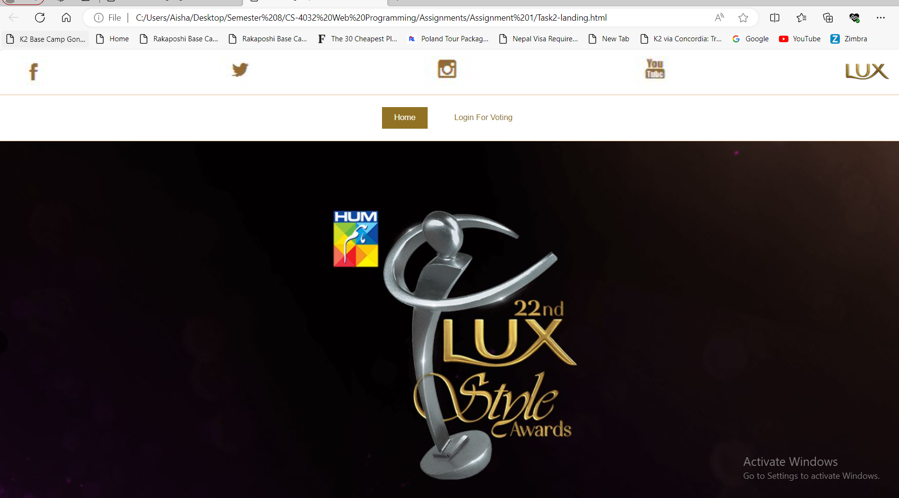

1. **Login Page With Animation**

**Code:**

<!DOCTYPE html>

<html lang="en">

<head>

    <meta charset="UTF-8">

    <meta name="viewport" content="width=device-width, initial-scale=1.0">

    <title>Login Page</title>

    <style>

        body {

            margin: 0;

            padding: 0;

            font-family: Arial, sans-serif;

            background-color: lavender;

            display: flex;

            flex-direction: column;

            min-height: 100vh;

        }

        .container-navbar {

            display: flex;

            align-items: center;

            justify-content: space-between;

            height: 75px;

            padding: 0 20px;

            background-color: white;

            border-bottom: 1px solid burlywood;

        }

        .container-navbar img {

            height: 50px;

            width: auto;

            margin: 0 10px;

        }

        .container-login {

            text-align: center;

            background-color: white;

            border-bottom: 1px solid burlywood;

            padding: 20px;

        }

        .button-home,

        .button-login {

            padding: 10px 20px;

            background-color: rgb(145, 114, 36);

            color: white;

            border: none;

            cursor: pointer;

            margin: 0 10px;

        }

        .button-login {

            background-color: white;

            color: rgb(145, 114, 36);

            transition: background-color 0.3s, color 0.3s;

        }

        .button-login:hover {

            background-color: rgb(145, 114, 36);

            color: white;

        }

        .container-login1 {

            background-image: url("C:/Users/Aisha/Desktop/Semester 8/CS-4032 Web Programming/Assignments/Assignment 1/Images/background-login.jpg");

            text-align: center;

            padding: 20px;

            flex: 1;

            display: flex;

            justify-content: center;

            align-items: center;

            flex-direction: column;

        }

        .login-form {

            max-width: 400px;

            background-color: transparent;

            padding: 20px;

            border: 1px solid rgb(145, 114, 36);

            opacity: 0;

            transform: translateX(-100px);

            animation: slideInFromLeft 1s ease-in-out forwards;

        }

        @keyframes slideInFromLeft {

            to {

                opacity: 1;

                transform: translateX(0);

            }

        }

        .login-form input[type="text"],

        .login-form input[type="password"],

        .login-form input[type="email"],

        .login-form input[type="tel"]

         {

            width: 100%;

            padding: 10px;

            margin: 10px 0;

            box-sizing: border-box;

            border: 1px solid rgb(145, 114, 36);;

            border-radius: 5px;

            background-color: rgba(255, 255, 255, 0.1);

            color: rgb(145, 114, 36);

        }

        .login-form input::placeholder {

            color: rgba(145, 114, 36, 0.9);

        }

        .login-form img {

            height: 50px;

            width: auto;

            margin: 0 10px;

        }

        .login-form button {

            width: 100%;

            padding: 10px;

            background-color: rgb(145, 114, 36);

            color: white;

            border: none;

            border-radius: 5px;

            cursor: pointer;

        }

        .login-form button:hover {

            background-color: #8b5e2b;

        }

        .signup-link {

            display: block;

            margin-top: 20px;

            color: rgb(145, 114, 36);

            text-decoration: none;

        }

        .signup-link:hover {

            text-decoration: underline;

        }

        .footer {

            background-color: white;

            text-align: center;

            padding: 20px;

            margin-top: auto;

        }

        .footer img {

            height: 30px;

            width: auto;

            margin-right: 10px;

        }

        .footer a {

            color: seagreen;

            text-decoration: none;

            margin: 0 10px;

        }

        .footer a:hover {

            text-decoration: underline;

        }

        @media only screen and (max-width: 768px) {

            .container-navbar {

                height: auto;

                flex-direction: column;

                align-items: flex-start;

                padding: 20px;

            }

            .container-navbar img {

                margin: 10px 0;

            }

            .container-login {

                padding: 10px;

            }

            .button-home,

            .button-login {

                margin: 10px;

            }

            .container-login1 {

                padding: 10px;

            }

            .login-form {

                max-width: 100%;

            }

        }

    </style>

</head>

<body>

    <header>

        <div class="container-navbar">

            <a href="https://www.facebook.com/LuxPakistan/" target="_blank"><img src="C:/Users/Aisha/Desktop/Semester 8/CS-4032 Web Programming/Assignments/Assignment 1/Images/facebook_logo1.jpg" alt="Facebook"></a>

            <a href="https://twitter.com/i/flow/login?redirect_after_login=%2FLuxStylePk" target="_blank"><img src="C:/Users/Aisha/Desktop/Semester 8/CS-4032 Web Programming/Assignments/Assignment 1/Images/twitter_logo1.jpg" alt="Twitter"></a>

            <a href="https://www.instagram.com/luxstylepk/" target="_blank"><img src="C:/Users/Aisha/Desktop/Semester 8/CS-4032 Web Programming/Assignments/Assignment 1/Images/instagram_logo1.jpg" alt="Instagram"></a>

            <a href="https://www.youtube.com/channel/UCUjdhbKM8OuXNwbtpnLkt0A" target="_blank"><img src="C:/Users/Aisha/Desktop/Semester 8/CS-4032 Web Programming/Assignments/Assignment 1/Images/youtube_logo1.jpg" alt="Youtube"></a>

            <a href="Task2-landing.html"><img src="C:\Users\Aisha\Desktop\Semester 8\CS-4032 Web Programming\Assignments\Assignment 1\Images\logo1.png" alt="Logo"></a>

        </div>

    </header>

    <div class="container-login">

        <button class="button-home" onclick="location.href='Task2-landing.html'">Home</button>

        <button class="button-login" onclick="location.href='Task2-login.html'">Login For Voting</button>

    </div>

    <div class="container-login1">

        <div class="login-form">

            <img src="C:\Users\Aisha\Desktop\Semester 8\CS-4032 Web Programming\Assignments\Assignment 1\Images\logo1.png" alt="Logo">

            <h2 style="color: rgb(145, 114, 36);font-weight: lighter;">Login</h2>

            <form action="login_process.php" method="post">

                <input type="text" name="username" placeholder="User Name *"  required>

                <input type="password" name="password" placeholder="Password *" required>

                <button type="submit">Login</button>

            </form>

            <a href="Task2-signup.html" class="signup-link">Didn't Have Any Account? Create New Account</a>

        </div>

    </div>

    <footer>

        <div class="footer">

            <img src="C:\Users\Aisha\Desktop\Semester 8\CS-4032 Web Programming\Assignments\Assignment 1\Images\logo1.png" alt="Logo">

            <p>© 2024 LUX, UNILEVER PAKISTAN LIMITED. ALL RIGHTS RESERVED</p>

            <a href="#privacy-policy">Privacy Policy</a>

            <a href="#cookie-policy">Cookie Policy</a>

            <a href="#contact">Contact</a>

        </div>

    </footer>

</body>

</html>

**Output:**

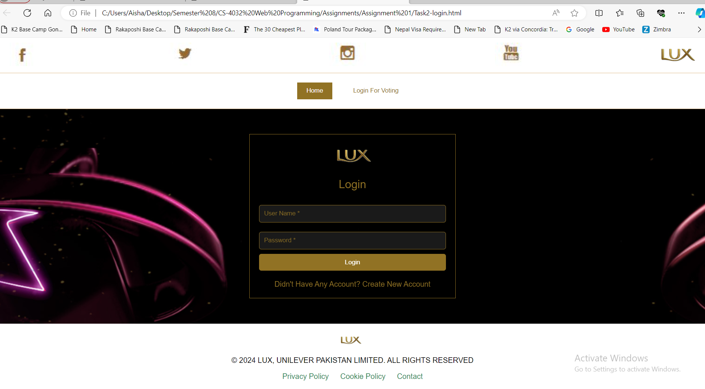

1. **Signup Page with Amination**

**Code:**

<!DOCTYPE html>

<html lang="en">

<head>

    <meta charset="UTF-8">

    <meta name="viewport" content="width=device-width, initial-scale=1.0">

    <title>Login Page</title>

    <style>

        body {

            margin: 0;

            padding: 0;

            font-family: Arial, sans-serif;

            background-color: lavender;

            display: flex;

            flex-direction: column;

            min-height: 100vh;

        }

        .container-navbar {

            display: flex;

            align-items: center;

            justify-content: space-between;

            height: 75px;

            padding: 0 20px;

            background-color: white;

            border-bottom: 1px solid burlywood;

        }

        .container-navbar img {

            height: 50px;

            width: auto;

            margin: 0 10px;

        }

        .container-login {

            text-align: center;

            background-color: white;

            border-bottom: 1px solid burlywood;

            padding: 20px;

        }

        .button-home,

        .button-login {

            padding: 10px 20px;

            background-color: rgb(145, 114, 36);

            color: white;

            border: none;

            cursor: pointer;

            margin: 0 10px;

        }

        .button-login {

            background-color: white;

            color: rgb(145, 114, 36);

            transition: background-color 0.3s, color 0.3s;

        }

        .button-login:hover {

            background-color: rgb(145, 114, 36);

            color: white;

        }

        .container-login1 {

            background-image: url("C:/Users/Aisha/Desktop/Semester 8/CS-4032 Web Programming/Assignments/Assignment 1/Images/background-login.jpg");

            text-align: center;

            padding: 20px;

            flex: 1;

            display: flex;

            justify-content: center;

            align-items: center;

            flex-direction: column;

        }

        .login-form {

            max-width: 400px;

            background-color: transparent;

            padding: 20px;

            border: 1px solid rgb(145, 114, 36);

            opacity: 0;

            transform: translateX(-100px);

            animation: slideInFromLeft 1s ease-in-out forwards;

        }

        @keyframes slideInFromLeft {

            to {

                opacity: 1;

                transform: translateX(0);

            }

        }

        .login-form input[type="text"],

        .login-form input[type="password"],

        .login-form input[type="email"],

        .login-form input[type="tel"]

         {

            width: 100%;

            padding: 10px;

            margin: 10px 0;

            box-sizing: border-box;

            border: 1px solid rgb(145, 114, 36);;

            border-radius: 5px;

            background-color: rgba(255, 255, 255, 0.1);

            color: rgb(145, 114, 36);

        }

        .input-group {

            display: flex;

            justify-content: space-between;

        }

        .login-form input::placeholder {

            color: rgba(145, 114, 36, 0.9);

        }

        .login-form img {

            height: 50px;

            width: auto;

            margin: 0 10px;

        }

        .login-form button {

            width: 100%;

            padding: 10px;

            background-color: rgb(145, 114, 36);

            color: white;

            border: none;

            border-radius: 5px;

            cursor: pointer;

        }

        .login-form button:hover {

            background-color: #8b5e2b;

        }

        .signup-link {

            display: block;

            margin-top: 20px;

            color: rgb(145, 114, 36);

            text-decoration: none;

        }

        .signup-link:hover {

            text-decoration: underline;

        }

        .footer {

            background-color: white;

            text-align: center;

            padding: 20px;

            margin-top: auto;

        }

        .footer img {

            height: 30px;

            width: auto;

            margin-right: 10px;

        }

        .footer a {

            color: seagreen;

            text-decoration: none;

            margin: 0 10px;

        }

        .footer a:hover {

            text-decoration: underline;

        }

        @media only screen and (max-width: 768px) {

            .container-navbar {

                height: auto;

                flex-direction: column;

                align-items: flex-start;

                padding: 20px;

            }

            .container-navbar img {

                margin: 10px 0;

            }

            .container-login {

                padding: 10px;

            }

            .button-home,

            .button-login {

                margin: 10px;

            }

            .container-login1 {

                padding: 10px;

            }

            .login-form {

                max-width: 100%;

            }

        }

    </style>

</head>

<body>

    <header>

        <div class="container-navbar">

            <a href="https://www.facebook.com/LuxPakistan/" target="_blank"><img src="C:/Users/Aisha/Desktop/Semester 8/CS-4032 Web Programming/Assignments/Assignment 1/Images/facebook_logo1.jpg" alt="Facebook"></a>

            <a href="https://twitter.com/i/flow/login?redirect_after_login=%2FLuxStylePk" target="_blank"><img src="C:/Users/Aisha/Desktop/Semester 8/CS-4032 Web Programming/Assignments/Assignment 1/Images/twitter_logo1.jpg" alt="Twitter"></a>

            <a href="https://www.instagram.com/luxstylepk/" target="_blank"><img src="C:/Users/Aisha/Desktop/Semester 8/CS-4032 Web Programming/Assignments/Assignment 1/Images/instagram_logo1.jpg" alt="Instagram"></a>

            <a href="https://www.youtube.com/channel/UCUjdhbKM8OuXNwbtpnLkt0A" target="_blank"><img src="C:/Users/Aisha/Desktop/Semester 8/CS-4032 Web Programming/Assignments/Assignment 1/Images/youtube_logo1.jpg" alt="Youtube"></a>

            <a href="Task2-landing.html"><img src="C:\Users\Aisha\Desktop\Semester 8\CS-4032 Web Programming\Assignments\Assignment 1\Images\logo1.png" alt="Logo"></a>

        </div>

    </header>

    <div class="container-login">

        <button class="button-home" onclick="location.href='Task2-landing.html'">Home</button>

        <button class="button-login" onclick="location.href='Task2-login.html'">Login For Voting</button>

    </div>

    <div class="container-login1">

        <div class="login-form">

            <img src="C:\Users\Aisha\Desktop\Semester 8\CS-4032 Web Programming\Assignments\Assignment 1\Images\logo1.png" alt="Logo">

            <h2 style="color: rgb(145, 114, 36);font-weight: lighter;">Please Submit Your Details</h2>

            <form action="login_process.php" method="post">

                <div class="input-group">

                    <input type="text" name="firstname" placeholder="First Name *" required>

                    <input type="text" name="lastname" placeholder="Last Name *" required>

                </div>

                <div class="input-group">

                    <input type="tel" name="phone" placeholder="Contact Number *" required>

                    <input type="email" name="email" placeholder="Email Address *" required>

                </div>

                <div class="input-group">

                    <input type="text" name="cnic" placeholder="CNIC *" required>

                    <input type="text" name="city" placeholder="City *" required>

                </div>

                <div class="input-group">

                    <input type="password" name="password" placeholder="Password *" required>

                    <input type="password" name="cnfpassword" placeholder="Confirm Password *" required>

                </div>

                <div class="input-group">

                    <input type="checkbox" id="terms" name="terms" required>

                    <label style="color: rgb(145, 114, 36);" for="terms">I agree to the terms and conditions</label>

                </div>

                <div class="input-group">

                    <input type="checkbox" id="subscribe" name="subscribe">

                    <label style="color: rgb(145, 114, 36);" for="subscribe"> I confirm I am 18 years old.*</label>

                </div><br>

                <button type="submit">Sumbit</button>

            </form>

        </div>

    </div>

    <footer>

        <div class="footer">

            <img src="C:\Users\Aisha\Desktop\Semester 8\CS-4032 Web Programming\Assignments\Assignment 1\Images\logo1.png" alt="Logo">

            <p>© 2024 LUX, UNILEVER PAKISTAN LIMITED. ALL RIGHTS RESERVED</p>

            <a href="#privacy-policy">Privacy Policy</a>

            <a href="#cookie-policy">Cookie Policy</a>

            <a href="#contact">Contact</a>

        </div>

    </footer>

</body>

</html>

**Output:**

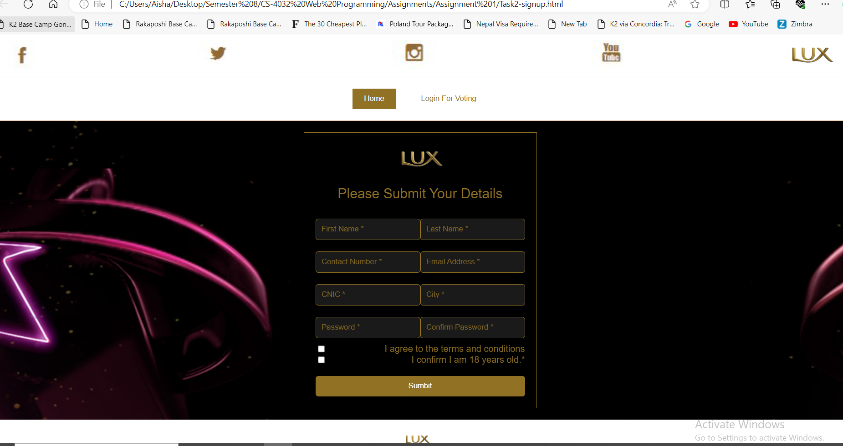

**Thank You**