Module 9: SQL Operations Report
FastAPI Calculator | PostgreSQL | pgAdmin | Docker Compose
This report documents the SQL operations performed in pgAdmin and verifies that the three Docker Compose services were running.

1. Create Users Table
Created the users table with a primary key and unique username and email fields.
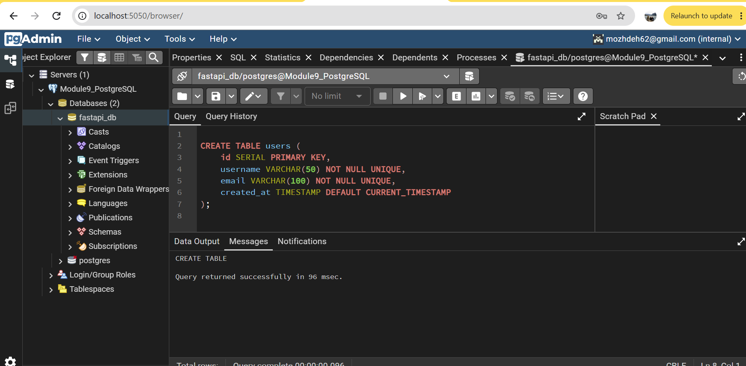
Figure 1: Create Users Table

2. Create Calculations Table
Created the calculations table with a foreign key connecting calculations to users.
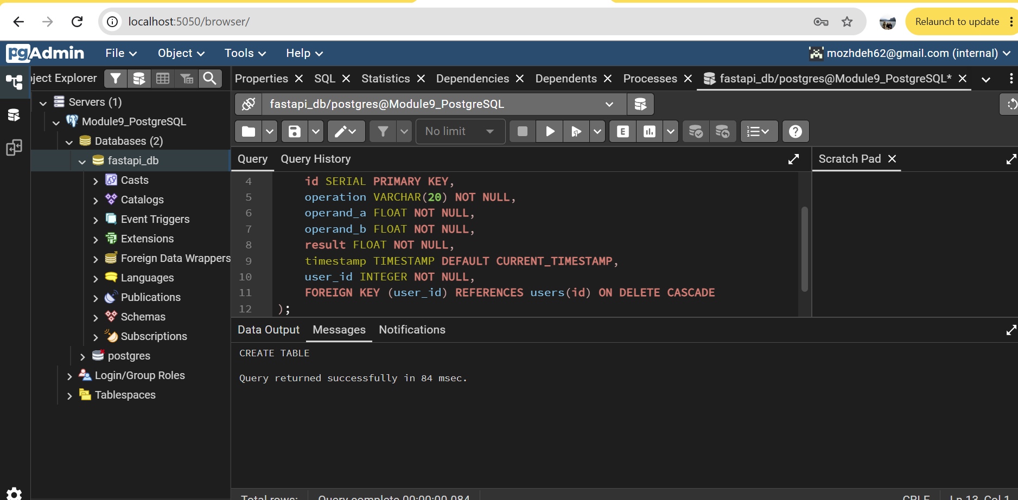
Figure 2: Create Calculations Table

3. Insert Users
Inserted two sample users, Alice and Bob.
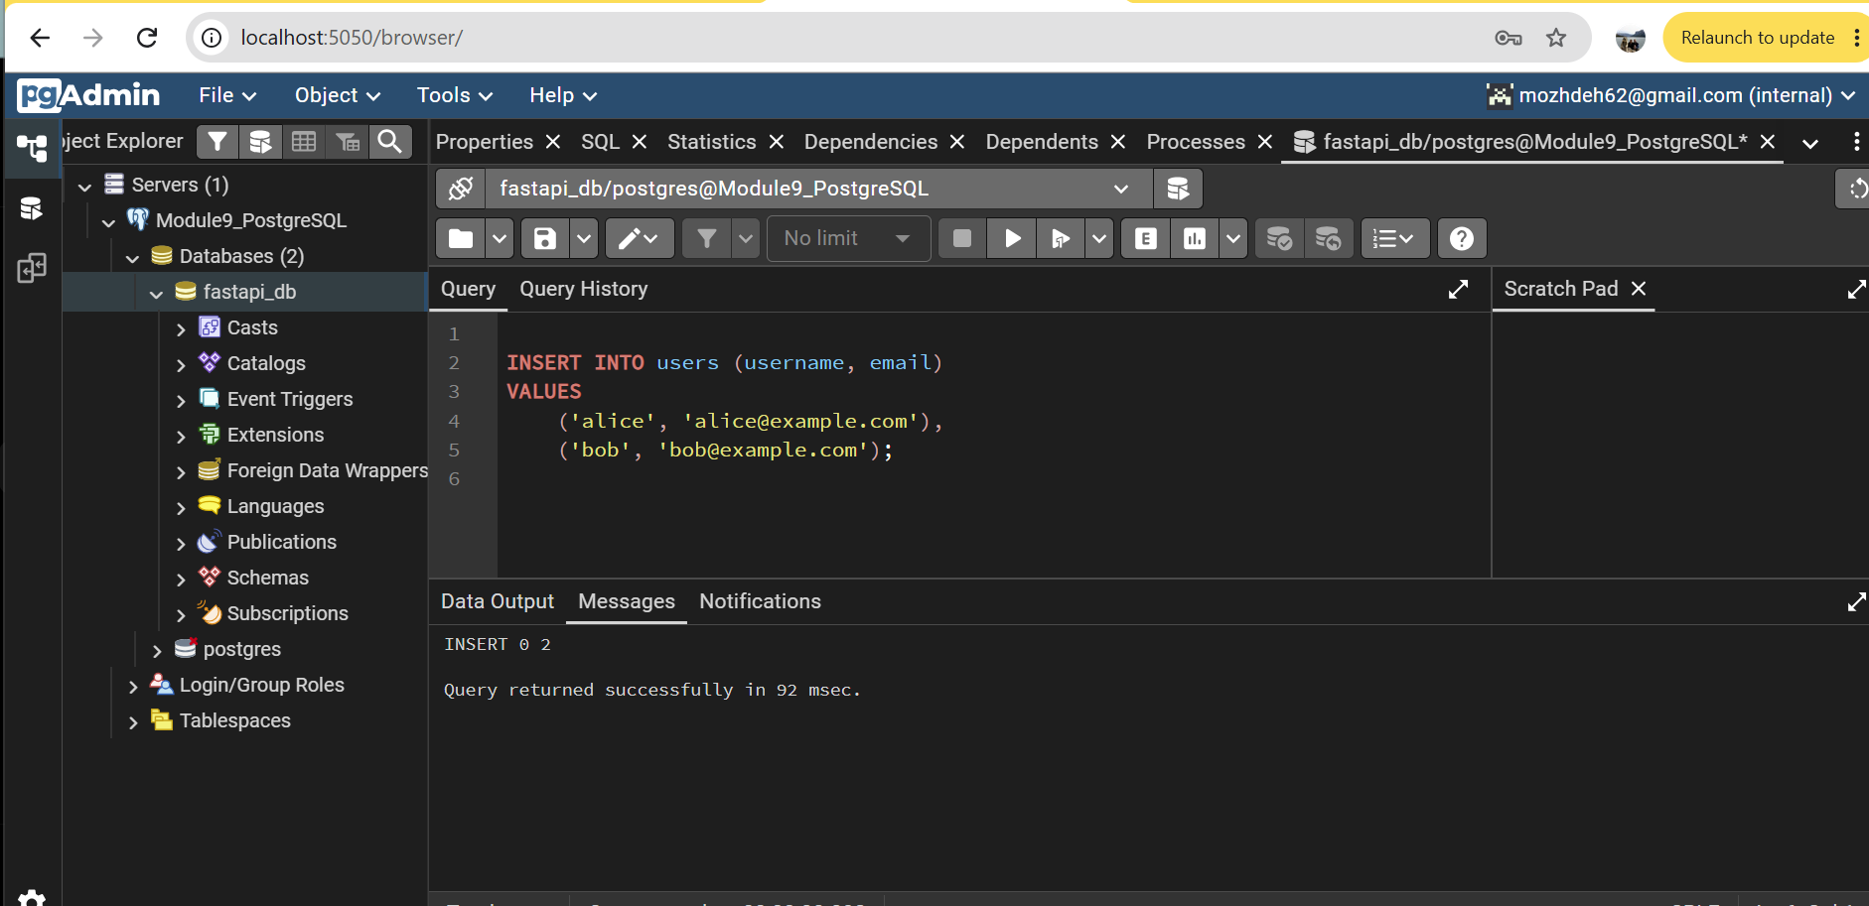
Figure 3: Insert Users

4. Insert Calculations
Inserted three calculations associated with the correct users.
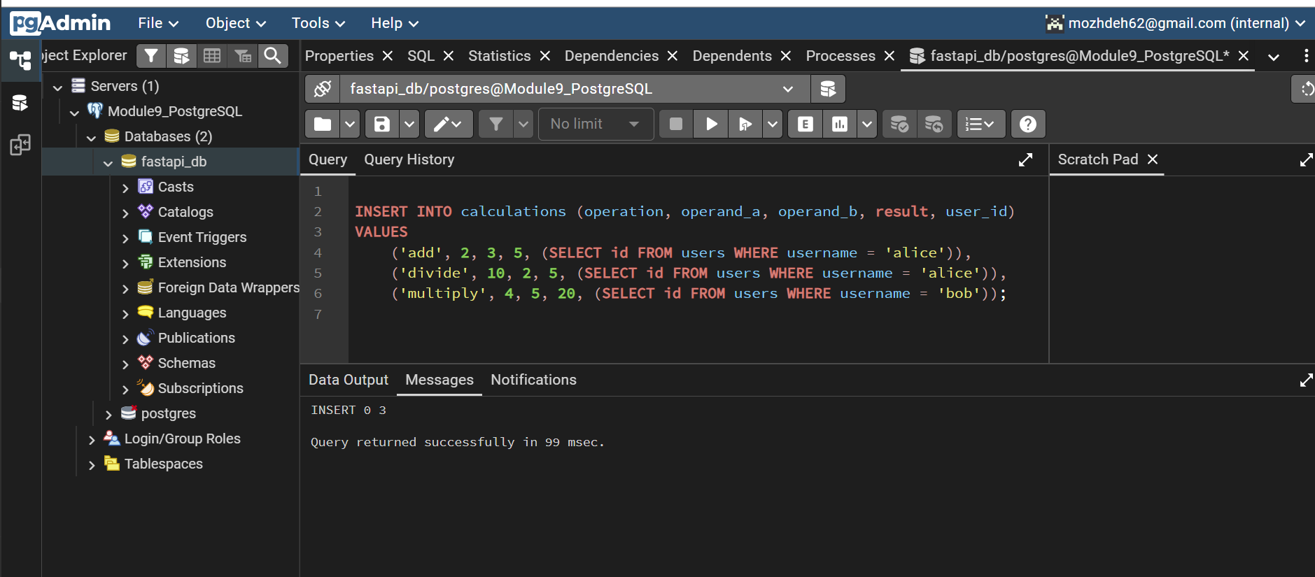
Figure 4: Insert Calculations

5. Select Users
Retrieved all records from the users table.
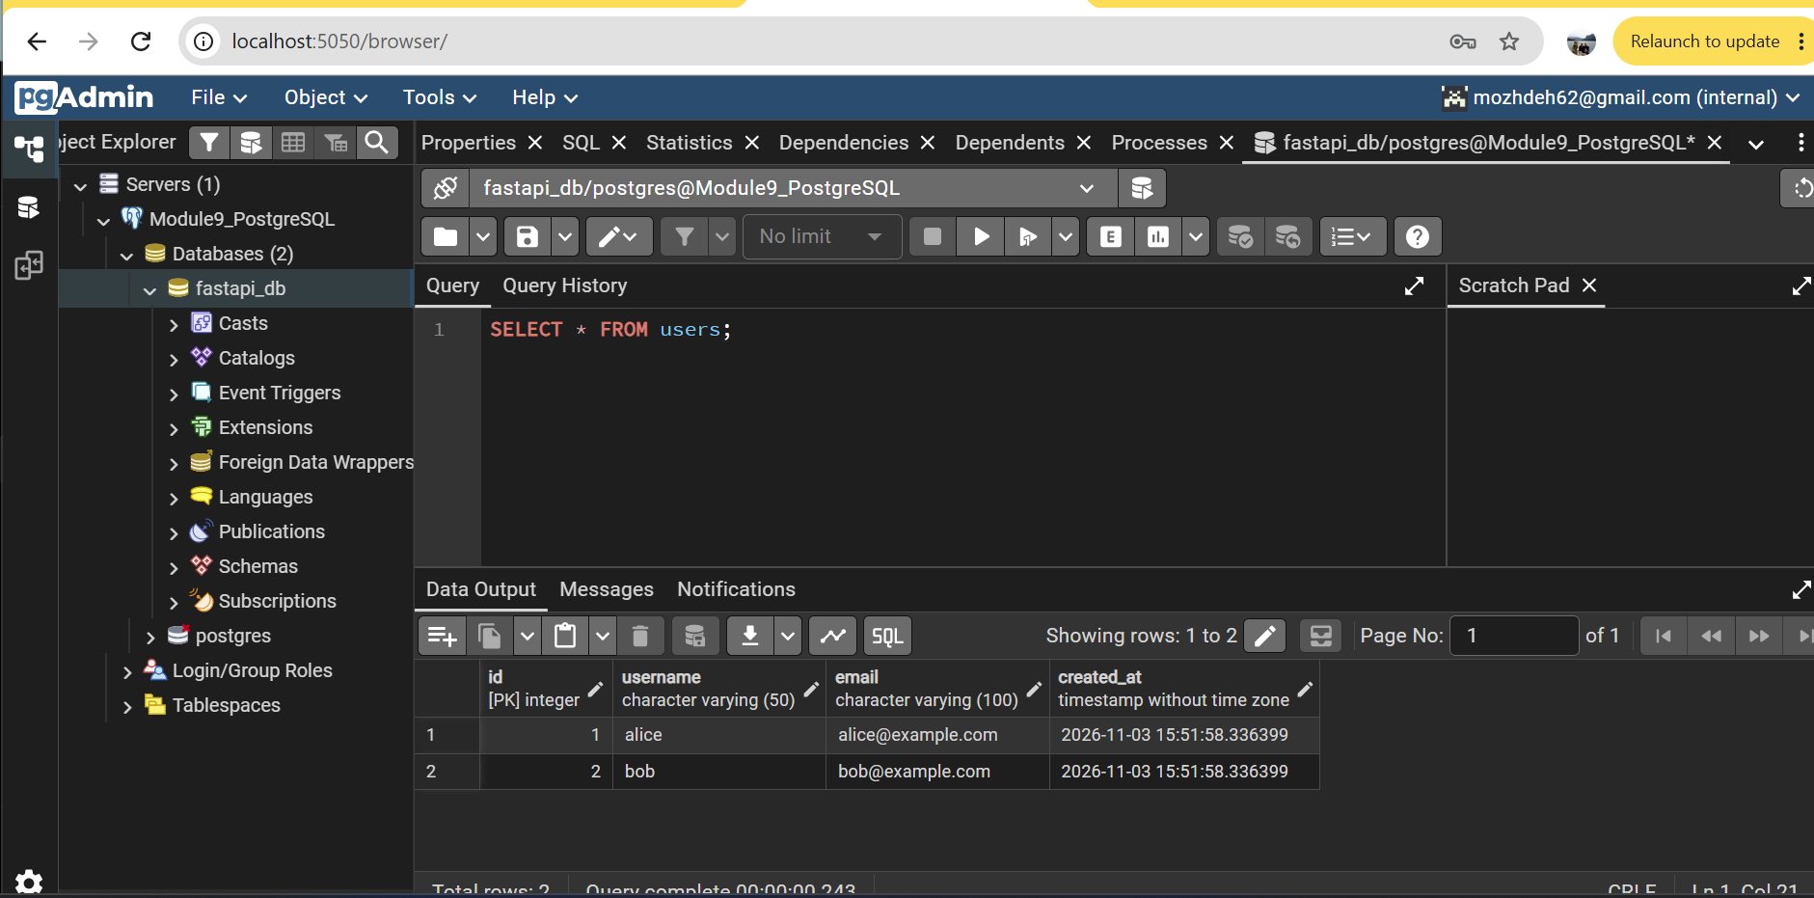
Figure 5: Select Users

6. Select Calculations
Retrieved all three calculations from the database.
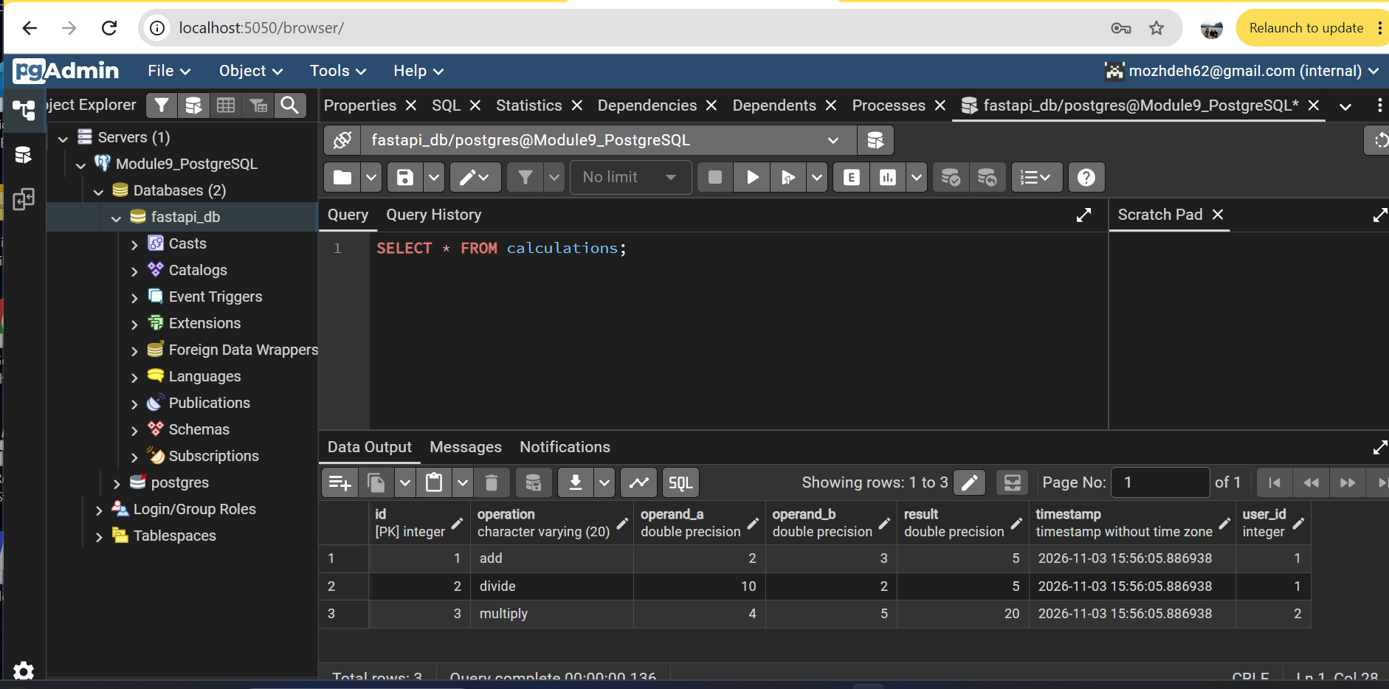
Figure 6: Select Calculations

7. JOIN Tables
Combined the users and calculations tables to display usernames with their calculations.
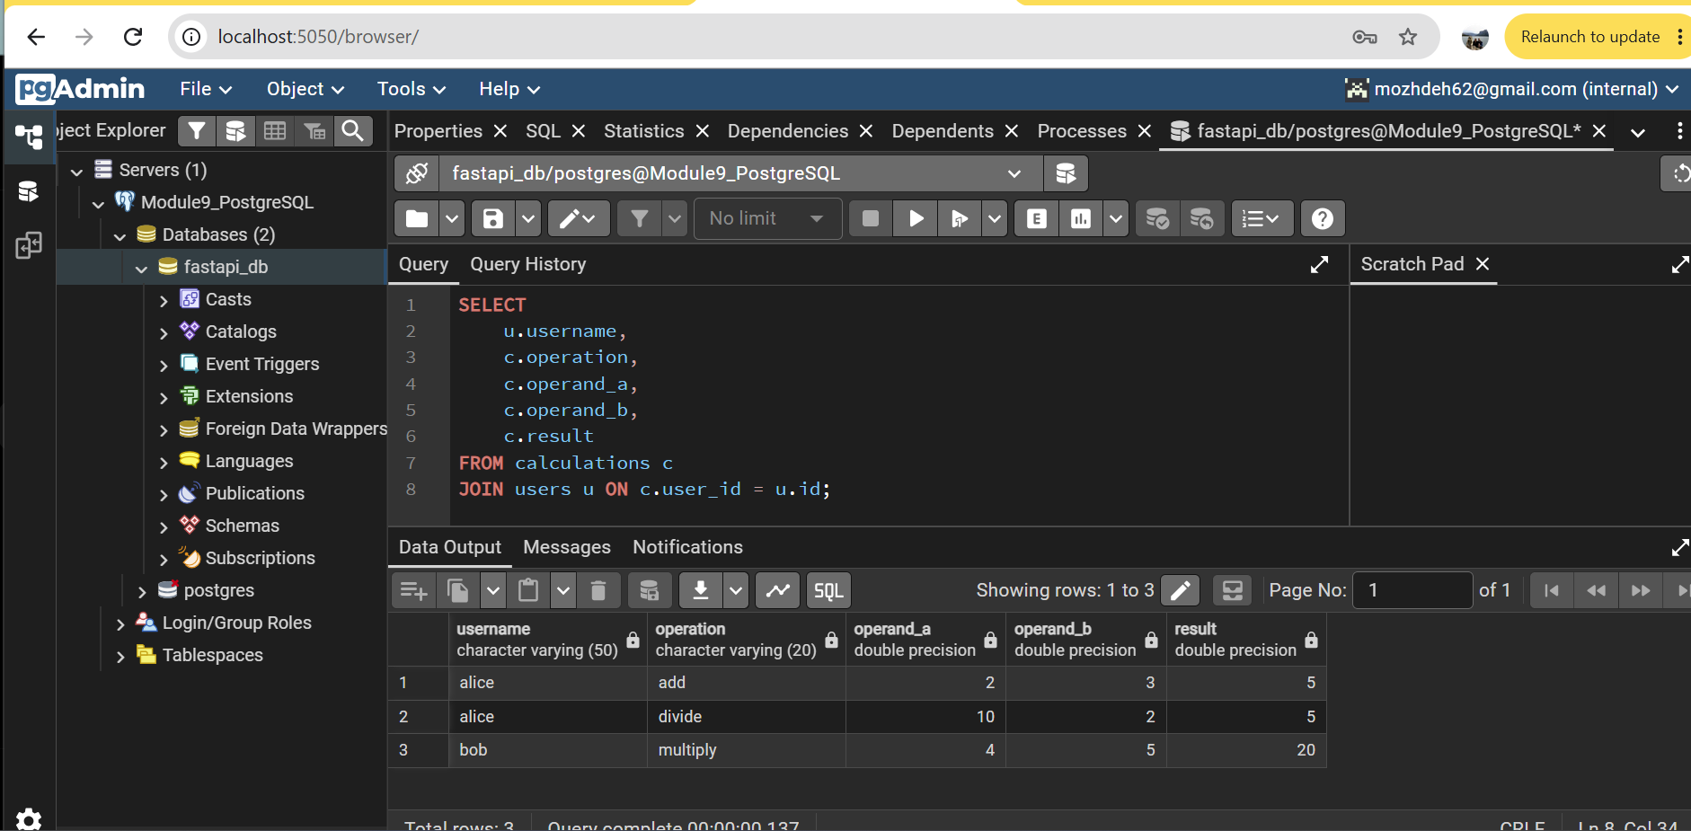
Figure 7: JOIN Tables

8. Update Record
Updated the result of calculation ID 1 from 5 to 6.
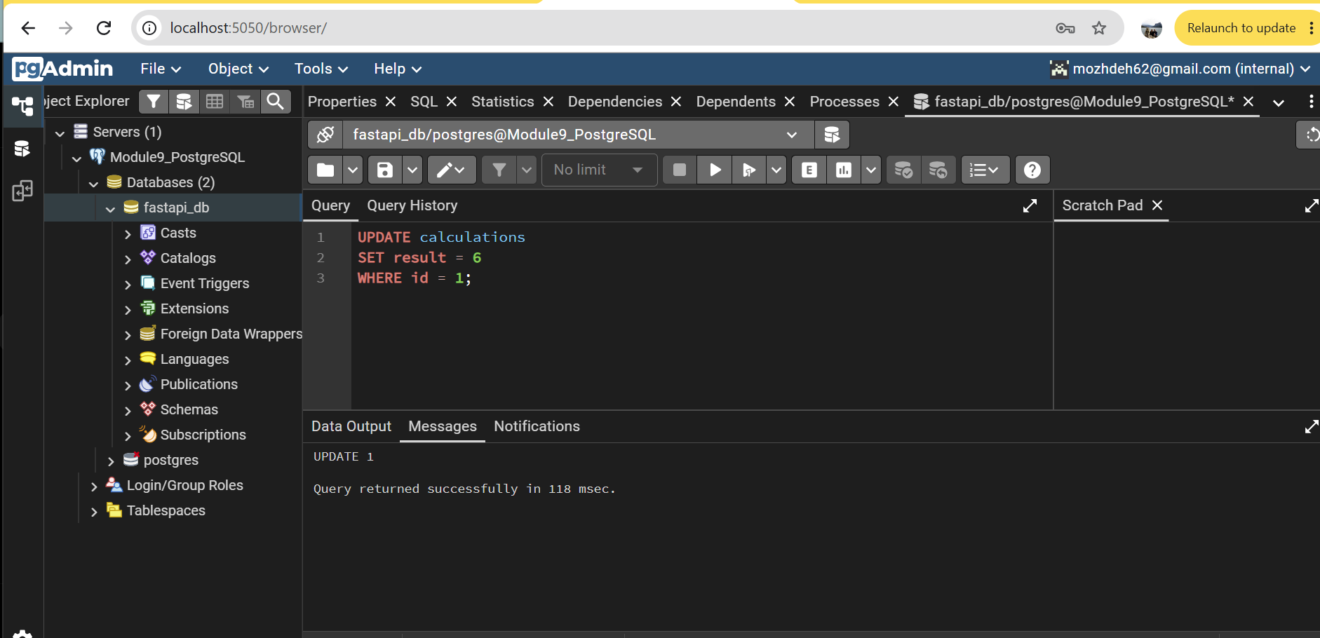
Figure 8: Update Record

9. Delete Record
Deleted calculation ID 2 from the database.
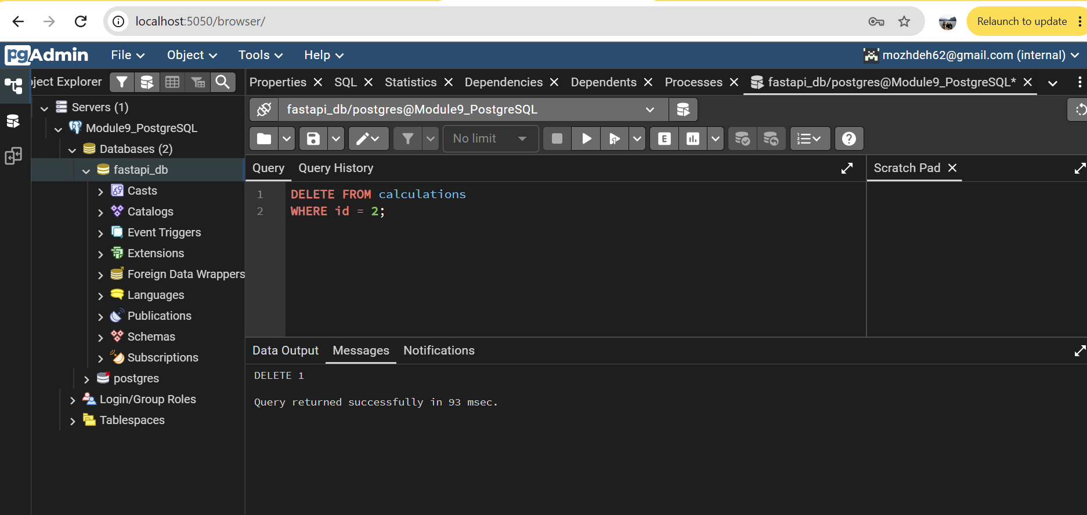
Figure 9: Delete Record

10. Docker Compose Services
Verified that FastAPI, PostgreSQL, and pgAdmin containers were running successfully.
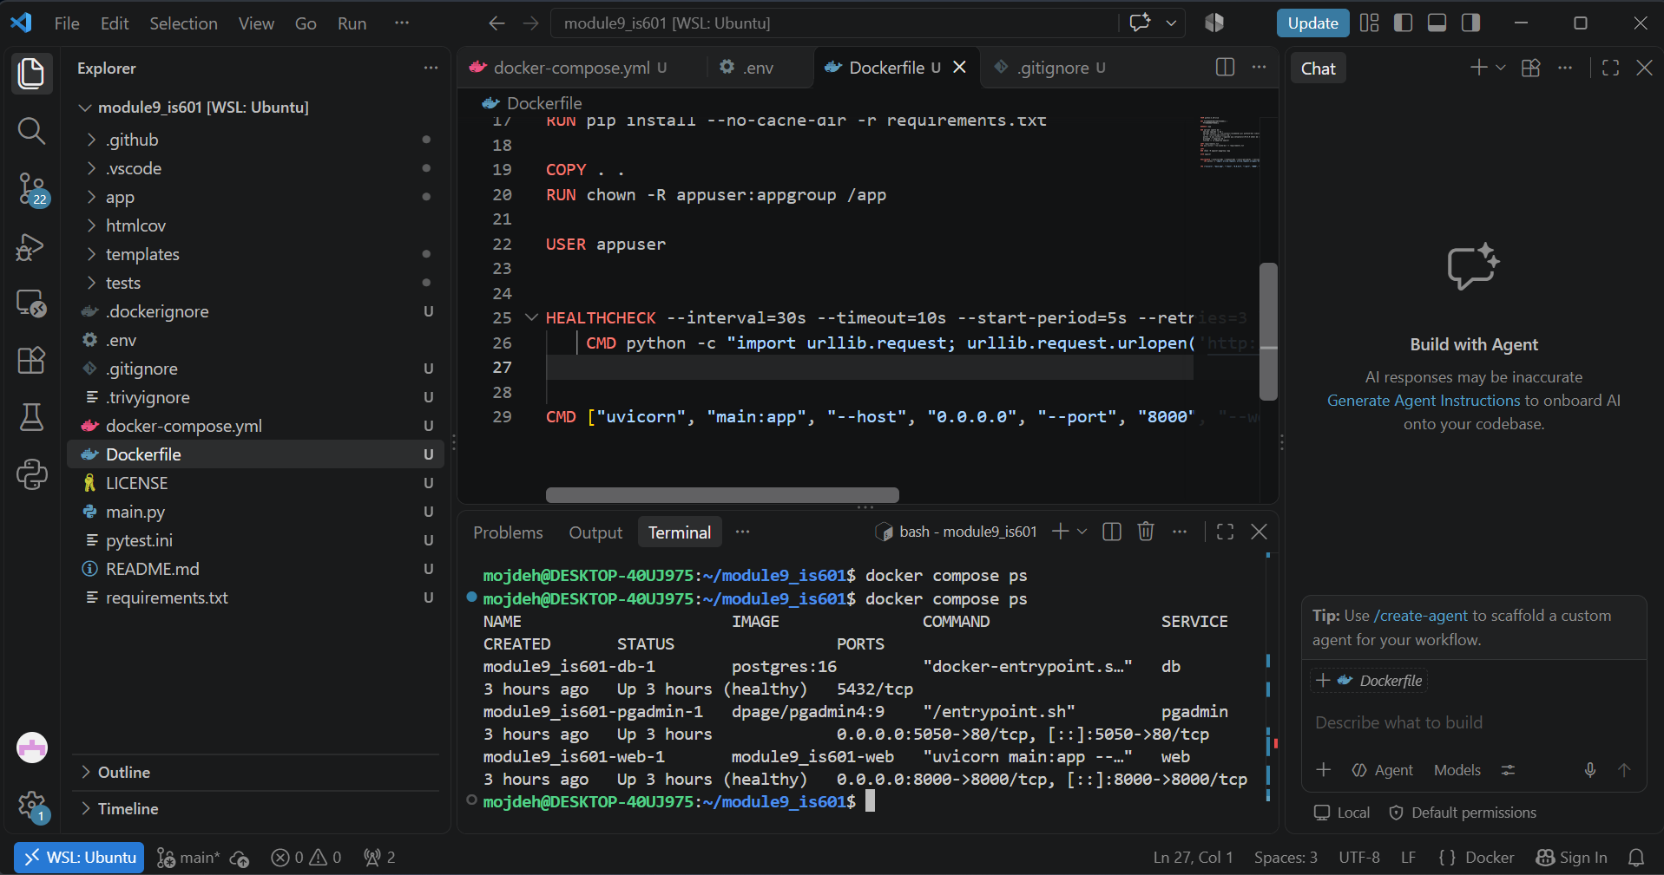
Figure 10: Docker Compose Services

