CLASSIFICATIONS OF LIVING ORGANISMS
More than 1.8 million kinds of living organisms have been examined and described. There are still many more to be discovered and described, therefore, we must have a meaningful way of classifying, identifying and naming them. Aristotle (384-322 BC) a Greek Philosopher, was the first make an attempt to classify living organisms. The present method of classifying and m=naming living organisms is based on the work of Linnacus (1707 – 1778), a Swedish naturalist. The study of the general principle of classification is known as taxonomy or systematic.

HIERARCHY OF LIVING ORGANISMS
Kingdom has the largest group of organisms. Each kingdom is split into smaller groups, and these groups into even smaller groups and so on. The arrangement of living organisms in this hierarchy from the highest to the lowest is as follows:
Kingdom
Phylum or Division (Plants)
Class
Order
Genius
Species

Arrangement of Living Organisms in Hierarchy

The variety of organisms decreases from top to the bottom. The kingdom has the largest variety of organisms. They have certain important features in common but show many differences. The species is the smallest unit of classification. They are identical in general appearance. They can mate with one another and produce fertile offspring. Organisms within a species are very closely related.

BINOMIAL NOMENCLATURE
This is the use of a standard system to name living organisms, though we are familiar with common names of living organisms such as mango, goat, pawpaw, lion etc. in Binomial Nomenclature, each kind of organisms is given two names: the first name is the genus to which the organism belongs and the second been the species to which it belongs. On the genius name begins with an initial capital letter, hence the scientific name of pawpaw is carica papaya, lizard – Agama agama. The names are written in italics or underlined separately.

KINGDOMS
All living organism were placed into two kingdoms by Linnaeus. The kingdom was plants and animals. This is known as two – kingdom classification. In this classification, many one-celled organisms could not fit in properly; it failed to establish clear-cut distinction between plants and animals. It also could not indicate correct relations among organisms. So, in 1969, Whittaker proposed the five-kingdom classification which is generally used at present. The classifications are:
- Moneras
- Protists
- Fungi
- Plantae and
- Animalia

The kingdom Monera contains the prokaryotes – which are the very simple – called organisms that have no true nuclei. The eukaryotes – which cells are highly organized with definite or true nuclei are classified into the four remaining kingdom: protest, fungi, plantae and animalia.

The Characteristics of the five – Kingdom Organisms

Kingdom Monera (Prokaryotes)
Single-celled organisms, motile or non-motile, microscopic simple – celled structure with no definite nucleus. Examples includes bacteria, blue-green algae, actinomycetes.

Kingdom Protista (Eukaryotes)
Single-celled, motile or non-motile. Organisms are much larger than the monerans. Complex cell structure with a definite nucleus. Examples includes: chlamydomonas, amoeba.

Kingdom Fungi (Eukaryotes)
Non-motile organisms usually of thread-like structure or hyphae. Pant-like but cannot carry out photosynthesis due to absence of chlorophyll, obtain food through surface from living or non living organism source by absorption, reproduction could be by asexual or sexual or sexual spores. Examples includes: moulds, mushrooms, shine moulds, yeasts.

Kingdom Plantae
Many-celled, non-motile, contain chlorophyll that enables them make their own food by photosynthesis. Plants have indeterminate growth. Examples includes: Mosses, Ferns, Pines, Seed plants (yam, bean and plants).

Kingdom Animalia
Multicellular, eukaryotes and heterotrophy. They lack chlorophyll. Growth is determinate with definite shape and size example include; rat, dog, bat, horse, man).

KINGDOM PLANTAE

Plants can readily be understood in the context of their autotrophic mode of nutrition. They simply transform light energy unto chemical energy by anchoring firmly in one place with a maximum surface area to capture sunlight. Plants use the cheapest material around, water and carbohydrate to generate size because plants are immobile, they are extremely responsive to environmental cues and have their life cycle in perfect synchrony with the seasons.

Plants have a unique mode of development. This involves giving by meristerms at their tips. They also have remarkable power of regeneration. Any single plant cell can regenerate an entire plant with its cell types. The cells have cellulose cell wall.

The plant kingdom is mainly classified into: Thallophtes, Bryophytes, Pteridophtes, Gymnosperms, Angiosperms.

THALLOPHYTES (ALGA)

Thallophytes are eukaryotic organisms that do not have well-differentiated body designs but rather have a simple thalloid body structure without definite organs such as leaves, stems, roots and flowers.

They are a polyphylectic group of non-motile and motile organisms traditionally described as relatively simple plants or lower plants because they consisted of one cell or a relatively undifferentiated mass of cells called a thallus. The term was used in former classifications; comparing what is now considered as assemblage of flowerless and seedless organism phycophyta, mycophyta and lichens. The phycophyta are the photosynthetic forms called the algae, the mycophyta are the non-photosynthetic forms called the fungi, while the lichems are the symbiotic forms.

Currently, some authors do not group fungi under the thallophytes. The reason is because the recent phylogenetic analysis of DNA sequences and protein sequences indicates that fungi are more closely related to animals than in plants. Despite this, fungi still share some characteristics with the algae in having simple body structure and also symbionts with algae and lichens.

PHYCOPHYTES (ALGAE)
General Features and Characteristics
Algae (singular, algae) or Unicellular algae occur most frequently in water, especially in anklon. Phytoplankton is the population of free-floating micro-organism composed primarily of unicellular algae.

The multicellular algae develop speculated tissues, but lack the true stems leaves or roots of the more complex higher plants. They do not develop multicellular sex organs.

Most algae are photoautotrophic and carry on photosynthesis. Some forms however are chemoheterotropic and obtain energy from chemical reaction and nutrients from preformed organic matter. Most species are saprobe while some are parasites.

The cell of an alga has eukaryotic mproperties and some species have flagella. A nucleus is present, and multiple chromosomes are observed in mitosis. The chlorophyll and other pigments occur in chloroplasts, which membranes are known as thylakoids.

Reproduction may take place vegetatively by cell division (mitosis) or by detachment of a portion of the mother plant through the fragmentation of colonial and filamentous algae, or asexually by spores or binary fission, or sexually by gametes. During sexual reproduction, algae form differentiated sex cells that fuse to produce a diploid zygote with two sets of chromosomes. The zygote develops into a sexual spore, which germinates when conditions are favourable to reproduce and reform the haploid organism having a single set of chromosomes. This pattern of reproduction is called alternation of generation.
Algae can occur in salt or fresh waters, or on the surface of moist soil or rocks and woods. They include the green slimes on ponds, green films on trees and walls, the sea weeds of the shores and the phytophankton that support animal life in the seas. Algae are responsible for producing the oil reserves of the world.

Alga also known as Thallophytes are the simple green plants. They are aquatic plants (lives in water) that are threadlike or flat (thallus) bodies with no roots or stems. They inhabit damp places on the land surface. They exhibit a distinct alternation of generation. The sporophyte is always attached and dependant on the gametophyte.

Alga exhibits biological diversity and have the ability to produce a wide variety of metabolic products, hence they are extensively exploital in biotechnology. Algae other usefulness includes: an important source of food for fresh water and marine organisms and also supplies oxygen to them.

Used as biofertilizer, for example nitrogen fixing algae which farmers can grow in their fields are used to enrich soil controlling pollution in water bodies and also in purification of sewage.

Algae show great diversity in size and structures. They are unicellular, colonial, filamentous and thalloid in form. Some are microscopic, while others are very big in size. They do not form complex organs or tissues. The study of their ultra structure under electron microscope shows that blue-green algae have prokaryotic type of cell like that of bacteria while all other algae are eukaryotes.

Algal Morphology
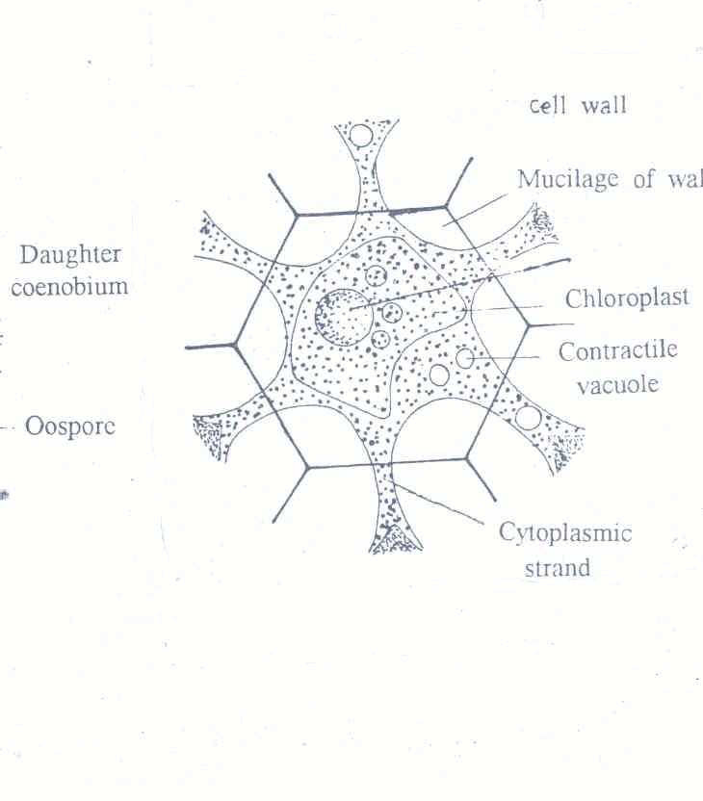
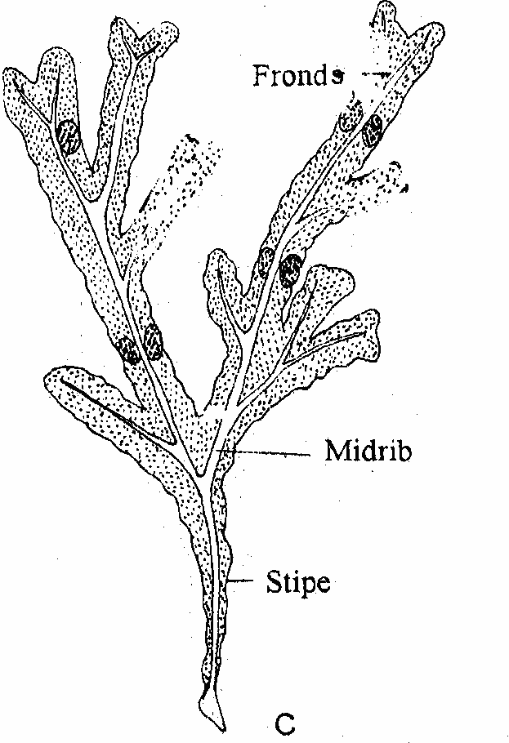
Morphologically, algae can be distinguished as unicellular, colonial, filamentous, heterotrichus, thalloid and polysiphoid forms. Examples of each of these types of algae are given below.
Colonial Algae
Thallus Algae

Various Forms of Algae
S/n | Form | Example(s)
1 | Unicellular Algae | Anacystis Microcystis
2 | Colonial Algae | Microcystic Volvox
3 | Filamentous Algae | Nostoc} blue-green algae  Ulothrix  Oedogonium
4 | Heterotrichous Algae | Draparnaldiopsis  Coleochacte  Ectocarpus
5 | Thalloid | Ulva  Fucus} Brown algae
6 | Polysiphonoid | Polysiphonia (Red algae)

Characteristic features of Algae
- They are simple plants without roots, stems and leaves.
- They have chlorophyll. Some have blue, yellow, brown and red pigments with the chlorophyll.
- Majority are uni-cellular while few are multicellular. Some, such as sea weeds are large.
- They are mainly aquatic, with a few on damp soils and shady places examples are spirogyra, anabaena and sargassum.
- The cell wall of algae is composed of true cellulose.
- Reserve carbohydrates are usually starch and not glycogen as in fungi.

Classification of Algae
Classification means grouping of organisms according to the simularity in their characters. It is not farfetched but true that organisms showing similar morphology, life cycle, physiology and biochemistry are genetically related from the evolutionary point of view. Therefore, Algae are classified into classes. These are:
- Cyanophyta (prokaryotic algae) or blue-green algae e.g Nostoc, anabaena, oscillatoria
- Chlorophyta (Green algae) e.g Chlamydomonas, Spirogyra, Chlorella
- Phaeophyta (Brown algae) e.g Fucus, Sargassum, Laminaria
- Xantophyta (Yellow – green algae) e.g Vaucheria, Botrydium
- Chrysophyta (Golden – Brown algae) e.g Synura, Mallomonas, Chromalina
- Euglenophyta (Euglenoids) e.g Euglena, Trachelommas
- Dinophyta (Dinoflagellates) e.g Ceratium, Peridinum
- Crytophyta (Crytomanads) e.g Crytomones, Chromonas
- Bucillariophyta (Diatoms) e.g Diatoms, Fragilaria

Ecological Adaptation
Algae range from Unicellular (Microscopic) to large (Macroscopic) thalloid forms growing in variety of habitats almost all over the surface of earth. Wherever there is water, a little moisture or water vapours, and light, however feeble, algae are sure to appear as green, yellow or brown patch. When several types of algae grow together under similar natural conditions we call them communities. The composition of a community is determined by the physical and chemical nature of the habitat. In many cases, the algal community indicates to us about the nature of the habitat, whether, it is rich or poor in nutrients or polluted etc., in other words it serves as an ecological indicator.

Aquatic Algae
Most of the algae grow in water; however, there are also sub-aerial algae. Depending on the concentration of salts there are various kinds of water bodies, such as fresh water brackish water, sea water, brine-salt lakes and salt pans. Their habitats nowadays may contain many types of pollutants, like excessive organic metal, heavy metals, pesticides, industrial effluents which are produced and dumped into them by man. This greatly affects algae and other organisms present in the water.

Fresh Water Habitats
Fresh water habitats comprise of rivers, mountains streams, lakes and temporary rainwater puddles. Examples of algae find here include green algae like oedogonium, diatoms, desmids, etc.

In slow flowing rivers with rocky shores, one may find many filamentous algae like spirogyra, oedogonium. The surface of submerged rocks also shows epiphytic algae like desmids and cyanobacteria.

Marine Habitats
Sea inhabits largest number of algae collectively known as seaweed. Seacoast is periodically flooded and exposed to sun because of the feeds. The area between the high tide and low tide level is known as intertidal zone. The seaweed that grows in the intertidal zone face alternate drying and wetting. They are also firmly attached to the underlying rocks by means of hold fasts. At times they may get detached and found flowing in the open sea as in the case of Sargasso Sea. Example of seaweed include Sargassum wightii (brown algae), turbinaria, gracilaria edulis.

Special Attributes
Algae are also found in special habitats where environmental conditions are in extreme such as brines and salt lakes where cyano bacteria (Anabaeria) and unicellutal green alga Dunaliclla can be found; Thermal Regions (hot water) thermal springs with temperatures ranging from 40⁰ to 70⁰c) inhabit alga like oscillareria, mastigocladus and cyanobacteria; polar regions (extremely cold climate conditions) where nostoc, oscillatatoria can be found.
Soil and Subaerial Algae
Surface layers of soils provide a favourable substratum when wet for the growth of several types of algae. Terrestrial algae such anabaena, play a major role as primary colonizers on newly exposed areas.

Subaerial algae obtain their water from the moisture in air and grow if moisture is available. They are capable of enduring drought like the soil algae. One can see dark brown patches sometimes with a velvety carpet like cushions covering extensively the exposed surface of buildings, walls, fences, asbestos, roofs, rock surfaces and also tree trunks.

SPIROGYRA (Family Zygnematoceae)
Spirogyra a green algae belongs to the family Chlorophyceae and the order conjulaes or Zygnematales. It is a cosmopolitan plant which forms a tangled mass of filaments floating on stagnant fresh water, especially in ponds, ditches, springs and streams. Some species grow in running water. Such species produce a short unicellular organ of attachment, called hapteron, for anchorage on sea weeds.

Spirogyra is commonly found as bright green masses of thread-like or filamentous structures on the surfaces of waters, and is often referred to as a “Pond Seum”.

Structure of a Spirogyra
Mature filament of spirogyra is unbranched and consists of single row of identical cylindrical cells joined end to end.
Cell wall is made of cellulose and pectin
External cell wall is covered by mucilage, making it shinny. Cytoplasm is a thin layer with spiral bands of chloroplast. Nucleus is suspended at the centre by strands of cytoplasm.
Chloroplast contains small nodular protoplasmic bodies called the pyrenoids.
Starch grains are deposited around each pyrenoid.

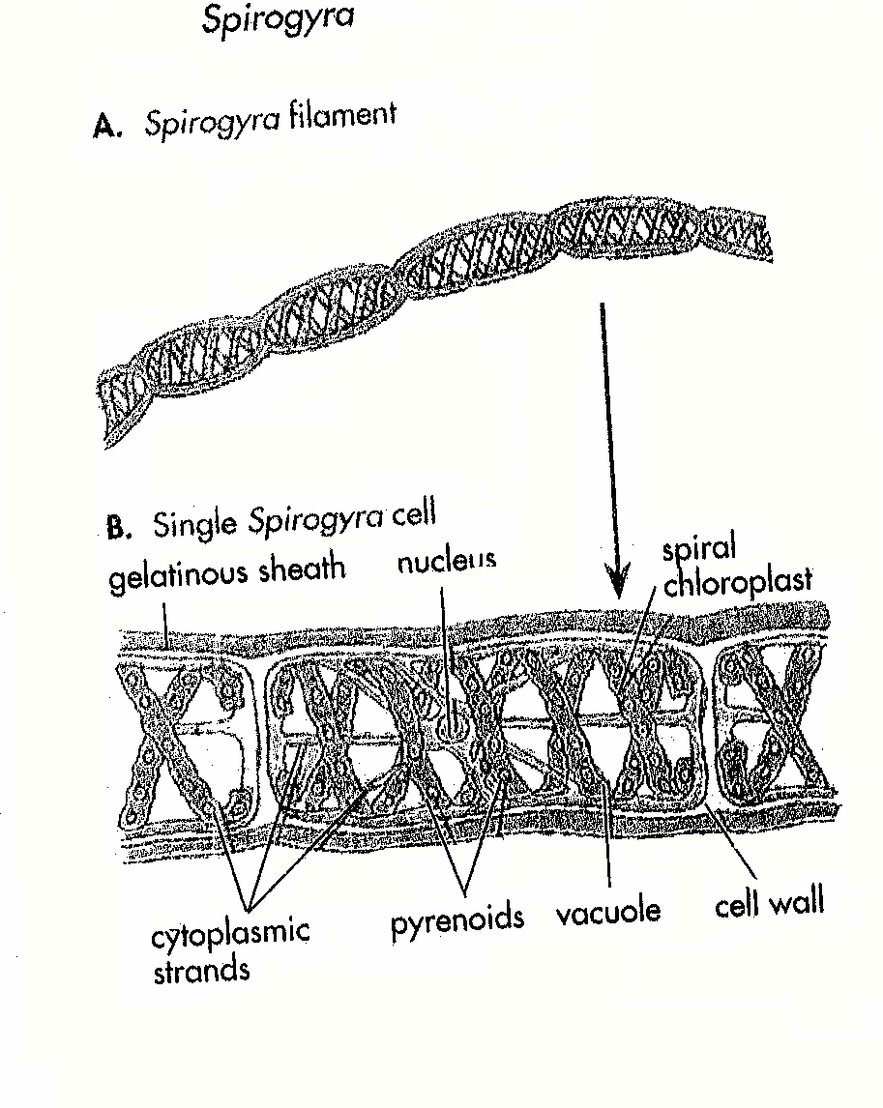

Ecological Adaptation of Spirogyra
- Presence of pectin layer encases spirogyra filament thereby protecting the organism from external forces.
- Chloroplasts enable the plants to manufacture it’s food for feeding.
- Pyrenoids store starch for feeding.
- Nucleus for cell division hence there is multiplication.

EUGLENA
Euglena belongs to the family of Euglenaceae

Characteristics
- Unicellular organism
- Presence of chloroplast (green in colour) for photosynthesis.
- A flexible outer covering called pellicle that allows it to change its shape.
- Presence of flagellum for movement.
- Presence of dark-red spot called eye spot which is light-sensitive.
- Contractile vacuole present for regulating osmotic pressure within the organism.
- Paramylum granules made of reserved food (starch) are present.
- Presence of a central nucleus.
Ecological Adaptation
- Presence of chloroplasts enables it to manufacture its food by photosynthesis for feeding.
- Gullet present enables it to ingest solid food particles from surrounding water.
- The flagellum enables it move.
- Eye spot helps euglena move towards light.
- Contractile vacuole collects and removes excess waste from all parts of the organism.
- Nucleus aid asexual reproduction by dividing.
- It form cyst to withstand unfavourable conditions.

CHLAMYDOMONAS
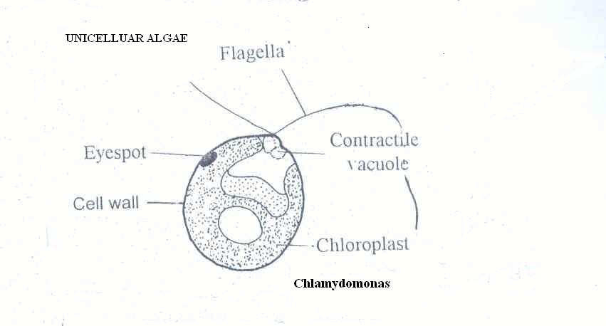

Characteristics of Chlamydomonas
- Unicellular green alga
- It is microscopic
- Two flagellae present
- Contractile vacuole present
- There is sensitive eye-spot that directs the movement of the organism towards light.
- Chloroplast for photosynthesis is present
- Pyrenoid (a protinaceous body) that stores starch is present.
- Nucleus is present.
Ecological Adaptation
- Presence of flagellae enables the organism to move.
- Contractile vacuole helps to remove waste products from the body thereby regulating osmotic pressure within the organism.
- Eye-spot directs movement of the organism towards light.
- Chloroplast for trapping light energy enables it to feed by photosynthesis.
- Presence of nucleus for multiplication and continuity.

BRYOPHYTES
During the course of evolution, a change from aquatic habitat to terrestrial habitat occurred and the only primitive land plants evolved. These are known as bryophytes. Although bryophytes colonize terrestrial habitats but they are still dependent on water for completion of their life cycle. They produce motile male gametes which require a thin film of water for their motility to reach the non-motile female gametes to accomplish fertilization.

General Characteristics of Bryophytes
- Bryophytes lack roots and do not have vascular system.
- Some mosses have a primitive system of tubes that conduct water and food conducting tubes called leptoids.
- A single plant is very small, hardly a few cm in size. it seldom grows large because of lack of supporting tissues.
- Bryophytes show two distinct and well defined phases of life cycle, sexual and asexual which follow each other. The gametophyte is haplod and produces gametes. The sporophytes is diploid and produces spore. The haploid generation alternates with diploid generation known as alternation of generation.
- The gametophyte may be thalloid or has an axis differential into stem-like and leaf-like structures which have xylem and phloem (not well developed).
- The gametophyte is green, photosynthetic and nutritionally independent and anchors to the soil by unicellular filaments called rhizoids.
- Rhizoids appear like roots but they lack vascular tissues.
- Bryophytes are more abundant in moist tropical areas. They also grow in deserts, mountains. In dry areas, their growth and activity is restricted to wet season only.

Morphology of Bryophytes
Bryophyte is mostly divided into liverworts and mosses.

LIVERWORTS
Gametophytes usually are close to the ground.
There are two forms of liverworts namely; thalloid liverworts (gametophyte) and is dorsi-ventral, with upper and lower surfaces.
Leafy liverworts (differentiated into leaf-like and stem-like structures).
Leaves of liverworts are without midribs.
Grows on moist ground or rocks that are also wet. (can be found in muddy areas)
Examples include Marchantia and Riecia.
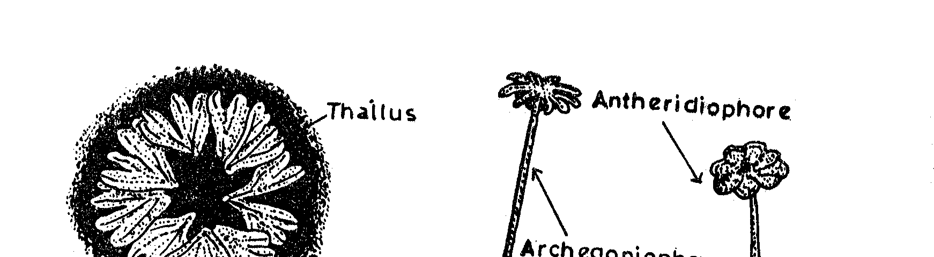
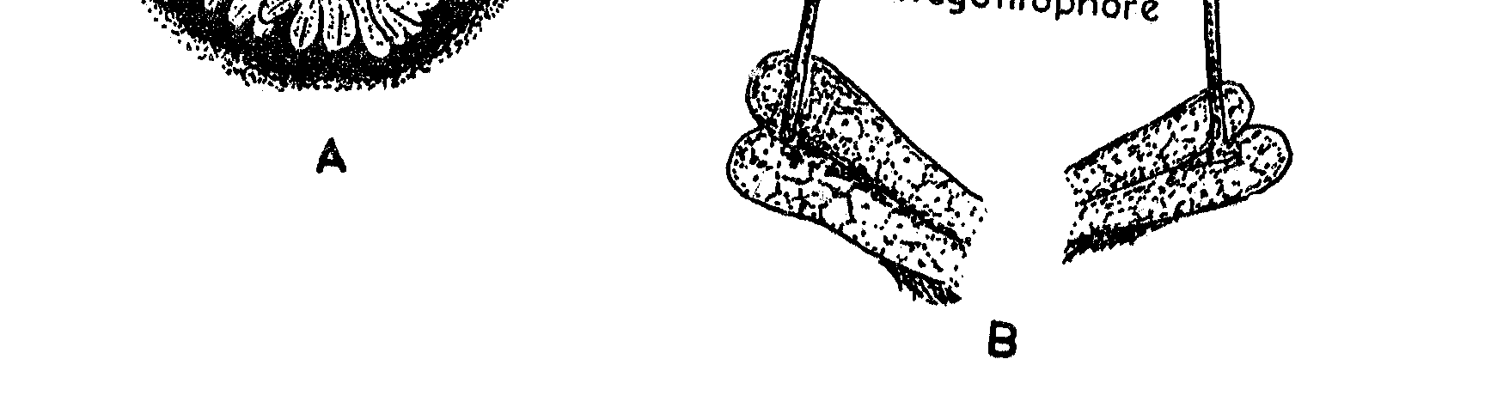

External Features of Marchantia
Marchantia belongs to the family marchantiaceae.
- The gametophyte bears archegonia on vertical stalked receptacles called archegoniophore.
- It grows in cool moist places along with mosses and increases of burnt grounds.
- It is deep green in colour
- Has a prominent midrib which is marked on the dorsal surface by a shallow groove and in the ventral surface by a low ridge covered with rhizoids.
- Marchantia is decorous.
- The thallus of marchantia is anchored to the surface by rhizoids which are of smooth walled.
- Scales are also present on the ventral surface arranged on both side of the mid-rib.

MOSSES
This is the largest class of Bryophytes.
They are divided into three subclasses; sphagnidae (Reat mosses), Andreaide (rock mosses) and Bryidae (true mosses).
Example includes funaria

External features or Characteristics of funaria (Mosses)
- Funaria is a very common moss and widely distributed throughout the world.
- The adult gametophyte is the most conspicuous form of the moist plant.
- It consists of a main erect axis bearing leaves which are arranged spirally.
- The adult gametophyte is called gametophine. It is small and about 1 – 3 cm high.
- The leaves do not have a stalk but show a distinct midrib.
- The gametophore is attached to substratum by means of rhizoids. They are multicellular, branched and have oblique septae.
- The gametophyte bears sporophyte which has foot, seta and capsule.
- The gametophore develops from a filamentous, green short-lived protonema.
- The protonema produces buds at certain stage of development, which inhate development of upring leafy green axis, the gametophores.
- The species, Funaria hygrometrica is cosmopolitan and is the best known of all the mosses.

Adaptation of Bryophytes
- Bryophytes are fixed to the soil by thread-like, small structures called rhizoids. Rhizoids are unicellular and unbranched in liverworts but multicellular and branched in mosses.
- They fix the plant to the soil and absorb water and minerals from it.
- The hydroids transfer water from rhizoids to the leaves at the apex and the food conducting leptoids transport sucrose.

In most other bryophytes, external capillary system takes care of the distribution of water to all parts of the plant body.

PTERIDOPHYTES
The Pteridophytes is the last group of non-flowering plants. The most familiar plants of this group are ferns which are commonly seen as house plants, in parks and also in house landscape along with ornamental plants. Ferns are rather small plants, often delicate compound leaves. Because of their beauty and difficulty in propagation, they are considered very precious plants. Pteridophytes are vascular plants and they posses root, stem and leaves. A common and widely distributed ferns is Dryopteris which grows in wet soil and under shade of tress. We also have water fern Azolta. There are also medium-sized tree ferns like cyathea.

General Characteristics of Pteridophytes
- Pteridophytes have two distinct phases in the life cycle. These are gametophyte and sporophytes which follow each other in regular succession. The two generations look different.
- The sporophyte is the dominant generation, independent of the gametophyte; it possess a vascular system and it is in a different habitat.
- Pteridophytes exhibit a great variation in form, size and structure.
- Most are herbaceous except a few woody tree ferns.
- They may be dorsi-ventral or radial in symmetry.
- They have dichotomously or laterally branched stems that bear megaphyllous leaves.
- Roots are generally adventitious, the primary embryonic root being short-lived.
- Spores are produced in special structures called the sporangia that are invariably subtended by leaf-life appendages known as sporophylls.
- In most cases, the sporangia are compacted to form distinct spore producing regions called the strobile. The sporangia in some cases may be produced within specialized structures called the sporocarp.
- The leaves of a fern plant is called frond.
- Pteridophytes, in general, are homophonous i.e they produce only one type of spores. However, a few species produce two types of spores (micro-spores and megaspores).
- They form green, dorsiventrally differential, thallose gametophytes with sex organs restricted to the ventral surface.
- The female reproductive structure is archegonium and the male reproductive structure is antheridium.
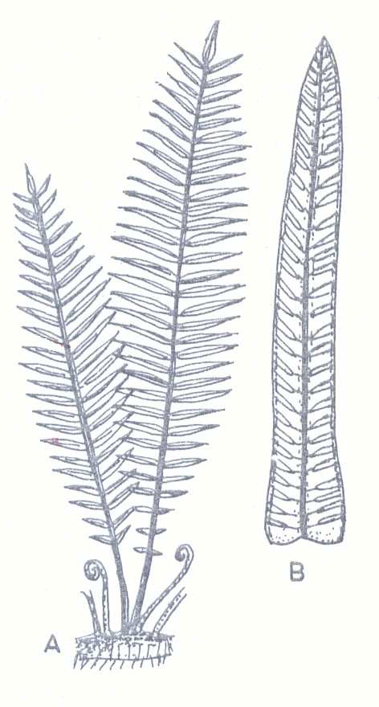

Pteridophytes (External Features of fern (Pteris vittata)

PTERIDOPHYTES AND BRYOPHYTES
Similarities
- Liverworts and Pteridophytes show similarity in vegetative structure of gametophytes.
- Their female and male reproductive structures are archegonium and antheridium respectively.
- The opening of the mature sexual reproductive organs and the subsequent fertilizations are condition by the presence of water in liquid salt i.e both require water for fertilization.
- They usually show a distinct and clearly defined heteromorphic alternative of generation and the two generations follow each other in regular succession.
- The spores arise in the same manner in both groups.
- Development of embryo occurs in the archegonium.
- The young sporophyte or embryo is partially parasitic upon the gametophyte.

Differences Between Pteridophytes and Bryophytes
S/n | Pteridophytes | Bryophytes
1 | They are vascular plants | They are non-vascular plants.
2 | In the alternation of generation, the sporophyte is more predominant in which the plant itself is the sporophyte | In the alternation of generation, the gametophyte is more predominant in which the plant itself is the gametophyte.
3 | The gametophyte is very much reduced to a prothalus. | The gametophyte consists of rhizoid, axis and leaves.
4 | The sporophyte consists of rachis and sori. | The sporophyte is very much reduced to seta, capsule and calyptras.
5 | Spores are contained in sori | Spores are contained in capsules
6 | They have true roots, stems and leaves. | They do not have true roots, stems and leaves but have structures resembling them.
7 | They are either terrestrial or epiphytic | They are either terrestrial or semi-aquatic.
8 | The sporophyte is independent at maturity | The sporophyte is dependent at maturity.
9 | The sporophyte has well developed conducting tissues. | The sporophyte has no well developed conducting tissues (Xylem and Phloem).
10 | Some of the Pteridophytes are heterosporous (producing spores of different size and type-micro-spores and megaspores). | All the bryophytes are homosporous (i.e producing spores of the same size and type).

Pteridophytes and Flowering Plants
- In Pteridophytes, plant body is not divided into root and shoots system.
- Vascular bundles are less developed in Pteridophytes, (tracheids). Flowering plants has well developed vascular bundles (xylem and phloem).
- There is no pollen grain, pollen tube in Pteridophytes; flowering plant has pollen grain.
- Pteridophytes has no seeds (but sori) while flowering plants produce seeds with cotyledons or endosperms.

Morphology of a Pteridophyte (Pteris vittata)
- Pteris is a widely distributed genus with about 250 species.
- It grows abundantly in cool, damp and shady places in tropical and subtropical regions of the world.
- Pteris vittata is a low level fern which brings out new leaves throughout the year.
- It is very common along mountain walls and grows up to 1200 metres above sea level.
- All the species of pteris are terrestrial, perennial herbs with either creeping or semi erect rhizome covered by scales.
- Roots arise either from the lower surface or all over the surface of rhizome.
- Leaves are compound in most species, but a few have simple leaves e.g Pteris cretica.
- The stalk of leaf continues as rachis and bears leaflets called pinnae. In Pteris vittata, the pinnae present near the base and tips are smaller than those in the middle.

Condition for Adaptation
- Sporophyte shows greater degree of complexity in structural organization.
- It is organized into stem, root and leaves.
- The vascular tissues (xylem and phloem) are developed only in the sporophyte.
- The aerial parts are covered with a layer of cuticle.
- On the epidermis, there are stomata for the exchange of gases.
- These anatomical complexities of the sporophyte of Pteridophytes helped in inhabiting a much wider range of environmental condition than the gametophyte could do.

PHYLUM CHORDATA
VERTEBRATA
The Vertebrata is a subphylum of the Phylum Chordata. The Chordates have a notochord, a flexible rod of tightly packed cells, a tubular nerve cord (dorsal) amd gill slits at some stage in their life histories.
Note: a backbone or vertebral column replaces the notochord in vertebrates.

Characteristics
- A bilaterally symmetrical body, divided into a head, a trunk and a tail. In most vertebrates, a neck joins the head to the trunk.
- An internal skeleton or endoskeleton of bone and cartilage, with a backbone or vertebral column made up of a series of small bones called vertebrae.
- A well-developed central nervous system with a brain (within a brain case) and a spinal cord (dorsal position).
- Well-developed sense organs.
- A ‘closed’ blood system made up of a muscular heart (ventral position).
- Two pairs of limbs (tetrapods).
- Kidneys for eliminating body wastes.
- Skin may be naked or have a covering of scales, feathers or hairs. Vertebrates are divided into five classes:
- Pisces
- Amphibian
- Reptilian
- Aves and
- Mammals

PISCES (FISHES)
These are the fishes which are all aquatic. The jawless fishes like the hagfish and lamprey are the most primitive. They have sucker-like mouths and no paired fins. The cartilaginous fishes like sharks, skates and rays have jaws and paired fins, but their skeletons are made of cartilage like the jawless fishes. The bony fishes like the tilapia and carp are the largest and most successful pisces.

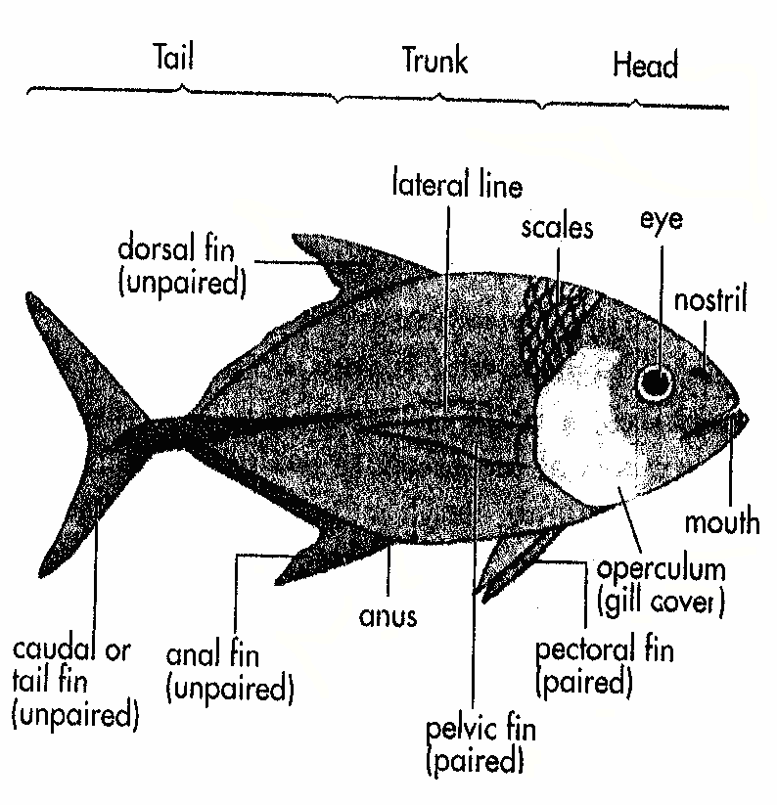
Characteristics

- It is a cold-blooded (poikilothermic) animal, i.e its body temperature varies with that of its surroundings.
- Its body is covered with scales (absent in jawless fishes) and a layer of slime. A cartilaginous fish has sharp, tooth-like scales that do not overlap, while a bony fish has thin, flat rounded scales that overlap.
- It has fins. The paired fins are adaptations of the fore-and hind limbs.
- It carries out gaseous exchange by gills. A bony fish has gill covers while a cartilaginous fish does not.
- It has a well-developed sense of smell, and a lateral line system which enables it to detect movements and changes in water pressure. It only has inner ears.
- A bony fish possesses a swim bladder, a gas-filled sac which allows it to regulate its density so that it can remain still at any depth in the water.
- It has a two-chambered heart.
- Fertilization is usually external. The eggs are tiny and may develop directly into a young fish or pass through a larval stage.

Adaptive Features of Fishes
Living organisms are found in many types of ecosystem. The environment in this ecosystem varies considerably. Generally, organisms show features that enable them to go live successfully and reproduce in a particular environment. These features may be structural, functional or behavioural. Such features are known as adaptative features. Adaptations to a particular environment are evolved over a long period of time.

Nature of medium
Water is a denser medium than air. It is difficult to move rapidly through it. As a result active aquatic animals like fish have streamlined bodies. Water, however, helps to support the body mass of large aquatic animals.

Osmoregulation and Water Loss
Most marine organisms have body fluids that are nearly the same concentration as the sea water in which they live. So the rate at which water enters and leaves the body cells is the same. However, the body fluids of freshwater organisms are at a much higher concentration than the surrounding water. So much water enters the body cells than leaves them. Successful freshwater organisms have osmoregulatory structures that get rid of the excess water that enters the body cells.
Bony fishes are the most successful aquatic organisms. The body fluid of the marine bony fish is less concentrated than its surrounding water, while the body fluid of the freshwater bony fish is more concentrated. Fig. below shows osmoregulatory adaptation of freshwater and marine bony fishes.
NOTE: In aquatic organisms where there is no need to conserve water, gaseous exchange occurs through the whole body surface or through special structures called gills.

Movement
Aquatic organisms that move actively use appendages like fins which are modified for swimming.

Adaptations of the Fish
The fish show the following structural adaptations to life in water.
- Have a streamlined body shape without a neck that enables them to move easily through water.
- The tail and tail fin of a fish are special adaptive structures for swimming.
- Gills are gaseous exchange organs that are adapted for an aquatic environment. They are found in the fish.

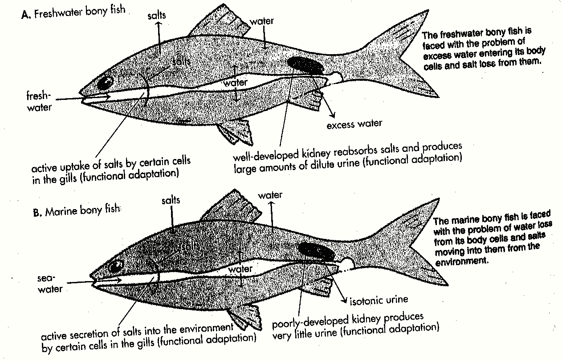

AMPHIBIA
The Amphibians made the first transition from the aquatic to the terrestrial mode of life; they were the first to venture out of the water and live on land. Examples of amphibians include the frogs, toads, newts and salamanders. Most of them live in moist environments and return to water to breed.

Characteristics features of Amphibians
An amphibian has these features;
- It is cold-blooded
- It has paired fore-and hind limbs in the adult stage.
- It has a naked, moist skin.
- It has a sticky tongue which can be protruded and retracted quickly.
- It has inner and middle ears.
- It carries out gaseous exchange by gills, lungs, skin or mouth lining, separately or in combination. Gills are present at some stage in its life cycle.
- It has a three-chambered heart.
- Fertilization is external. The eggs are small.
- An aquatic larval stage is usually present.

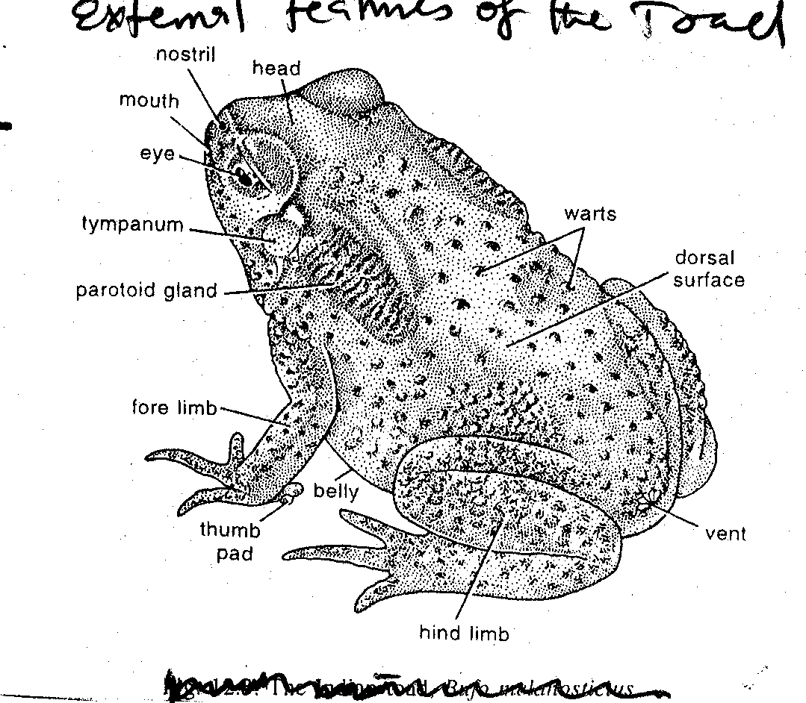

Differences Between Frog and Toad
S/n | Frog | Toad
1 | It is mainly aquatic | It lives on land among stones in damp places (Terrestrial).
2 | It is diurnal in habit, that is, it comes out mainly during the day time. | It is mainly nocturnal in habit, that is, it comes out only towards evening.
3 | It does not possess good sense of locality. | As it has a good sense it can keep within a certain locality for a long time.
4 | It shows quick and nervous movement. | It shows sluggish creeping movements, which seem to be carried on with greater sense of security.
5 | The skin is smooth and slippery. | The skin is always rough, nearly dry wrinkled and warty.
6 | Skin is provided with relatively few poison glands. | Skin is abundantly supplied with poison glands and irregularities of the skin are mainly caused by the large number of poison glands contained in them.

Ecological Adaptation of Amphibians
- Skin secretes substances that scare away enemies (other animals) e.g snakes from attack.
- The tongue is an insect-catching apparatus which aids feeding.
- Have five (5) fingered limbs for locomotion.
- Has webbed feet for swimming.
- Has powerful hind-legs for jumping/leaping.
- Soft, moist skin for skin or cutaneous respiration.
- The young ones, tadpoles, live in water and breathe by gills.
- The tadpoles have a streamline body for swimming.
- The tadpole has a fin-like tail that aids swimming.
- Adults breathe by lungs hence can live in land and water.

REPTILES (REPTILIA)
Reptiles are the first group of vertebrates to have become completely adapted to life on land. There are four main groups of reptiles namely; lizards, snakes, crocodiles and turtles. Lizards and their close relatives, the snakes, are the dominant reptiles today.
Characteristic features of Reptiles
- Reptiles are known for their crawling method of locomotion.
- They are mostly terrestrial, but not well adapted for walking or running (their body is covered with scales).
- Which are developed only from the outer layers of the skin, having connection with blood vessels and nerves.
- The whole skin is characterized by being dry and devoid of glands. They are poikilothermic and most of them have imperfectly four-chambered heart.
- The reptiles have become independent of water due to the development of embryonic membranes. The embryo always lies in a fluid-filled sac known as amnion. The allantols arises as an outgrowth from the hinder part of the gut and serves as a receptacle for the storage of embryonic urine. Part of the allantols becomes closely applied to the shell for respiration. Gills are absent and the lungs form the respiratory organs.

LIZARD
Lizard is a typical example of reptilian. They are typically dry-land animals, loving the sun and its heat. They are very common reptiles most of them are four-legged animals and are capable of very active movement. They are usually rather small and slender creatures. The common garden lizard has a very long tail.

Characteristic features of Lizard
- They are cold blooded animals (poikilothermic).
- Has a well developed tongue which can be protruded and retracted quickly.
- Its jaws have teeth of the same kind embedded in sockets.
- It usually has paired fore and hind limbs each with five toes ending in claws. This enables them to chase insects along vertical walls and ceilings of rooms.
- It has inner and middle ears.
- It has a skin that is covered with scales.
- It carries out gaseous exchange through its lungs.
- Fertilization is internal. The females lay large fertilized eggs in land. Even aquatic reptiles return to the land to lay eggs.
- Some lizard posses a peculiar kind of joint between two of their caudal vertebrae, which enables them to break off the tail in an emergency. This tends to divert attention of the pursing enemy and give chance to the lizard to escape. This is known as autonomy.

AVES (BIRDS)
The aves or bird are warm-blooded vertebrates specially adapted for flight. Their body is covered with soft feathers which are epidermal outgrowths like the scales of reptiles and hairs of mammals. Scales are also present on the lower part of the legs and on the feet. They have a four-chambered heart. The fore limbs are modified to form wing axes (in flying birds) or reduced in non-flying birds. The hind limbs have clawed digits which are variously modified for walking, perching, hopping, running or swimming. The head is usually small and rounded, the neck is well marked and the whole body is oval and streamlined. Tail is short and the caudal vertebrae are fused to form a pygostyle. The jaw bones are modified in relation to the back and are devoid of teeth.

Characteristic Features of Aves (Birds)
- The body of the birds is streamlined or spindle-shaped well adapted for aerial life.
- The neck is usually long and flexible.
- The head is rounded and the facial portion is produced into beak.
- Close to the base of the beak are two slit-like nostrils.
- The eyes of the bird are of considerable size
- The sense of smell seems to be feebly developed but the power-vision is correspondingly advanced, especially in some birds of prey.
- Each eye is provided with three eyelids: the upper and lower eyelids are like fold of skin while the third eyelid, the nictitating membrane is a delicate transparent membrane which can be drawn across the eye. Usually the lower lid is movable.
- On each side of head there is a small aperture with a short passage leading to the eardrum. It lies behind and below the eyes and is usually hidden by the features.
- Unlike mammals, the external ears are absent.
- The fore limbs form the wings which are organs of flight while the hind limbs are adapted for bearing the entire weight of the body when walking.
- The legs are covered with scales.
- The cloaca lies on the ventral surface at the root of the tail and on the dorsal surface of the same region is an oil-gland. Its oily secretion is used for preening feathers.
- The typical number of the toes is four, of which, three are directed forwards and one backwards. In perching birds the toes are adapted for grasping and clutching the support; birds of prey use their feet for seizing.
- The claws form great talons as in the eagles, hawks, kites, falcons etc. the legs of the wading birds are usually very long and partly or completely unfeathered up to the tibial region. They have very long toes for catching and killing prey and for running.
- Swimming birds like ducks have webbed feet which serve as paddles.
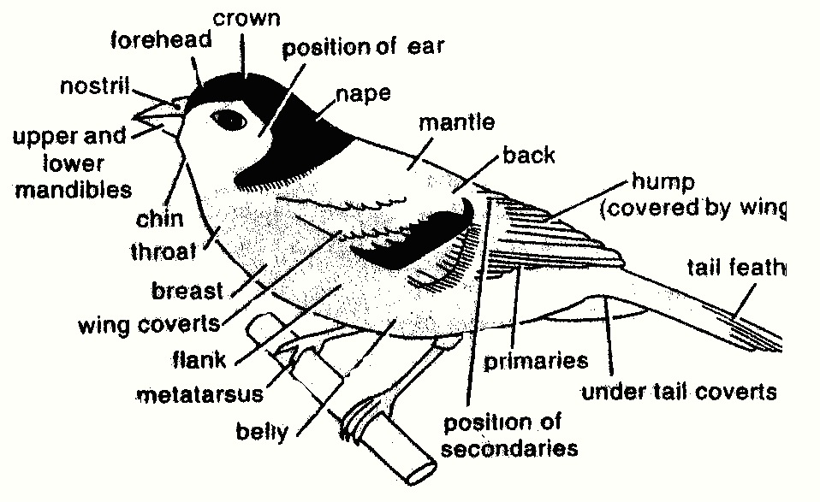

Outline of Adaptive Features of Flight
- The wings act as propeller.
- The streamlined body is well adapted for movement through the air.
- There is considerable shifting of the weight of the body from the periphery to the centre due to the loss of teeth; moreover as the wings are placed high up on the trunk the body is prevented from turning over.
- The skull is very light and most of the bones are welded together.
- Feathers which clothe a bird hold a blanket of enveloping air next to the body; since this air is warmed by the body and is consequently lighter than the surrounding air, it adds somewhat to the buoyancy of the bird.
- The rectum where the faeces is carried is very much reduced in length. Since flying birds would be greatly handicapped by the presence of too much of faecal matter there.

MAMMALIA
The class mammalian is made up of the most advanced animals which include man, rabbit, etc. Mammals, of which there are three to four thousand species, have attained the most complete structural, developmental and physiological adaptations to the terrestrial mode of life. They are characterized by their great activity, high metabolism, intelligence and by the display of their parental care – a feature in which they are only rivaled by birds. Various mammals live in all sorts of habitat from Polar Regions to tropics and from the sea to the densest forests and driest deserts.

Mammals generally are of great aesthetic interest, some wild species are hunted as game and others for their fur. Some rodents and flesh eaters damage man’s crop and livestock and certain species are reservoirs of disease-germs. The domestic mammals provide man with food, clothing and means of transport.

As a matter of fact the mammals represent the top of the evolution of the living animals and this claim rests almost exclusively on the superiority of their nervous system.
Characteristic features of a Mammal
The main characteristics of a mammal are as follows;
- It is warm-blooded (homoeothermic).
- The skin has sweat and sebaceous glands and a covering of hairs.
- It has different types of teeth, with each type carrying out a specific function.
- It has external ears called pinnae.
- Its body cavity is separated into two by a muscular sheet called a diaphragm. The upper thoracic cavity contains the lungs and the heart while the lower abdominal cavity contains the alimentary canal, the kidneys and the reproductive organs.
- It has a well-developed heart.
- If has a well-developed brain.
- Fertilization is internal. In most mammals, the tiny fertilized egg develops inside the body of the female parent for a period. During this time, the young is attached to the mother by a placenta, an organ through which it obtains nourishment from the mother. The young is born alive (Vivipary) and feeds on the milk secreted by the mother’s mammary glands. It is looked after by the parents until it learns to be independent.

External feature of a Rabbit
Rabbit, a typical example of the class mammalian, is taken as a convenient types of mammals for a detailed study.
- The head of the rabbit is large and spherical behind but is pointed anteriorly to form the snout.
- At sides of the snout are long stiff sensory hairs called whiskers or vibrissae.
- Has a pair of large and protuberant immobile eyes.
- Have two long erect external ears or pinnae situated at the spherical top of the head.
- The head is followed by a very short neck which passes abruptly behind to the trunk.
- The truck consists of a narrow chest or thorax
- Has short and rigid fore limbs divided into upper arm, fore arm, wrist and hand.
- The hind limbs are much longer, divided into thigh, shank, ankle and foot.
- An anus and urinogenital aperture are present at the posterior end of the trunk.
- Has a short bush tail at the posterior end of the trunk.

Adaptation to their Ecological Environment
The wild rabbit has no end of enemies from man to rats, foxes, jackals, badgers, cat, hawks, owls, etc. In fact, it has the maximum number of enemies and yet it is able to live and thrive. Its survival against so many odds is not because of its wits, for it is not a clever creature, and it is also not because of weapons, for it is not armed and its teeth are not suitable for biting. The real reason for its being able to hold out its own is to be found in its general habits such as:
- great fertility
- burrowing habits
- crepuscular nature, and
- the care of the young ones and their early education by the mother.

The adaptation of rabbits which enable them to live and thrive, inspite of their numerous enemies, may be summed up as follows:
- Wide field of vision (large and protuberant immobile eye).
- Acute sense of smell and hearing.
- Protective colouration (hair or fur).
- Their alertness in recognizing enemies and their swiftness and sureness in running.
- Possession of thirteen pairs of ribs which enable them to breath better during a run for life.
- Their burrowing habits and crepuscular nature.
- Their wide range of appetite.
- Their ability to live in different climates.
- Their extreme fertility and attachment of the mother to its young ones.

