**A BRIEF HISTORY OF ORGANIC CHEMISTRY**

The history of organic chemistry can be dated to ancient times when the Romans and Egyptians used organic chemicals as dyes, medicines and poisons from natural sources, but the chemical compositions of the substances were unknown**.**  For example, the bark of the willow plant was used as an analgesic (painkiller or pain reliever) without the knowledge of the chemical compound responsible for this effect. Acetylsalicylic acid, which is the active compound in aspirin, was latter identified as the compound in the bark responsible for the analgesic effect.

In the 16th century, organic compounds were isolated from nature in the pure forms and analytical methods were developed for determination of elemental compositions.

In 1806, Jöns Jacob Berzelius, classified chemical compounds into two main groups:

I) O**rganic**: if they originated in living or once-living matter

Ii) **Inorganic** if they came from "mineral" or non-living matter. Berzelius, in 1807, theorized that organic chemicals found in nature contained a special "**vital force**" (or **vitalism)** that directed their natural synthesis, and that it would be impossible to accomplish their laboratory synthesis. Fortunately, in 1828, a student of Berzelius by name Frederich Wöhler, discovered that urea, a natural organic compound in urine, could be synthesized in the laboratory by reacting silver cyanate with ammonium chloride to for ammonium cyanate, which when head isomerized to urea His discovery meant that the natural "vital force" was not required to synthesis organic compounds, and paved the way for many chemists to synthesize organic compounds.

Wohler’s reaction is illustrated with the equation below



He also obtained the same result when he used lead cyanate instead of silver cyanate

Pb (OCN)2 +2NH3+ 2H2O 2NH4OCN +Pb(OH)2

NH4OCN NH2CONH2

Heat

This discovery was important in two ways:

i) It helped to refute (disprove) the theory of “vitalism”

ii) it introduced the concept of isomerism for the first time.

**Definition of Organic Chemistry -** Organic chemistry is the study of the structure, properties, composition, reactions, and preparation of carbon-containing compounds. However, it is not all carbon-containing compounds that are organic, some are classified as inorganic. Examples are:

phase CS2, CaCO3, KCN, KSCN, CaC2

**Basic separation Methods Organic Chemistry**

Most organic compound occur in combination with other compounds in nature and when synthesized, hence the need to isolate and purify them. The compound of interest intended to be isolated from a sampled is called an **analyte**. The substance left after the analyte has been removed from the sample is called the **matrix**. Some of the separation techniques employed for the isolation and purification of organic compounds are as followwing:

1) **Purification of organic compounds by Sublimation**:

sublimation is direct transition of a solid to a vapor without passing through a liquid.

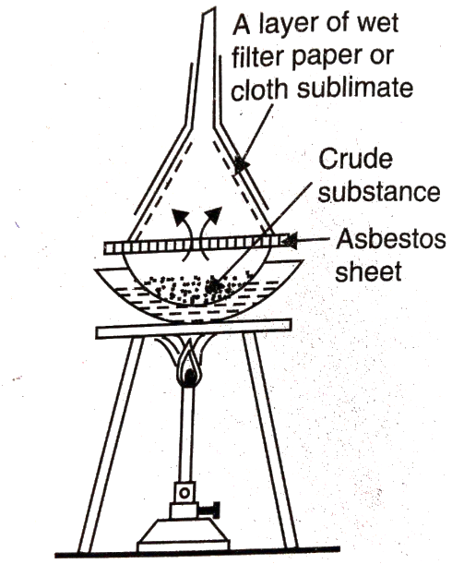

Fig 1: Experimental Setup for Purification By Sublimation

It is often used to separate solids from their crude samples. Some of the organic compounds that can be purified by sublimation are: camphor, benzoic acid, naphthalene, salicylic acid and the quinines.

**2) Separation and Purification of Organic Compounds by crystallization**

Crystallization is a process which involves the production of pure crystals from solution, after dissolving the impure substance in a suitable solvent or mixture of solvents. The following factors are considered for the choice of solvents for crystallization.

1)The solvent should not react chemically with the substance to be purified.

2) It should dissolve the impurities readily.

3) It should well-formed crystals of the compound intended to be purified

4) It must be capable of easy removal from the crystals of the purified compound.

*In this process, advantage is taken of differences in solubility of the analyte ( a compound be purified) from the impurity*.

3) **Separation and Purification of Organic Compounds by Solvent Extraction:** -

The process of extraction with solvents is generally employed either for the isolation of dissolved substances from solution or from solid mixtures or for the removal of undesired soluble impurities from mixtures. If the sample is solid, it will be necessary to reduce it to powder or smaller sizes in order to increase its surface area for better contact with the extraction molecules. When extracting with a solvent, it is necessary to repeat the process four or more times, until most of the organic substance is transferred to the solvent layer, and then returned to the stand in order to allow the mixture to settle. When two sharply defined layers have formed, separate the two layers into two different flasks. Volatile organic solvents with appropriate polarity are often used so that they can easily be removed from the analyte. *The principle here is often based on differences in solubility of the components of the sample in the extracting solvent.*

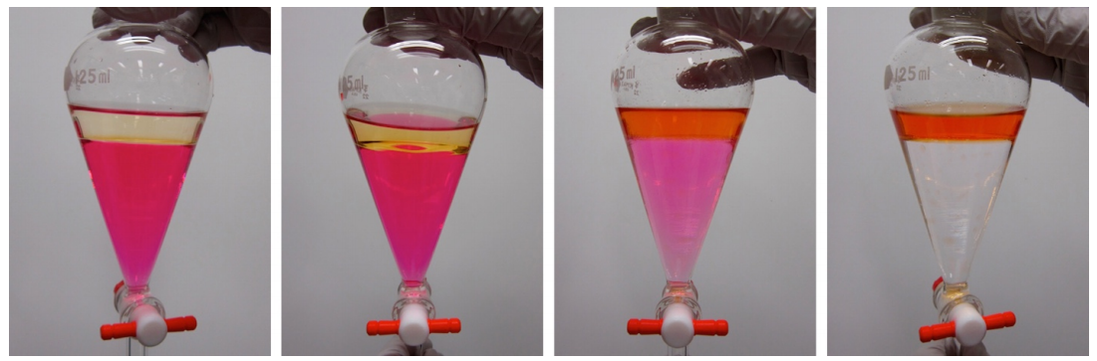

**Fig 2: Solvent Extraction using Separating funnel**

**4) Separation and Purification of Organic mixtures by Distillation**

Distillation is the conversion of the liquid compound to the vapour state with the aid of heat, and condensation of the vapours to the liquid state. It is suitable for organic liquids with boiling point that **differs** by at least 25 °C. Fractional distillation method is preferred for samples with boiling point differences that is less than 25 °C. The principle of separation is based on exploiting differences in boiling points of the components of a sample mixture. A pictorial representation of distillation setup is as shown in figure 3 below

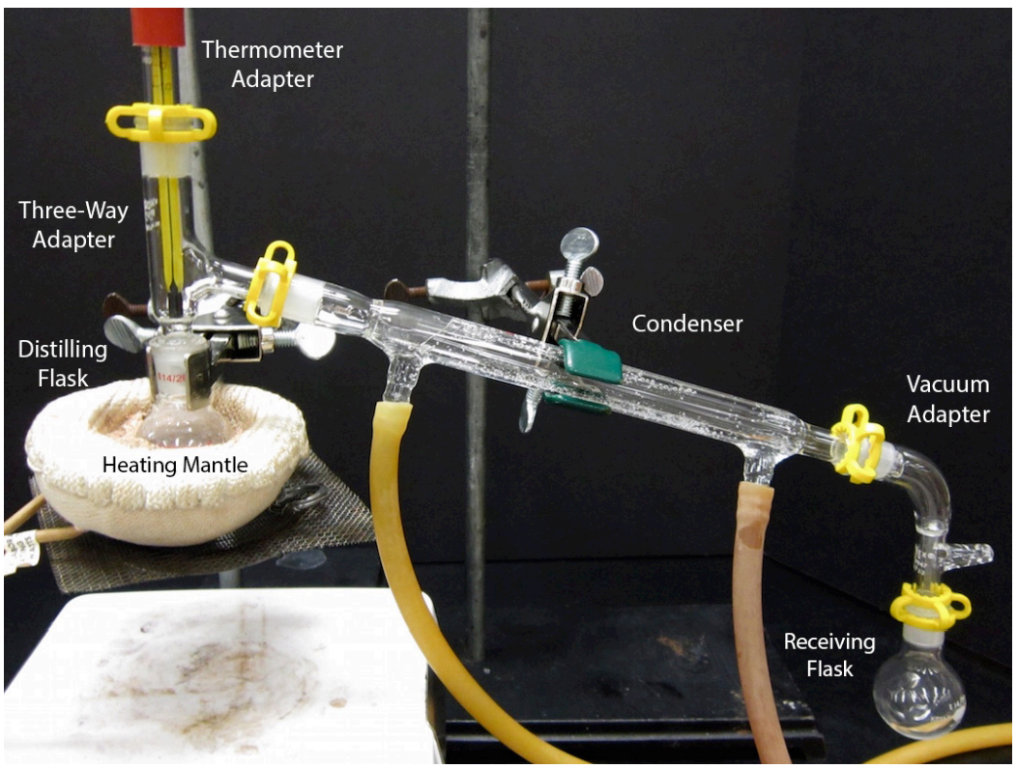

**Fig 3: Distillation setup for separating organic mixtures**

**5) Fractional Distillation Method of Separating organic mixtures**

Fractional distillation is the process of separating a mixture using heat. *The principle is similar to that of distillation. In Fractional distillation the different liquids boil at different temperatures into different parts (called fractions) according to their different boiling point . But their boiling point difference are less than 25 degree. points various liquids separation depends on their boiling points*. The liquid having a lower boiling point, boils first and can be obtained first from the fractionating column than the liquid having a higher boiling point.

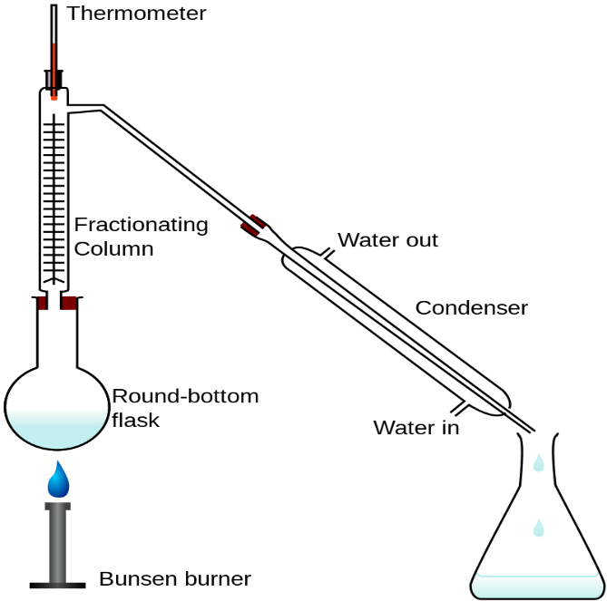

**Fig 4: Fractional distillation setup**

**6) Chromatography chromatographic method of separation and purification of organic compounds.**

Chromatography is based on the principle where molecules in mixture applied onto the surface or into the solid, and fluid stationary phase (stable phase) is separating from each other while moving with the aid of a mobile phase. *The type and degree of interaction between stationary phase and substances contained in the mixture carried by the mobile phase is what accounts for effective separation of molecules from each other.* There are different types of chromatography, examples includ.e

Column chromatography

Ion-exchange chromatography

Gel-permeation (molecular sieve) chromatography

Affinity chromatography

Paper chromatography

Thin-layer chromatography

High-pressure liquid chromatography

Images of thin layer chromatographic plates and column chromatography showing elusions are shown below.

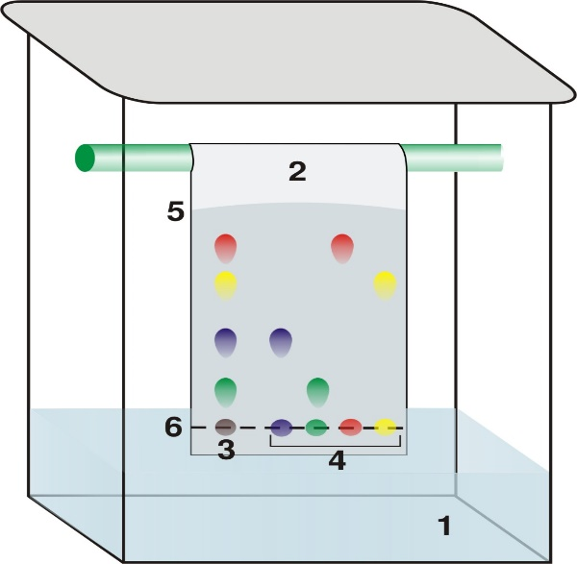 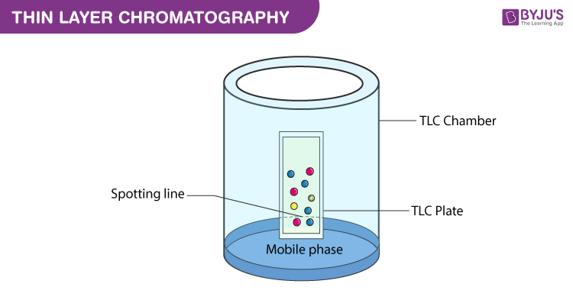

**Fig.5: images of Thin Layer Chromatography**

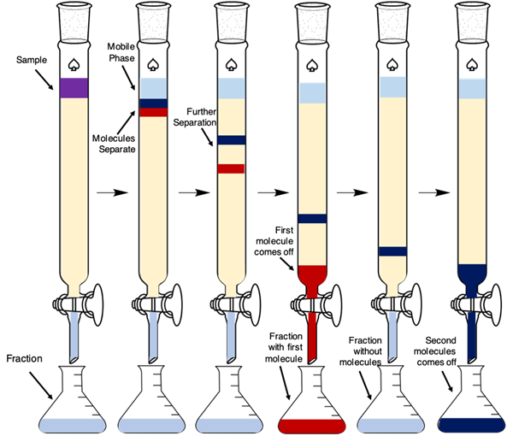

**Fig. 6 : Image of Column chromatography**