**PRINCIPLE OF METAL JOINING**

Metallic components are manufacture individually and assembled or joined together by various methods to form machine parts or products. The term joining in manufacturing includes various processes such as:

1. Welding
2. Brazing
3. Soldering
4. Mechanical fastening: metal parts joined together by making holes on them and fasteners are inserted through them.
5. Adhesive bonding: this is a method in which filler materials in form of liquid called adhesive are used to hold two or more closely packed parts together by surface attachment.

As an Engineer, the knowledge and skill about these processes are very important and necessary to have progress and economy in engineering production.

**Classification of metal joining methods**

Joints made on metallic parts in manufacturing can be broadly classified as follows:

1. Permanent joints: examples are joints made by welding, brazing, soldering, riveting, adhesive bonding etc.
2. Detachable joints: this type of joints are group into two
3. Detachable rigid joints which include joints made by screw, thread, keys, cotters, pins etc.
4. Detachable flexible joints: examples are knuckle joints, flexible couple, universal joints etc.

Metal joining methods mostly used in industries are generally grouped under the following four categories:

* Welding
* Joining by metal deposition i.e. brazing and soldering
* Mechanical fastening
* Adhesive bonding

**WELDING**

Welding is the method of joining metals/materials by application of heat with or without the use of solder or any other metal or alloy having a lower melting point than the metal being joined (the base metal).

Welding produces coalescence (union) of metals by heating them to the welding temperature, with or without the application of pressure or by application of pressure alone and with or without the use of filler.

Welding can be explained as a process of joining together pieces of metal by bringing them into intimate proximity and heating the places of contact to a state of fusion or plasticity.

**Welding process are broadly classified into two groups:**

1. Fusion welding
2. Solid state/pressure welding

**FUSION WELDING**

Fusion welding is a type of welding in which the welding area of a metal or material to be joined together is heated by concentrated source of heat to a molten state and filler metal is usually added to a the weld. The concentrated source of heat during fusion welding allows the coalescence of the metal to produce a solidification.

The source of heat in fusion welding is either electrical or chemical energy. Based on source of heat, fusion welding grouped into:

1. Arc welding
2. Gas welding.

Fusion welding using electric energy are formally called electric arc welding and they are grouped based on the mode of operation and application of heat. They include

1. Shielded metal arc welding (SMAW)
2. Submerged arc welding (SAW)
3. Gas metal arc welding (GMAW)
4. Gas tungsten arc welding (GTAW)
5. Flux cored arc welding (FCAW)

Fusion welding using chemical energy are called gas welding and those which are popular use in industries are

1. Oxy-acetylene welding (OAW)
2. Air –acetylene welding (AAW)
3. Oxy –hydrogen welding (OHW)

The type of fusion welding differ from each other based on mode of operations and different ways in which the obtained heat and produces coalescence.

**ARC WELDING**: a fusion welding process where coalescence of workpiece is produced by melting the surface to be joined with heat energy (electric energy) obtained from alternating current (A.C) or direct current (D.C), flux or inert gas (e.g. Argon, CO2, helium) etc., electric arc struck between the workpiece and electrode (consumable or non-consumable) with or without the addition of filler metal and with or without the application of pressure. Among the types of arc- welding, shielded metal arc welding is the most widely used welding process.

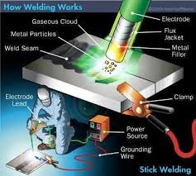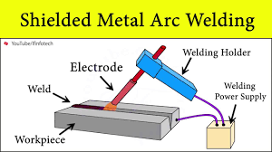

**SHIELDED METAL ARC WELDING (SMAW)**: employs the heat of the arc to melt the base metal and the tip of a consumable covered electrode. Here, the circuit begins with the electrode power source either from transformer or generator and includes the welding cables, an electric holder, a workpiece connection, the workpiece and an arc welding electrode. One of the two cables from the power source is attached to the work. The other is attached to the electrode holder. Welding commences when an electric arc is struck between the tip of the electrode and workpiece. The intense heat of the arc melts the tip of the electrode and surface of the work close to the arc producing the joint, hence, a joint weld is produce.

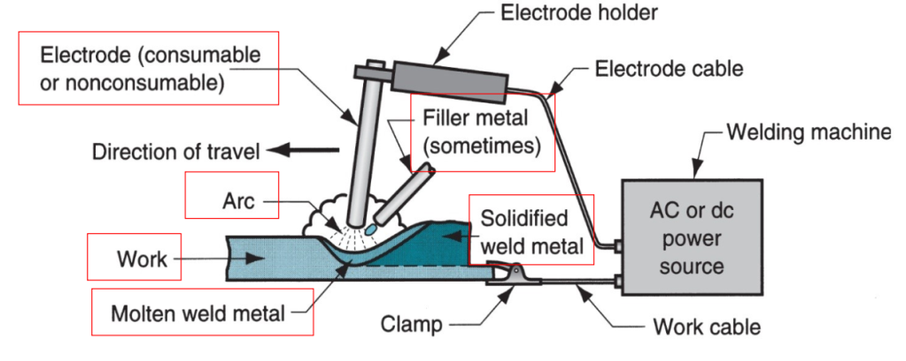

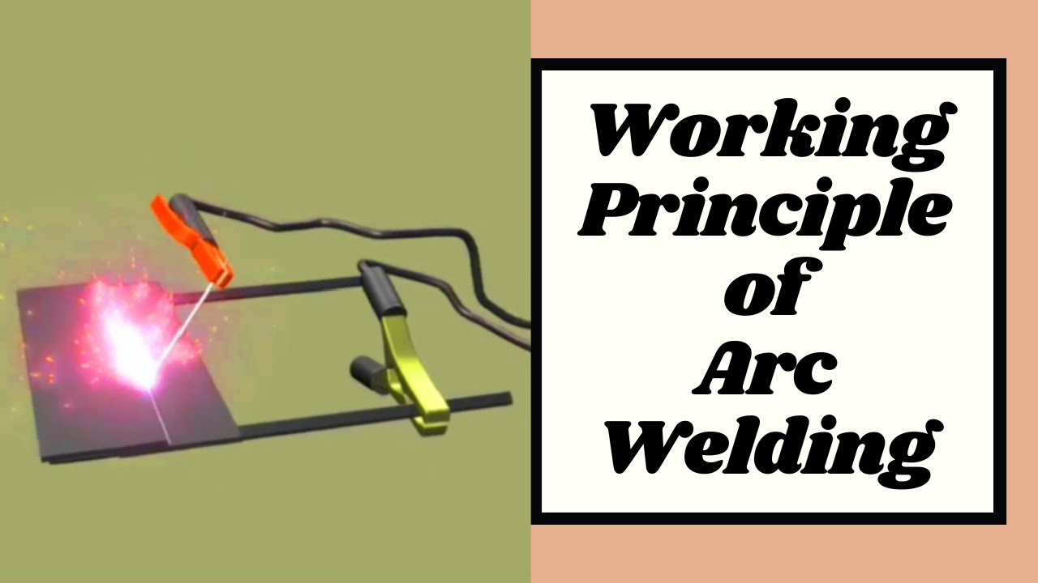

**GAS WELDING:** this is a method of fusion welding processes that uses the heat produced by gas flame (combustion of gas) for melting the base metal and filler metal is employed in the process of welding the workpiece together. The gas flame which is acetylene or hydrogen and oxygen are mixed in proportion in the gas torch and delivered to the welding torch tip where they are ignited and flame formed is used to melt the base metal and the filler metal.

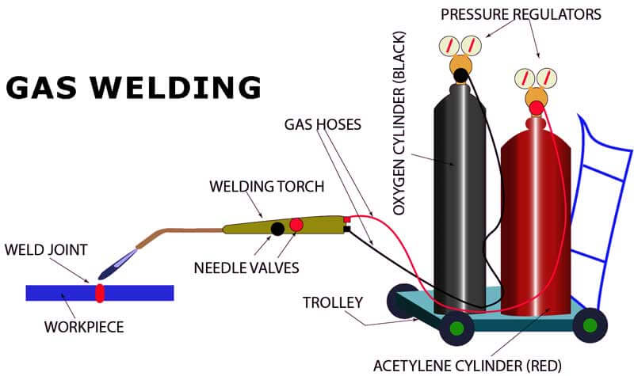

**Principle of operation of oxy-acetylene welding;** the ignition of oxygen and acetylene gases mixed in a blow pipe fitted with a nozzle of suitable diameter. This flame is applied to the edges of the joint and to a wire filler of the appropriate metal which is thereby melted and run into joint. When the acetylene is burned in an atmosphere of oxygen, an intense hot flame with a temperature of about 3300oC is produced.

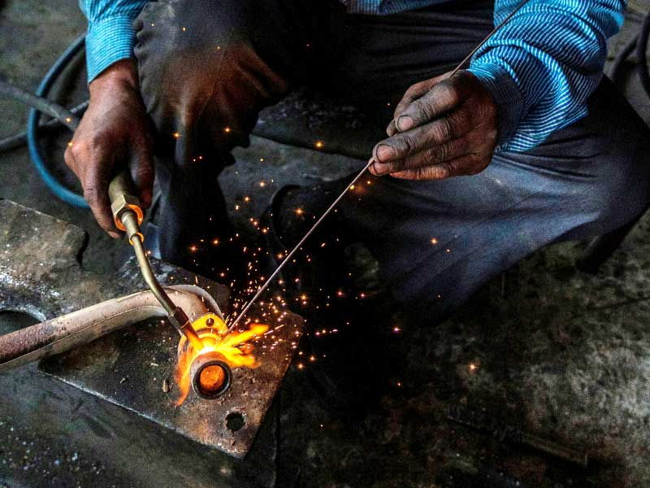

**SOLID STATE/PRESSURE WELDING:** solid state welding involve heating of metallic parts only to plastic or slightly fused state and forcing them together with external pressure. Solid state welding processes are applied to metals which are capable of being brought to plastic deformation state by heating or due to the action of external forces.

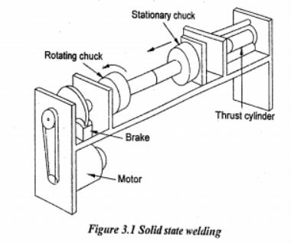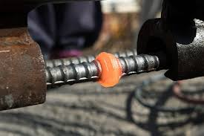

The popular welding processes coming under the solid state welding are as follows:

1. Resistance spot welding (RSW)
2. Resistance seam welding (RSEW)
3. Projection welding (PW)
4. Flash welding (FW)
5. Upset welding (UW)

From the listed types of solid state welding, resistance welding (spot and Seam) processes are commonly used in industries to join sheet metal parts**.**

**Resistance welding:**  is a group of solid state welding processes in which joint is produced at the contacting surface by the heat generated due to the resistance of the applied before, during and after the application of current to confine the weld contact area at the faying surfaces.

**Two resistance welding that commonly used in industries are**

1. Resistance spot welding
2. Resistance seam welding.

**Resistance spot welding**: (principle of operation)

In resistance spot welding (RSW) two sheet metal pieces are kept one over the other and joined in one or more spots by the heat generated due to resistance to flow of electrical current through the workpieces. The sheet metal pieces are held together in contact under force by round electrodes. The contacting surface in the region of current concentration are heated by a short time pulse of low-voltage, high amperage current to form a fused region of weld metal. The interface between the two sheets offers maximum resistance to the flow of current, the interface melts and consequently solidifies under pressure of the two electrodes, thereby joining the two sheets of a spot that was under two electrodes.

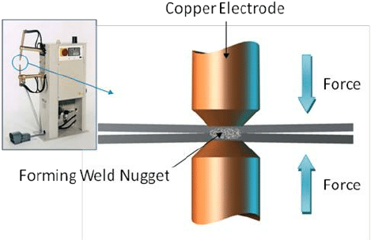

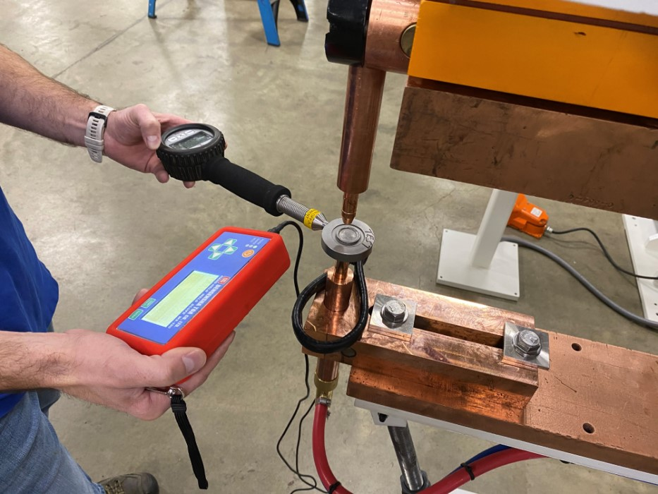

Resistance spot welding has

1. High speed welding process
2. Adaptable for automation in large rate production of sheet metal assemblies
3. It is economical in job shop operation
4. Less operator skill is required et.c

**Resistance Seam welding – principle of operation**

This is modification of resistance spot welding. In resistance seam welding process, the cylindrical electrodes of spot welding are replaced by electrically conducting wheel or roller electrode and continuous A.C low voltage power supply to produce overlapping spot weld. Here, series of spot welds in a row with a seam welding machine are made without removing the electrode force between welds.

Resistance seam welding uses rotating wheel electrodes which roll the overlapping components between them. The welding current passes intermittently through the electrodes, forming a series of welds that overlap one another.

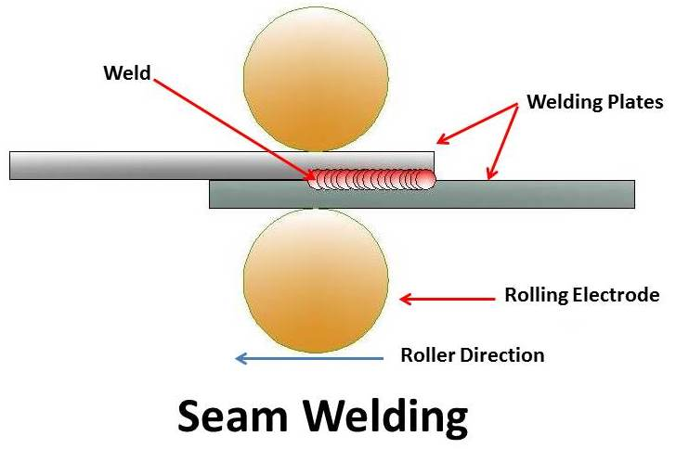

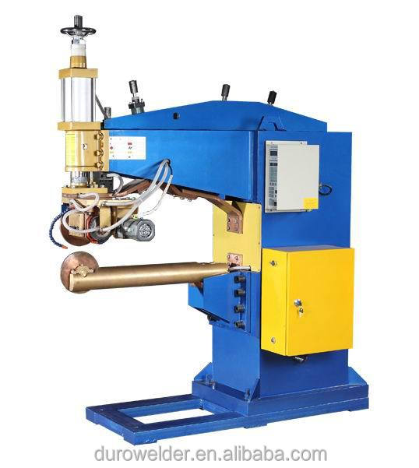

Seam welds are typically used to produce gas or liquid-tight joint in sheet assemblies such as automotive gasoline tank. Leak-proof or air tight vessels components are joined by resistance seam welding process.

Nuggets is a molten metal that quickly cools and solidifies into a round joint formed from the welding of overlapping pieces of metal at small joints by application of pressure and electric current .

**Old welding processes.**

These are welding processes which are coming under either fusion or solid state welding but at the same time not very commonly used in industries are called old welding. The include:

1. Forge welding
2. Carbon arc welding
3. Atomic hydrogen welding
4. Thermit welding
5. Electron slag welding
6. Stud welding
7. Bare metal arc welding

**Morden welding processes.** Morden methods which are recently discovered and applied generally for special purposes are called modern welding processes. They include:

1. Electron beam welding
2. Plasma arc welding
3. Laser beam welding
4. High frequency welding
5. Percussion welding
6. Electron gas welding
7. Friction welding
8. Cold welding
9. Diffusion welding
10. Explosion welding
11. Ultrasonic welding

Note, each of them differ according to the way the produce coalescence of material through method the obtain heat and material contact.

**BRAZING PROCESSES**

Brazing is a metal deposition joining method that uses brass as joining medium. It is a metal joining process in which joint or coalescence is produced by heating the components to a suitable temperature above 4500C and below the solidius of the base metal, and inserting a filler metal (brazing alloy) at the joint which has a melting point below that of the base metal. The filler metal is distributed between the closely flited surface of the joint in a molten state by capillary attraction.

**Brazing procedure:** the process of brazing is carried as follows

The surface to be joined are thoroughly cleaned. Then a paste made of flux and spelter (the brass used in making the joint) is kept in the joint, the joint being held in position by suitable clamp and tongs. The flame is directed over the joint held on fire brick piece. The flux and spelter will melt and fill the racess between the joint. The liquid is spread uniformly over the joint either with a pointed wire piece or by moving the jet of flame circular over the joint. The work is removed from the clamp after it is cooled. OR

The surface to be joined are thoroughly cleaned first with either solvent cleaning, vapour degreasing, alkaline emulsion etc. the type of the cleaning reagent depends on the type of coating or scale of surface. The surface to be brazed and the surrounding areas are coated with flux **(flux is a chemical reagent for cleaning metal prior to soldering or welding. The aim of flux is to remove oxides from the base material and to prevent oxidation during heating process)**

**The** fluxed parts are preheated almost nearer to the brazing temperature. The brazing filler metal is added in the joint gap and heated to melt at the brazing temperature, when the filler metal is converted to liquid form, it fills the joint by wetting them which it will later allow to solidify to form a joint. After solidification, the flux grains are removed by washing vigorously in hot water.

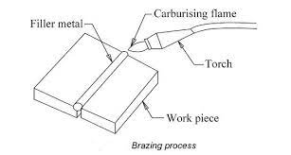

Brazing is used where a ductile joint is required which will not have only good strength but are able to withstand higher service temperature than soft soldered joints. In brazing process, metallic parts are joined by a non-ferrous filler metal alloy.

**Advantages:**

1. The process of brazing is economical for complex assembling of components
2. The method is a simple way to join parts with large joint areas
3. Excellent stress and heat distribution is obtained
4. Dissimilar material or non-metals can be joined by brazing etc.

Application of brazing cover the entire manufacturing of aircraft engine vehicles, joining of copper tubes in air conditioning, fixing the carbide tips on cutting tools, joining of belt saw for wood working machines etc., pipe joint subjected to vibrations, parts of bicycle such as frames, exhaust pipes in motor engines

**SOLDERING PROCESSES**

Soldering is an operation of joining two or more parts together by molten metal. It is a group of joining processes that produce joint of materials by heating them to the soldering temperature and by using a filler metal (solder) having a liquidus temperature not exceeding 450oC and below the solidus of the base metal. Soldering is extensively used to make electrical connections, joining of lead pipe and copper tubing repair works.

It is quick method of making joints in light articles made from steel, copper and brass and for wire joints. Soldering should not be used where joint will be subjected to vibration or heat as solder is comparatively weak and has a low melting point.

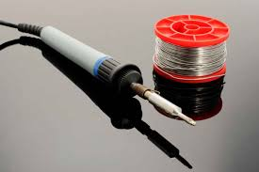

**Soldering procedure:**  in order to get a good soldered joint, the steps given below are to be followed.

1. Pre-clean the surface of workpiece, remove all traces of grease, oil, wax etc.
2. Coat the surface with appropriate flux sufficiently in the soldering area
3. Take a blob of solder on the bit of the hot soldering iron and allow to run down the filling the recess of the joints for light work. Bring the molten solder in contact in contact with the soldering region and heat the joint thoroughly to 55oC to 800C above the melting point of the solder alloy so that the solder flows to the joining by capillary action.
4. Wipe off excess of solder with a piece of felt or cotton waste
5. Leave the joint to cool to room temperature without distributing the alignment.

**SOLDERING METHOD**

* Soldering iron method
* Torch soldering method
* Dip soldering method
* Furnace soldering method
* Resistance soldering method
* Inducting soldering method etc.

**Advantages**

* it has a low temperature process, hence, has minimum effect on the base metal
* high joint reliability can be obtained with carefully controlled procedures
* the process is economical and less investment is required
* the low temperature for joining requires little energy input etc.