Test Layout

wnarifin

2017-07-19

# R Markdown

This is an R Markdown document. Markdown is a simple formatting syntax for authoring HTML, PDF, and MS Word documents. For more details on using R Markdown see <http://rmarkdown.rstudio.com>.

When you click the **Knit** [1] button a document will be generated that includes both content as well as the output of any embedded R code chunks within the document. You can embed an R code chunk like this:

summary(cars) # summary of cars

## speed dist   
## Min. : 4.0 Min. : 2.00   
## 1st Qu.:12.0 1st Qu.: 26.00   
## Median :15.0 Median : 36.00   
## Mean :15.4 Mean : 42.98   
## 3rd Qu.:19.0 3rd Qu.: 56.00   
## Max. :25.0 Max. :120.00

# Including Plots

You can also embed plots, for example:

plot(pressure)

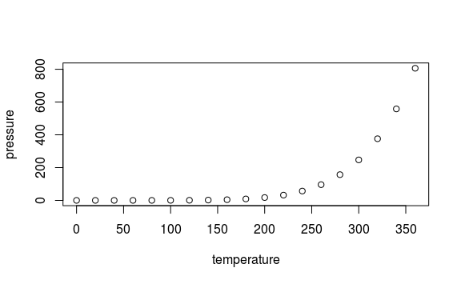

Pressure vs Temperature

# Tables

Chicky information.

|  |  |  |  |
| --- | --- | --- | --- |
| weight | Time | Chick | Diet |
| 42 | 0 | 1 | 1 |
| 51 | 2 | 1 | 1 |
| 59 | 4 | 1 | 1 |
| 64 | 6 | 1 | 1 |
| 76 | 8 | 1 | 1 |
| 93 | 10 | 1 | 1 |

Patient information

|  |  |  |
| --- | --- | --- |
| Gr | Out | n |
| Rx | Imp | 8 |
| Rx | Not_Imp | 4 |
| Waiting | Imp | 3 |
| Waiting | Not_Imp | 10 |

Demographic information [2]

|  |  |  |
| --- | --- | --- |
| Variables | Mean (SD) | n (%) |
| Age | 30 (2.5) | - |
| Gender (Female) | - | 60 (60%) |
| Diabetes | - | 40 (40%) |

Demographic information.

|  |  |  |
| --- | --- | --- |
| Variables | Mean (SD) | n (%) |
| Age | 30 (2.5) | - |
| Gender (Female) | - | 60 (60%) |
| Diabetes | - | 40 (40%) |

1. Right-upper tab
2. Cannot set proper caption using markdown table approach.