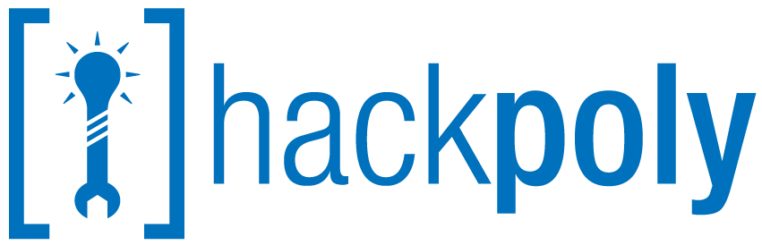

2015 Sponsorship Info

# Contact

**President Poly Founders | Bryan Thornbury** – [brthornbury@csupomona.edu](mailto:brthornbury@csupomona.edu)

**President FAST | David Khacherian –** [dmkhacherian@csupomona.edu](mailto:dmkhacherian@csupomona.edu)

# About

## What is HackPoly?

HackPoly is Cal Poly Pomona’s event of the year for ingenuity, technical skills, and creativity. Over a period of 24 hours, students majoring in Computer Science, many of the Engineering Disciplines, and Business will come together to build a unique hack.

The 2015 event will be open to students from all Universities. Last year we had over 150 students from Cal Poly Pomona alone attend. This year we expect over 500 attendees.

## Who is Organizing Hackpoly?

Hackpoly is an interdisciplinary event hosted by a collaboration of student clubs on campus and supported by the University. Poly Founders is the lead organizing club and last year 9 clubs representing 6 majors from 4 colleges supported this event.

## Why should you Sponsor?

Competition for Technical Talent is only getting stronger. Taking the time to interview and identify ideal candidates cost valuable time as well as money. By sponsoring this event, you will be helping to orchestrate the most telling working interview in existence.

Your company will see what teams of students are capable of building in 24 frantic hours. The strongest technical talent in Southern California will build awesome products and come up with truly innovative ideas. You will also be pushing the hacker community forward in Southern California, creating opportunities for students to further their talents.

The students who attend hackathons are the “doers”. These are the students who are interested in more than what they learn in the classroom. They want to learn to apply their knowledge in the real world and build awesome stuff. These students will be building the next generation of apps and devices. If your company offers an API, this is also a great way to build awareness.

A Relevant Article: <http://mashable.com/2014/04/12/hackerhub-hackathon/>

Please see the Sponsorship Table below for Tiers and Benefits.

# Creative Sponsorship

We are open to other forms of sponsorship rather than straight cash. If you have something in mind, please reach out to one of the contacts listed above. Here are a few suggestions:

* **Sponsor a Meal or Snack.** (ex. Pinkberry by Github at HackMIT)
* **Sponsor Hacker Transportation: We want the top talent at hackpoly from all over California and, if possible, the U.S. If you can sponsor a bus from a specific school, a group of flights, or any other type of transportation we would love it!**
* **Munchies, Beverages, or Other goodies: Going for 24 hours straight takes a lot of snacks and caffeine.**

**For any form of Creative Sponsorship, we will be sure to emphasize your companies involvement in the event.**

# Sponsorship

|  |  |  |  |  |
| --- | --- | --- | --- | --- |
|  | Seed | Series A | Series B  (Limit: 3) | Monopoly (Limit: 1) |
| Amount | $1,000 | $2,000 | $5,000 | $10,000 |
| Send Mentors | Yes | Yes | Yes | Yes |
| Logo On Website | Yes | Yes | Yes | Yes |
| Award API Prize | Yes | Yes | Yes | Yes |
| Demo during Opening Ceremony |  | 2 Minutes | 5 Minutes | 10 Minutes |
| Logo on Hackpoly T-Shirts |  | Yes | Yes | Yes |
| Tech Talk (During the Event) |  | 30 Minutes | 1 Hour | 1 Hour |
| Booth on The Competition Floor |  | Yes | Yes | Yes |
| Access to Participant’s Resumes, Github, and LinkedIn |  |  | Yes | Yes |
| Candidate Interviews at Hackpoly |  |  | Yes | Yes |
| Present At Awards Ceremony |  |  | Yes | Yes |
| Keynote at Opening Ceremony |  |  |  | Yes |
| “Hackpoly Co-hosted By [you]” On website, all communications, and Marketing Materials |  |  |  | Yes |