October 13, 2015

**DEPARTMENT OF MICROBIOLOGY AND IMMUNOLOGY**

5641 MEDICAL SCIENCE BUILDING II

ANN ARBOR, MICHIGAN 48109-0620

PHONE: (734) 763-3531

FAX: (734) 764-3562



Dear Dr. Huttenhower,

We are happy to submit our manuscript, “**Microbiota-based model improves the sensitivity for detecting colonic lesions**”, to *Genome Medicine* for your consideration as a contribution to your special issue titled, “Translating the microbiome: health and disease”. We have selected *Genome Medicine* because of the upcoming special issue and the clinical relevance of colorectal cancer as well as the novel statistical modeling approach we have taken to the problem of identifying infected individuals based on the inclusion of microbiome data. Most importantly, we believe that our approach represents a translational application of microbiome research to the important problem of developing non-invasive screens for colorectal cancer. Our approach combined patients’ clinical data with their microbiome data. Most important, we demonstrated that inclusion of the microbiome data significantly improved our predictions based on the subject’s clinical data alone. More broadly, across the field of microbial ecology there has been a lot of discussion regarding the need to acquire metadata without much demonstrated use that inclusion of this data can improve our understanding of the underlying biology. Thus we are confident that those interested in the specific problem of colorectal cancer and members of the broader microbial ecology field will be interested in our story.

Finally, we would recommend the following as potential reviewers because of their knowledge of colorectal cancer biology and microbiome research:

* Wendy Garrett, MD/PhD (Harvard University; [wgarrett@hsph.harvard.edu](mailto:wgarrett@hsph.harvard.edu))
* Eric Pamer, MD (Memorial Sloan Kettering Cancer Center; [pamere@mskcc.org](mailto:pamere@mskcc.org))
* David Relman, MD (Stanford University; [relman@stanford.edu](mailto:relman@stanford.edu))

Unfortunately, we must also ask you to exclude the following scientists as reviewers as previous interactions with these scientists indicates that they are unable to provide an unbiased review of our work:

* Rob Knight, PhD (University of Colorado)

Should any questions arise during the review of our manuscript please do not hesitate to contact us.

Sincerely,

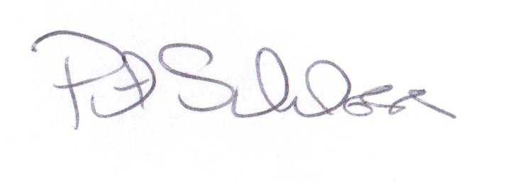

Patrick D. Schloss, PhD

Associate Professor