Microbiota-based model improves the sensitivity for detecting colonic lesions

Nielson T. Baxter1, Mack T. Ruffin IV2, Mary A.M. Rogers3, and Patrick D. Schloss1*

1Department of Microbiology and Immunology, University of Michigan, Ann Arbor, Michigan.  
2Department of Family Medicine, University of Michigan, Ann Arbor, Michigan.  
3Department of Internal Medicine, University of Michigan, Ann Arbor, Michigan.  
*Correspondence to: [pschloss@umich.edu](mailto:pschloss@umich.edu)

**Colorectal cancer is the second leading cause of death among cancers in the United States1. Although individuals diagnosed early have a greater than 90% chance of survival, more than one-third of individuals do not adhere to screening recommendations partly because the standard diagnostics, colonoscopy and sigmoidocsopy, are expensive and invasive1–4. Thus, there is a great need to improve the sensitivity of non-invasive tests to detect early stage cancers and adenomas. Numerous studies have demonstrated a causal link between the formation of colonic lesions and the activity of the gut microbiota in tissue culture and animal models5–8. These findings have been complemented by studies in human populations identifying shifts in the composition of the gut microbiota associated with the progression of colorectal cancer9–13. These results suggest that the gut microbiota may represent a reservoir of biomarkers that would complement existing non-invasive methods such as the widely used fecal immunochemical test (FIT). Using stool samples from 490 patients we developed a cross-validated random forest classification model that detects colonic lesions using the relative abundance of gut microbiota and the concentration of hemoglobin in stool. The microbiota-based random forest model detected 95.0% of cancers and 57.1% of adenomas while FIT alone only detected 75.0% and 15.7%, respectively. Of the colonic lesions missed by FIT, the model detected 80.0% of cancers and 49.1% of adenomas. These findings demonstrate the potential for microbiota analysis to complement existing screening methods to improve detection of colonic lesions. Due to its low rate of false negatives, our model could be used to accurately identify those patients for whom a colonoscopy is unnecessary, potentially reducing healthcare costs and complications due to invasive screening.**

CRC incidence and mortality have steadily declined in recent decades, due in large part to increased screening1. Further progress is possible by increasing access to and accuracy of diagnostic tests. Although structural exams including colonoscopy and sigmoidoscopy are able to detect both adenomas and carcinomas, the high cost and invasive nature are barriers for many people. For example, fear, discomfort, and embarrassment are among the most cited reasons patients choose to forego CRC screening4. Likewise the large disparity in screening rates between those with and without health insurance highlights the need for inexpensive screening methods1–3. Unfortunately cheaper, less invasive stool-based tests like guaic fecal occult blood test and fecal immunochemical test (FIT) are unable to reliably detect adenomas14. The newly introduced stool DNA panel has improved accuracy compared to FIT, but is still limited in its ability to accurately detect adenomas15. Thus there is need for novel screening methods that are inexpensive and capable of detecting both cancer and adenomas.

The gut microbiota, the collection of microorganisms that inhabit the gastrointestinal tract, are one potential source of biomarkers for detecting colonic lesions. Numerous studies have observed alterations in the gut bacterial communities of patients with CRC9–13. Experiments in animal models have demonstrated that such alterations have the potential to accelerate tumorigenesis5. Furthermore, several members of the gut microbiota have been shown to potentiate both the development and progression of CRC by a variety of mechanisms6–8. Although each of these organisms may play a role in certain cases of CRC, none of them is present in every case. Therefore no one organism is an effective biomarker on its own, and focusing on a single bacterial population excludes the potential that the microbial etiology of the disease is actually polymicrobial.

We and others have shown that statistical models that take into account the abundances of multiple bacteria species can be used to distinguish healthy individuals from those with CRC16,17. In the present study we expanded upon those findings by demonstrating the potential for microbiota analysis to complement FIT for improved detection of colonic lesions, including adenomas. We utilized the random forest algorithm, which is a decision tree-based machine algorithm for classification that accounts for non-linear data and interactions among features and includes an internal cross-validation to prevent overfitting18. By incorporating both FIT and bacterial abundances into a single model, we were able to improve the sensitivity for adenomas and cancer compared to FIT alone.

We characterized the bacterial communities of stool samples from 490 patients using 16S rRNA gene sequencing. Among these patients, 120 had CRC, 109 had advanced adenomas, 89 had non-advanced adenomas, and 172 had no colonic lesions. We also tested each sample for the concentration of occult blood using FIT. With these data we developed a random forest model that incorporated the microbiota and FIT data and would differentiate normal individuals from those with any type of colonic lesion (i.e. adenoma or carcinoma). We determined the optimal model using the AUC-RF algorithm for maximizing the area under the curve (AUC) of the receiver operator characteristic (ROC) curve for the combined model19. The optimal model combining FIT and the microbiota used 23 bacterial populations, or operational taxonomic units (OTUs) (Extended Data Fig. 1). Of those OTUs, 16 were members of the Firmicutes phylum, including 3 from the Ruminococcaceae family and 10 from the Lachnospiraceae family, the predominant producers of butyrate in the gut20. Three OTUs were associated with the genus *Bacteroides*. The remaining OTUs were associated with *Porphyromonas*, *Parabacteroides*, *Collinsella*, and Enterobacteriaceae. The OTU associated with *Porphyromonas* was most closely related to *Porphyromonas asaccharolytica*, which has been previously shown to be predictive of CRC16,21. Like other studies13,16 we also observed an OTU associated with *Fusobacterium nucleatum* that was enriched in cancer samples, however its relative abundance did not add sufficient information to be included in the model. Interestingly the majority of OTUs used in the model, especially the Lachnospiraceae, were enriched in normal patients, suggesting that a loss of beneficial organisms in addition to the emergence of pathogens may be indicative of CRC development.

To determine whether microbiota sequence data could be used to complement FIT, we compared the performance of the combined model to using FIT alone. The AUC for the combined model (AUC=0.755) was significantly higher than FIT alone (AUC=0.639) for distinguishing adenoma from normal (p<0.001) or all lesions from normal (FIT AUC=0.749, combined model AUC=0.829, p<0.001), but not cancer from normal (FIT AUC=0.929, combined model AUC=0.952, p=0.091) (Fig. 1A).

To generate a categorical prediction from the combined model, we determined that the optimal threshold for the combined model's probability was 0.622 using Youden's J statisitc22. Samples scoring above this cutoff were classified as lesions, and those below the cutoff were classified as normal. We then compared the sensitivity and specificity of the combined model to those of FIT using the manufacturer recommended threshold of 100 ng/ml of hemoglobin. At these cutoffs the combined model detected 95.0% of cancers and 57.1% of adenomas compared to 75.0% and 15.7% for FIT (Table 1, Fig. 1B). When adenomas and cancers were pooled together, the combined model detected 71.4% of lesions, while FIT only detected 38.1%. The combined model significantly improved sensitivity for both advanced and non-advanced adenomas as well as multiple stages of cancer (Fig. 2). The increased sensitivity of the combined model was accompanied by a decrease in specificity (83.7%) compared to FIT (97.1%).

To better understand the relationship between the combined model and FIT, we compared the results of the two tests for each sample (Fig. 3). All samples that tested positive by FIT also tested positive in the combined model, indicating that the combined model did not miss any of the lesions that FIT was able to detect. However the combined model was able to detect 80% of cancers and 49.1% of adenomas that FIT had failed to detect, while maintaining a specificity of 86.2% (Extended Data Fig. 3). This result demonstrated that incorporation of data from a subject's microbiota complemented FIT to improve its sensitivity.

As a final comparison of our model's performance, we estimated the posttest probabilities for each test by extrapolating their performance on an average-risk population using previously published values for CRC prevalence23. Based on a prevalence of 0.3% for cancer, the model would have a negative posttest probability (NPP) of 0.018%, compared to 0.0774% for FIT. In other words, a negative result with the combined model would be one-fourth as likely to be a false negative than would a negative result from FIT. Likewise assuming a prevalence of 5.7% for advanced adenomas, the NPP for the combined model (2.89%) would be approximately half that of FIT (4.79%), meaning FIT would be nearly twice as likely to result in a false negative for advanced adenomas. Assuming a prevalence of 17.7% for non-advanced adenomas, the NPP would be 16.4% for FIT and 10.4% for the combined model. In costrast to the NPP, the positive posttest probability of the combined model would be worse than that of FIT for cancer and advanced adenomas and similar for non-advanced adenomas. Therefore the combined model is more likely that FIT to result in false positives. However the posttest probabilities for all types of lesions could be improved by using the two tests in series (Extended Data Table 1).

Previous studies have identified differences in diagnostic test performance for certain demographic groups or for people taking certain medications24–26. Therefore we tested whether the combined model performance differed between patient populations. We found no difference in model performance according to age, BMI, NSAID usage, diabetes, smoking, or previous history of polyps (all p>0.05). However the model was significantly better at differentiating normal from lesion for females than for males (p=0.016; Extended Data Fig. 4). For females the model detected 73.5% of lesions with a specificity of 89.2%. For males the model detected 69.9% of lesions with a specificity of 73.8%. This difference was more pronounced for adenomas. The combined model detected 62.5% of adenomas in females and 53.4% in males. Despite performing more poorly overall for males, the combined model did have a higher sensitivity for cancer among males (98.5%) than females (90.4%). The difference in performance between males and females seems to be due to differences in FIT results rather than differences in the microbiome. After correcting for diagnosis, there was a significant effect of sex on FIT result (p=0.0057), but not on the overall structure of the microbiome(p=0.063).

It was recently shown that when FIT was combined with host-associated DNA biomarkers the ability to detect adenomas and carcinomas was significantly improved over FIT alone15. The sensitivity of the host-associated DNA screen was 92.3% for CRC and 42.4% for adenomas, which are both slightly lower than what we observed with our combined model. Regardless of the relative performance, such results support the assertion that because of the large interpersonal variation in markers for adenomas and carcinomas, it is necessary to employ a panel of biomarkers and to use a model that integrates the biomarkers. The accuracy of our model may be further improved by incorporating additional biomarkers such as the host-associated biomarkers or those targeting specific genes involved in the underlying mechanism of tumorigenesis such as toxins7,8,17. More generally, predictive and diagnostic models for other diseases with a microbial etiology may benefit from a similar approach. For example, we recently demonstrated the ability to detect *Clostridium difficile* infection based on the composition of the microbiota27. Such models are likely to be useful as microbiota sequencing gains traction as a tool for characterizing health.

Our findings demonstrate the potential for combining the analysis of a patient's microbiota with conventional stool-based tests to improve CRC detection. Using the random forest algorithm it was possible to interpret FIT results in the context of the microbiota. The combined model had significantly higher sensitivity for lesions at almost all stages of tumorigenesis. Moreover the model detected the majority of lesions that FIT was unable to detect. The shortcomings of the combined model were its lack of specificity and low positive predictive value. However, individuals at average risk in the United States are already encouraged to receive regular colonoscopies once they reach the age of 5021. Therefore the potential value of the combined model is in its high sensitivity and negative posttest probability. With a lower risk of false negatives compared to FIT, the model could be used to identify people for whom a colonoscopy is unnecessary. This strategy could result in a decrease in the number of colonoscopies, thereby reducing both the financial costs and potential health risks of more invasive screening methods.

**Methods Summary.** Fecal samples were collected from 490 subjects in 4 locations: Toronto (Ontario, Canada), Boston (Massachusetts, USA), Houston (Texas, USA), and Ann Arbor (Michigan, USA). Patient diagnoses were determined by colonoscopy and subsequent histopathological examination. FIT was performed using OC FIT-CHEK sampling bottles and processed using an OC-Auto Micro 80 automated system (Polymedco Inc.). The V4 region of the bacterial 16S rRNA gene was amplified using custom barcoded primers, sequenced using an Illumina MiSeq sequencer, and analyzed as described previously28. A data analysis pipeline and all necessary scripts to generate this paper are available at github.com/SchlossLab/Baxter_glne007Modeling_2015. The sequence data are available in the Sequence Read Archive under accession number SRP062005.

### Methods (online only)

***Study Design/Patient sampling.*** Eligible patients for this study were at least 18 years old, willing to sign informed consent, able to tolerate removal of 58 ml of blood, and willing to collect a stool sample. Patient age at the time of enrollment ranged from 29 to 89 with a median of 60. All patients were asymptomatic and were excluded if they had undergone surgery, radiation, or chemotherapy for current CRC prior to baseline samples or had inflammatory bowel disease, known hereditary non-polyposis CRC, or familial adenomatous polyposis. Colonoscopies were performed and fecal samples were collected from subjects in 4 locations: Toronto (Ontario, Canada), Boston (Massachusetts, USA), Houston (Texas, USA), and Ann Arbor (Michigan, USA). Patient diagnoses were determined by colonoscopic examination and histopathological review of any biopsies taken. Patients with an adenoma greater than 1cm, more than three adenomas of any size, or an adenoma with villous histology were classified as advanced adenoma. Whole evacuated stool was collected from each patient either prior to colonoscopy preparation or 1-2 weeks after colonoscopy. This has been shown to be sufficient time for the microbiota to recover from colonoscopy preparation. Stool samples were packed in ice, shipped to a processing center via next day delivery and stored at -80˚C.

***Fecal Immunochemical Tests.*** Fecal material for FIT was collected from frozen stool aliquots using OC FIT-CHEK sampling bottles (Polymedco Inc.) and processed using an OC-Auto Micro 80 automated system (Polymedco Inc.). Raw FIT results were used for generating ROC curves and for building the combined model. Sensitivities and specificities reported for FIT are based on a cutoff of 100 ng/ml.

***16S rRNA Sequencing.*** DNA was extracted from roughly 50 mg of fecal material from each subject using the PowerSoil-htp 96 Well Soil DNA isolation kit (MO BIO Laboratories) and an epMotion 5075 automated pipetting system (Eppendorf). The V4 region of the bacterial 16S rRNA gene was amplified using custom barcoded primers and sequenced as described previously using an Illumina MiSeq sequencer28. The 490 samples were divided into three sequencing runs to increase the per sample sequencing depth. Although the same percentage of samples from the three groups were represented on each sequencing run, samples were randomly assigned to the sequencing runs to avoid confounding our analysis based on diagnosis or demographics.

***Sequence Curation.*** The 16S rRNA gene sequences were curated using the mothur software package, as described previously28. Briefly, paired-end reads were merged into contigs, screened for quality, aligned to SILVA 16S rRNA sequence database, and screened for chimeras. Curated sequences were clustered in to operational taxonomic units (OTUs) using a 97% similarity cutoff with the average neighbor clustering algorithm. The number of sequences in each sample was rarefied to 10,000 per sample to minimize the effects of uneven sampling.

***Statistical Methods.*** All statistical analyses were performed using R. Random Forest models were generated using the AUCRF package19. The AUC of ROC curves was compared using the method described by DeLong et al.29. The optimal cutoff for the combined model was determined using Youden's *J* statistic as implemented in the pROC package in R22. The sensitivities of FIT and the combined model were compared using McNemar's chi-squared test.

***Data Availability.*** Raw fastq files and MIMARKS file are available through the NCBI Sequence Read Archive [SRP062005]. A data analysis pipeline and all necessary scripts are available at github.com/SchlossLab/Baxter_glne007Modeling_2015.

### Author Contributions

All authors were involved in the conception and design of the study. NTB processed samples and analyzed the data. All authors interpreted the data. NTB and PDS wrote the manuscript. All authors reviewed and revised the manuscript.

### Author Information

The authors declare no competing financial interests.

### Figures

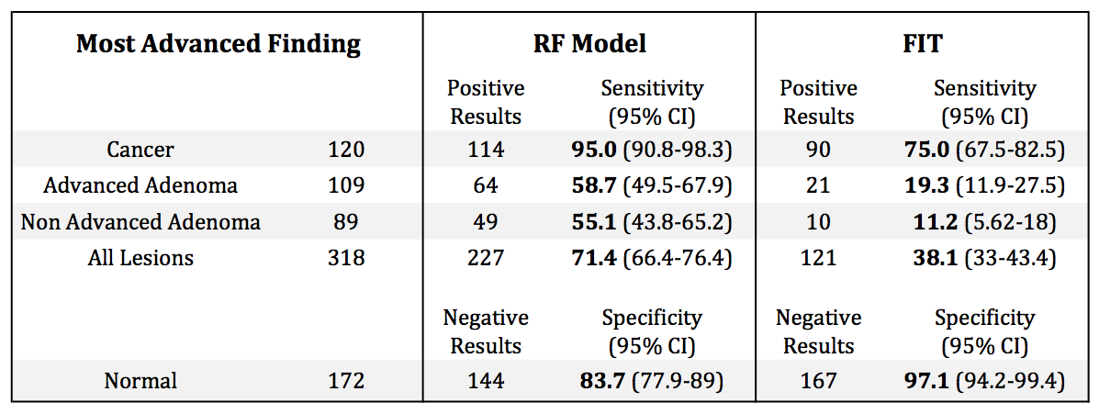  
**Table 1.** Table of sensitivities and specificities for the combined model and FIT. The 95% confidence intervals were computed with 2000 stratified bootstrap replicates.

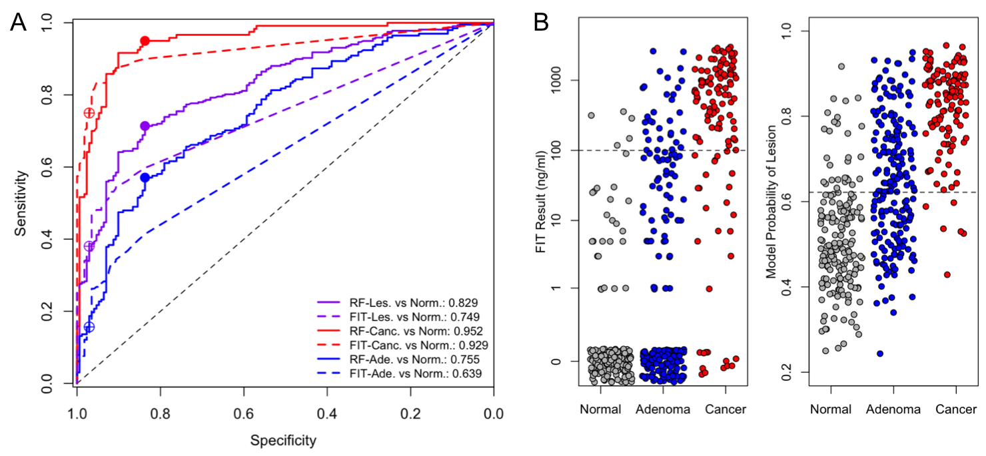  
**Figure 1.** (a) ROC Curves for the combined model (solid lines) and FIT (dashed lines) for distinguishing normal from any lesion (purple), normal from cancer (red) and normal from adenoma (blue). Filled dots show the sensitivity and specificity of the combined model at the optimal cutoff (0.622). Open dots show the sensitivity and specificity of FIT at the 100ng/ml cutoff. (b) Strip charts showing the results for FIT and the combined model. Dashed lines show the cutoff for each test. Points with a FIT result of 0 are jittered to improve visibility.

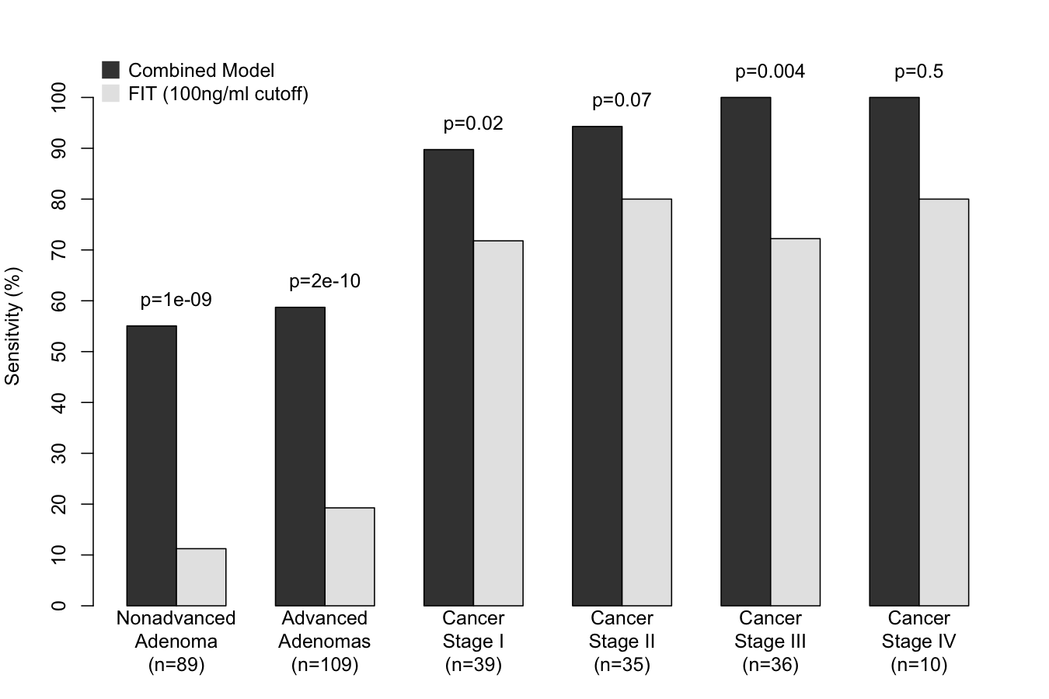  
**Figure 2.** Barplot of sensitivities for the combined model and FIT for each stage of tumor development. P-values based on McNemar's chi-squared test.

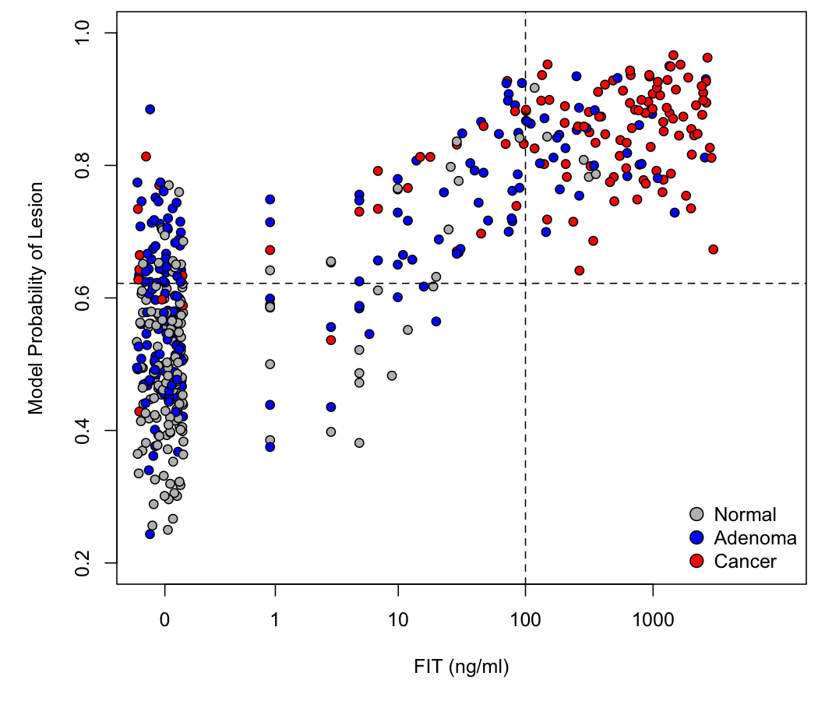  
**Figure 3.** Scatter plot of the results of the combined model and FIT for each sample. Dashed lines show the cutoff for each test.

### Extended Data Figures

**Extended Data Table 1.** Positive and negative predictive values for the combined model and FIT based on published estimates of CRC prevalence.

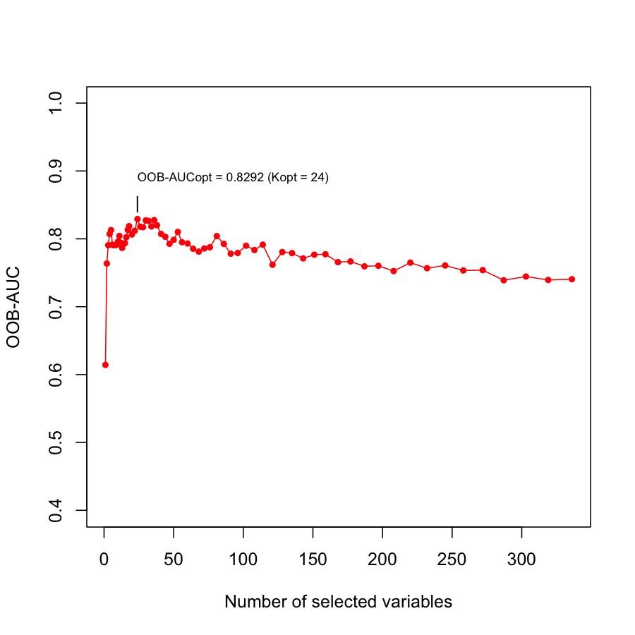  
**Extended Data Figure 1.** Change in out-of-bag AUC with number of features in the combined model. The optimal model contains 24 features and has an AUC of 0.829.

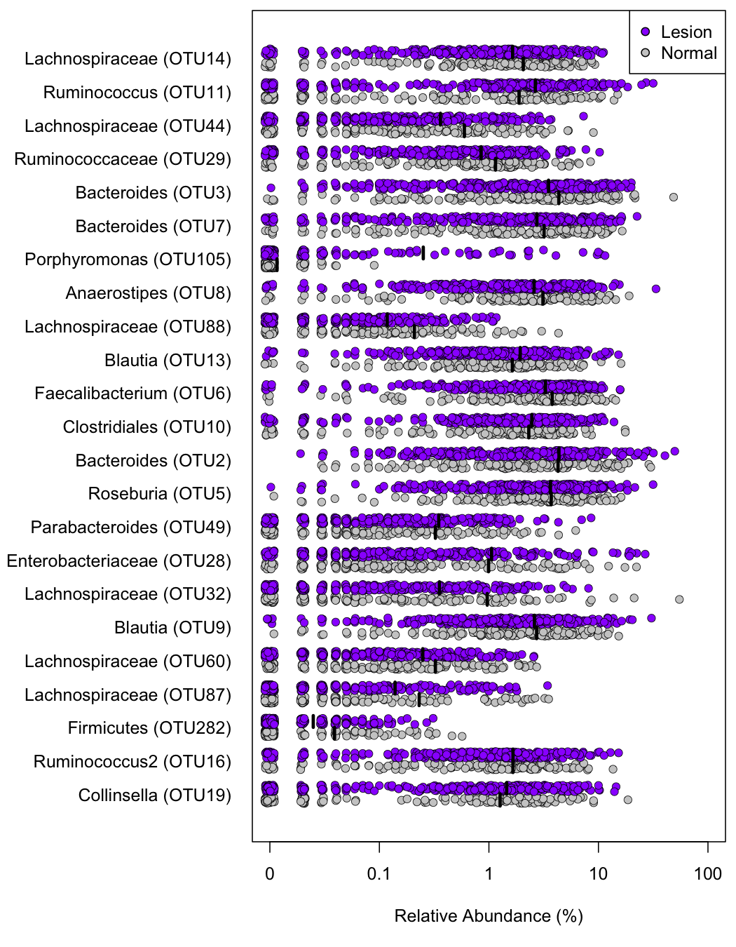  
**Extended Data Figure 2.** Stripchart of the relative abundances of each OTU in the combined model with black lines at the means.

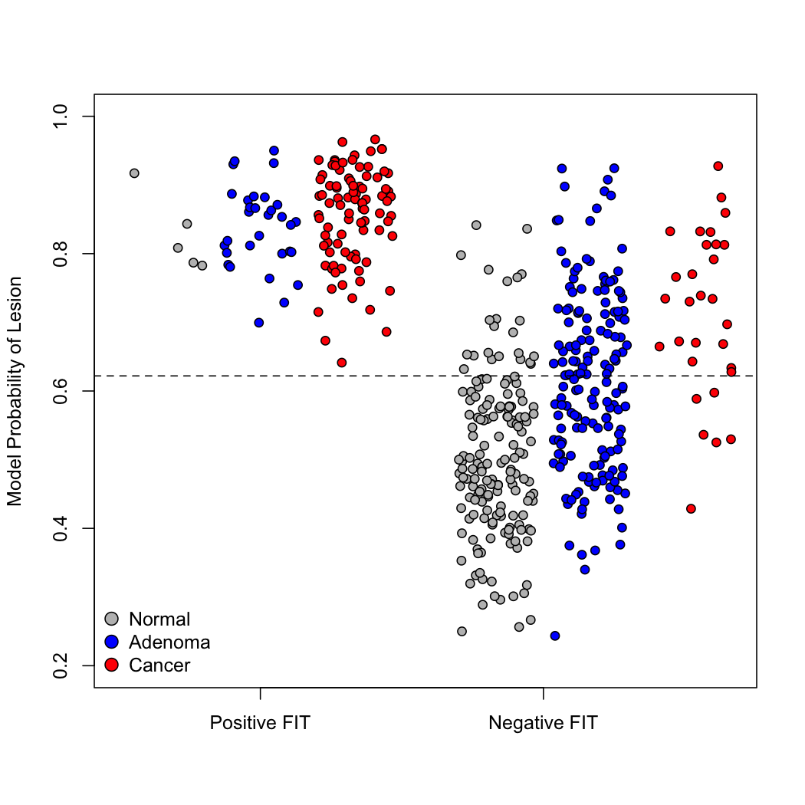  
**Extended Data Figure 3.** Stripchart of combined model results for each sample based on FIT result.

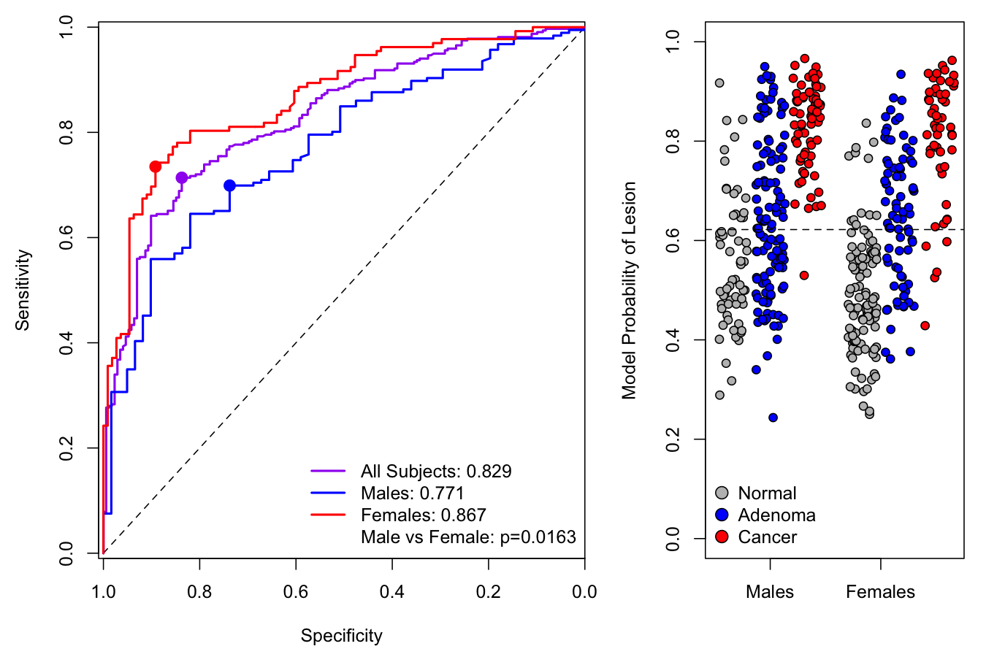  
**Extended Data Figure 4.** ROC curves (left) and stripchart (right) of combined model separated by sex.

### Literature cited

1. Siegel, R., DeSantis, C. & Jemal, A. Colorectal cancer statistics, 2014. *CA: A Cancer Journal for Clinicians* **64,** 104–117 (2014).

2. Disease Control, C. for, (CDC, P. & others. Vital signs: Colorectal cancer screening test use–United states, 2012. *MMWR. Morbidity and Mortality Weekly Report* **62,** 881 (2013).

3. Hsia, J. *et al.* The importance of health insurance as a determinant of cancer screening: evidence from the Women’s Health Initiative. *Preventive Medicine* **31,** 261–270 (2000).

4. Jones, R. M., Devers, K. J., Kuzel, A. J. & Woolf, S. H. Patient-reported barriers to colorectal cancer screening: a mixed-methods analysis. *American Journal of Preventive Medicine* **38,** 508–516 (2010).

5. Zackular, J. P. *et al.* The gut microbiome modulates colon tumorigenesis. *MBio* **4,** e00692–13 (2013).

6. Kostic, A. D. *et al.* Fusobacterium nucleatum potentiates intestinal tumorigenesis and modulates the tumor-immune microenvironment. *Cell Host & Microbe* **14,** 207–215 (2013).

7. Wu, S. *et al.* A human colonic commensal promotes colon tumorigenesis via activation of T helper type 17 T cell responses. *Nature Medicine* **15,** 1016–1022 (2009).

8. Arthur, J. C. *et al.* Intestinal inflammation targets cancer-inducing activity of the microbiota. *Science* **338,** 120–123 (2012).

9. Wang, T. *et al.* Structural segregation of gut microbiota between colorectal cancer patients and healthy volunteers. *The ISME Journal* **6,** 320–329 (2012).

10. Chen, H.-M. *et al.* Decreased dietary fiber intake and structural alteration of gut microbiota in patients with advanced colorectal adenoma. *The American Journal of Clinical Nutrition* **97,** 1044–1052 (2013).

11. Chen, W., Liu, F., Ling, Z., Tong, X. & Xiang, C. Human intestinal lumen and mucosa-associated microbiota in patients with colorectal cancer. *PloS One* **7,** e39743 (2012).

12. Shen, X. J. *et al.* Molecular characterization of mucosal adherent bacteria and associations with colorectal adenomas. *Gut Microbes* **1,** 138–147 (2010).

13. Kostic, A. D. *et al.* Genomic analysis identifies association of Fusobacterium with colorectal carcinoma. *Genome Research* **22,** 292–298 (2012).

14. Hundt, S., Haug, U. & Brenner, H. Comparative evaluation of immunochemical fecal occult blood tests for colorectal adenoma detection. *Annals of Internal Medicine* **150,** 162–169 (2009).

15. Imperiale, T. F. *et al.* Multitarget stool DNA testing for colorectal-cancer screening. *New England Journal of Medicine* **370,** 1287–1297 (2014).

16. Zackular, J. P., Rogers, M. A., Ruffin, M. T. & Schloss, P. D. The human gut microbiome as a screening tool for colorectal cancer. *Cancer Prevention Research* **7,** 1112–1121 (2014).

17. Zeller, G. *et al.* Potential of fecal microbiota for early-stage detection of colorectal cancer. *Molecular Systems Biology* **10,** 766 (2014).

18. Liaw, A. & Wiener, M. Classification and regression by randomForest. *R News* **2,** 18–22 (2002).

19. Calle, M. L., Urrea, V., Boulesteix, A.-L. & Malats, N. AUC-RF: A new strategy for genomic profiling with random forest. *Human Heredity* **72,** 121–132 (2011).

20. Pryde, S. E., Duncan, S. H., Hold, G. L., Stewart, C. S. & Flint, H. J. The microbiology of butyrate formation in the human colon. *FEMS Microbiology Letters* **217,** 133–139 (2002).

21. Rex, D. K. *et al.* American College of Gastroenterology guidelines for colorectal cancer screening 2008. *The American Journal of Gastroenterology* **104,** 739–750 (2009).

22. Youden, W. J. Index for rating diagnostic tests. *Cancer* **3,** 32–35 (1950).

23. Heitman, S. J. *et al.* Prevalence of adenomas and colorectal cancer in average risk individuals: a systematic review and meta-analysis. *Clinical Gastroenterology and Hepatology* **7,** 1272–1278 (2009).

24. Symonds, E. L. *et al.* Factors affecting faecal immunochemical test positive rates: demographic, pathological, behavioural and environmental variables. *Journal of Medical Screening* 0969141315584783 (2015).

25. Kapidzic, A. *et al.* Gender differences in fecal immunochemical test performance for early detection of colorectal neoplasia. *Clinical Gastroenterology and Hepatology* (2015).

26. Levi, Z. *et al.* Sensitivity, but not specificity, of a quantitative immunochemical fecal occult blood test for neoplasia is slightly increased by the use of low-dose aspirin, NSAIDs, and anticoagulants. *The American Journal of Gastroenterology* **104,** 933–938 (2009).

27. Schubert, A. M., Sinani, H. & Schloss, P. D. Antibiotic-Induced Alterations of the Murine Gut Microbiota and Subsequent Effects on Colonization Resistance against Clostridium difficile. *MBio* **6,** (2015).

28. Kozich, J. J., Westcott, S. L., Baxter, N. T., Highlander, S. K. & Schloss, P. D. Development of a dual-index sequencing strategy and curation pipeline for analyzing amplicon sequence data on the MiSeq Illumina sequencing platform. *Applied and Environmental Microbiology* **79,** 5112–5120 (2013).

29. DeLong, E. R., DeLong, D. M. & Clarke-Pearson, D. L. Comparing the areas under two or more correlated receiver operating characteristic curves: a nonparametric approach. *Biometrics* 837–845 (1988).