Objective

To calculate Turnaround and Normalized Turnaround Times for our systems as they exist and to compare those with another selection algorithm of our choosing.

Experiment

Tested with 10 processes with three different selection algorithms. Each process time is as follows:

proc001 800

proc002 1500

proc003 250

proc004 3000

proc005 3050

proc006 100

proc007 300

proc008 750

proc009 1000

proc010 2050

The best quantum for this sequence of processes in the round-robin algorithm was measured to be **1025**, so the quantum for the round-robin algorithm in this experiment was set to this value.

In this third project, the Turnaround Time (final wait time + process time) and the Normalized Turnaround Time (Turnaround Time / process time) were measured for the FCFS, Round Robin, and HRRN algorithms while the sequence of processes and each process’s process time remained the same. For all cases, the ready queue was first filled in the ascending order of the process id (i.e. 001, 002, …, 010), so the proc001 always processed first.

Result

Below is the table of the Turnaround Time and the Normalized Turnaround Time for each process with different selection algorithms. It also contains the mean values of both times.



And the graphs to visualize the Turnaround Time and the Normalized Turnaround Time for each process with different selection algorithms.

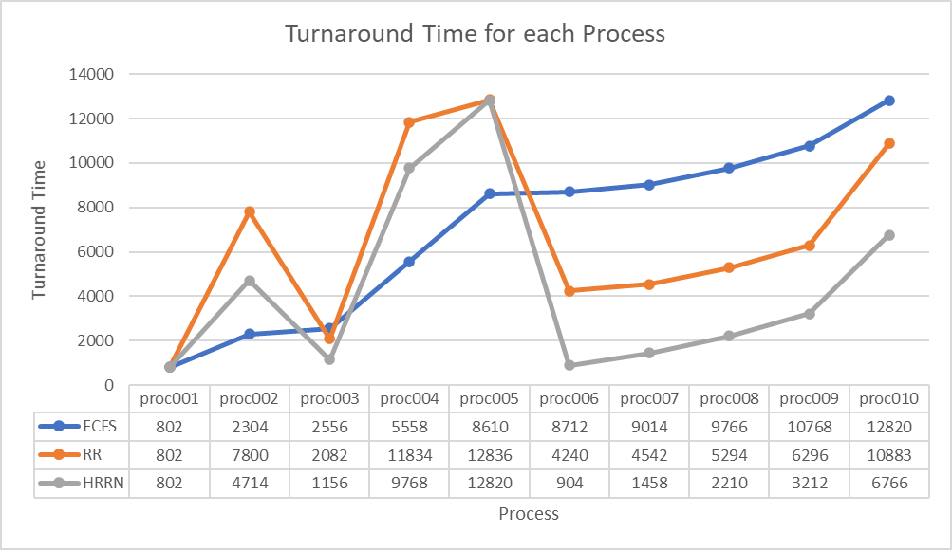

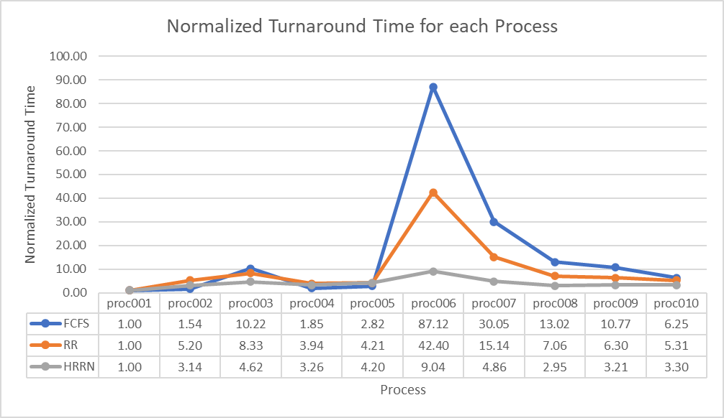

Conclusion

From the result, both the mean Turnaround Time and the mean Normalized Turnaround Time were the smallest in the HRRN algorithm.

In the “Turnaround Time for each Process” graph, the Turnaround Time for proc002, proc004, and proc005 in the Round Robin algorithm and the HRRN algorithm is larger than that in the FCFS algorithm. Considering that the Turnaround Time is calculated by the resulted wait time plus the process time and the process times remained the same for all cases, larger Turnaround Time suggests that the resulted wait time was larger, and that means it was processed later or did not finish within the quantum. The opposite is true for the smaller Turnaround Times.

In the “Normalized Turnaround Time for each Process” graph, there is an obvious contributor to the difference in the Normalized Turnaround Time among three algorithms: proc006. Considering that the Normalized Turnaround Time is calculated by the Turnaround Time divide by the process time, or the resulted wait time plus the process time divide by the process time, and the process times remained the same for all cases, larger Normalized Turnaround Time suggests, as same as in the Turnaround Time, that the resulted wait time was larger, and that means it was processed later or did not finish within the quantum. The opposite is, again, true for the smaller Normalized Turnaround Times. For proc006 (and proc007) in the FCFS algorithm and the Round Robin algorithm, the Normalized Turnaround Time was significantly large because these processes require small process time but were processed later. The HRRN algorithm achieved the smaller resulted wait time by processing them earlier and resulted in the smaller Normalized Turnaround Time.