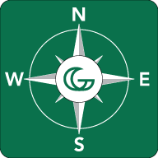GGC Map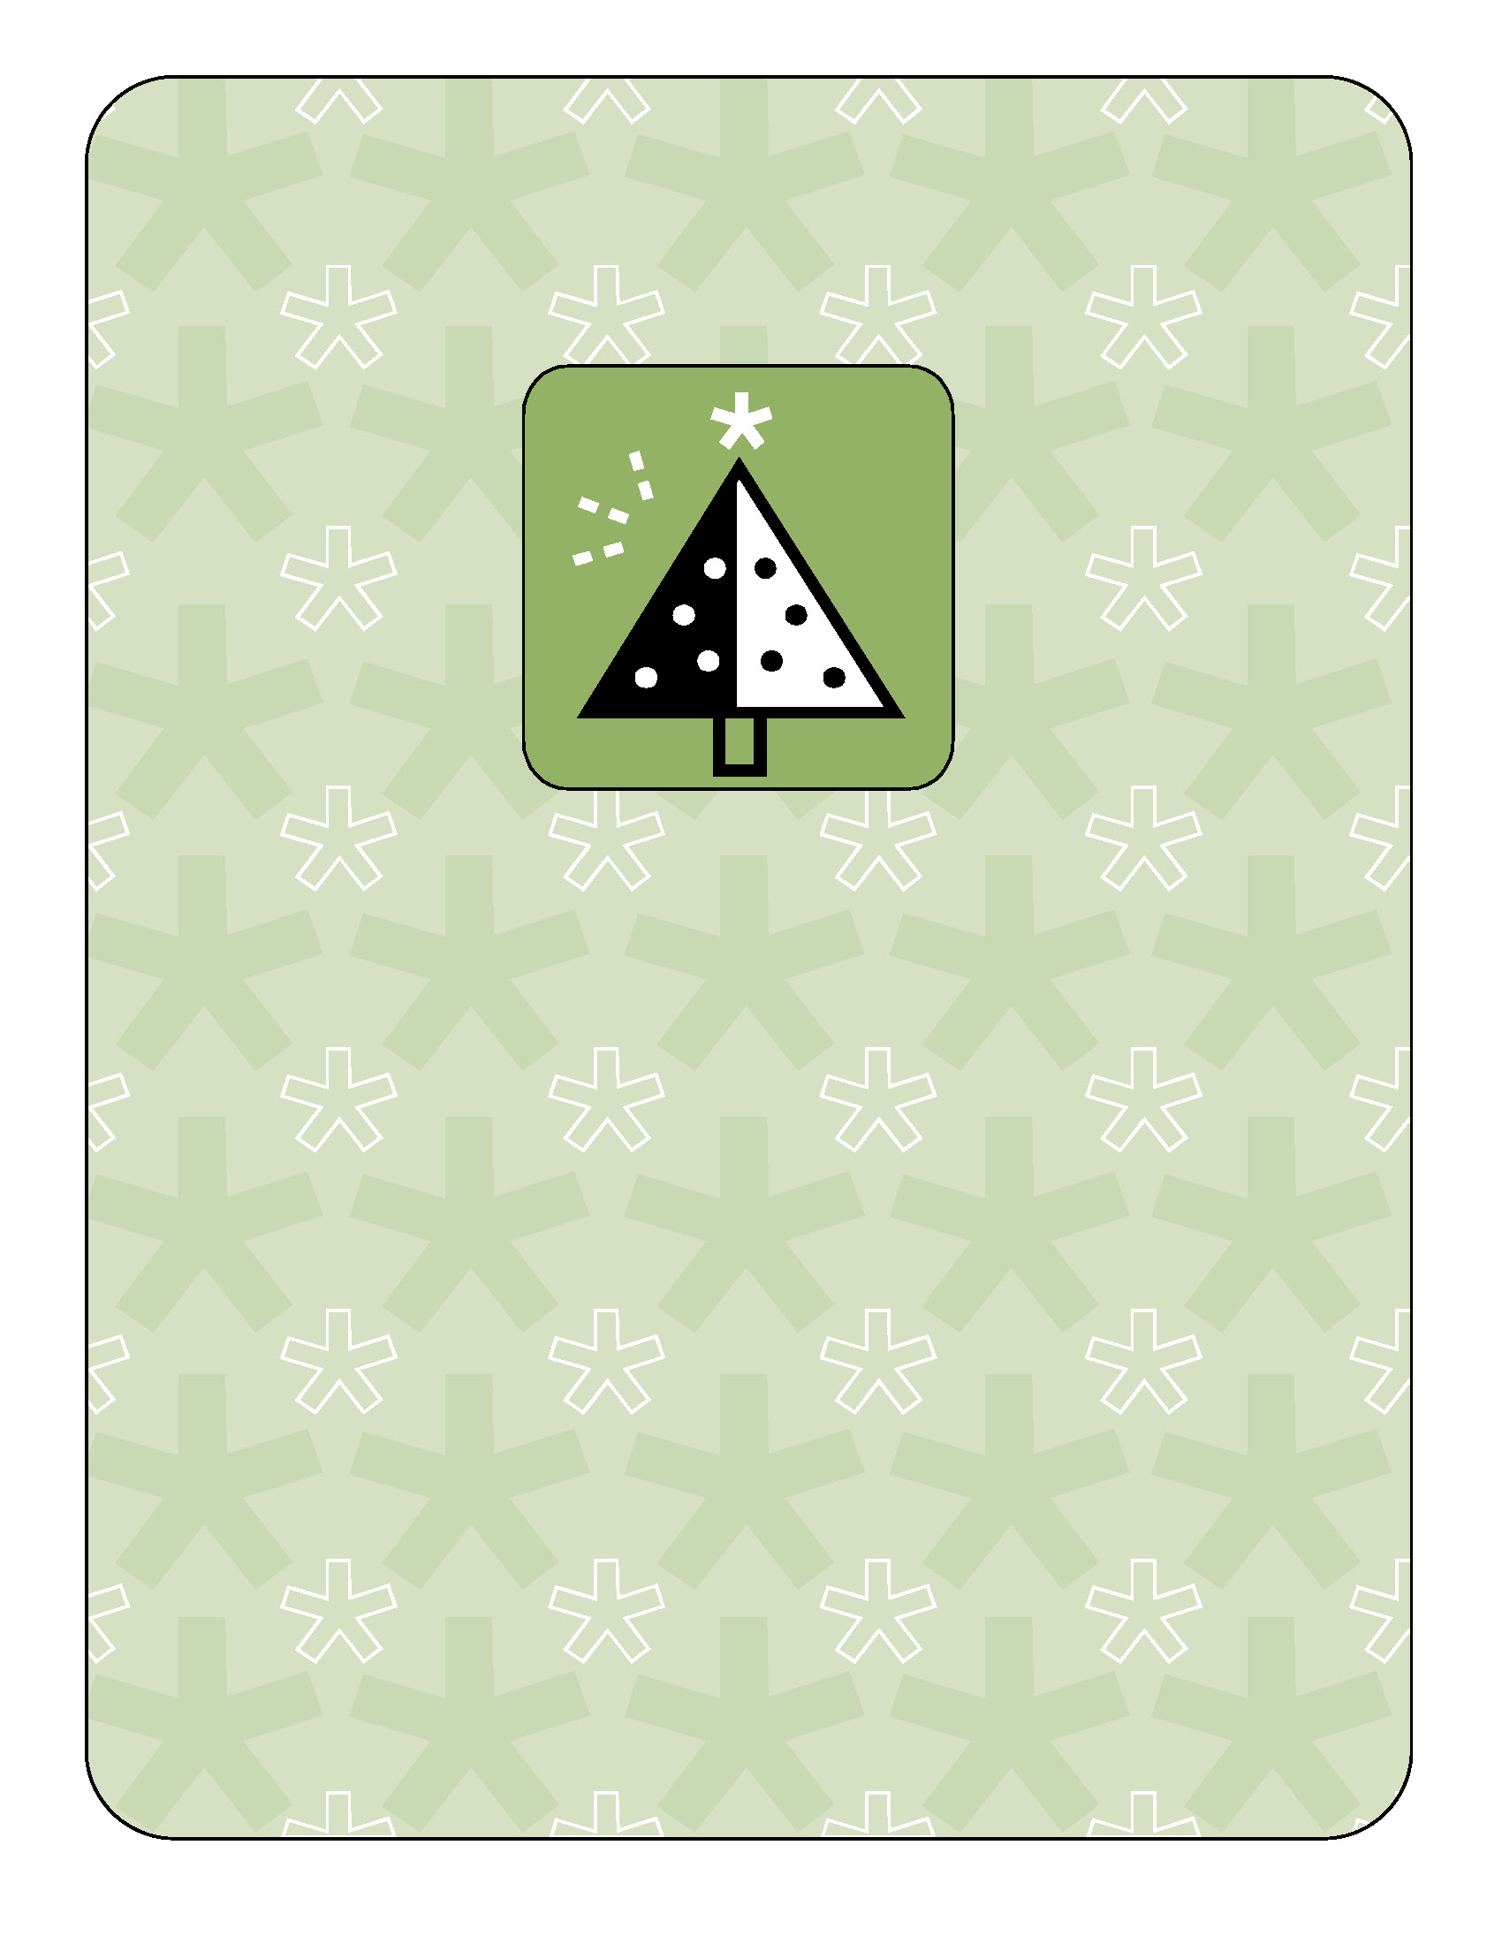s

GGCMaps App aims to enhance the experience for students at GGC, and put the ease into locating various places across campus.

It allows users to search for rooms on an interactive map for easier meetups.

That means, less time wasted finding that classroom, and easier navigation across campus for guests.