Development of a Task Management Application Using Python and File-Based Storage

Table of Contents
Task A: Portfolio (Preparation Work) 3
Week 1 : Python Basics 3
Week 2 : Loops (For and While Loops) 4
Week 3 – Functions (Modular Programming) 4
Week 4 – File Handling (Reading and Writing Files) 5
Week 5 – Lists and Dictionaries 5
Part B — Main Project 6
1. Introduction 6
2. Problem Statement 7
3. Features 8
4. System Design 9
5. Implementation Approach 10
6. Testing 11
7. Conclusion 12
Bibliography 13

Task A: Portfolio (Preparation Work)
The task is devoted to the introduction of the main concepts of Python programming such as variables and user input along with the basic arithmetic operations. The program asks the user to key in his / her name and age which is stored with the help of relevant defined variables. The results of these inputs are then returned to the user to show how Python processes dynamic data given by the user at run time.
Besides this, the program also does an approximate calculation of the year of birth of the user by taking the difference between the year of birth and the age entered before the year (Alshehri, 2024). This is an application of numerical operations and is a strength of the concept of Python manipulating integer numbers. The output will be used to ensure that it has been executed properly because it shows both the information on the user as well as the result calculated.
On the whole, this assignment can be used to learn the underlying architecture of Python programs, such as input processing, assigning variables, and formatting results. It sets the foundation of the fundamental skills that will be used to work on higher level programming concepts like loops, functions and file manipulation in subsequent works (Alshehri, 2024).

Week 1 : Python Basics
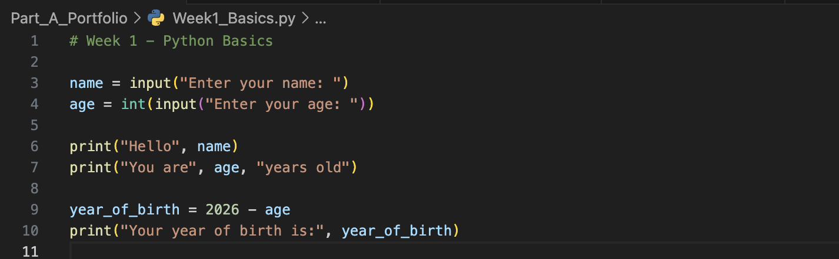
Output
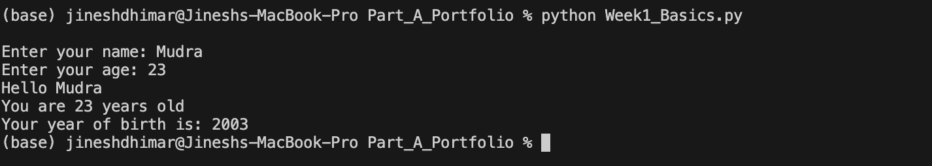

Week 2 : Loops (For and While Loops)
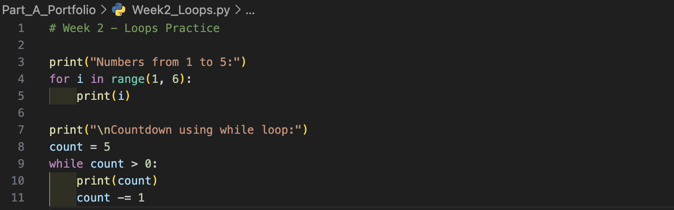
Output
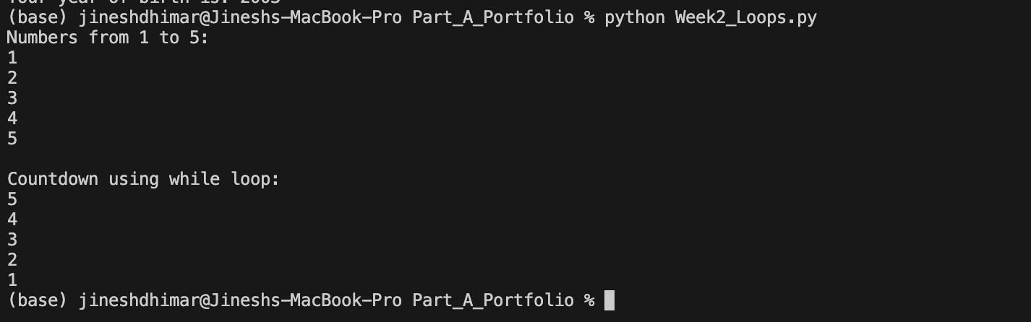

Week 3 : Functions (Modular Programming)
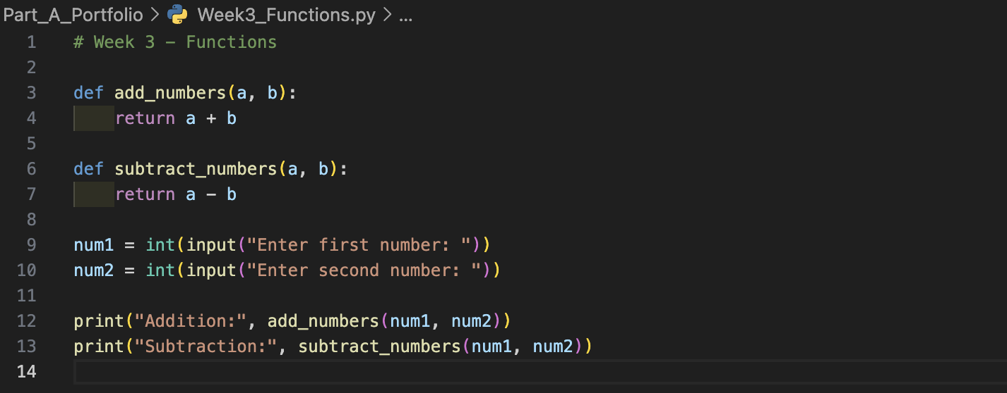
Output
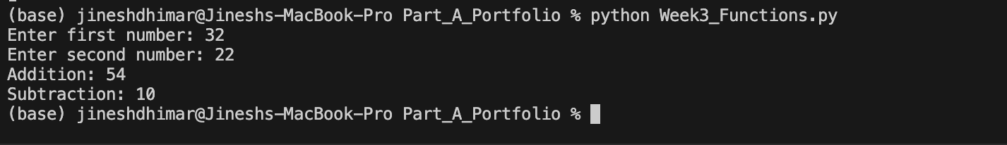
Week 4 : File Handling (Reading and Writing Files) 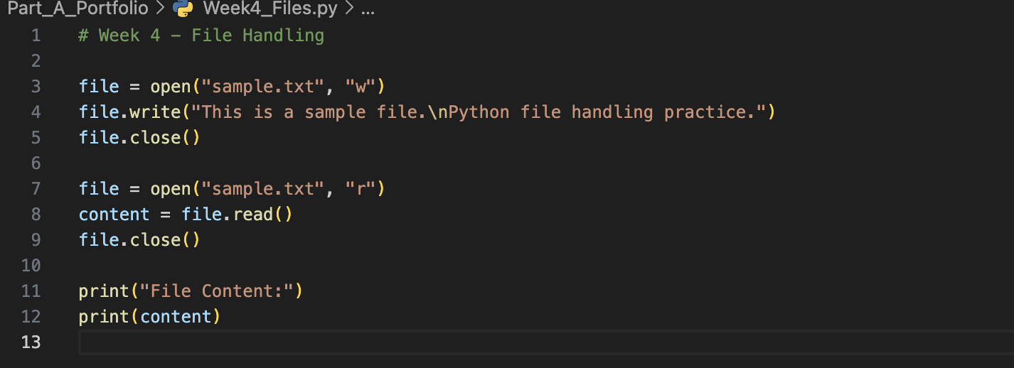
Output
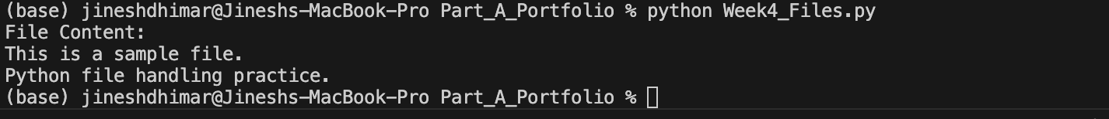

Week 5 : Lists and Dictionaries
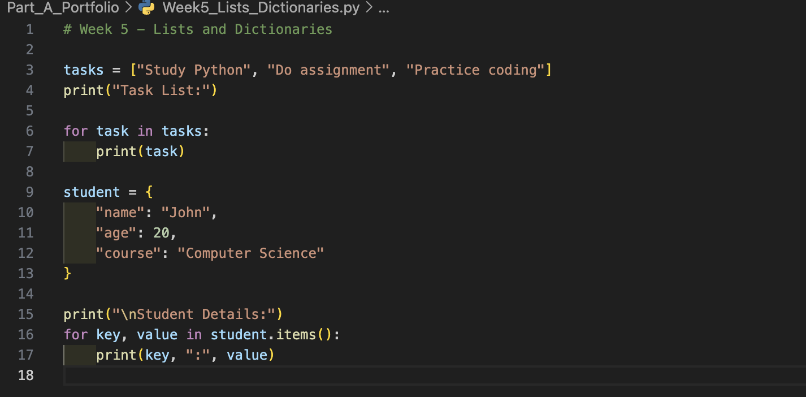
Output
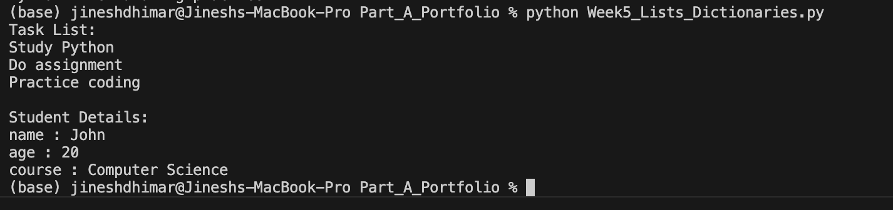

Part B — Main Project

Introduction
Management of tasks is an essential factor of personal productivity and organizational efficiency. As people get more and more digital workloads, they need to have lightweight and dependable tools that will help them to organize their tasks in a systematic manner. Developers and other technical customers find command-line task management tools especially helpful as they are fast, easy, and do not incur huge system overhead. Python is a high-level and general-purpose programming language used in creating such productivity programs due to its readable syntax and a large standard library (Bósa, 2025).
The given project offers a command-line Task Management Application written in Python enabling a user to add, view, complete and delete tasks and retain them in a persistent storage through the use of JSON files. The application focuses on clean code design, easy interaction, strong error handling and the ease of use (Gote, 2026).

Problem Statement
The manual parameters of the traditional task tracking such as the use of notebooks or memory can easily cause missed deadlines, disorganization and inefficiency. There are numerous graphical task management tools available, however, they could consume resources of the computer system or even demand network connection. The users who may want to work in minimalistic environments may get a better access and control via a lightweight and offline based solution that is command-based (Houlborg, 2026).
The main issue that was discussed within the framework of the present project is that there is no easy and yet efficient system of managing the everyday work locally in Python. The solution is intended to offer task storage that is structured, fast operations, and continuity in data storage so that every program execution is continuous.

Features
The Task Management Application has the following main functionalities:
Feature | Description
Add Task | Allows users to create new tasks
View Tasks | Displays all stored tasks with status
Complete Task | Marks tasks as completed
Delete Task | Removes tasks from the list
Persistent Storage | Saves tasks in JSON file
Error Handling | Prevents crashes from invalid input
Table 1 - System Features
This table is the summary of the core functionalities that have been executed in the Task Management Application. All the features will help to organize and manage the tasks, the interaction with the users, and the information processing effectively. All these functionality features guarantee usability, persistence and robustness of the application.These characteristics are well aligned with best practices of small-scale productivity tools and guarantee usability and reliability (Damilola, 2026).

System Design
The application has a modular procedural design approach. Every major operation is deployed as a stand-alone function, which makes it readable and maintains. The data in the task is registered in Python lists and dictionaries that allow manipulating data in a flexible way. The continuous storage is provided based on the work with JSON files that make it possible to save structured data in the form that is easy to analyze by human hands (HEGDE, 2026).
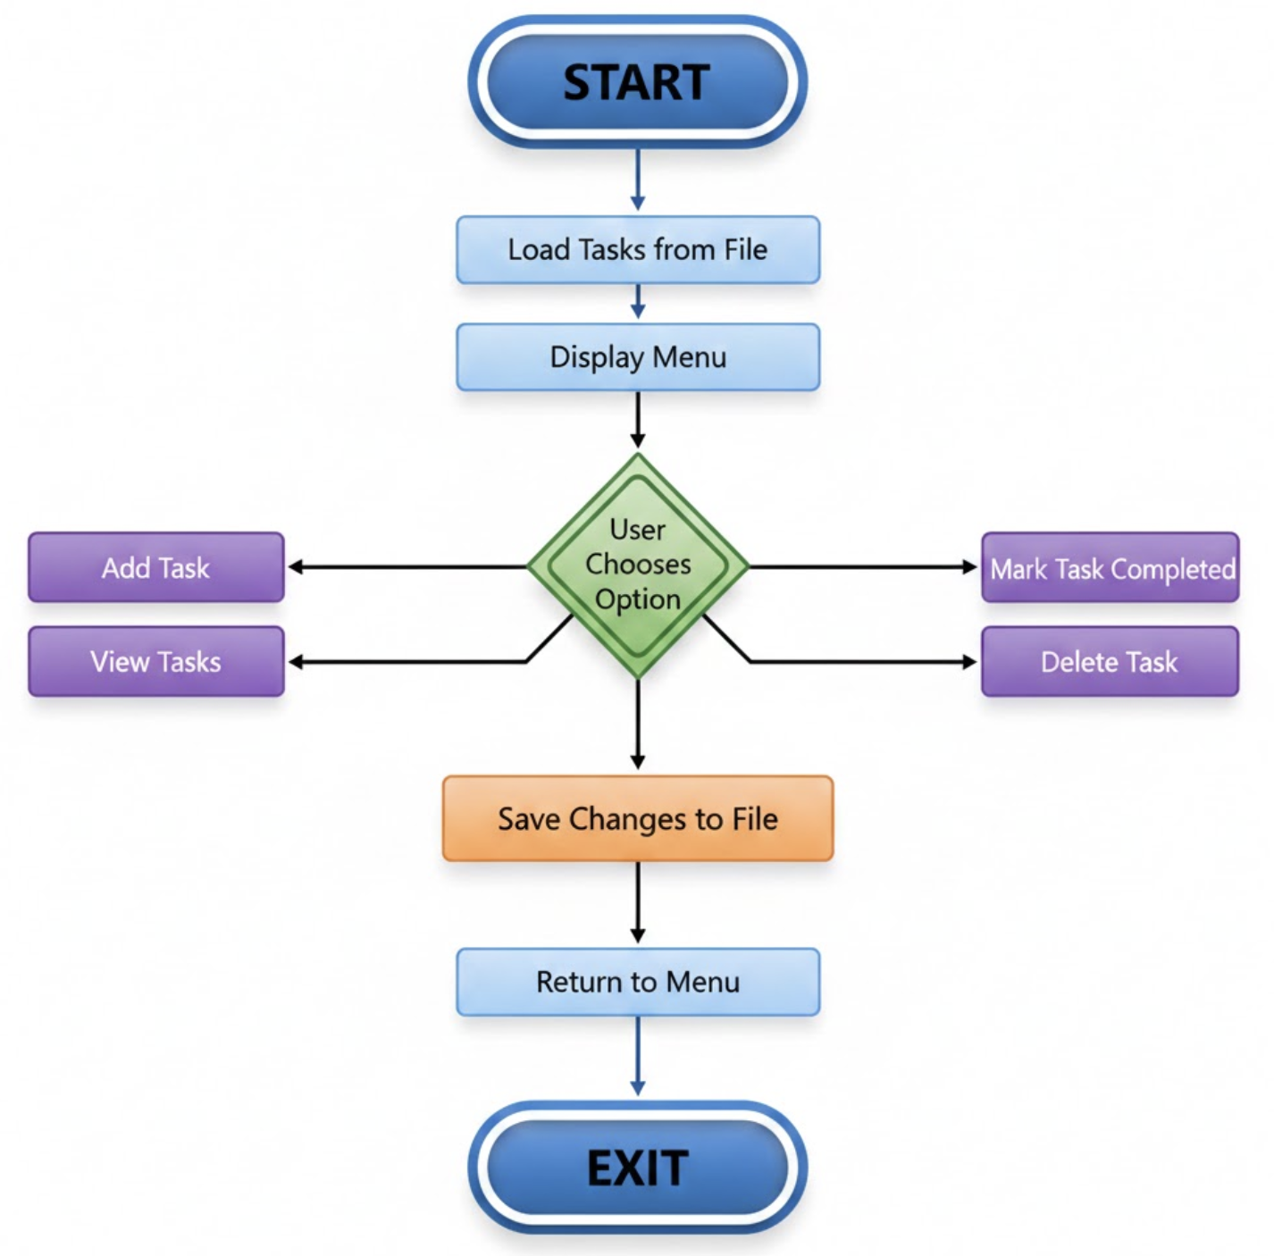
Figure 1 - Flow Diagram
The flow diagram shows the sequential execution of the Task Management Application starting with program initiation up to program termination. It shows how work is loaded, the information input is handled using a menu-driven loop, and the updates are stored continuously after any operation. This hierarchical flow of tasks makes sure that user communication is maintained throughout the task execution until the user leaves the application.

Implementation Approach
Task Management Application is coded in Python and relies on in-built Python modules including json and os to store data and work with files effectively. The program loads the already saved tasks in a JSON file when it opens, and it provides information permanence across program invocations. All tasks are defined as dictionaries of a task name and task completion status, so that the task records can be stored in an organized manner, and their data can be easily manipulated when the program is running.
The user interaction and navigation is provided in a menu-based command-line interface. The application is straight forward and easy to use with a clear defined choice to add, view, complete or delete tasks. The error of the input is handled with try except block to deal with the invalid input like an invalid task number or the missing files(Bósa, 2025).
The application has a modular coding design, with every significant functionality being encapsulated into individual functions, such as, add task, view tasks, complete task and delete task. This division of responsibilities enhances the readability of codes, their maintainability and scalability(Badreddine, 2026).

Testing
Various real-life scenarios were used to test to verify functional correctness and stability. The test cases that were done were:
Test Case | Expected Outcome | Result
Add new task | Task saved successfully | Pass
Empty input | Error message | Pass
Invalid task number | Error handled | Pass
File missing | Auto-created | Pass
Restart program | Data persists | Pass
Table 2 -Test Table
Empty task lists and wrong user inputs were identified as the examples of boundary cases that were tested to ensure that the program was robust. This made the application reliable to perform both in regular and extreme situations (Gote, 2026).

Conclusion
The PythonTask Management Application is able to meet the requirements of writing a simple, efficient, and persistent command-line task manager. With modular code design, file-based storage and structured error handling, the application is a reliable productivity solution to users who feel comfortable using lightweight tools (Pisu, 2026).
The project exhibits the basic principles of software development such as application of data structures, input verification, persistent storage, and even clean code structure. It also correlates with the learning outcomes of the academic program because it strengthens the problem-solving skills and the real-world knowledge of Python. Priorities of tasks, due dates, search function and export features are some of the areas that this can be improved in the future to enhance the usability (Piskala, 2026).

Bibliography
Alshehri. (2024). PyHEP.dev 2024 Workshop Summary Report, August 26–30 2024, Aachen, Germany. arXiv preprint arXiv:2410.02112.
Alshehri. (2024). dev 2024 Workshop Summary Report, August 26–30 2024, Aachen, Germany (No. arXiv:2410.02112). arXiv: PyHEP.
Badreddine. (2026). TwinCity: An urban digital twin framework for data-scarce environments — A case study of Benguerir, Morocco.
Bósa. (2025). Automated execution of data pipelines based on configuration files. Open Research Europe, 5, 291.
Damilola. (2026). Development of malware detection web plugin using one-dimensional convolutional neural networks model. In E3S Web of Conferences (Vol. 684, p. 03001). EDP Sciences.
Gote. (2026). Cowbase—A library for automatic milking system related data handling and curation in Python. Information Processing in Agriculture.
HEGDE. (2026). GlucoVision: AI-driven dietary intelligence system using NER and context-injected RAG for diabetes risk assessment.
Houlborg. (2026). Flexible I/O for database management systems with xNVMe. In Conference on Innovative Data Systems Research.
Piskala. (2026). From everything-is-a-file to files-are-all-you-need: How Unix philosophy informs the design of agentic AI systems. arXiv preprint arXiv:2601.11672.
Pisu. (2026). Race against time: Investigating the factors that influence web race condition exploits. Computers & Security, 160, 104740.

