PHP Basics
Marcelo Gaspar
drmpgaspar@gmail.com
https://github.com/Mpgaspar/phpbasics-pill.git
PHP BASICS
27th November 2019

Overview
In this project you will learn the basic notions of the famous PHP language which is so used in the world of web development.

List of tasks to be performed:
01. Priority of each task
02. Title and description of each of them
03. Difficulty level
04. Estimated time for each task.
05. Record of incidents that were detected during project execution.
06. Record of lessons learned.
07. Project calendar
08. The Chronogram of the project.
09. Quality control measurements.
10. Quality metrics
11. Requirements documentation.
12. Risk documentation in the event that these exist
13. Documentation about the git WORKFLOW you are going to use
14. Documentation about the tools used in the project

Priority (1-3) 1 = low, 2 = moderate, 3 = high
A: Organization -------------------------------------------------------------- 3
B: Study PHP documentation -------------------------------------------- 2
C: Repository in git --------------------------------------------------------- 3
D: Test php server ---------------------------------------------------------- 2
E: Create PHP files ----------------------------------------------------------3
F: Test PHP functions ------------------------------------------------------ 3
G: Create PHP classes---------------------------------------------------- 2
H: Test ------------------------------------------------------------------------- 3

A: Organization = structuring all tasks by priority and estimated execution time.

B: Layout = design container with search and filters inputs + grid of results.

C: Repository in git = put the project into a git repository to organize changes during construction.

D: HTML Structuring = create semantics tags and define tag that append template create in JavaScript.

E: Get itunes and Countries api = get data, work with it and put in page.

F: CSS styling = the artist part to give the site beauty.Make responsive with Materialize.css

G: jQuery functions:
+ Create a function to get api with ajax.
+ Show data in html.
+ Create class search.
+ Use class to user filter data
+ Create classes to song, artist, album and video
+ Use these classes
+ Put data in localStorage to create favorites

H: Test = test in all browsers but the code has to be tested all the time.

Difficulty level (1-3) 1 = low, 2 = moderate, 3 = hard
A: Organization and Documentation ------------------------------------------2
B: Layout -------------------------------------------------------------------------------1
C: Repository in git ------------------------------------------------------------------1
D: Structuring in HTML ----------------------------------------------------------- 2
E: Get api ----------------------------------------------------------------------------- 3
F: CSS styling ----------------------------------------------------------------------- 1
G: jQuery functions ------------------------------------------------------------------3
H: Test --------------------------------------------------------------------------------- 2

Time (hours)
A: Organization and Documentation = 4h
B: Layout = 2h
C: Repository in git = 1h
D: Structuring in HTML = 4h
E: Get api = 6h
F: CSS styling = 3h
G: jQuery functions = 9h
H: Test = 3h
I: Incidents = 8h (20% total time)

Total time: 40h

Incidents

- Difficulty fulfilling the given time for each task
- Some tasks were underestimated
- Difficulty to create some classes
- Stop the project to study class concepts used
- Knowledge limitation in POO
- Difficulty optimizing time for each task
- Limitation to implement certain features
- Difficulty to working and creating more elaborate jQuery functions

Lessons

- Better organize myself to accomplish the tasks
- I learned to prioritize the most important tasks
- Use git to our advantage
- Understand how classes works
- Improve my knowledge in logic and programming POO
- Improve my knowledge in jQuery, HTML and CSS
- Improve my knowledge in work with data.
- Make good use of jQuery
- Better understand jQuery functions
- Take questions and discussed project organization with colleagues
- Improve your knowledge in project management.
- Have patience and be humble

Project Calendar

Main tasks
27/11 → Organization and Create repository in git
28/11 → Create Layout and HTML structure
29/11 → Study and work with classes
30/11 → Create JavaScript functions
01/12 → Styling with CSS and make responsive
02/12 → Test functions and make the code more clean
03/12 → Test functions and make the code more clean

TASK/  DAY | WED  27/11 | THU  28/11 | FRI  29/11 | SAT  30/11 | SUN  01/12 | MON  02/12 | TUE  03/12
A | X |  |  |  |  | X
B | X | X
C | X
D | X | X | X
E |  | X | X | X
F |  |  | X | X | X
G |  | X | X | X | X | X
H |  |  |  |  |  |  | X

Chronogram of the project
11/12 - Organization and division of tasks by priorities
- Start documentation
- Put repository in git
- Start HTML basic structuring
- Study Ajax to get api with jQuery

12/12 - Continue HTML basic structuring
- Work with git
- Create JavaScript functions
- Work to get api with jQuery

13/12 - Finish HTML basic structuring
- Start basic styling with CSS
- Continue work with data and api
- Continue work with data and api

14/12 - Continue styling with CSS
- Continue work with jQuery functions and classes
- Continue work with data and api

15/12 - Finish styling with CSS
- Continue work with jQuery functions and classes

16/12 - Finish jQuery functions and classes
- Finish documentation

17/12 - Test in browsers
- Push to GitHub repository

Quality control measurements
The quality control measurements are used to analyze as well as evaluate the quality of the different processes involved in a project against the standards of the organization or on the requirements specified during the project management planning.

- Is the HTML code properly validated by the W3C ?
- Are the HTML, JS and CSS files properly formatted ?
- Did you use clean code?
- Is the site responsive and easy for the customer to understand?
- Are user interactions made with JavaScript(jQuery) functionality only?
- Does the site have all the specifications requested?
- Does the site look good when displayed in any of the common browser clients?
- Do the commit messages properly explain the development flow of the project?
- Have all functions been tested throughout the project realization process?

Requirements
- You must use GIT
- You must use a version of PHP higher than 5.1
- Create a clear and orderly directory structure
- Both the code and the comments must be written in English
- Use the camelCase code style to define variables and functions
- In the case of using HTML, never use online styles
- In the case of using different programming languages always define the implementation in separate terms
- Remember that it is important to divide the tasks into several sub-tasks so that in this way you can associate each particular step of the construction with a specific commit
- You should try as much as possible that the commits and the planned tasks are the same
- Delete files that are not used or are not necessary to evaluate the project

Risk documentation
Incidents (disease, technical failure, poor performance, unrealistic deadlines) may change:
+ Statement of work (SOW)
+ Work breakdown structure (WBS)
+ Budget
+ Schedule
+ Execution plan

Git Workflow
Described by Vincent Driessen in 2010.
I used 3 branches:
- Master
- Develop
- Feature

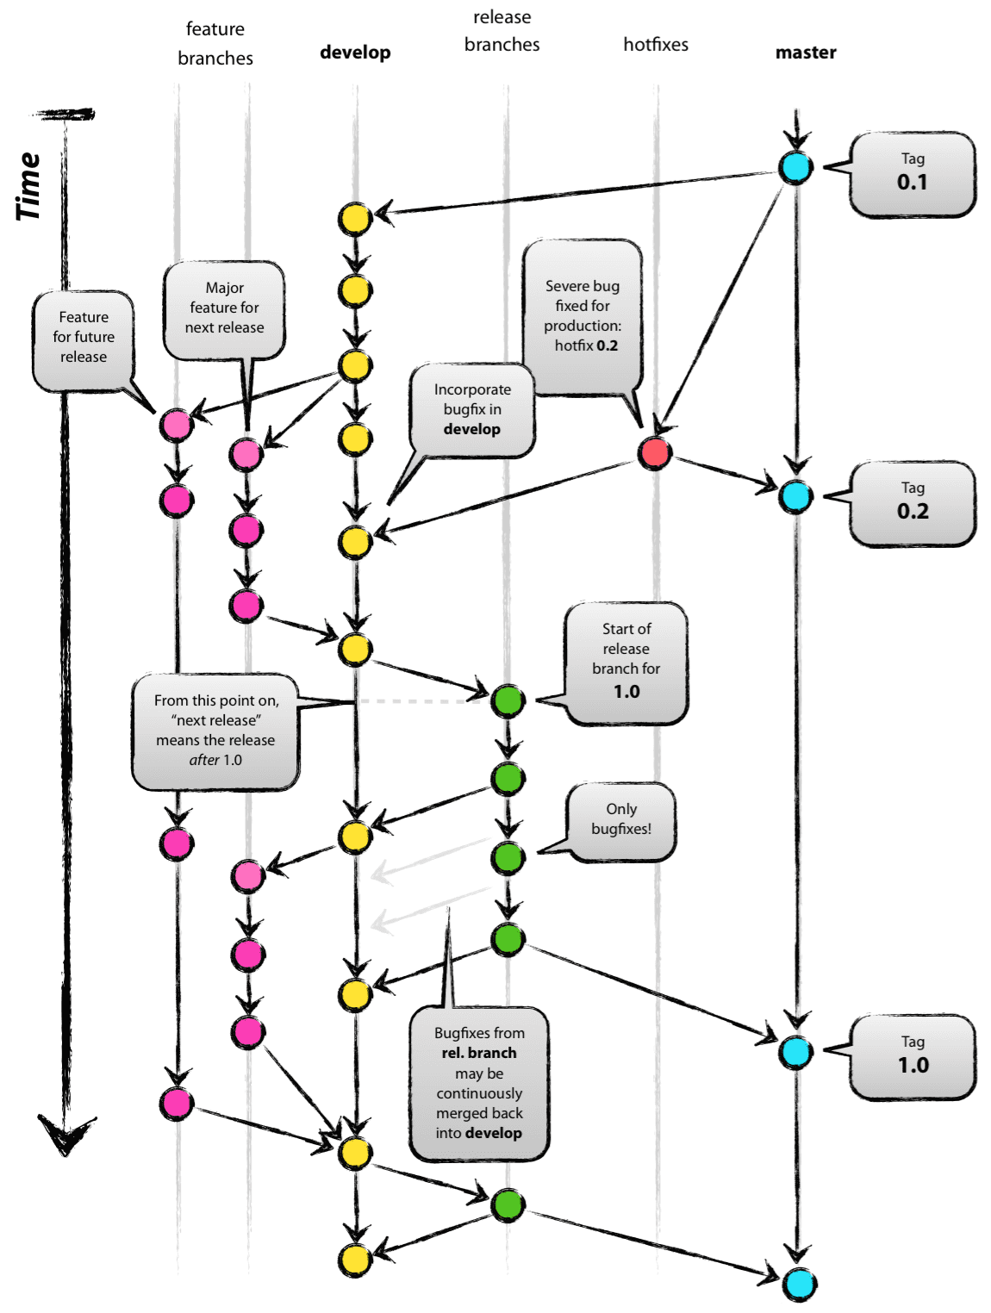

+ “Master” is always ready to be released on LIVE, with everything fully tested and approved (production-ready).

+ “Develop” is the branch to which all feature branches are merged and where all tests are performed. Only when everything’s been thoroughly checked and fixed it can be merged to the Master.

Project Tools
- Visual Studio Code
- Git and GitHub
- Materialize.css
- Google Chrome Developer Tools

Resources:
- https://validator.w3.org/
- https://developer.mozilla.org/es/docs/Web/API/Window/localStorage
- https://stackoverflow.com/
- iTunes Search API Doc: https://affiliate.itunes.apple.com/resources/documentation/itunes-store-web-service-search-api/
- README Guidelines Example:
https://gist.github.com/PurpleBooth/109311bb0361f32d87a2

