**UNIVERSITY OF ZULULAND**

**FACULTY SCIENCE AND AGRICULTURE**

**DEPARTMENT OF COMPUTER SCIENCE**

***Assessment I – 15 August 2023***

**COURSE CODE:** ***4CPS232* Databases and Information Management I**

**Examiner:** S. Mathaba

**Moderator:** IN Mba

Duration: 1h30 50 marks

**Instructions**

Answer **all** questions.

1. Briefly explain the business rules and their purpose in data modelling [2]
2. Given the following business rules, create the appropriate ERD using **UML**  notation.
   1. A company operates many departments.
   2. Each department employs one or more employees.
   3. Each of the employees may or may not have one or more dependents.
   4. Each employee may or may not have an employment history. **[12]**
3. In the context of entity relationship modelling, you wrote above in question 2, explain the following and be specific:
4. Optionality and mandatory entities in question (a b, c, d) [4]
5. Cardinality in question (a, b, c, d) [4]
6. Weak and strong entities (a, b, c, d) [4]

1. Using the following tables, evaluate the relational algebra operations listed below:

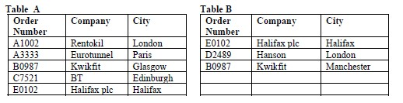

* 1. A U B (Union)
  2. A – B (Difference)
  3. B – A (Difference)
  4. A ∩ B (Intersect)

**[16]**

1. Refer to the table **Employee** below to answer the following questions and **motivate** your answer.

**EMPLOYEE Table**

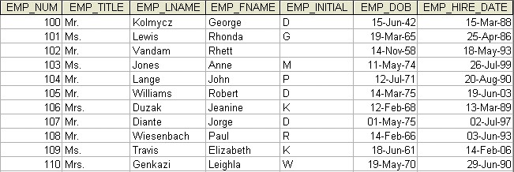

1. Define the Primary key.
2. Derived attribute
3. Composite attribute
4. Dependant attribute

**[8]**