4/12/2023

**OPSC POE**

Part 1

mEMBERS

ST10102652 Pitsi mpho nkoana

st10102962 mukoko henock kiniki

st10097490 alphy andre chauke

ST10103128 MONDLI MONGEZI THUKWANA

**Table of Contents**

**Introduction 2**

**Overview 2**

**List Of Requirements for Swap Pals 3**

**Screen Description 6**

**Diagram 15**

**Project plan 16**

**Conclusion 18**

**Referencing 19**

## **Introduction**

Welcome to Swap Pals an online app that will revolutionise the trading world forever. We at DEV4G are determined to make this the best trading platform. We started off by looking at the trading market and we found that there was a lack in the market for an app that is able to give people a platform where they could communicate, trade, share collections and offer advice to each other about their collection.

## **Overview**

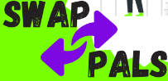**icon**

Swap pals is a web-based application that allows users to swap their collectibles with other users in a safe and secure environment. With Swap pals, users can easily trade their rare and valuable items with other collectors who share their interests.

The initial icon for swap pals features a modern design incorporating the app name in bold stylized lettering with two arrows pointing the opposite direction left and right. The colour choice of white, green, and purple purity, cleanliness, creativity and inspiration.

How it Works: To get started, users will need to create an account and sign into the Swap pal’s platform. Once logged in, they can browse through the collection of items that other users have listed for trade. Users can filter the items by category, value, rarity, and other parameters to find the collectibles that they are interested in.

When a user finds an item, they would like to trade for, they can send a trade proposal to the owner of the item. The owner can then review the proposal and accept or decline it. If the owner accepts the proposal, the two users can initiate a trade, where they ship the items to each other. If user desire to save some item for future purpose they can be save in the Wishlist.

This system will ensure that both parties receive their items, and that the transaction is completed successfully. If there are any issues, Swap pals has a dedicated support team that can help resolve the problem.

## **List Of Requirements for Swap Pals**

* User Registration: The user registration is one of the requirements that will be included in our **Swap Pals App**. Users will be able to create an account which will be stored in database. In the user registration, the user will be able to login into his/her account with a **username** and a **password** which they have created. If the user doesn’t have an account, he/she will not be able to login, the user will then be directed to the **Register Page**.They will then have to fill in details that are on that page, for them to create an account. Details such as their: **Name**, **Email**, **Phone**, **Password.** Once the user creates an account, they will then receive a verification link to verify their account, after that they can then be able to log in, for them to get access into the app.
* User Account: The user’s account is another important requirement in the **Swap Pals** **App.** Without a **User Account,** a user won’t be able to view, edit or do other functions on their account. The user’s account will have the functions such as the user being able to edit their account or fill in any other missing details. The user’s account may include features such as the user being able to deactivate or delete their account. Furthermore, having the **User Account**, will help the user manage their account and information, and view their information and be able to edit your information, such as their **email, phone number,** or even change their **password**.
* Category Creation: Another requirement is category creation. This requirement will help organise the user’s account and keep the app simple, easy to use and organised in such a way by the user will be able to create categories of their own, with name of their choosing where they can store their collections of their items. This will help the user remember where they put their items which they collected in the categories they created. This will be easier for the user to manage their collections and keep them the way they want. So, the items the user collected will be belonged to created categories, helps the user kept their collection of each item in one place.
* Item Goals: The user will be able to set a goal of how many items they want in each category. This requirement will help organise the user’s collections of items in each category based on how many collected items they want. In our **Swap Pals App**, this will benefit the app in such a way of it being simple and organised instead of squashing items into one place which can be seen by a user as unattractive and disorganised.
* New Items: The **New Items** requirements will allow a user to create/add a new item which they will store in their collection. This requirement will allow the user to store a picture(s) of their item, the title of their item, select a category, if they don’t a have a category for this item, they can create one. This will benefit the app and be helpful to users who are willing to swap items with other users, because a user will be able to see that item the user added.
* Item(s) View: The item(s) that was added user, collected, or got from other users after swapping them. Will be stored in the **My Collections** page, so that the user can be able to view a list of their collections of items with their dates of when the items were added to the collections. This helps the user keep track of the items in a collection and view them anytime.
* Communication & Negotiation: **Swap Pals**’ communication and negotiation will be a required because it will allow a user to communicate with other users when it comes to the swapping of items. Users will be able to communicate with other users and negotiation the price of the item(s) they would like to swap in return for item(s) from other users. Users will be able to share images of their items with each other.
* Search & Discovery: Our app **Swap Pals** will have a search bar on our home page that will allow users to search for collections and items. This will save users time instead of them scrolling up and down or searching everywhere on the app for what they are looking for.
* User Rating: The user rating requirement, is a requirement that we will have. Users will be able to rate each other based on their swapping experience. Ratings will be displayed on each user, so that other users can know if this user is a the one to swap with, if not they will search with other users who have the same items and check their ratings.
* Notification System: **Swap Pals** will have a notification system as one of our requirements. The notification system will be able to alert, reminder and update the user. The app will notify users when they receive messages from other users based on the swapping of items, as well when an item becomes available. The user will also be notified about their goals or achievements.
* Achievements: **Dev4G’s Swap Pals App** will have an achievement system, this system will display the user’s achievements, which they achieved while using the app. Achievements such as user being a **Starter: Added the first item to the app, Collector: Added three items to the app** and the final one a **Packrat: Added 10 items to the app**. Other achievements will be included as well. Having achievements will motivate the users to continue to use **Swap Pals**.
* Analytics: Having analytics in our app, can be another good requirement for users, this system will help users keep track of their **achievements**, tasks and so on. Users will be able to see how many, **achievements,** they completed, the number of swaps deals they made or items they swapped, how many items they have in each collection and how many categories they created.
* Customer Support: The **Customer Support** system is one of the important requirements to **Swap Pals**. Having the **Customer Support** system benefits the users and our company in a way by us as **Dev4G** helping our users, who may have issues or questions about the **Swap Pals App**.
* Wishlist: The Wishlist system will allow users to save or add the items they are interested in, into the Wishlist, the app will then notify the user when that item they added to the Wishlist is available for swapping.

## **Screen Description**

Cover Page:

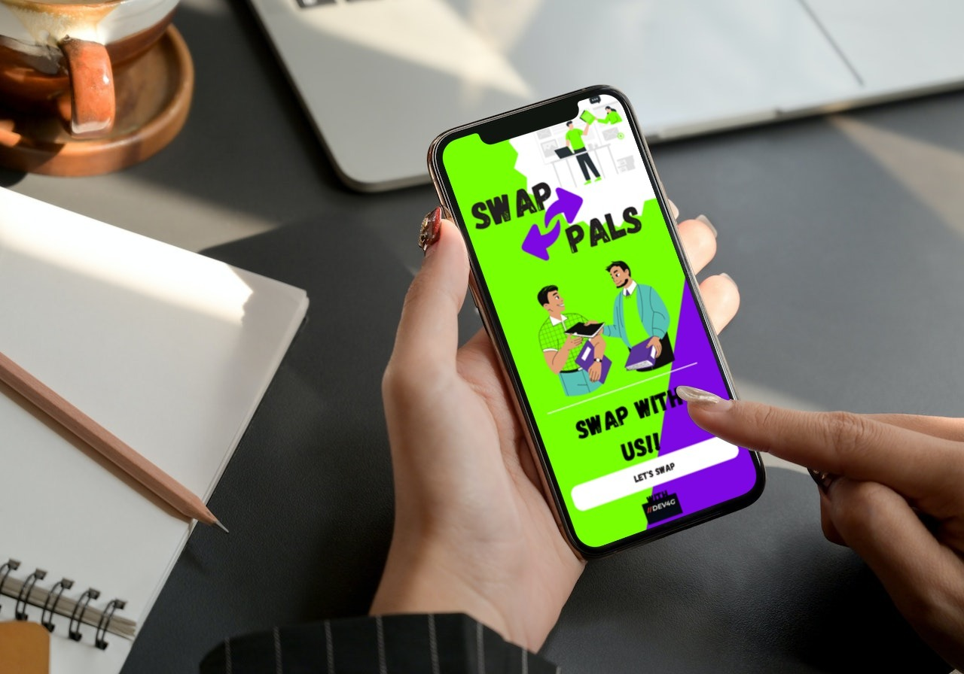

This is the first page the user will see when they enter the **Swap Pals App**. Its purpose is to make a strong impression on the user and to introduce the **Swap Pals App** to the user.

Login Page:

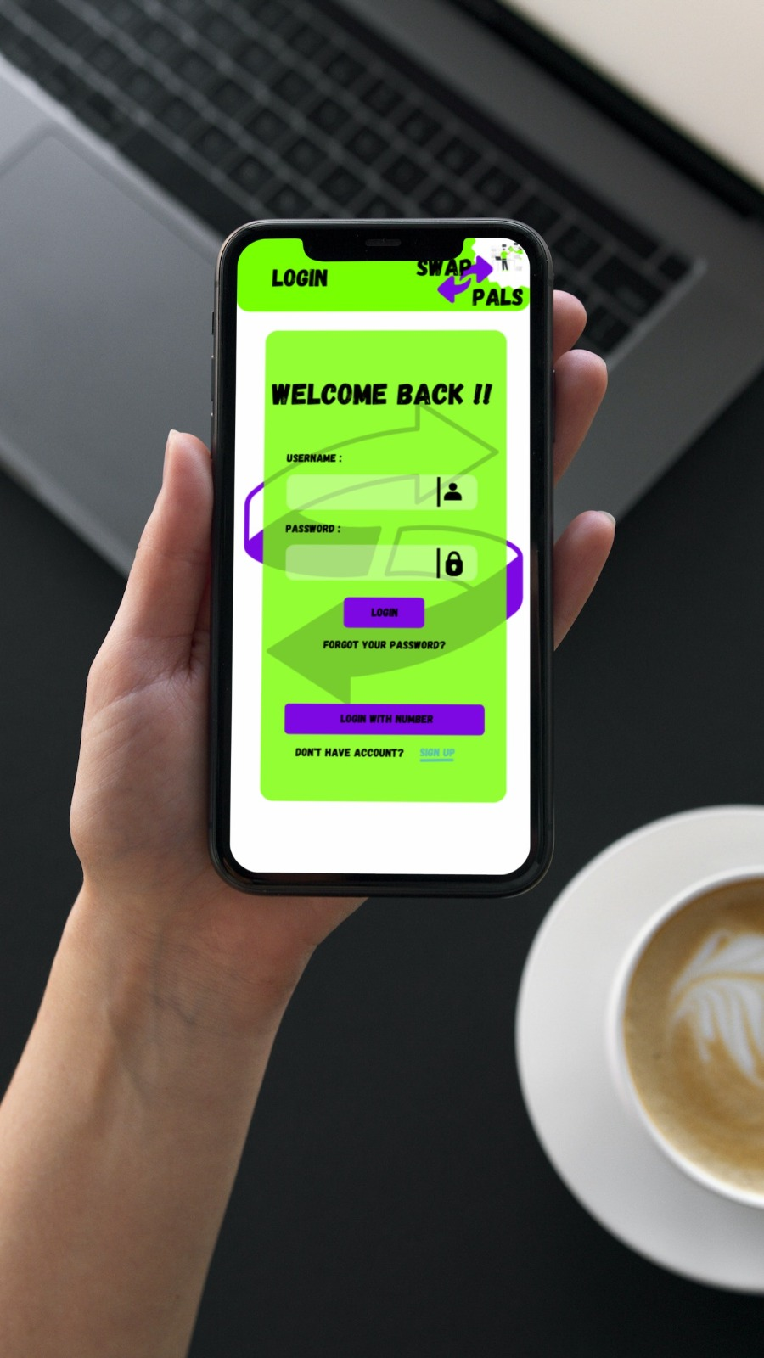

The purpose of the **Login Page** is to allow users to access the account after they have logged in, to able to see the rest of the app. The user would have login with their credentials, if they forgot their password, they could reset their password, and if they don’t have an account, they will then have to register.

Register Page:

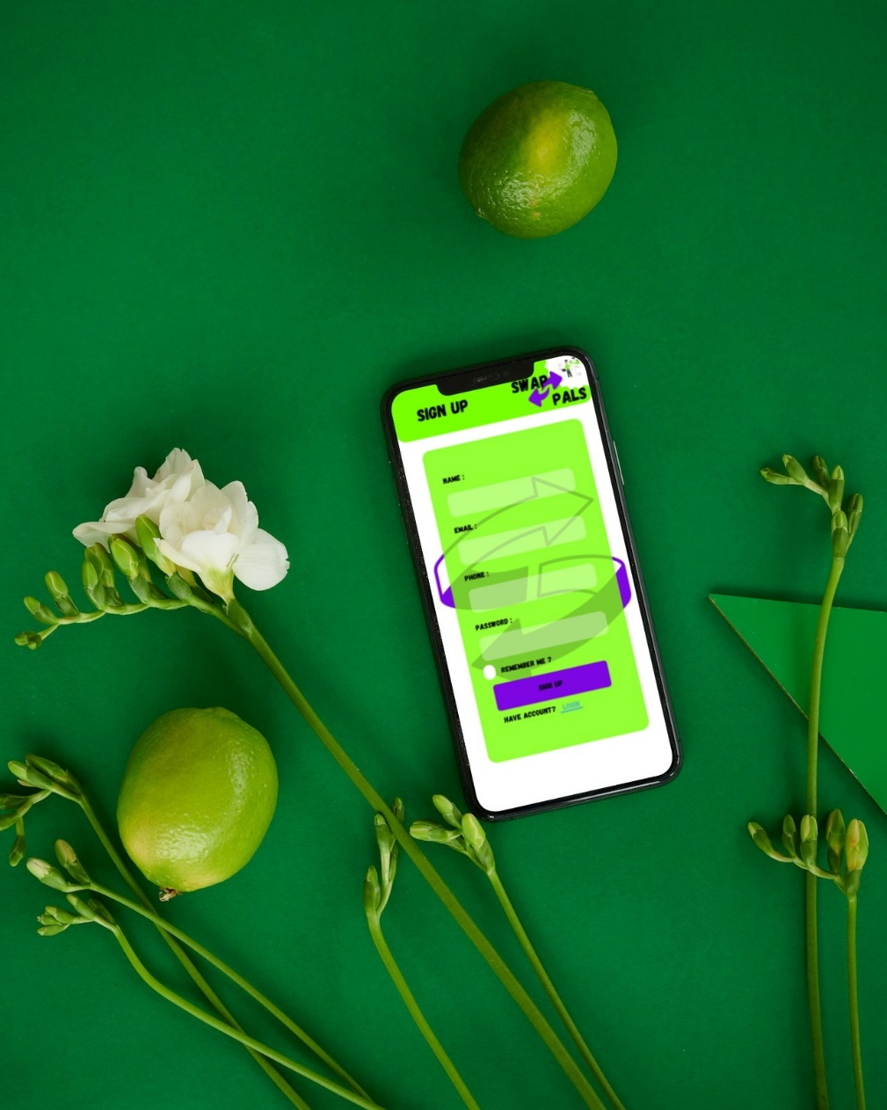

The purpose of the **Register Page** is to allow a user to create an account, so that they can then be able to login and access their account. If a user already has an account for **Swap Pals**, therefore they can then log in. The user will have to enter their name, email, phone number and password, when creating an account. After the user created an account, a verification link will be sent to the user’s email for them to verify their account before logging in.

Home Page:

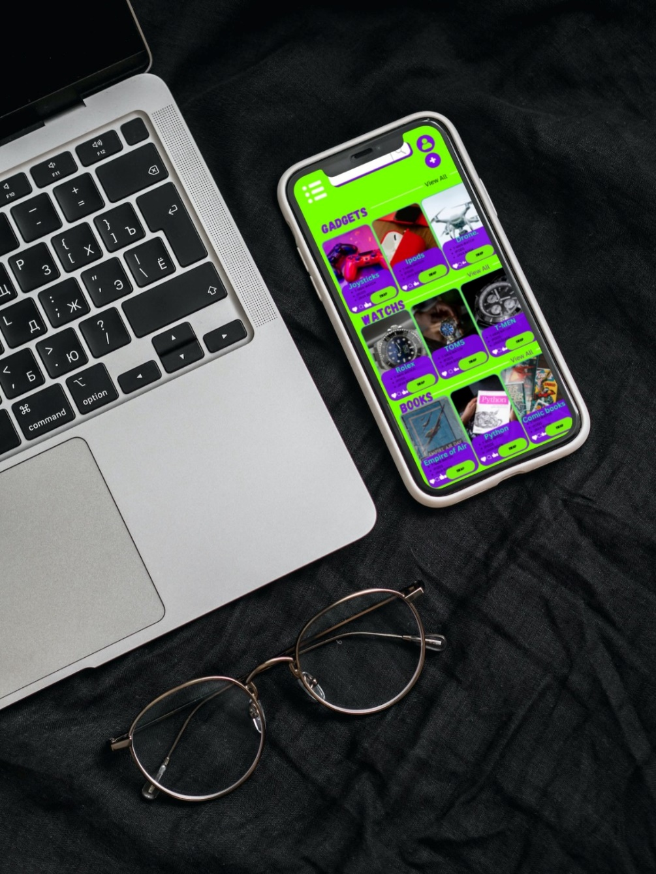

The purpose of the **Home Page** is to provide users with the different features they would see on the app, the **home page** will allow users to navigate app, they will be able to search, view the navigation bar, add items and so on through the **home page**.

My Account:

The purpose of **My Account** is to allow the user to view other pages or access other pages such as my collection, add to collection, chats and so on. Users will be able to manage their account, collections, items and so on.

Collection Page:

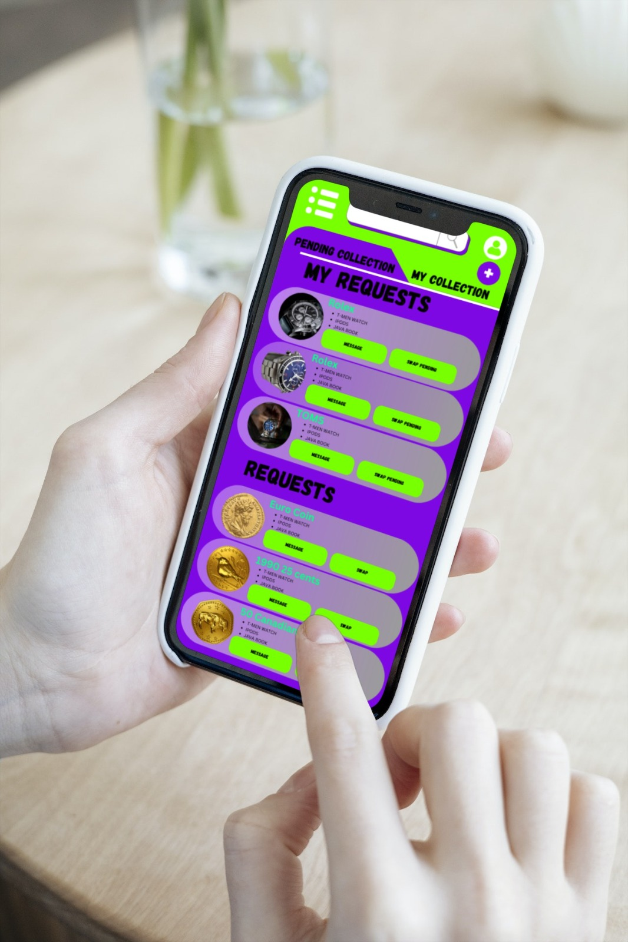

The purpose of the **Collection Page** is to allow users to be able to access or view their collections and view their requests of the items they want to swap with others, they able to even send a message to request an item.

Add Item Page:

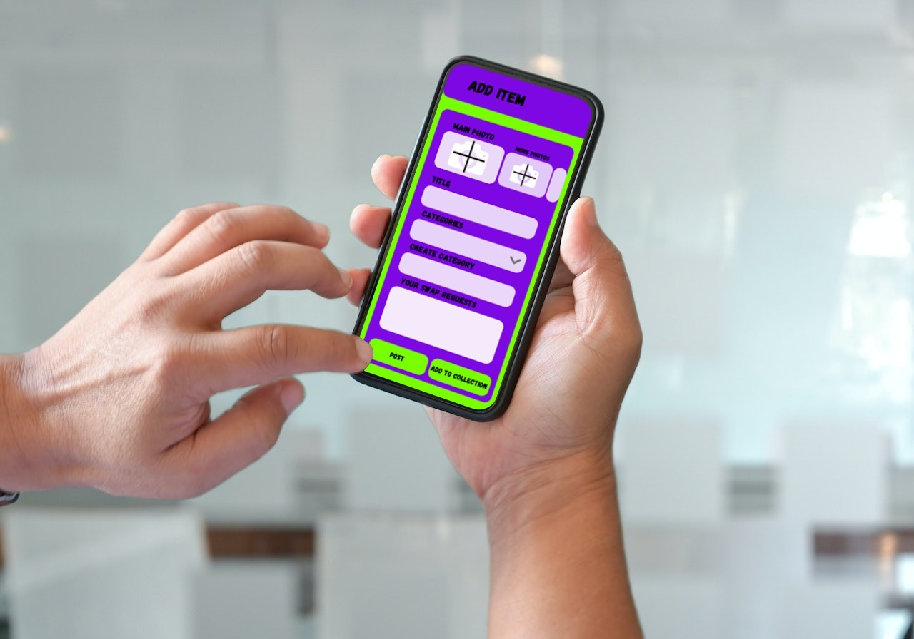

The purpose of the **Add Item Page** is for user to be able to add a new item into their collection, which is in a category they created. The user will be able to upload images of the item they want to add, give it a title, select, or create a category, and a description of what item they requesting to swap it for.

Wishlist Page:

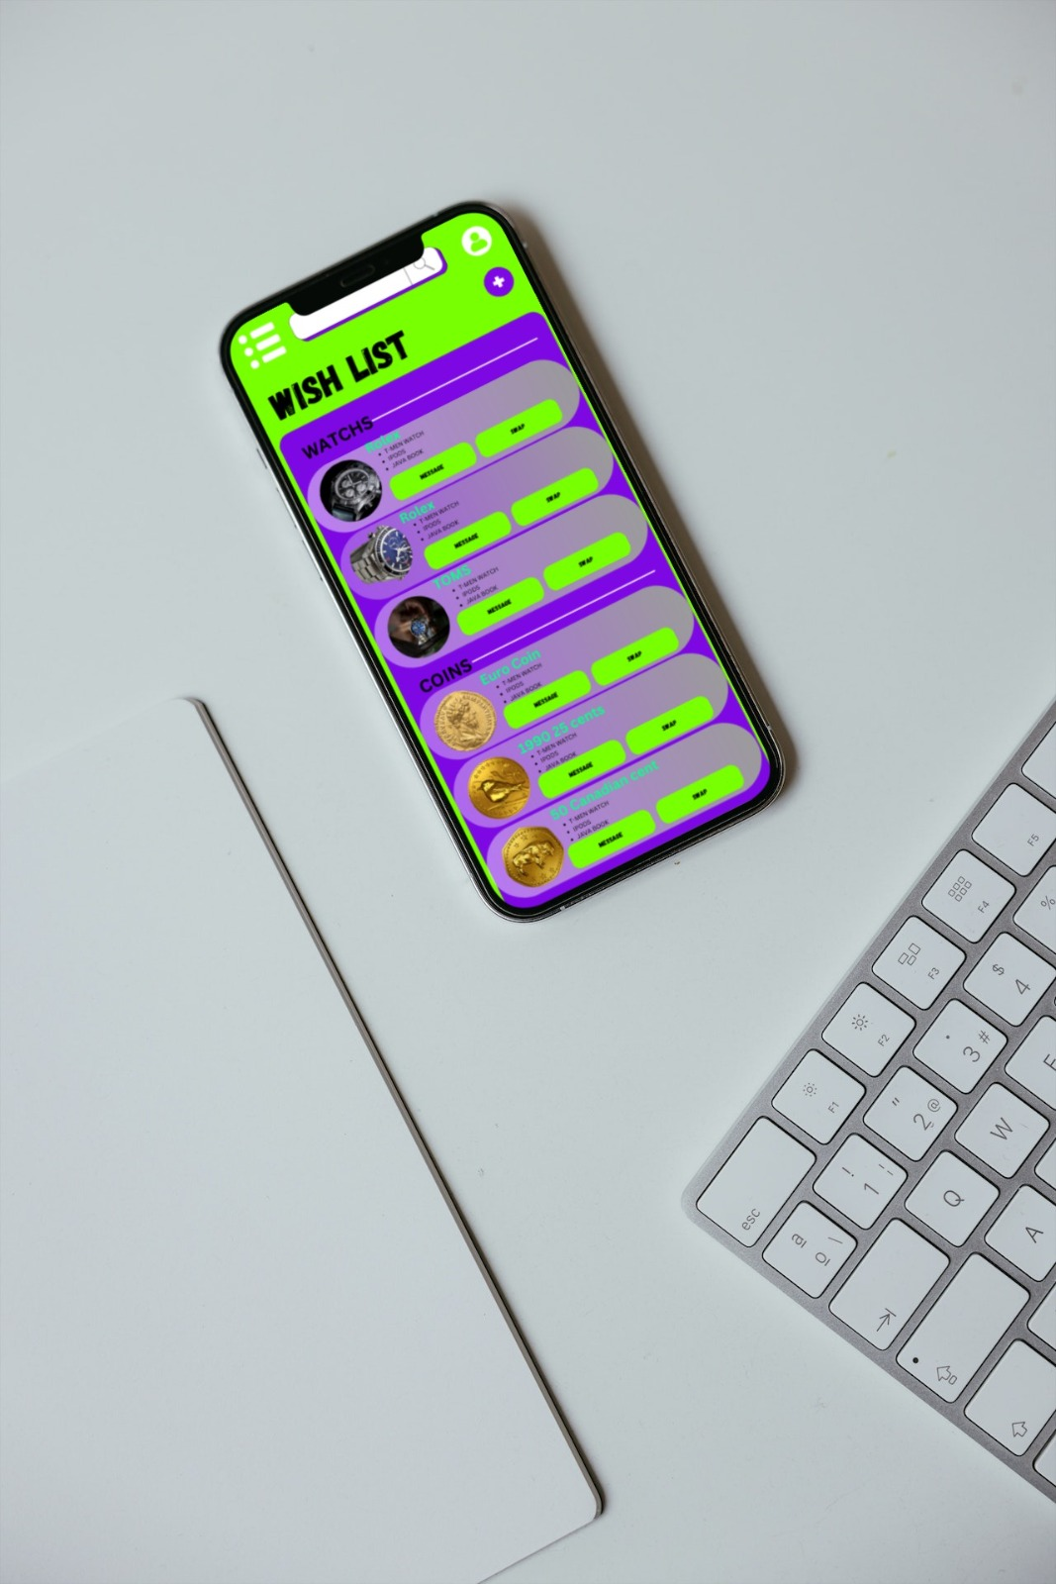

The purpose of the **Wishlist Page** is allow users to add the items they are interested in, into the Wishlist. Users will be able to view these items on the Wishlist at any time the user chooses to. The Wishlist will be accessible through the **home page.**

History Collection Page:

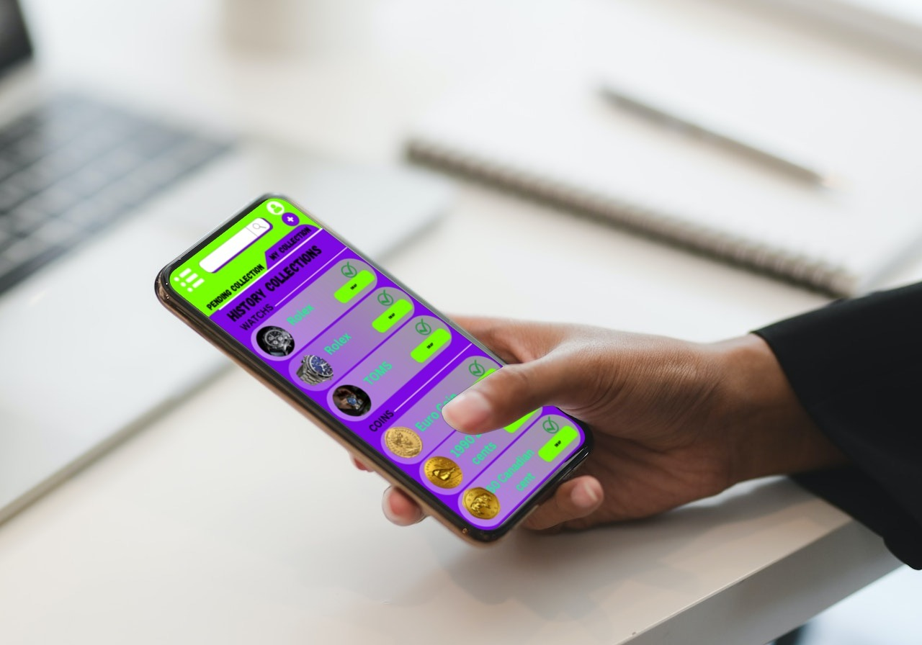

The purpose of the **History Collection Page** is allowing users to be able to view their past swapping items and keep track of the items they swapped so far. Every item the user swaps will be stored in the **History Collection Page** and will have a tick on each one. Users will have an **option** to swap either or exchange an item in their history collection with the same user or other users. This **swap or exchange option** will allow users to swap or exchange an item, the user can commence again with the same swap item they are willing to swap or exchange that again, in return for a better item from other users.

## **Diagram**

## **Project plan**

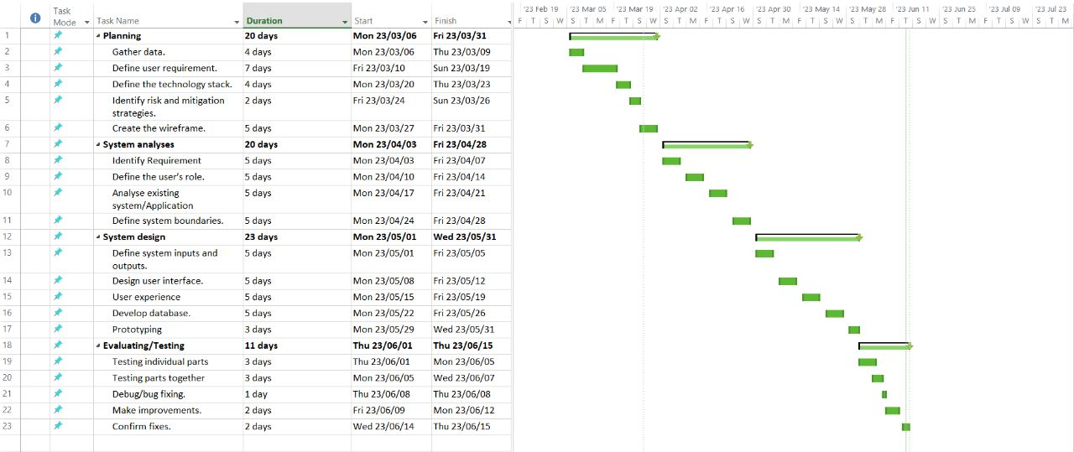

## **Conclusion**

The whole purpose of this app is to help people who love collecting and trade to be able to find each other and interact on an online platform, this also improves human safety because they interact through a screen on their devices and with reduced physical interaction. Our **Swap Pals** provides a convenient platform for users to create and manage their collections. One of the issues we are going to have been introducing the app to the trading community, but we trust that we will be able to find a way. Furthermore **Swap Pals** is a user-friendly, attractive and a valuable app for anyone interested in building their collection and connecting with others who have the same interest and passion for their collections.

## **Referencing**

* **Swapit:** [**https://swapit.mystrikingly.com/#4**](https://swapit.mystrikingly.com/#4) **[Accessed:  7 April 2023]**
* **Vinted:** [**https://www.vinted.com/**](https://www.vinted.com/) **[Accessed: 7 April 2023]**
* **Draw.io:** [**https://app.diagrams.net/**](https://app.diagrams.net/) **[Accessed 11 April 2023]**
* **11 things to know before building an app:** [**https://www.peerbits.com/blog/things-to-know-before-building-an-app.html**](https://www.peerbits.com/blog/things-to-know-before-building-an-app.html) **[4 April 2023]**