**SpecFlow Test Automation Framework**

1. **Getting Started**
   1. Download Visual Studio IDE (Community, Professionalor or Ultimate not Visual Studio Code) from the link <https://visualstudio.microsoft.com/> /...Steps missing..to add later../
      1. Open Visual Studio and create a new Project of type C# Class library (.NetFramework not .NetCore) with the .NET version 4.5. Click next and give the project a name.

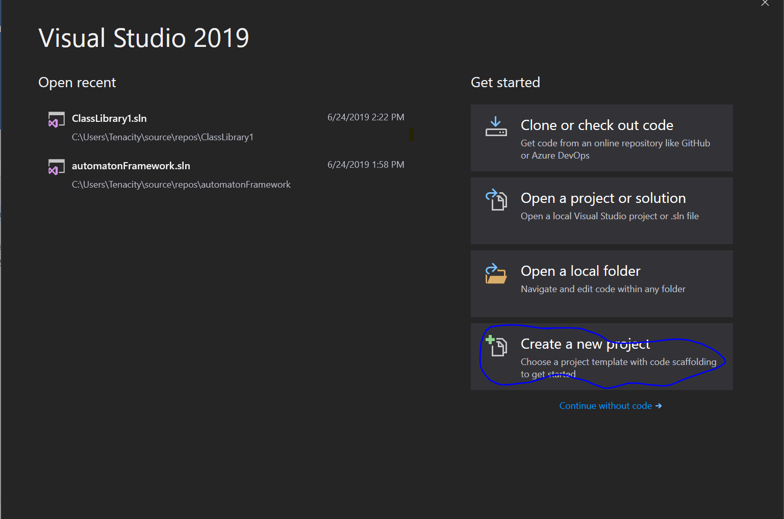

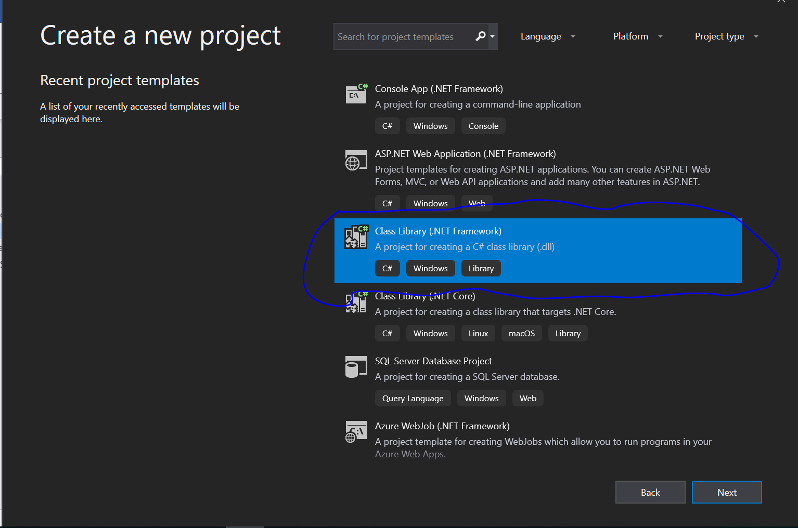

* + 1. On File Menu Bar, click on "Tools => Extensions and Updates" (for Visual Studio 2017). For Visual Studio 2019 click on the “Extensions” Menu Bar and click on “Manage Extensions” on the drop down.

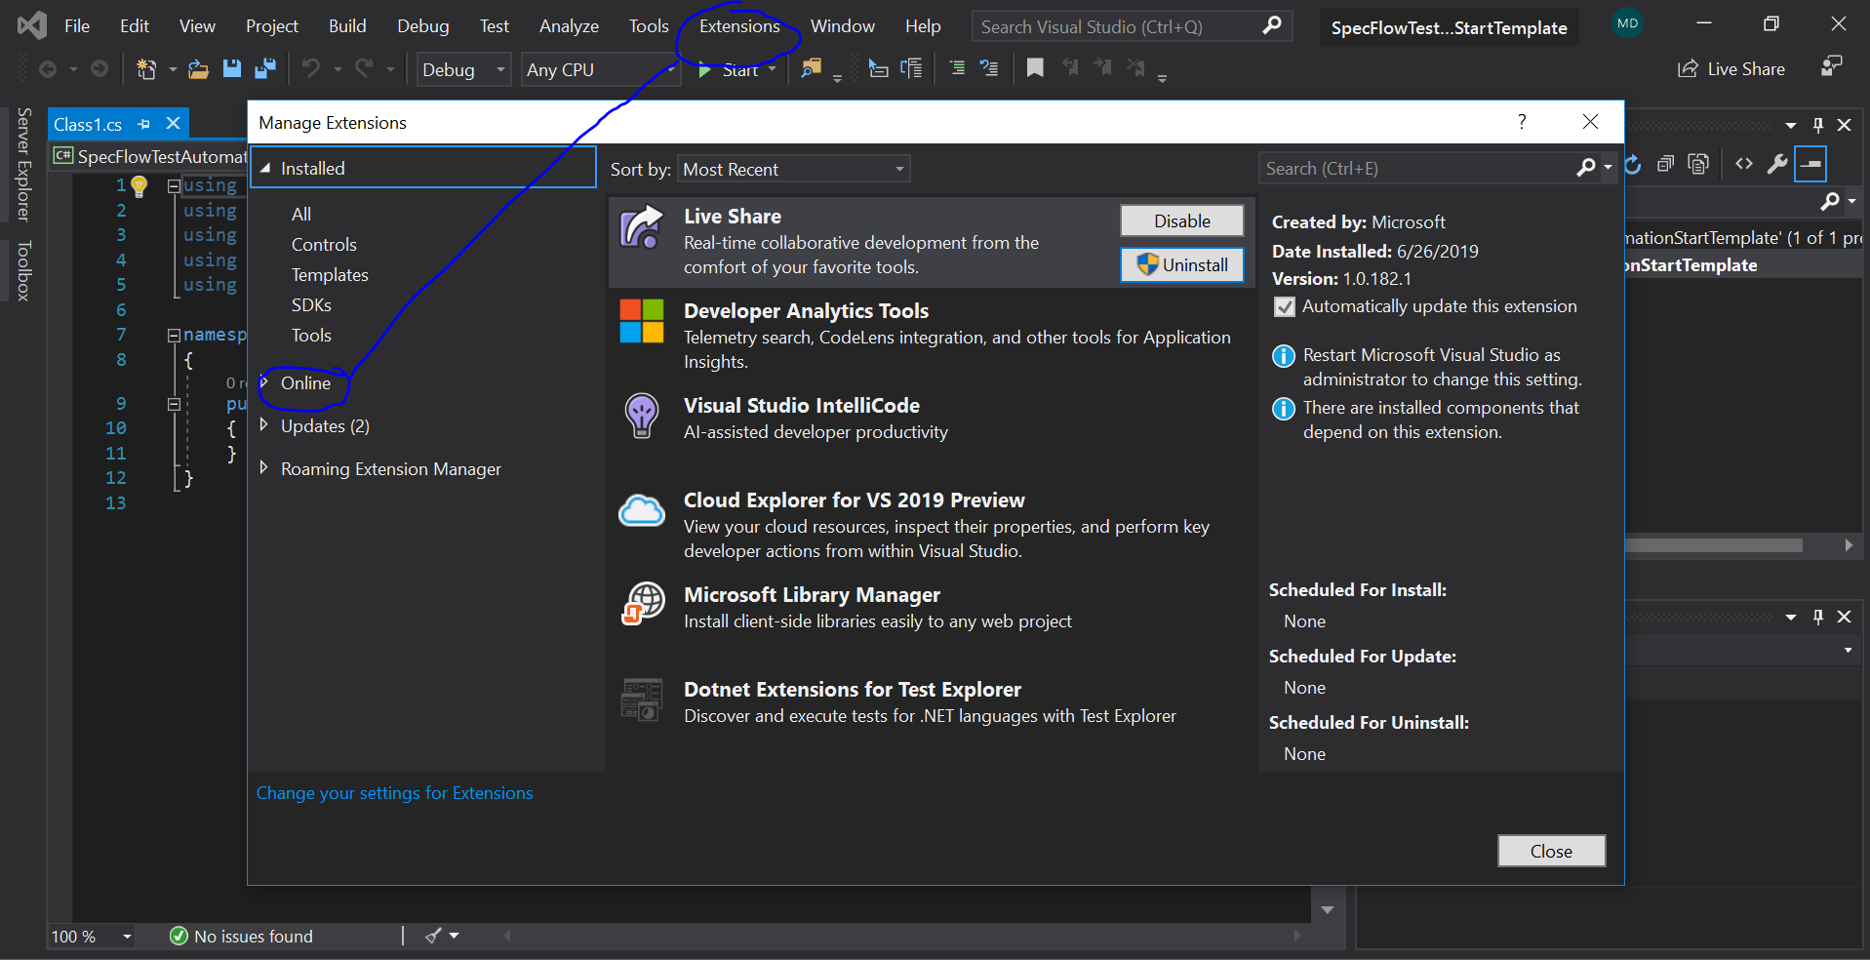

* + 1. On the Left Pane, click on "Online" (as seen on the screen shot above)
    2. Press ctrl + E on the keyboard to search or click on the Search text box on the top right corner then type "SpecFlow for Visual Studio [currentYear]"

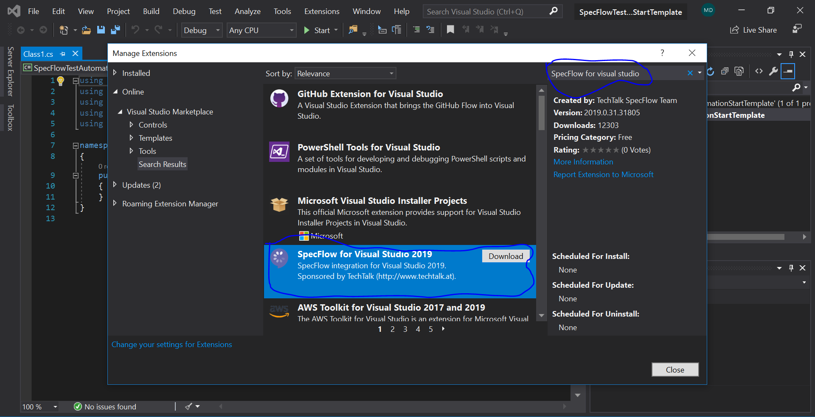

* + 1. Click to “Download to Install "SpecFlow For Visual Studio 2019"

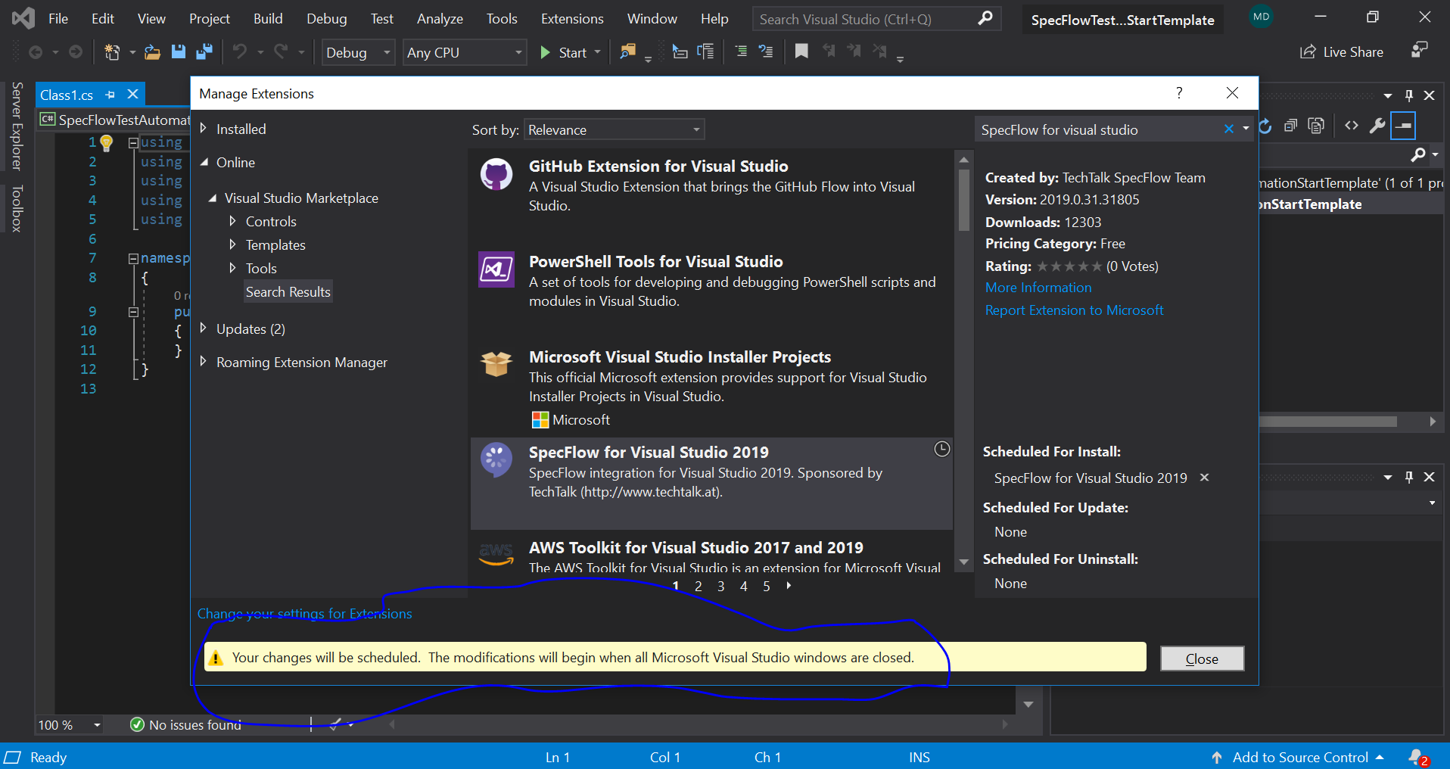

* + 1. Restart Visual Studio and a VSIX Installer will appear as seen below.

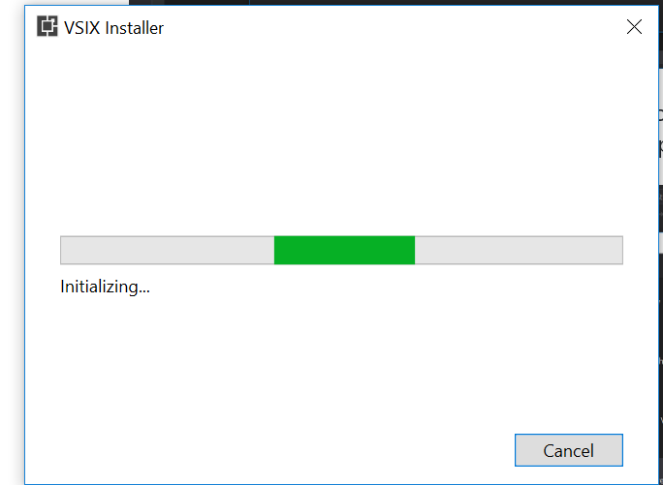

* + 1. Click on Modify on the prompt, and wait for the installer

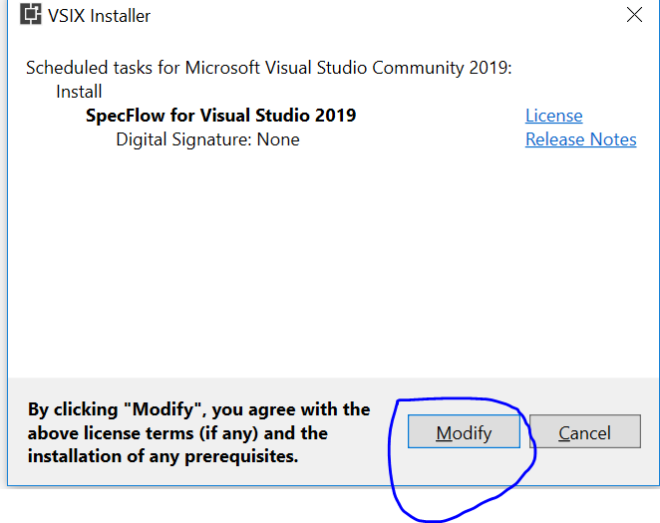

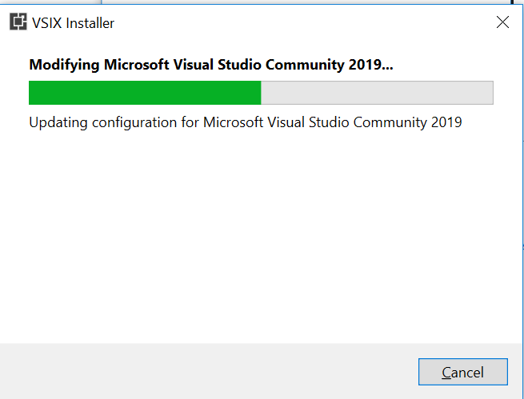

* + 1. After the installation is complete, click on the close button and relaunce visual studio and open the projects created previously. Please see step 1.1.1.

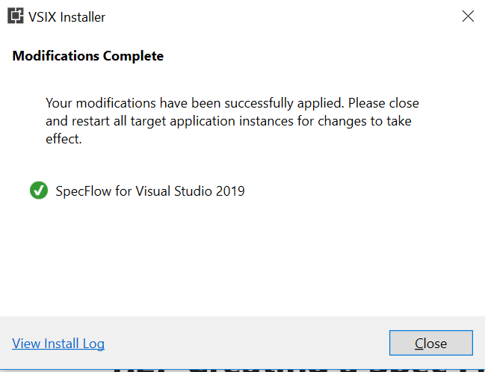

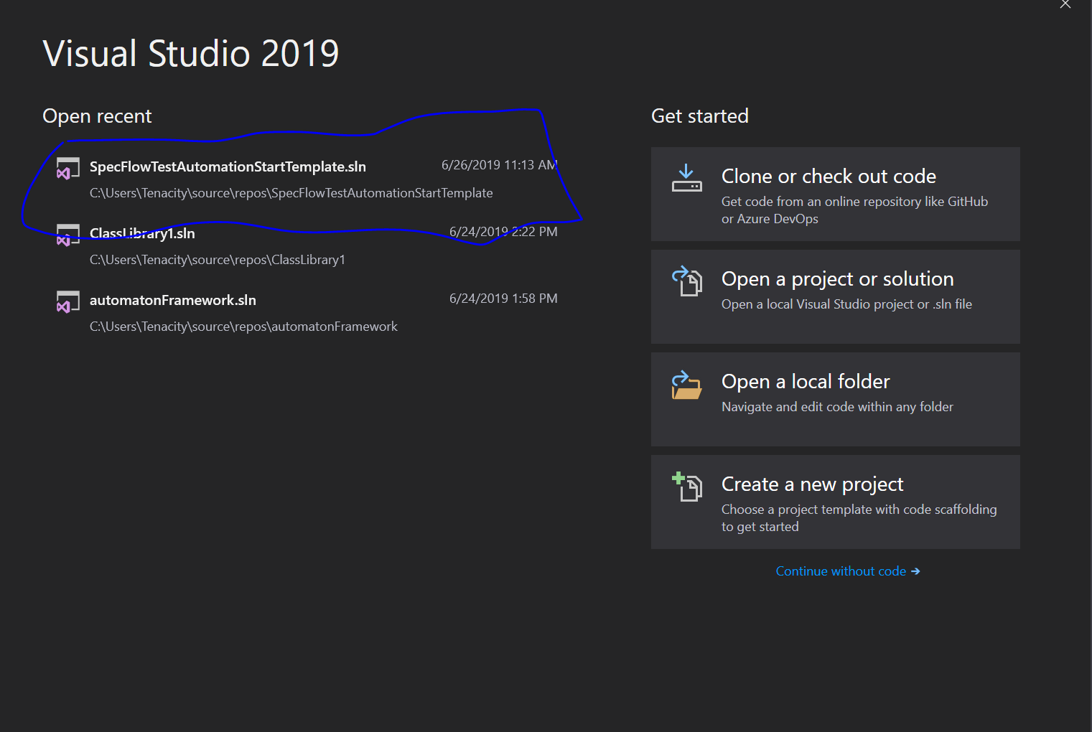

* 1. **Creating a Spec Flow Project - Installing Dependencies**
     1. Create a New Project or open the project crated before. (please see screenshot above).
     2. Navigate to the “Tools” Menu-Bar -> NuGet Package Manager -> Manage NuGet Package for Solution

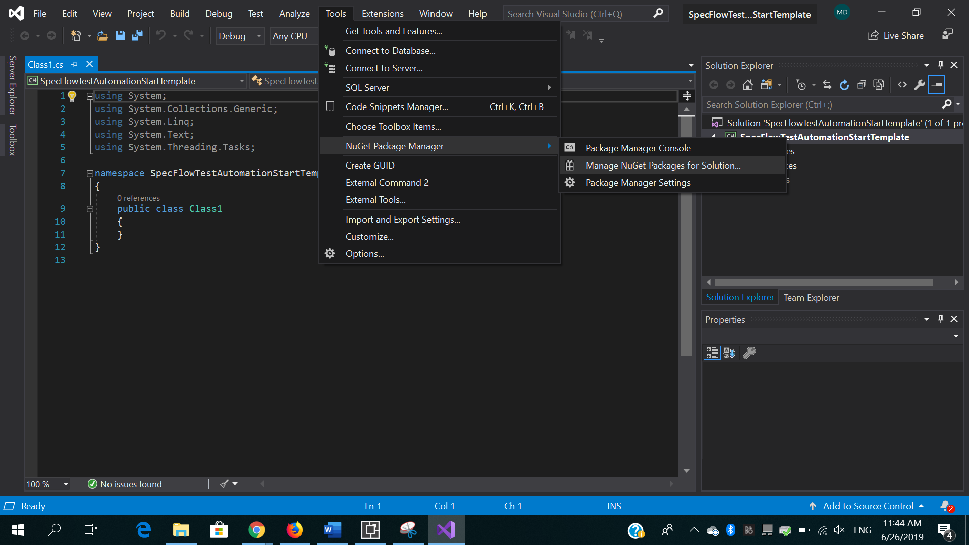  
*C# Class Library *Project name >> Next Dependencies (Tools -> NuGet Package Manager -> Manage NuGet Packages for Solution )

* + 1. Click on “Browse” sub-menu

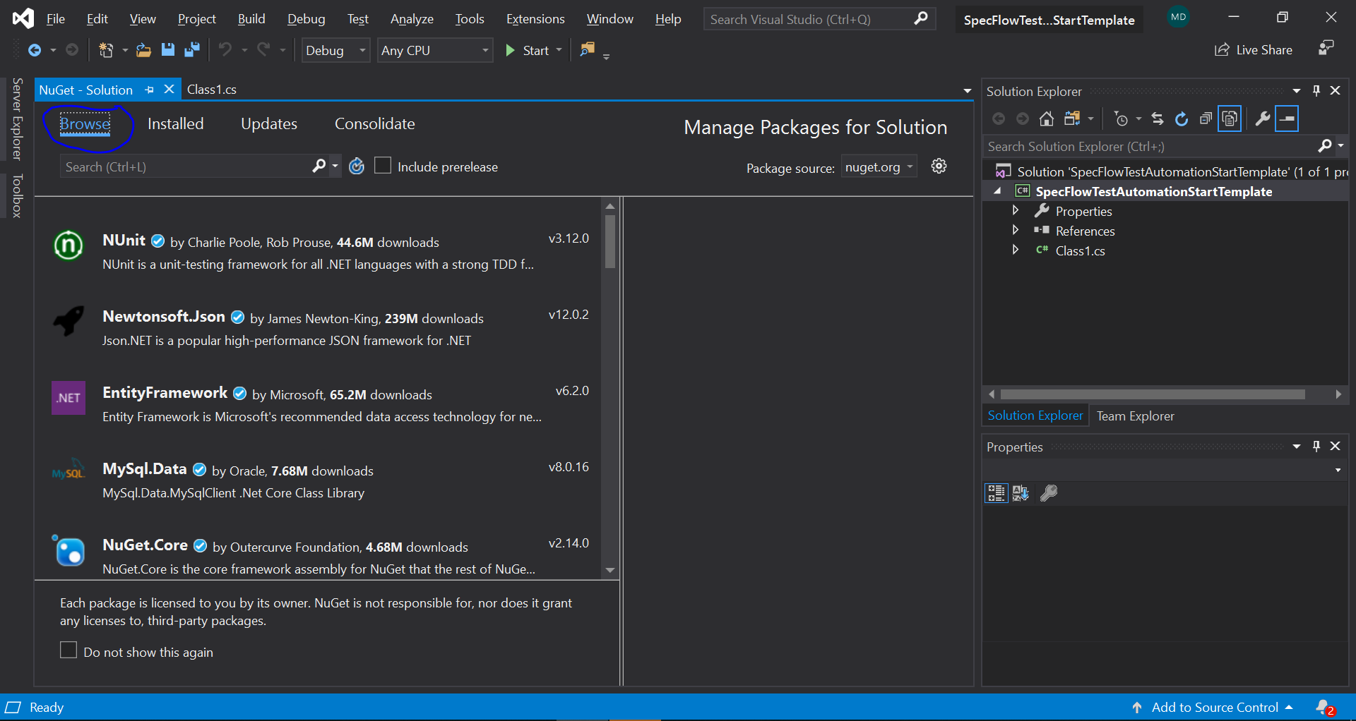

* + 1. Search and Install the following using the versions advised below.

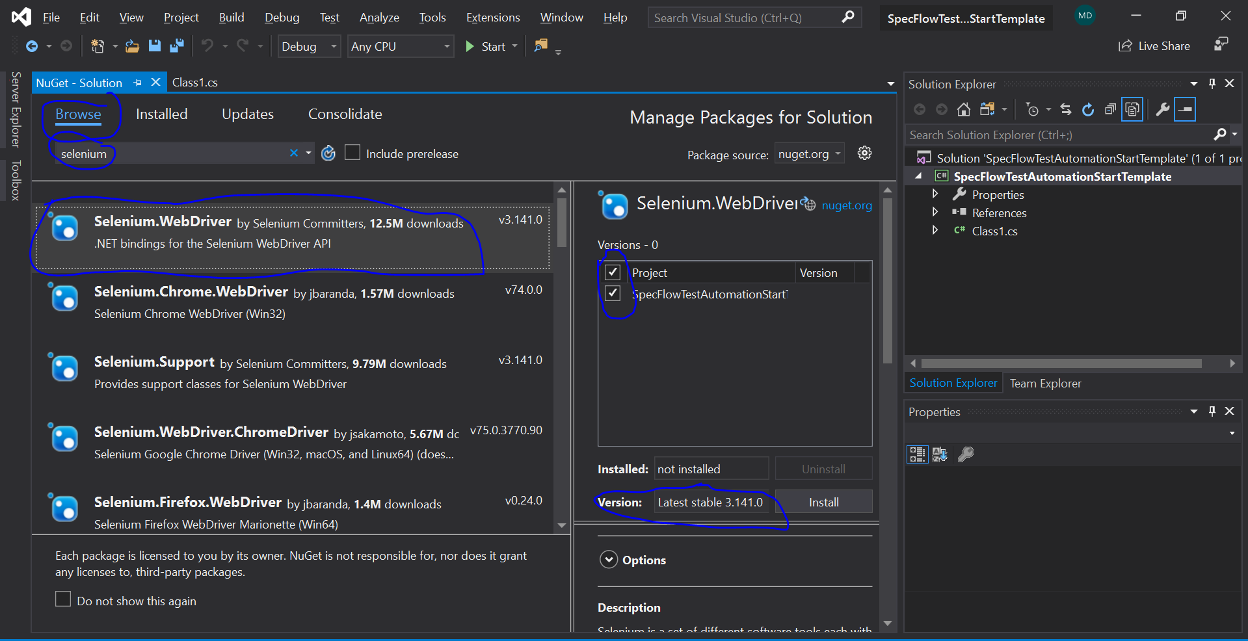

Dependency Version

* + - 1. Selenium.Webdriver v3.9.0

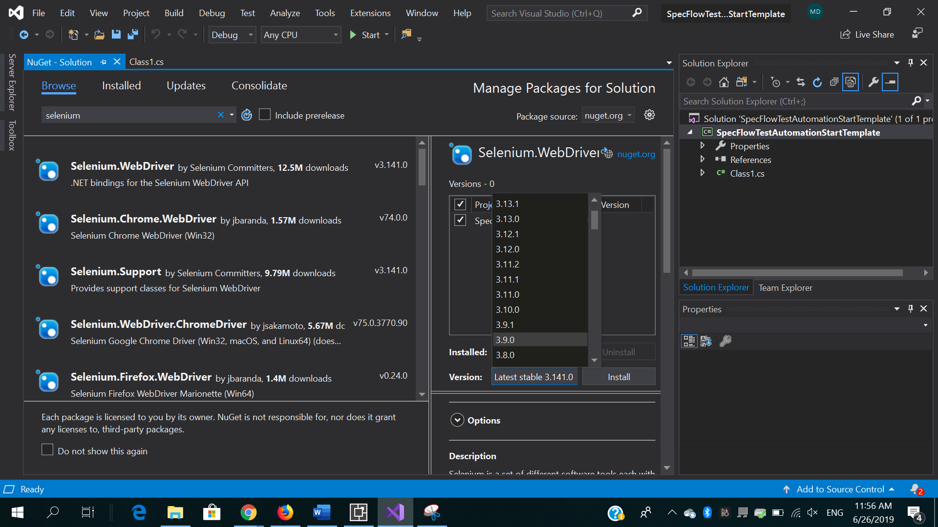

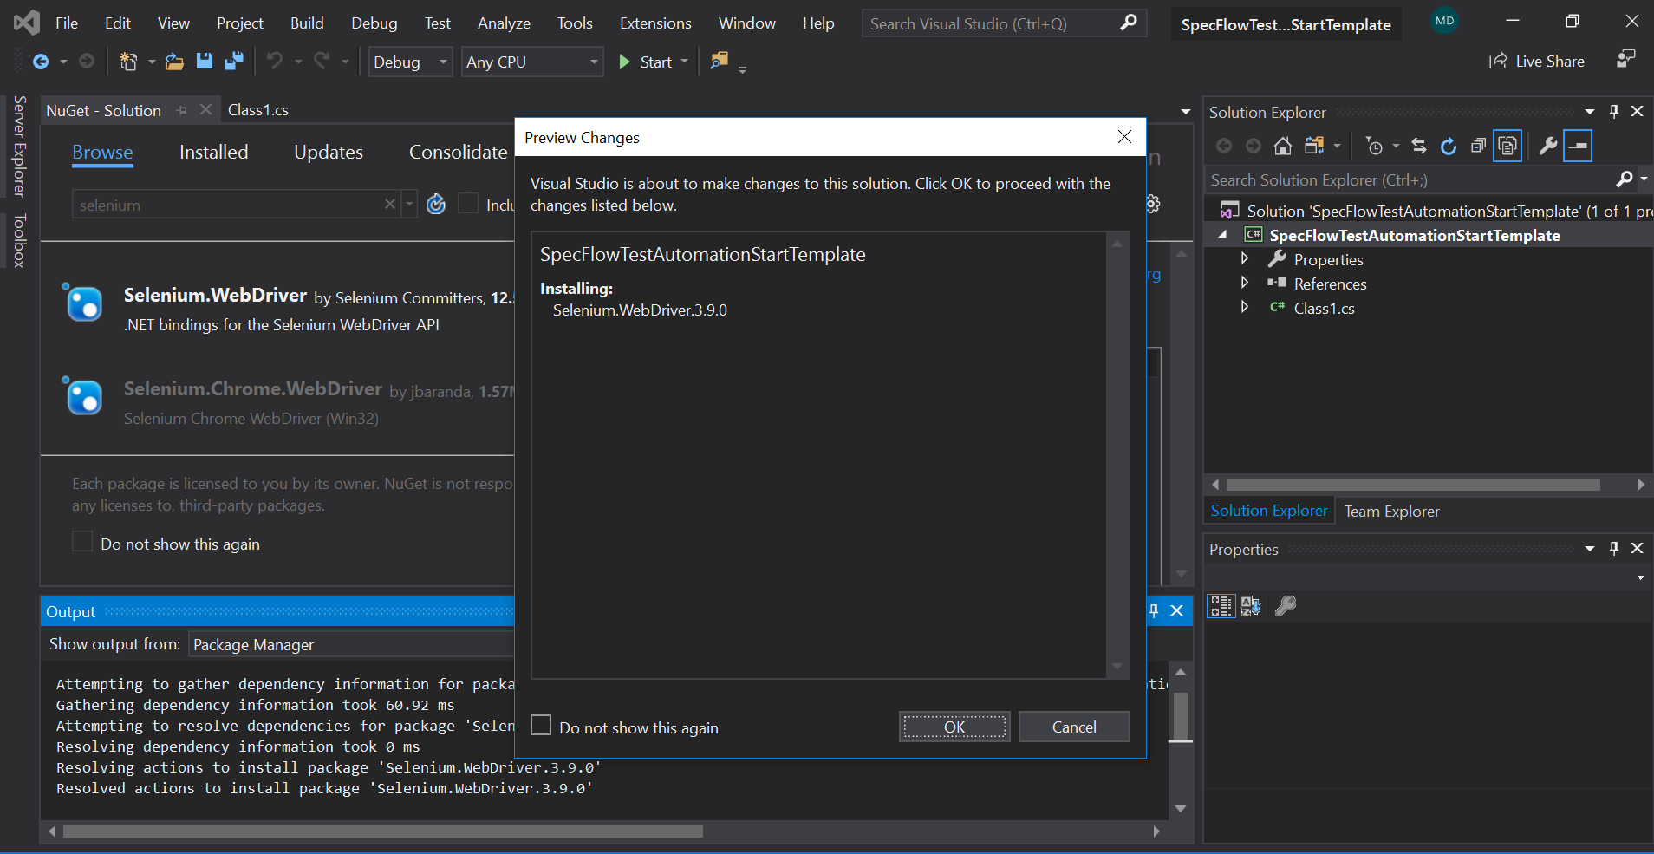

* + - 1. Selenium.Chrome.Webdriver v2.46.0
      2. Selenium.Support v3.0.1
      3. NUnit v3.11.0

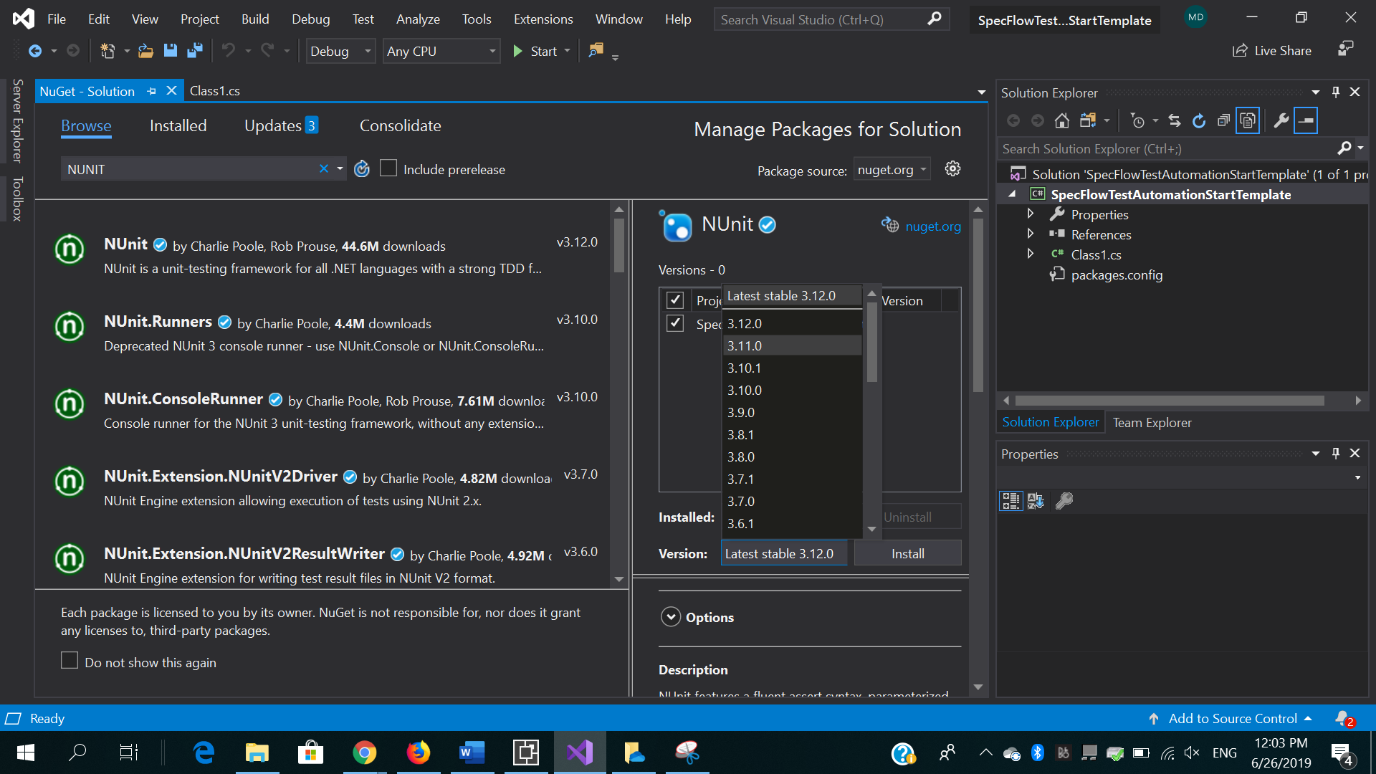

* + - 1. Appium.Webdriver latest (INSTALL ONLY IF YOU INTEND TO RUN MOBILE BROWSER AND MOBILE APP TESTS)
      2. Castle.Core v3.3.3

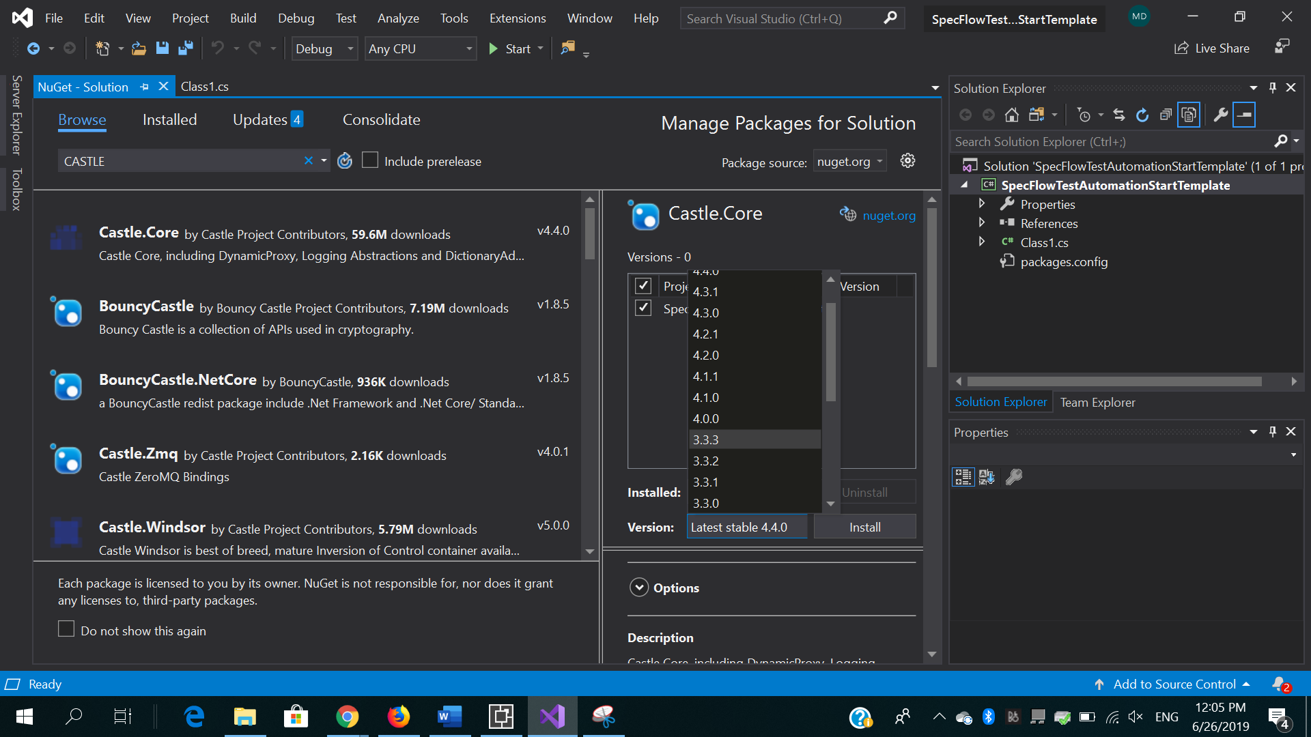

* + - 1. Newtonsoft.Json v10.0.1

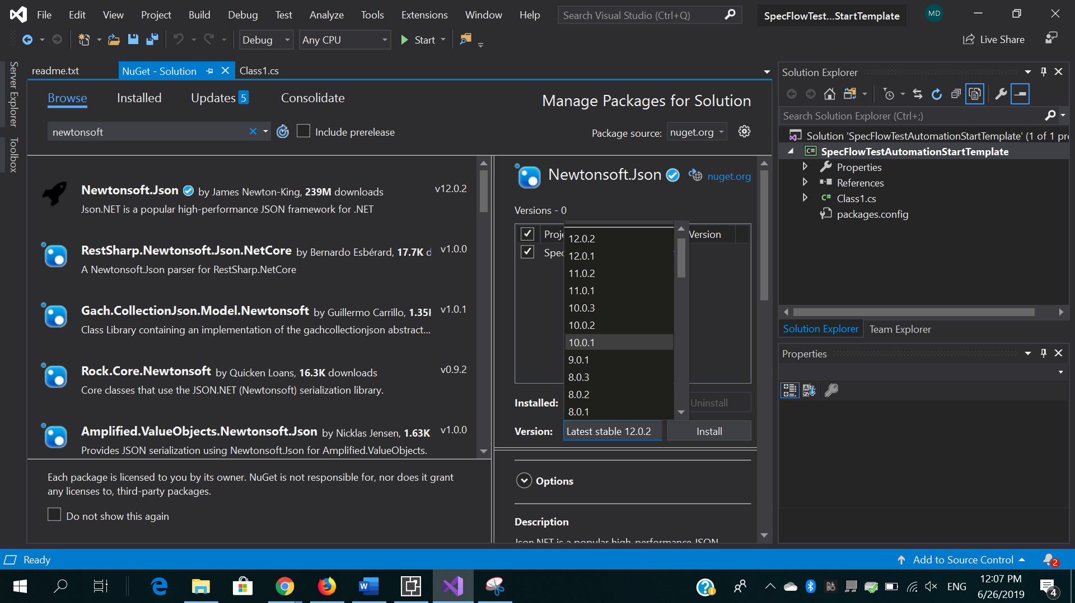

* + - 1. SpecFlow v2.3.2

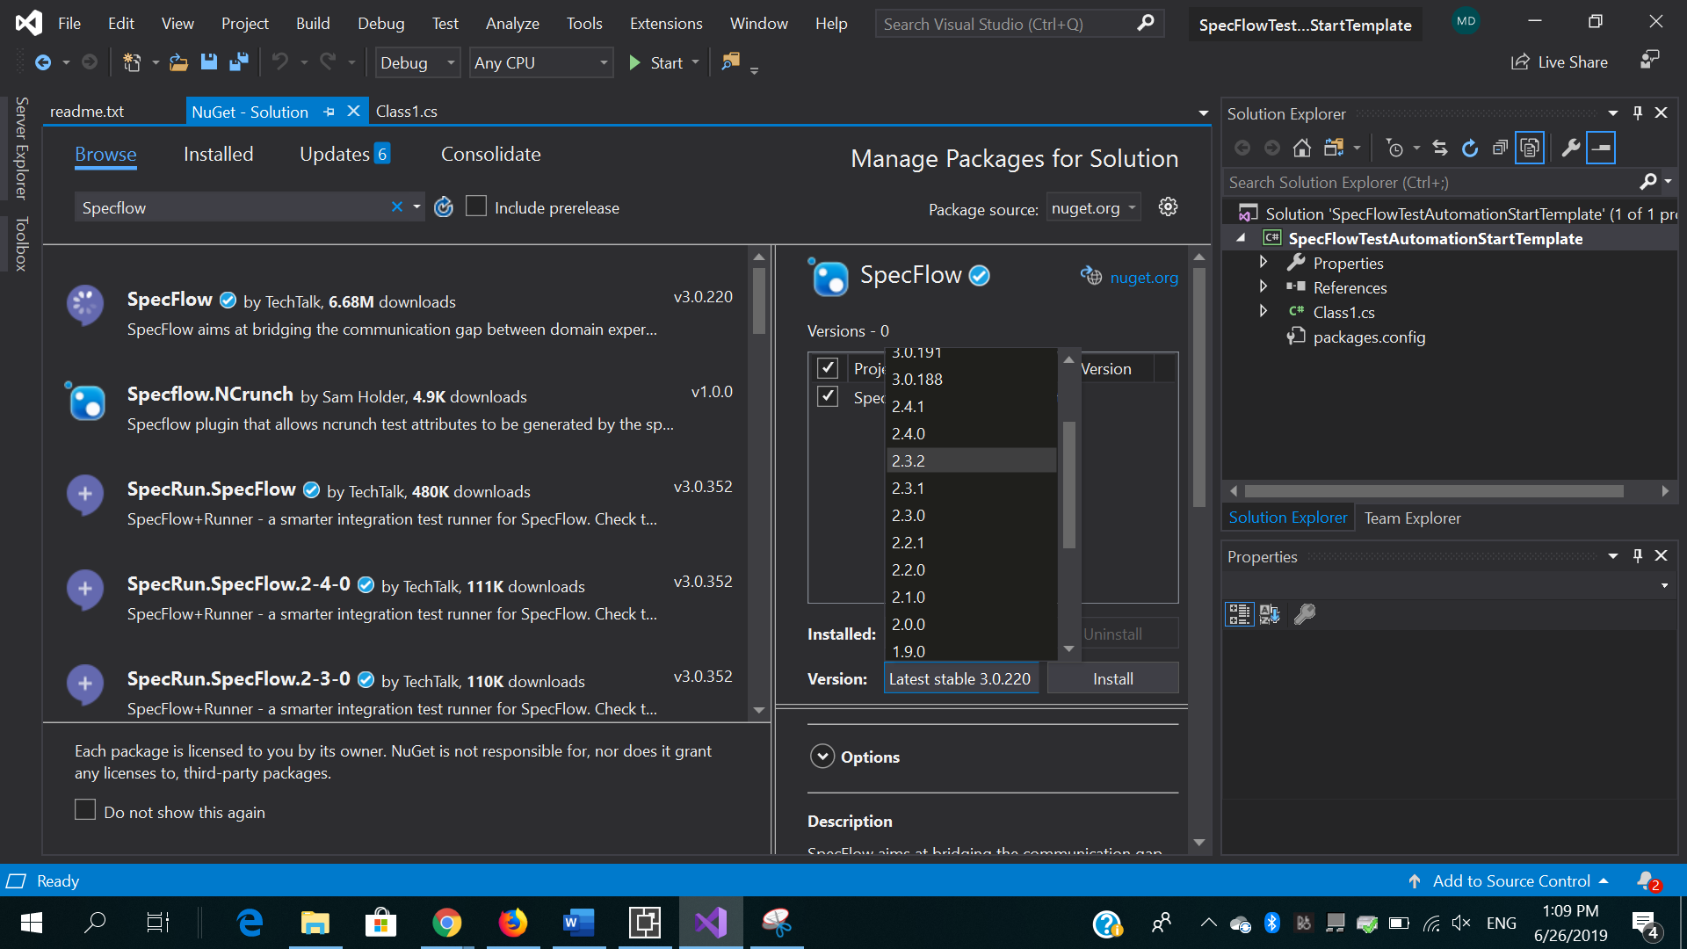

* + - 1. SpecRun.Runner v1.8.5
      2. SpecRun.SpecFlow.2-3-0 v1.8.5

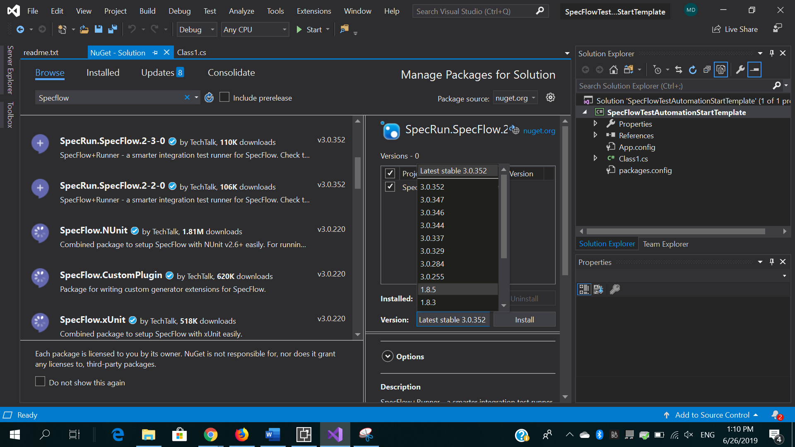

* + - 1. Sytem.ValueTuple v4.3.0
  1. **Creating the WorkSpace - Folder Structure**

Create Folders

* + 1. Right Click on the Project Properties under the ‘Solution Explorer’ -> ‘Add’ -> ‘New Folder’…

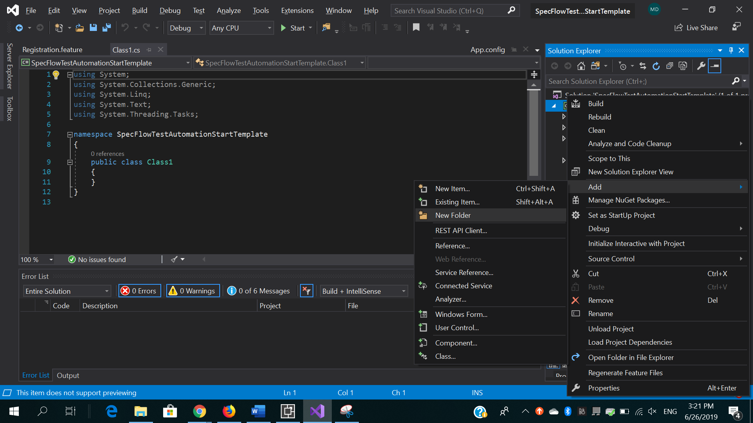

* + - 1. Folder one = Feature. This is where '.feature' files will be stored
         1. Right click on the folder -> ‘Add’ -> ‘New Item’ ->’SpecFlow’ -> ‘SpecFlow Feature File’ then give it a name based on the requirement being tested.

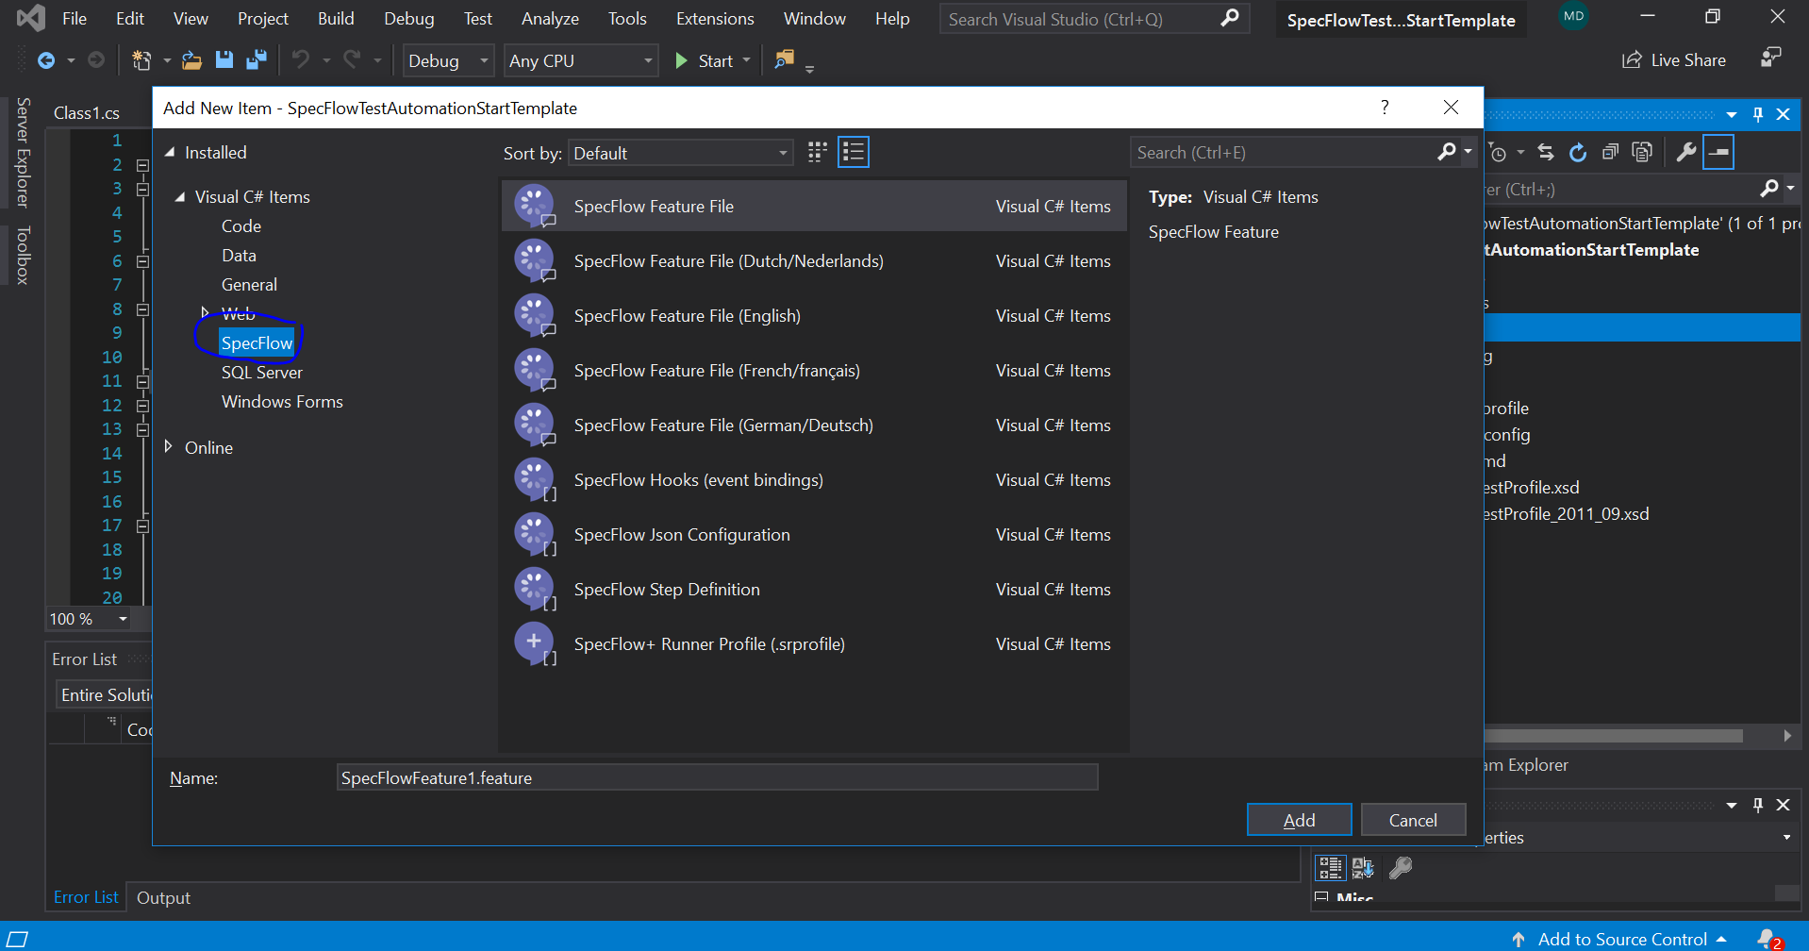

* + - 1. Folder 2 = *Steps . this is where .cs step definition files will be stored

