FOOTPRINTING & RECONNAISSANCE ATTACKS WITH MULTIPLE KALI TOOLS
Whois Tool: This phase is focusing on obtaining publicly available registration information associated with the target domain.
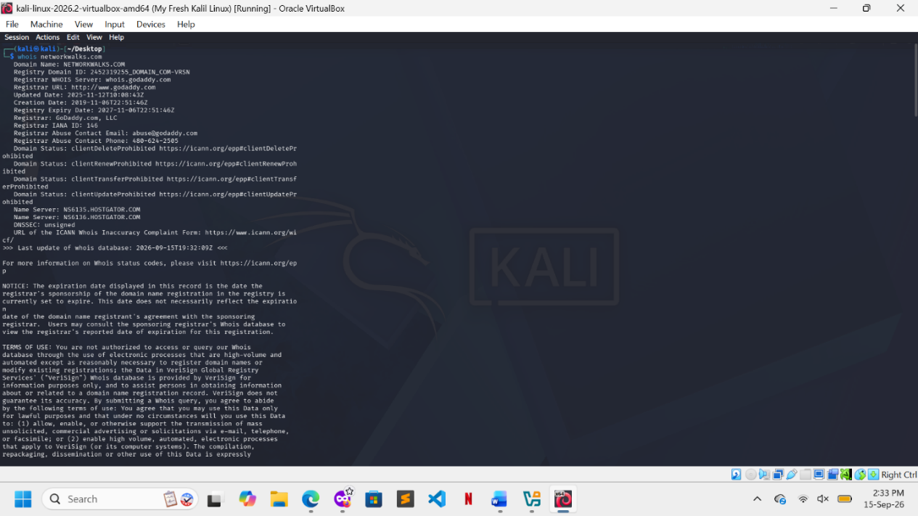
WhatWeb Tool: it used to identify technologies exposed by the target's web application.
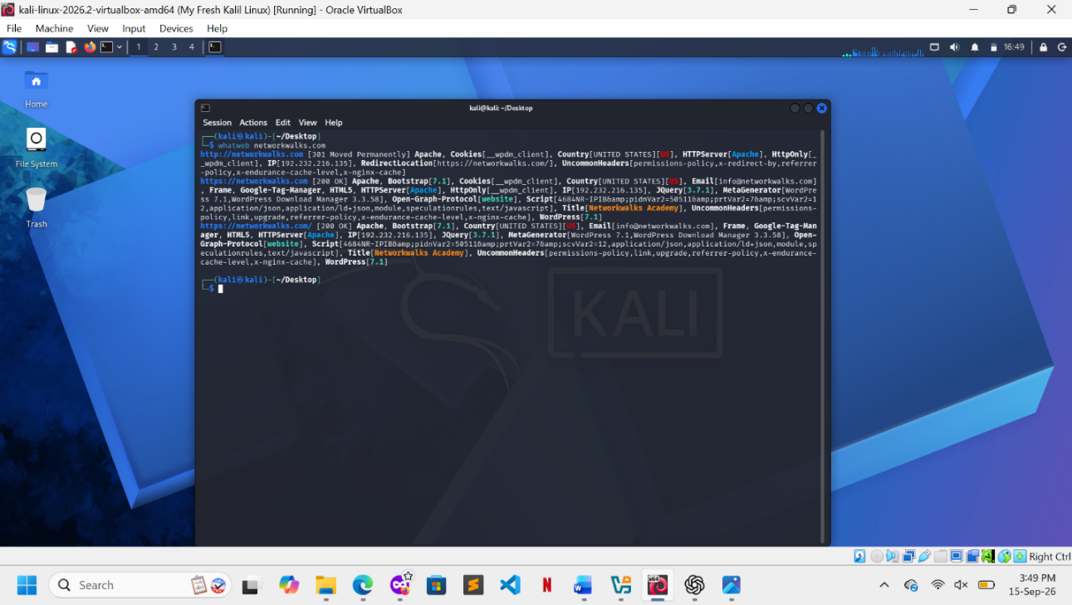

Nslookup Tool: this phase used to examined the relationship between the target domain and its DNS infrastructure.
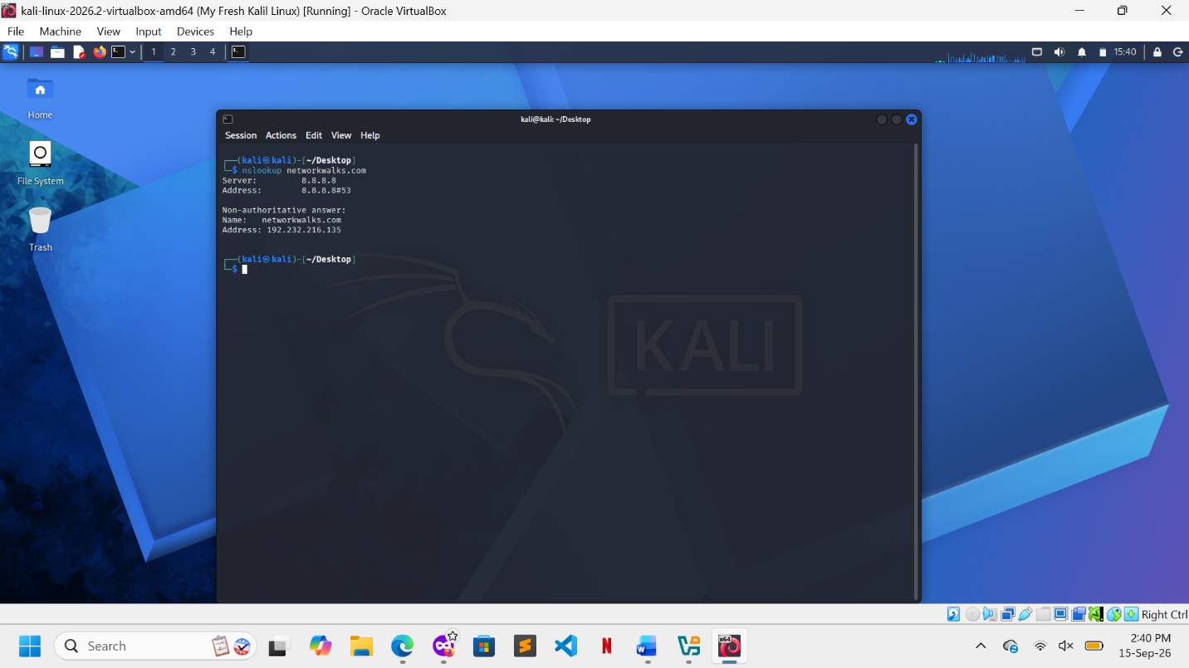

Curt Tool: was used to inspect the HTTP response returned by the target.
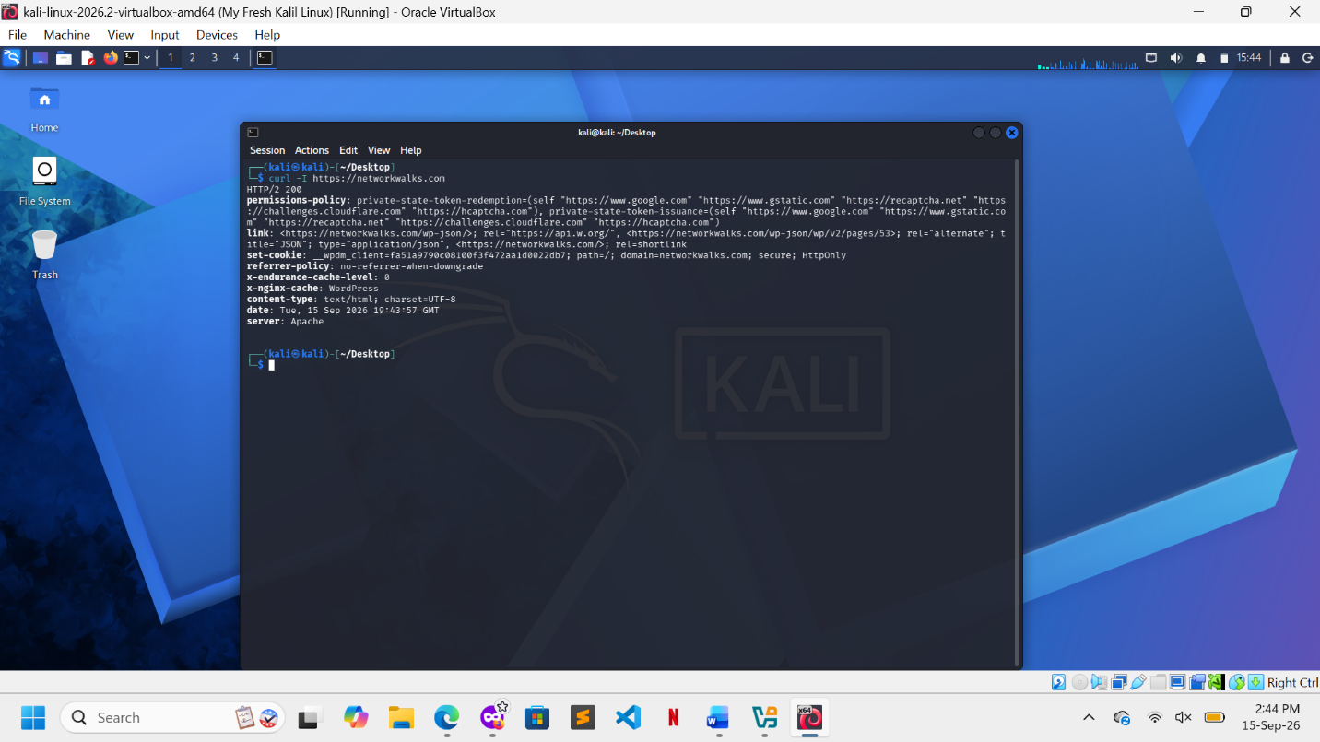
Wafw00f Tool: was used to determine whether the target appeared to be protected by a Web Application Firewall.
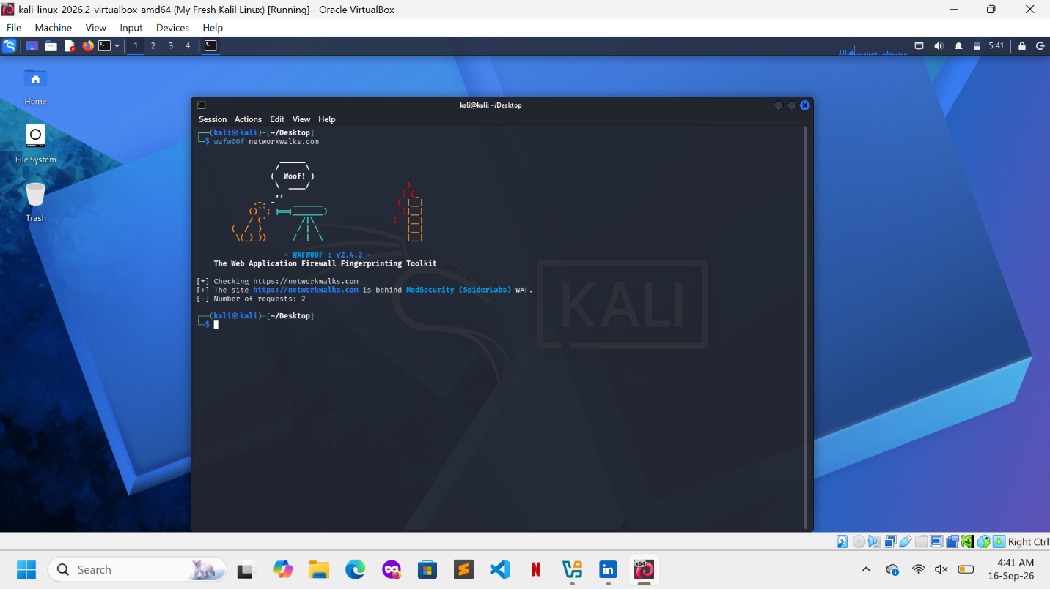
Dnsrecon Tool: was used to examine publicly accessible DNS records.
