Name: Mpoki Mwaisela

Report: Visual Computing

Question 1. 4

Gausian Filtered image used

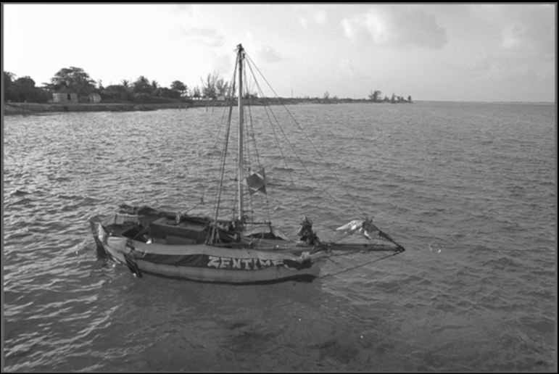

1. Gradient

* Image Ix

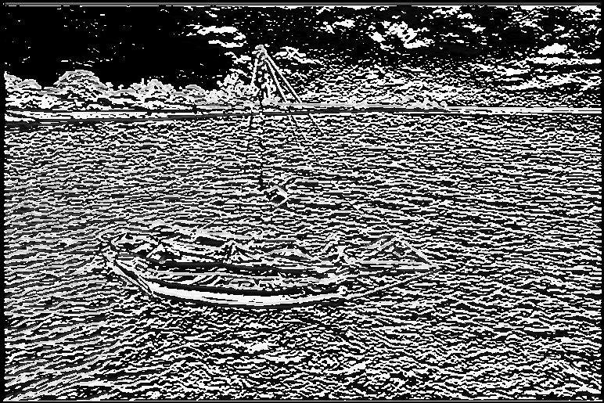

* Image Iy

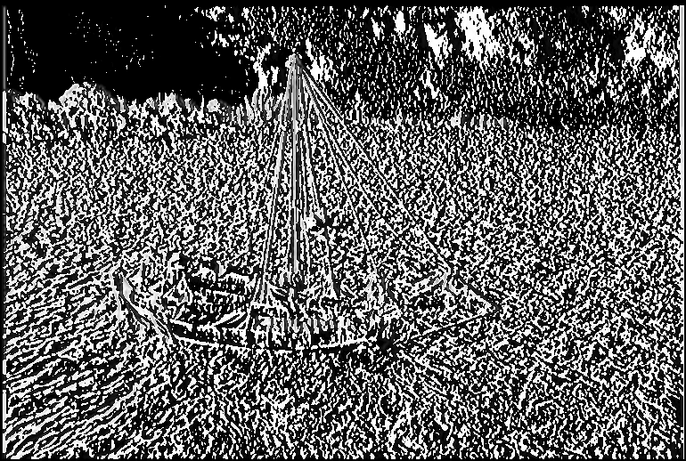

b)Ans

* Full image after taking the magnitude of the vector i.e

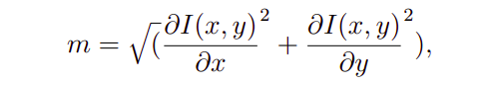

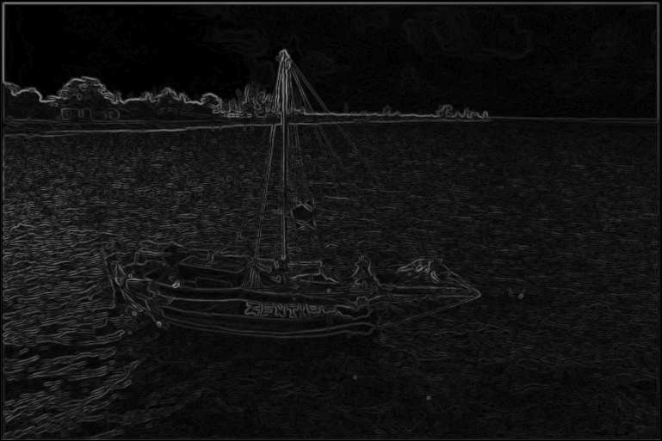

Question 2 a)Ans.

Below images are displayed by varying the threshold for the magnitude of the gradient. The observation is that as the threshold increases more edges are eliminated and when threshold is 255 no edge is observed with the chosen image.

i)Threshold = 50

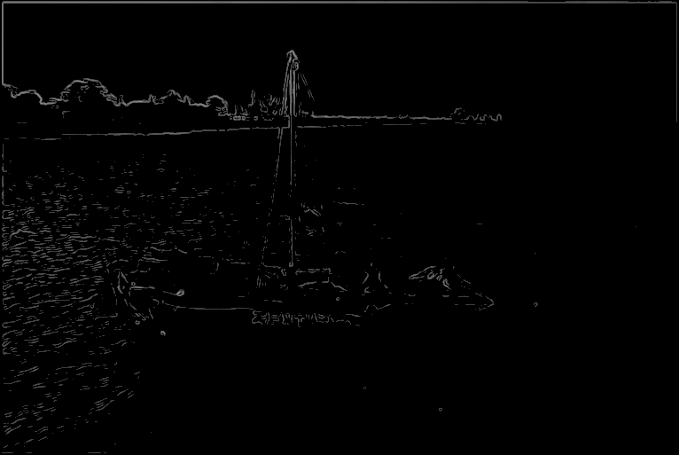

ii)Threshold = 75

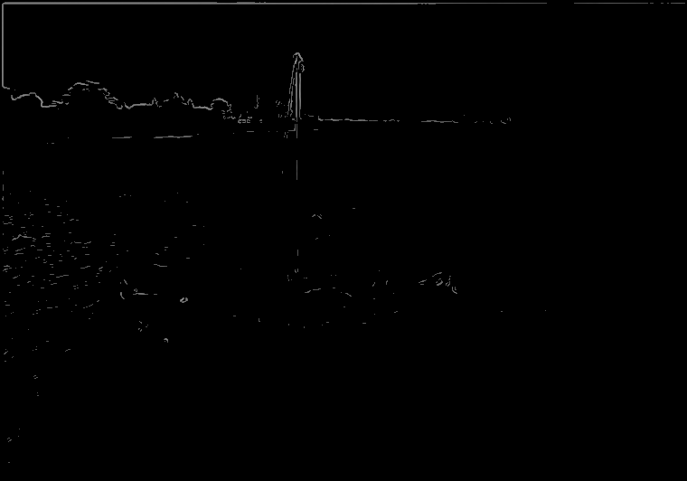

iii)Threshold = 100

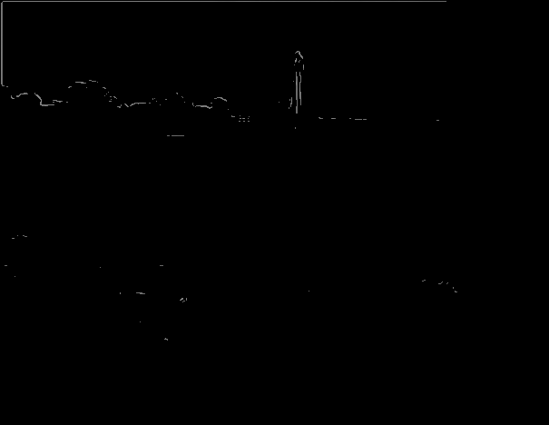

2 b)Ans.