MPower
Citizen Grievance Tracking System
Master Presentation & Reference Document
Prepared for
Office of Sri Vegulla Jogeswara Rao
Hon’ble MLA, Mandapeta Assembly Constituency
East Godavari District, Andhra Pradesh
Prepared by Team MPower
30 August 2026

Contents
Part I — The Proposal
- Executive Summary
- The Challenge Today
- The CTS Platform — Key Features
- How Each MLA Gets Their Own Portal
- Access & Permissions
- Official AP Welfare Schemes — Pre-Loaded
- Documents Citizens Need
- Automatic Citizen Feedback System
- Cost to Government: ₹0
- State-Wide Rollout Plan
- Benefits for the Constituency
- Next Steps
Appendix A — Technical Supplement
Appendix B — Administrator & Staff Guide
Appendix C — Citizen Guide

Executive Summary
The Citizen Grievance Tracking System (CTS) is a purpose-built digital platform giving every citizen of the constituency a simple, transparent way to raise a grievance and follow it through to resolution — without repeated office visits, lost paperwork, or uncertainty about where a complaint stands.
This document introduces CTS for the office of the Hon’ble MLA, Mandapeta Assembly Constituency, as the pilot for what can grow into a state-wide rollout across all 175 Andhra Pradesh MLA constituencies and 25 Lok Sabha MP offices — at zero cost to government at every stage.
175  AP MLA constituencies | 25  Lok Sabha MP offices | 1 day  To go live per office | ₹0  Cost to government, ever

The Challenge Today
Grievance handling through conventional channels — in-person visits, phone calls, and paper registers — creates real, everyday friction for both citizens and staff:
- Citizens often cannot tell whether their complaint was received, who is handling it, or when to expect a resolution.
- Paper-based records are hard to search, easy to misplace, and offer no way to spot recurring problems across villages or mandals.
- Staff have no structured way to prioritise, assign, or track grievances at scale as complaint volume grows.
- There is no consolidated, constituency-wide view of grievance patterns to guide where attention and resources are most needed.

The CTS Platform — Key Features
CTS replaces this with a structured digital workflow: a citizen submits a grievance once, it is automatically routed to the right staff member, tracked through resolution, and the citizen is kept informed at every step — in Telugu or English, on any basic smartphone, with no app installation required.
Feature | What it does
Citizen Portal | Phone-based sign-in (OTP via WhatsApp, no password) — citizens submit a grievance with details, photos, and location, in Telugu or English.
Real-Time Status Tracking | Citizens can check the live status of their complaint at any time using their tracking token.
WhatsApp Notifications | Automatic WhatsApp updates at every stage — received, under review, escalated, and resolved.
Staff Dashboard | Office staff see incoming grievances organised and ready to triage, assign, and act on — not buried in a paper register.
Verified Staff Access | New staff access requests are reviewed and approved before anyone can view or manage citizen data.
Reports & Analytics | A consolidated dashboard of grievance volume, resolution timelines, and category breakdowns — by village and mandal.
Citizen Feedback | Automatic feedback collection after every resolved complaint — star rating plus free-text comments.
Printable Acknowledgement | A formal, printable copy of every complaint — with a reference number — for the citizen’s own record.

How Each MLA Gets Their Own Portal
Every MLA and MP receives a completely isolated grievance portal, live within one day, at no cost — ever.
1. MLA office applies: A simple onboarding request starts the process.
2. Identity verified: MPower confirms the office and constituency details.
3. Portal live in 1 day: The onboarding wizard creates the isolated database partition, seeds local geography (villages, mandals), and generates the unique citizen portal link.
4. Staff accounts added: The office adds its own staff with role-based access — no coding or MPower involvement required.
5. Citizen link shared: The unique portal URL is shared with citizens via WhatsApp, notice boards, or any existing channel.
6. Live — completely free: The portal is fully operational, with zero setup or ongoing cost to the office or government.

Access & Permissions

What Each MLA Gets
- A unique citizen portal URL for their constituency alone.
- A private staff dashboard — no other MLA’s office can access it.
- Unlimited staff accounts with role-based access.
- Reports scoped to their own constituency only.
- The built-in citizen feedback system.
- Complete data isolation, enforced at the database level.

What the MLA Controls
- Add or remove staff at any time.
- Assign staff, senior, or admin roles.
- View all complaints with full history.
- Print or export reports at any time.
- View citizen feedback ratings and comments.
- Set complaint priority and deadlines.

Complete Access Matrix
Role | Own Constituency | Other MLA Data | State Level | Add Staff | Feedback
MLA / MP Admin | Full | No | No | Yes | All
Senior Staff | Full | No | No | No | All
Complaint Staff | Own queue only | No | No | No | Own only
State Govt / CM | Read-only | Read, all | Full dashboard | No | State level
Every person only sees complaints for their own constituency — except Grievance Admin and state-level roles, who can see the whole state. This is enforced automatically by the system, not chosen by the user.

Official AP Welfare Schemes — Pre-Loaded
The citizen portal comes pre-loaded with the current, officially renamed Andhra Pradesh government welfare scheme categories — kept up to date so citizens select the correct, currently active scheme name when filing a grievance.

Education
- Talliki Vandanam Scheme — annual support to mothers, ₹15,000
- Sarvepalli Radhakrishnan Vidya Mitra — student kits
- Dokka Seethamma Madhyahana Badi Bhojanam — mid-day school meals
- Mana Badi — Mana Bhavishyathu — school infrastructure
- Balika Raksha — hygiene support for school girls

Higher Education
- Post Matric Scholarships — tuition fee reimbursement
- Post Matric Scholarships — hostel and mess (maintenance) support
- Ambedkar Overseas Vidya Nidhi (AOVN) — overseas education support
- Abdul Kalam Prathiba Puraskaram — award for exam toppers
- NTR Vidyonnathi — competitive exam coaching support
- Incentives for Civil Services Examination — support for UPSC candidates

Agriculture & Nutrition
- Annadata Sukhibhava — farmer investment support
- Bala Sanjeevani — school and anganwadi nutrition programme
- Anna Amrutha Hastam — nutrition support for pregnant and lactating mothers

Welfare, Pension & Housing
- NTR Bharosa Pension Scheme — elderly, disabled, and widow pensions
- Chandranna Pelli Kanuka — marriage assistance for brides from poor families
- NTR Housing Scheme — housing for the economically weaker sections

Documents Citizens Need
- All grievances: Aadhaar card, ration card (rice card), income certificate (MeeSeva / Secretariat)
- Land and property disputes: Pattadar passbook copy, registered sale deed, Adangal/Pahani, 1B records, survey numbers, geo-tagged photographs
- Scheme-related complaints: Aadhaar card, ration card, relevant scheme enrolment documents

Automatic Citizen Feedback System
Feedback is collected automatically after every complaint is marked resolved — no extra effort required from citizens or staff:
1. Automatic WhatsApp message: Sent to the citizen the moment their complaint is marked resolved.
2. 1-to-5 star rating: Covering speed of service, staff attitude, and quality of resolution.
3. Comments in Telugu or English: Citizens can add free-text feedback in their own words.
4. Reports in the MLA dashboard: Monthly feedback trends, with low-rated categories highlighted.
5. State-level summary for the CM’s office: Feedback analytics rolled up across all constituencies.

Cost to Government: ₹0
The entire platform — setup, staff training, all 175 portals, the CM dashboard, and the feedback system — is provided at zero cost to the Andhra Pradesh government, at every phase of rollout:
- Setup: ₹0
- Staff training: ₹0
- 175 portals: ₹0
- CM office dashboard: ₹0
- Citizen feedback system: ₹0
- Ongoing maintenance: ₹0
- Future upgrades: ₹0

State-Wide Rollout Plan
Mandapeta constituency is proposed as the pilot — the first of a phased, state-wide rollout reaching all 175 AP MLA constituencies and 25 Lok Sabha MP offices within six months.
Phase | Scope | Timeline
Phase 1 | Mandapeta Pilot — 1 constituency | Month 1 — live with all updated scheme categories, feedback system active, staff trained
Phase 2 | East Godavari district — 16 constituencies | Months 2–3 — all East Godavari MLAs and MPs, district-level reports, CM office read access
Phase 3 | Coastal AP — 60 constituencies | Months 3–4 — full coastal coverage, MP portals added, Minister department dashboards, state feedback analytics
Phase 4 | All 175 constituencies + 25 MPs | Months 5–6 — full state rollout, CM full analytics, Secretariat integration, complete feedback system

Benefits for the Constituency
- Transparency: citizens can see exactly where their grievance stands, at any time.
- Accountability: every grievance is logged, timestamped, and traceable from submission to resolution.
- Efficiency: staff triage and resolve grievances through an organised workflow instead of a paper backlog.
- Insight: constituency-wide reporting highlights which villages, mandals, or issue categories need the most attention.
- Convenience: citizens can raise and track grievances from home, reducing repeated office visits.
- Trust: a visible, well-run grievance system strengthens public confidence in constituency governance.

Next Steps
We would welcome the opportunity to walk the office of the Hon’ble MLA through a live demonstration of the platform — configured for Mandapeta constituency — and to discuss onboarding as the state’s pilot constituency.
For scheduling a demonstration or any further information, please reach out to Team MPower.

APPENDIX A

Technical Supplement
How the platform’s multi-tenant architecture keeps 175 MLA offices sharing one system with zero data mixing between them.

Technology Stack
Component | Details
Frontend | React 18 + Vite, deployed on Netlify CDN (200+ global edge nodes)
Auth | Supabase Auth — JWT (RS256) tokens, OTP via WhatsApp, email confirmation
Database | PostgreSQL on Supabase — Row Level Security (RLS) enforced per app_id at the database engine level, not application-layer trust
Edge Functions | WhatsApp OTP, ABHA verification, translation, complaint print, audit stamp, report generation
WhatsApp | Twilio WhatsApp Business API — OTP delivery, status updates, citizen notifications in Telugu
Security | TLS 1.3 in transit · AES-256 at rest · SHA-256 audit trail · India data residency (Mumbai, AWS ap-south-1)

Data Isolation — How Row-Level Security Works
- Every table has an app_id column identifying which MLA the row belongs to.
- On login, Supabase sets the session’s current app_id.
- Every read and write is filtered by the database itself using this app_id — not by application code.
- Even if application code had a bug, the database engine still blocks cross-tenant access.
- One MLA’s query is physically incapable of returning another MLA’s rows — this is enforced at the engine level, not the application level.

Citizen Filing Flow
1. Open portal: The MLA shares a unique WhatsApp link. Citizens click it — opens on any mobile browser, no app download needed.
2. OTP verification: Citizen enters their mobile number; OTP is sent via WhatsApp within seconds. No password required.
3. Select category: Citizen chooses a scheme category — pension, housing, roads, water, electricity, and more.
4. Enter details: Village, mandal, and district are auto-detected from the constituency. The complaint can be typed in Telugu or English, with an optional photo.
5. Submit: The complaint is registered with a unique tracking token; a WhatsApp confirmation is sent instantly.
6. Track status: The citizen can re-open the portal at any time, enter their token, and see real-time status.

Complaint Lifecycle
Status | Who Acts | What Happens | Citizen Notified
Pending | Auto | Complaint filed, waiting for staff to pick up | Confirmation
Under Review | Staff | Staff assigns to self, adds notes, contacts relevant department | Status update
Escalated | Senior staff | Flagged for MLA’s direct attention as a priority complaint | Escalation notice
Resolved | Staff | Resolution details added; citizen can print resolution certificate | Resolution notice
Closed | Admin | Confirmed closed; appears in monthly reports | Closure notice

Privacy & Data Protection
What Is Stored
- Mobile number (hashed, not stored in plain text)
- Complaint text, category, village, mandal, and district
- Status history with timestamps
- Internal staff notes (never shown to the citizen)
- A full audit trail — who changed what, and when
What Is NOT Stored
- Aadhaar number
- Bank account details
- Caste, religion, or income
- GPS location data
- Any biometric data

Technical Q&A
The most common technical questions raised by MLA offices and IT departments.
Q1. If one MLA’s portal is compromised, can the attacker see other MLAs’ data?
No. Data isolation is enforced at the PostgreSQL database engine level using Row Level Security (RLS). Even with full application access to one MLA’s account, the database physically blocks any query attempting to read another MLA’s rows. Application code is never trusted for isolation — the database itself enforces it.
Q2. What happens if the internet is down in the MLA office?
Citizens can still file complaints on mobile data. The staff dashboard requires internet, but the app is cached via Netlify CDN, so it loads quickly even on slow connections. Complaint data syncs automatically once the connection is restored.
Q3. Can a citizen from one constituency accidentally file into another MLA’s portal?
No. Each portal URL is unique to its MLA, with the tenant identifier embedded in the link itself. There is no path by which a citizen using the shared URL system can reach the wrong MLA’s portal.
Q4. How is the WhatsApp OTP system protected against fraud?
The OTP is 6 digits, valid for 5 minutes, and single-use. It is rate-limited to 3 attempts per mobile number per hour. OTPs are never stored in plain text — only a bcrypt hash is kept. The WhatsApp Business API requires verified business registration.
Q5. Where is the data physically stored — is it within India?
Yes. The database is hosted on AWS ap-south-1 (Mumbai), and the frontend is served from Indian edge nodes for Indian users. No data leaves Indian jurisdiction, in line with the IT Act 2000 and the framework of the Digital Personal Data Protection Act.
Q6. How long does it take to add a new MLA to the system?
One business day. The onboarding wizard creates the app record, seeds geographic data (villages, mandals, constituencies), sets up RLS policies, generates the unique citizen portal URL, and sends credentials to the office — no coding required per MLA.
Q7. Can the CM’s office see individual citizens’ personal details?
No. The planned CM office dashboard shows only aggregated statistics — total complaints per constituency, resolution rates, category breakdowns, pending counts. Individual citizen details are never exposed at state level; this is enforced by a separate read-only view that strips personal information before returning data.
Q8. What happens to government data if MPower were to stop operating?
The government can export the entire database as a standard SQL dump at any time. The schema and data are portable to any PostgreSQL-compatible hosting. Monthly encrypted backups to a government-designated storage location can also be provided on request.
Q9. Does the system work on basic Android phones with 2G/3G connections?
Yes. The citizen portal is a lightweight app — under 180KB gzipped on initial load — tested on Android 8+ devices over 2G connections. WhatsApp OTP works on any network; the staff dashboard benefits from 3G or better for real-time updates.
Q10. Is the source code auditable by government?
Yes. Full source code access can be provided to an authorised government IT audit team under an NDA. The codebase is standard React and Node.js, with no obfuscation. An independent security audit report can also be provided on request.
Q11. How many concurrent users can the system handle?
The CDN handles unlimited concurrent frontend users globally. The database tier used comfortably supports all 175 MLA offices operating simultaneously, with a clear upgrade path available if usage grows beyond that — covered by MPower, not government.
Q12. What is the planned Minister role, and when will it be available?
A Minister view is designed but not yet built. It will show complaints filtered to a Minister’s assigned department — read-only, with no personal citizen information exposed. Planned for roughly two weeks after the Mandapeta pilot confirms stable operation.

APPENDIX B
Administrator & Staff Guide
Every screen explained in plain language — for constituency office staff

MPower
Constituency Grievance Tracking System (CTS)
Admin & Staff Guide
Every screen explained in plain language — how you get there, what each part is for, and when to use it
August 2026

Foreword
MPower CTS exists because filing a grievance with an elected representative should not require knowing the right person, travelling to an office, or hoping a paper complaint doesn’t quietly get lost. It should take a phone, a few minutes, and nothing else.
This guide was written by the person who actually built the system — not a documentation team working from a spec, one developer working directly against the real, running application. Every screen described here was checked against the actual code and the actual screens rather than assumed, because a guide that doesn’t match what you really see on your own screen is worse than no guide at all. Where something is a known limitation rather than a finished feature, this guide says so plainly instead of glossing over it.
MPower CTS is one part of a larger effort — MPower also serves schools and hospitals — built with the belief that essential software for Indian institutions and citizens should be genuinely well-made, not an afterthought. This guide, like the system itself, will keep improving as real offices and real citizens start using it.
If anything in these pages is unclear, or the app itself falls short of what’s promised here, I want to hear about it directly.

Surya
Founder & Developer, MPower Services
Email: support@mpowerind.in
Website: mpowerind.in

Contents

1. About This Guide
This guide explains, one screen at a time, how constituency office staff use MPower CTS. Every section follows the same simple pattern:
• A path of boxes showing exactly how you reach that screen
• A box-by-box breakdown of everything on the screen, explained in plain words
• A short note on what to do if that screen ever needs to change
Nothing here is guessed — every field name, button, and rule comes from checking the real system.

1.1 Who this guide is for
Role | What they can do | Screens they use
Grievance Admin | The most senior role in an office. Can act on any complaint, approve new offices, and see everything. | Login, Queue, Reports, Verify, Print, Feedback
Representative | Works complaints for their own constituency only. This is the everyday, hands-on role. | Login, Queue, Print
Authority | Only handles complaints that have already been escalated up to them for a decision. | Login, Queue, Print
Developer / Support | MPower’s own team, for support and testing. Same access as Grievance Admin. | All screens
NOTE: Every person only sees the complaints for their own constituency — except Grievance Admin and Developer/Support, who can see the whole state. You do not choose this; the system decides it automatically based on who is logged in.

2. Signing In
This is the very first screen every staff member sees.

2.1 How you get here
This path shows exactly how you arrive at this screen — each arrow is one real click or action, nothing skipped.
Your office is approved by MPower | → | You are given a login email + password | → | You open the login page

2.2 What this screen looks like
This is the real screen, redrawn exactly as it appears — same layout, same wording, same order:
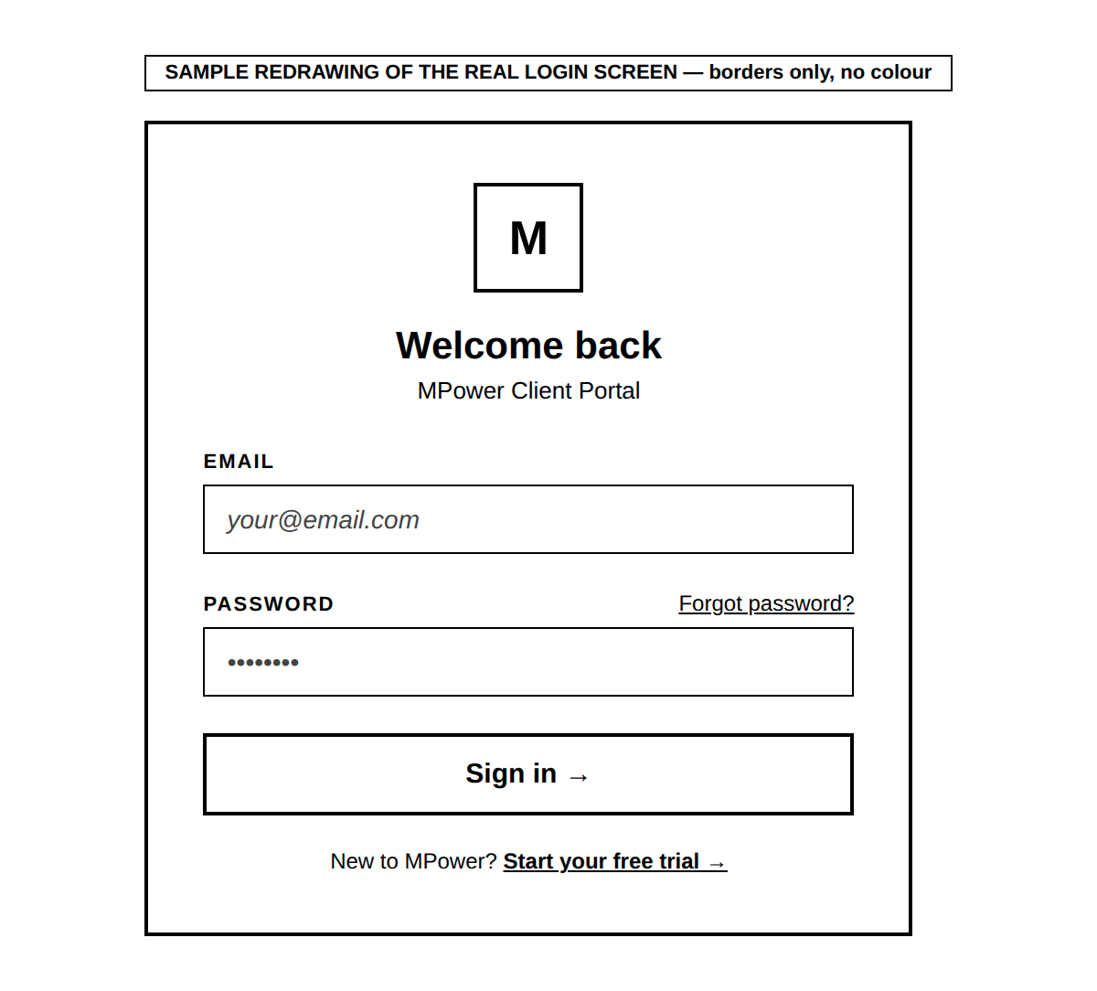
HONEST NOTE: The exact wording on this screen (such as "Forgot password?" and "Start your free trial") is shown here exactly as it appears on screen. If pressing either of those ever behaves unexpectedly, that is worth reporting separately — this guide describes what is shown, not a guarantee of what every link does.

IF THIS NEEDS TO CHANGE: If you ever need extra fields on this screen, or a different way to sign in (for example, signing in with just a phone number instead of an email), that is a request for whoever maintains the system to build. As of this guide, only email + password sign-in exists — there is currently no way for a staff member approved without an email to log in at all.

3. Getting Access — Registering a New Office
Before anyone can sign in (Section 2), their office must first be registered and approved. This only happens once per office, not once per person.

3.1 How you get here
This path shows exactly how you arrive at this screen — each arrow is one real click or action, nothing skipped.
State’s CTS page | → | "I am an MLA/MP Office" | → | "Register here" | → | Registration form opens

3.2 What this screen looks like
Shown here filled in with made-up sample details, so the real layout and field order are clear:
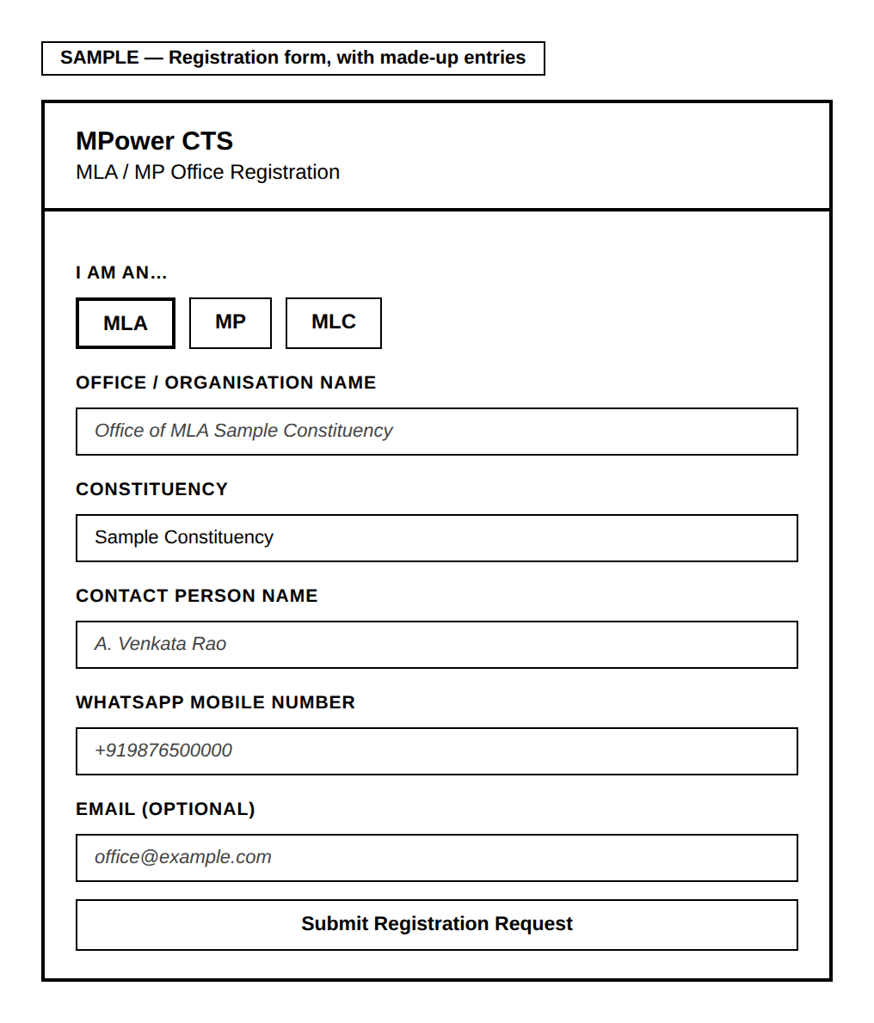

What each field means
Field | Required? | What it means
I am an… (MLA / MP / MLC) | Yes | Pick which kind of office this is. This choice controls what appears in the Constituency list next, so pick it first.
Office / Organisation Name | Yes | For example: "Office of MLA Mandapeta."
Constituency | Yes | Chosen from a real list, not typed freely — this stops a spelling mistake or a made-up constituency from ever being submitted.
Contact Person Name | Yes | The name of the MLA/MP, or whoever is in charge of the office day-to-day.
WhatsApp Mobile Number | Yes | Used to send the confirmation message once MPower approves the office.
Email | No | Optional, but worth adding since it becomes the login email later.
After you submit, you will see a confirmation with a reference number. MPower then checks the details and activates the office, usually within one working day.

IF THIS NEEDS TO CHANGE: Any change to which fields are collected here — adding or removing one — is a request to whoever maintains the system, since this form feeds directly into how the office gets approved (Section 4).

4. Screen: Verify — Approving a New Office
Once someone submits the registration form in Section 3, an admin must review and approve it here before that office can sign in. Only Grievance Admin, Developer, and Support can see this screen.

4.1 How you get here
This path shows exactly how you arrive at this screen — each arrow is one real click or action, nothing skipped.
You are signed in | → | Bottom menu bar | → | "Verify"

4.2 What this screen looks like
Shown here with one made-up sample request, so you can see the real shape of the screen, not just a description of it:
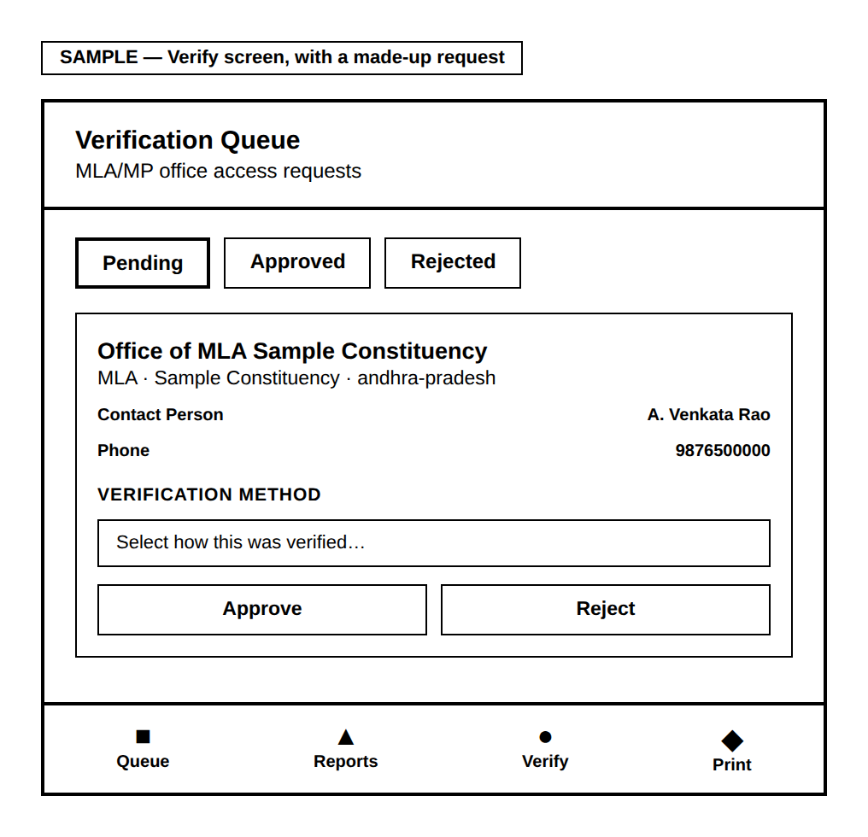
The three tabs sort requests by decision status — "Pending" is where new, undecided requests wait, and is the one you will open most often. Each card is created automatically the moment someone fills in the Section 3 form. Before you can approve anyone, you must pick a Verification method — the system blocks approval without one, on purpose. Pressing Approve creates the office’s real, working login — the exact login they will use on the Section 2 screen. Reject only records the decision; it does not create any login.

IF THIS NEEDS TO CHANGE: The list of verification methods (winners’ list, gazette notice, and so on) is fixed in the system right now. Adding a new one is a request to whoever maintains the system.

5. Getting Around — The Bottom Menu
Once signed in, every screen shares one menu bar fixed to the bottom of the screen. This is how you move between the main working areas.
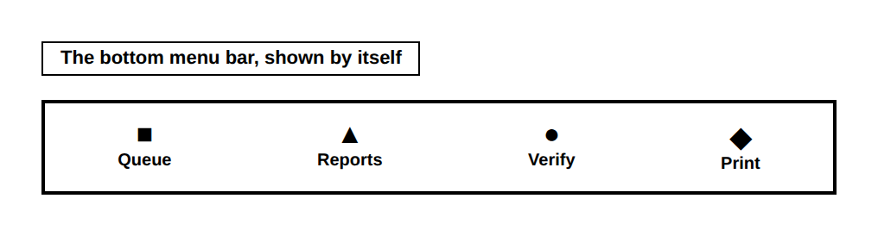
Button | Takes you to | Who sees it
Queue | The everyday working list of complaints (Section 6) | Everyone signed in
Reports | Charts and summaries of all complaints (Section 7) | Everyone signed in
Verify | New office approvals (Section 4) | Everyone signed in
Print | Letters and printed reports (Section 8) | Everyone, including citizens
NOTE: The Print button is a little different from the rest: from any other screen, it takes you to the Print screen. But if you are already ON the Print screen and press it again, it skips navigating anywhere and just opens your printer dialog straight away.
ABOUT THE SYMBOLS: The real menu bar uses small picture icons rather than the plain shapes shown here — the shapes are used in this guide only so every symbol displays correctly no matter which program opens this document.

6. Screen: Queue — Your Everyday Working List
This is where staff spend most of their time — the list of complaints that need attention.

6.1 How you get here
This path shows exactly how you arrive at this screen — each arrow is one real click or action, nothing skipped.
You are signed in | → | Bottom menu bar | → | "Queue"
This is also the very first screen you land on right after signing in.

6.2 What this screen looks like
Shown with two made-up sample complaints, so the layout, wording, and buttons are real — not just described:
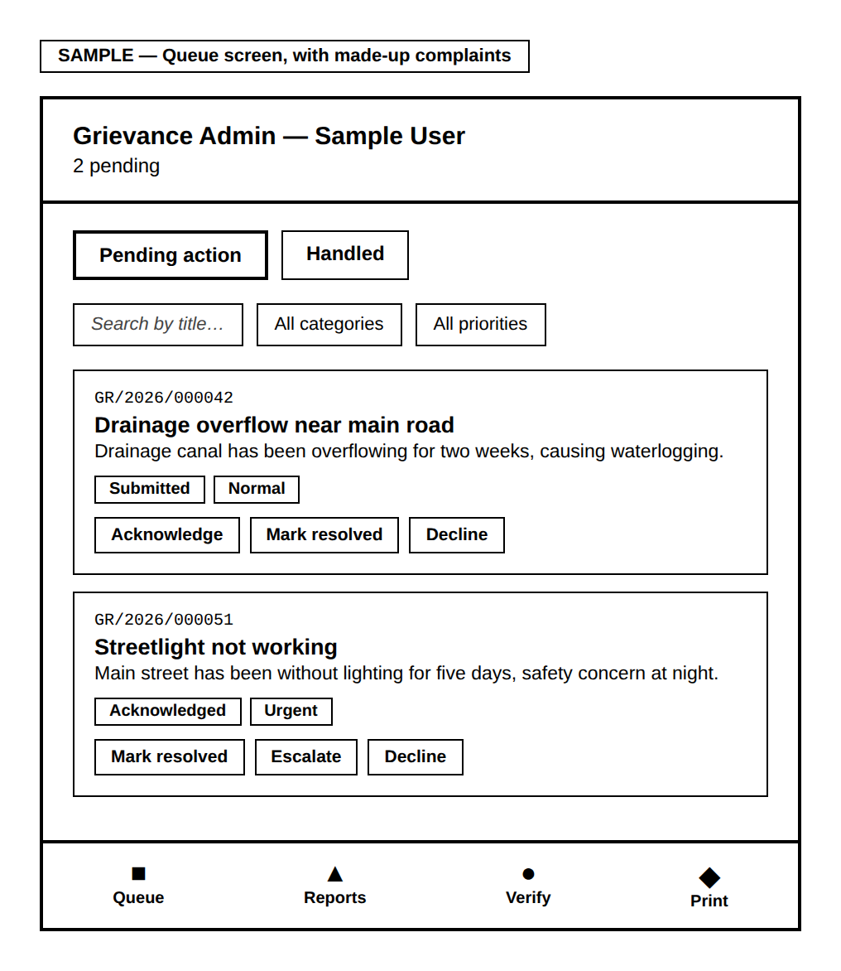
The title bar at the top is generated automatically — it always shows your role and name, plus a live count. The two tabs split complaints by whether they still need action or are already finished. The search box and category/priority filters narrow a long list — only useful once the list is long; for a short list, feel free to just scroll. Every complaint card is created automatically the moment a citizen submits it — you never make one yourself. The action buttons you see on each card change depending on your role and that complaint’s current stage, shown in the table below.

What each role is allowed to press
Role | What they can do to a pending complaint
Representative | Acknowledge it, then Start work, then either Mark resolved, Escalate (send it further up), or Decline with a reason.
Authority | Only on complaints already escalated to them: Approve & sanction, Send it back for more work, or Decline with a reason.
Grievance Admin | Acknowledge, Mark resolved, or Decline with a reason — directly, on any complaint, without the extra steps above.
NOTE: Whenever you press Decline, you must type a reason first — the system will not let you decline without one, because the citizen will read that reason.

How a complaint’s status actually changes
This is the real mechanism behind those buttons — not just what each one is called, but what pressing it actually does.
Submitted  (citizen files it) | → | Acknowledged  (press Acknowledge) | → | In Progress  (press Start work) | → | Resolved  (press Mark resolved)

From Acknowledged or In Progress, a representative can also press Escalate instead of continuing straight to Resolved:
Escalated  (rep sends it up) | → | Sanctioned  (Authority approves)
The Authority role can also press "Send back," which returns an escalated complaint to In Progress instead of approving it.

Every single one of these button presses does the same two things behind the scenes:
• A new entry is written to that complaint’s history log — recording the new stage, who did it, when, and any note left with it.
• The complaint’s own current-stage field is updated to match.
The citizen’s tracking screen (their Section 7) picks this up and shows it immediately — there is no separate notification step, no delay. The moment you press Mark resolved, that is what the citizen sees.
IMPORTANT: The word "Escalated" itself is never shown to the citizen. Citizens query a separate, simplified view of their own complaints that deliberately displays Escalated as "In Progress" instead — the internal Sanctioned/Send back workflow above is for staff and Authority only. A citizen may see "In Progress" for longer than expected while a complaint is genuinely being escalated and reviewed above your office — that is expected, not a bug.
NOTE: Pressing Decline works the same way — it also writes a history entry and updates the stage — but the system requires a reason to be typed first, since that reason is exactly what the citizen reads.
GOOD TO KNOW: Adding a Remark or setting an Assigned Department (below) does NOT move the complaint through this flow at all — it is a way to leave an internal note without forcing a stage change, useful when work is happening but nothing is ready to report to the citizen yet.
GOOD TO KNOW: These same action buttons work identically whether you are on a phone, a desktop browser, or acting on a complaint from within Reports (Section 7) — all three reach the same underlying screen, so nothing is mobile-only.

Opening a complaint’s full detail
Tapping any complaint card opens more detail, including the citizen’s evidence and two extra things you can set:
Field | What it is for
Evidence photos | Any photos or video the citizen attached when filing appear here. You can also add your own evidence photos here — but only photos, not video, and only one at a time (5MB limit each). Video is only ever accepted from the citizen at the moment they first file.
Assigned Department | A free-text note saying which department is handling it — shown later to the District Collector’s office on batch reports.
Remark | An optional internal note. Adding one does not change the complaint’s stage — so you can leave a note without being forced to also change its status.

IF THIS NEEDS TO CHANGE: If a new action or a new filter is ever needed on this screen, that is a request to whoever maintains the system — the list of actions is tied directly to each role’s permissions, so it cannot simply be changed by a staff member.

7. Screen: Reports — Seeing the Bigger Picture
While Queue shows individual complaints, Reports shows patterns and totals across all of them.

7.1 How you get here
This path shows exactly how you arrive at this screen — each arrow is one real click or action, nothing skipped.
You are signed in | → | Bottom menu bar | → | "Reports"

7.2 What this screen looks like
Shown with made-up sample totals, so the real shape and wording are clear:
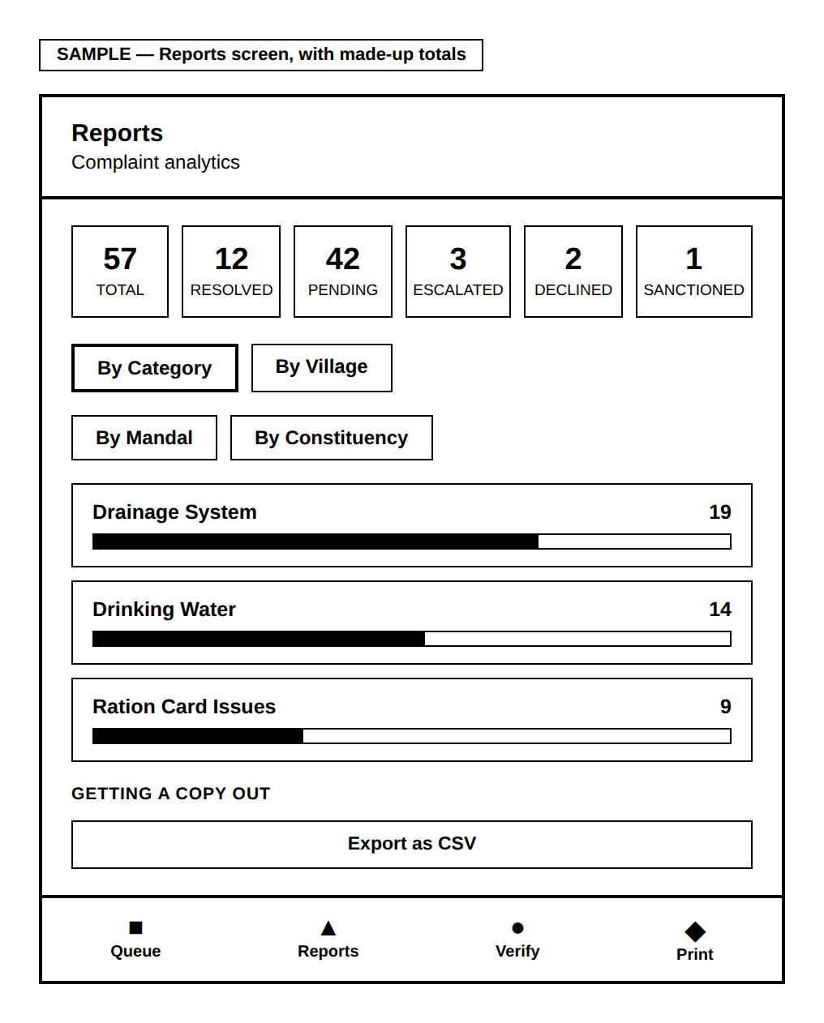
The six summary cards at the top — Total, Resolved, Pending, Escalated, Declined, and Sanctioned — give a fast, at-a-glance total. Declined and Sanctioned both count toward Total but are excluded from Pending, since neither is still "open" work — without these two cards, Total would never quite add up to Resolved + Pending + Escalated, with nothing explaining the gap. The four tabs let you regroup the same complaints by Category, Village, Mandal, or Constituency — switching between them never changes the data, only how it is organised. Each row can be tapped open to reveal the real complaints inside it, sorted so the longest-waiting one appears first.
GOOD TO KNOW: Tapping any individual complaint — whether from an opened row, or from a Patterns group below — opens the exact same detail view used on Queue. You can Acknowledge, Mark resolved, or take any other action for your role directly from Reports; you do not need to go find that complaint again on Queue first.

Patterns & Duplicates — what it actually checks for
This panel is collapsed by default — a count next to its heading tells you if anything was found, so you only open it when it matters. It checks for three distinct things automatically:
What it flags | The real rule behind it
Hotspots | 3 or more complaints, in the same village, about the same category. A real signal that several households are hitting the same underlying problem — stronger case escalated together than as separate low-priority tickets.
Family patterns | 2 or more complaints where the citizens share the same father’s/husband’s name and village — likely the same household filing under different names or for different issues.
Exact duplicates | The same citizen filing the same category twice within 24 hours — almost always an accidental double-submit, flagged so it is not mistaken for two separate problems.
Every complaint shown in any of these three groups is itself tappable, opening the same actionable detail view mentioned above.

Getting a copy out of the system
Button | What it makes
Export as CSV | A spreadsheet file with one row per group (Name, Total, Resolved, Pending, Urgent, Escalated), using whatever grouping and filters are currently selected on screen.
HONEST NOTE: There is currently no PDF or print-formatted export on this screen — only the plain CSV button above. If a print-ready version of Reports is ever needed, that is a request to whoever maintains the system.

IF THIS NEEDS TO CHANGE: Adding a fifth way to group complaints (beyond Village/Mandal/Category/Constituency), or a new pattern-detection rule, is a request to whoever maintains the system, since each is built from its own underlying data/logic.

8. Screen: Print — Letters and Reports
Every printable document in CTS is produced here — from a single citizen’s formal letter to a full batch report for the District Collector.

8.1 How you get here
This path shows exactly how you arrive at this screen — each arrow is one real click or action, nothing skipped.
You are signed in | → | Bottom menu bar | → | "Print"
You can also arrive here directly from a "Print this view" button on the Queue screen, which brings your current search/filter choices along with it.

8.2 The three kinds of document
Shown here as the actual mode-selector screen you choose from:
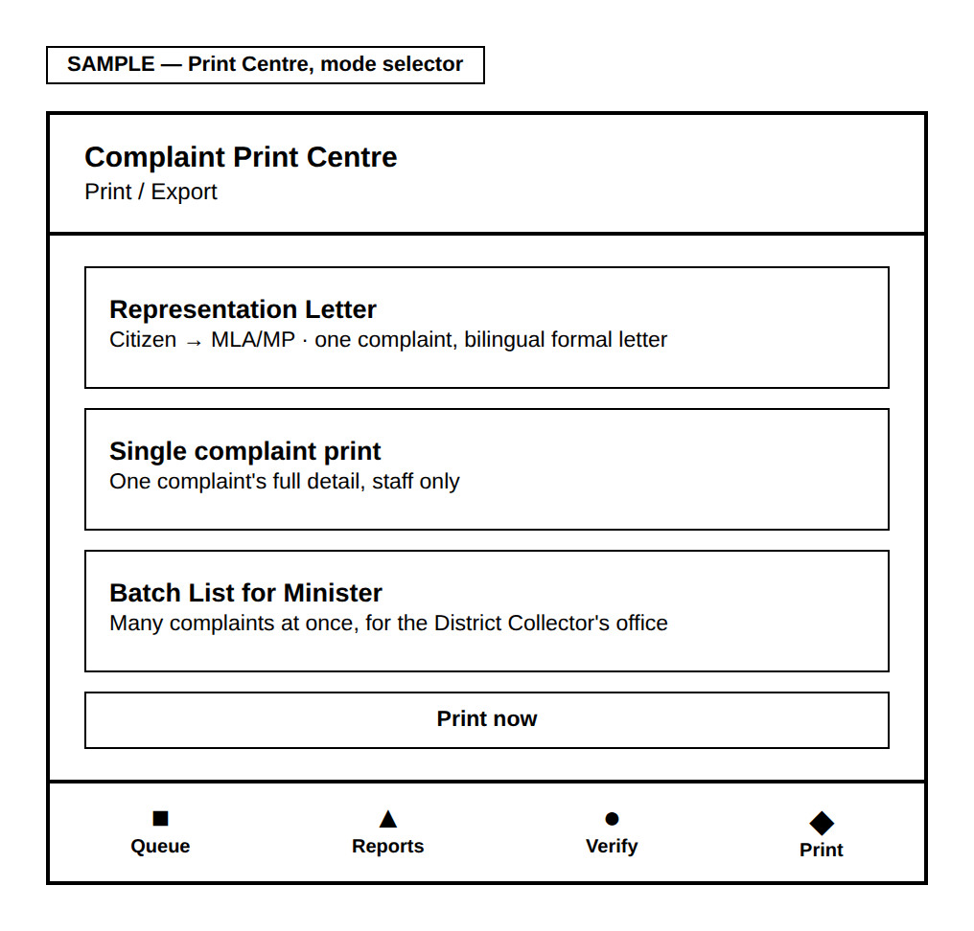
Representation Letter turns one complaint into a formal, bilingual letter from the citizen to their MLA/MP — it is the only one of the three a citizen can produce themselves. Single complaint print is one complaint’s full detail, staff only. Batch List for Minister lays out many complaints at once, sideways (landscape), staff only.

Whichever one you choose, pressing "Print now" opens your browser’s own print window — from there you can print on paper, or choose "Save as PDF" to keep a digital copy instead.

8.3 Sample output — what a Representation Letter actually looks like
Instead of only describing it, here is a real example — built with made-up sample details so you can see the exact layout, wording, and bilingual formatting a citizen and MLA/MP office would actually receive.
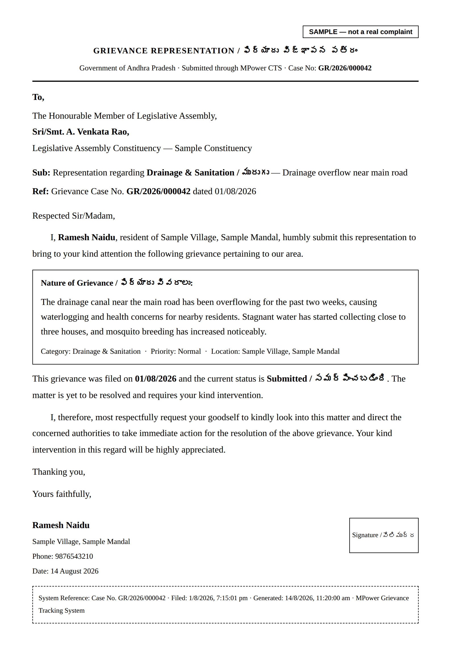
ABOUT THIS SAMPLE: Every name, village, phone number, and case number on this sample is invented for illustration. No real citizen’s data is shown here.

8.4 Sample output — what a Batch List for Minister actually looks like
This is the report a constituency office would hand to the District Collector — built here with a small set of made-up sample complaints so the real layout is visible: the letterhead, the executive summary table, and the category-by-category detail table with blank columns for the Collector’s office to fill in by hand.
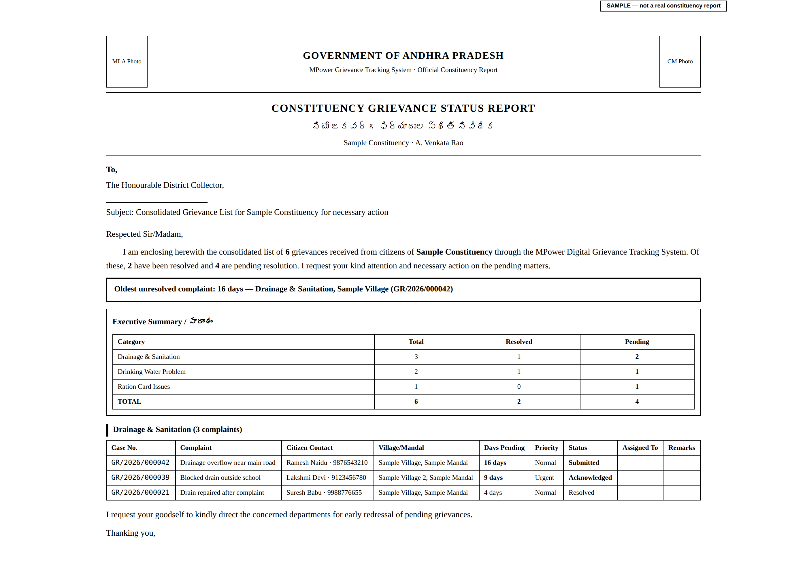
ABOUT THIS SAMPLE: Every office name, citizen name, phone number, and complaint on this sample is invented for illustration. No real citizen’s data is shown here.

IF THIS NEEDS TO CHANGE: A fourth kind of printed document, or a change to what appears on any of these three, is a request to whoever maintains the system.

9. Screen: App Feedback
Shows what citizens and staff have said about the CTS app itself — not about any specific complaint, but about how easy or hard the tool itself is to use. Only Grievance Admin, Developer, and Support can see this.

9.1 How you get here
This path shows exactly how you arrive at this screen — each arrow is one real click or action, nothing skipped.
You are signed in | → | "Verify" screen | → | "View App Feedback" link
This screen is deliberately not on the main bottom menu — it is used less often than Queue or Reports, so keeping it one extra tap away avoids crowding the main menu.

9.2 What this screen looks like
Shown with two made-up sample entries:
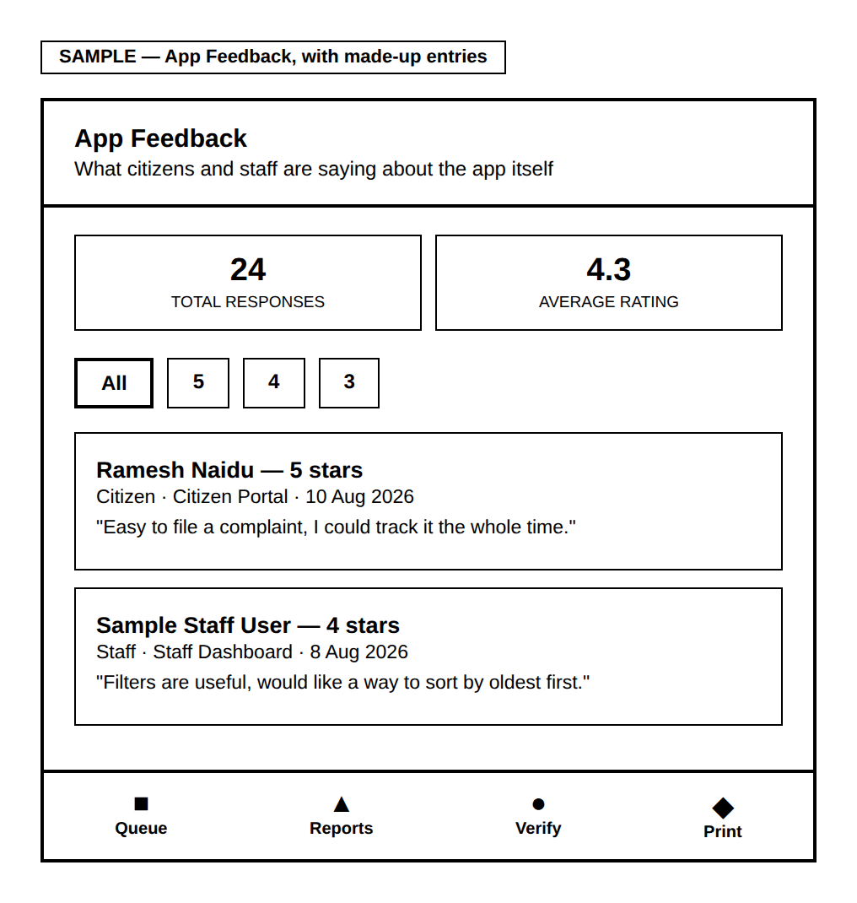
The summary cards give the total number of responses and the average star rating at a glance. The star filter lets you look at only the 5-star comments, or only the 1-star ones, instead of scrolling through everything. Each entry shows whether the person was a citizen or staff, which screen they were on when they left it, the date, and what they wrote.
This screen is read-only — there is nothing to fill in here yourself.

IF THIS NEEDS TO CHANGE: Replying directly to feedback from this screen does not currently exist — that would be a request to whoever maintains the system.

10. Quick Reference
Screen | How to get there | Section
Sign in | Login page (given to your office) | 2
Register a new office | CTS page → "I am an MLA/MP Office" → "Register here" | 3
Approve an office | Bottom menu → Verify | 4
Work a complaint | Bottom menu → Queue | 6
See charts & totals | Bottom menu → Reports | 7
Print a letter or report | Bottom menu → Print | 8
See app feedback | Verify screen → "View App Feedback" | 9

Appendix: Roles at a Glance
Role | What they can see and do
Grievance Admin | The whole state; can act on any complaint; approves new offices; sees App Feedback.
Representative | Their own constituency only; works complaints step by step from Acknowledge through to Resolved/Escalated/Declined.
Authority | Their own constituency; only handles complaints already escalated to them.
Developer / Support | Same as Grievance Admin, used by MPower’s own team.

This guide reflects the CTS module as of August 2026. Some things — such as signing in with just a phone number — are planned but do not exist yet; look for "IF THIS NEEDS TO CHANGE" boxes throughout for details.

APPENDIX C
Citizen Guide
How citizens file, track, and print their grievances

MPower
Constituency Grievance Tracking System (CTS)
Citizen Guide
Every screen explained in plain language — how you get there, what each part is for, and when to use it
Free for every citizen — no office visit needed
August 2026

Foreword
MPower CTS exists so that filing a complaint with your MLA or MP doesn’t require knowing the right person, travelling to an office, or hoping a paper complaint doesn’t quietly get lost. It should take a phone, a few minutes, and nothing else.
This guide was written by the person who actually built the system — not a documentation team working from a spec, one developer working directly against the real, running app. Every screen shown here was checked against the actual app rather than assumed, so it genuinely matches what you’ll see on your own phone. Where something is a known limitation rather than a finished feature, this guide says so plainly.
If anything in these pages is unclear, or the app itself falls short of what’s promised here, I want to hear about it directly — the "Feedback" link inside the app (Section 9) reaches me too.

Surya
Founder & Developer, MPower Services
Email: support@mpowerind.in
Website: mpowerind.in

Contents

1. About This Guide
This guide explains, one screen at a time, how a citizen uses MPower CTS to file a complaint (grievance) with their local MLA, MP, or MLC office, and how to track it afterwards. Every section follows the same simple pattern:
• A path of boxes showing exactly how you reach that screen
• A real drawing of the screen, redrawn in plain black and white
• A plain-language explanation of everything on it
Nothing here is guessed — every field name and button comes from checking the real system.
NOTE: Filing a complaint through MPower CTS is completely free. No prior account or office visit is needed — signing in with your own phone number creates your citizen account automatically.

2. Getting Started

2.1 How you get here
This path shows exactly how you arrive at this screen — each arrow is one real click or action, nothing skipped.
MPower website | → | "Get Started with CTS" | → | Choose your state | → | "I am a Citizen"

NOTE: Your choice of "Citizen" is remembered on this device/browser — next time you visit, you go straight back to your sign-in screen without picking a state again.

3. Signing In (Phone OTP)
There is no separate password to remember — your phone number is verified with a one-time code (OTP) sent to it.

3.1 What this looks like
Shown here as the two real steps, one after the other:
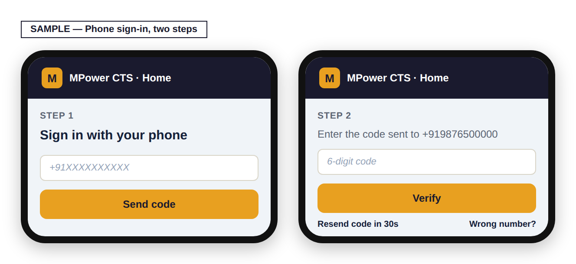
Step 1: type your mobile number and press "Send code." Step 2: type the 6-digit code sent to that number and press "Verify." "Resend code" becomes available 30 seconds after each send. "Wrong number?" takes you back to Step 1 to re-enter your number.

Once verified, first-time citizens continue to the profile form (Section 4). Returning citizens go straight to Your Complaints (Section 5).

4. One-Time Profile Registration
The first time you sign in, you enter your details once — these are reused automatically on every complaint you file afterwards, so you never have to re-enter them.

4.1 What this screen looks like
Shown here filled in with made-up sample details:
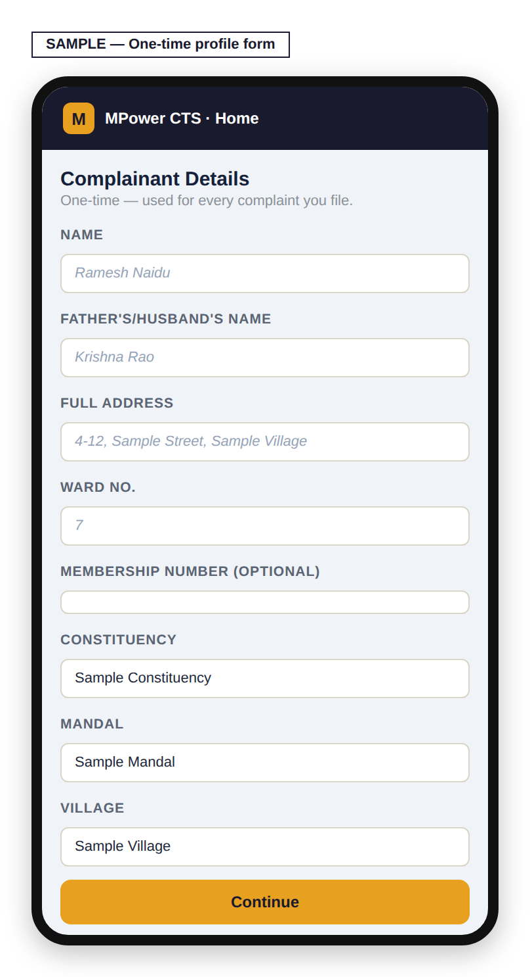

What each field means
Field | Required? | Notes
Name | Yes
Father’s/Husband’s Name | No
Full Address | No
Ward No. | No
Membership Number | No
Constituency | Yes | Chosen from a dropdown
Mandal | Yes | Type your mandal name — matches an existing one, or can be added if genuinely not listed
Village | Yes | Same as Mandal — type to match or add
NOTE: When typing your Mandal or Village, make sure to select it from the suggestions that appear — typing a name and simply moving on without selecting it will not save your entry.

Pressing Continue shows a full review screen of everything you entered, with the constituency/mandal/village names shown in full. Use "← Edit" to go back and correct anything, or "Confirm & Continue" to save it. Nothing is saved until you press Confirm.
NOTE: These details go directly onto your official Representation Letter later (Section 8) — it’s worth checking them carefully on the review screen.

5. Your Complaints — the Main Screen
This is what you see every time you sign in after your first registration.

5.1 What this screen looks like
Shown here with two made-up sample complaints:
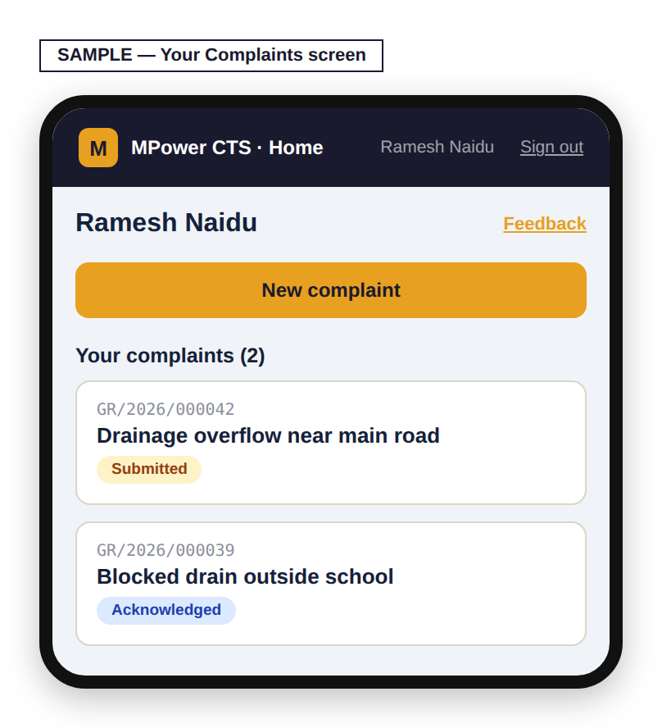
Your name and a "Feedback" link (about the app itself, not a specific complaint) sit at the top. "New complaint" starts a fresh complaint (Section 6). Below it is the list of every complaint you have filed, each showing its case number, title, and current status. Tapping any of them opens its tracking view (Section 7).

6. Filing a New Complaint
Reached by pressing "New complaint" on Your Complaints.

6.1 What this screen looks like
Shown here filled in with a made-up sample complaint:
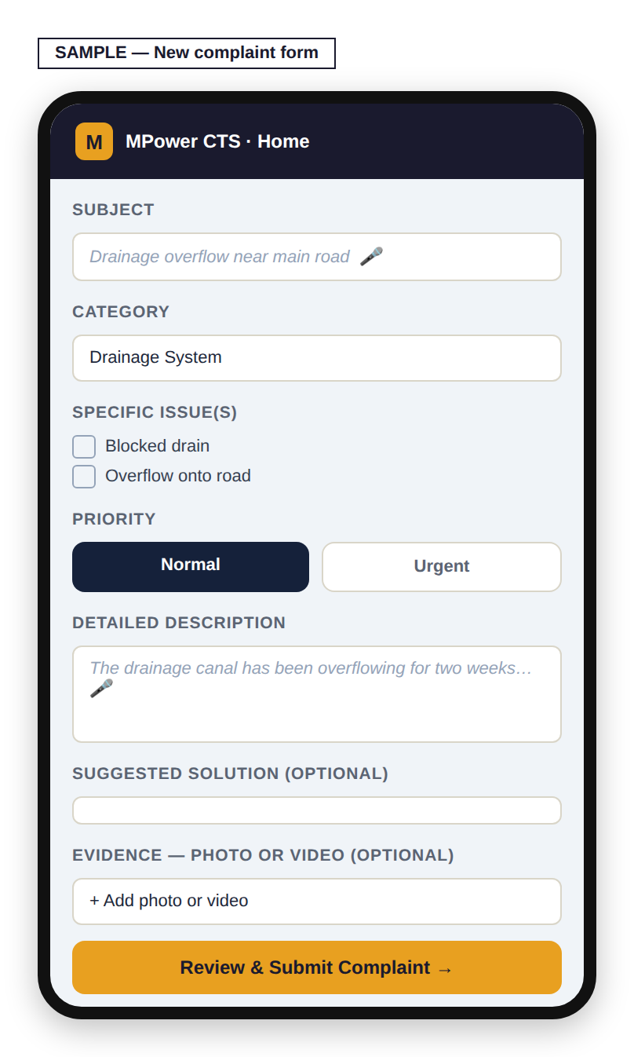

Field | Required? | Notes
Subject | Yes | A short title. A microphone button lets you speak this instead of typing.
Category | Yes | e.g. Drainage System, Ration Card Issues — shown with the local-language name alongside where available
Specific issue(s) | No | Checkboxes specific to the category chosen
Priority | Yes | Normal or Urgent — defaults to Normal
Detailed Description | Yes | Explain the problem fully. Microphone button available here too.
Suggested Solution | No | What you think would fix it, if you have a view
Evidence — Photo or Video | No | More than one file can be attached

Pressing "Review & Submit Complaint" shows everything you entered for a final check. Use "← Edit" to go back, or "Confirm & Submit Complaint" to file it. Nothing is submitted until you press Confirm.
NOTE: You can file up to 3 complaints per day. If you reach this limit, you’ll be told how many you’ve already filed and asked to try again the next day.

7. Tracking a Complaint
Tapping a complaint from Your Complaints opens its tracking panel.

7.1 What this screen looks like
Shown here with made-up sample history:
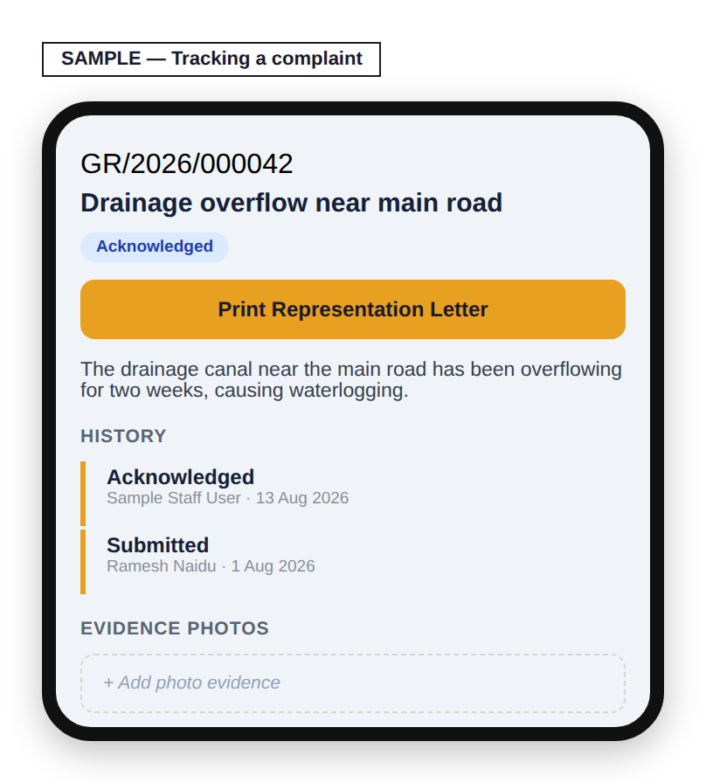
Case number, title, and current status sit at the top, followed by a "Print Representation Letter" button (Section 8) and your full description. History is a timeline of every status change, who made it, when, and any note left with it. An Evidence section lets you view previously attached photos and add more at any time.
GOOD TO KNOW: Video is only accepted when you first file a complaint (Section 6). Adding evidence here afterward only accepts photos, one at a time, up to 5MB each — if you need to add a video after filing, that currently isn’t possible.
This view is read-only for you — status changes are made by the constituency office as they work on your complaint; you will see each update appear here as it happens.

7.2 How your complaint’s status actually moves
This is the real path a complaint travels, from the moment you file it to the moment it’s resolved:
Submitted  (you filed it) | → | Acknowledged  (office has seen it) | → | In Progress  (work has started) | → | Resolved  (marked fixed)

GOOD TO KNOW: Sometimes a complaint needs approval from higher up than your local office before it can be marked Resolved. When that happens, your status stays showing "In Progress" the whole time — it will not change to a different label while that review is happening. If your complaint seems to stay on "In Progress" longer than you expected, this is very likely why, and it does not mean it has been forgotten.

Every update that does change your status appears on your tracking screen (Section 7.1) the moment the office makes it — in the History list, with who made the change and when. There is no separate notification step and no delay.
NOTE: If your complaint is ever declined instead of resolved, the office is required to type a reason first — you will always see that reason in your History list, never just a bare "Declined" with no explanation.

8. Printing Your Representation Letter
Every complaint can be printed as a formal, bilingual (English/Telugu) letter addressed from you to your MLA/MP — useful if you want a physical copy or need to submit one in person.

8.1 How you get here
This path shows exactly how you arrive at this screen — each arrow is one real click or action, nothing skipped.
Complaint tracking panel | → | "Print Representation Letter"

8.2 Sample output — what it actually looks like
Built here with made-up sample details so you can see the exact layout, wording, and bilingual formatting your MLA/MP office would actually receive:

ABOUT THIS SAMPLE: Every name, village, phone number, and case number on this sample is invented for illustration. No real citizen’s data is shown here.

Pressing "Print now" opens your browser’s own print window — from there you can print physically, or choose "Save as PDF" to keep a digital copy instead.

9. Giving Feedback About the App
The "Feedback" link on Your Complaints is for feedback about MPower CTS itself — how easy it is to use, anything confusing, anything you’d like to see — not for updates on a specific complaint (use that complaint’s own tracking panel for that).

10. Quick Reference
To… | Do this
File a new complaint | Your Complaints → "New complaint"
Check a complaint’s status | Your Complaints → tap the complaint
Print a letter for a complaint | Open the complaint → "Print Representation Letter"
Add more photos to a complaint | Open the complaint → Evidence section
Give feedback about the app | Your Complaints → "Feedback"
Sign out | Top bar → Sign out

This guide reflects the CTS module as of August 2026.

