MPower
Control Panel
Internal Guide
Billing, CRM, Help System, and App Feedback — every screen, real fields, plain language
For MPower staff only — not client-facing
August 2026

Foreword
The Control Panel is the one place that runs the actual business behind MPower — every client, every invoice, every piece of help content, every scrap of feedback across School, Hospital, and CTS, all in one place, seen by nobody but MPower’s own team.
This guide was written by the person who actually built it, checked screen by screen against the real, current code rather than assumed — including several real bugs found and fixed while writing it, not just documented around. Where something is a known limitation rather than a finished feature, this guide says so plainly.
If anything in these pages is unclear, or the app itself falls short of what’s promised here, I want to hear about it directly.

Surya
Founder & Developer, MPower Services
Email: support@mpowerind.in
Website: mpowerind.in

Contents

1. About This Guide
This guide explains, one screen at a time, how the Control Panel works. Every section follows the same simple pattern:
• A path of boxes showing exactly how you reach that screen
• A real drawing of the screen, redrawn in plain black and white
• A plain-language explanation of everything on it
Nothing here is guessed — every field, button, and rule comes from checking the real system.
NOTE: Every screen in this guide is restricted to the developer and support roles only — confirmed by checking the real access-control code, not assumed. If you can’t reach one of these screens, that restriction is working as intended.

2. Getting Around
Once signed in, every Control Panel screen shares one menu bar at the bottom, plus an overflow drawer for the screens that don’t fit.
Button | Takes you to | Where it lives
Home | Your main portal dashboard | Main bar
Clients | CRM — every client, one place (Section 4) | Main bar
Tickets | Support tickets | Main bar
Billing | Billing Tracker (Section 3) | Main bar
More → Onboarding | Client onboarding | Overflow drawer
More → Requests | Modification requests | Overflow drawer
More → Help Admin | Help System Admin (Section 5) | Overflow drawer
More → Access | Access management | Overflow drawer
More → Security | Security settings | Overflow drawer
NOTE: Sign out lives inside the "More" drawer, not directly on the main bar — one extra tap compared to every client-facing module’s Home+Sign-out pair. Worth knowing so you’re not looking for it on the main bar.

3. Screen: Billing Tracker
Tracks every client’s monthly subscription — generating invoices, recording who’s paid and how, and flagging what’s overdue. Payment itself is collected outside the app (bank transfer, UPI, and so on); this screen is where you record that it happened.

3.1 How you get here
This path shows exactly how you arrive at this screen — each arrow is one real click or action, nothing skipped.
You are signed in | → | Bottom menu bar | → | "Billing"

3.2 What this screen looks like
Shown here with made-up sample clients and invoices:
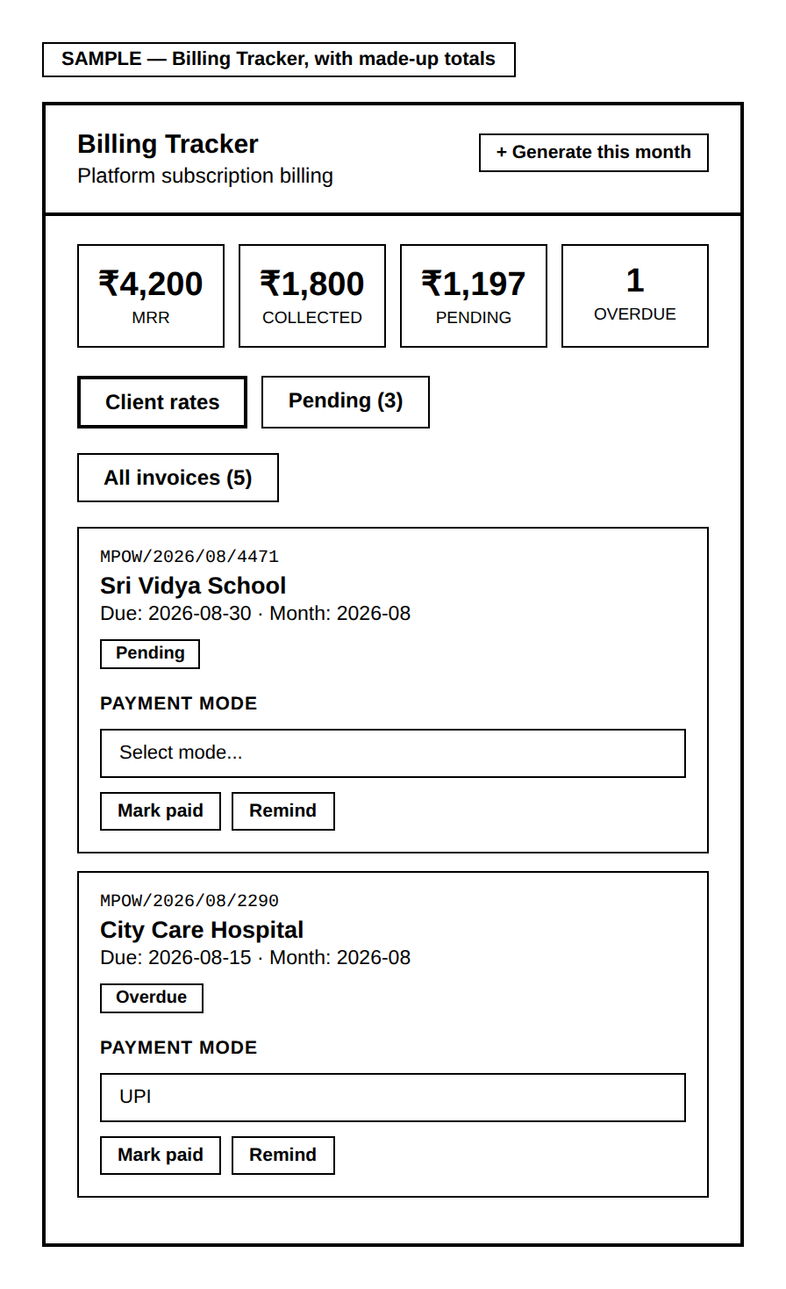
The four stat cards give a fast read on the business: MRR (monthly recurring revenue from every active client), how much has actually been collected this month, how much is still pending, and how many invoices are overdue.

"+ Generate this month"
Creates one invoice per active client for the current month, using their tier’s price. Pressing it twice — or again later the same month — is safe: the database itself refuses a duplicate invoice for the same client and month, so nothing can be double-billed by accident, no matter what causes a second attempt.

Marking an invoice paid
NOTE: You must choose how the client actually paid — UPI, Bank Transfer, Cash, or Cheque — before "Mark paid" becomes clickable. This isn’t a formality; it’s real reconciliation data you’ll want later.

"Remind"
HONEST NOTE: Sends a WhatsApp message to the client about their invoice. As of this guide, this is honestly blocked — no WhatsApp template for billing reminders has been approved by Twilio yet, so pressing it will clearly tell you it did NOT send, with the real reason, rather than falsely claiming success.

IF THIS NEEDS TO CHANGE: The four payment modes are fixed in the code right now. Adding a new one, or wiring up an actual payment gateway instead of manual tracking, is a request to whoever maintains the system.

4. Screen: CRM — Client 360°
Every client across every module (School, Hospital, CTS), in one place — status, contact details, recent tickets, onboarding progress, and recent billing, all from one card you can tap open.

4.1 How you get here
This path shows exactly how you arrive at this screen — each arrow is one real click or action, nothing skipped.
You are signed in | → | Bottom menu bar | → | "Clients"

4.2 What this screen looks like
Shown here with made-up sample clients:
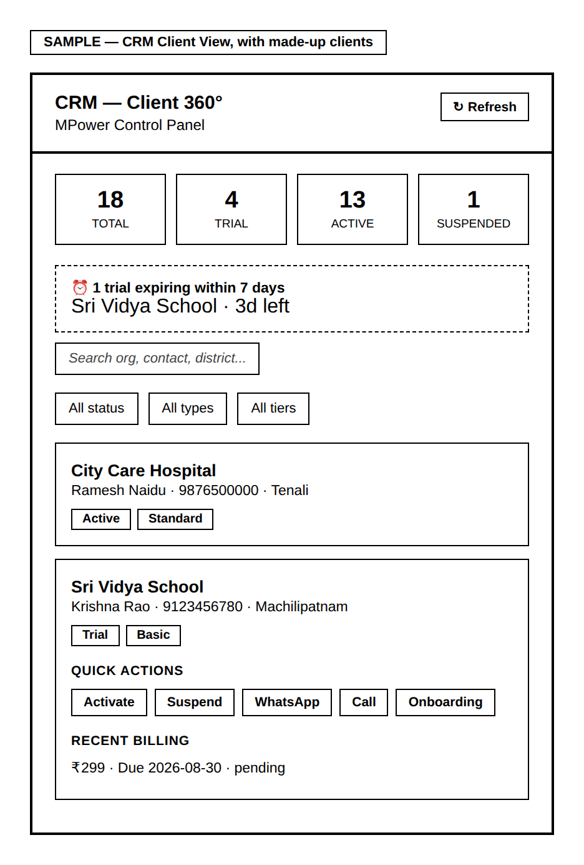
The four stat cards and the trial-expiry alert give an at-a-glance read on the whole client base. Search and the three filters (status, type, tier) narrow the list below — useful once you have more than a handful of clients. Tapping any client’s card opens it, loading their recent tickets, onboarding status, and recent billing in one place.

Quick actions, once a client is open
Action | What it does
Activate | Moves the client to Active status.
Suspend | Cuts off the client’s access. Requires a confirmation step first, naming the actual client, since this is a real, immediate, disruptive action.
WhatsApp | Sends a general reminder message. Same honest limitation as Billing’s Remind button — no approved template exists for this yet, so it will tell you plainly if it didn’t send.
Call | Opens your phone’s own dialer with the client’s number.
Onboarding | Opens that client’s onboarding page.

IF THIS NEEDS TO CHANGE: The four status values (Trial/Active/Suspended/Churned) and four tiers are fixed in the code right now. Adding a new one is a request to whoever maintains the system.

5. Screen: Help System Admin
Manages the help videos and field tooltips every client sees inside their own app, plus basic usage analytics on what’s actually being watched.

5.1 How you get here
This path shows exactly how you arrive at this screen — each arrow is one real click or action, nothing skipped.
You are signed in | → | Bottom menu bar | → | "More" | → | "Help Admin"

5.2 What this screen looks like
Shown here filtered to School, with made-up sample entries:
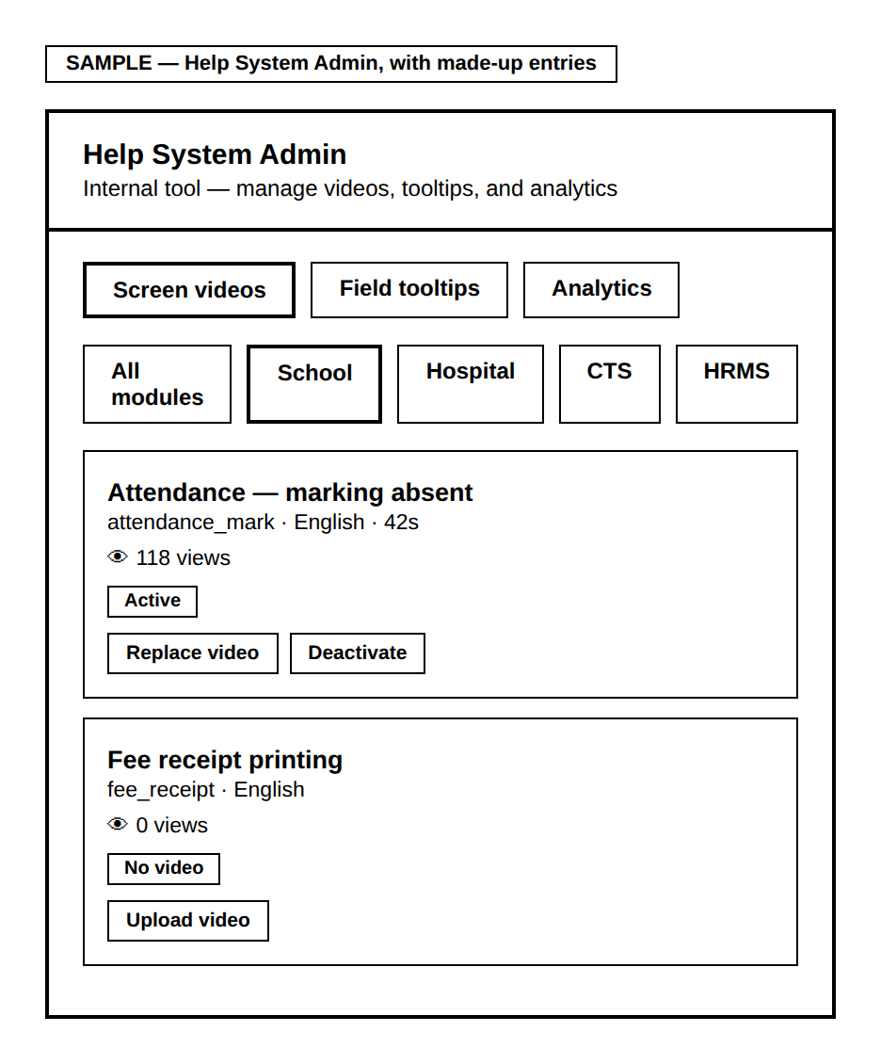
Three tabs split the screen’s purpose: Screen videos (short help videos tied to a specific screen), Field tooltips (short text hints tied to a specific field), and Analytics (what’s actually being viewed, and which screens have no video at all yet). The module filter row (All modules / School / Hospital / CTS / HRMS) narrows the video list to just one module at a time.

The other two tabs, shown here with made-up sample data:
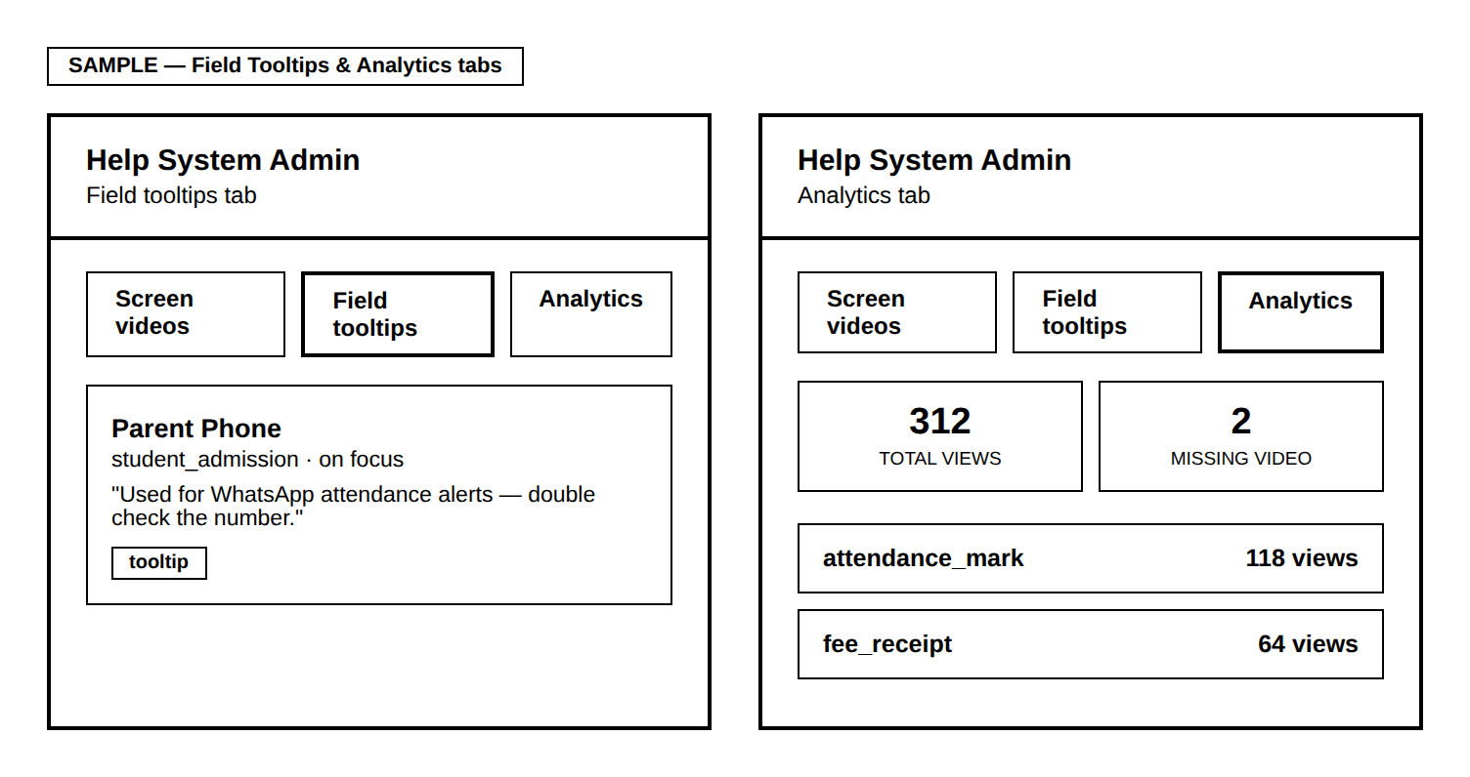
Field tooltips lists every short text hint configured for a specific field, along with when it triggers (e.g. "on focus") and how many times it’s been viewed. Analytics gives the same "total views" and "screens missing a video" counts shown in the summary, plus a ranked list of the most-viewed screens overall — useful for deciding where to record a video next.
NOTE: "HRMS" appears as a filter option here because it’s a genuinely planned future module, not a leftover — confirmed directly rather than assumed. It won’t show any videos yet since that module doesn’t exist as a real app_type in the data yet.

Uploading or replacing a video
Pressing "Upload video" or "Replace video" asks you to paste a YouTube or Cloudflare video ID. The moment you confirm it, every client using that screen sees the new video immediately — there is no separate publish step.

IF THIS NEEDS TO CHANGE: Adding a real 5th module to this filter (beyond School/Hospital/CTS/HRMS) is a request to whoever maintains the system, since it also needs a matching app_type value wired up in the actual client data.

6. Screen: App Feedback
Every piece of feedback submitted by citizens and staff, across every module, in one unified view — rather than three separate near-duplicate screens.

6.1 How you get here
This path shows exactly how you arrive at this screen — each arrow is one real click or action, nothing skipped.
You are signed in | → | CRM screen | → | "View App Feedback"

6.2 What this screen looks like
Shown here with made-up sample entries:
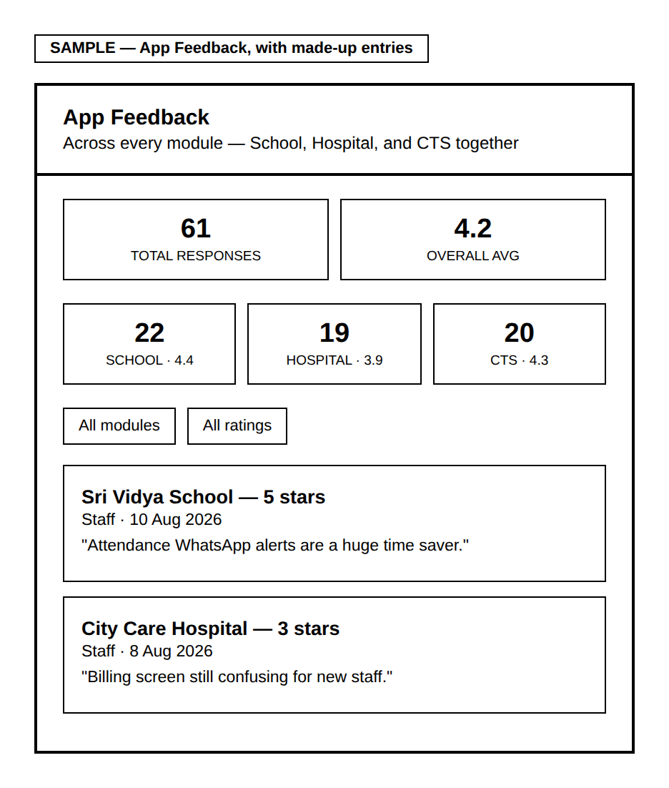
The overall summary (total responses, average rating) sits above a per-module breakdown — the whole point of a unified view is seeing at a glance which module is doing well and which isn’t, not a single blended number that hides that. The module and rating filters narrow the list below to whichever slice you want to read.
This screen is read-only — there is nothing to fill in here yourself.

7. Quick Reference
To… | Do this
Generate this month’s invoices | Billing → "+ Generate this month"
Record a payment | Billing → open the invoice → choose payment mode → "Mark paid"
Find a specific client | Clients → search or filter
Suspend a client | Clients → open the client → "Suspend" → confirm
Upload a help video | More → Help Admin → Screen videos → "Upload video"
See app feedback | Clients → "View App Feedback"

This guide reflects the Control Panel as of August 2026.

