MPower
Constituency Grievance Tracking System (CTS)
Citizen Guide
Every screen explained in plain language — how you get there, what each part is for, and when to use it
Free for every citizen — no office visit needed
August 2026

Foreword
MPower CTS exists so that filing a complaint with your MLA or MP doesn’t require knowing the right person, travelling to an office, or hoping a paper complaint doesn’t quietly get lost. It should take a phone, a few minutes, and nothing else.
This guide was written by the person who actually built the system — not a documentation team working from a spec, one developer working directly against the real, running app. Every screen shown here was checked against the actual app rather than assumed, so it genuinely matches what you’ll see on your own phone. Where something is a known limitation rather than a finished feature, this guide says so plainly.
If anything in these pages is unclear, or the app itself falls short of what’s promised here, I want to hear about it directly — the "Feedback" link inside the app (Section 9) reaches me too.

Surya
Founder & Developer, MPower Services
Email: support@mpowerind.in
Website: mpowerind.in

Contents

1. About This Guide
This guide explains, one screen at a time, how a citizen uses MPower CTS to file a complaint (grievance) with their local MLA, MP, or MLC office, and how to track it afterwards. Every section follows the same simple pattern:
• A path of boxes showing exactly how you reach that screen
• A real drawing of the screen, redrawn in plain black and white
• A plain-language explanation of everything on it
Nothing here is guessed — every field name and button comes from checking the real system.
NOTE: Filing a complaint through MPower CTS is completely free. No prior account or office visit is needed — signing in with your own phone number creates your citizen account automatically.

2. Getting Started

2.1 How you get here
This path shows exactly how you arrive at this screen — each arrow is one real click or action, nothing skipped.
MPower website | → | "Get Started with CTS" | → | Choose your state | → | "I am a Citizen"

NOTE: Your choice of "Citizen" is remembered on this device/browser — next time you visit, you go straight back to your sign-in screen without picking a state again.

3. Signing In (Phone OTP)
There is no separate password to remember — your phone number is verified with a one-time code (OTP) sent to it.

3.1 What this looks like
Shown here as the two real steps, one after the other:
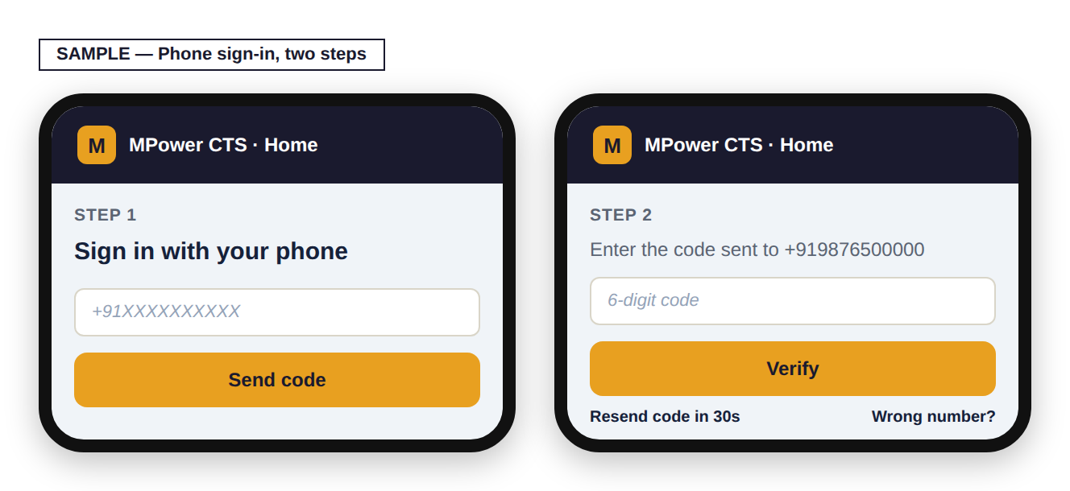
Step 1: type your mobile number and press "Send code." Step 2: type the 6-digit code sent to that number and press "Verify." "Resend code" becomes available 30 seconds after each send. "Wrong number?" takes you back to Step 1 to re-enter your number.

Once verified, first-time citizens continue to the profile form (Section 4). Returning citizens go straight to Your Complaints (Section 5).

4. One-Time Profile Registration
The first time you sign in, you enter your details once — these are reused automatically on every complaint you file afterwards, so you never have to re-enter them.

4.1 What this screen looks like
Shown here filled in with made-up sample details:
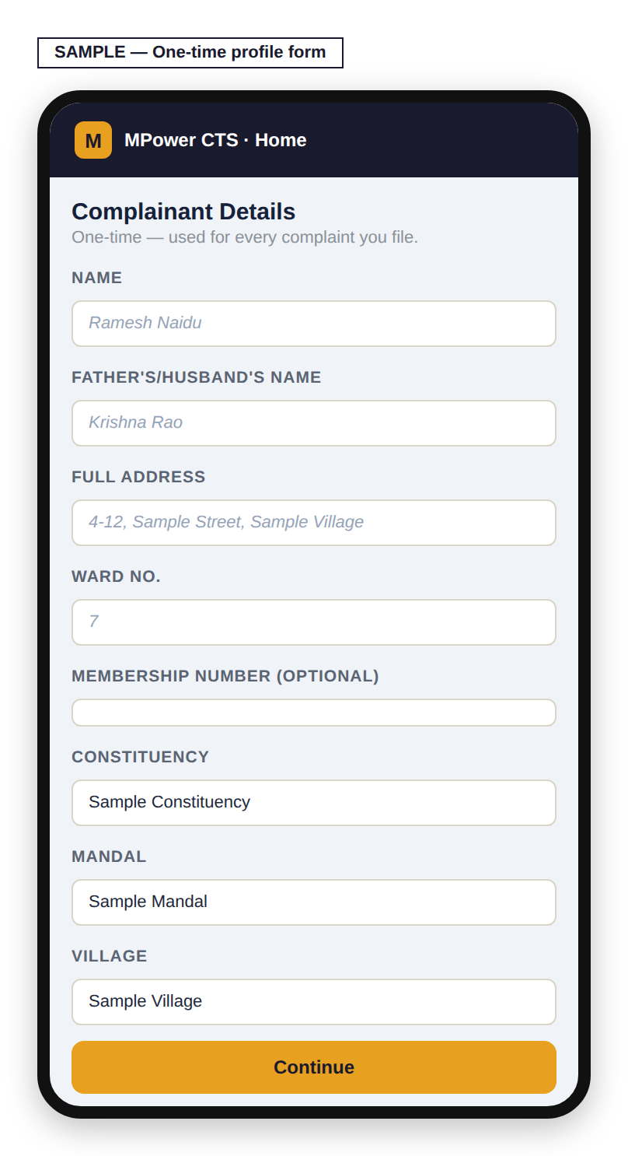

What each field means
Field | Required? | Notes
Name | Yes
Father’s/Husband’s Name | No
Full Address | No
Ward No. | No
Membership Number | No
Constituency | Yes | Chosen from a dropdown
Mandal | Yes | Type your mandal name — matches an existing one, or can be added if genuinely not listed
Village | Yes | Same as Mandal — type to match or add
NOTE: When typing your Mandal or Village, make sure to select it from the suggestions that appear — typing a name and simply moving on without selecting it will not save your entry.

Pressing Continue shows a full review screen of everything you entered, with the constituency/mandal/village names shown in full. Use "← Edit" to go back and correct anything, or "Confirm & Continue" to save it. Nothing is saved until you press Confirm.
NOTE: These details go directly onto your official Representation Letter later (Section 8) — it’s worth checking them carefully on the review screen.

5. Your Complaints — the Main Screen
This is what you see every time you sign in after your first registration.

5.1 What this screen looks like
Shown here with two made-up sample complaints:
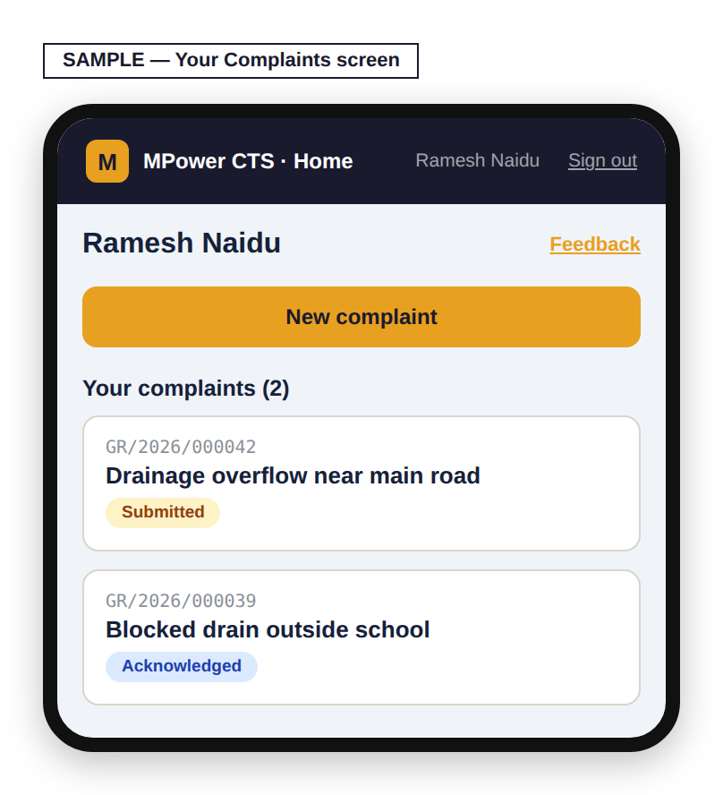
Your name and a "Feedback" link (about the app itself, not a specific complaint) sit at the top. "New complaint" starts a fresh complaint (Section 6). Below it is the list of every complaint you have filed, each showing its case number, title, and current status. Tapping any of them opens its tracking view (Section 7).

6. Filing a New Complaint
Reached by pressing "New complaint" on Your Complaints.

6.1 What this screen looks like
Shown here filled in with a made-up sample complaint:
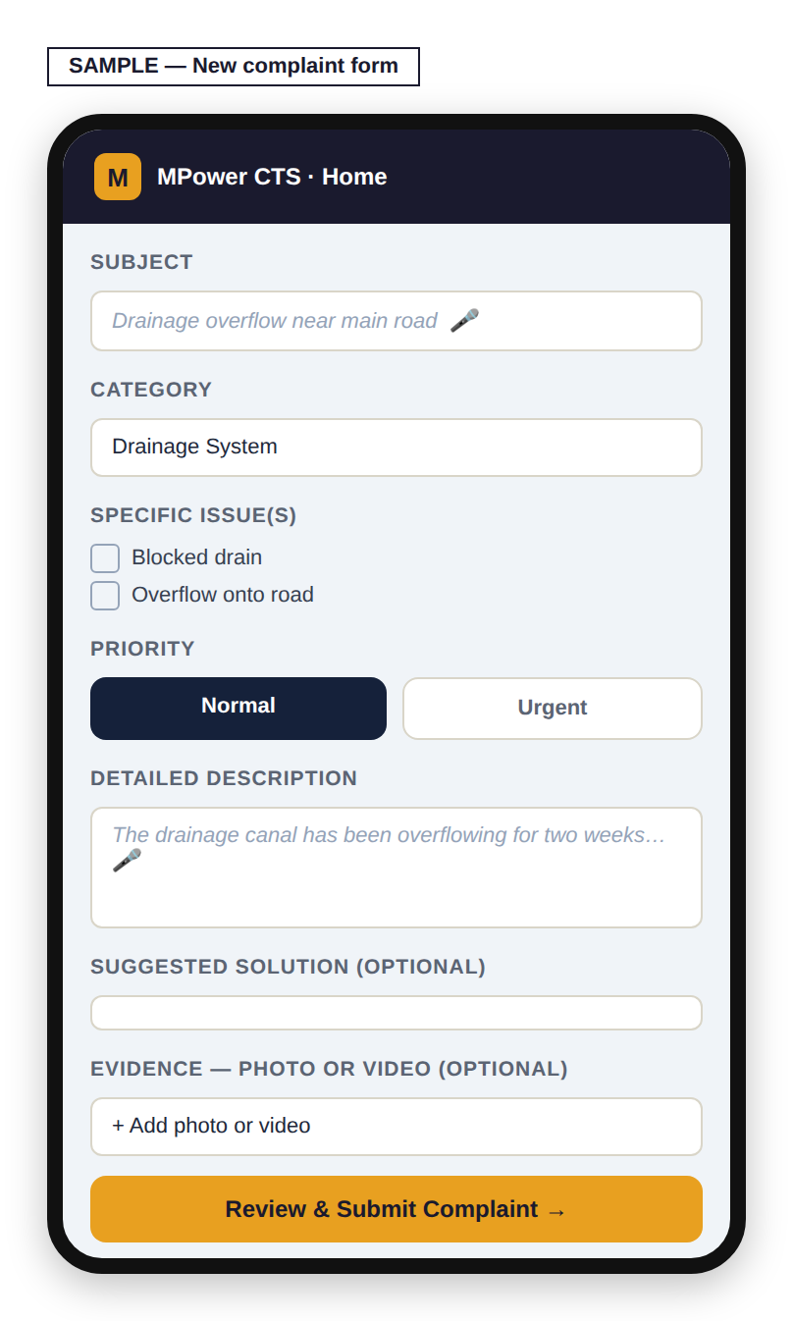

Field | Required? | Notes
Subject | Yes | A short title. A microphone button lets you speak this instead of typing.
Category | Yes | e.g. Drainage System, Ration Card Issues — shown with the local-language name alongside where available
Specific issue(s) | No | Checkboxes specific to the category chosen
Priority | Yes | Normal or Urgent — defaults to Normal
Detailed Description | Yes | Explain the problem fully. Microphone button available here too.
Suggested Solution | No | What you think would fix it, if you have a view
Evidence — Photo or Video | No | More than one file can be attached

Pressing "Review & Submit Complaint" shows everything you entered for a final check. Use "← Edit" to go back, or "Confirm & Submit Complaint" to file it. Nothing is submitted until you press Confirm.
NOTE: You can file up to 3 complaints per day. If you reach this limit, you’ll be told how many you’ve already filed and asked to try again the next day.

7. Tracking a Complaint
Tapping a complaint from Your Complaints opens its tracking panel.

7.1 What this screen looks like
Shown here with made-up sample history:
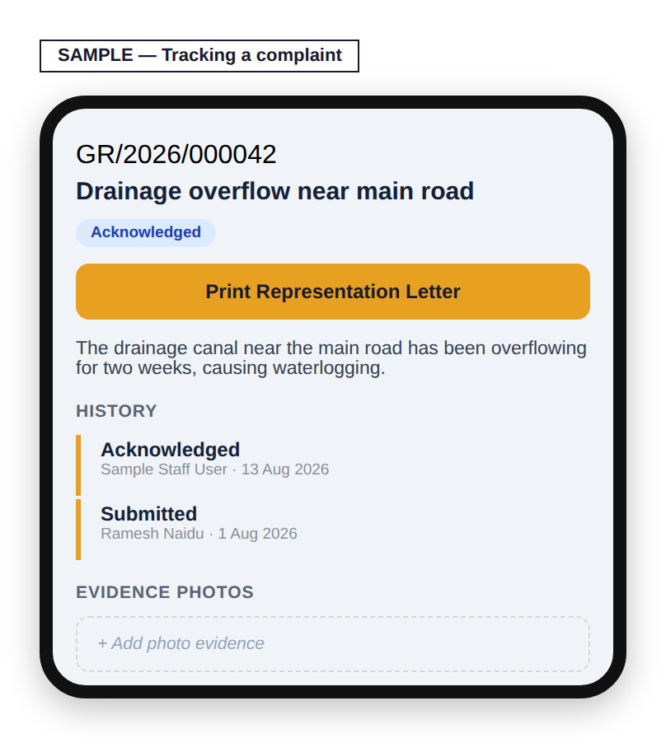
Case number, title, and current status sit at the top, followed by a "Print Representation Letter" button (Section 8) and your full description. History is a timeline of every status change, who made it, when, and any note left with it. An Evidence section lets you view previously attached photos and add more at any time.
GOOD TO KNOW: Video is only accepted when you first file a complaint (Section 6). Adding evidence here afterward only accepts photos, one at a time, up to 5MB each — if you need to add a video after filing, that currently isn’t possible.
This view is read-only for you — status changes are made by the constituency office as they work on your complaint; you will see each update appear here as it happens.

7.2 How your complaint’s status actually moves
This is the real path a complaint travels, from the moment you file it to the moment it’s resolved:
Submitted  (you filed it) | → | Acknowledged  (office has seen it) | → | In Progress  (work has started) | → | Resolved  (marked fixed)

GOOD TO KNOW: Sometimes a complaint needs approval from higher up than your local office before it can be marked Resolved. When that happens, your status stays showing "In Progress" the whole time — it will not change to a different label while that review is happening. If your complaint seems to stay on "In Progress" longer than you expected, this is very likely why, and it does not mean it has been forgotten.

Every update that does change your status appears on your tracking screen (Section 7.1) the moment the office makes it — in the History list, with who made the change and when. There is no separate notification step and no delay.
NOTE: If your complaint is ever declined instead of resolved, the office is required to type a reason first — you will always see that reason in your History list, never just a bare "Declined" with no explanation.

8. Printing Your Representation Letter
Every complaint can be printed as a formal, bilingual (English/Telugu) letter addressed from you to your MLA/MP — useful if you want a physical copy or need to submit one in person.

8.1 How you get here
This path shows exactly how you arrive at this screen — each arrow is one real click or action, nothing skipped.
Complaint tracking panel | → | "Print Representation Letter"

8.2 Sample output — what it actually looks like
Built here with made-up sample details so you can see the exact layout, wording, and bilingual formatting your MLA/MP office would actually receive:
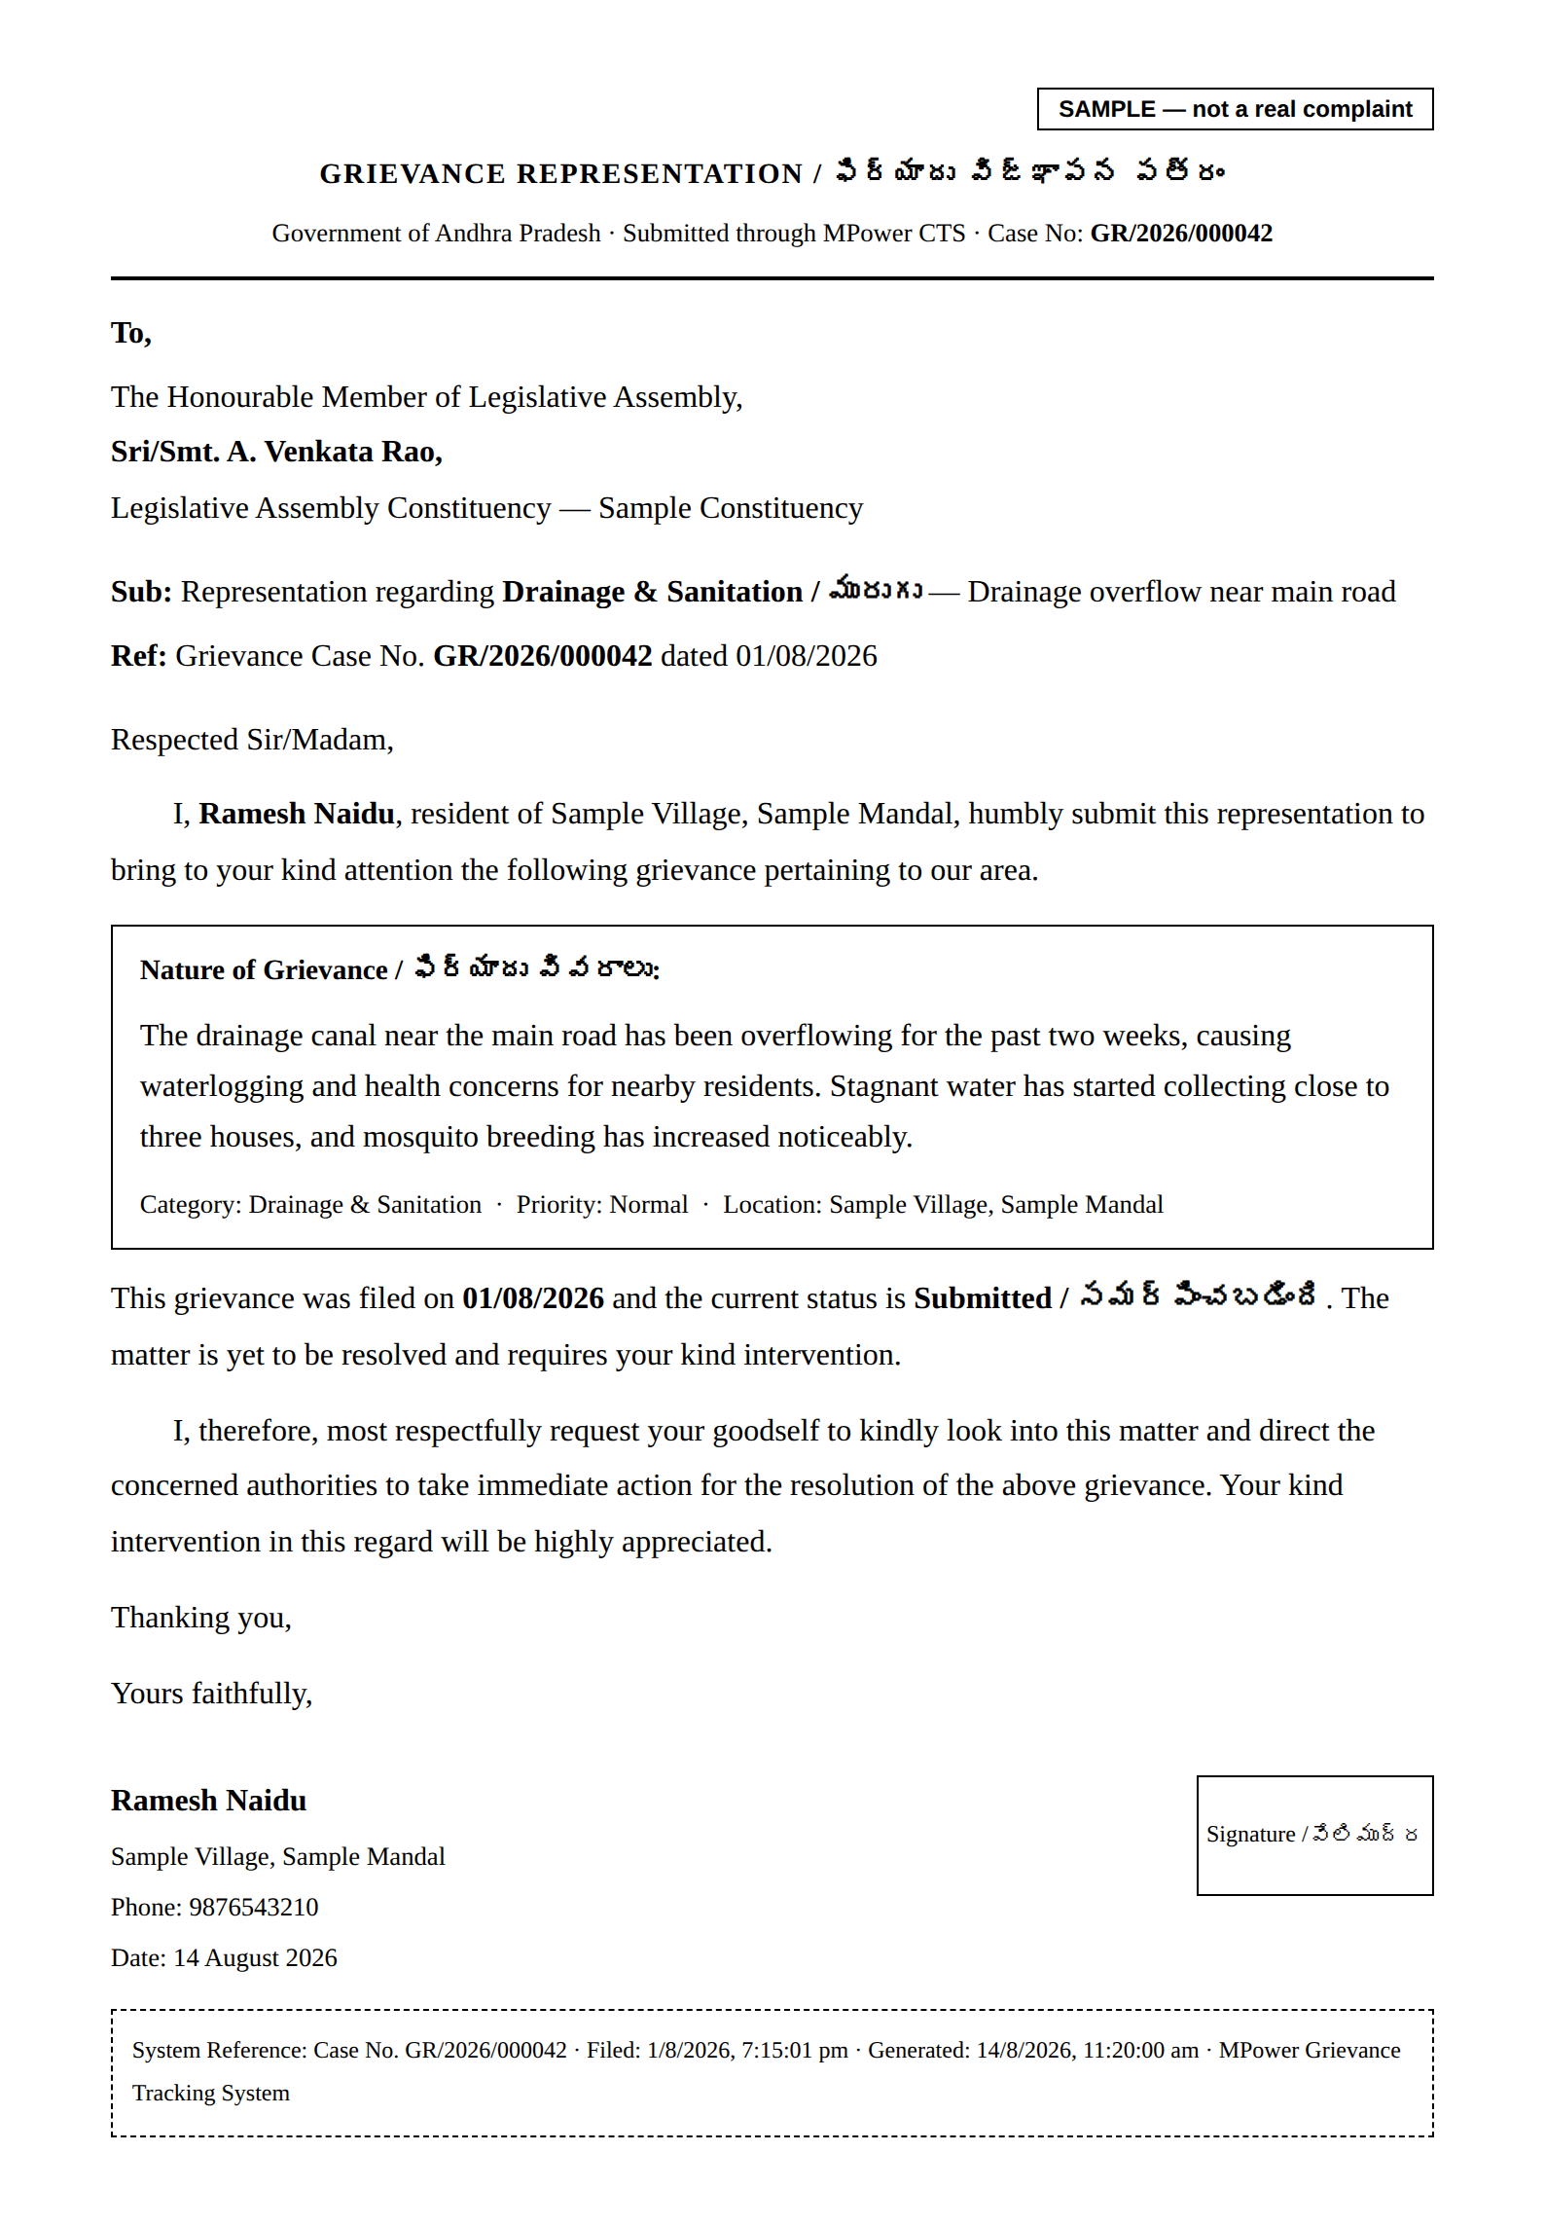
ABOUT THIS SAMPLE: Every name, village, phone number, and case number on this sample is invented for illustration. No real citizen’s data is shown here.

Pressing "Print now" opens your browser’s own print window — from there you can print physically, or choose "Save as PDF" to keep a digital copy instead.

9. Giving Feedback About the App
The "Feedback" link on Your Complaints is for feedback about MPower CTS itself — how easy it is to use, anything confusing, anything you’d like to see — not for updates on a specific complaint (use that complaint’s own tracking panel for that).

10. Quick Reference
To… | Do this
File a new complaint | Your Complaints → "New complaint"
Check a complaint’s status | Your Complaints → tap the complaint
Print a letter for a complaint | Open the complaint → "Print Representation Letter"
Add more photos to a complaint | Open the complaint → Evidence section
Give feedback about the app | Your Complaints → "Feedback"
Sign out | Top bar → Sign out

This guide reflects the CTS module as of August 2026.

