MPower
Constituency Grievance Tracking System (CTS)
Admin & Staff Guide
Every screen explained in plain language — how you get there, what each part is for, and when to use it
August 2026

Foreword
MPower CTS exists because filing a grievance with an elected representative should not require knowing the right person, travelling to an office, or hoping a paper complaint doesn’t quietly get lost. It should take a phone, a few minutes, and nothing else.
This guide was written by the person who actually built the system — not a documentation team working from a spec, one developer working directly against the real, running application. Every screen described here was checked against the actual code and the actual screens rather than assumed, because a guide that doesn’t match what you really see on your own screen is worse than no guide at all. Where something is a known limitation rather than a finished feature, this guide says so plainly instead of glossing over it.
MPower CTS is one part of a larger effort — MPower also serves schools and hospitals — built with the belief that essential software for Indian institutions and citizens should be genuinely well-made, not an afterthought. This guide, like the system itself, will keep improving as real offices and real citizens start using it.
If anything in these pages is unclear, or the app itself falls short of what’s promised here, I want to hear about it directly.

Surya
Founder & Developer, MPower Services
Email: support@mpowerind.in
Website: mpowerind.in

Contents

1. About This Guide
This guide explains, one screen at a time, how constituency office staff use MPower CTS. Every section follows the same simple pattern:
• A path of boxes showing exactly how you reach that screen
• A box-by-box breakdown of everything on the screen, explained in plain words
• A short note on what to do if that screen ever needs to change
Nothing here is guessed — every field name, button, and rule comes from checking the real system.

1.1 Who this guide is for
Role | What they can do | Screens they use
Grievance Admin | The most senior role in an office. Can act on any complaint, approve new offices, and see everything. | Login, Queue, Reports, Verify, Print, Feedback
Representative | Works complaints for their own constituency only. This is the everyday, hands-on role. | Login, Queue, Print
Authority | Only handles complaints that have already been escalated up to them for a decision. | Login, Queue, Print
Developer / Support | MPower’s own team, for support and testing. Same access as Grievance Admin. | All screens
NOTE: Every person only sees the complaints for their own constituency — except Grievance Admin and Developer/Support, who can see the whole state. You do not choose this; the system decides it automatically based on who is logged in.

2. Signing In
This is the very first screen every staff member sees.

2.1 How you get here
This path shows exactly how you arrive at this screen — each arrow is one real click or action, nothing skipped.
Your office is approved by MPower | → | You are given a login email + password | → | You open the login page

2.2 What this screen looks like
This is the real screen, redrawn exactly as it appears — same layout, same wording, same order:
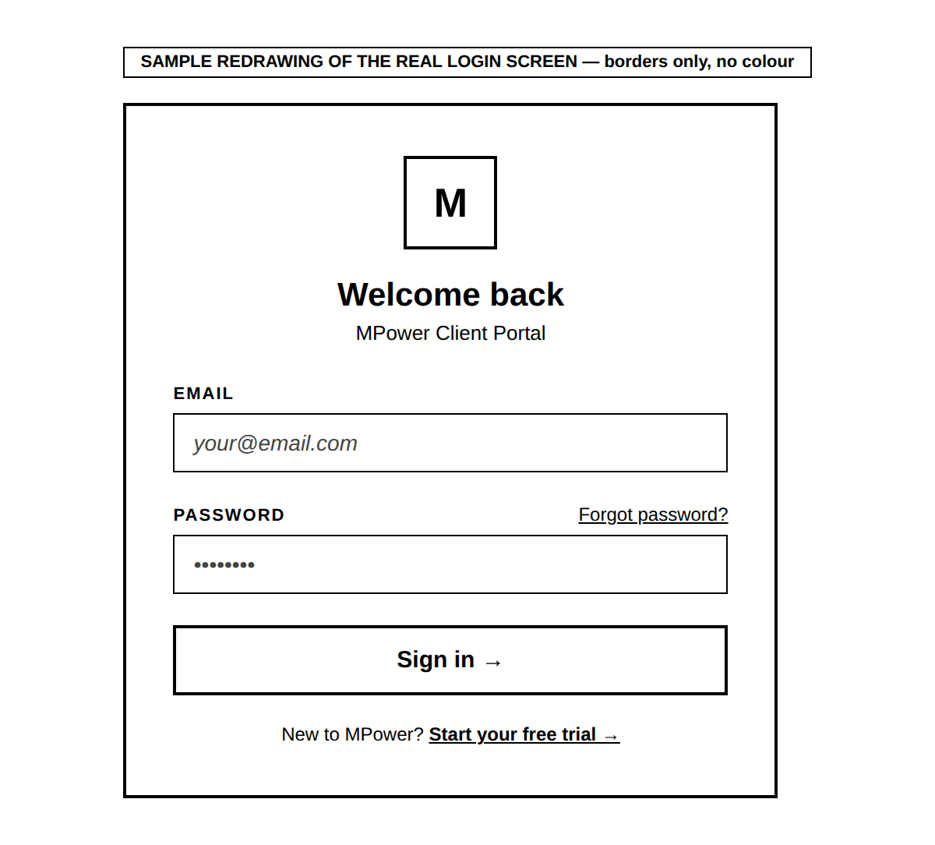
HONEST NOTE: The exact wording on this screen (such as "Forgot password?" and "Start your free trial") is shown here exactly as it appears on screen. If pressing either of those ever behaves unexpectedly, that is worth reporting separately — this guide describes what is shown, not a guarantee of what every link does.

IF THIS NEEDS TO CHANGE: If you ever need extra fields on this screen, or a different way to sign in (for example, signing in with just a phone number instead of an email), that is a request for whoever maintains the system to build. As of this guide, only email + password sign-in exists — there is currently no way for a staff member approved without an email to log in at all.

3. Getting Access — Registering a New Office
Before anyone can sign in (Section 2), their office must first be registered and approved. This only happens once per office, not once per person.

3.1 How you get here
This path shows exactly how you arrive at this screen — each arrow is one real click or action, nothing skipped.
State’s CTS page | → | "I am an MLA/MP Office" | → | "Register here" | → | Registration form opens

3.2 What this screen looks like
Shown here filled in with made-up sample details, so the real layout and field order are clear:
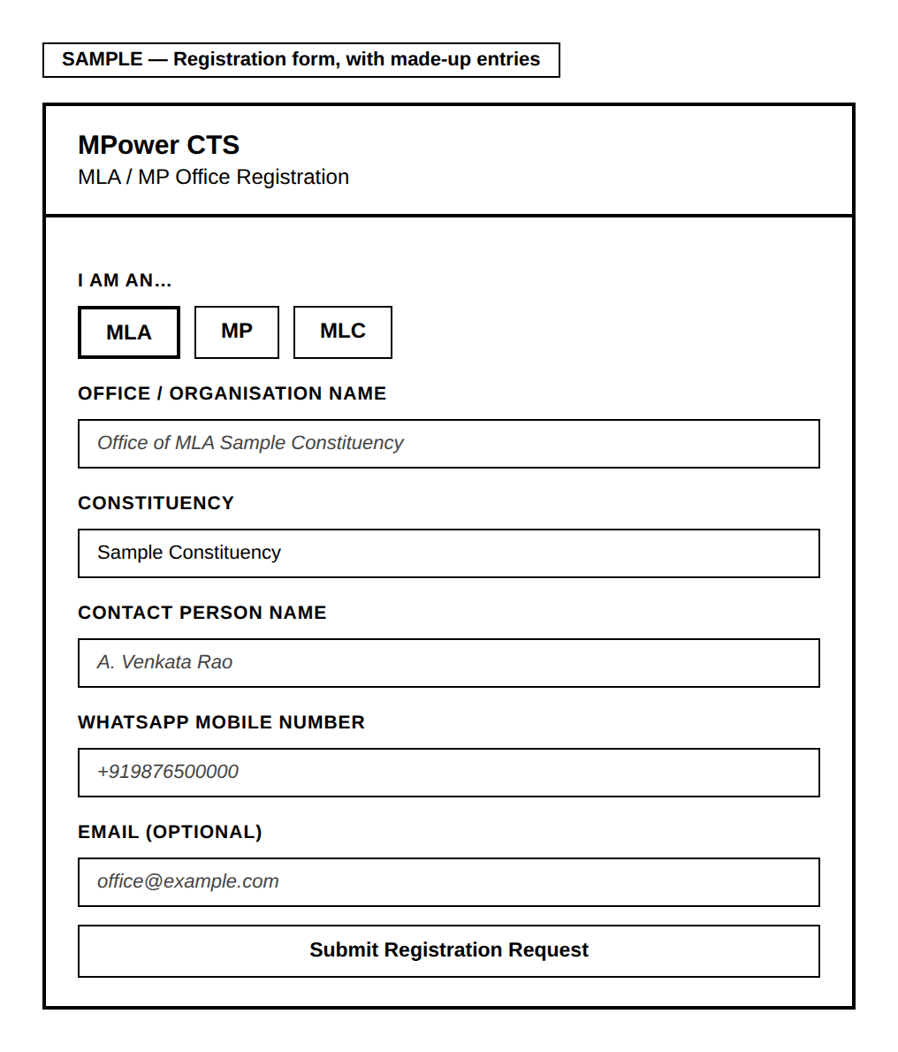

What each field means
Field | Required? | What it means
I am an… (MLA / MP / MLC) | Yes | Pick which kind of office this is. This choice controls what appears in the Constituency list next, so pick it first.
Office / Organisation Name | Yes | For example: "Office of MLA Mandapeta."
Constituency | Yes | Chosen from a real list, not typed freely — this stops a spelling mistake or a made-up constituency from ever being submitted.
Contact Person Name | Yes | The name of the MLA/MP, or whoever is in charge of the office day-to-day.
WhatsApp Mobile Number | Yes | Used to send the confirmation message once MPower approves the office.
Email | No | Optional, but worth adding since it becomes the login email later.
After you submit, you will see a confirmation with a reference number. MPower then checks the details and activates the office, usually within one working day.

IF THIS NEEDS TO CHANGE: Any change to which fields are collected here — adding or removing one — is a request to whoever maintains the system, since this form feeds directly into how the office gets approved (Section 4).

4. Screen: Verify — Approving a New Office
Once someone submits the registration form in Section 3, an admin must review and approve it here before that office can sign in. Only Grievance Admin, Developer, and Support can see this screen.

4.1 How you get here
This path shows exactly how you arrive at this screen — each arrow is one real click or action, nothing skipped.
You are signed in | → | Bottom menu bar | → | "Verify"

4.2 What this screen looks like
Shown here with one made-up sample request, so you can see the real shape of the screen, not just a description of it:
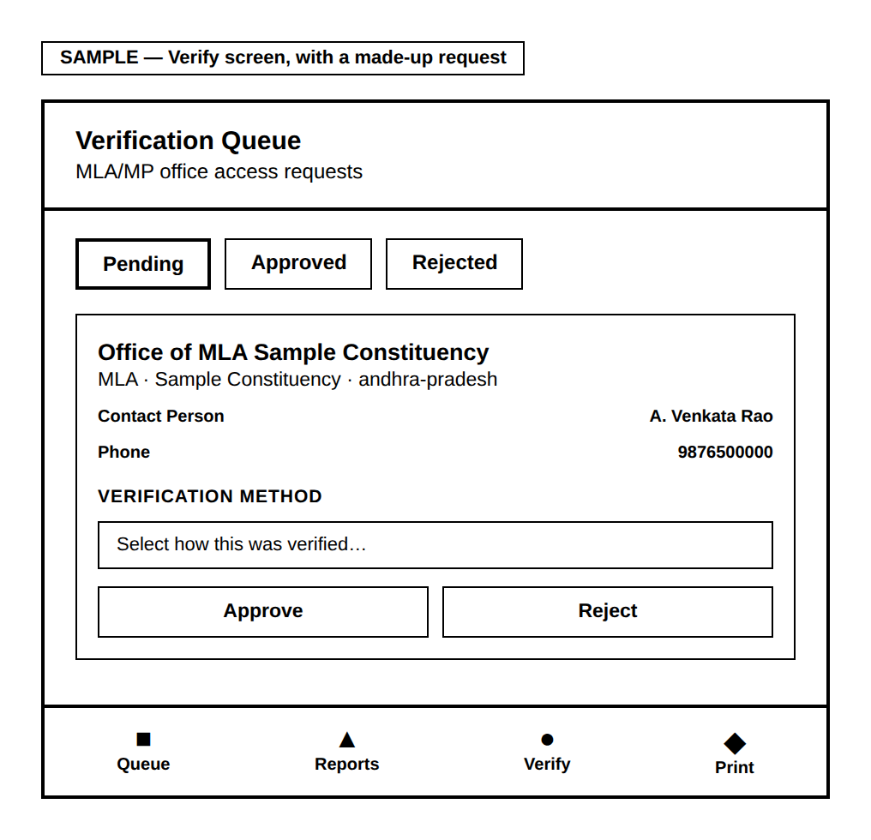
The three tabs sort requests by decision status — "Pending" is where new, undecided requests wait, and is the one you will open most often. Each card is created automatically the moment someone fills in the Section 3 form. Before you can approve anyone, you must pick a Verification method — the system blocks approval without one, on purpose. Pressing Approve creates the office’s real, working login — the exact login they will use on the Section 2 screen. Reject only records the decision; it does not create any login.

IF THIS NEEDS TO CHANGE: The list of verification methods (winners’ list, gazette notice, and so on) is fixed in the system right now. Adding a new one is a request to whoever maintains the system.

5. Getting Around — The Bottom Menu
Once signed in, every screen shares one menu bar fixed to the bottom of the screen. This is how you move between the main working areas.
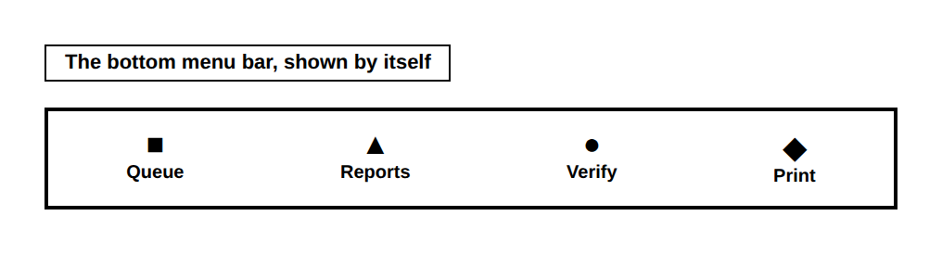
Button | Takes you to | Who sees it
Queue | The everyday working list of complaints (Section 6) | Everyone signed in
Reports | Charts and summaries of all complaints (Section 7) | Everyone signed in
Verify | New office approvals (Section 4) | Everyone signed in
Print | Letters and printed reports (Section 8) | Everyone, including citizens
NOTE: The Print button is a little different from the rest: from any other screen, it takes you to the Print screen. But if you are already ON the Print screen and press it again, it skips navigating anywhere and just opens your printer dialog straight away.
ABOUT THE SYMBOLS: The real menu bar uses small picture icons rather than the plain shapes shown here — the shapes are used in this guide only so every symbol displays correctly no matter which program opens this document.

6. Screen: Queue — Your Everyday Working List
This is where staff spend most of their time — the list of complaints that need attention.

6.1 How you get here
This path shows exactly how you arrive at this screen — each arrow is one real click or action, nothing skipped.
You are signed in | → | Bottom menu bar | → | "Queue"
This is also the very first screen you land on right after signing in.

6.2 What this screen looks like
Shown with two made-up sample complaints, so the layout, wording, and buttons are real — not just described:
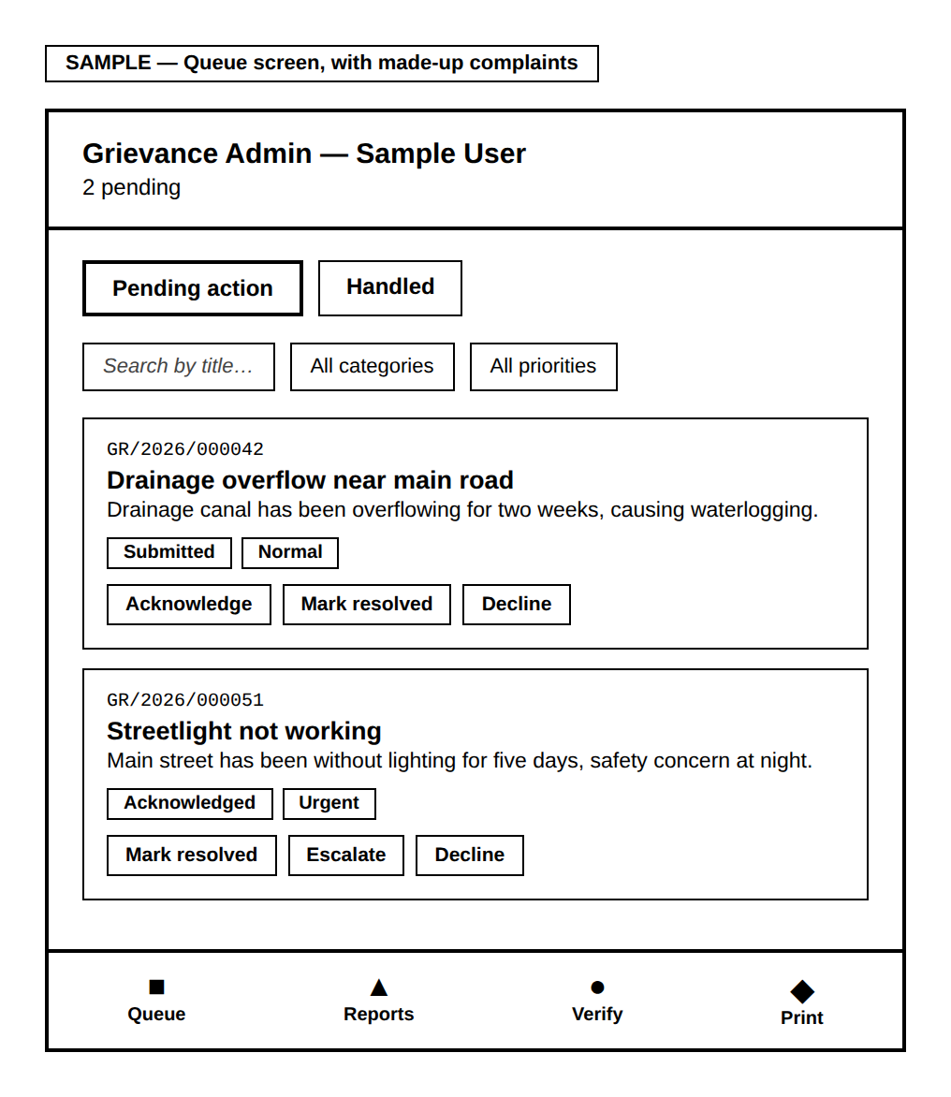
The title bar at the top is generated automatically — it always shows your role and name, plus a live count. The two tabs split complaints by whether they still need action or are already finished. The search box and category/priority filters narrow a long list — only useful once the list is long; for a short list, feel free to just scroll. Every complaint card is created automatically the moment a citizen submits it — you never make one yourself. The action buttons you see on each card change depending on your role and that complaint’s current stage, shown in the table below.

What each role is allowed to press
Role | What they can do to a pending complaint
Representative | Acknowledge it, then Start work, then either Mark resolved, Escalate (send it further up), or Decline with a reason.
Authority | Only on complaints already escalated to them: Approve & sanction, Send it back for more work, or Decline with a reason.
Grievance Admin | Acknowledge, Mark resolved, or Decline with a reason — directly, on any complaint, without the extra steps above.
NOTE: Whenever you press Decline, you must type a reason first — the system will not let you decline without one, because the citizen will read that reason.

How a complaint’s status actually changes
This is the real mechanism behind those buttons — not just what each one is called, but what pressing it actually does.
Submitted  (citizen files it) | → | Acknowledged  (press Acknowledge) | → | In Progress  (press Start work) | → | Resolved  (press Mark resolved)

From Acknowledged or In Progress, a representative can also press Escalate instead of continuing straight to Resolved:
Escalated  (rep sends it up) | → | Sanctioned  (Authority approves)
The Authority role can also press "Send back," which returns an escalated complaint to In Progress instead of approving it.

Every single one of these button presses does the same two things behind the scenes:
• A new entry is written to that complaint’s history log — recording the new stage, who did it, when, and any note left with it.
• The complaint’s own current-stage field is updated to match.
The citizen’s tracking screen (their Section 7) picks this up and shows it immediately — there is no separate notification step, no delay. The moment you press Mark resolved, that is what the citizen sees.
IMPORTANT: The word "Escalated" itself is never shown to the citizen. Citizens query a separate, simplified view of their own complaints that deliberately displays Escalated as "In Progress" instead — the internal Sanctioned/Send back workflow above is for staff and Authority only. A citizen may see "In Progress" for longer than expected while a complaint is genuinely being escalated and reviewed above your office — that is expected, not a bug.
NOTE: Pressing Decline works the same way — it also writes a history entry and updates the stage — but the system requires a reason to be typed first, since that reason is exactly what the citizen reads.
GOOD TO KNOW: Adding a Remark or setting an Assigned Department (below) does NOT move the complaint through this flow at all — it is a way to leave an internal note without forcing a stage change, useful when work is happening but nothing is ready to report to the citizen yet.
GOOD TO KNOW: These same action buttons work identically whether you are on a phone, a desktop browser, or acting on a complaint from within Reports (Section 7) — all three reach the same underlying screen, so nothing is mobile-only.

Opening a complaint’s full detail
Tapping any complaint card opens more detail, including the citizen’s evidence and two extra things you can set:
Field | What it is for
Evidence photos | Any photos or video the citizen attached when filing appear here. You can also add your own evidence photos here — but only photos, not video, and only one at a time (5MB limit each). Video is only ever accepted from the citizen at the moment they first file.
Assigned Department | A free-text note saying which department is handling it — shown later to the District Collector’s office on batch reports.
Remark | An optional internal note. Adding one does not change the complaint’s stage — so you can leave a note without being forced to also change its status.

IF THIS NEEDS TO CHANGE: If a new action or a new filter is ever needed on this screen, that is a request to whoever maintains the system — the list of actions is tied directly to each role’s permissions, so it cannot simply be changed by a staff member.

7. Screen: Reports — Seeing the Bigger Picture
While Queue shows individual complaints, Reports shows patterns and totals across all of them.

7.1 How you get here
This path shows exactly how you arrive at this screen — each arrow is one real click or action, nothing skipped.
You are signed in | → | Bottom menu bar | → | "Reports"

7.2 What this screen looks like
Shown with made-up sample totals, so the real shape and wording are clear:
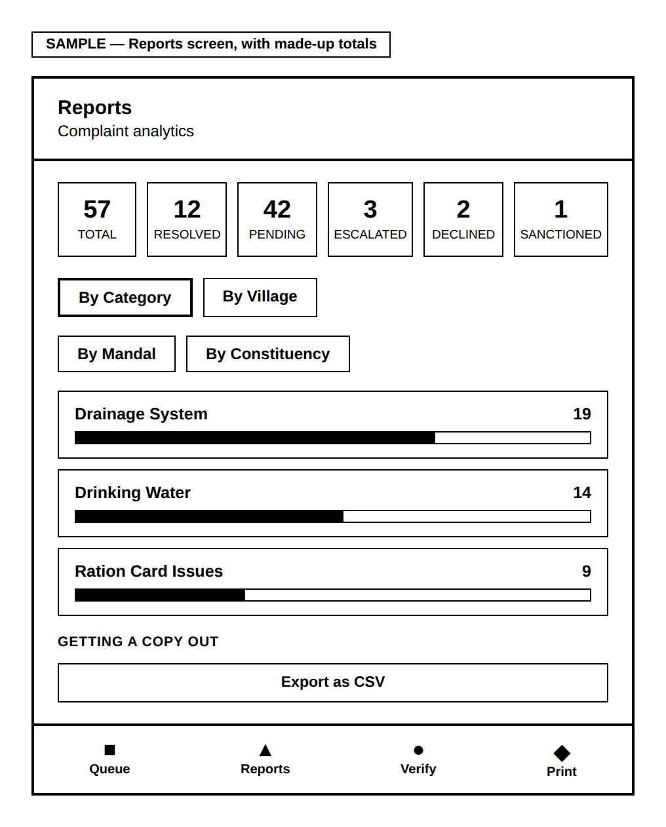
The six summary cards at the top — Total, Resolved, Pending, Escalated, Declined, and Sanctioned — give a fast, at-a-glance total. Declined and Sanctioned both count toward Total but are excluded from Pending, since neither is still "open" work — without these two cards, Total would never quite add up to Resolved + Pending + Escalated, with nothing explaining the gap. The four tabs let you regroup the same complaints by Category, Village, Mandal, or Constituency — switching between them never changes the data, only how it is organised. Each row can be tapped open to reveal the real complaints inside it, sorted so the longest-waiting one appears first.
GOOD TO KNOW: Tapping any individual complaint — whether from an opened row, or from a Patterns group below — opens the exact same detail view used on Queue. You can Acknowledge, Mark resolved, or take any other action for your role directly from Reports; you do not need to go find that complaint again on Queue first.

Patterns & Duplicates — what it actually checks for
This panel is collapsed by default — a count next to its heading tells you if anything was found, so you only open it when it matters. It checks for three distinct things automatically:
What it flags | The real rule behind it
Hotspots | 3 or more complaints, in the same village, about the same category. A real signal that several households are hitting the same underlying problem — stronger case escalated together than as separate low-priority tickets.
Family patterns | 2 or more complaints where the citizens share the same father’s/husband’s name and village — likely the same household filing under different names or for different issues.
Exact duplicates | The same citizen filing the same category twice within 24 hours — almost always an accidental double-submit, flagged so it is not mistaken for two separate problems.
Every complaint shown in any of these three groups is itself tappable, opening the same actionable detail view mentioned above.

Getting a copy out of the system
Button | What it makes
Export as CSV | A spreadsheet file with one row per group (Name, Total, Resolved, Pending, Urgent, Escalated), using whatever grouping and filters are currently selected on screen.
HONEST NOTE: There is currently no PDF or print-formatted export on this screen — only the plain CSV button above. If a print-ready version of Reports is ever needed, that is a request to whoever maintains the system.

IF THIS NEEDS TO CHANGE: Adding a fifth way to group complaints (beyond Village/Mandal/Category/Constituency), or a new pattern-detection rule, is a request to whoever maintains the system, since each is built from its own underlying data/logic.

8. Screen: Print — Letters and Reports
Every printable document in CTS is produced here — from a single citizen’s formal letter to a full batch report for the District Collector.

8.1 How you get here
This path shows exactly how you arrive at this screen — each arrow is one real click or action, nothing skipped.
You are signed in | → | Bottom menu bar | → | "Print"
You can also arrive here directly from a "Print this view" button on the Queue screen, which brings your current search/filter choices along with it.

8.2 The three kinds of document
Shown here as the actual mode-selector screen you choose from:
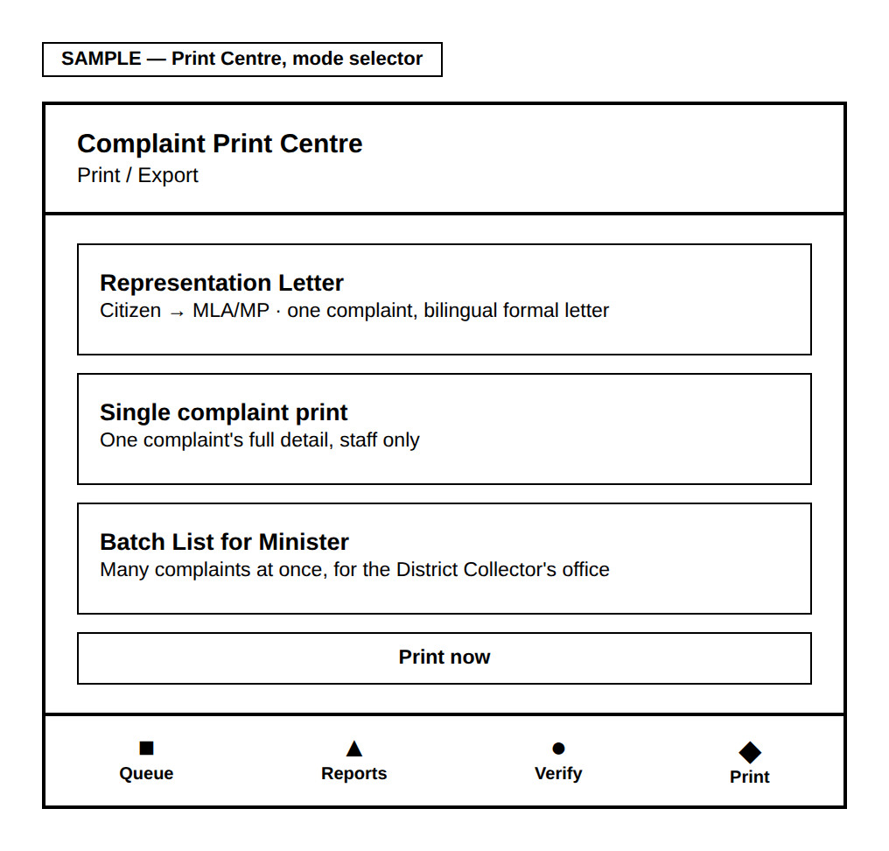
Representation Letter turns one complaint into a formal, bilingual letter from the citizen to their MLA/MP — it is the only one of the three a citizen can produce themselves. Single complaint print is one complaint’s full detail, staff only. Batch List for Minister lays out many complaints at once, sideways (landscape), staff only.

Whichever one you choose, pressing "Print now" opens your browser’s own print window — from there you can print on paper, or choose "Save as PDF" to keep a digital copy instead.

8.3 Sample output — what a Representation Letter actually looks like
Instead of only describing it, here is a real example — built with made-up sample details so you can see the exact layout, wording, and bilingual formatting a citizen and MLA/MP office would actually receive.
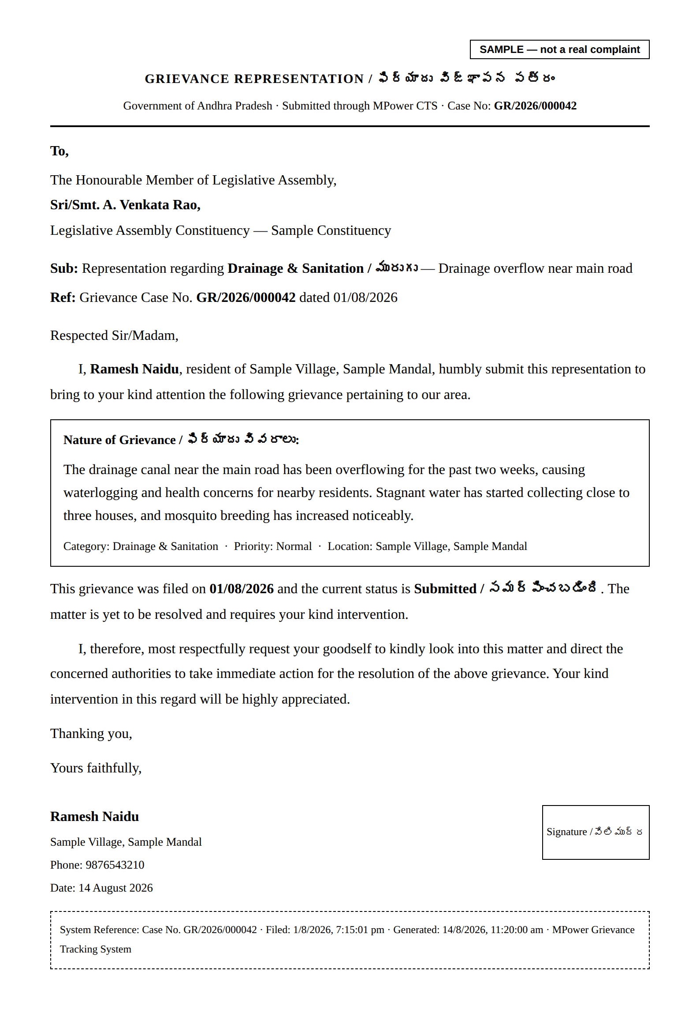
ABOUT THIS SAMPLE: Every name, village, phone number, and case number on this sample is invented for illustration. No real citizen’s data is shown here.

8.4 Sample output — what a Batch List for Minister actually looks like
This is the report a constituency office would hand to the District Collector — built here with a small set of made-up sample complaints so the real layout is visible: the letterhead, the executive summary table, and the category-by-category detail table with blank columns for the Collector’s office to fill in by hand.
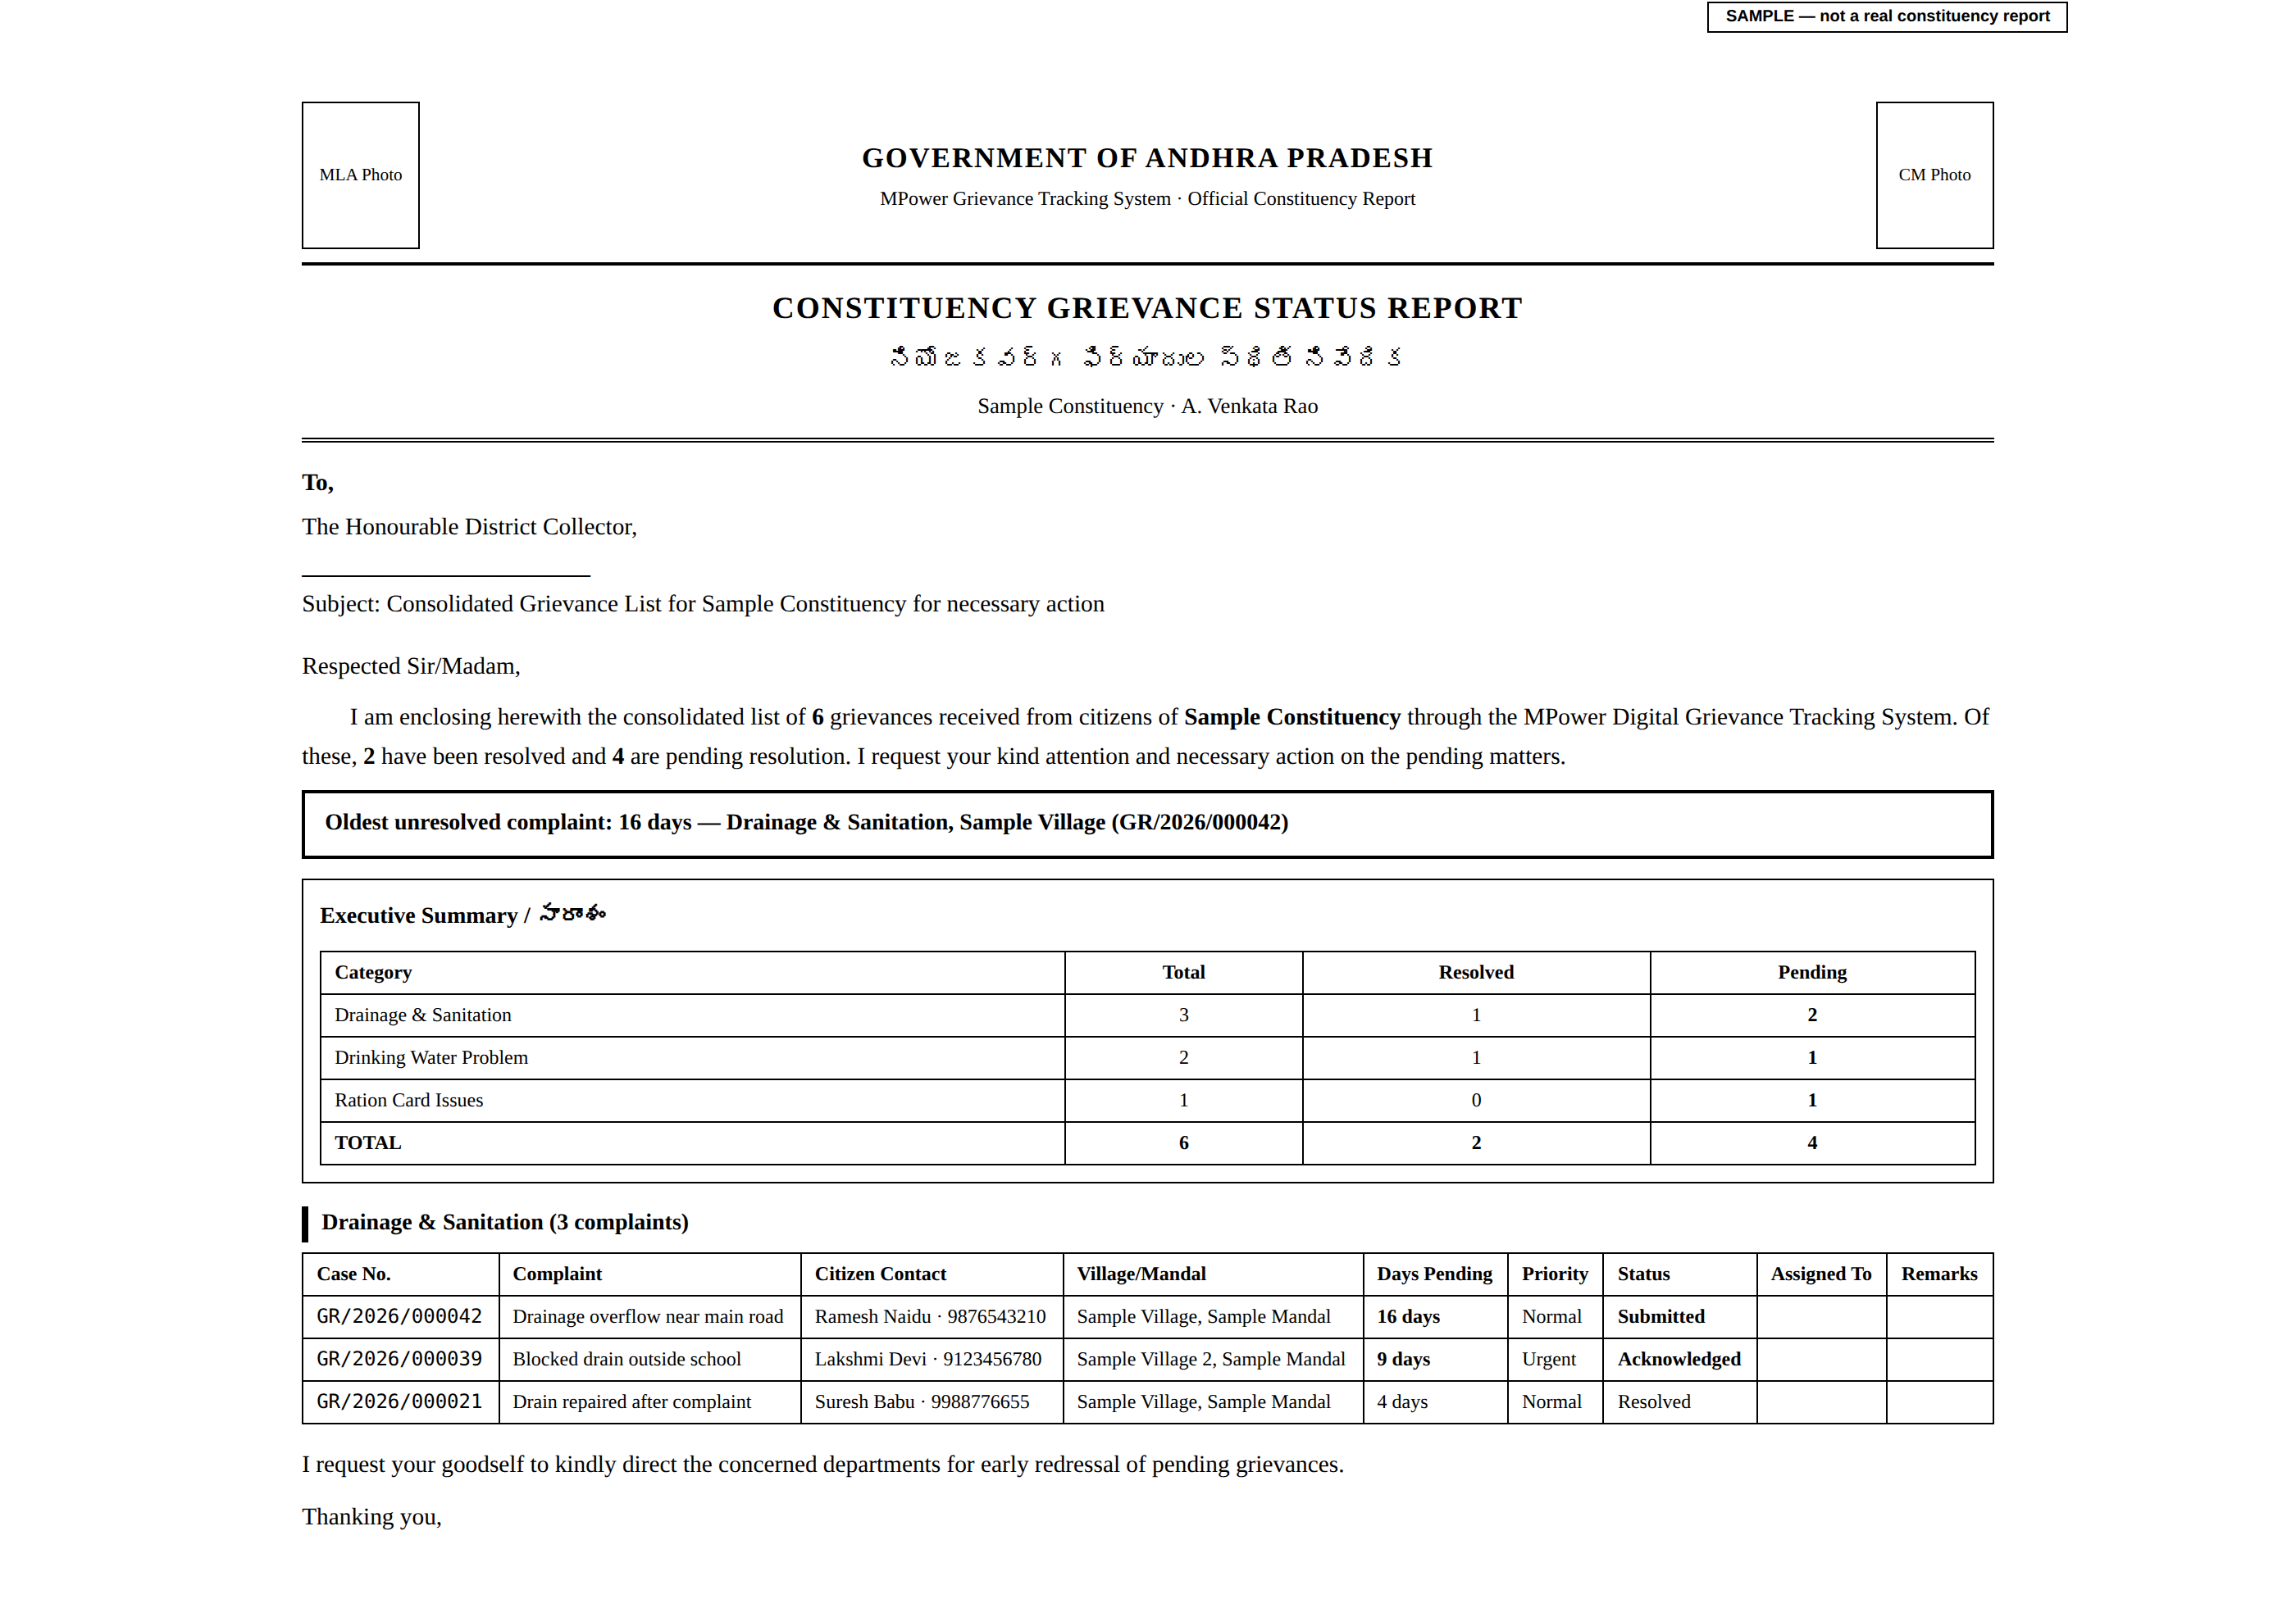
ABOUT THIS SAMPLE: Every office name, citizen name, phone number, and complaint on this sample is invented for illustration. No real citizen’s data is shown here.

IF THIS NEEDS TO CHANGE: A fourth kind of printed document, or a change to what appears on any of these three, is a request to whoever maintains the system.

9. Screen: App Feedback
Shows what citizens and staff have said about the CTS app itself — not about any specific complaint, but about how easy or hard the tool itself is to use. Only Grievance Admin, Developer, and Support can see this.

9.1 How you get here
This path shows exactly how you arrive at this screen — each arrow is one real click or action, nothing skipped.
You are signed in | → | "Verify" screen | → | "View App Feedback" link
This screen is deliberately not on the main bottom menu — it is used less often than Queue or Reports, so keeping it one extra tap away avoids crowding the main menu.

9.2 What this screen looks like
Shown with two made-up sample entries:
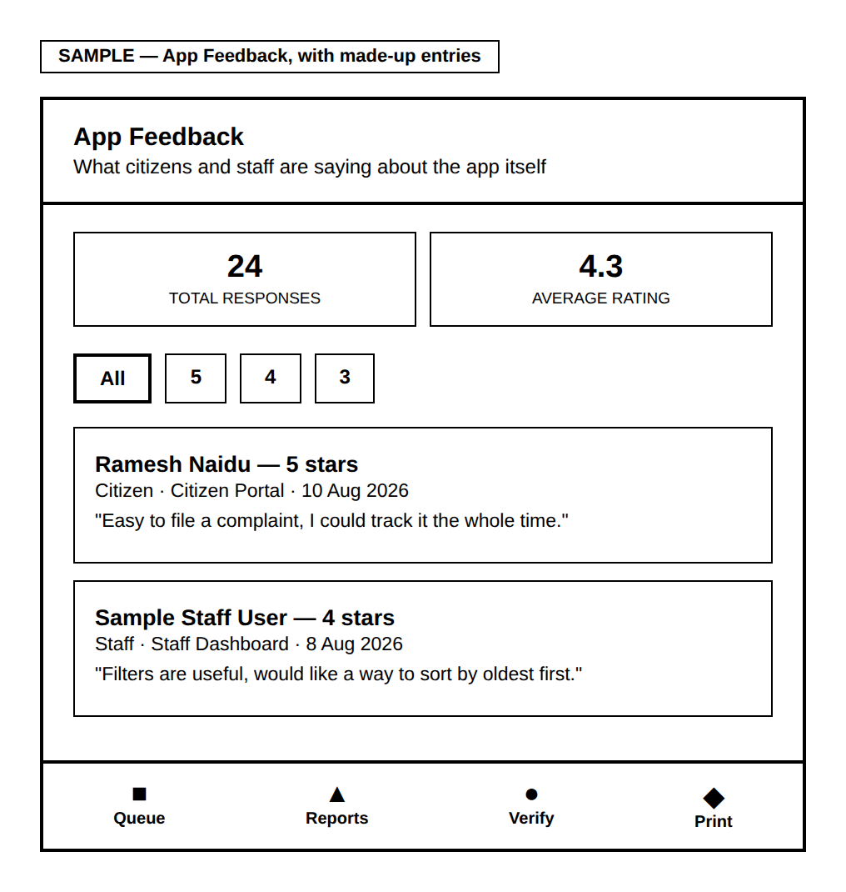
The summary cards give the total number of responses and the average star rating at a glance. The star filter lets you look at only the 5-star comments, or only the 1-star ones, instead of scrolling through everything. Each entry shows whether the person was a citizen or staff, which screen they were on when they left it, the date, and what they wrote.
This screen is read-only — there is nothing to fill in here yourself.

IF THIS NEEDS TO CHANGE: Replying directly to feedback from this screen does not currently exist — that would be a request to whoever maintains the system.

10. Quick Reference
Screen | How to get there | Section
Sign in | Login page (given to your office) | 2
Register a new office | CTS page → "I am an MLA/MP Office" → "Register here" | 3
Approve an office | Bottom menu → Verify | 4
Work a complaint | Bottom menu → Queue | 6
See charts & totals | Bottom menu → Reports | 7
Print a letter or report | Bottom menu → Print | 8
See app feedback | Verify screen → "View App Feedback" | 9

Appendix: Roles at a Glance
Role | What they can see and do
Grievance Admin | The whole state; can act on any complaint; approves new offices; sees App Feedback.
Representative | Their own constituency only; works complaints step by step from Acknowledge through to Resolved/Escalated/Declined.
Authority | Their own constituency; only handles complaints already escalated to them.
Developer / Support | Same as Grievance Admin, used by MPower’s own team.

This guide reflects the CTS module as of August 2026. Some things — such as signing in with just a phone number — are planned but do not exist yet; look for "IF THIS NEEDS TO CHANGE" boxes throughout for details.

