ECA5604- 5g/6g communication
Slot A
M.Pregna
192412350
Ex.No. 13: V2X Latency Comparison
AIM:
To simulate and compare the performance of a Vehicle-to-Everything (V2X)
communication system by analyzing End-to-End Latency (ms), Packet Delivery Ratio (%),
and Vehicle Speed (km/h) using MATLAB.
Objective 1:
clc;
clear;
close all;
% Vehicle Speed (km/h)
speed = 20:20:120;
% Simulated End-to-End Latency (ms)
latency = [18 16 14 12 10 9];
disp('Vehicle Speed (km/h) End-to-End Latency (ms)')
disp([speed' latency'])

figure
% -------- Graph 1 --------
subplot(2,1,1)
plot(speed,latency,'-o','LineWidth',2)
title('Vehicle Speed vs End-to-End Latency')
xlabel('Vehicle Speed (km/h)')
ylabel('Latency (ms)')
grid on
% -------- Graph 2 --------
subplot(2,1,2)
plot(1:length(latency),latency,'-s','LineWidth',2)
title('Latency Variation Across Vehicles')
xlabel('Vehicle Index')
ylabel('End-to-End Latency (ms)')
grid on

output:
\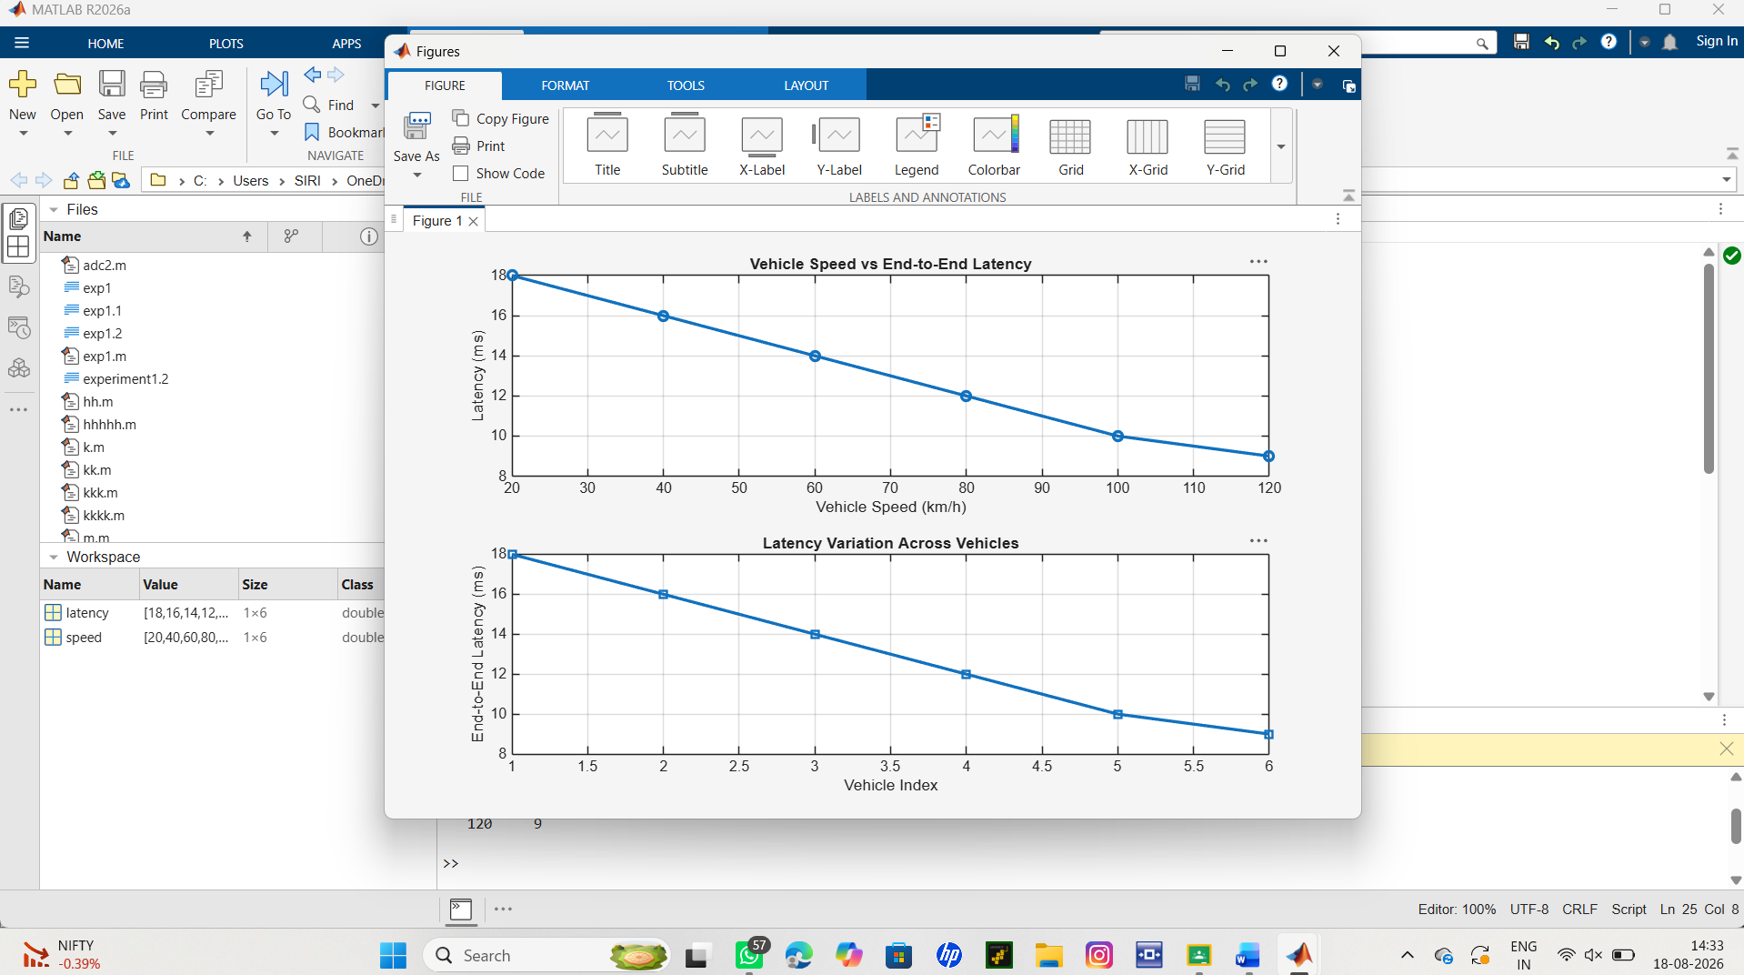

Objective 2:
clc;
clear;
close all;
% Vehicle Speed (km/h)

speed = 20:20:120;
% Simulated Packet Delivery Ratio (%)
PDR = [99 98 97 95 93 90];
disp('Vehicle Speed (km/h) Packet Delivery Ratio (%)')
disp([speed' PDR'])
figure
% -------- Graph 1 --------
subplot(2,1,1)
plot(speed,PDR,'-o','LineWidth',2)
title('Vehicle Speed vs Packet Delivery Ratio')
xlabel('Vehicle Speed (km/h)')
ylabel('Packet Delivery Ratio (%)')
grid on
% -------- Graph 2 --------
subplot(2,1,2)
plot(1:length(PDR),PDR,'-s','LineWidth',2)
title('Packet Delivery Ratio Across Vehicles')
xlabel('Vehicle Index')
ylabel('Packet Delivery Ratio (%)')
grid on
output:
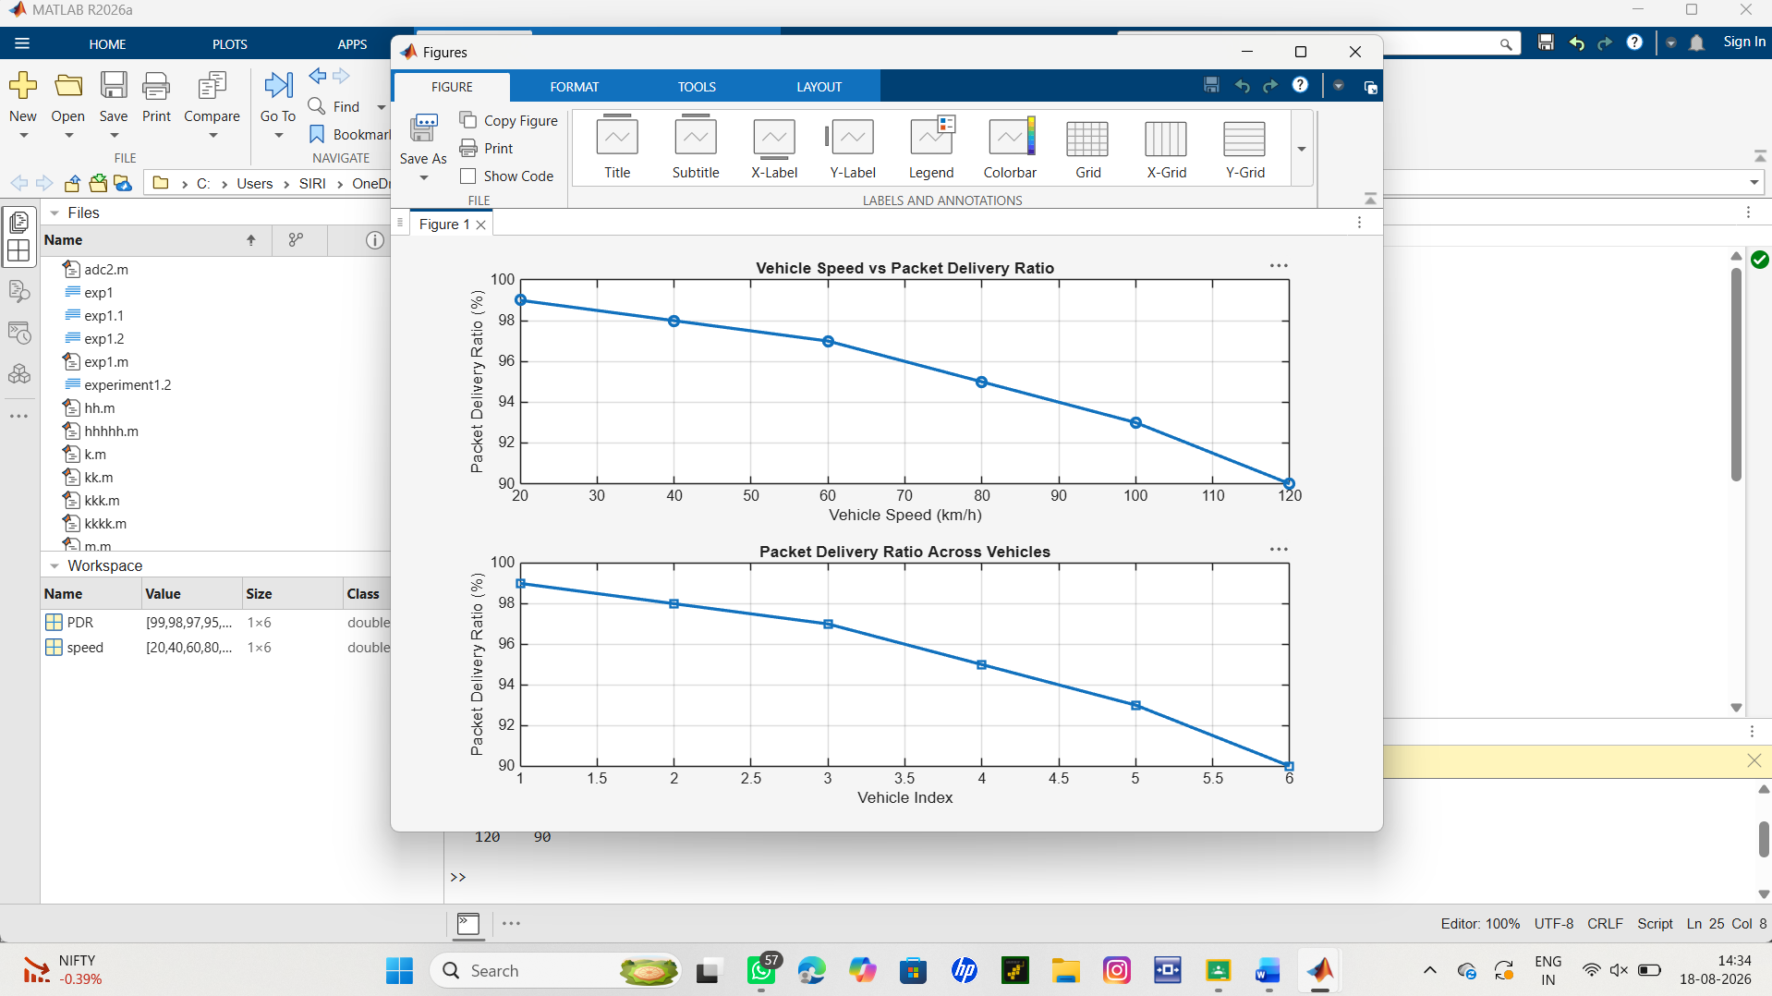
Objective 3:
clc;
clear;
close all;
% Vehicle IDs
vehicle = 1:6;
% Vehicle Speed (km/h)
speed = [30 45 60 75 90 105];
% Communication Range (m)
range = [280 260 240 220 200 180];
disp('Vehicle Speed(km/h) Communication Range(m)')
disp([vehicle' speed' range'])
figure
% -------- Graph 1 --------
subplot(2,1,1)
plot(vehicle,speed,'-o','LineWidth',2)
title('Vehicle Speed of Different Vehicles')
xlabel('Vehicle Index')
ylabel('Vehicle Speed (km/h)')
grid on
% -------- Graph 2 --------
subplot(2,1,2)
plot(speed,range,'-s','LineWidth',2)
title('Vehicle Speed vs Communication Range')
xlabel('Vehicle Speed (km/h)')
ylabel('Communication Range (m)')
grid on
output:
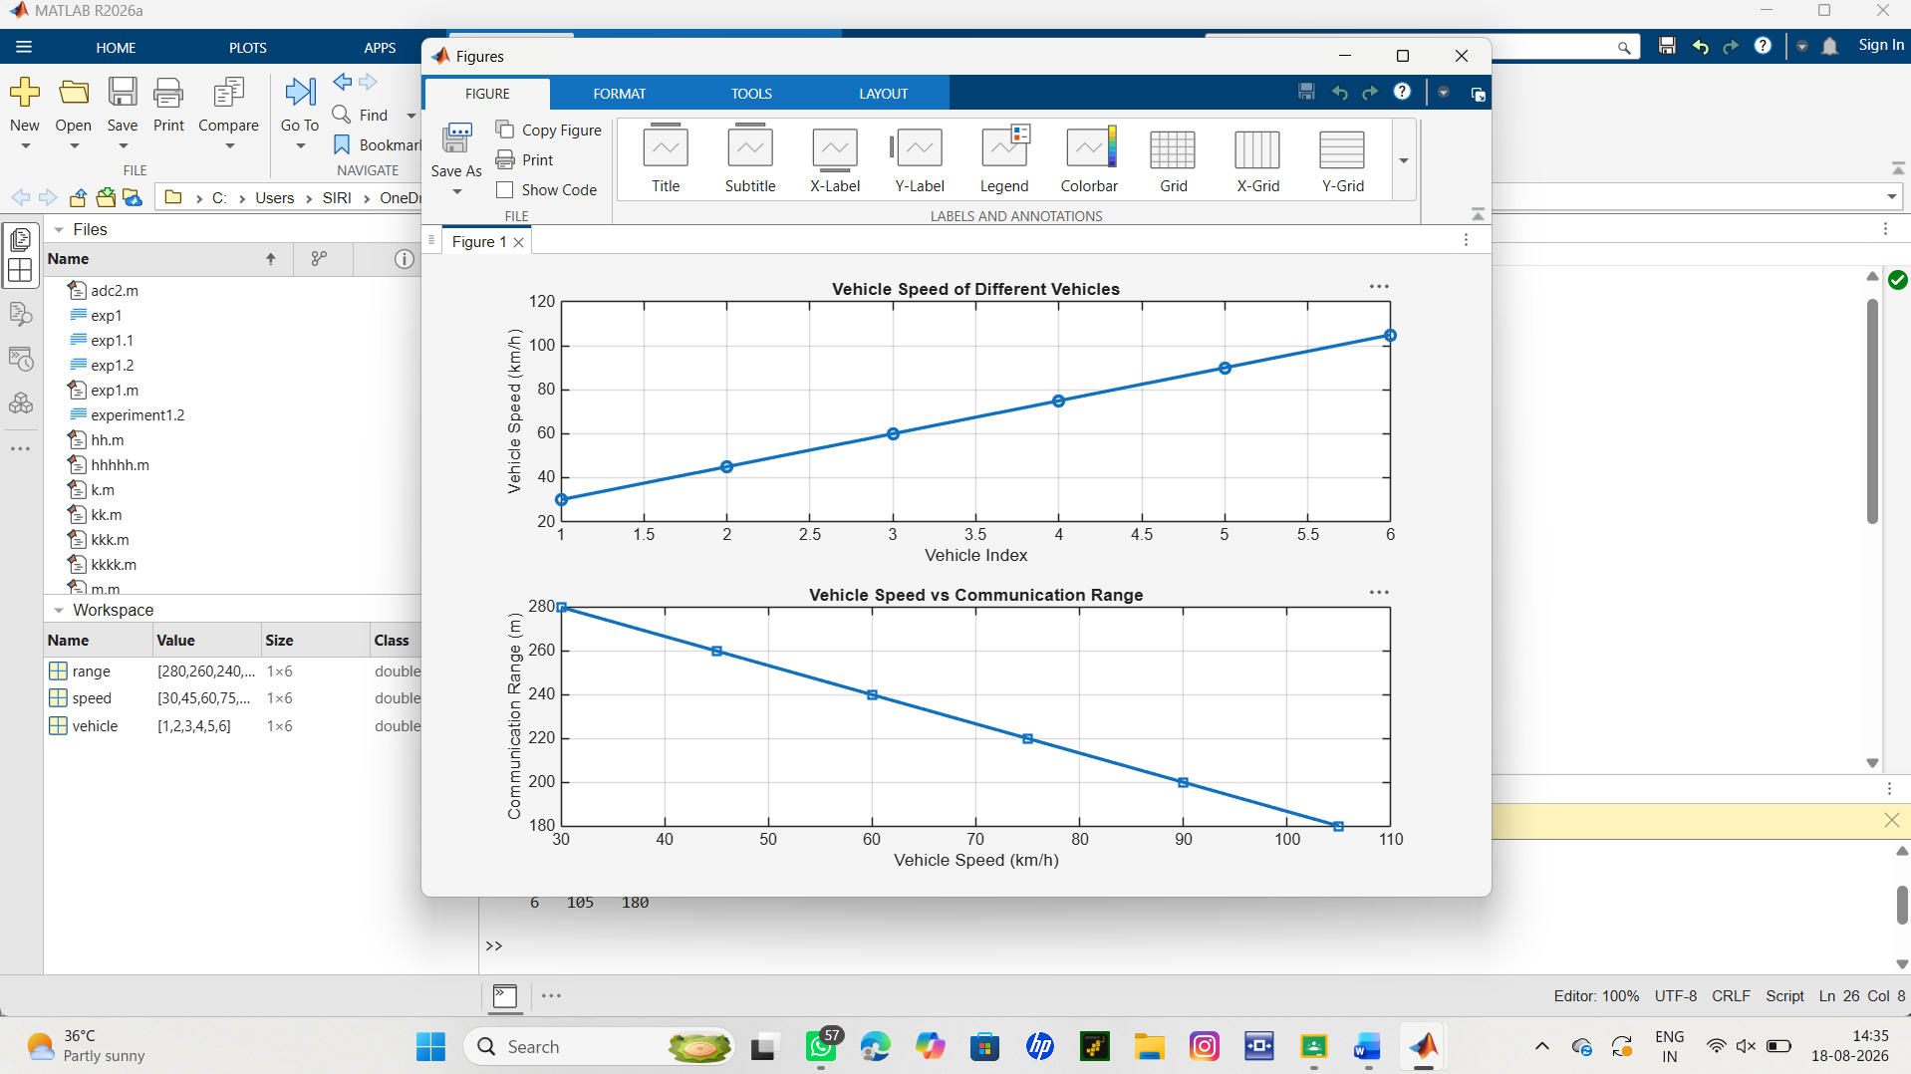
Result:
The first graph shows the variation in speed among different vehicles in the V2X
communication network.
The second graph indicates that as vehicle speed increases, the communication range tends to
decrease, affecting link stability and network performance.

