ECA5604- 5g/6g communication
Slot A
M.Pregna
192412350
Experiment 10: 5G Network Slicing Environment Using MATLAB5G Network Slicing Environment Using MATLAB
AIM:
To analyze the performance of a 5G Network Slicing environment by studying the number of
network slices, slice utilization, and end-to-end latency using MATLAB.
Objective 1:
Analyze the creation and allocation of multiple network slices in a 5G network using MATLAB.
Observe how different slices can be configured to support diverse service requirements and
applications.
Matlab Code:
clc;
clear;
close all;
slices = {'eMBB','URLLC','mMTC','Private','IoT'};

count = [1 1 1 1 1]; % One instance of each network slice
figure
bar(count)
grid on
set(gca,'XTickLabel',slices)
xlabel('Network Slice Type')
ylabel('Number of Network Slices')
title('Number of Configured 5G Network Slices')

output:
\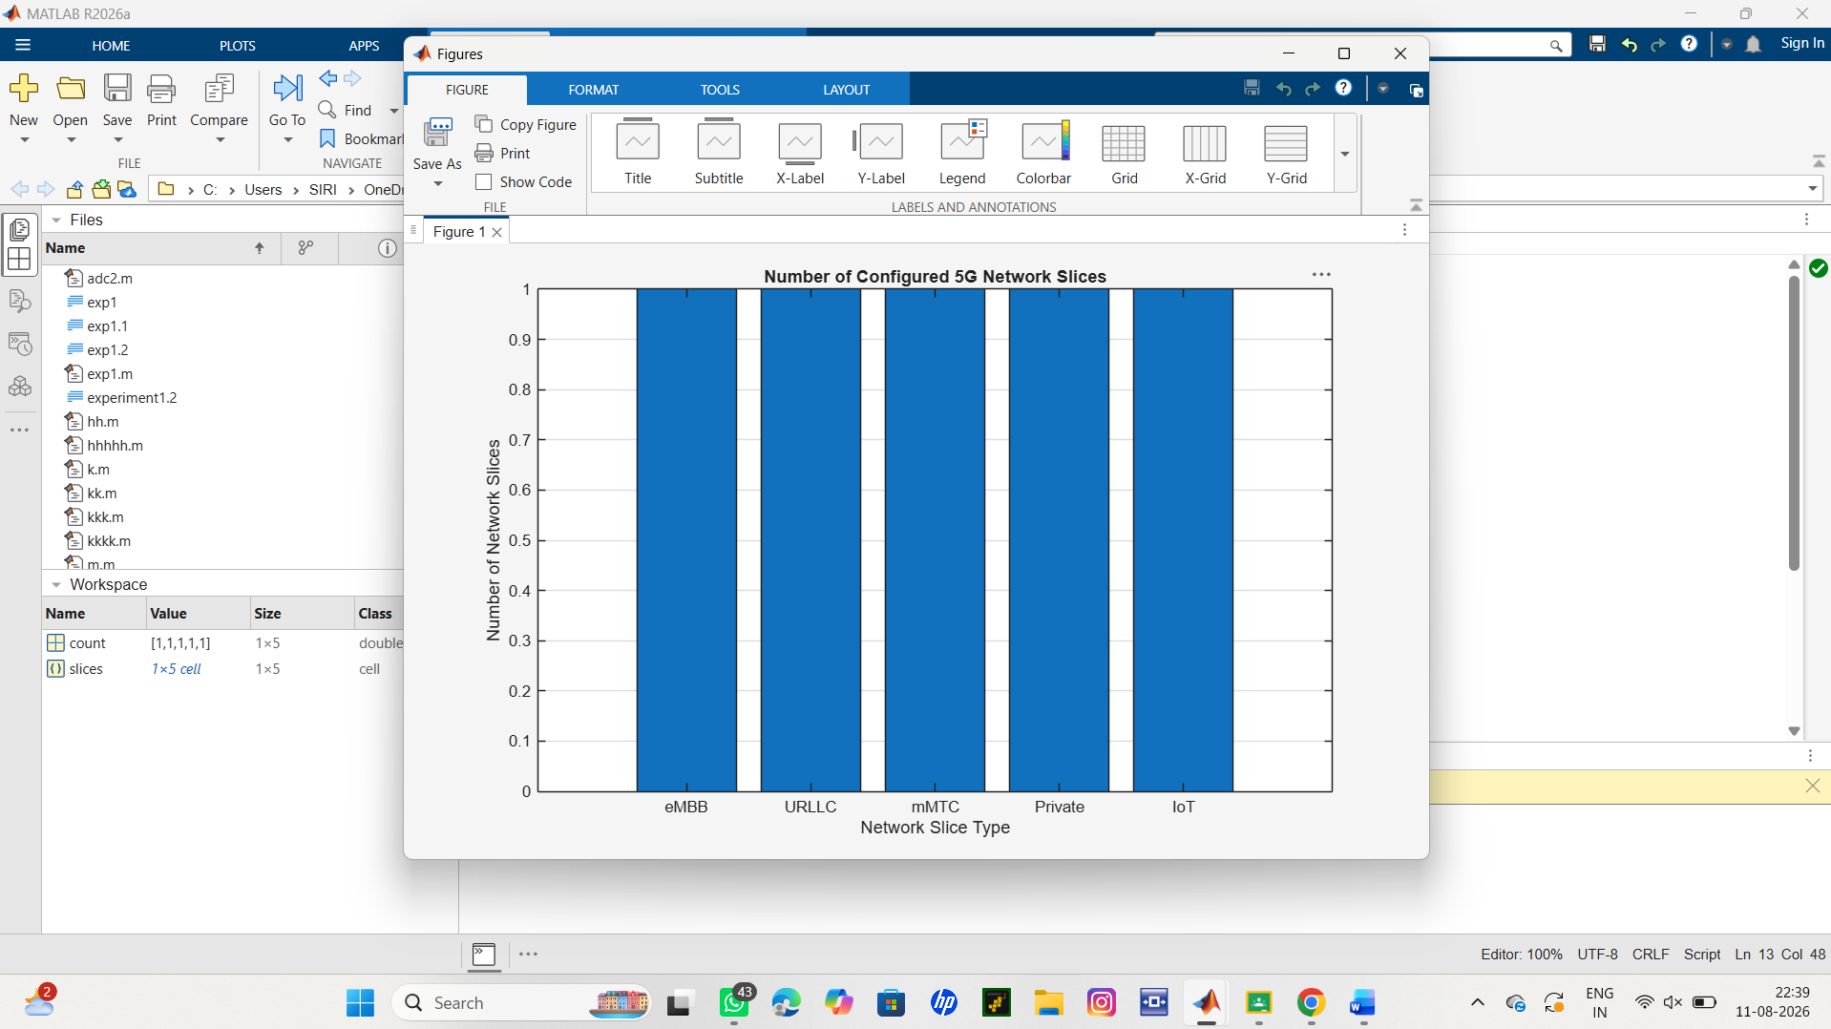

Objective 2:
Analyze the utilization percentage of different network slices using MATLAB. Compare the
resource usage of each slice to evaluate network efficiency.
Matlab Code:
clc;
clear;
close all;
slices = categorical({'eMBB','URLLC','mMTC','Private','IoT'});
utilization = [85 70 60 75 50];

figure;
bar(slices, utilization);
grid on;
xlabel('Network Slice Type');
ylabel('Slice Utilization (%)');
title('Slice Utilization in 5G Network Slicing');
ylim([0 100]);
output:
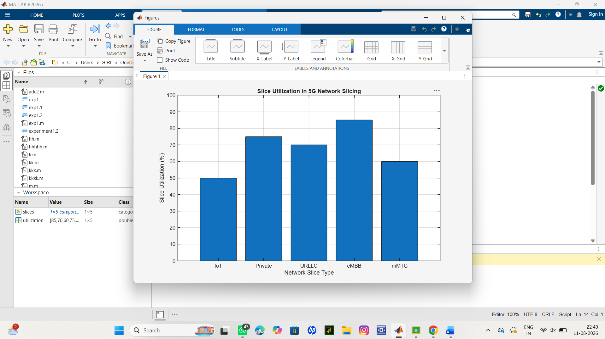
Objective 3:
Compare the end-to-end latency of different network slices using MATLAB. Observe how latency
varies depending on the service requirements of each slice.
Matlab Code:
clc;
clear;
close all;
slices = [1 2 3 4 5];
latency = [25 5 40 15 60];
figure;
plot(slices, latency, '-o','LineWidth',2,'MarkerSize',8);
grid on;

xticks(slices);
xticklabels({'eMBB','URLLC','mMTC','Private','IoT'});
xlabel('Network Slice Type');
ylabel('End-to-End Latency (ms)');
title('5G Network Slicing: End-to-End Latency');
ylim([0 70]);
output:
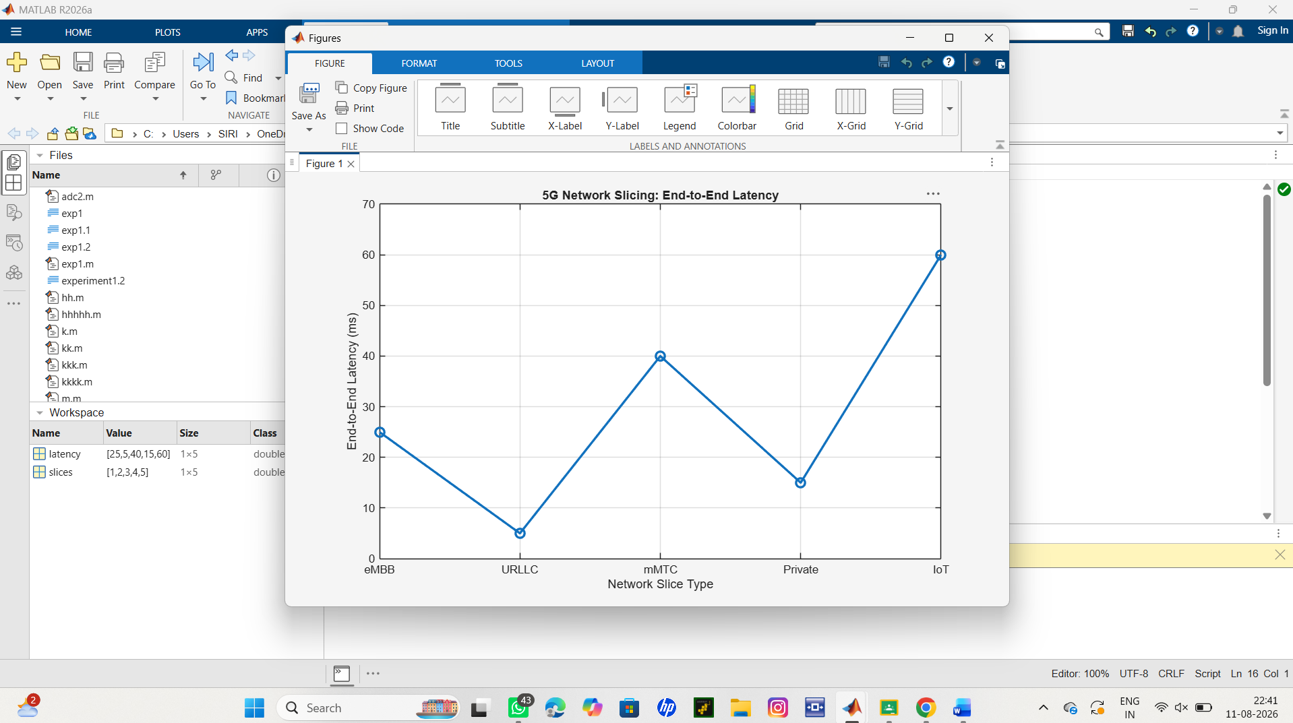
Result:
The MATLAB analysis successfully demonstrated the characteristics of a 5G Network
Slicing environment. The results showed that multiple network slices can coexist while
exhibiting different utilization levels and latency characteristics based on their intended
services.

