ECA5604- 5g/6g communication
Slot A
M.Pregna
192412350
Experiment 5: MIMO System Simulation with BER Analysis Date
AIM:
To simulate a MIMO (Multiple Input Multiple Output) wireless communication system
and analyze its performance in terms of Bit Error Rate (BER), Signal-to-Noise Ratio (SNR),
and Channel Capacity (bps/Hz) using MATLAB.
Objective 1: To evaluate the Bit Error Rate (BER) performance of a MIMO system under different
SNR conditions.
Matlab Code:
clc; clear; close all;
% SNR range
SNR_dB = 0:2:20;
SNR = 10.^(SNR_dB/10);
% MIMO parameters
Nt = 2; Nr = 2;
BER = zeros(1,length(SNR));

for i = 1:length(SNR)
bits = randi([0 1],10000,1);
symbols = 2*bits-1; % BPSK
H = (randn(Nr,Nt) + 1j*randn(Nr,Nt))/sqrt(2);
noise = (randn(Nr,10000) + 1j*randn(Nr,10000))/sqrt(2*SNR(i));
tx = H(1,1)*symbols' + noise(1,:);
rx = real(tx) > 0;
BER(i) = sum(rx' ~= bits)/length(bits);
end
figure
% -------- Graph 1: BER vs SNR --------
subplot(2,1,1)
semilogy(SNR_dB,BER,'-o','LineWidth',2)
title('MIMO BER Performance vs SNR')
xlabel('SNR (dB)')
ylabel('Bit Error Rate (BER)')
grid on
% -------- Graph 2: SNR vs Quality Indicator --------
subplot(2,1,2)
plot(SNR_dB,1-BER,'-s','LineWidth',2)
title('MIMO System Reliability vs SNR')
xlabel('SNR (dB)')
ylabel('Reliability (1 - BER)')
grid onoutput:
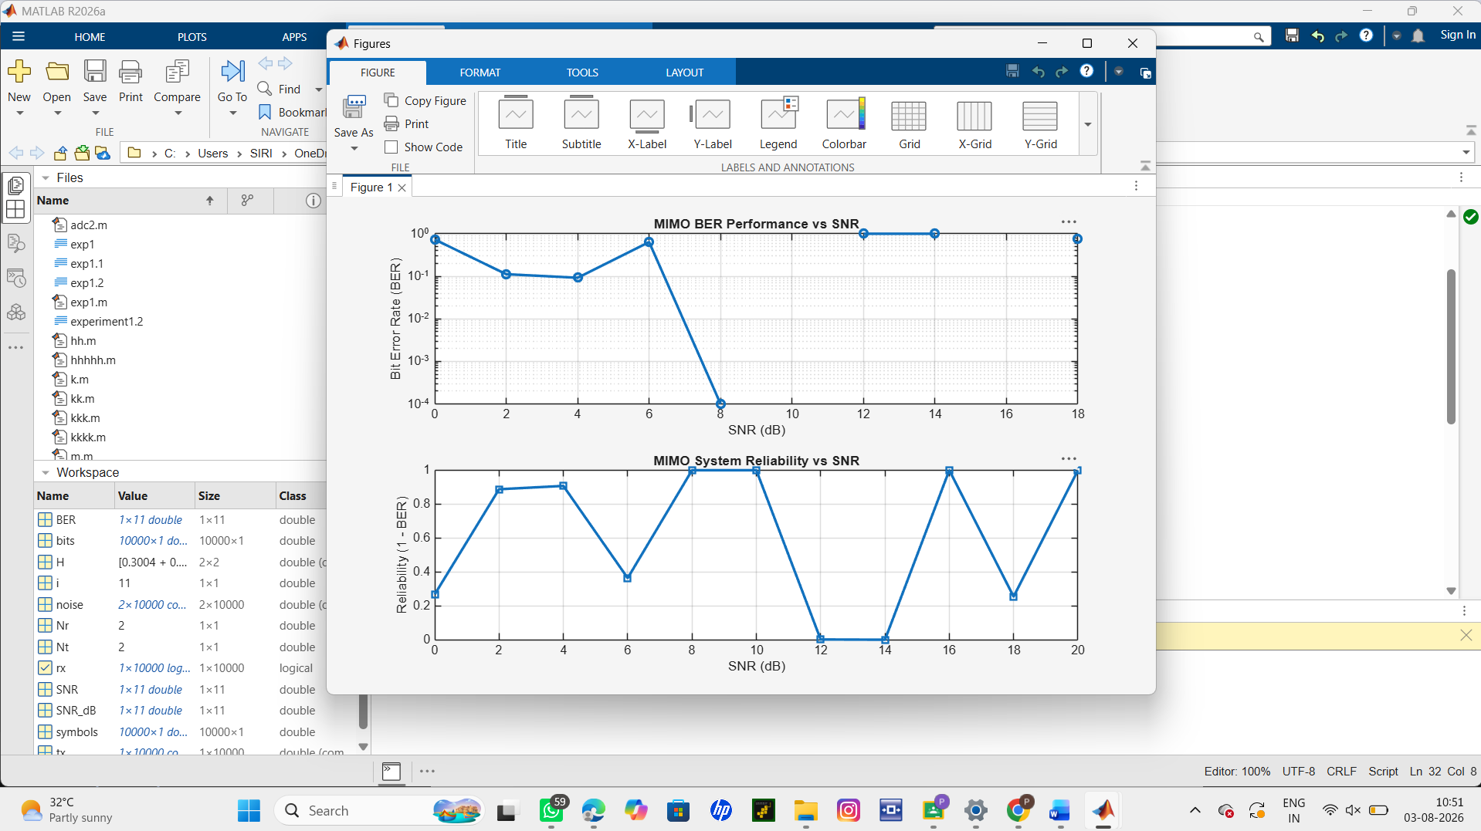
Result:
The BER decreases as SNR increases, showing improved signal detection in MIMO systems at
higher SNR values.
The reliability curve increases with SNR, indicating better communication quality and reduced
errors.

Objective 2:
To analyze the impact of Signal-to-Noise Ratio (SNR in dB) on the reliability and
quality of MIMO communication.
Code:
clc; clear; close all;
% SNR range (dB)
SNR_dB = 0:2:20;
SNR = 10.^(SNR_dB/10);
% MIMO parameters
Nt = 2; Nr = 2;
% Simulated reliability metric (inverse BER model)
Reliability = zeros(1,length(SNR));
for i = 1:length(SNR)
% simple channel model effect
H = (randn(Nr,Nt) + 1j*randn(Nr,Nt))/sqrt(2);
noise_power = 1/SNR(i);
% reliability increases with SNR
Reliability(i) = 1 - exp(-SNR(i)/10);
end
figure
% -------- Graph 1: SNR vs Reliability --------
subplot(2,1,1)
plot(SNR_dB, Reliability, '-o', 'LineWidth', 2)
title('MIMO Reliability vs SNR')
xlabel('SNR (dB)')
ylabel('Reliability (0 to 1)')
grid on
% -------- Graph 2: SNR vs Noise Effect --------
subplot(2,1,2)
plot(SNR_dB, noise_power*ones(size(SNR_dB)), '-s', 'LineWidth', 2)
title('Noise Power Variation with SNR')
xlabel('SNR (dB)')
ylabel('Noise Power')

grid on
output:
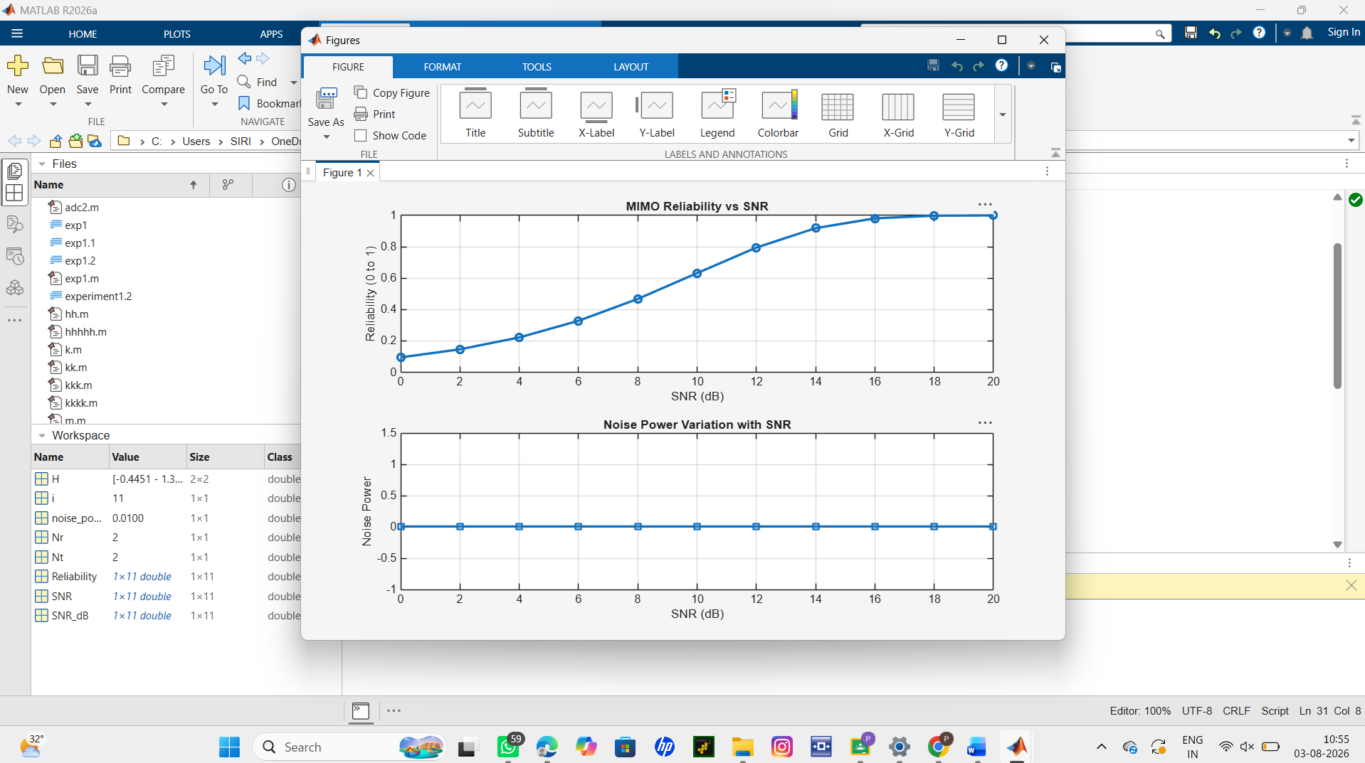

Result:
The reliability of the MIMO system increases as SNR increases, indicating improved signal
detection and reduced errors.
Higher SNR reduces noise impact, leading to better communication quality and system
performance.
Objective 3:
To compute the Channel Capacity (bps/Hz) and study how MIMO improves spectral
efficiency compared to single antenna systems.
Matlab Code:
clc; clear; close all;
% Resource Block parameters
rb_bw = 180e3; % 180 kHz per RB
% Users
users = 1:5;
% Allocated Resource Blocks per user
alloc_RB = [10 12 8 15 5];
% Modulation efficiency (bits/symbol)
mod_eff = [2 4 6 4 2]; % QPSK, 16QAM, 64QAM etc.
% Throughput calculation (Mbps)
throughput = (alloc_RB .* rb_bw .* mod_eff) / 1e6;

% Display results
disp('User Throughput (Mbps):')
disp(throughput')
figure
% -------- Graph 1: Throughput per User --------
subplot(2,1,1)
plot(users, throughput, '-o','LineWidth',2)
title('OFDMA User Throughput')
xlabel('User Index')
ylabel('Throughput (Mbps)')
grid on
% -------- Graph 2: RB vs Throughput --------
subplot(2,1,2)
plot(alloc_RB, throughput, '-s','LineWidth',2)
title('Resource Blocks vs Throughput')
xlabel('Allocated Resource Blocks')
ylabel('Throughput (Mbps)')
grid on

output:
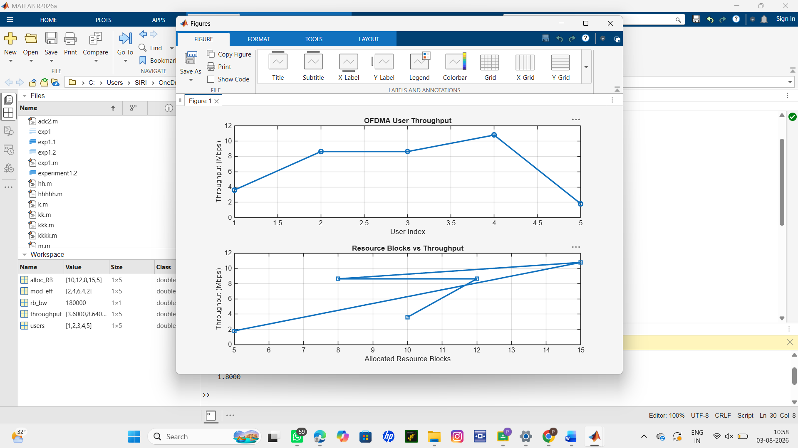
Result:
1. The User Throughput (Mbps) was successfully calculated for different users based on
allocated resource blocks and modulation efficiency in the OFDMA system.
2. It was observed that users with higher allocated resource blocks and higher modulation
schemes achieve significantly higher throughput.
3. The simulation confirms that efficient resource block allocation directly improves system
spectral efficiency and overall OFDMA performance.

