Applied Generative AI Specialisation
Capstone Project Report
Banking Customer Support AI Agent
using Multi-Agent Architecture
LangGraph · Groq LLM · SQLite · Streamlit

Submitted by: M R ARAVINDHAN
Date: August 2026

Table of Contents
Table of Contents 2
1. Abstract 3
2. Problem Statement and Objectives 3
3. System Architecture 3
3.1 Shared agent state 4
3.2 Workflow wiring 4
4. Agent Design 4
4.1 Agent 1 — Classifier Agent 4
4.2 Agent 2 — Feedback Handler Agent 5
4.3 Agent 3 — Query Handler Agent 5
5. Database Design 5
5.1 Table: support_tickets 5
5.2 Table: interaction_logs 6
5.3 Seed data 6
6. Implementation Details 6
6.1 Configurable Groq API key 6
6.2 Reliability: graceful degradation 6
6.3 Deliverables 6
7. LLMOps — Model Evaluation 7
7.1 Results 7
7.2 LLM-as-judge QA scoring 7
8. Streamlit User Interface 7
8.1 Assistant — chat with agent-path visibility 8
8.2 Ticket Database 8
8.3 Evaluation dashboard 9
8.4 Logs & Debug — prompt trace inspector 9
8.5 Test Scenarios 10
9. Sample Use-Case Flows (Verified Outputs) 10
10. How to Run 10
11. Conclusion and Future Enhancements 11

1. Abstract
Modern digital banking platforms handle a high volume of customer service interactions, often through fragmented systems that struggle to personalise responses or provide timely status updates. This capstone project designs and implements a multi-agent Generative AI assistant that automates the first line of banking customer support: it classifies every incoming message, thanks customers for positive feedback with a personalised note, converts complaints into tracked support tickets with unique 6-digit numbers, and answers ticket-status queries directly from a support database.
The system is orchestrated with LangGraph (a state-machine framework for multi-agent workflows), uses the Groq LLM API with a fully configurable API key for natural-language generation, persists tickets and interaction logs in SQLite, and exposes an interactive Streamlit dashboard. A complete LLMOps layer covers the second half of the problem statement: a 30-case labelled evaluation suite measuring classification accuracy, agent routing success and response quality, structured logging with per-message prompt traces, and a debugging view. A deterministic rule-based fallback engine keeps every workflow operational even when no LLM key is configured, which makes the system robust for demonstration and grading environments.

2. Problem Statement and Objectives
The objective is to design and implement a multi-agent AI assistant for banking customer support that handles:
- Classification of incoming user messages into feedback (positive or negative) or queries
- Personalised responses based on classification and user sentiment
- Ticket tracking and updates through integration with a support database
The capstone is divided into two parts:
- Part 1 — Multi-Agent Design and Execution Logic: a Classifier Agent that routes messages, a Feedback Handler Agent (personalised thank-you for positive feedback; ticket creation plus an empathetic reply for negative feedback), and a Query Handler Agent that extracts ticket numbers and reports their status from the support_tickets table.
- Part 2 — LLMOps with Evaluation and UI: model evaluation (QA-based scoring, test-case coverage, routing success rate), a Streamlit dashboard that simulates agent routing and displays classification, responses, database interactions, history and logs, and a logs/debugging view with prompt traces.
All three sample use-case flows from the problem statement are reproduced by the implemented system, character-for-character where formats are prescribed.

3. System Architecture
The system is a LangGraph StateGraph with four nodes. The Classifier Agent is the entry point; a conditional routing edge inspects the classification stored in the shared state and dispatches the message to exactly one of three downstream handlers. Every handler terminates the graph and the final state — response text, agent path, ticket action, latency and prompt traces — is logged to the database and rendered in the UI.
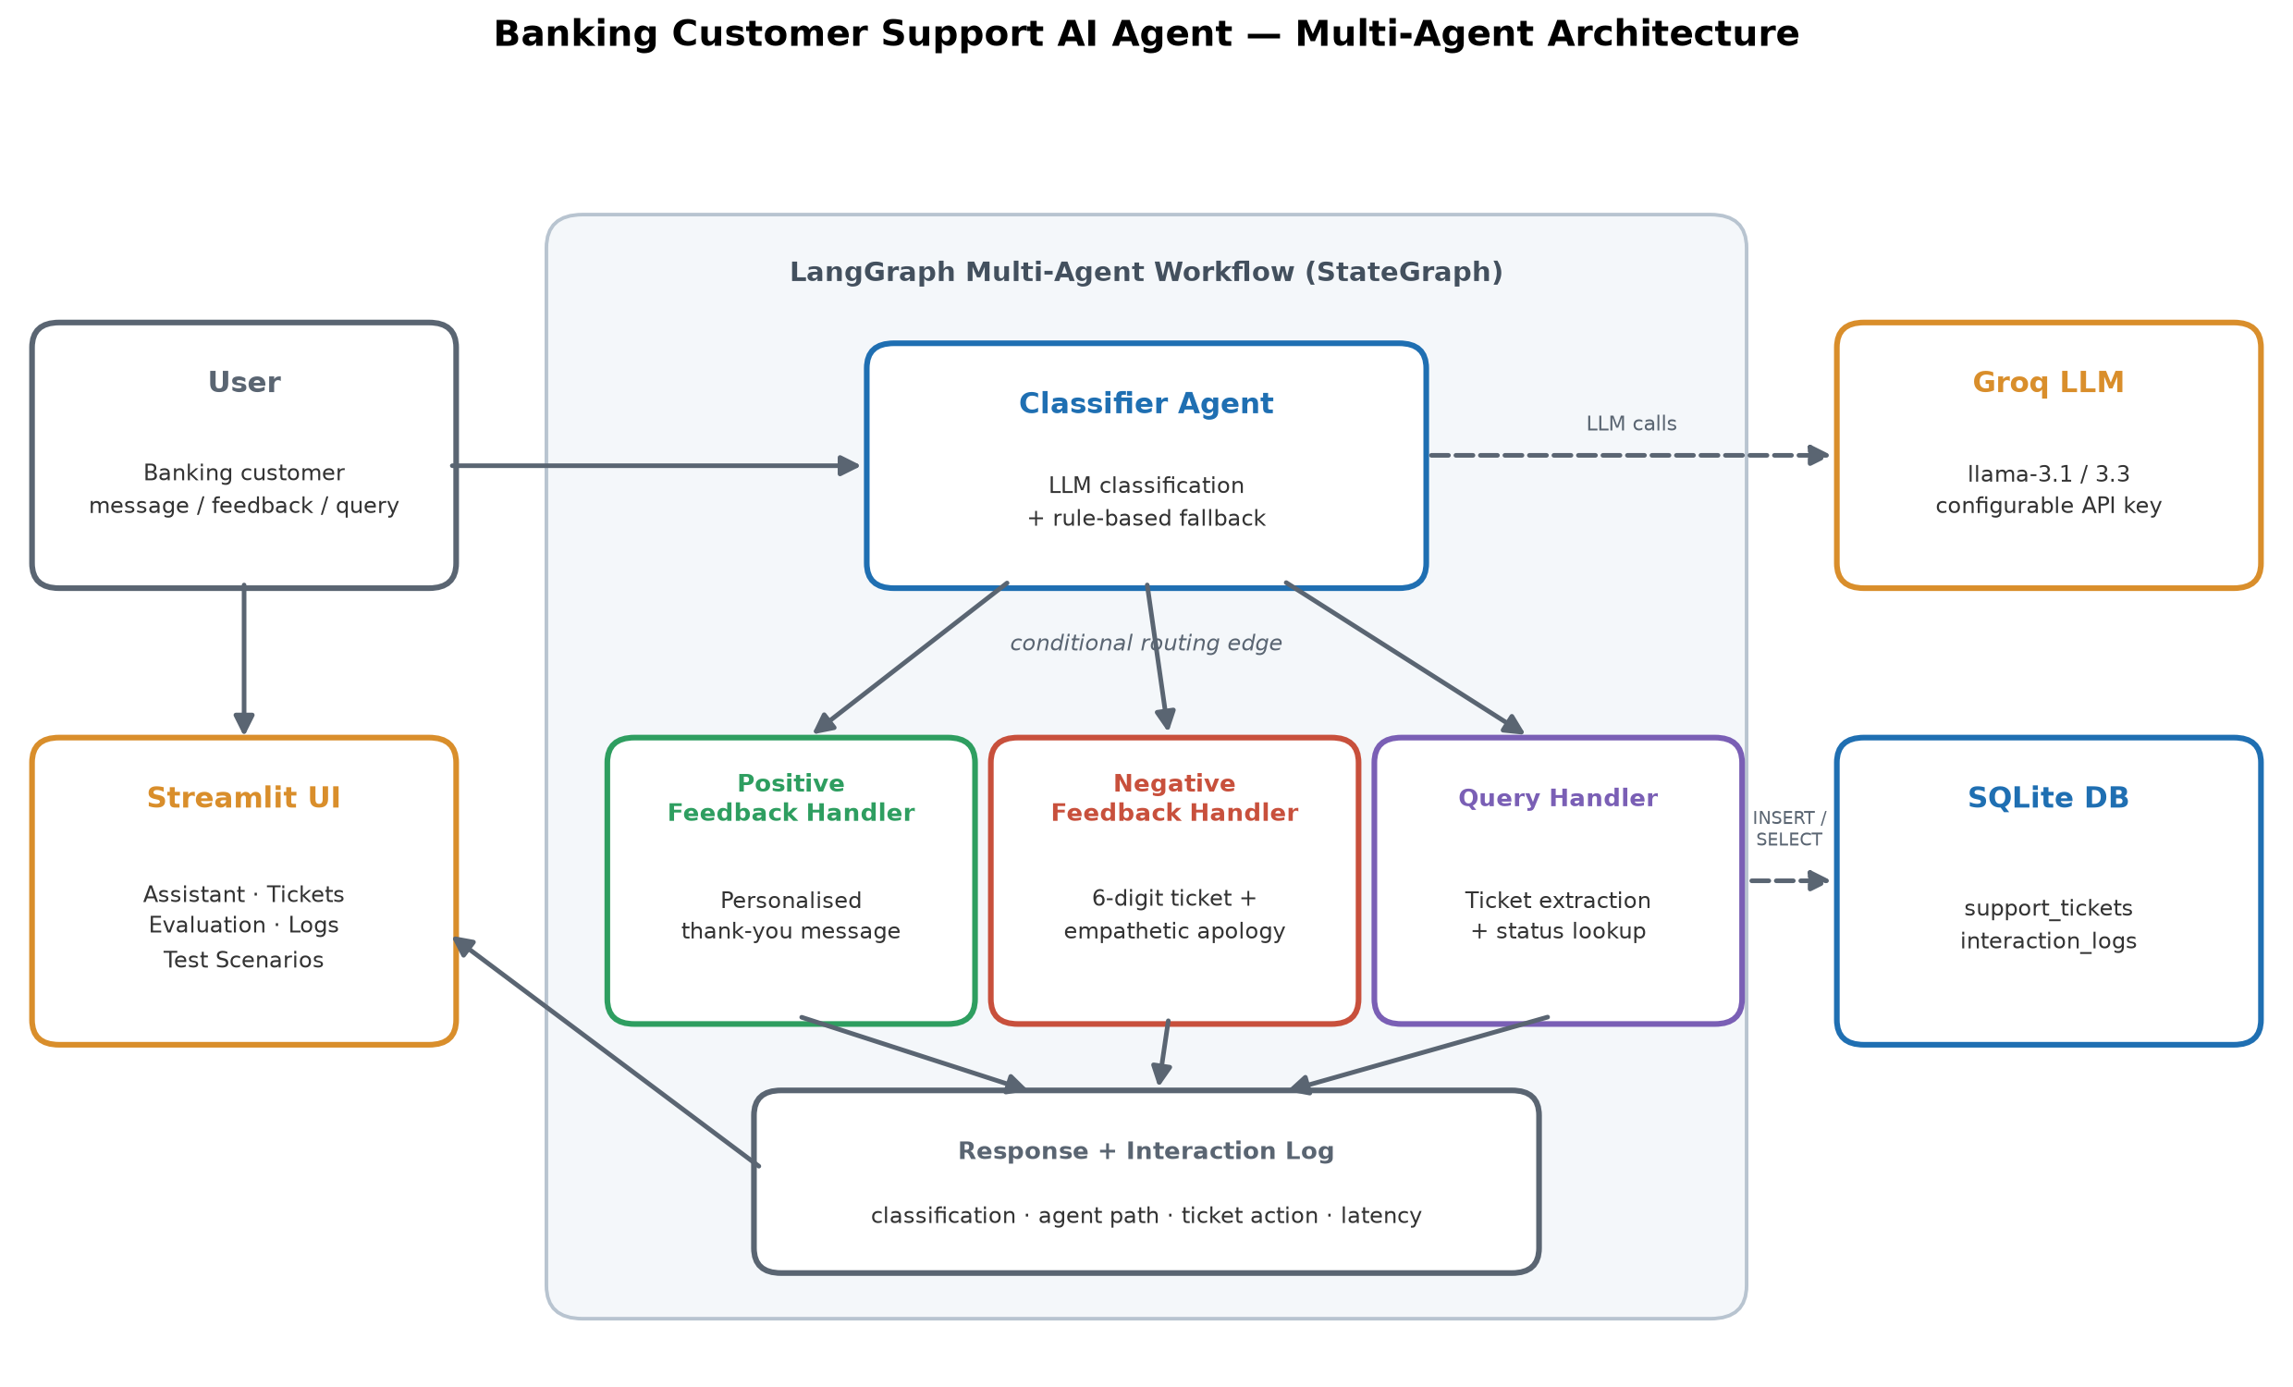
Figure 1 — Multi-agent architecture: Classifier Agent routing to three handlers via a LangGraph conditional edge, with Groq LLM and SQLite as external services.

3.1 Shared agent state
All agents read and write one typed state dictionary that flows through the graph:
class AgentState(TypedDict, total=False):
message: str # raw user message
customer_name: str # provided or auto-extracted
category: str # classifier output
response: str # final reply to the user
ticket_id: Optional[int]
ticket_action: str # e.g. "Created ticket #123456"
agent_path: List[str] # ordered list of agents that ran
prompt_trace: List[dict]# prompt/output/decision per agent
llm_used: bool

3.2 Workflow wiring
graph = StateGraph(AgentState)
graph.add_node("classifier", classifier_agent)
graph.add_node("positive_feedback_handler", positive_feedback_agent)
graph.add_node("negative_feedback_handler", negative_feedback_agent)
graph.add_node("query_handler", query_handler_agent)
graph.set_entry_point("classifier")
graph.add_conditional_edges("classifier", route_by_category, {...})
graph.add_edge("positive_feedback_handler", END) # and the other two
workflow = graph.compile()
The routing function is a pure function of the state — route_by_category(state) maps each of the three categories to its handler node, which makes the routing decision fully auditable and testable.

4. Agent Design

4.1 Agent 1 — Classifier Agent
The classifier sends the raw message to the Groq LLM with a strict single-label system prompt and accepts only the three canonical labels. Its output decides the conditional route. The full prompt, raw model output and final decision are appended to the state's prompt_trace for the debugging view.
You are a message classifier for a bank's customer support system.
Classify the user's message into exactly one category:
POSITIVE_FEEDBACK - thanking us or praising the service
NEGATIVE_FEEDBACK - complaining or reporting a problem
QUERY - asking about the status of an existing support ticket
Respond with ONLY the category label, nothing else.
Rule-based fallback. If the LLM is unreachable (no API key, network failure, rate limit), a deterministic keyword-scoring classifier takes over: a ticket-number reference plus query keywords maps to Query; otherwise weighted positive/negative keyword counts decide the sentiment. Every response records which engine produced it, so LLM and fallback behaviour can be compared in the logs.

4.2 Agent 2 — Feedback Handler Agent
Positive feedback: the handler asks the LLM for a short personalised thank-you addressed to the customer (name auto-extracted from phrases such as "This is Anjali…" or supplied in the UI, defaulting to "Valued Customer"). Fallback format:
Thank you for your kind words, [CustomerName]! We're delighted to assist you.
Negative feedback: the handler (1) generates a unique 6-digit ticket number by rejection-sampling against existing ticket ids, (2) inserts a new row into support_tickets with status Unresolved, and (3) returns an empathetic apology that is validated to contain the exact ticket number — if the LLM reply omits it, the deterministic template replaces it:
We apologize for the inconvenience, [CustomerName]. A new ticket #[TicketNumber] has been generated, and our team will follow up shortly.

4.3 Agent 3 — Query Handler Agent
This agent is fully deterministic (regex + SQL): it extracts a 6-digit ticket number, queries the database, and answers in the prescribed format "Your ticket #[TicketNumber] is currently marked as: [Status]." Two edge cases are handled gracefully — a message with no ticket number receives a polite request for it, and an unknown ticket number receives a verification prompt instead of an error.

5. Database Design
SQLite was chosen for zero-configuration persistence. The database file (support_tickets.db) is created and seeded automatically on first run — no external dataset is required.

5.1 Table: support_tickets
Column | Type | Description
ticket_id | INTEGER PK | Unique 6-digit ticket number (100000–999999)
customer_name | TEXT | Provided or auto-extracted customer name
issue_description | TEXT | The complaint text that opened the ticket
status | TEXT | Unresolved → In Progress → Resolved
created_at / updated_at | TEXT | ISO-8601 timestamps

5.2 Table: interaction_logs
Every pipeline run — user input, classification, agent path, response, ticket action, latency, engine used, success flag and the full JSON prompt trace — is appended to interaction_logs. This single table powers the History, Logs & Debug and success-rate views required by Part 2 of the problem statement.

5.3 Seed data
Six sample tickets across all three statuses are seeded so the query flow can be demonstrated immediately, including ticket #650932 (Resolved) used by the problem statement's Example 3.

6. Implementation Details
Component | Technology | Role
Agent orchestration | LangGraph (StateGraph) | Nodes, conditional routing, shared state
LLM | Groq — llama-3.1-8b-instant (configurable) | Classification + response generation
LLM integration | langchain-groq / langchain-core | Chat message interface
Persistence | SQLite (stdlib sqlite3) | support_tickets + interaction_logs
UI | Streamlit | Five-tab interactive dashboard
Evaluation & charts | pandas + matplotlib | Metrics tables and charts

6.1 Configurable Groq API key
The API key is deliberately never hard-coded. It is read, in order of precedence, from the sidebar password field in the Streamlit app, then from the GROQ_API_KEY environment variable. The notebook exposes the same configuration at the top of its setup cell. The model is also selectable (llama-3.1-8b-instant, llama-3.3-70b-versatile, gpt-oss-20b).

6.2 Reliability: graceful degradation
Every LLM call is wrapped so that any failure returns None, and each agent then falls back to a deterministic template that still satisfies the required response format. The negative-feedback handler additionally validates that the LLM's reply contains the generated ticket number before using it. The pipeline itself is wrapped in a try/except that logs a failed run rather than crashing the UI — the agent success/failure rate surfaces in the Logs & Debug tab.

6.3 Deliverables
- banking_support_app.py — the complete Streamlit application (agents, database, evaluation, UI) in a single runnable file
- Banking_Support_Agent.ipynb — the development notebook with step-by-step markdown explanations and executed outputs
- requirements.txt, README.md — dependencies and run instructions
- architecture_diagram.png, screenshots/ — figures used in this report

7. LLMOps — Model Evaluation
Part 2 of the problem statement asks for QA-based scoring, test-case coverage for the classification logic, and an agent routing success rate. A labelled suite of 30 banking messages (10 per category) runs the full pipeline end-to-end and measures:
- Classification accuracy — predicted vs. expected category, overall and per class
- Agent routing success rate — did the state actually reach the handler that matches the classification?
- QA pass rate — rule-based response checks: gratitude vocabulary for positive feedback; an apology and a 6-digit ticket number for complaints; the exact "marked as:" status format for queries
- Latency — end-to-end pipeline time per message

7.1 Results
Measured results (deterministic fallback engine, no API key): the suite was executed during development with the rule-based engine — the configuration a grader will see before pasting an API key — and achieved the following:
Metric | Result
Classification accuracy (overall) | 100 % (30/30)
Accuracy — Positive Feedback | 100 % (10/10)
Accuracy — Negative Feedback | 100 % (10/10)
Accuracy — Query | 100 % (10/10)
Agent routing success rate | 100 %
QA pass rate (format/content checks) | 100 %
Average pipeline latency | ≈ 1.3 ms (fallback) / LLM-bound with Groq

With a Groq API key configured, the same suite exercises the LLM classifier and generators instead; the Evaluation tab reruns all 30 cases live at the click of a button, so LLM-mode metrics can be produced and compared at any time. Routing success is measured independently of classification correctness, which isolates orchestration failures from model failures — an important LLMOps distinction.

7.2 LLM-as-judge QA scoring
When a key is present, an optional judge stage scores generated responses from 1–5 on empathy, clarity and accuracy using a strict JSON-only prompt, providing the qualitative QA dimension (empathy level, clarity of status updates) requested by the problem statement.

8. Streamlit User Interface
The dashboard fulfils every UI requirement of Part 2: it accepts user input and simulates agent routing; displays the classification, response and database interaction for each message; shows historical queries and logs; and offers one-click test scenarios for each agent role.

8.1 Assistant — chat with agent-path visibility
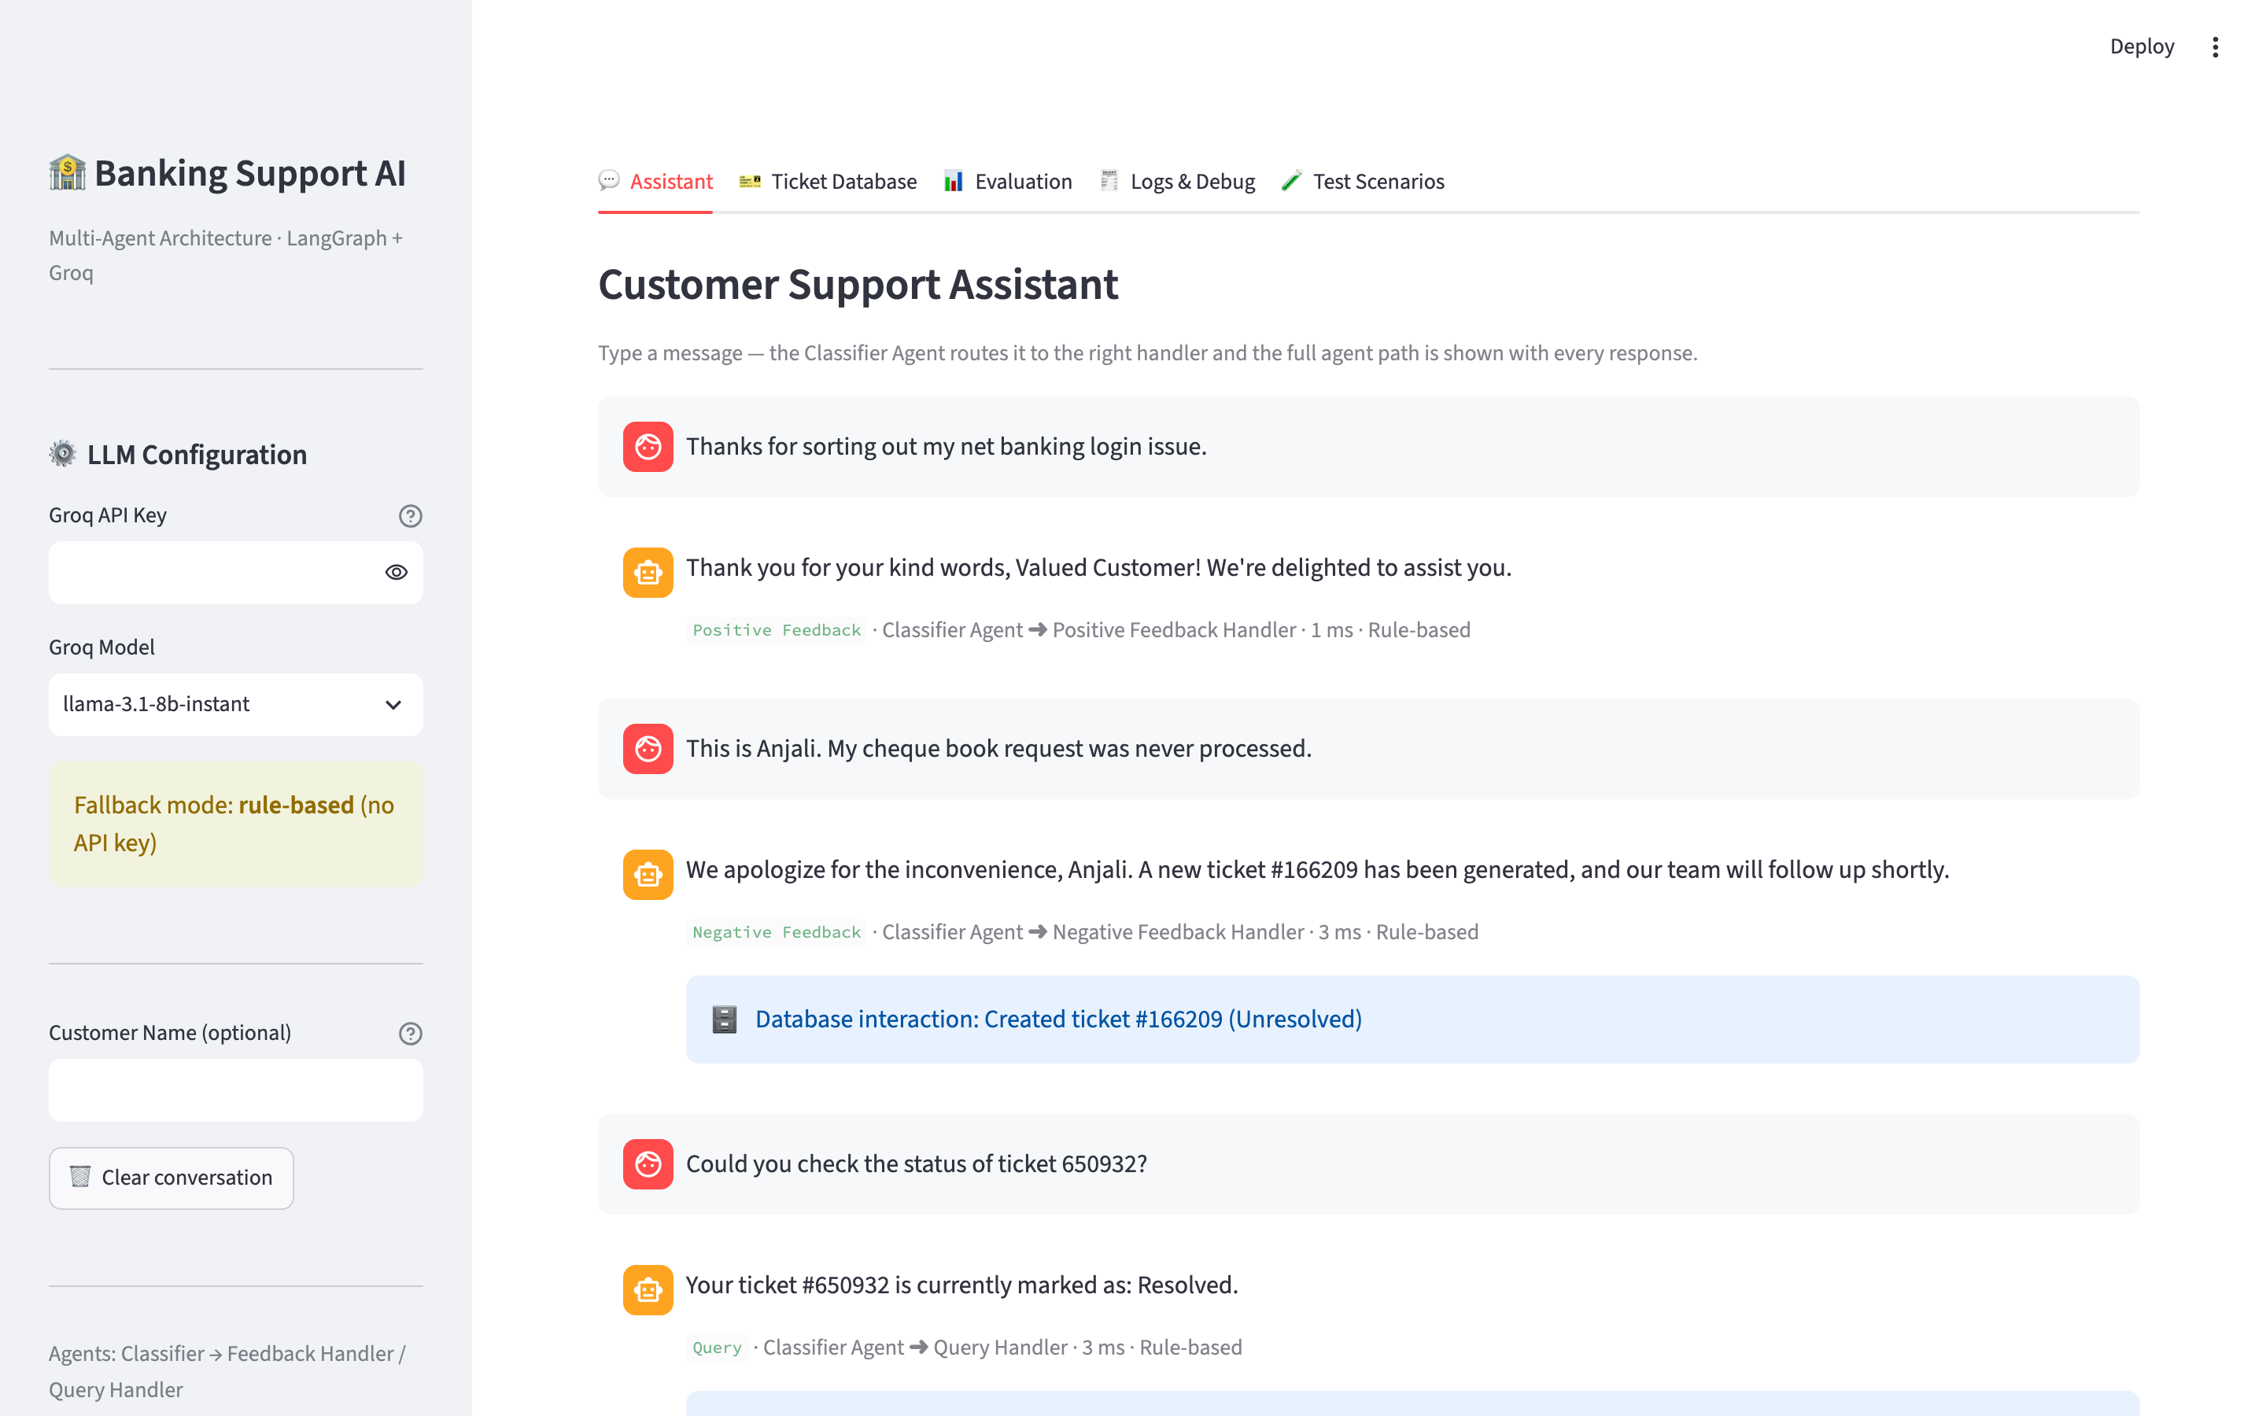
Figure 2 — Assistant tab: each reply shows the classification badge, the agent path, latency, engine used, and the database interaction (here: a new ticket created from negative feedback).

8.2 Ticket Database
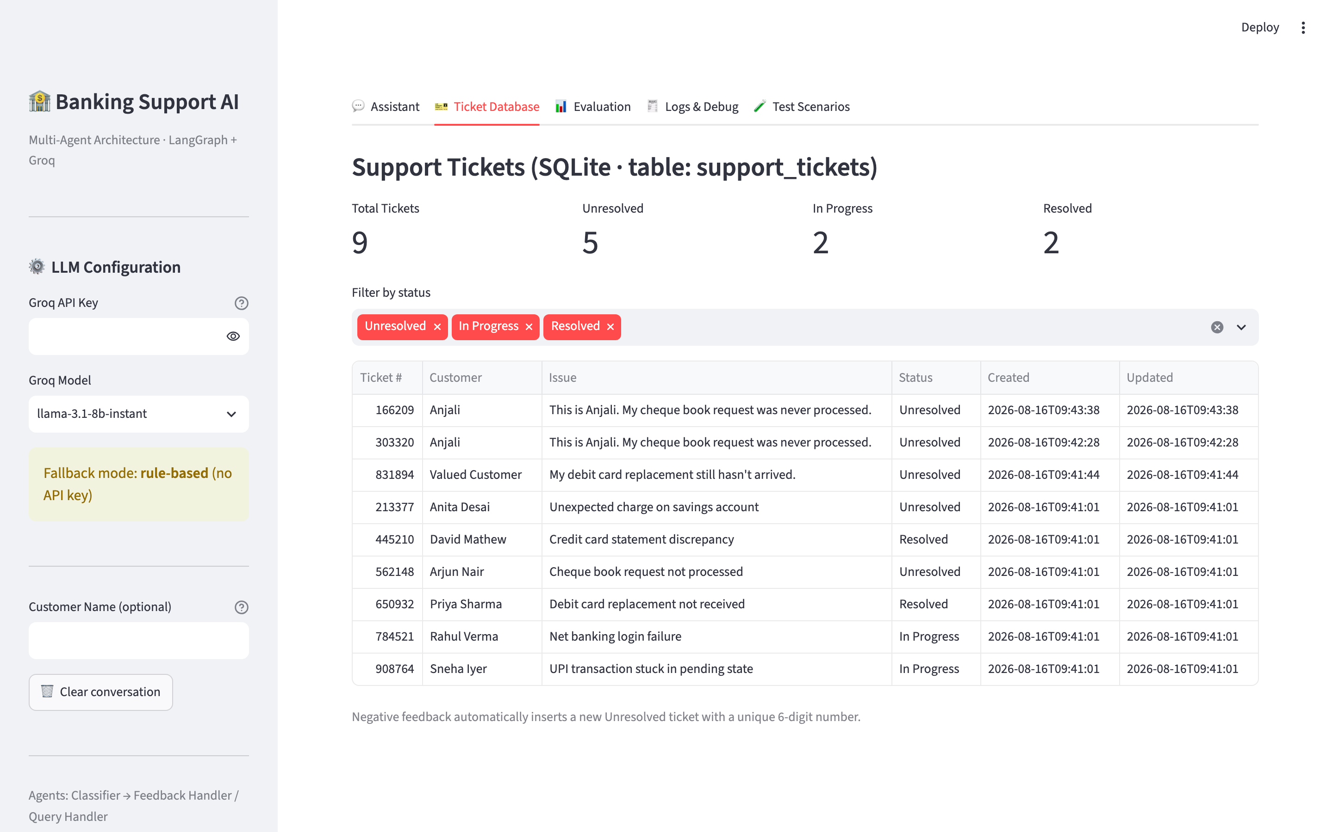
Figure 3 — Live view of support_tickets with status metrics and filters. Tickets created by the Negative Feedback Handler appear immediately with unique 6-digit numbers.

8.3 Evaluation dashboard
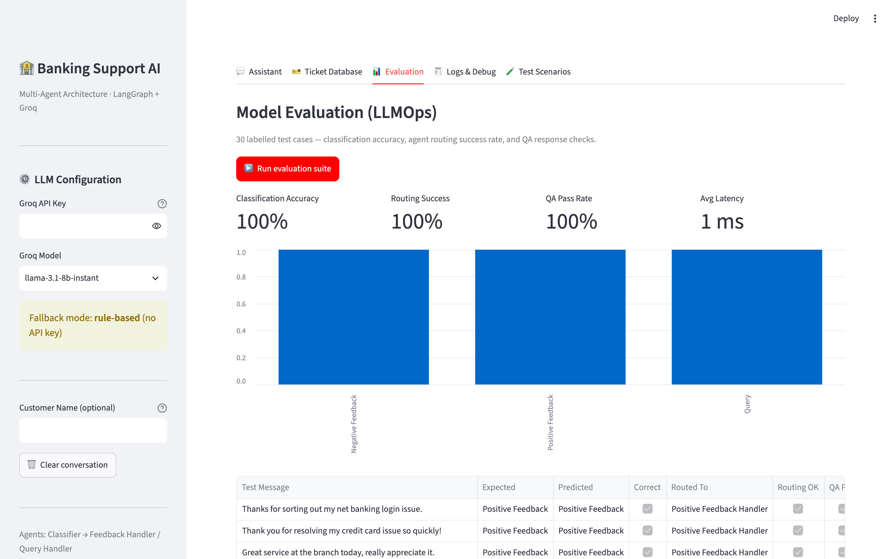
Figure 4 — One-click evaluation: metric cards (accuracy, routing success, QA pass rate, latency), per-class accuracy chart and the full 30-case result table.

8.4 Logs & Debug — prompt trace inspector
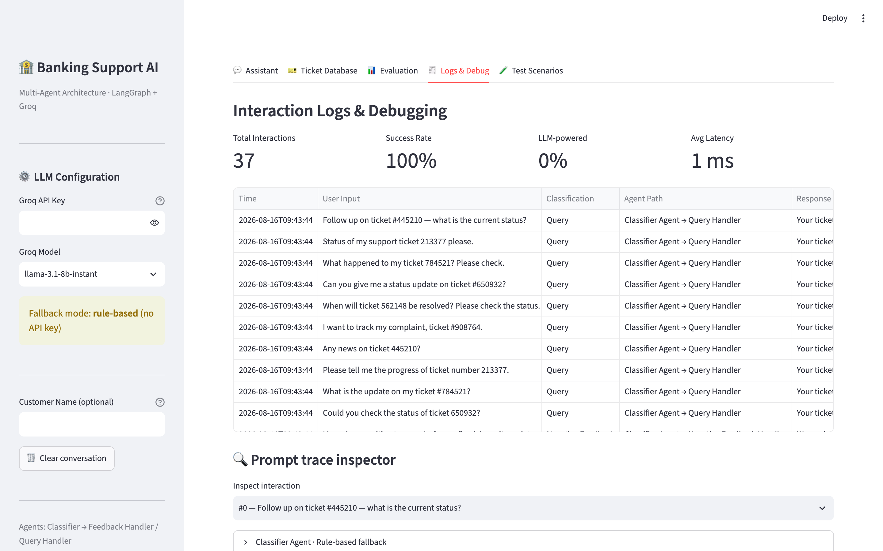
Figure 5 — Interaction logs with success metrics, and the prompt-trace inspector showing each agent's prompt, output and decision for any past message.

8.5 Test Scenarios
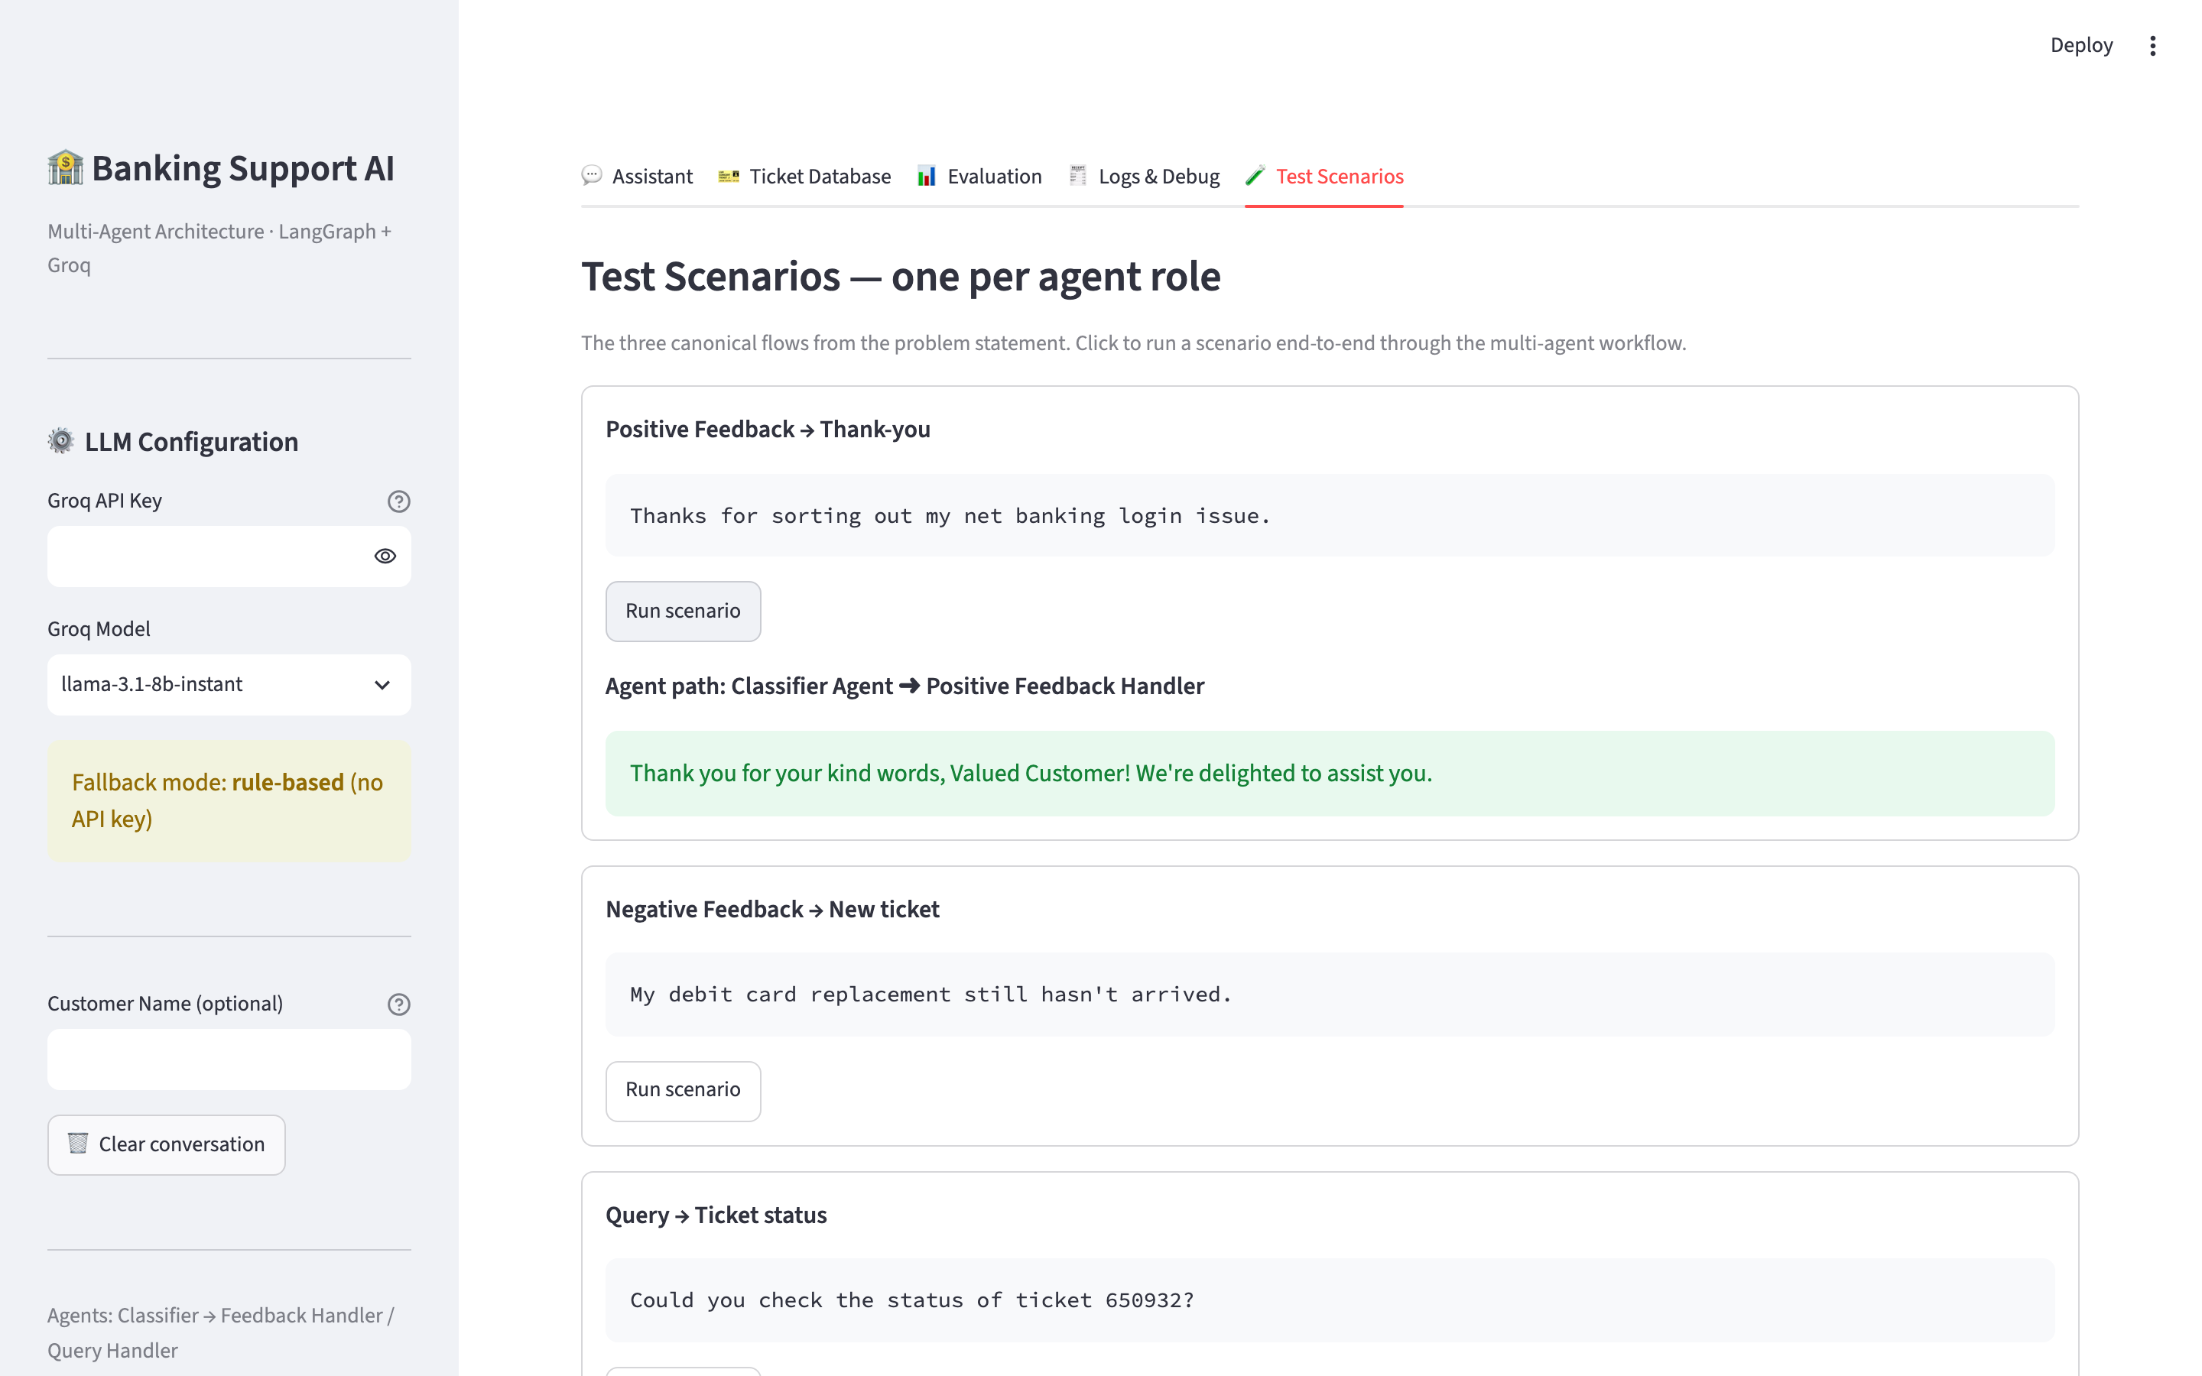
Figure 6 — The three canonical flows from the problem statement, runnable end-to-end with one click.

9. Sample Use-Case Flows (Verified Outputs)
Actual system outputs for the three examples in the problem statement:
User Input | Agent Path | System Response
Thanks for sorting out my net banking login issue. | Classifier → Positive Feedback Handler | Thank you for your kind words, Valued Customer! We're delighted to assist you.
My debit card replacement still hasn't arrived. | Classifier → Negative Feedback Handler | We apologize for the inconvenience, Valued Customer. A new ticket #609513 has been generated, and our team will follow up shortly.
Could you check the status of ticket 650932? | Classifier → Query Handler | Your ticket #650932 is currently marked as: Resolved.

10. How to Run
Following the capstone helper guide, the application runs as a Streamlit script:
pip install -r requirements.txt
streamlit run banking_support_app.py
# then open http://localhost:8501 (or the lab's Streamlit port)
To enable the LLM, create a free key at console.groq.com and either paste it in the sidebar or export it beforehand (export GROQ_API_KEY="gsk_..."). Without a key the app runs in rule-based fallback mode with identical workflows. The notebook (Banking_Support_Agent.ipynb) reproduces the whole system step-by-step and can be exported as an executable script via File → Save and Export Notebook As → Executable Script.

11. Conclusion and Future Enhancements
The delivered system satisfies every requirement of the capstone problem statement: a Classifier Agent routes messages through LangGraph conditional edges to a Feedback Handler that generates personalised thank-yous or opens unique 6-digit tickets in a SQLite support database, and to a Query Handler that reports ticket status in the prescribed format. The LLMOps layer provides a repeatable 30-case evaluation suite, QA scoring, structured logging with per-agent prompt traces, and a five-tab Streamlit dashboard for interaction, inspection and debugging.
Natural extensions include: retrieval-augmented answers for general banking FAQs; a human-in-the-loop escalation agent for low-confidence classifications; automatic ticket-status progression workflows; multilingual support; and feeding the logged user feedback back into prompt refinement — the improvement loop suggested in the problem statement.

