Web Development (Introduction)
WEDE5020

Website Project Proposal

Student Name: Mpumelelo Katleho Baatjie
Student Number: ST10517925
Group: 2
Date: 9 August 2026

Table of Contents
Table of Contents 2
Proposal 1: FlowFix Plumbing Services (Small Business) 3
1. Organisation Overview 3
2. Website Goals and Objectives 3
3. Current Website Analysis 3
4. Proposed Website Features and Functionality 3
Site Map 4
5. Design and User Experience 4
6. Technical Requirements 5
7. Timeline and Milestones 5
8. Budget 5
9. References 6
Proposal 2: Paws & Hope Animal Shelter (Non-Profit Organisation) 7
1. Organisation Overview 7
2. Website Goals and Objectives 7
3. Current Website Analysis 7
4. Proposed Website Features and Functionality 7
5. Design and User Experience 8
6. Technical Requirements 8
7. Timeline and Milestones 8
8. Budget 8
9. References 8
10. Bibliography…………………………………………………………………………………………………………9

Proposal 1: FlowFix Plumbing Services (Small Business)

1. Organisation Overview
- Name: FlowFix Plumbing Services
- FlowFix Plumbing Services is a small, family-run plumbing business based in Pretoria, offering residential and small commercial plumbing repairs and installations since 2019.
- Mission: To provide fast, honest, and reliable plumbing services to homes and small businesses across Pretoria.
- Target audience: Homeowners, landlords, and small business owners in Pretoria who need plumbing repairs, installations, or emergency callouts.

2. Website Goals and Objectives
- Make it easy for customers to request a plumber and describe their problem online, instead of relying only on phone calls.
- Build trust and credibility with potential customers before they even call, since most shoppers research a business online before making a decision (Wix.com, 2026).
- KPIs: Number of enquiry form submissions, number of emergency callout requests, and growth in monthly website visitors.

3. Current Website Analysis
FlowFix currently has no website and relies on word-of-mouth and a listing on a local classifieds app. Wix.com (2026) reports that 81% of shoppers research a business online before making a purchase decision, which means FlowFix is likely losing potential customers to competitors who already have an online presence. This is supported by DreamHost (2026), whose 2026 Local Business Trust Index found that businesses with a website are seen as 41% more trustworthy than those without one.

4. Proposed Website Features and Functionality
- Homepage: Introduction, service area, a visible emergency contact number, and a hero image.
- About Us: Company history, values, and the team's qualifications and experience.
- Services: A list of services offered, such as leak repairs, geyser installation and repair, drain unblocking, and bathroom or kitchen plumbing.
- Inquiries: A form for booking a job or requesting a quote, including fields for describing the problem and how urgent it is.
- Contact: Two service areas, phone numbers, operating hours, and a contact form.

Site Map
The diagram below shows the website's structure and how the five pages relate to each other. The homepage is the parent page, and all other pages sit one level below it and are reachable from the navigation menu on every page.
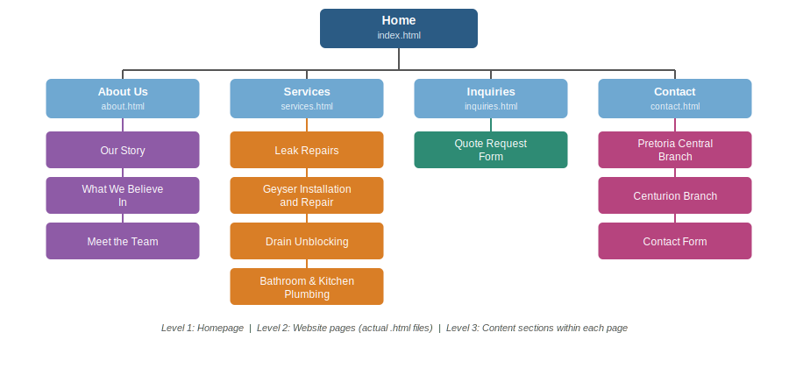
Figure 1: Site map of the FlowFix Plumbing Services website

5. Design and User Experience
- Colour Scheme: Blues and greys, to give a sense of trust, cleanliness, and professionalism.
- Typography: A bold, clean sans-serif font for headings and an easy-to-read font for body text.
- Layout and Design: A simple, mobile-first layout, since many customers will be searching for a plumber on their phone during an emergency.
- User Experience: The emergency contact number is visible on every page, and the enquiry form is short and simple. This matters because 57% of consumers say they will not recommend a business whose website is not mobile-friendly (WebFX, 2026).
Low-Fidelity Wireframe: The wireframe below shows the planned layout and information hierarchy of the homepage, before any colours, fonts, or images are applied. It focuses purely on structure: what content sits where, and in what order a visitor sees it.
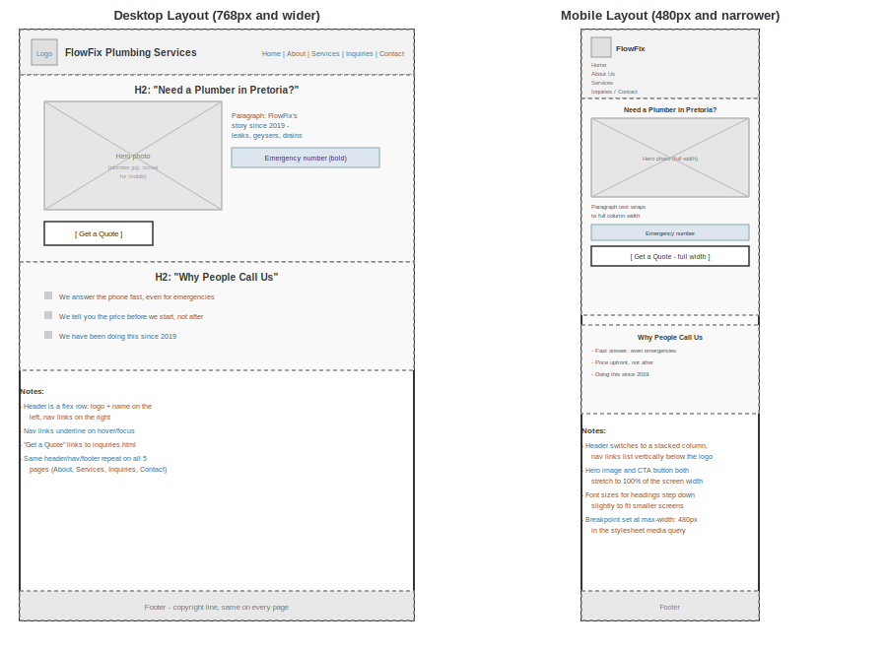
Figure 2: Low-fidelity wireframe of the FlowFix Plumbing Services homepage

6. Technical Requirements
- Hosting and domain: GitHub Pages for the coursework version; a domain such as www.flowfixplumbing.co.za for a real launch.
- Languages and frameworks: HTML5, CSS3, and basic JavaScript for interactive elements such as a click-to-call button.

7. Timeline and Milestones
- Week 1: Choose the target organisation, research competitors, and gather initial content and images.
- Week 2: Write and submit the Website Project Proposal; set up the private GitHub repository.
- Week 3: Plan the sitemap and file/folder structure; build the HTML structure for all 5 pages.
- Week 4: Add real content to every page, test that all navigation links work, and submit Part 1.
- Week 5: Review Part 1 feedback; create the external stylesheet and apply base styles, typography, and the colour scheme.
- Week 6: Build the responsive layout with Flexbox, add the tablet and mobile breakpoints, test across screen sizes, and submit Part 2.
- Week 7: Review Part 2 feedback; plan and build JavaScript features such as form validation.
- Week 8: Test JavaScript functionality across browsers, proofread the whole site, and submit Part 3 (final submission).

8. Budget
- Domain registration: approximately R150 per year.
- Hosting: R100 per month for shared hosting.
- Development: R 3500
- Estimated total: under R5 000 for the first year.

9. References
DreamHost. 2026. Gen Z says websites matter most (new 2026 study). [Online]. Available: https://www.dreamhost.com/blog/dreamhost-2026-local-business-trust-index/ [Accessed: 5 August 2026].
WebFX. 2026. 40+ website statistics every marketer should know in 2026. [Online]. Available: https://www.webfx.com/web-design/statistics/ [Accessed: 4 August 2026].
Wix.com. 2026. 50+ small business website statistics, 2026. [Online]. Available: https://www.wix.com/blog/small-business-website-statistics [Accessed: 4 August 2026].

Proposal 2: Paws & Hope Animal Shelter (Non-Profit Organisation)

1. Organisation Overview
- Name: Paws & Hope Animal Shelter
- Paws & Hope is a registered non-profit organisation based in Pretoria that has been rescuing and rehoming abandoned and stray animals since 2018.
- Mission: To give every rescued animal a safe space and a loving home, and to encourage responsible pet ownership in the community.
- Target audience: Potential adopters, donors, volunteers, and animal lovers in the greater Pretoria area.

2. Website Goals and Objectives
- Raise awareness of the shelter's work and the animals available for adoption.
- Encourage more donations and volunteer sign-ups by making it simple for supporters to give online.
- KPIs: Number of donation link clicks, volunteer form submissions, and adoption enquiries received per month.

3. Current Website Analysis
Paws & Hope currently has no website and relies only on a Facebook page. This makes it harder for new supporters to find the shelter, donate, or learn which animals need homes, especially since donors increasingly expect a trustworthy website before they give.

4. Proposed Website Features and Functionality
- Homepage: Mission statement, featured rescue animals, and a prominent "Donate" button.
- About Us: The shelter's history, mission, and the team/volunteers behind it.
- Adopt/Donate: A list of adoptable animals with photos and short bios, plus a simple online donation option. This matters because 63% of donors prefer to give online using a credit or debit card (Double the Donation, 2026).
- Enquiry: A form for people to sign up as a volunteer or sponsor.
- Contact: Shelter address, opening hours, and a contact form.

5. Design and User Experience
- Colour Scheme: Soft blues and greens to create a calm, trustworthy feel.
- Typography: A clean, simple sans-serif font that is easy to read.
- Layout and Design: Photo-heavy homepage to put the animals front and centre, with a simple, uncluttered layout, since photos and videos of animals help supporters feel more connected to the cause (Zeffy, 2026).
- User Experience: Clear, easy-to-find "Donate" and "Adopt" buttons, and a mobile-friendly design so people can browse and donate from their phones.

6. Technical Requirements
- Hosting and domain: GitHub Pages for the coursework version. For a real launch, a .org domain is recommended, since 68% of online donors say they trust websites and email addresses using a .org domain the most (Nonprofit Tech for Good, 2026).
- Languages and frameworks: HTML5, CSS3, and basic JavaScript for features like a simple animal filter or slideshow.

7. Timeline and Milestones
- Week 1–2: Research, planning, and content gathering.
- Week 3: Build the HTML structure for all pages

8. Budget
- Domain registration: approximately R150 per year.
- Hosting: R100 (may receive discounts)
- Development: Below R5000
- Estimated total: under R5500 for the first year, since NPOs often qualify for free or discounted hosting.

9. References
Double the Donation. 2026. Nonprofit fundraising statistics to boost results in 2026. [Online]. Available: https://doublethedonation.com/nonprofit-fundraising-statistics/ [Accessed: 4 August 2026].
Nonprofit Tech for Good. 2026. 2026 online fundraising statistics for nonprofits. [Online]. Available: https://www.nptechforgood.com/101-best-practices/online-fundraising-statistics-for-nonprofits/ [Accessed: 4 August 2026].
Zeffy. 2026. 18 animal shelter fundraiser ideas for your charity in 2026. [Online]. Available: https://www.zeffy.com/en-gb/blog/animal-shelter-fundraiser [Accessed: 5 August 2026].

Bibliography
Double the Donation. 2026. Corporate philanthropy and nonprofit fundraising statistics hub. [Online]. Available: https://doublethedonation.com/research/ [Accessed: 14 August 2026].
DreamHost. 2026. Gen Z says websites matter most (new 2026 study). [Online]. Available: https://www.dreamhost.com/blog/dreamhost-2026-local-business-trust-index/ [Accessed: 5 August 2026].
Nonprofit Tech for Good. 2026. 2026 online fundraising statistics for nonprofits. [Online]. Available: https://www.nptechforgood.com/101-best-practices/online-fundraising-statistics-for-nonprofits/ [Accessed: 4 August 2026].
WebFX. 2026. 40+ website statistics every marketer should know in 2026. [Online]. Available: https://www.webfx.com/web-design/statistics/ [Accessed: 4 August 2026].
Wix.com. 2026. 50+ small business website statistics, 2026. [Online]. Available: https://www.wix.com/blog/small-business-website-statistics [Accessed: 4 August 2026].
Zeffy. 2026. 18 animal shelter fundraiser ideas for your charity in 2026. [Online]. Available: https://www.zeffy.com/en-gb/blog/animal-shelter-fundraiser [Accessed: 5 August 2026]

