CAPE PENINSULA UNIVERSITY OF TECHNOLOGY
Faculty of Informatics and Design
Department of Information Technology
AIE580S / DSE580S Group Assignment 2026
Natural Language Sentiment Analyser
(Rule-Based Approach)
Topic 7
Scenario: Product and service review sentiment analysis
Group member | Student number
Lakhikhaya Mpumlwana | 220204594
Boka Winston Mokoena | 221203052
Sibabalwe Ngadana | 220193894
Submission date: 04 October 2026

PART A: PROBLEM AND SOLUTION

1. Problem / scenario overview
Product and service reviews are the digital word-of-mouth of modern consumers. Every day customers describe, in their own words, whether a product worked, how long it lasted and how the seller treated them. For a business this is some of the most honest feedback available, but it arrives as unstructured text in volumes that nobody can read manually: one popular product can attract thousands of reviews, and a retailer sells thousands of products.
Sentiment analysis, a branch of natural language processing (NLP), addresses this by automatically deciding whether a piece of text is positive, negative or neutral (Liu, 2012). Applied to reviews, it lets a business track its reputation over time, find the products that generate complaints, route unhappy customers to support quickly and check whether a fix has improved opinion.
Reflecting on the scenario, the star rating alone is not enough. Our dataset shows that ratings are heavily skewed: about 90% of reviews are positive and only 3% are neutral. The text carries the detail that a rating hides: negative reviews in our data are more than twice as long as positive ones (median 78 words against 31), because unhappy customers explain what went wrong. That detail is exactly what a business needs, and it is the part that cannot be read manually at scale.
The scenario also contains real difficulties: negation (“not good”), mixed opinions (“great card, but it died”), sarcasm and product-specific vocabulary (“refund”, “RMA”). A rule-based approach, which scores words with a sentiment dictionary and applies hand-written rules, is a sensible starting point for an introduction to NLP. It needs no training, runs instantly and is transparent, because the analyser can show which words produced a decision. Its weakness is that it cannot truly understand context, which this project measures rather than ignores.

2. Proposed solution
Aim: to build a working rule-based sentiment analyser that reads the text of a product review, classifies it as positive, negative or neutral, and explains its decision.
Objectives:
- Source a real review dataset and derive ground-truth labels from star ratings.
- Assess data quality, clean the text and explore the data to understand class balance, review length and vocabulary.
- Implement a lexicon-based analyser (VADER), tune its decision thresholds and extend it with a small domain lexicon, using training data only.
- Compare it with alternative tools (TextBlob and a rule-free word-count dictionary) on unseen test data using accuracy, precision, recall, F1 and macro-F1.
- Analyse misclassified reviews, state the limitations and propose improvements.
- Deliver a working notebook with setup instructions, a demo video and a presentation.
Success criterion: the analyser must beat the trivial baseline of labelling every review “positive” on macro-F1 (0.317 on our test data), because that baseline reaches 90.5% accuracy while being useless for finding unhappy customers.

PART B: PROJECT PLAN

3. Applying the Data Science life cycle
We followed the four-step Data Science life cycle: (1) problem definition, (2) data collection, (3) data preparation and analysis, and (4) modelling and deployment. The cycle is iterative: the error analysis in step 4 fed back into step 3 (for example, the discovery that complaint words were missing from the dictionary led to the domain lexicon). Table 1 shows how each step was applied.
Table 1: The Data Science life cycle applied to this project
Step | What we did in this project | Output
1. Problem definition | Defined the business question (“Is this review positive, negative or neutral, and why?”), the users (e-commerce and customer-support teams), the three output classes, the constraint (rule-based, no trained model) and the success measure (macro-F1 above the trivial baseline). | Aim, objectives and success criterion (Part A)
2. Data collection | Searched for a public product-review dataset containing both review text and a star rating, and selected a 4,915-review Amazon dataset from GitHub. The star rating supplies the ground truth. | amazon_reviews.csv
3. Data preparation and analysis | Checked missing values, duplicates and outliers; derived labels; cleaned and tokenized the text; engineered length and dictionary-coverage features; carried out exploratory analysis; split the data 70% training / 30% test. | Clean dataset, train/test files, EDA graphs
4. Modelling and deployment | Built three versions of the rule-based analyser; tuned thresholds and the domain lexicon on training data; evaluated on test data; analysed errors; packaged everything as a notebook with an analyse() function and an interactive demo. | Notebook, evaluation results, demo video, presentation

The key milestones in the assignment brief are: group and topic selection on 18 September 2026 (completed); report and deliverables submission on 4 October 2026; and presentation and demo on 6 and 8 October 2026.
Deployment plan. For this assignment the analyser is deployed as a Jupyter notebook that any user can run in Google Colab without installing software on their own computer (the first cell installs the required packages). Because the core is a single function, it can later be wrapped as a web form or an API so that a business can paste reviews or upload a file of them (see Future Work).

PART C: DATASET

4. Dataset

4.1 Description
The dataset is a public collection of Amazon product reviews published on GitHub (repository AnayDubey/Amazon-Product-Reviews-Sentiment-Analysis, file amazon_reviews.csv). Judging by the review content, most reviews concern memory cards and similar electronics. We did not verify how the reviews were originally collected. Table 2 summarises the dataset.
Table 2: Description of the dataset
Property | Value
Source | GitHub repository AnayDubey/Amazon-Product-Reviews-Sentiment-Analysis (Amazon product reviews)
Size | 4,915 reviews × 12 columns
Period | 9 January 2012 to 7 December 2014
Text feature (input) | reviewText: median 33 words, mean 50.4 words
Ground-truth feature | overall: star rating from 1 to 5
Other features | reviewerName, reviewTime, day_diff, helpful_yes, helpful_no, total_vote, score_pos_neg_diff, score_average_rating, wilson_lower_bound (metadata, not used for scoring)

4.2 Data quality
Table 3: Data quality checks
Check | Finding | Action taken
Missing values | 1 missing reviewText (0.02%) and 1 missing reviewerName; no other nulls | Removed the row with missing text (it cannot be scored); names are not used
Duplicates | No fully duplicated rows; 2 duplicated review texts (for example “No issues.”) | Kept the first occurrence of each
Outliers (length) | IQR upper fence of 103 words; 452 reviews above it; longest review 1,554 words; 17 reviews of 2 words or fewer | Kept: long reviews are genuine feedback and the scorer handles any length
Invalid ratings | None outside 1 to 5 | None needed

After removing one null and two duplicates, 4,912 reviews remained.

4.3 Data cleaning and transformation
Label creation. Star ratings were converted to sentiment labels using a standard convention for review data: 1 to 2 stars = negative, 3 stars = neutral, 4 to 5 stars = positive. This gives 4,446 positive (90.5%), 324 negative (6.6%) and 142 neutral (2.9%) reviews.
Text cleaning. We keep two versions of each review. The original text is used for scoring, because VADER relies on punctuation, capital letters and negations. A cleaned version is used for analysis: the text is lowercased; HTML tags, URLs, digits and punctuation are removed; contractions are expanded (“doesn’t” becomes “does not”); the text is tokenized with NLTK; and stopwords (very common words such as “the” and “and”) are removed. Negation words (not, no, never, nor and similar) were deliberately kept by removing them from the stopword list (158 stopwords were used instead of NLTK’s 198), because deleting “not” would reverse the meaning of “not good”. No review became empty after cleaning.
Train/test split. The data were split 70/30 with stratification (3,438 training and 1,474 test reviews, random seed 42) so that both parts keep the same class proportions. Everything tuned in this project uses the training part only.

4.4 Feature engineering
Because the analyser is rule-based, no features are needed to train a model. We engineered a few features for analysis and error analysis: word_count (words per review), n_tokens (tokens after cleaning), dictionary coverage (the share of a review’s tokens found in the VADER dictionary) and four flags used in the error analysis (contains a contrast word such as “but”, contains a negation, contains no dictionary word, is longer than 100 words).

4.5 Exploratory data analysis
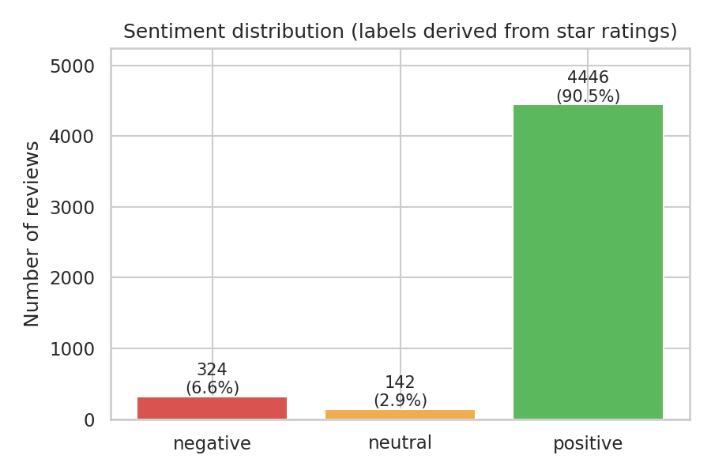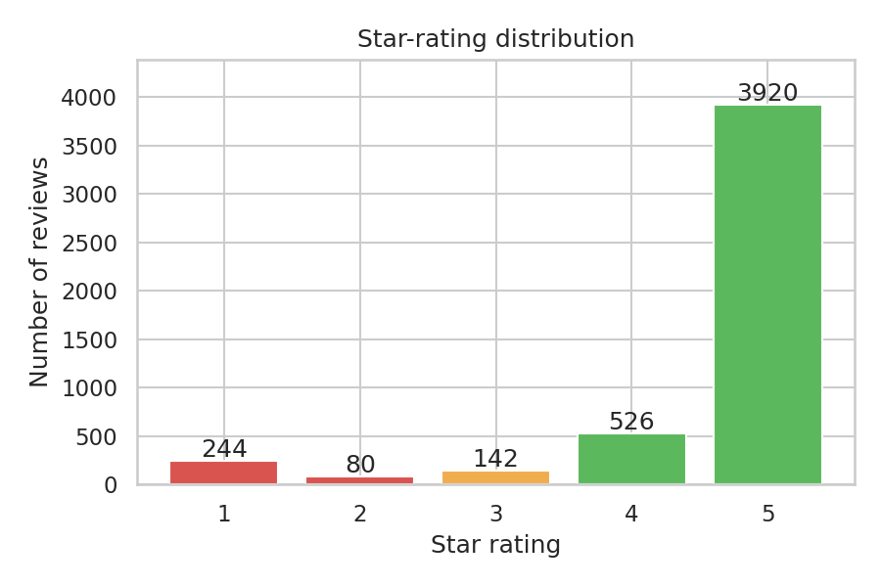
Figure 1: Sentiment distribution (left) and star-rating distribution (right)
Class and rating distribution (Figure 1). The data are strongly imbalanced: 90.5% of reviews are positive, and 5-star reviews alone make up 3,922 of the 4,915. This helps the problem in two ways. A tool that always answers “positive” would score about 90% accuracy, so accuracy cannot be our main metric and we use per-class precision, recall and F1 and macro-F1 instead. It also warns us that the neutral class (3-star reviews, which are often mixed) will be hard.
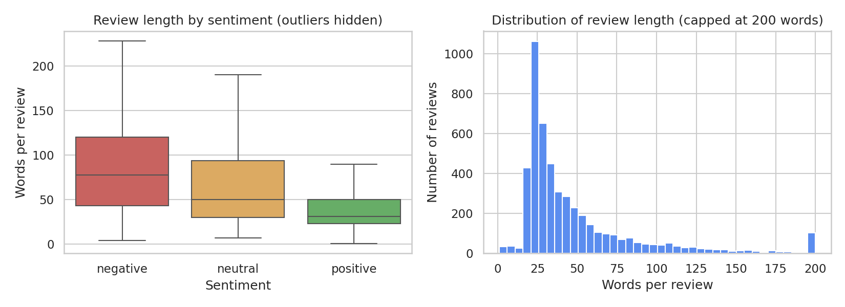
Figure 2: Review length by sentiment (left) and overall distribution (right)
Review length (Figure 2). Review length is right-skewed. Negative reviews are the longest (mean 106.5, median 78 words), then neutral (73.3, 50) and positive (45.7, 31). Longer reviews hold more sentiment words and more mixed signals, so they are harder to classify, while very short reviews give the scorer little to work with.
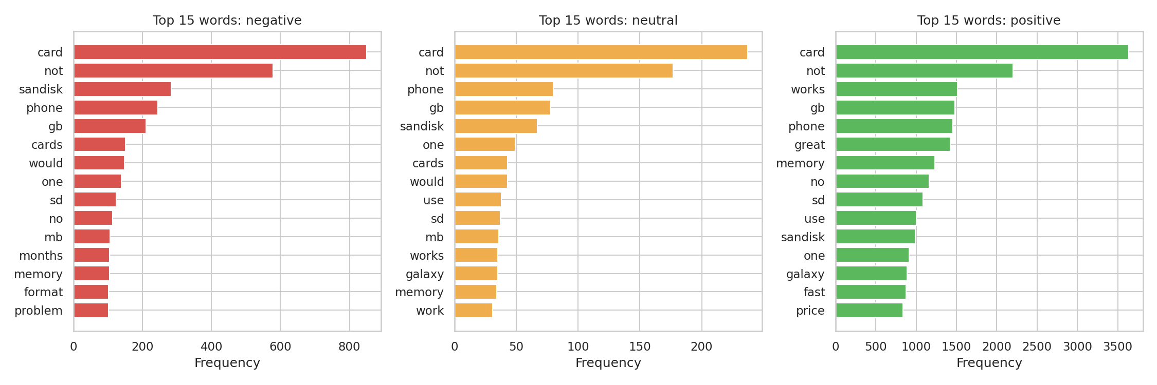
Figure 3: Most frequent words in negative, neutral and positive reviews
Word frequency (Figure 3). The most frequent words in every class are product words (card, phone, memory and similar), so raw frequency does not separate the classes. This justifies using a sentiment dictionary instead of simple word counts.
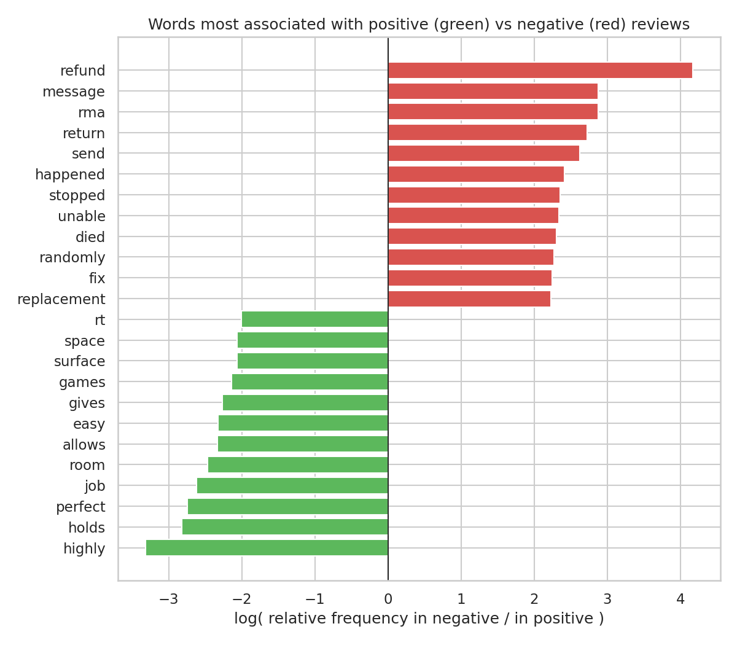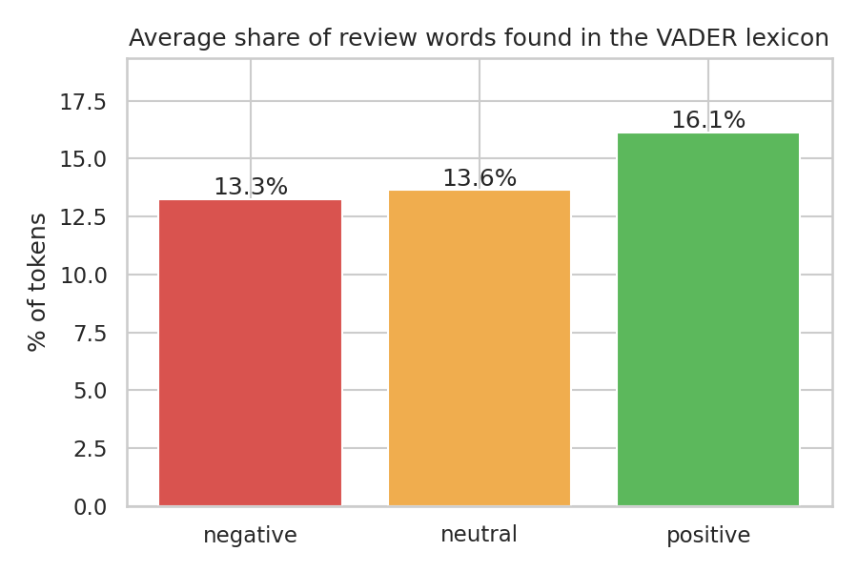
Figure 4: Words most associated with positive and negative reviews (left) and share of words found in the VADER dictionary (right)
Distinctive words and dictionary coverage (Figure 4). Words such as refund, rma, return, replacement, unable and died are far more common in negative reviews, while perfect, easy and highly lean positive, so sentiment is carried by individual words and a lexicon approach is appropriate. However, VADER’s dictionary (7,506 words) does not contain refund, rma, return, replacement, unable or fix. Although 94.6% of reviews contain at least one dictionary word, on average only 13% to 16% of a review’s tokens are found in it (13.3% negative, 13.6% neutral, 16.1% positive). This exposed a concrete weakness and led directly to our domain-lexicon improvement.

PART D: TECHNOLOGY AND IMPLEMENTATION

5. Alternative tools: exploration and critique
We examined the main options for rule-based sentiment scoring and tested three of them on the same data. Table 4 compares them; the macro-F1 values were measured on the unseen test set (Section 9).
Table 4: Comparison of rule-based sentiment tools
Tool | How it works | Strengths | Weaknesses | Macro-F1
Manual word-count lexicon | Adds up the dictionary scores of every word, with no other rules (we used the VADER dictionary) | Simplest and fully transparent; easy to extend | Ignores negation, intensity and “but”; “not good” scores positive | 0.416
TextBlob | Averages the polarity of words found in a built-in dictionary (Loria, 2018) | Very easy to use; also reports subjectivity | Lowest on negative (F1 0.26) and neutral (F1 0.02) reviews | 0.385
VADER | About 7,500 human-rated words (−4 to +4) plus rules for negation, capitals, punctuation, boosters and “but” (Hutto and Gilbert, 2014) | Handles negation and emphasis; fast; no training; explainable | Fixed dictionary, blind to domain words and sarcasm; default thresholds rarely output “neutral” | 0.428
VADER + domain lexicon (ours) | VADER with 17 review-specific words added and thresholds tuned on training data | Best result; still explainable | Domain words come from one product type | 0.485

AFINN (a simple scored word list) and SentiWordNet (WordNet-based scores) work in a similar way but were not tested. Machine-learning classifiers are excluded by the topic brief and are discussed under Future Work.

6. The chosen approach: VADER with a domain lexicon
We chose VADER because it gave the best macro-F1 of the tools tested, because its rules for negation, emphasis and contrast suit review text, because it needs no training data, and because every prediction can be explained by listing the words that drove it. VADER (Valence Aware Dictionary and sEntiment Reasoner) was designed for short informal text; its dictionary was rated by human judges, and each word has a valence from −4 (very negative) to +4 (very positive) (Hutto and Gilbert, 2014). We added a small domain lexicon and tuned the decision thresholds because the exploratory analysis showed that the unmodified tool misses complaint vocabulary and rarely outputs “neutral”.

7. Solution design and implementation details
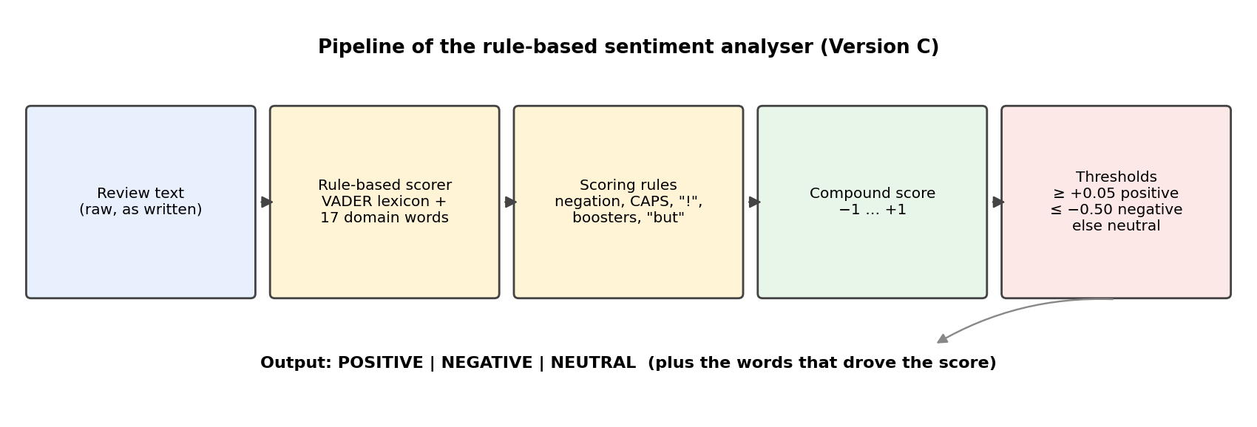
Figure 5: Pipeline of the rule-based sentiment analyser (Version C)
How the rule-based scoring works. For each review the analyser performs these steps (Figure 5):
- Dictionary lookup: each word is looked up in the lexicon (VADER plus our domain words); unknown words score zero.
- Emphasis rules: capital letters, exclamation marks and boosters (“very”, “extremely”) strengthen a word’s score; dampeners (“slightly”) weaken it.
- Negation rule: if a negator (“not”, “never”, “n’t”) appears in the three words before a sentiment word, that word’s score is reversed and weakened.
- Contrast rule: sentiment after “but” is weighted up and sentiment before it is weighted down.
- Compound score: the word scores are summed and normalised to a single compound score between −1 and +1 using x / √(x² + 15).
- Decision rule: a compound score at or above the positive threshold gives positive; at or below the negative threshold gives negative; anything in between is neutral.
Three versions were built to measure the value of each improvement (Table 5). Thresholds were chosen by searching a grid of values and keeping the pair with the highest macro-F1 on the training data only.
Table 5: The three versions of the analyser
Version | Dictionary | Positive threshold | Negative threshold | Train macro-F1
A. VADER default | VADER | +0.05 | −0.05 | 0.459
B. Tuned thresholds | VADER | +0.05 | −0.40 | 0.475
C. Domain lexicon | VADER + 17 words | +0.05 | −0.50 | 0.505

Domain lexicon. From the training reviews we listed the words most associated with negative or positive reviews that VADER does not contain, then kept only words that clearly express sentiment, skipping brand names, dates and ambiguous words. The 17 words and their scores on VADER’s −4 to +4 scale are: refund −1.5, rma −1.5, replacement −1.0, return −1.0, returned −1.2, returning −1.0, unable −1.5, unreadable −2.0, unmount −1.2, unmounting −1.2, randomly −1.0, unexpectedly −1.0, suddenly −0.8, fix −0.8, works +0.8, fast +1.2 and plenty +0.8. The scores are our own judgement.
Implementation. The analyser is written in Python 3 in a Jupyter notebook, using pandas and NumPy (data handling), NLTK (tokenization and stopwords) (Bird, Klein and Loper, 2009), vaderSentiment (scoring), TextBlob (comparison), scikit-learn (data split and metrics) (Pedregosa et al., 2011) and matplotlib and seaborn (graphs). The function analyse(text) returns the label and compound score and prints the dictionary words that drove the decision. An optional loop lets a user type reviews interactively, which is used in the demo video.

8. Assumptions
- Star ratings are a valid proxy for sentiment (1 to 2 negative, 3 neutral, 4 to 5 positive), although individual ratings can be noisy.
- Reviews are written in English; no language detection or translation is performed.
- Each review is treated as one document with one overall sentiment, even when it contains several opinions.
- VADER’s word valences, rated for general informal text, transfer reasonably to product reviews, with the domain lexicon covering the main gaps.
- The 70/30 stratified split is representative, and the thresholds and domain words chosen on training data generalise to unseen reviews.
- This dataset (mainly memory cards and electronics, 2012 to 2014) is representative enough for the project; results may differ for other product types.
- Sarcasm, slang and emoji are not specifically handled.

PART E: TESTING

9. Testing and performance evaluation

9.1 Test design and metrics
All results use the 1,474 test reviews (1,334 positive, 97 negative, 43 neutral), which were not used for tuning. The metrics are: accuracy (share of reviews classified correctly); precision (of the reviews we assigned to a class, the share that truly belong to it); recall (of the reviews that truly belong to a class, the share we found); F1 (the balance of precision and recall); and macro-F1 (the average F1 over the three classes, which treats the rare classes as equal to the common one and is our main metric).

9.2 Input and output examples
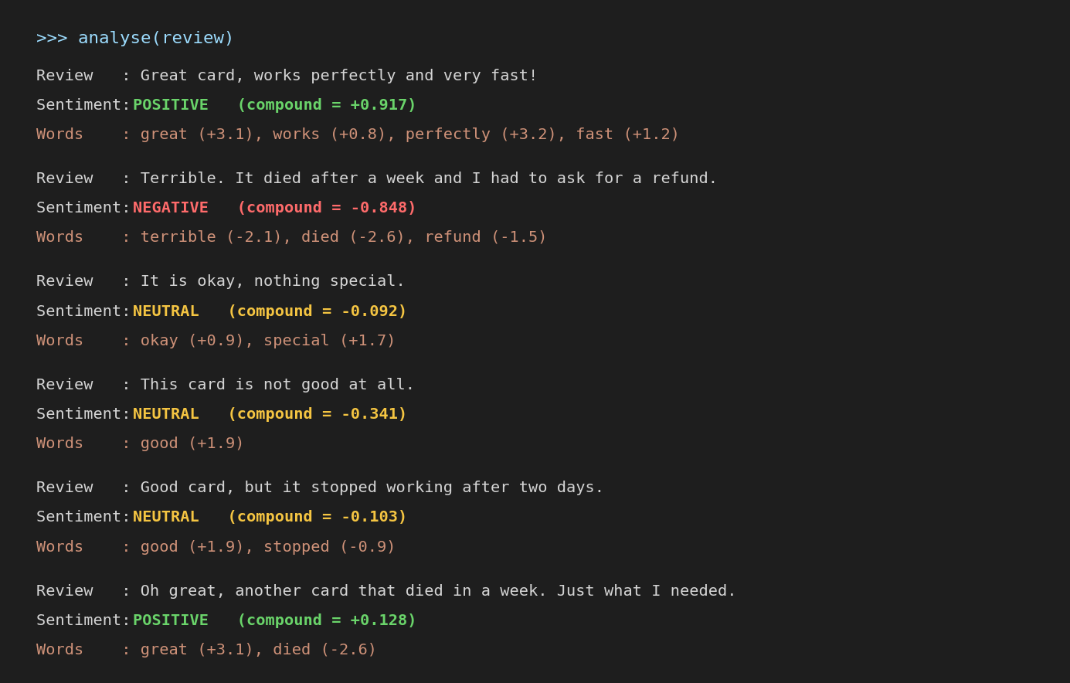
Figure 6: Sample input and output of the analyser (Version C), produced by the analyse() function
Figure 6 shows the analyser on six example reviews, listing the dictionary words that drove each decision. The first two are classified correctly. The rest show typical weaknesses discussed in Section 9.4: a clearly negative review (“not good at all”) falls into the neutral band, a mixed review is called neutral, and a sarcastic review is read as positive.

9.3 Results
Table 6: Test-set results for all tools (1,474 reviews)
Tool | Accuracy | Macro-P | Macro-R | Macro-F1 | F1 neg | F1 neu | F1 pos
Baseline: always “positive” | 0.905 | 0.302 | 0.333 | 0.317 | 0.000 | 0.000 | 0.950
TextBlob | 0.775 | 0.402 | 0.377 | 0.385 | 0.255 | 0.017 | 0.882
Word count, no rules | 0.739 | 0.415 | 0.468 | 0.416 | 0.338 | 0.056 | 0.853
A. VADER default | 0.791 | 0.415 | 0.473 | 0.428 | 0.358 | 0.038 | 0.886
B. VADER, tuned thresholds | 0.786 | 0.460 | 0.466 | 0.448 | 0.400 | 0.058 | 0.886
C. VADER + domain lexicon | 0.814 | 0.502 | 0.513 | 0.485 | 0.456 | 0.097 | 0.904

Table 7: Per-class results for Version C
Class | Precision | Recall | F1 | Test reviews
Negative | 0.494 | 0.423 | 0.456 | 97
Neutral | 0.060 | 0.256 | 0.097 | 43
Positive | 0.951 | 0.861 | 0.904 | 1,334

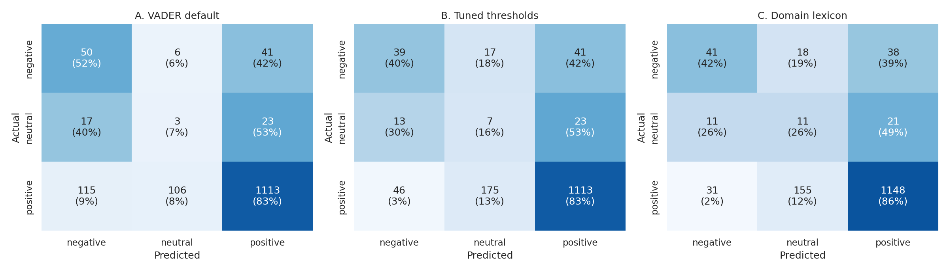
Figure 7: Confusion matrices for Versions A, B and C on the test set (rows = actual, columns = predicted)

9.4 Discussion of results
Version C performed best, with a macro-F1 of 0.485 against 0.428 for default VADER, 0.416 for the rule-free word count and 0.385 for TextBlob. Each improvement helped: tuning the thresholds added 0.020 and the domain lexicon a further 0.037. VADER’s rules mainly improved accuracy over the plain word count (0.791 against 0.739).
Accuracy is misleading here. The trivial baseline reaches 0.905, higher than every tool, yet it finds no negative or neutral review (macro-F1 0.317), which is why macro-F1 is our main metric. Per class, positive reviews are handled well (F1 0.90), negative reviews moderately (F1 0.46, with precision 0.49 and recall 0.42) and neutral reviews poorly (F1 0.10). Neutral recall (0.26) is far higher than neutral precision (0.06): most reviews labelled neutral are actually positive (Figure 7).
Two cautions apply. The test set contains only 97 negative and 43 neutral reviews, so differences of a few points could partly be chance. The thresholds and domain words were also fitted to this product domain.

9.5 Error analysis of misclassified reviews
Version C misclassified 274 of the 1,474 test reviews (18.6%). Table 8 shows the error types and Table 9 shows which review characteristics go with more errors; the characteristics overlap, so they suggest likely causes without proving them.
Table 8: Error types for Version C (correct predictions in bold)
Actual ↓ / Predicted → | Negative | Neutral | Positive
Negative (97) | 41 | 18 | 38
Neutral (43) | 11 | 11 | 21
Positive (1,334) | 31 | 155 | 1,148

Table 9: Error rate by review characteristic (Version C)
Characteristic | Reviews | Error rate with | Error rate without
Contains but / however / although | 386 | 27.2% | 15.5%
Contains a negation (not, never, n’t) | 828 | 22.9% | 13.0%
No dictionary word found | 57 | 98.2% | 15.4%
Long review (over 100 words) | 143 | 28.0% | 17.6%
3-star (“neutral”) review | 43 | 74.4% | 16.9%

The largest error group is positive reviews labelled neutral (155, or 57% of all errors). Almost every review with no dictionary word is wrong (98%), because the analyser defaults to neutral when it has nothing to score. Reading the misclassified reviews (saved in misclassified_test_reviews.csv) revealed four patterns:
- Technical complaints without sentiment words (negative called positive or neutral): phrases such as “slower write speeds”, “will unmount” or “stopped seeing the card” describe a failure without any dictionary word, while polite words in the same review (“works fine”, “reputable company”) add positive score.
- Problem solved, rating still high (positive called negative): customers gave 4 or 5 stars while describing a fault that was later fixed (for example a card returned and replaced within a week). Problem words, including some of our own domain words such as “returned”, push the score negative.
- Mixed 3-star reviews (neutral called positive or negative): “Great card but have had some issues with my GoPro” scores positive, while a review that says the card fails in one phone but works in another scores strongly negative. A single score cannot represent a review that is genuinely both.
- Imperfect ground truth: star ratings do not always match the wording, so part of the measured error is label noise rather than a failure of the analyser.

10. Other application areas
The same approach applies wherever short free-text opinions must be sorted quickly:
- Brand monitoring: scoring social-media posts, news comments and review sites that mention a brand, to track reputation and detect sudden negative spikes.
- Customer-support triage: scoring incoming emails, chats or tickets so that strongly negative messages reach a human first, with the displayed trigger words explaining the priority.
- Product improvement: grouping negative reviews by their frequent words (for example refund or replacement) to find recurring defects.
- Education and public services: analysing course evaluations or citizen feedback on municipal services to highlight problem areas.
- Hospitality and retail: monitoring hotel, restaurant and shop reviews by branch or location.
In each case the domain lexicon would need to be adapted, because this project showed that vocabulary matters.

PART F: LIMITATIONS AND FUTURE WORK

11. Limitations of the current implementation
- Weak neutral class: neutral F1 is only 0.10. A rule-based score cannot separate “neutral” from “mixed” or from mildly positive text.
- Sarcasm and irony: “Oh great, another card that died in a week” is classified positive because “great” outweighs “died”.
- Mixed sentiment: one score per review cannot express different opinions about different aspects of a product.
- Fixed dictionary: words outside the lexicon score zero, so complaints described in technical terms are missed; slang, misspellings and emoji are not specifically handled.
- Limited negation scope: negation is applied only within a short window of preceding words.
- Domain dependence: our 17 domain words and thresholds were tuned on one product category and may not suit others.
- Data limitations: strong class imbalance, few negative and neutral test reviews, star ratings used as imperfect labels, and English-only text.
- Threshold trade-off: thresholds tuned for macro-F1 sometimes place clearly negative reviews in the neutral band (for example “not good at all”).

12. Future work
- Upgrade to a machine-learning approach, starting with TF-IDF features and logistic regression and moving to a pre-trained transformer model, and compare it with this rule-based baseline.
- Score each sentence or product aspect (for example price, battery, delivery) separately to handle mixed reviews (aspect-based sentiment analysis).
- Improve negation handling and add rules for sarcasm cues, intensifiers and emoji.
- Build a larger domain lexicon validated by several human raters and test it on other product categories.
- Collect a larger, balanced, human-labelled test set, especially for the neutral class.
- Support South African languages and code-switching.
- Deploy the analyser as a web application or API that processes a whole file of reviews and produces a summary dashboard for managers.

PART G: ADDENDUM
Table 10: Evidence and links
Item | Link / information
13. Solution / application / tool | [Insert link to the notebook (Google Colab or SharePoint)]
14. Codebase | [Insert link to the GitHub repository or SharePoint folder]
15. Dataset | https://github.com/AnayDubey/Amazon-Product-Reviews-Sentiment-Analysis (file: amazon_reviews.csv). Cleaned and split copies: amazon_reviews_clean.csv, train.csv, test.csv.
16. Other relevant information | Files: sentiment_analyser.ipynb, README.md (setup instructions), requirements.txt, misclassified_test_reviews.csv and the figures folder. Setup: see README.md. In short, install Python 3 and run pip install -r requirements.txt (or, in Google Colab, just run the first cell); place amazon_reviews.csv in the same folder as the notebook; open the notebook and choose Run All. For the live demo set RUN_INTERACTIVE = True in Section 5.8. Demo video and presentation: [Insert SharePoint links].

REFERENCES
AnayDubey (n.d.) Amazon-Product-Reviews-Sentiment-Analysis [GitHub repository]. Available at: https://github.com/AnayDubey/Amazon-Product-Reviews-Sentiment-Analysis (Accessed: 4 October 2026).
Bird, S., Klein, E. and Loper, E. (2009) Natural Language Processing with Python. Sebastopol, CA: O’Reilly Media.
Hutto, C.J. and Gilbert, E. (2014) ‘VADER: A parsimonious rule-based model for sentiment analysis of social media text’, Proceedings of the 8th International AAAI Conference on Weblogs and Social Media, Ann Arbor, MI, pp. 216–225.
Liu, B. (2012) Sentiment Analysis and Opinion Mining. San Rafael, CA: Morgan & Claypool.
Loria, S. (2018) TextBlob: Simplified text processing. Available at: https://textblob.readthedocs.io (Accessed: 4 October 2026).
Pedregosa, F. et al. (2011) ‘Scikit-learn: Machine learning in Python’, Journal of Machine Learning Research, 12, pp. 2825–2830.

