# PERSONAL DETAILS

First Name: Olwethu

Last Name: Malumla

Date Of Birth: 31 January 2001

Nationality: South Africa

Civil Status: Single

Nationality: South African

Gender: Female

Disability: None

Criminal record(s) None

Home Language: IsiXhosa

Other Languages: English (Read, Speak and write) State of health Excellent (non-smoker)

Availability From 30th September 2024

# OBJECTIVE

I seek challenging opportunities where I can fully use my skills for the progress of the organization to obtain entry level position at this respected organization and utilize the experience and education I’ve obtained so far. I am highly driven, I have great communication skills, I bring an environment that encourages others and that allows me to grow. I look forward to improving my skills, experiences and capabilities.

# PERSONAL ATTRIBUTES

* Fast Learner
* Always keen to learn and share new ideas
* Able to work individually but can work with a team as well
* Able to work under pressure
* Good interpersonal skills

# EDUCATIONAL BACKGROUND

Last school attended: False bay College Fish Hoek Campus

Course: Information Technology & Computer Science (NCV LEVEL4)

Year: 2022

Achievements: Comptia A+ and Comptia N+ National ( awaiting certificate ) Institution: Northlink College Tygerberg Campus

Experience: IT Support Intern

Company: Northlink Tygerberg Campus

Year: 2023

Duration: 6 months

Current Occupation: Student

Institution: Life Choices Academy

Course: Full Stack Software Developer

# REFERENCES

|  |  |  |
| --- | --- | --- |
| ***NAME*** | ***RELATIONSHIP*** | ***CONTACT NUMBER*** |
| Mr S Karriem | Mentor | 082 307 2537 |
| Mr G Arries | Trainer/Lecturer (N.Link) | 076 838 6714 |
| Mrs P Chivige | Lecturer (F.Bay) | 071 895 6094 |
| Mr G Magwaza | IT Program manager &  Lecturer (F.Bay) | 073 415 1906 |

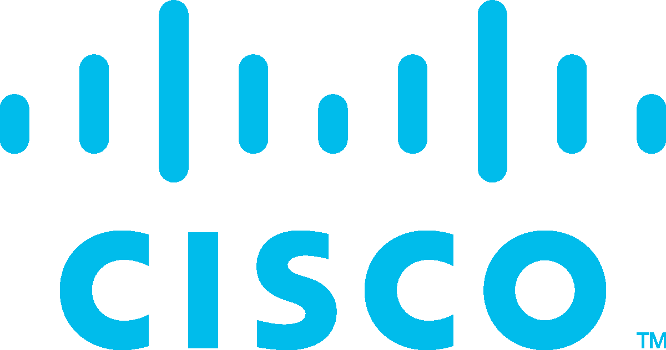Corporate Social Responsibility

Certificate of Course Completion

Cybersecurity Essentials

Cisco Networking Academy

For completing the Cisco Networking Academy® Cybersecurity Essentials course, and demonstrating the following abilities:

Describe the tactics, techniques and procedures used by cyber criminals. Describe the principles of confidentiality, integrity, and availability as they relate to data states and cybersecurity countermeasures.

Describe technologies, products and procedures used to protect confidentiality, ensure integrity and provide high availability.

Explain how cybersecurity professionals use technologies, processes and procedures to defend all components of the network.

Explain the purpose of laws related to cybersecurity.

**Olwethu Malumla**

Student

**Northlink College**

Academy Name

**South Africa 13 Apr 2024**

Location Date



Laura Quintana

VP & General Manager, Cisco Networking Academy

