**Mr. Ali Raza** 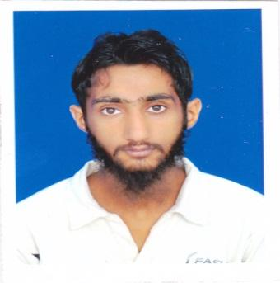

|  |
| --- |
| ***Personal Data*** |

* Contact No: ***0344 8796096***
* E-mail: ***raza_997@hotmail.com***
* DOB: *12th DEC 1989*
* Languages Known: English, Urdu

|  |
| --- |
| ***Career Objective*** |

My aim is to utilize my knowledge and education towards a creative and challenging work environment in a leading organization with an aim to contribute positively according to its objectives in ***software/web development*** field areas.

|  |
| --- |
| ***Educational Qualification*** |

* **Matriculation in Science (Secondary School Education) in 2007**
* **Intermediate in Pre-Engineering (Higher Secondary School Education) 2009**
* **Diploma/Bsc in Electronics and Telecommunication 2013**
* ***Msc Computer Science* (University of Management and Technology)**

|  |
| --- |
| ***Key skills and focus*** |

* ***Object Oriented Programing Concepts***
* ***Understanding of MVC framworks codeignitor, Laravel and Asp.NET***
* ***Known languages java, c# and PHP***
* ***Web Development(PHP Laravel framework)***
* ***Database servers MS SQL ,MYSQL***
* ***Ajax & Jquery***
* ***Android Development (fresh)***
* ***Can swith and ability to learn and adopt other frameworks as ASP.NET MVC***

|  |
| --- |
| ***Experience*** |

* ***1 year of experience***
* ***Internship in PHP, Codeigniter , Laravel and JS***
* ***Currently job: Working as PHP web developer Laravel framework***
* ***Operation on MySQL database and queries***
* ***Worked on ajax & jquery***
* ***Worked on image storage database with local file system , Laravel commands, Jobs and queues, Task Scheduling, Email with queue, Authentication and authorization.***
* ***Worked and integrate group chat in application using socket.io, angularjs and redis.***