Payilagam

UI System Design

STATUS  Proposed |  | OWNER  To assign |  | LAST UPDATED  2 October 2026

Authors | Codex
Reviewers | Frontend and backend reviewers
Related docs | UI_DESIGN_CONTRACT.md
Scope | Current architecture and intended full UI refresh

1 Summary
Refresh Payilagam as a neutral, compact learning workspace with emerald actions. Consolidate existing shared UI and preserve theme choice, route behavior, and backend authority.
For frontend and backend reviewers. Current describes the code snapshot of 2 October 2026; intended describes proposed decisions. This companion does not approve a release or replace API contracts.

2 Goals and Non Goals
Goals | Non goals
Compact neutral workspace | New marketing landing page
Emerald actions and accessible controls | Forced palette replacement
Shared shell and responsive navigation | Router or state-library migration
Server-backed courses and settings | Invented data or API redesign

3 Current Architecture
React Router composes public, authenticated, and fullscreen routes. AppProviders supplies Redux auth, React Query, and ThemeContext; App adds SocketProvider. CourseDetail and Settings also use direct HTTP calls, so query caching is not universal.
Shared controls live in components/ui; page primitives live in components/workspace and styles/workspace.css. Express mounts domain APIs at /api. Prisma targets PostgreSQL. The refresh changes presentation, not persisted domain ownership.

4 Intended UI Architecture

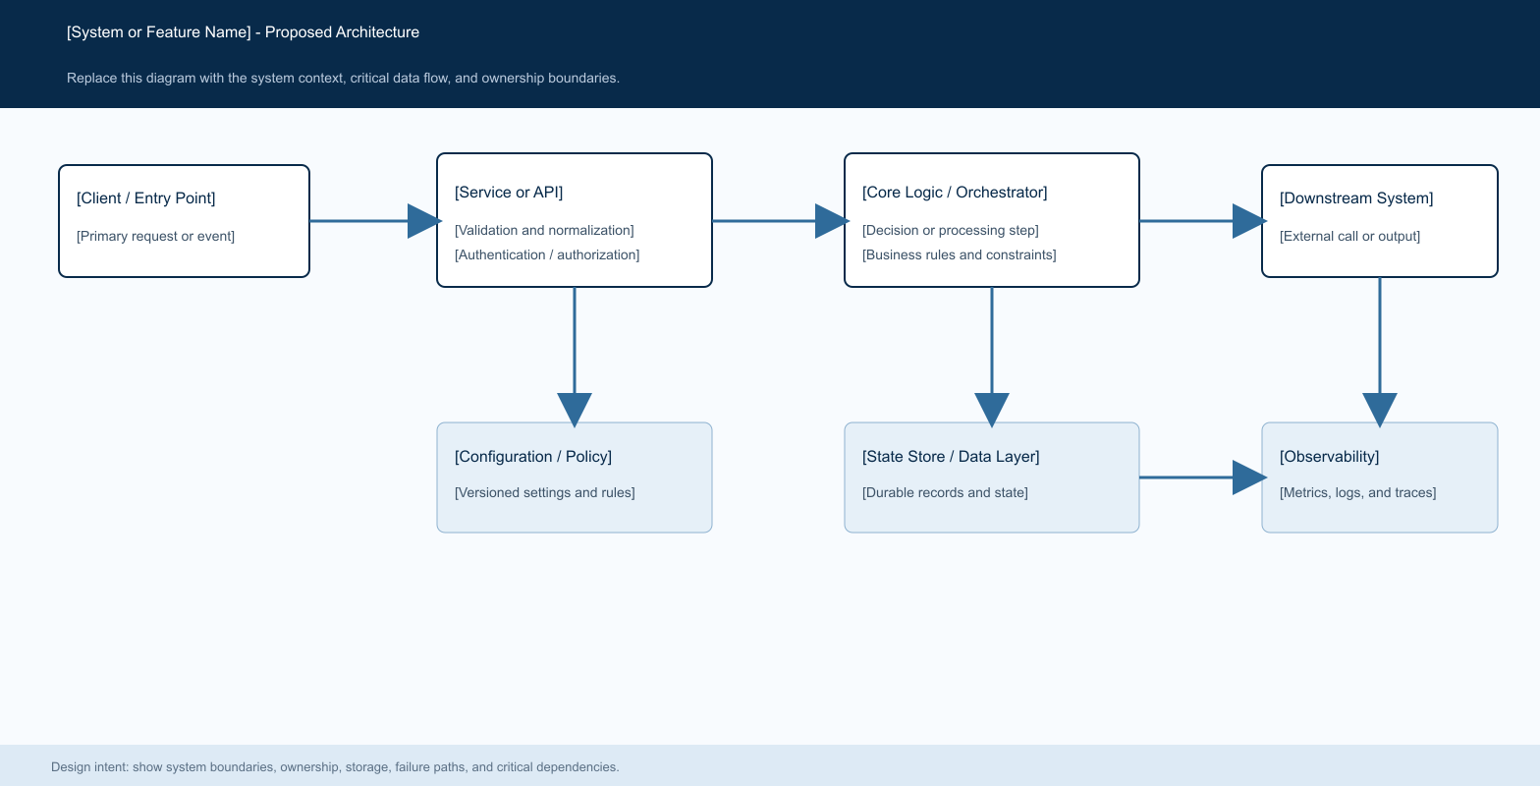
Current flow: route and shell > page/query or HTTP helper > Axios > Express domain API > Prisma/PostgreSQL.

Shared responsibilities

Component | Responsibility | State source | Intended behavior
Shell | SidebarLayout and public/fullscreen exceptions | Router and auth | Preserve role-aware navigation
Shared UI | ui controls; workspace page/header/states | Props and tokens | Accessible consistent states
ThemeContext | Seven palettes; light fallback in code | Profile + local preference | Preserve graphite/dark/light and other palettes
Courses | Catalog, detail, enrollment, builder | Express APIs | Real data; clear retry and missing-value states
Settings | Profile/avatar, security, mentor flows, appearance | Profile APIs and draft form state | Keep input and disclose save failures

5 Interaction Lifecycle
- Navigate through the existing shell and preserve public and fullscreen exceptions.
- Use route guards for UX; backend authentication and authorization remain decisive.
- Read server data through existing hooks/helpers. Query defaults: five-minute stale time, one retry, no focus refetch.
- Intended: show explicit loading, empty, error, and ready states without fabricated metrics.
- Intended: validate forms, keep dirty values on errors, disable duplicate pending submissions.
- Intended: reconcile successful writes with returned data or refetch/invalidation before presenting durable success.
- Theme selection currently updates locally first; failed server persistence only warns. Intended: disclose unsaved preference without blocking the workspace.

6 Existing API Contracts

Representative endpoints

Operation | Method | API path | UI boundary
Catalog | GET | /courses/published | Server filters and pagination
Detail | GET | /courses/:id | Retain identifier semantics
Enrollment | POST | /enrollments/:courseId/enroll | Confirm server result
Profile/theme | PUT | /auth/profile | Reconcile saved values
Password | PUT | /auth/change-password | Protect credential input
Avatar upload | POST | /auth/profile/avatar | Multipart validation
Avatar delete | DELETE | /auth/profile/avatar | Confirm destructive action

Data boundaries

- Frontend API constants omit /api; VITE_API_URL configures the Axios base URL.
- HTTP helpers return Axios responses. The catalog reads response.data.data and response.data.pagination; do not assume a universal envelope.
- Keep existing course identifiers, role checks, payloads, and pagination semantics.
- Backend data is authoritative. Redux currently holds auth; local state holds transient controls and draft forms.
Source map and implementation criteria:
docs/design/UI_DESIGN_CONTRACT.md; FrontEnd/src/api/constants.ts; BackEnd/src/routes/index.js.

7 Consistency and Failure States

Intended: reconcile writes explicitly and keep failures distinguishable from empty data. No general idempotency, replay, or automatic mutation-retry guarantee is asserted.
Scenario | Intended response | Reason
Repeated submit | Disable pending action | Reduce duplicate writes; not an idempotency guarantee
API failure | Keep inputs; explain retry | Avoid false success
Timeout | Reconcile before write retry | Outcome may be uncertain
Theme save fails | Keep local selection; report unsaved state | Local preference is not confirmed persistence

8 Accessibility and Security

- Intended: visible labels, autocomplete, linked inline errors, visible focus, and announced pending/results. Toasts must not be the only error feedback.
- Reuse Radix-based dialogs, selects, and menus. Verify keyboard interaction, Escape, focus return, and popover collision handling.
- Preserve desktop collapse and mobile navigation. Test focus containment, restoration, active links, and narrow-screen toolbars.
- Axios currently reads a local token for Bearer authorization and clears stored credentials on 401. Do not expose credentials in UI logs or add new client-side secret storage.
- Preserve server permission checks for enrollment, editing, and administration. Proposed contrast and keyboard gates require validation; conformance is not yet certified.

9 Proposed Acceptance Gates
Check | Proposed criterion | Reviewer | Gate
Navigation | Guest/student/mentor/admin and denied links | To assign | Required
Responsive UI | 360/768/1440 px; 200% zoom; no clipping | To assign | Required
Themes | Light/dark/graphite; other palette smoke checks | To assign | Required
Accessibility | Keyboard flow; 4.5:1 text and 3:1 control/focus contrast targets | To assign | Required
Data integrity | Real API success/failure and reload checks | To assign | Required
Validation status: source inspection only. No application build, tests, browser checks, or accessibility audit ran for this document.

10 Alternatives Considered

Alternative | Benefit | Why not selected
Page-local styling | Fast isolated edits | Drifts across themes and states
Replace state stack | Uniform new approach | Unneeded migration risk
Force emerald palette | Single appearance | Breaks saved theme expectations
Local demo domain data | Easy visual previews | Not backend truth

11 Review Decisions
- Confirm emerald action values and contrast for each existing palette.
- Agree on query invalidation for direct-call pages and shared lists.
- Choose visible feedback for failed theme persistence.
- Assign implementation reviewers and rollout ownership.

12 Decision and Next Steps
Recommended: consolidate incrementally. Refresh courses and settings on shared foundations, then extend to other workspaces. Keep routes, domain APIs, and saved theme values stable; promote only after the proposed checks pass.
Milestone | Intended deliverable | Exit criteria
M1 | Shared tokens, shell, controls | Theme and navigation review
M2 | Courses and settings | Real API and failure-state checks
M3 | Remaining workspace pages | Responsive and keyboard review
M4 | Rollout decision | Build/tests reviewed; UI rollback ready

Current means inspected code; intended means a proposed refresh decision.

